Electronic Supplementary Information
Highly Efficient Regulation Strategy of Fluorescence Emission Wavelength via Designing the Structure of Carbon Dots
Haiyan Bai^{a,b}, Xilang Jin^{a,b,c ∗}, Zhao Cheng^{d}, Hongwei Zhou^{a,b}, Haozhe Wangª, Jiajia Yuª, Jialing Zuoª, Weixing Chen^{a,b ∗}

CONTENTS
Fig S1 Effect of (a) reaction temperature; (b) reaction time on the fluorescence intensity of CDs; (c) pH stability (d) salt resistance (e) UV absorption of CDs
Fig S2 High-resolution XPS spectra of d-CDs: (a) N (b) O (c) S
Fig S3 High-resolution XPS spectra of e-CDs: (a) N (b) O (c) S
Fig S4 High-resolution XPS spectra of m-CDs: (a) N (b) O (c) S
Tab S1 The peaks of the four constituent elements of C1s, N1s, O1s and S2p
Fig S5 Raman spectrum of d-CDs and a-CDs

Materials and measurements
All reagents were obtained from commercial sources and used without further purification throughout the experiments.
Fluorescence spectra were performed on a Quanta Master 8000 spectrofluorometer with a slit width of 5 nm for both excitation and emission. UV-Vis spectra were measured on a Shimadzu UV-2550 spectrophotometer. FT-IR analyses were performed on a Bruker VERTEX 70 spectrometer. Raman spectrum was obtained using a Lab RAM HR Evolution. The X-ray photoelectron spectrum (XPS) was acquired on Thermo Scientific K-Alpha. The XRD spectrum was measured on a D2 PHASER Gen2 x-ray diffractometer. The TEM spectrum was measured on a JEM-2010 transmission electron microscope.

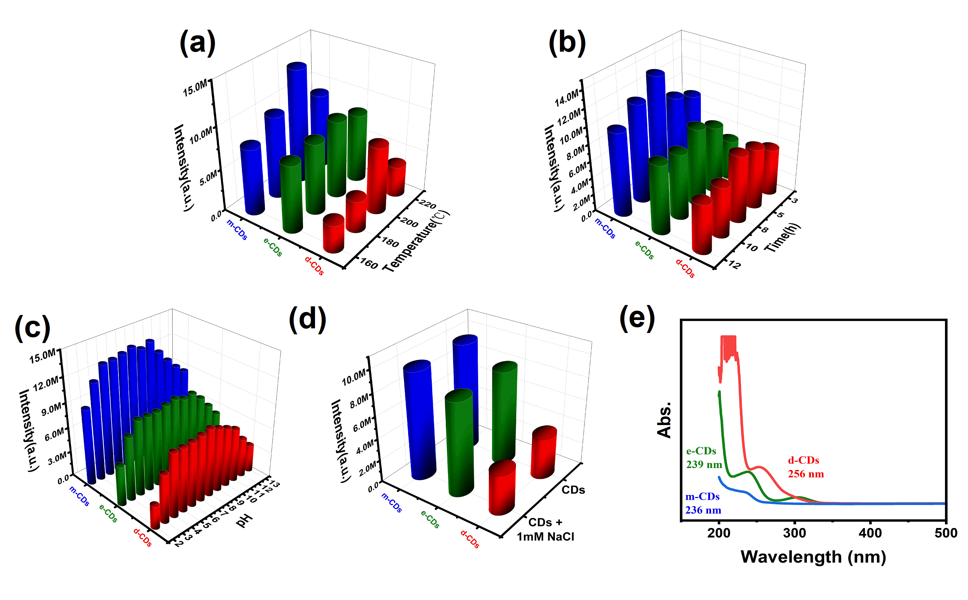
Fig S1 Effect of (a) reaction temperature; (b) reaction time on the fluorescence intensity of CDs; (c) pH stability (d) salt resistance (e) UV absorption of CDs

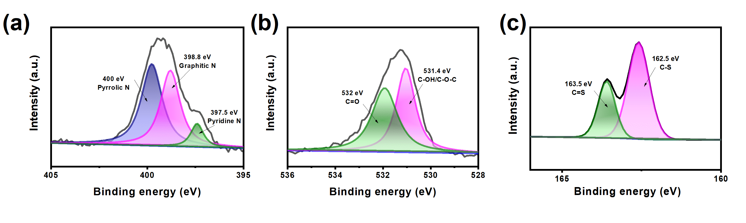
Fig S2 High-resolution XPS spectra of d-CDs: (a) N (b) O (c) S

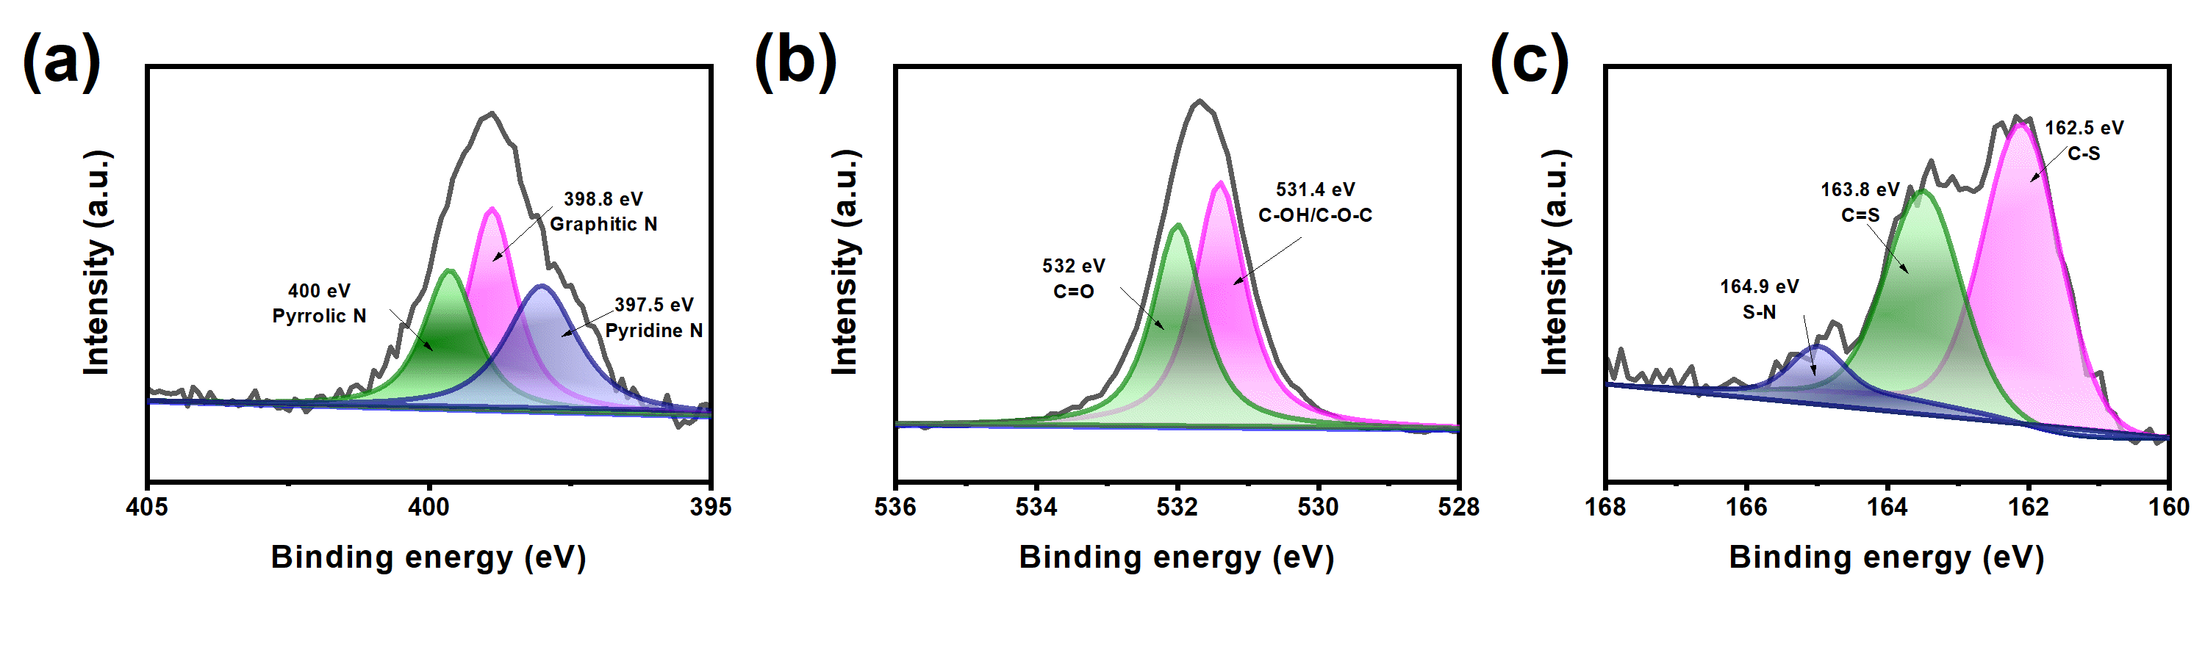
Fig S3 High-resolution XPS spectra of e-CDs: (a) N (b) O (c) S

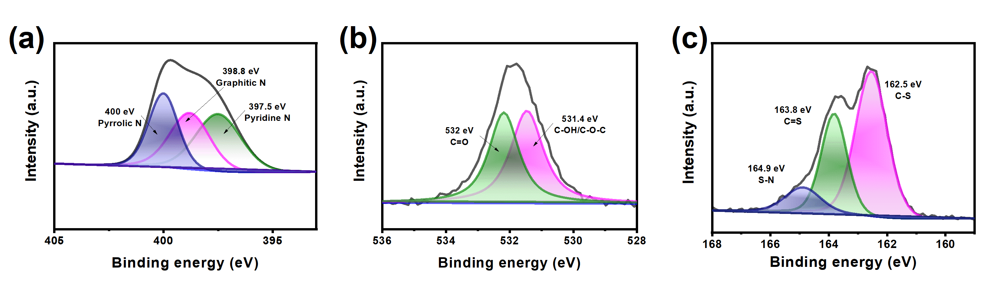
Fig S4 High-resolution XPS spectra of m-CDs: (a) N (b) O (c) S

Tab S1 High-resolution XPS spectra of CDs
 | d-CDs |  | e-CDs |  | m-CDs
Peak of C | 284eV | C=C/C-C | 283.7 eV | C=N | 283.7 eV | C=N
Peak of C | 284.4eV | C-O | 284.4eV | C-O | 284.4eV | C-O
Peak of C | 285.3eV | C-N | 285.3eV | C-N | 285.3eV | C-N
Peak of C | 287.4 eV | -CONH-
Peak of N | 397.5 Ev | Pyridine N | 397.5 Ev | Pyridine N | 397.5 Ev | Pyridine N
Peak of N | 398.8 eV | Graphitic N | 398.8 eV | Graphitic N | 398.8 eV | Graphitic N
Peak of N | 400 eV | Pyrrolic N | 400 eV | Pyrrolic N | 400 eV | Pyrrolic N
Peak of O | 531.4 eV | C-OH/C-O-C | 531.4 eV | C-OH/C-O-C | 531.4 eV | C-OH/C-O-C
Peak of O | 532 eV | C=O | 532 eV | C=O | 532 eV | C=O
Peak of S | 162.5 eV | C-S | 162.5 eV | C-S | 162.5 eV | C-S
Peak of S | 163.5 eV | C=S | 163.5 eV | C=S | 163.5 eV | C=S
Peak of S |  |  | 164.9 eV | S-N | 164.9 eV | S-N

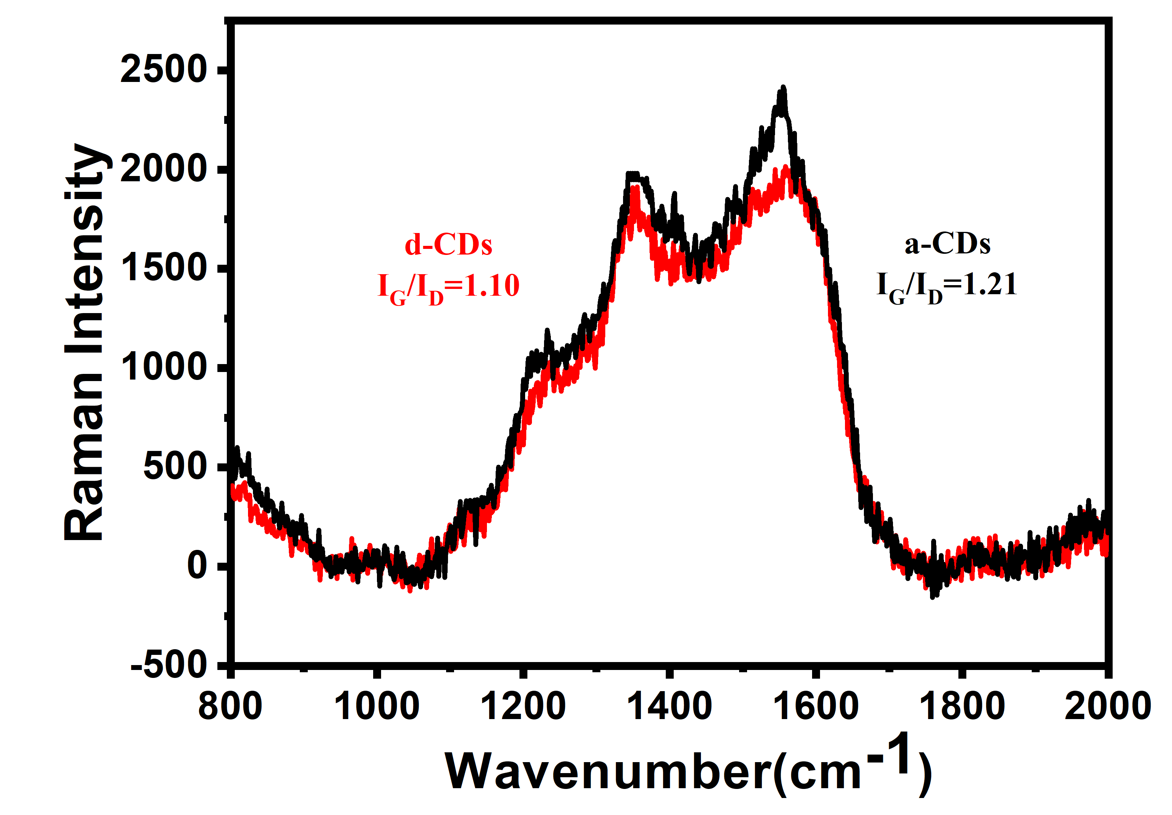
Fig S5 Raman spectrum of d-CDs and a-CDs

