Confusion Matrix of Classification
Table 10: Confusion matrix of classification using texture features
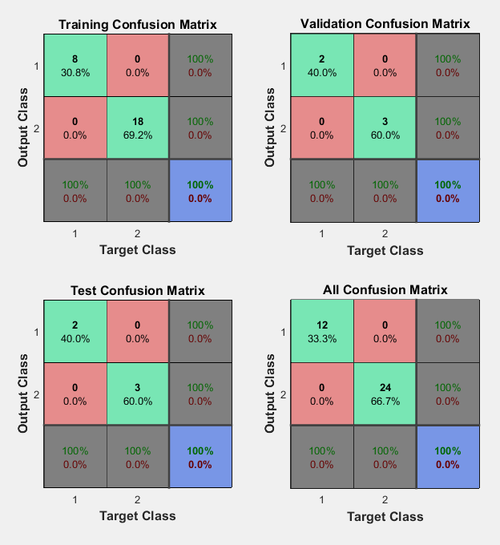
Table 11: Confusion matrix of classification using morphological features
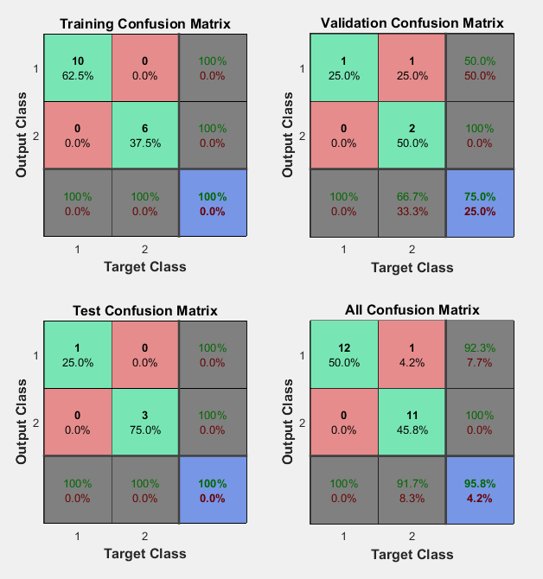

Texture Feature Extraction Result
Normal liver

TEXTURE
FEATURE

Image | Mean | Variance | Standard  deviation | Range | Contrast | Energy | Homogeneity | correlation | Entropy
1 | 1020 | 1.0820e+07 | 3.2894e+03 | 19122 | 0.0356 | 0.1756 | 0.9822 | 0.9965 | 1.298331
2 | 1020 | 1.1869e+07 | 3.4452e+03 | 27679 | 0.0335 | 0.1911 | 0.9832 | 0.9935 | 1.26334
3 | 1020 | 1.0273e+07 | 4.2479e+03 | 27491 | 0.0448 | 0.1675 | 0.9776 | 0.9968 | 1.278336
4 | 1020 | 1.0874e+07 | 3.2976e+03 | 18643 | 0.0514 | 0.1764 | 0.9743 | 0.9969 | 1.208335
5 | 1020 | 2.5238e+07 | 3.7887e+03 | 33982 | 0.0264 | 0.2278 | 0.9868 | 0.9959 | 1.238337
6 | 1020 | 9.5463e+06 | 3.0897e+03 | 32945 | 0.0279 | 0.1568 | 0.9861 | 0.9963 | 1.288338
7 | 1020 | 1.1869e+07 | 3.4452e+03 | 27679 | 0.0335 | 0.1911 | 0.9832 | 0.9935 | 1.258339
8 | 1020 | 1.0273e+07 | 4.2479e+03 | 27491 | 0.0448 | 0.1675 | 0.9776 | 0.9968 | 1.268333
9 | 1020 | 1.2368e+07 | 3.5169e+03 | 29092 | 0.0368 | 0.1738 | 0.9889 | 0.9978 | 1.278334
10 | 1020 | 1.0820e+07 | 3.2894e+03 | 26044 | 0.0348 | 0.1817 | 0.9895 | 0.9989 | 1.288331
11 | 1020 | 1.1869e+07 | 3.4452e+03 | 28984 | 0.0298 | 0.1770 | 0.9899 | 0.9941 | 1.208332
12 | 1020 | 1.0874e+07 | 3.2976e+03 | 27949 | 0.0292 | 0.1568 | 0.9878 | 0.9952 | 1.098320

Abnormal liver
TEXTURE
FEATURE

Images | Mean | Variance | standard deviation | Range | Contrast | Energy | Homogeneity | correlation | Entropy
1 | 1020 | 2.7133e+07 | 5.2089e+03 | 38560 | 0.9954 | 0.3163 | 0.6694 | 0.7611 | 1.280649
2 | 1020 | 4.4034e+03 | 1.9390e+07 | 29747 | 0.0430 | 0.1664 | 0.6978 | 0.7967 | 1.280648
3 | 1020 | 1.7985e+07 | 4.2409e+03 | 24557 | 0.0815 | 0.2815 | 0.6592 | 0.7894 | 1.280647
4 | 1020 | 1.2368e+07 | 3.5169e+03 | 25261 | 0.0572 | 0.1985 | 0.6714 | 0.6958 | 1.280643
5 | 1020 | 1.4409e+07 | 3.7960e+03 | 2125 | 0.0610 | 0.2286 | 0.6695 | 0.6858 | 1.280643
6 | 1020 | 1.7932e+07 | 4.2346e+03 | 26360 | 0.0394 | 0.2807 | 0.6803 | 0.5921 | 1.280642
7 | 1020 | 1.7985e+07 | 4.2409e+03 | 24557 | 0.0815 | 0.2815 | 0.6592 | 0.5894 | 1.280641
8 | 1020 | 1.2368e+07 | 3.5169e+03 | 25261 | 0.0572 | 0.1985 | 0.6714 | 0.6958 | 1.280640
9 | 1020 | 2.0103e+07 | 4.4837e+03 | 28648 | 0.0478 | 0.2907 | 0.6714 | 0.6856 | 1.280648
10 | 1020 | 3.0765e+07 | 5.0460e+03 | 23986 | 0.0496 | 0.3146 | 0.6695 | 0.6799 | 1.280646
11 | 1020 | 2.5238e+07 | 3.7887e+03 | 22264 | 0.0426 | 0.2704 | 0.69714 | 0.6864 | 1.280645
12 | 1020 | 1.5932e+07 | 4.2346e+03 | 23259 | 0.0445 | 0.2280 | 0.5695 | 0.6490 | 1.280648
13 | 1020 | 2.9164e+07 | 5.4425e+03 | 39740 | 0.0580 | 0.3637 | 0.6710 | 0.6928 | 1.181041
14 | 1020 | 1.3189e+07 | 4.2496e+03 | 24330 | 0.1583 | 0.2826 | 0.6227 | 0.6246 | 1.182033
15 | 1020 | 2.0103e+07 | 4.4837e+03 | 26923 | 0.0859 | 0.3073 | 0.6689 | 0.6948 | 1.183016
16 | 1020 | 1.2163e+07 | 3.4875e+03 | 22092 | 0.0595 | 0.2448 | 0.6402 | 0.6877 | 1.187025
17 | 1020 | 1.2704e+07 | 4.0148e+03 | 23044 | 0.1611 | 0.2539 | 0.6209 | 0.5769 | 1.185005
18 | 1020 | 3.0765e+07 | 5.0460e+03 | 41448 | 0.0541 | 0.3920 | 0.6735 | 0.6959 | 1.184067
19 | 1020 | 1.3189e+07 | 4.2496e+03 | 24330 | 0.1583 | 0.2826 | 0.6227 | 0.6846 | 1.189087
20 | 1020 | 2.0103e+07 | 4.4837e+03 | 26923 | 0.0859 | 0.3073 | 0.6589 | 0.6848 | 1.180090
21 | 1020 | 1.2704e+07 | 1.9390e+03 | 36361 | 0.0658 | 0.4221 | 0.6291 | 0.6760 | 1.181308
22 | 1020 | 2.5238e+07 | 3.7887e+03 | 44558 | 0.0758 | 0.3458 | 0.6225 | 0.6778 | 1.1860831
23 | 1020 | 4.4837e+07 | 2.4325e+03 | 35263 | 0.0785 | 0.2885 | 0.6412 | 0.6908 | 1.182058
24 | 1020 | 3.0234e+07 | 5.0140e+03 | 38645 | 0.0653 | 0.3149 | 0.6308 | 0.6191 | 1.181015

Morphological Feature Extraction Result
Benign liver tumors

MORPHOLOGICAL
FEATURES
Images | Area | perimeter | Major axis | Minor axis | Eccentricity | Roundness
1 | 4292 | 270 | 97 | 71 | 0.73 | 0.73
2 | 3969 | 261 | 91 | 58 | 0.63 | 0.73
3 | 1034 | 133 | 25 | 15 | 0.60 | 0.73
4 | 3432 | 243 | 123 | 119 | 0.96 | 0.73
5 | 862 | 118 | 44 | 25 | 0.57 | 0.78
6 | 636 | 106 | 53 | 17 | 0.32 | 0.71
7 | 989 | 131 | 133 | 95 | 0.71 | 0.72
8 | 1246 | 465 | 123 | 119 | 0.96 | 0.32
9 | 1051 | 136 | 43 | 30 | 0.70 | 0.71
10 | 1097 | 140 | 43 | 31 | 0.72 | 0.70
11 | 1146 | 142 | 45 | 32 | 0.71 | 0.71
12 | 1070 | 137 | 44 | 30 | 0.68 | 0.72

Malignant liver tumors
MORPHOLOGICAL
FEATURES
Images | Area | perimeter | Major axis | Minor axis | Eccentricity | Roundness
1 | 1226 | 236 | 144 | 117 | 0.81 | 0.28
2 | 2503 | 179 | 106 | 71 | 0.67 | 0.20
3 | 1113 | 283 | 125 | 122 | 0.97 | 0.17
4 | 3367 | 319 | 126 | 46 | 0.37 | 0.41
5 | 590 | 91 | 133 | 95 | 0.71 | 0.49
6 | 2817 | 304 | 132 | 81 | 0.61 | 0.11
7 | 2276 | 270 | 25 | 15 | 0.60 | 0.39
8 | 169 | 51 | 81 | 61 | 0.75 | 0.81
9 | 5292 | 450 | 97 | 71 | 0.73 | 0.33
10 | 1977 | 240 | 40 | 31 | 0.77 | 0.43
11 | 1657 | 201 | 48 | 26 | 0.59 | 0.52
12 | 1251 | 260 | 52 | 30 | 0.58 | 0.23

