Re-visiting the paradigm of coral reef depth zonation on contemporary reefs
Richardson LE¹, Heenan A¹, Delargy AJ^{1,2}, Neubauer P³, Lecky J^{4,5}, Gove JM⁴, Green JAM¹, Kindinger TL⁴, Ingeman KE^{4,6}, Williams GJ¹

¹ School of Ocean Sciences, Bangor University, Menai Bridge, Wales, UK
² School for Marine Science & Technology, University of Massachusetts Dartmouth, MA, USA
³ Dragonfly Data Science, Wellington, New Zealand
⁴ Pacific Islands Fisheries Science Center, National Oceanic Atmospheric Administration, Honolulu, HI, USA
⁵ IBSS Corporation, Silver Spring, MD, USA
⁶ Department of Environmental Studies, Linfield University, McMinnville, OR, USA

Supplemental information

Table S1 Surveyed island information, including geographic location within ecoregions, latitude (lat) and longitude (long), human population (pop.) status (populated islands highlighted in grey), human population estimates from the 2010 US census (www.census.gov/2010census), average island bathymetric steepness, sampling effort (stationary point count, SPC, surveys and number of sites), and survey year(s).
Island | Island code | Lat | Long | Pop. status | Human population | Mean ± SE bathy. steepness (°) | No. of SPC surveys (n) | No. of sites | Years surveyed
Mariana Islands
Farallon de Pajaros | FDP | 20.542 | 144.895 | U | - | 20.68 ± 0.13 | 52 | 23 | 2011, 2014
Maug | MAU | 20.023 | 145.222 | U | - | 20.93 ± 0.82 | 122 | 53 | 2011, 2014
Asuncion | ASU | 19.693 | 145.401 | U | - | 17.22 ± 0.06 | 90 | 41 | 2011, 2014
Agrihan | AGR | 18.775 | 145.668 | U | - | 12.31 ± 0.07 | 46 | 20 | 2011
Pagan | PAG | 18.105 | 145.760 | U | - | 11.04 ± 0.33 | 170 | 72 | 2011, 2014
Alamagan | ALA | 17.597 | 145.832 | U | - | 14.72 ± 0.30 | 32 | 16 | 2011, 2014
Guguan | GUG | 17.312 | 145.837 | U | - | 14.84 ± 0.07 | 48 | 21 | 2011, 2014
Sarigan | SAR | 16.705 | 145.774 | U | - | 18.79 ± 0.09 | 56 | 20 | 2011, 2014
Saipan | SAI | 15.191 | 145.735 | P | 48,220 | 7.88 ± 0.83 | 180 | 78 | 2011, 2014
Tinian | TIN | 15.025 | 145.627 | P | 3,136 | 8.41 ± 0.65 | 84 | 38 | 2011, 2014
Aguijan | AGU | 14.850 | 145.553 | P | - | 13.90 ± 0.65 | 48 | 23 | 2011, 2014
Rota | ROT | 14.149 | 145.193 | P | 2,527 | 7.51 ± 1.05 | 104 | 52 | 2011, 2014
Guam | GUA | 13.451 | 144.773 | P | 162,810 | 9.21 ± 0.08 | 480 | 237 | 2011, 2014
Hawaii Islands
Kure | KUR | 28.413 | -178.339 | U | - | 6.71 ± 1.03 | 86 | 30 | 2010, 2012
Pearl & Hermes | PHR | 27.876 | -175.799 | U | - | 2.37 ± 0.81 | 146 | 47 | 2010, 2011, 2012
Lisianski | LIS | 26.016 | -173.941 | U | - | 1.77 ± 1.75 | 212 | 87 | 2010, 2011, 2012, 2014
French Frigate | FFS | 23.767 | -166.228 | U | - | 1.98 ± 0.05 | 74 | 28 | 2010, 2011, 2012, 2014
Niihau | NII | 21.917 | -160.157 | U* | 170 | 1.21 ± 1.52 | 106 | 42 | 2010, 2013
Johnston | JOH | 16.746 | -169.510 | U | - | 9.10 ± 0.93 | 26 | 11 | 2010, 2012
Kauai | KAU | 22.037 | -159.568 | P | 65,689 | 1.69 ± 0.80 | 160 | 63 | 2010, 2013
Oahu | OAH | 21.471 | -157.956 | P | 953,207 | 1.57 ± 0.41 | 350 | 139 | 2010, 2012, 2013
Molokai | MOL | 21.102 | -157.058 | P | 7,404 | 2.20 ± 0.21 | 216 | 99 | 2010, 2012, 2013
Lanai | LAN | 20.850 | -156.900 | P | 3,102 | 3.49 ± 0.50 | 176 | 74 | 2010, 2012, 2013
Maui | MAI | 20.834 | -156.369 | P | 144,444 | 2.57 ± 0.69 | 286 | 116 | 2010, 2012, 2013
Hawaii | HAW | 19.683 | -155.548 | P | 185,079 | 10.24 ± 0.08 | 275 | 101 | 2010, 2013
Line Islands
Kingman | KIN | 6.405 | -162.405 | U | - | 18.88 ± 0.62 | 108 | 43 | 2010, 2012
Palmyra | PAL | 5.877 | -162.092 | U | 20 | 11.42 ± 0.28 | 203 | 79 | 2010, 2012
Jarvis | JAR | -0.374 | -159.993 | U | - | 19.80 ± 0.10 | 180 | 72 | 2010, 2012
Phoenix/Tokelau/Northern Cook Islands
Howland | HOW | 0.807 | -176.620 | U | - | 31.20 ± 0.04 | 142 | 55 | 2010, 2012
Baker | BAK | 0.194 | -176.474 | U | - | 16.23 ± 0.17 | 120 | 45 | 2010, 2012
Swains | SWA | -11.056 | -171.080 | U | 17 | 40.48 ± 0.27 | 154 | 62 | 2010, 2012
Samoa Islands
Ofu & Olosega | O&O | -14.172 | -169.649 | P | 353 | 8.51 ± 0.60 | 158 | 60 | 2010, 2012
Tau | TAU | -14.240 | -169.464 | P | 790 | 18.25 ± 0.33 | 120 | 46 | 2010, 2012
Tutuila | TUT | -14.295 | -170.681 | P | 55,149 | 6.99 ± 0.12 | 589 | 212 | 2010, 2012
Rose | ROS | -14.543 | -168.156 | U | - | 34.37 ± 0.43 | 150 | 57 | 2010, 2012

* Niihau Island was classified as unpopulated despite its human population marginally exceeding the threshold limits (<50 residents) and being located approximately 30 km from neighboring populated island Kauai. Niihau is privately owned and closed to the public and therefore was considered relatively free from local human impacts.

Table S2 Bathymetric and shoreline data sources used to create continuous bathymetric surfaces for each island in the study. Where multiple input bathymetry data sources are listed, they were mosaicked together with priority given to higher resolution datasets (as shown in 'Mosaic Resolution' column), then any remaining data holes were filled by interpolation with the Topo To Raster tool in ArcGIS, with the indicated shoreline dataset (if any) used as an additional input with a specified elevation of 0 m. The mean and standard error (SE) percentage of pixels derived from bathymetric data (as opposed to interpolated values) used to estimate survey site-level bathymetric steepness within 400 m radial buffers of sites at each island, are shown. Available high resolution bathymetry data frequently has data gaps. We created gapless continuous depth surfaces for each island by combining existing bathymetry datasets into mosaics of consistent grid resolution with preference for the highest resolution available with the best area coverage. While imagery derived depths alone often have the highest resolution for a given island, it is typically the least accurate and is limited to 4–5 m depths. Reef zone data provided by NOAA ESD were used to remove land, and interior habitat zones (e.g. lagoon, back reef, reef flat) before summarizing slope values. All analyses were done in the appropriate Universal Transverse Mercator zone for each island.
Island | Island code | Mosaic resolution (m) | Input bathymetric data sources | Mean ± SE % pixels derived from bathy. data sources | Input shoreline data
Hawaii Islands
French Frigate Shoals | FFS | 20 | 5 m MB (PIBHMC) + 20 m MBDB (PIBHMC; IKONOS imagery) + 20 m MB (NCEI AutoGrid) | 47.36 ± 4.91 | NOAA ESD (islands.shp)
Hawaii | HAW | 50 | 50 m multibeam synthesis (HMRG v19) | 58.16 ± 3.35 | None (not needed)
Johnston | JOH | 20 | 20 m MB + 5 m MBDB (PIBHMC; IKONOS imagery) | 83.73 ± 3.92 | Digitized from ESRI World Imagery
Kauai | KAU | 50 | 50 m multibeam synthesis (HMRG v19) | 91.58 ± 1.78 | None (not needed)
Kure | KUR | 5 | 5 m MBDB (PIBHMC; IKONOS imagery) | 88.79 ± 2.31 | NOAA CUSP
Lanai | LAN | 50 | 50 m multibeam synthesis (HMRG v19) | 52.96 ± 4.22 | None (not needed)
Lisianski | LIS | 20 | 20 m MB (PIBHMC) + 4 m DB (NOAA CCMA; IKONOS imagery) | 60.46 ± 3.46 | NOAA CUSP
Maui | MAI | 50 | 50 m multibeam synthesis (HMRG v19) | 72.35 ± 1.92 | None (not needed)
Molokai | MOL | 50 | 50 m multibeam synthesis (HMRG v19) | 80.42 ± 2.44 | None (not needed)
Niihau | NII | 50 | 50 m multibeam synthesis (HMRG v19) | 41.16 ± 6.58 | None (not needed)
Oahu | OAH | 50 | 50 m multibeam synthesis (HMRG v19) | 91.04 ± 1.73 | None (not needed)
Pearl & Hermes | PHR | 20 | All PIBHMC: 5m MBDB (IKONOS imagery) + 20 m MB + 40 m MB | 60.32 ± 4.30 | None
Line Islands
Jarvis | JAR | 20 | 20 m MB (PIBHMC) | 64.92 ± 2.90 | NOAA CUSP
Kingman | KIN | 20 | 20 m MB + 5 m MBDB (PIBHMC; IKONOS imagery) | 88.21 ± 1.89 | NOAA CUSP
Palmyra | PAL | 40 | 40 m MB + 5 m MBDB (PIBHMC; IKONOS imagery) | 95.00 ± 0.98 | NOAA CUSP
Mariana Islands
Agrihan | AGR | 10 | 10 m MB (PIBHMC) | 33.52 ± 4.57 | NOAA CUSP
Aguijan | AGU | 5 | 5 m MBDBLD (PIBHMC; IKONOS imagery) | 0.00 ± 0.00 | NOAA CUSP
Alamagan | ALA | 10 | 10 m MB (PIBHMC) | 46.89 ± 4.08 | NOAA CUSP
Asuncion | ASC | 10 | 10 m MB (PIBHMC) | 51.26 ± 1.66 | NOAA CUSP
Farallon de Pajaros | FDP | 10 | 10 m MB (PIBHMC) | 60.55 ± 2.17 | NOAA CUSP
Guam | GUA | 10 | 10 m NOAA NCEI 1/3 arc-second gap-filled CEM + 5 m MBLD (PIBHMC) | 76.10 ± 0.88 | None
Guguan | GUG | 10 | 10 m MB (PIBHMC) | 53.75 ± 2.80 | NOAA CUSP
Maug | MAU | 10 | 10 m MB (PIBHMC) | 47.30 ± 1.87 | NOAA CUSP
Pagan | PAG | 10 | 10 m MB (PIBHMC) | 49.01 ± 2.29 | NOAA CUSP
Rota | ROT | 5 | 5 m MBDB (PIBHMC; WV2 imagery) | 60.43 ± 3.24 | NOAA CUSP
Saipan | SAI | 5 | 5 m MBLD (PIBHMC) | 73.79 ± 2.06 | NOAA CUSP
Sarigan | SAR | 10 | 10 m MB (PIBHMC) | 45.17 ± 2.98 | NOAA CUSP
Tinian | TIN | 5 | 5 m MBDBLD (PIBHMC; IKONOS imagery) | 72.11 ± 2.32 | NOAA CUSP
Phoenix/Tokelau/Northern Cook Islands
Baker | BAK | 5 | 5 m MBDB (PIBHMC; WV2 imagery) + 40 m MB (PIBHMC) | 83.79 ± 2.61 | NOAA CUSP
Howland | HOW | 5 | 5 m MB + 40m MB (PIBHMC) | 56.45 ± 0.88 | NOAA CUSP
Swains | SWA | 10 | 10 m MB (PIBHMC) + 40 m MB (PIBHMC) | 52.60 ± 0.48 | NOAA CUSP
Samoa Islands
Ofu & Olosega | O&O | 5 | 5 m MBDB (PIBHMC; IKONOS imagery) + 20 m (NCEI AutoGrid) | 73.13 ± 2.21 | NOAA ESD (islands.shp)
Rose | ROS | 5 | 5 m MBDB (PIBHMC; IKONOS imagery) + 40 m MB (PIBHMC) | 69.66 ± 1.23 | NOAA ESD (islands.shp)
Tau | TAU | 5 | 5 m MBDB (PIBHMC; IKONOS imagery) + 20 m MB (NCEI AutoGrid; cleaned) | 67.41 ± 1.82 | NOAA ESD (islands.shp)
Tutuila | TUT | 10 | 10 m (NOAA NCEI 1/3 arc-second gap-filled CEM) | 78.99 ± 1.24 | None

Acronyms: MB = Multibeam SONAR bathymetry; DB = Derived bathymetry from satellite imagery (i.e. IKONOS or Worldview2 (WV2), as specified); LD = bathymetric Lidar Depths; CEM = Coastal Elevation Model (topobathy); CUSP = Continually Updated Shoreline Product; PIBHMC = Pacific Islands Benthic Habitat Mapping Center; HMRG = Hawaii Mapping Research Group; NCEI = National Centers for Environmental Information; CCMA = Center for Coastal Monitoring and Assessment; ESD = Ecosystem Sciences Division (NOAA Pacific Islands Fisheries Science Center)
Note: Strings of consecutive 2 letter acronyms (MB, DB, and LD) in the 'input bathymetric data sources' column indicate mosaic data products available from PIBHMC produced from multiple types of bathymetry sources (e.g. MBDB = a mosaic product of multibeam bathymetry and imagery derived bathymetry).

Table S3 Prior distributions for Bayesian models of reef fish biomass. Intercept (𝛼), population effects (𝛽), group-level effects (γ), and Gamma distribution shape (ς). Note, σ_{j} stands for the standard deviation for random effect j, with the exception of the random depth effect within islands (σ _{DEPTH : ISLAND}) and priors for coefficients for the splines for steepness, and steepness by depth.
Biomass model (g-m⁻²) | Parameter | Model prior
Common parameters (positive biomass) | 𝛽  γ  σ_{j}  σ _{DEPTH : ISLAND}  σ_{spline}  gamma shape ς | Normal (0, 2)  Normal (0, σj)  Cauchy (0, 5)  Cauchy (0, 1)  Cauchy (0, 10)  Gamma (0.01, 0.01)
Common parameters (hurdle) | 𝛼 (hurdle)  𝛽 (hurdle)  γ (hurdle)  σ_{j} (hurdle)  σ _{DEPTH : ISLAND} (hurdle)  σ_{spline} (hurdle)  gamma shape ς | Logistic (-2, 0.5)  Normal (0, 2)  Normal (0, σj)  Cauchy (0, 5)  Cauchy (0, 1)  Cauchy (0, 10)  Gamma (0.01, 0.01)
Total fish biomass | 𝛼 | Normal (4.6, 1)
Primary consumer | 𝛼 | Normal (4.37, 1)
Planktivore | 𝛼 (positive biomass) | Normal (3.19, 1)
Secondary consumer | 𝛼 | Normal (3.27793, 1)
Piscivore | 𝛼 (positive biomass) | Normal (2.78, 1)

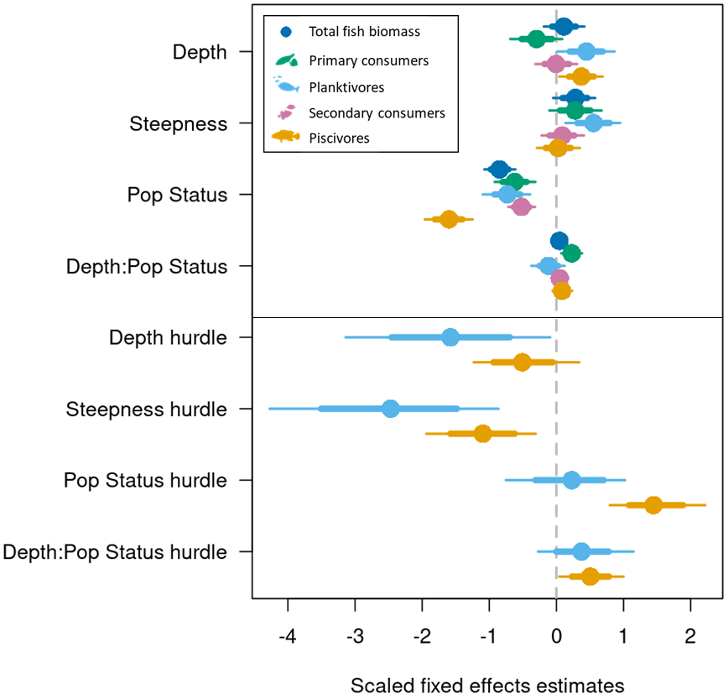
Fig. S1 Relationships between coral reef fish biomass of distinct trophic groups and overall effects of shallow reef depth, bathymetric steepness, and human population status of islands (Pop Status indicates the effect of ‘populated’) and effect estimates of hurdle models (piscivore and planktivore). Effect sizes are scaled and include interactions of depth with population status (Depth:Pop Status) on reef fish biomass. Points represent posterior median estimates from Bayesian hierarchical models testing for an effect of each explanatory variable on reef fish biomass, with 75% (thick lines) and 95% (thin lines) percentiles. Explanatory variables were mean-centred and scaled by one standard deviation to facilitate comparisons of effect sizes among them.

Table S4 Coefficient estimates and percentile credible intervals from Bayesian mixed-effects models of reef fish biomass (g-m²). All positive biomass response variables were modelled with a Gamma distribution on the log-scale, and where hurdle models were applied (HU), presence-absence biomass were modelled with a binomial distribution and logit function. Non-linear fitting basis splines (s) in depth-steepness interaction terms are indicated by s1 and s2. Continuous predictor variables were centred and scaled. Resulting model coefficients and 95% and 75% credible intervals are not back transformed.

Response | Predictor | Estimate | 95% CI | 75% CI
Total fish biomass | (intercept)  depth  population status (p)  bathymetric steepness  depth : population status (p)  depth : bathymetric steepness s1  depth : bathymetric steepness s2 | 4.08  0.11  -0.85  0.27  0.04  0.02  -0.07 | 3.64 4.64  -0.19 0.42  -1.07 0.61  -0.05 0.58  -0.08 0.16  -3.82 3.76  -4.00 3.79 | 3.83 4.35  -0.06 0.29  -0.98 0.71  0.09 0.46  -0.02 0.11  -2.23 2.26  -2.37 2.20
Primary consumer | (intercept)  depth  population status (p)  bathymetric steepness  depth : population status (p)  depth : bathymetric steepness s1  depth : bathymetric steepness s2 | 2.97  -0.29  -0.62  0.28  0.23  0.06  0.03 | 2.46 3.81  -0.69 0.09  -0.92 0.31  -0.11 0.67  0.07 0.38  -3.70 3.92  -3.68 3.93 | 2.67 3.30  -0.52 -0.07  -0.80 -0.45  0.05 0.51  0.14 0.31  -2.22 2.41  -2.22 2.36
Planktivore | (intercept)  (HU intercept)  depth  population status (p)  bathymetric steepness  depth : population status (p)  depth : bathymetric steepness s1  depth : bathymetric steepness s2  HU depth  HU population status (p)  HU bathymetric steepness  HU depth : population status (p)  HU depth : bathymetric steepness s1  HU depth : bathymetric steepness s2 | 2.24  -2.94  0.45  -0.73  0.55  -0.12  -0.03  0.03  -1.58  0.20  -2.49  0.38  0.08  0.14 | 1.36 3.61  -5.77 0.95  0.02 0.87  -1.10 -0.39  0.13 0.95  -0.37 0.12  -4.18 3.98  -3.96 3.91  -3.14 -0.09  -0.75 1.02  -4.27 0.86  -0.27 1.15  -3.94 3.75  -3.83 4.20 | 1.68 2.85  -4.35 -1.66  0.20 0.69  -0.93 -0.54  0.31 0.79  -0.25 0.02  -2.39 2.38  -2.25 2.36  -2.46 -0.69  -0.31 0.70  -3.51 1.48  -0.00 0.78  -2.26 2.32  -2.16 2.42
Secondary consumer | (intercept)  depth  population status (p)  bathymetric steepness  depth : population status (p)  depth : bathymetric steepness s1  depth : bathymetric steepness s2 | 2.26  -0.00  -0.52  0.09  0.05  0.06  -0.01 | 1.86 2.84  -0.31 0.31  -0.72 0.32  -0.22 0.41  -0.07 0.17  -3.69 4.02  -3.86 3.85 | 2.04 2.48  -0.18 0.19  -0.64 0.40  -0.10 0.27  -0.02 0.11  -2.27 2.46  -2.37 2.26
Piscivore | (intercept)  (HU intercept)  depth  population status (p)  bathymetric steepness  depth : population status (p)  depth : bathymetric steepness s1  depth : bathymetric steepness s2  HU depth  HU population status (p)  HU bathymetric steepness  HU depth : population status (p)  HU depth : bathymetric steepness s1  HU depth : bathymetric steepness s2 | 2.70  -3.66  0.37  -1.61  0.03  0.09  -0.07  0.02  -0.50  1.47  -1.10  0.51  0.03  0.02 | 2.06 3.61  -5.13 -2.17  0.04 0.69  -1.96 -1.25  -0.29 0.35  -0.06 0.24  -3.86 3.76  -3.93 3.94  -1.23 0.34  0.80 2.22  -1.94 0.31  0.04 1.00  -3.95 4.06  -3.80 3.87 | 2.32 3.07  -4.48 -2.82  0.19 0.56  -1.81 -1.40  -0.16 0.21  0.00 0.17  -2.27 2.22  -2.23 2.32  -0.94 -0.06  1.08 1.89  -1.58 -0.62  0.23 0.78  -2.28 2.39  -2.31 2.37

Table S5 Maximum probability of effect estimates for specified parameters in fitted mixed-effects models of reef fish biomass. Estimates represent the probability (expressed in percentage) that model parameters are strictly positive or negative, and are calculated as the proportion of the posterior distribution that is of the median’s sign. Effect estimates of non-linear fitting basis splines (s) in depth-steepness interaction terms are indicated by s1 and s2. Population status indicates the effect of human ‘populated’ islands. Probability of direction estimates for hurdle model parameters (HU) are shown where applicable.

Model parameter | Total fish biomass | Primary consumer | Planktivore | Secondary consumer | Piscivore
Depth | 76.55 | 93.20 | 97.75 | 51.55 | 98.85
HU depth |  |  | 98.05 |  | 90.05
Population status (P) | 100.00 | 100.00 | 100.00 | 100.00 | 100.00
HU population status (P) |  |  | 69.70 |  | 100.00
Steepness | 95.65 | 91.40 | 99.60 | 70.35 | 55.55
HU steepness |  |  | 100.00 |  | 99.70
Depth : population status (P) | 77.20 | 99.85 | 82.60 | 79.25 | 87.65
HU depth : population status (P) |  |  | 87.40 |  | 98.10
Depth : bathymetric steepness s1 | 51.10 | 50.05 | 50.95 | 50.55 | 51.00
HU depth : bathymetric steepness s1 |  |  | 52.65 |  | 50.90
Depth : bathymetric steepness s2 | 51.70 | 50.65 | 50.45 | 50.40 | 50.30
HU depth : bathymetric steepness s2 |  |  | 52.40 |  | 50.65

Table S6 Unadjusted marginal (fixed effects only) and conditional (fixed and random effects) R² values and percentiles for fitted Bayesian mixed-effects models of reef fish biomass. Bayesian regression model R² is estimated as the predicted values variance divided by the variance of predicted values plus the expected variance of the errors (standard error)¹.

Response |  | Bayesian R² | 95% CI | 75% CI
Total fish biomass | Marginal | 0.15 | 0.03 0.46 | 0.04 0.28
Total fish biomass | Conditional | 0.66 | 0.50 0.72 | 0.59 0.71
Primary consumer | Marginal | 0.17 | 0.03 0.46 | 0.03 0.29
Primary consumer | Conditional | 0.53 | 0.48 0.59 | 0.50 0.57
Planktivore | Marginal | 0.10 | 0.002 0.49 | 0.002 0.25
Planktivore | Conditional | 0.61 | 0.38 0.70 | 0.54 0.69
Secondary consumer | Marginal | 0.02 | 0.004 0.10 | 0.01 0.04
Secondary consumer | Conditional | 0.38 | 0.31 0.46 | 0.33 0.42
Piscivore | Marginal | 0.12 | 0.01 0.40 | 0.03 0.22
Piscivore | Conditional | 0.55 | 0.40 0.63 | 0.48 0.63

Table S7 Probability of greater absolute increase in fish biomass at unpopulated versus populated islands across specified 10-m depth intervals. Probability estimates are derived from the difference in posterior predicted changes in fish biomass at specified depth ranges between unpopulated and populated islands with bathymetric steepness held constant at the study mean value.

Depth (m) | Total fish biomass | Primary consumer | Planktivore | Secondary consumer | Piscivore
0–10 | 0.98 | 0.07 | 1.00 | 0.89 | 1.00
10–20 | 0.80 | 0.00 | 1.00 | 0.54 | 1.00
20–30 | 0.21 | 0.00 | 0.86 | 0.13 | 0.69

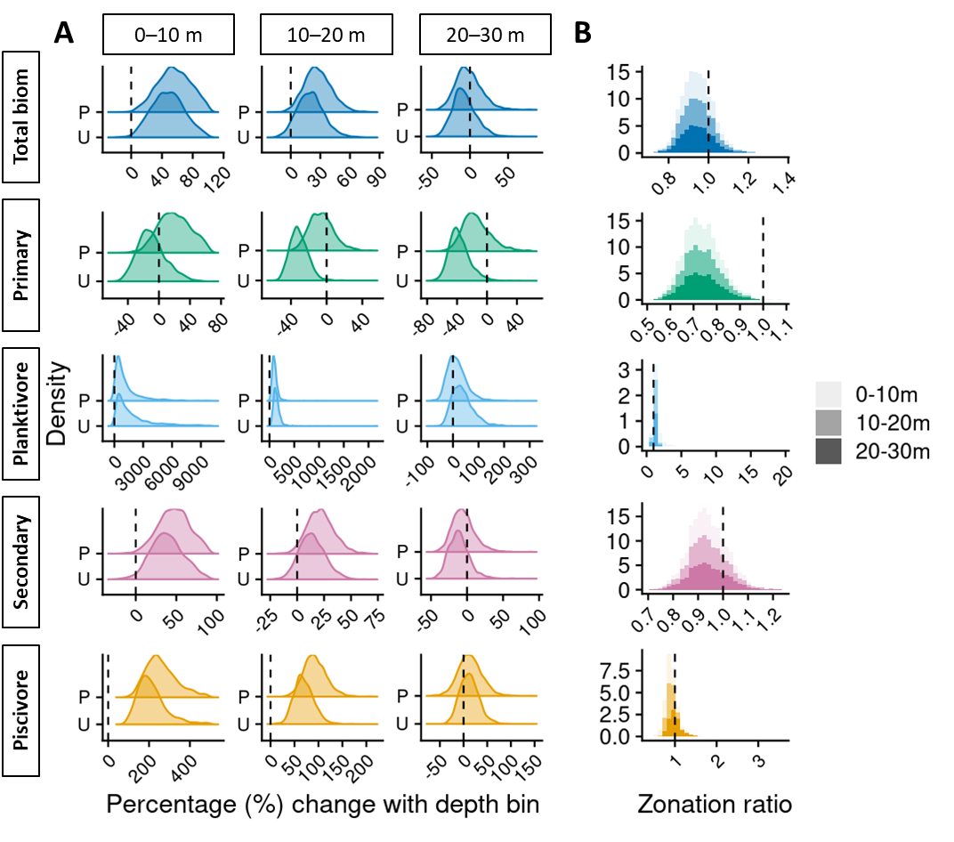
Figure S2 Percentage change in reef fish biomass across shallow reef depth: A) Density distributions of posterior predicted percentage change in biomass of each trophic group (rows labeled on left) with each 10 m depth bin (columns labeled at top), at populated (P) and unpopulated (U) islands. B) Posterior predicted distributions of zonation ratios of populated versus unpopulated islands in each 10 m depth bin.

Table S8 Probability of greater percentage (%) increase in fish biomass at populated versus unpopulated islands across specified 10-m depth intervals. Probability estimates are derived from the percentage difference in posterior predicted changes in fish biomass at specified depth ranges between unpopulated and populated islands with bathymetric steepness held constant at the study mean value.

Depth (m) | Total fish biomass | Primary consumer | Planktivore | Secondary consumer | Piscivore
0–10 | 0.77 | 1.00 | 0.14 | 0.79 | 0.86
10–20 | 0.77 | 1.00 | 0.17 | 0.79 | 0.88
20–30 | 0.77 | 1.00 | 0.16 | 0.79 | 0.57

Table S9 Number of stationary point count surveys with zero-count observations of the four trophic groups of reef fish at populated (P) and unpopulated (U) islands, across depth. The proportion of total zero-count observations for each trophic group within each depth category is indicated in brackets.

Depth (m) | Population status | Primary consumer | Planktivore | Secondary consumer | Piscivore
0–10 | P | 16 (26.2%) | 165 (49.0%) | 1 (33.3%) | 468 (41.3%)
0–10 | U | 5 (8.2%) | 46 (13.6%) | 0 (0.0%) | 132 (11.7%)
10–20 | P | 19 (31.1%) | 67 (19.9%) | 1 (33.3%) | 261 (23.0%)
10–20 | U | 3 (4.9%) | 22 (6.5%) | 0 (0.0%) | 53 (4.7%)
20–30 | P | 9 (14.8%) | 29 (8.6%) | 1 (33.3%) | 185 (16.3%)
20–30 | U | 9 (14.8%) | 8 (2.4%) | 0 (0.0%) | 34 (3.0%)

Table S10 Estimated median cross-scale variance partitioning (%), standard deviation (SD) and 95% and 75% credible intervals (upper and lower; CIs) for spatial random-effect terms in Bayesian mixed-effects models. SD estimates are derived from model posterior draws and include hurdle model spatial scale variance where applicable (planktivore and piscivore models).

Fish biomass model | Spatial scale | Variance partitioning across scales (%) | Median SD | 95% CIs | 75% CIs
Total fish biomass | Site | 51.65 | 0.62 | 0.59 0.65 | 0.60 0.64
Total fish biomass | Island | 20.64 | 0.25 | 0.14 0.36 | 0.19 0.32
Total fish biomass | Ecoregion | 27.71 | 0.33 | 0.05 1.29 | 0.16 0.70
Primary consumer | Site | 51.92 | 0.77 | 0.72 0.81 | 0.74 0.80
Primary consumer | Island | 22.50 | 0.33 | 0.23 0.49 | 0.27 0.42
Primary consumer | Ecoregion | 25.58 | 0.38 | 0.03 1.64 | 0.13 0.84
Planktivore | Site | 25.33 | 2.59 | 2.26 2.94 | 2.40 2.80
Planktivore | Island | 8.64 | 0.88 | - 1.52 | 0.55 1.20
Planktivore | Ecoregion | 66.03 | 6.74 | 2.72 15.69 | 4.18 10.76
Secondary consumer | Site | 64.15 | 0.62 | 0.60 0.65 | 0.61 0.64
Secondary consumer | Island | 20.03 | 0.19 | 0.06 0.32 | 0.13 0.26
Secondary consumer | Ecoregion | 15.82 | 0.15 | 0.01 0.80 | 0.04 0.39
Piscivore | Site | 38.46 | 2.18 | 1.97 2.40 | 2.05 2.32
Piscivore | Island | 19.17 | 1.09 | 0.79 1.48 | 0.90 1.30
Piscivore | Ecoregion | 42.37 | 2.40 | 1.25 5.51 | 1.61 3.77

Table S11 Probabilities of differing variation in fish biomass across hierarchical spatial scales: ecoregion, island, and site. Probability estimates are derived from comparing posterior model standard deviations (SD) at each of the hierarchical spatial terms. Probabilities derived from comparing SD across hurdle model components are indicated by HU. Probability estimates ≥ 0.75 are highlighted in bold. Probabilities ≥75% of the inverse difference (i.e., SD being less than rather than more than) are underlined.

Fish biomass model | Ecoregion > Island | Ecoregion > Site | Island > Site
Total fish biomass | 0.68 | 0.82 | 1.00
Primary consumer | 0.54 | 0.85 | 1.00
Planktivore | 0.95 | 0.35 | 1.00
Planktivore (HU) | 1.00 | 0.98 | >0.99
Secondary consumer | 0.43 | 0.95 | 1.00
Piscivore | 0.64 | 0.77 | 1.00
Piscivore (HU) | 0.98 | 0.72 | >0.99

