Table (1): advantages and disadvantages in different categories to detect selfish node
Systems | Advantages | Disadvantages
Reputation-based | High throughput  Less end-to-end delay  High detection rate  Less channel traffic | High energy Consumption  High overhead and complex systems  No Robustness Against  Collusions  High false positive rate
Credit-based | less channel traffic  High throughput  Less end-to-end delay | No Robustness Against  Collusions  No second chance  Less detection rate  Less energy Consumption
Acknowledgment-based | Less false positive rate  High detection rate | High channel traffic  Less throughput  High end-to-end delay
Game theory-based | Less end-to-end delay  High detection rate  Less channel traffic | No second chance  High energy Consumption  High false positive/negative rate  Less throughput

Table (2): equation of the evaluation metrics
Evaluation metrics | Equation
Detection Accuracy | $DA=\frac{TP}{TP+FN}$ (7)
False Positive Rate | $FPR=\frac{FP}{FP+TN}$ (8)
False Negative Rate | $FNR=\frac{FN}{FN+TP}$ (9)
Throughput | $Th=\frac{PD}{PP}$ (10)
Energy | $E_{TX}\left(l,d\right)=E_{TX-elec}\left(l\right)+E_{TX-amp}\left(l,d\right)=\{\begin{matrix}{lE}_{elec}+l_{εfs}d^{2} d<d_{0} \\ {lE}_{elec}+l_{εamp}d^{4} d≥d_{0}\end{matrix}$(11)

Table (3): different metrics of proposed methods in compare with other methods
Present of  selfish node  Algorithms | Metrics | 10 | 15 | 20 | 25 | 30 | 35 | 40
Proposed-method | Detection  Accurate  (DA) | 0.95 | 0.96 | 0.97 | 0.98 | 0.95 | 0.96 | 0.96
Game theory-based [21] | Detection  Accurate  (DA) | 0.93 | 0.99 | 1 | 0.99 | 0.98 | 0.96 | 0.95
PPS [25] | Detection  Accurate  (DA) | 0.75 | 0.72 | 0.78 | 0.79 | 0.77 | 0.76 | 0.74
Trust management [26] | Detection  Accurate  (DA) | 1 | 0.95 | 0.88 | 0.85 | 0.8 | 0.74 | 0.62
Proposed-method | False  Positive  Rate  (FPR) | 0.001 | 0.002 | 0.003 | 0.003 | 0.009 | 0.031 | 0.039
Game theory-based [21] | False  Positive  Rate  (FPR) | 0 | 0 | 0 | 0.002 | 0.0127 | 0.0347 | 0.0549
PPS [25] | False  Positive  Rate  (FPR) | 0.25 | 0.22 | 0.28 | 0.29 | 0.27 | 0.27 | 0.31
Trust management [26] | False  Positive  Rate  (FPR) | 0 | 0 | 0 | 0.02 | 0.1 | 0.14 | 0.2
Proposed-method | Throughput | 85 | 81 | 84 | 82 | 85 | 88 | 91
Game theory-based [21] | Throughput | 75.85 | 73.05 | 74.14 | 78.92 | 86.71 | 91.07 | 95
PPS [25] | Throughput | 48 | 41 | 43 | 38 | 35 | 32 | 19
Trust management [26] | Throughput | 85 | 78 | 81 | 84 | 82 | 71 | 73
Proposed-method | End-to-End  Delay  (ms) | 17 | 15.02 | 11.08 | 8.8 | 6.2 | 3.01 | 0.9
Game theory-based [21] | End-to-End  Delay  (ms) | 16.35 | 17.01 | 17 | 12 | 7.93 | 4.1 | 1.47
PPS [25] | End-to-End  Delay  (ms) | 48 | 41 | 43 | 38 | 35 | 32 | 19
Trust management [26] | End-to-End  Delay  (ms) | 85 | 78 | 81 | 84 | 82 | 71 | 73

Table (4): descriptive statistic
N | Mean( $\overline{x}$) | t* | standard deviation | SE mean
700 | 28.5 | 1.64 | 0.73 | 0.082
700 | 31.6 | 1.64 | 0.73 | 0.082

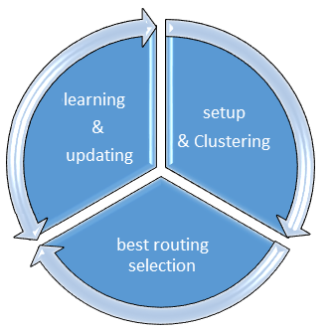
Figure 1. Selfish node detection mechanism

Residual _energy | Node_coordinate | Distance_nearest_Base station | Number_neighbor_node | Node_id

Figure2: the data packet content in nodes’ Table

Algorithm. Learning Step
- For r=1 to R^{m}
- Each N_{i} choose the neighbors with max Fitness to send packet N_{j}$∈$ Neighbor N_{i}
- For N_{j}=1 to n do
- If P_{j} < > P_{max}
- or P_{j} < > P_{min}
- Compute Rand (0,1)
- If rand< 0.33
- Expansion (P_{j}$∈$ Neighbor N_{i})
- If P_{j}=P_{max}
- State_{j}=C
- endif
- endif
- If 0.33<rand< 0.66
- No Change (P_{j}$∈$ Neighbor N_{i})
- endif
- If rand> 0.66
- Constraction (P_{j}$∈$ Neighbor N_{i})
- If P_{j}=P_{min}
- State_{j}=LS and report N_{CHi}
- endif
- endif
- Endif
- Endfor
- …..
Figure 3. Simi-code of learning automata

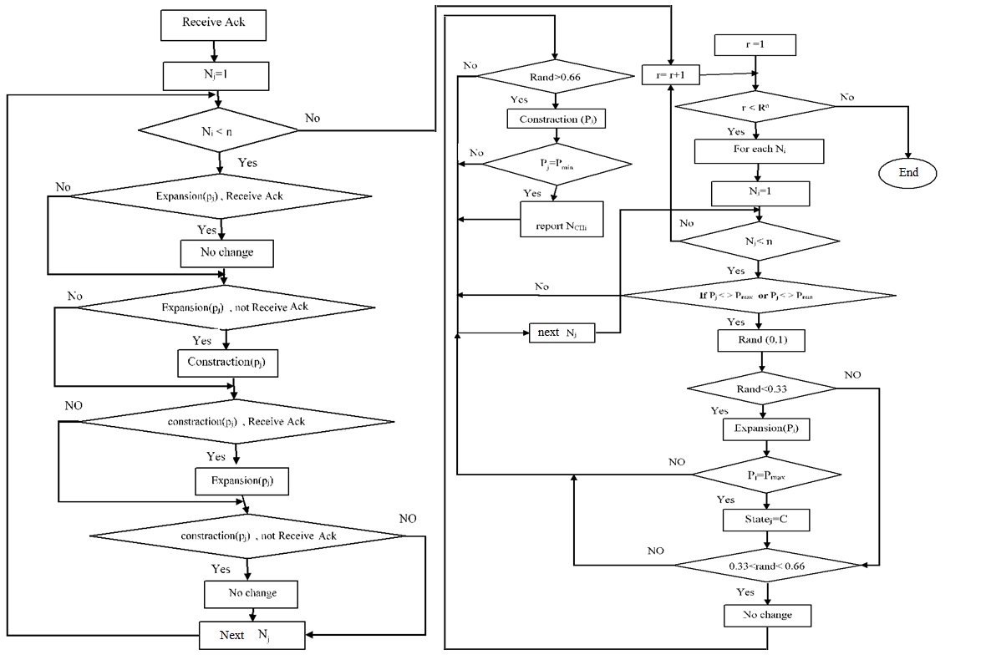

Figure 4.Flow chart of learning phase

Algorithm. reinforcement signal
- After ack of data packet recieved from destination each N_{i} check status
- For N_{j}=1 to n do
- If Expansion (P_{j}$∈$ Neighbor N_{i}) and (ack of packet received)
- No Change (P_{j}$∈$ Neighbor N_{i}) means reward
- Endif
- If Expansion (P_{j}$∈$ Neighbor N_{i}) and (ack of packet Not received)
- Constraction (P_{j}$∈$ Neighbor N_{i}) means punishment
- Endif
- If Constraction (P_{j}$∈$ Neighbor N_{i}) and (ack of packet received)
- Expansion (P_{j}$∈$ Neighbor N_{i}) means reward
- Endif
- If Constraction (P_{j}$∈$ Neighbor N_{i}) and (ack of packet Not received)
- No Change (P_{j}$∈$ Neighbor N_{i}) means punishment
- Endif
- Endfor
- Endfor
Figure 5. Reinforcement signal in learning phase
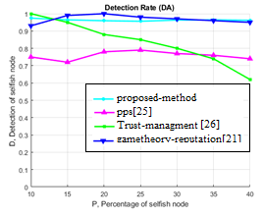
Fig. 6. Comparison of detection accuracy (DA) in IoT

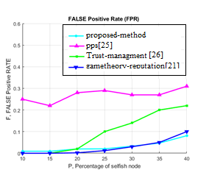
Fig. 7. Comparison of the different algorithm in false positive rate (FPR) metrics

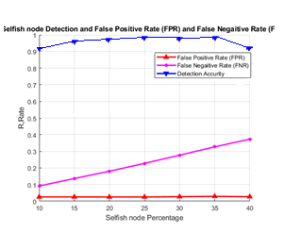
Fig. 8. DA, FPR,FNR metrics in the proposed method

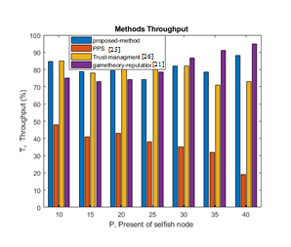
Fig. 9. Comparison of the throughput metrics in a different algorithm

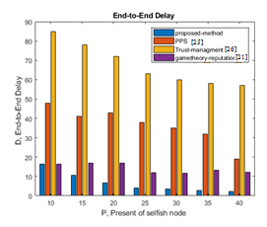
Fig. 10. Comparison of the average end-to-end delay by a different algorithm

.
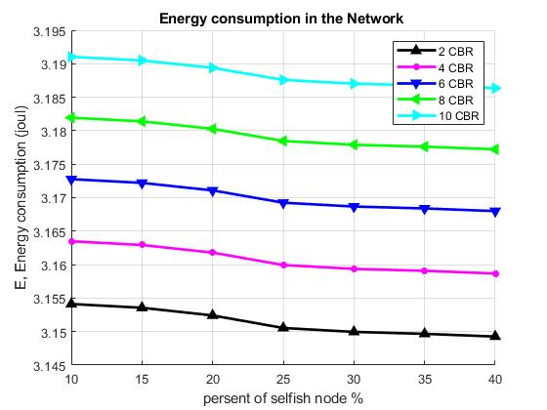
Fig. 11. Comparison of energy consumption in different traffic (2, 4, 6, 8, 10 CBR)

