Supplementary Figures
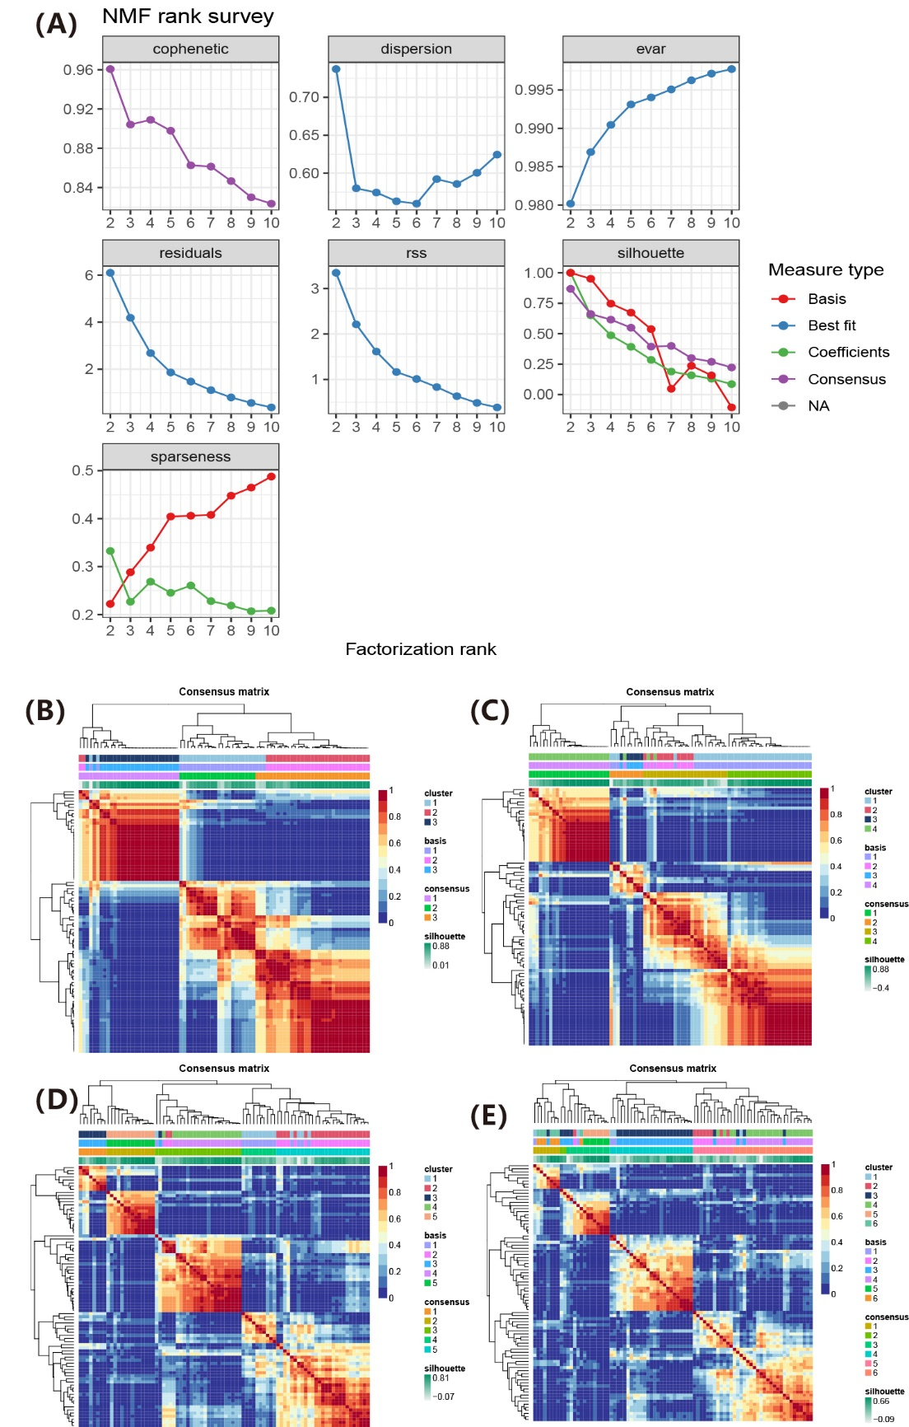
FIGURE S1 | NMF algorithm calculates the potential molecular subgroups. (A) An optimal clustering of two subgroups was identified by the NMF rank survey results; (B-E) the consensus heatmap of 3 ~ 6 subgroups was identified.

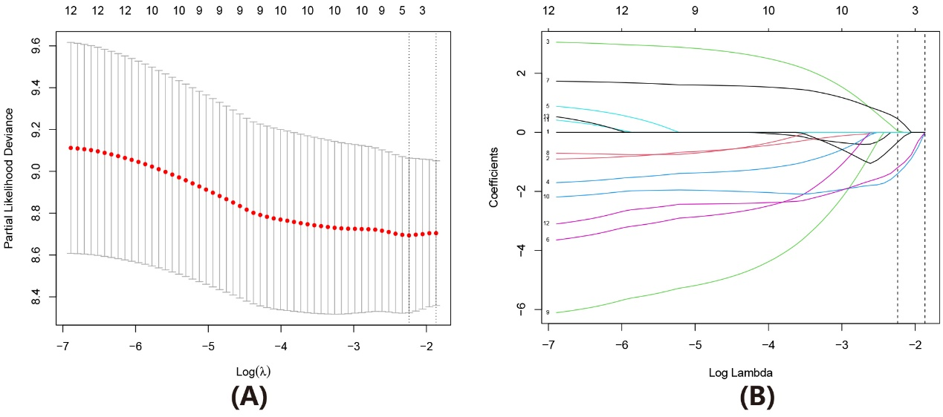
FIGURE S2 | LASSO analysis of survival related genes. (A, B) Five candidate genes generated by LASSO analysis with minimal lambda.

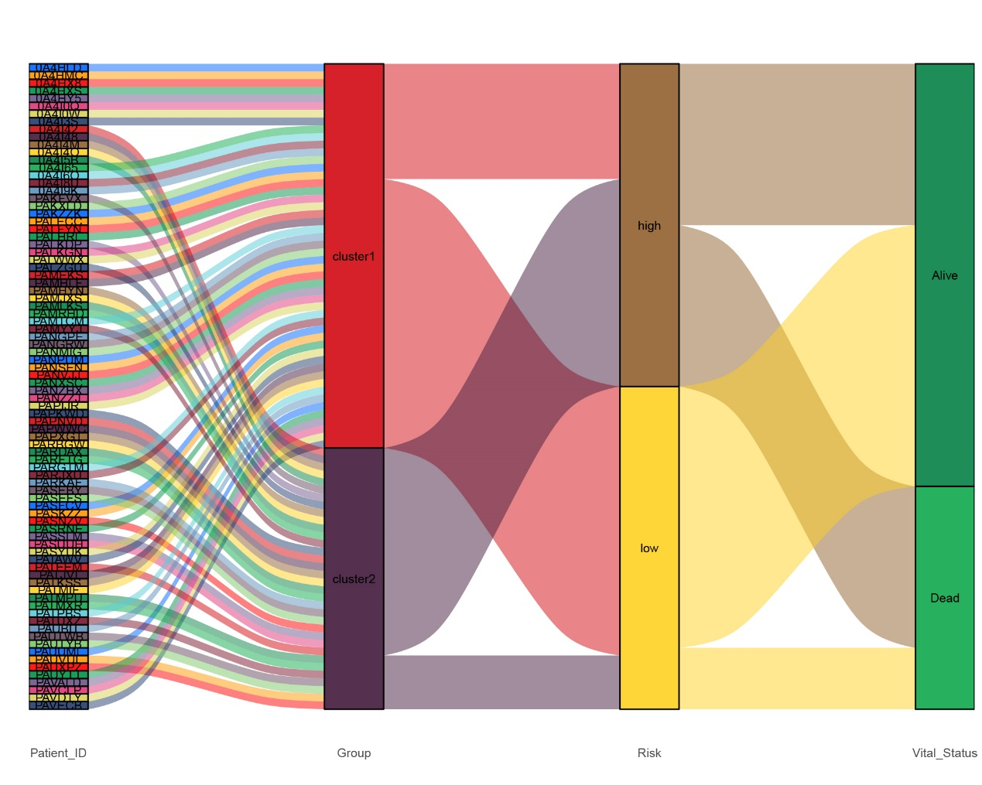
FIGURE S3 | Sankey diagram showing the relationship between molecular subtypes, risk group, and final event.

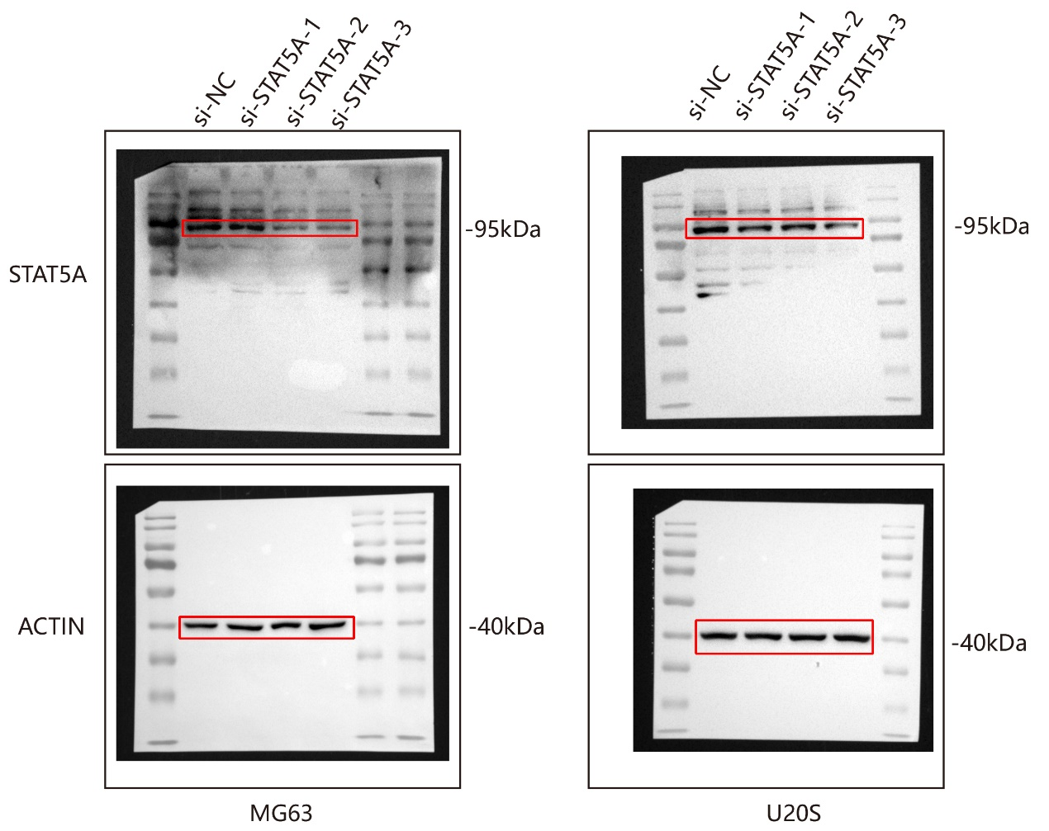
FIGURE S4 | The uncropped images of full-length blots.

