Supporting Information for
A hard molecular nanomagnet from confined paramagnetic 3d-4f spins inside a fullerene cage

Chenli Huang,^{a,#} Rong Sun,^{b,#} Lipiao Bao,^{a,}* Xinyue Tian,ª Changwang Pan,ª Mengyang Li,^{d} Wangqiang Shen,ª Kun Guo,ª Bingwu Wang,^{b,}* Xing Lu,^{a,}* and Song Gao^{b,c}
ª State Key Laboratory of Materials Processing and Die & Mould Technology, School of Materials Science and Engineering, Huazhong University of Science and Technology, 1037, Luoyu Road, Wuhan 430074 (P. R. China). E-mail: baol@hust.edu.cn; lux@hust.edu.cn
^{b} Beijing National Laboratory of Molecular Science, State Key Laboratory of Rare Earth Materials Chemistry and Applications, College of Chemistry and Molecular Engineering, Peking University, Beijing 100871 (P. R. China). E-mail: wangbw@pku.edu.cn;
^{c} Spin-X Institute, School of Chemistry and Chemical Engineering, State Key Laboratory of Luminescent Materials and Devices, Guangdong-Hong Kong-Macao Joint Laboratory of Optoelectronic and Magnetic Functional Materials, South China University of Technology, Guangzhou 510641, P. R. China.
^{d} School of Physics, Xidian University, Xi'an, 710071, P. R. China
# These authors contributed equally.

Content
S1. General Instruments S2
S2. HPLC Separation of Dy₂VN@I_{h}(7)-C₈₀. S2
S3. Crystal Structure of Dy₂VN@I_{h}(7)-C₈₀. S3
S4. Electronic Structure of Dy₂VN@I_{h}(7)-C₈₀. S5
S5. Magnetic Properties of Dy₂VN@I_{h}(7)-C₈₀. S6
S6. Theoretical Analysis S10
S7. Reference S12

S1. General Instruments.
High-performance liquid chromatography (HPLC) was conducted on an LC-908 instrument (Japan Analytical Industry Co., Ltd.) with toluene as mobile phase. Matrix-assisted laser desorption ionization time-of-flight (MALDI-TOF) mass spectrometry was measured on a BIFLEX III spectrometer (Bruker Daltonics Inc., Germany). UV-Vis-NIR spectra were recorded from a PE Lambda 750S spectrophotometer with sample dissolved in toluene. Cyclic voltammograms (CV) was measured in o-dichlorobenzene with 0.05 M TBAPF₆ as supporting electrolyte at a Pt working electrode with a CHI660E workstation. Magnetic properties were determined using Quantum Design MPMS3 magnetometer.

S2. HPLC Separation of Dy₂VN@I_{h}(7)-C₈₀.
The entire separation process consists of four steps. The first stage was performed using a Buckyprep column with toluene as mobile phase (Fig. S1a). Fr-6 (retention time: 61-68 min) was collected in the first stage and re-injected into the recycling second stage using a Buckyprep-M column and toluene as the eluent (Fig. S1b). Fr6-4 (retention time: 134-138 min) was collected in the second stage and re-injected into the third recycling stage using a Buckyprep column and toluene as the eluent. Fr6-4-2 was collected as the final product Dy₂VN@I_{h}(7)-C₈₀ (Fig. S1c).
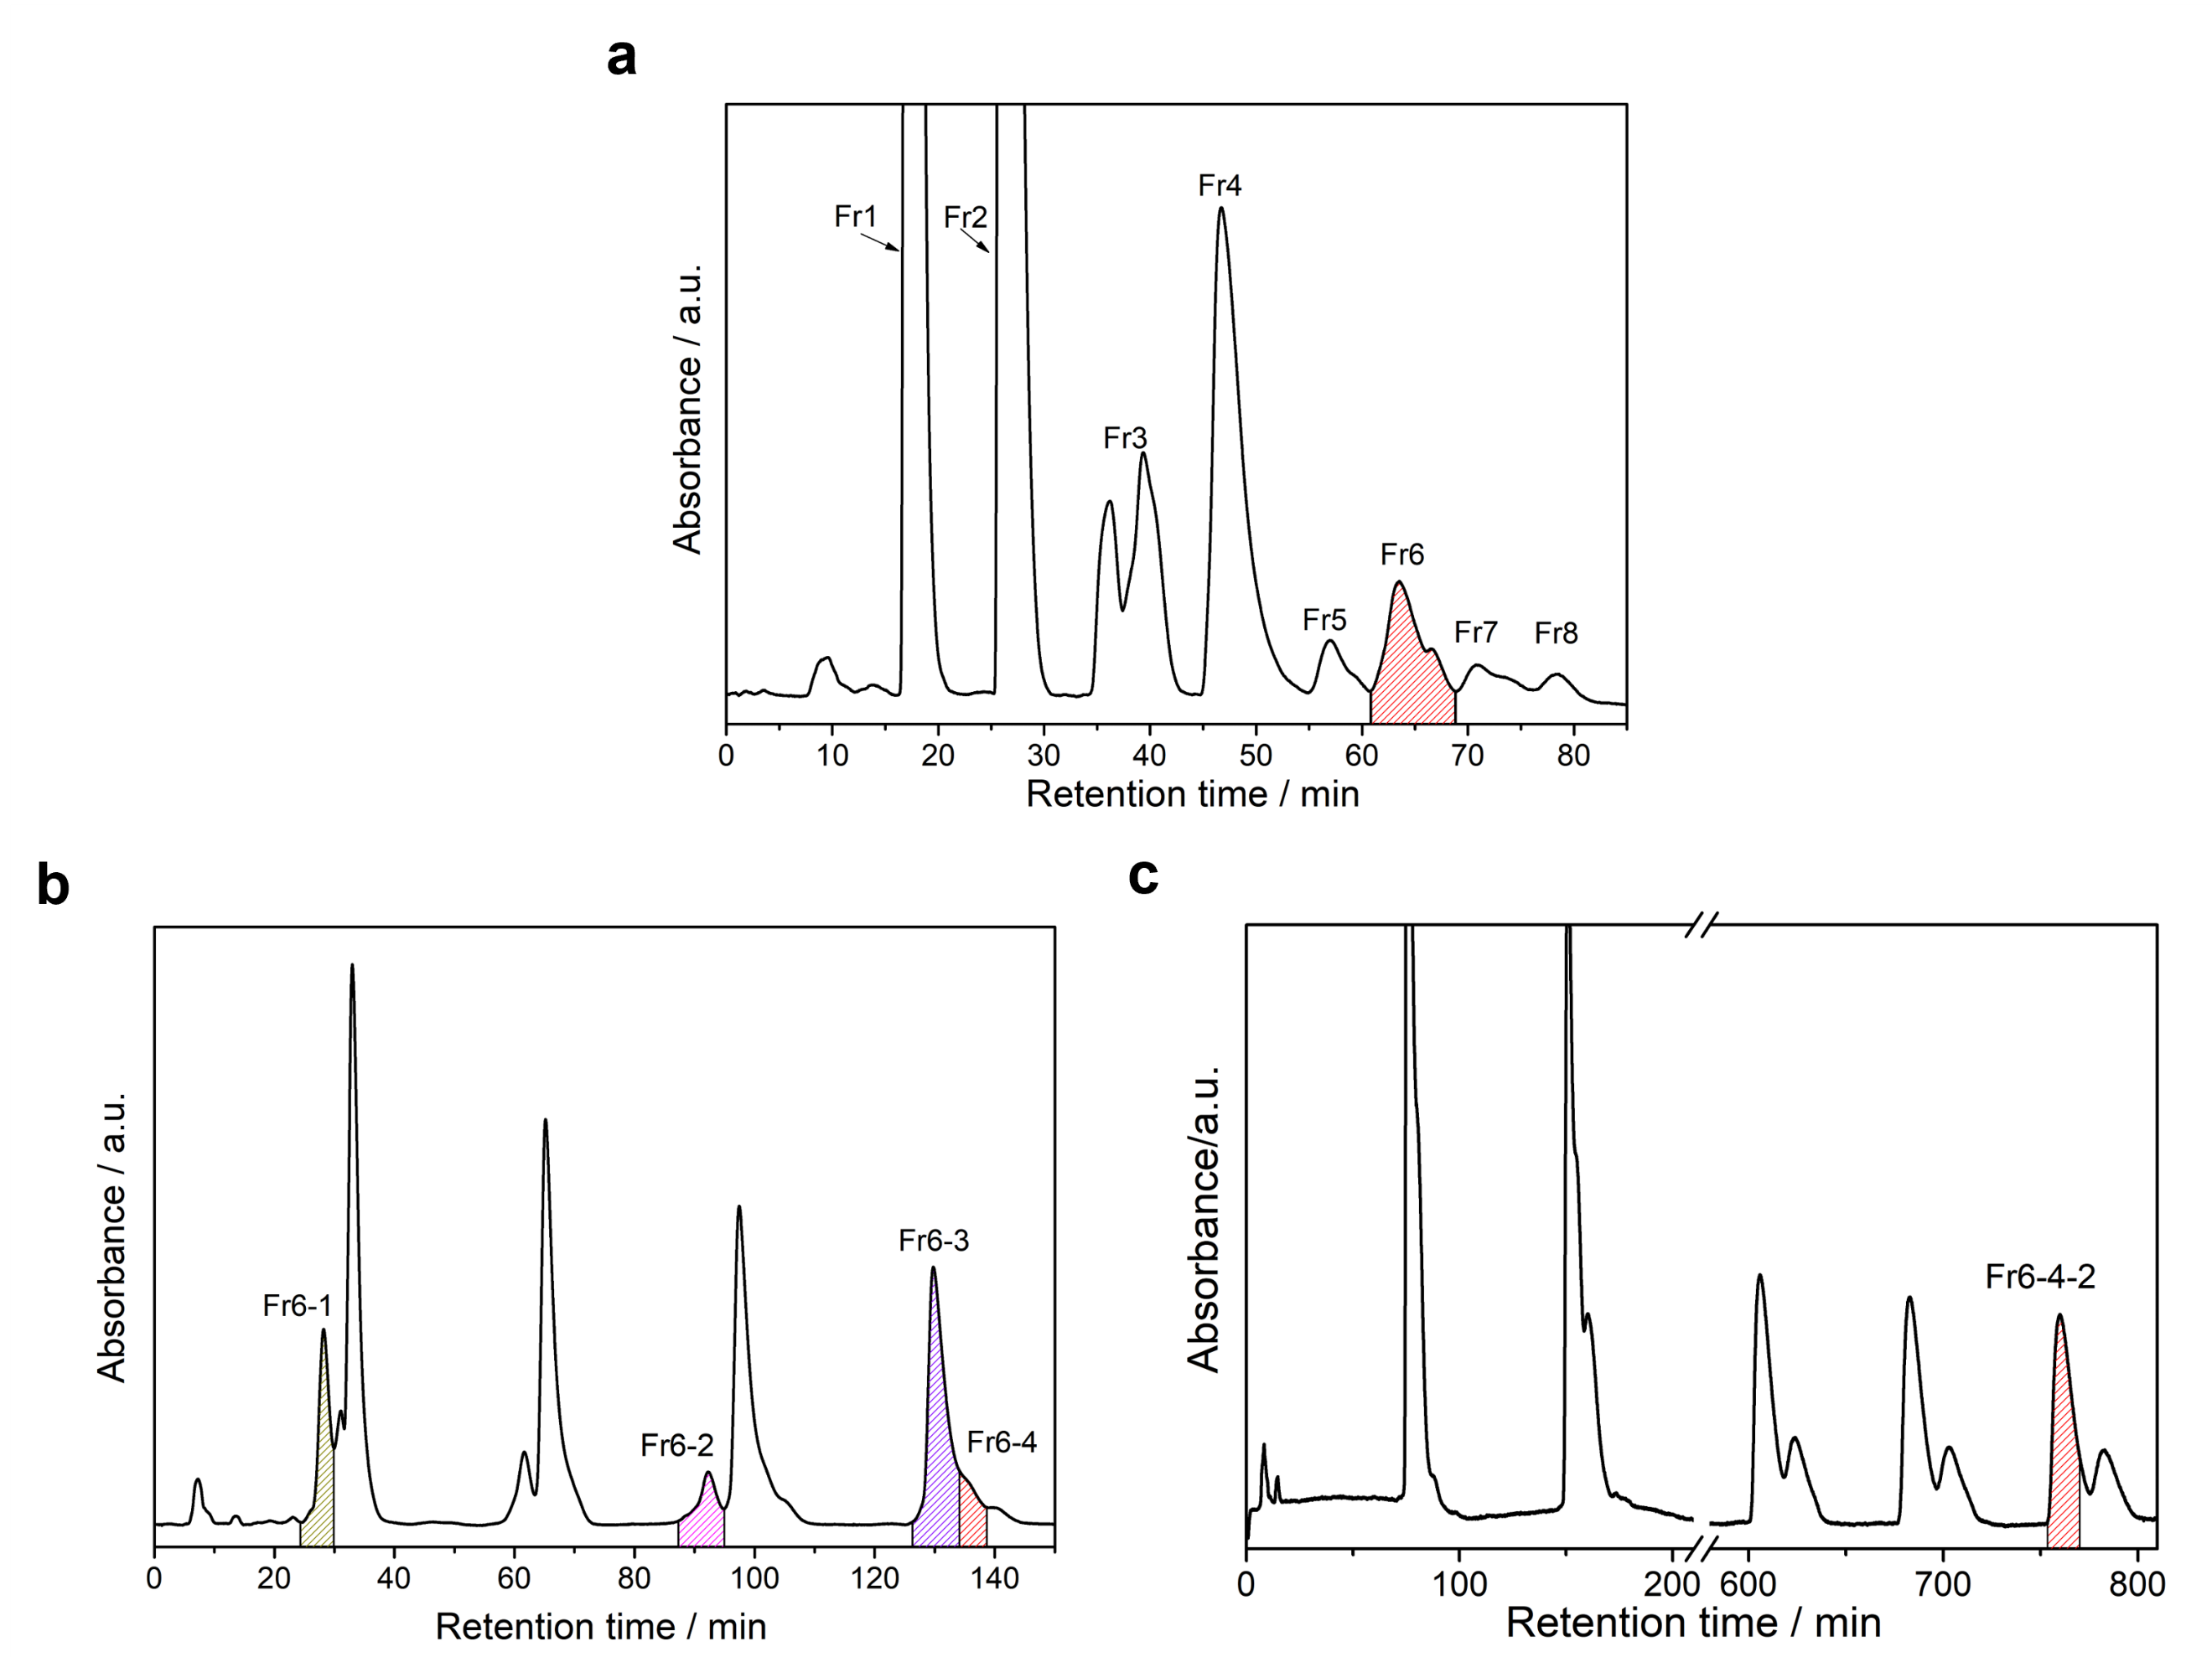
Supplementary Fig. S1. HPLC separation profiles of Dy₂VN@I_{h}(7)-C₈₀. a, The first stage HPLC chromatogram of the extract. HPLC conditions: Buckyprep column, Ф 20 mm × 250 mm, eluent = toluene, flow rate = 10 mL min⁻¹, detection wavelength = 330 nm. b, The recycling HPLC chromatogram of Fr6. HPLC conditions: Buckyprep-M column, Ф 20 mm × 250 mm, eluent = toluene, flow rate = 10 mL min⁻¹, detection wavelength = 330 nm; c, The recycling HPLC chromatogram of Fr6-4. HPLC conditions: Buckyprep column, Ф 20 mm × 250 mm, eluent = toluene, flow rate = 10 mL min⁻¹, detection wavelength = 330 nm.

S3. Crystal Structure of Dy₂VN@I_{h}(7)-C₈₀.
Supplementary Table S1. Crystal data of Dy₂VN@I_{h}(7)-C₈₀.
Compound | Dy₂VN@I_{h}(7)-C₈₀·Ni^{II}(OEP)·C₆H₆
Temperature, K | 100(2)
Wavelength, Å | 0.67012
Empirical formula | C250 H106 Dy4 N10 Ni2 V2
Formula weight | 4118.74
Z | 2
Crystal system | Monoclinic
Space group | C2/m
a, Å | 25.1985(11)
b, Å | 15.1525(7)
c, Å | 19.7180(9)
α, deg | 90
β, deg | 95.339(2)
γ, deg | 90
Volume, Å³ | 7496.1(6)
Density, mg cm⁻³ | 1.825
Absorption coefficient, mm⁻¹ | 2.095
F(000) | 4084
Crystal size, mm3 | 0.200 × 0.200 × 0.150
Data/restraints/parameters | 7133/715/696
Reflections collected | 47589
Independent reflections | 7133 [R(int) = 0.1107]
Goodness-of-fit on F2 | 1.066
Final R indices [I>2sigma(I)] | R₁ = 0.1348, wR₂ = 0.3270
R indices (all data) | R₁ = 0.1861, wR₂ = 0.3972

The shortest distance between the Ni atom in the porphyrin unit to the carbon cage is 2.954 Å, indicating strong π-π interactions between Dy₂VN@I_{h}(7)-C₈₀ and Ni (OEP). Inside the cage, both Dy and V atoms have multiple disordered sites. Fig. S2 shows the specific positions of disordered metal atoms inside the carbon cage. In the structure of Dy₂VN@I_{h}(7)-C₈₀·Ni (OEP)·C₆H₆, six disordered Dy ions were found in the crystal structure, which were denoted as Dy1, Dy2, Dy3, Dy4, Dy5, and Dy6, respectively. After the crystallographic symmetric operation, six disordered Dy sites named Dy1A, Dy2A, Dy3A, Dy4A, Dy5A, and Dy6A are respectively obtained. Compared with Dy ions, V has a lower degree of disorder. Two disordered V ions were found in the crystal structure analysis. V1 are located on the crystallographic mirror plane which has the highest occupancy of 0.44076. V2A is obtained by crystallographic symmetric operation of V2.
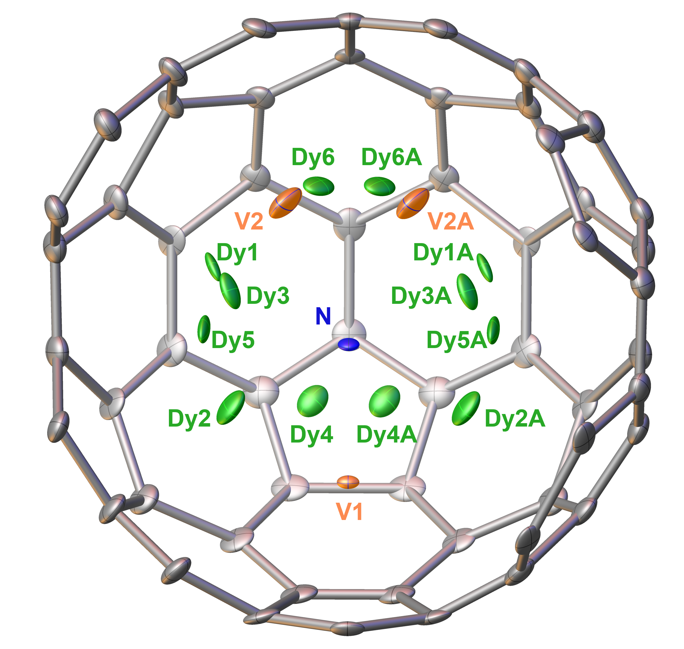
Supplementary Fig. S2. Disordered sites of internal Dy and V atoms in Dy₂VN@I_{h}(7)-C₈₀. Selected cage carbon atoms have been omitted for clarity.

Supplementary Table S2. Occupancy values of the inner Dy₂VN cluster.
Disordered site | Occupancy |  | Disordered site | Occupancy
Dy1 | 0.42758 |  | V1 | 0.44076
Dy1A | 0.42758 |  | V2 | 0.27962
Dy2 | 0.15661 |  | V2A | 0.27962
Dy2A | 0.15661
Dy3 | 0.11839
Dy3A | 0.11839
Dy4 | 0.05432
Dy4A | 0.05432
Dy5 | 0.15023
Dy5A | 0.15023
Dy6 | 0.09287
Dy6A | 0.09287

S4. Electronic Structure of Dy₂VN@I_{h}(7)-C₈₀.
Supplementary Table S3. The characteristic absorption peaks, absorption onset, and optical bandgap of Dy₂VN@I_{h}(7)-C₈₀, Dy_{x}Sc_{3-x}N@I_{h}(7)-C₈₀ (x = 1-3), and V_{x}Sc_{3-x}N@I_{h}(7)-C₈₀ (x = 1-2).
EMFs | Absorption peaks / nm | Absorption onset / nm | ΔE_{gap, optical} / eV^{[a]} | Ref.
Dy₂VN@I_{h}(7)-C₈₀ | 465, 581, 663, 773 | 1424 | 0.87 | This work
Dy₂ScN@I_{h}(7)-C₈₀ | 406, 565, 676, 705 | 850 | 1.46 | [S1]
Dy₃N@I_{h}(7)-C₈₀ | 320, 401, 554, 626, 643, 670, 700 | 823 | 1.51 | [S2]
V₂ScN@I_{h}(7)-C₈₀ | 327, 603 | 1290 | 0.96 | [S3]
VSc₂N@I_{h}(7)-C₈₀ | 313, 358, 748 | 1700 | 0.73 | [S3]
Dy₂ScN@D_{5h}(6)-C₈₀ | 416, 458, 636, 722 | 980 | 1.26 | [S4]
DySc₂N@D_{5h}(6)-C₈₀ | 408, 449, 641, 730 | 960 | 1.29 | [S4]
Dy₃N@D_{5h}(6)-C₈₀ | 463, 627, 714 | 929 | 1.33 | [S2]
V₂ScN@D_{5h}(6)-C₈₀ | 419, 481 | 1660 | 0.75 | [S5]
VSc₂N@D_{5h}(6)-C₈₀ | 413, 475 | 1900 | 0.65 | [S5]
[a] optical bandgap：ΔE_{gap, optical} = 1240 / λ_{onset}.

The electrochemical properties of Dy₂VN@I_{h}(7)-C₈₀ were studied by cyclic voltammetry with tetrabutylammonium hexafluorophosphate (TBAPF₆) as the supporting electrolyte. The characteristic redox potentials are listed in Table S4. Dy₂VN@I_{h}(7)-C₈₀ has one reversible oxidation process and four reduction processes, in which the first, third and fourth reduction processes are all reversible, and the second reduction process is irreversible. The first oxidation potential and the first reduction potential are 0.05 V and -0.81 V, respectively, the electrochemical bandgap is 0.86 eV, which is in great agreement with its optical bandgap. In comparison to Sc₂VN@I_{h}(7)-C₈₀, both the oxidation potential and reduction potential of Dy₂VN@I_{h}(7)-C₈₀ move to the negative direction, suggesting a stronger electron-donating properties of Dy₂VN@I_{h}(7)-C₈₀. This could be rationalized by considering the larger ionic radius of Dy than Sc and the presumably resulted stronger metal-cage interactions in Dy₂VN@I_{h}(7)-C₈₀ than Sc₂VN@I_{h}(7)-C₈₀.

Supplementary Table S4. Redox potential table of Dy₂VN@I_{h}(7)-C₈₀, and Sc₂VN@I_{h}(7)-C₈₀.
EMF | E_{1/2} (V vs. Fc/Fc⁺) |  |  |  |  |  |  | ΔE_{gap}  (V)
EMF | ^{ox}E₂ | ^{ox}E₁ | ^{red}E₁ | ^{red}E₂ | ^{red}E₃ | ^{red}E₄ | ^{red}E₅ | ΔE_{gap}  (V)
Dy₂VN@I_{h}(7)-C₈₀ |  | 0.05 | -0.81 | -1.53* | -1.81 | -2.35 |  | 0.86
Sc₂VN@I_{h}(7)-C₈₀ |  | 0.44* | -0.42 | -0.66 | -1.33 | -1.71 | -2.32* | 0.96
Sc₂VN@D_{5h}(6)-C₈₀ | 0.93* | 0.42* | -0.78* | -1.59* | -2.01* | -2.37* |  | 1.20
*irreversible procedure

S5. Magnetic Properties of Dy₂VN@I_{h}(7)-C₈₀.
Sample Preparation. The sample (0.340 mg) for magnetic measurements was prepared by drop-casting carbon disulfide (CS₂) solution onto a slice of Al foil (5.413 mg) which is paramagnetic to minimize the background of sample holder. Then, fast evaporation of CS₂ afforded black powder. After that, the Al foil was folded into a small cube and stuck on the inner wall of a plastic straw with very small amount of N grease (less than 1 mg). The mass of the sample was determined by the variation of the Al foil before and after drop-casting. All the mass values were weighed using a Metallo Toledo Ultra-micro balance (1 μg).

Magnetic measurements. Magnetic properties were determined using Quantum Design MPMS3 magnetometer. DC mode was adopted for the measurements of susceptibility and magnetization, while VSM mode was selected for hysteresis, zero-field-cooled (ZFC)/field-cooled (FC) magnetization (ZFC-FC) and magnetization decay measurements. The background of Al foil and Pascal correction were considered when the point-by-point diamagnetic correction was carried on the data. Due to the quantity limitation, alternative current (ac) susceptibility measurement was not conducted.

Relaxation times extraction from decay measurements. Considering the long magnetic relaxation times of Dy₂VN@I_{h}(7)-C₈₀, the relaxation times were determined from the magnetization decay measurements. The sample was first magnetized under 1 kOe dc field for saturation. Then the field was swept to zero as fast as possible and then the decay data was collected. The relaxation times were obtained by fitting the data using equation S1^{S6,S7}, where M_{eq}, M₀, τ and b are fitting parameters. Figure S5 shows the selected magnetization decay curves and their fittings. Table S7 shows the fitted relaxation times τ under different temperatures.
$M\left(t\right)=M_{eq}+\left(M_{0}-M_{eq}\right)exp\left[-{\left(\frac{t}{τ}\right)}^{b}\right]$ Eq. S1

Determination of the effective energy barrier (U_{eff}). The fitting of the whole dataset of relaxation times τ vs. T⁻¹ could be accomplished by combining Orbach and quantum tunneling of magnetization (QTM) processes using equation Eq. S2. The best fit gives the Orbach barrier of U₁ = 70.7 K and the QTM relaxation time of τ_{QTM} = 1249.8 s. The magnetic relaxation in high-temperature range is usually dominated by the Orbach process, thus we also only fit the relaxation times τ vs. T⁻¹ above 6 K. And only Arrhenius fitting of the dataset of relaxation times τ vs. T⁻¹ above 6 K using equation Eq. S3 gives the effective exchange barrier of 68.0 K, which is consistent with U₁.

$τ^{-1}=τ_{0}^{-1}exp\left(-U_{1}/T\right)+τ_{QTM}^{-1}$ Eq. S2
$τ^{-1}=τ_{0}^{-1}exp(-\frac{U_{eff}}{T})$ Eq. S3
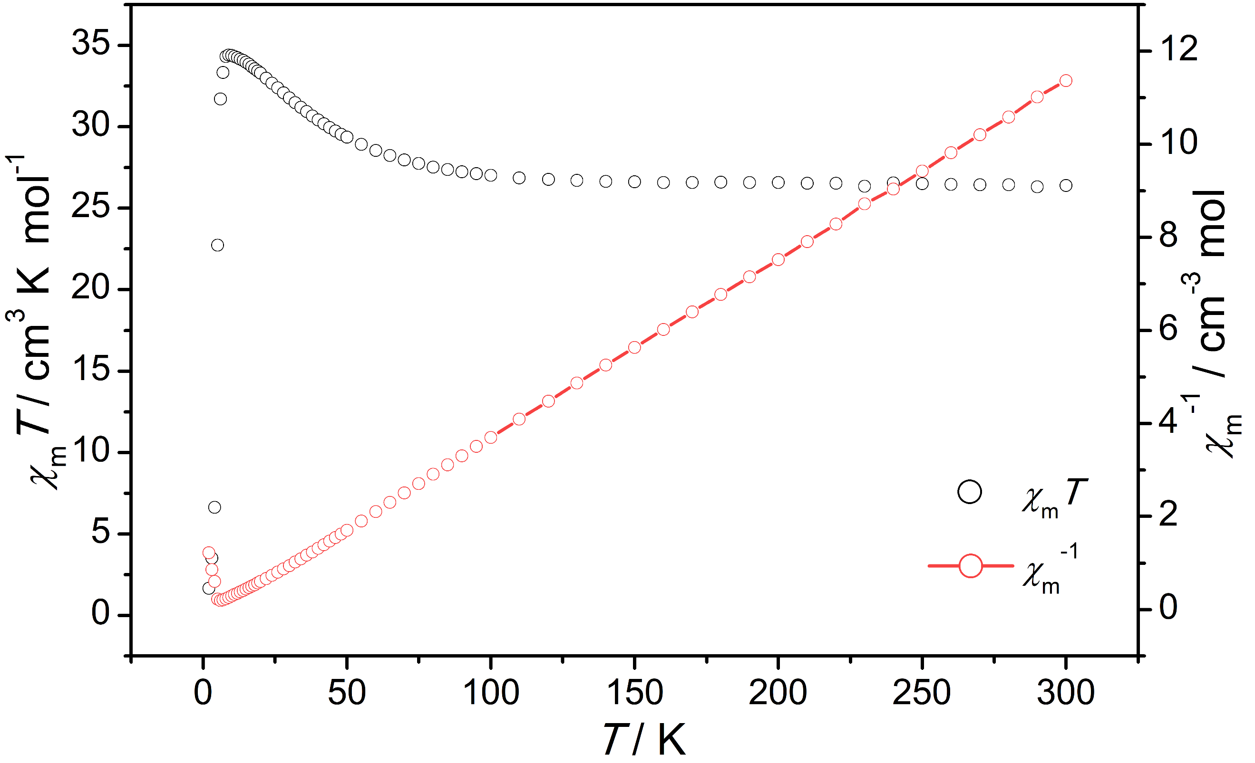
Supplementary Fig. S3. Temperature dependence of χ_{m}T and χ_{m}⁻¹ for Dy₂VN@I_{h}(7)-C₈₀ at 1 kOe dc field.
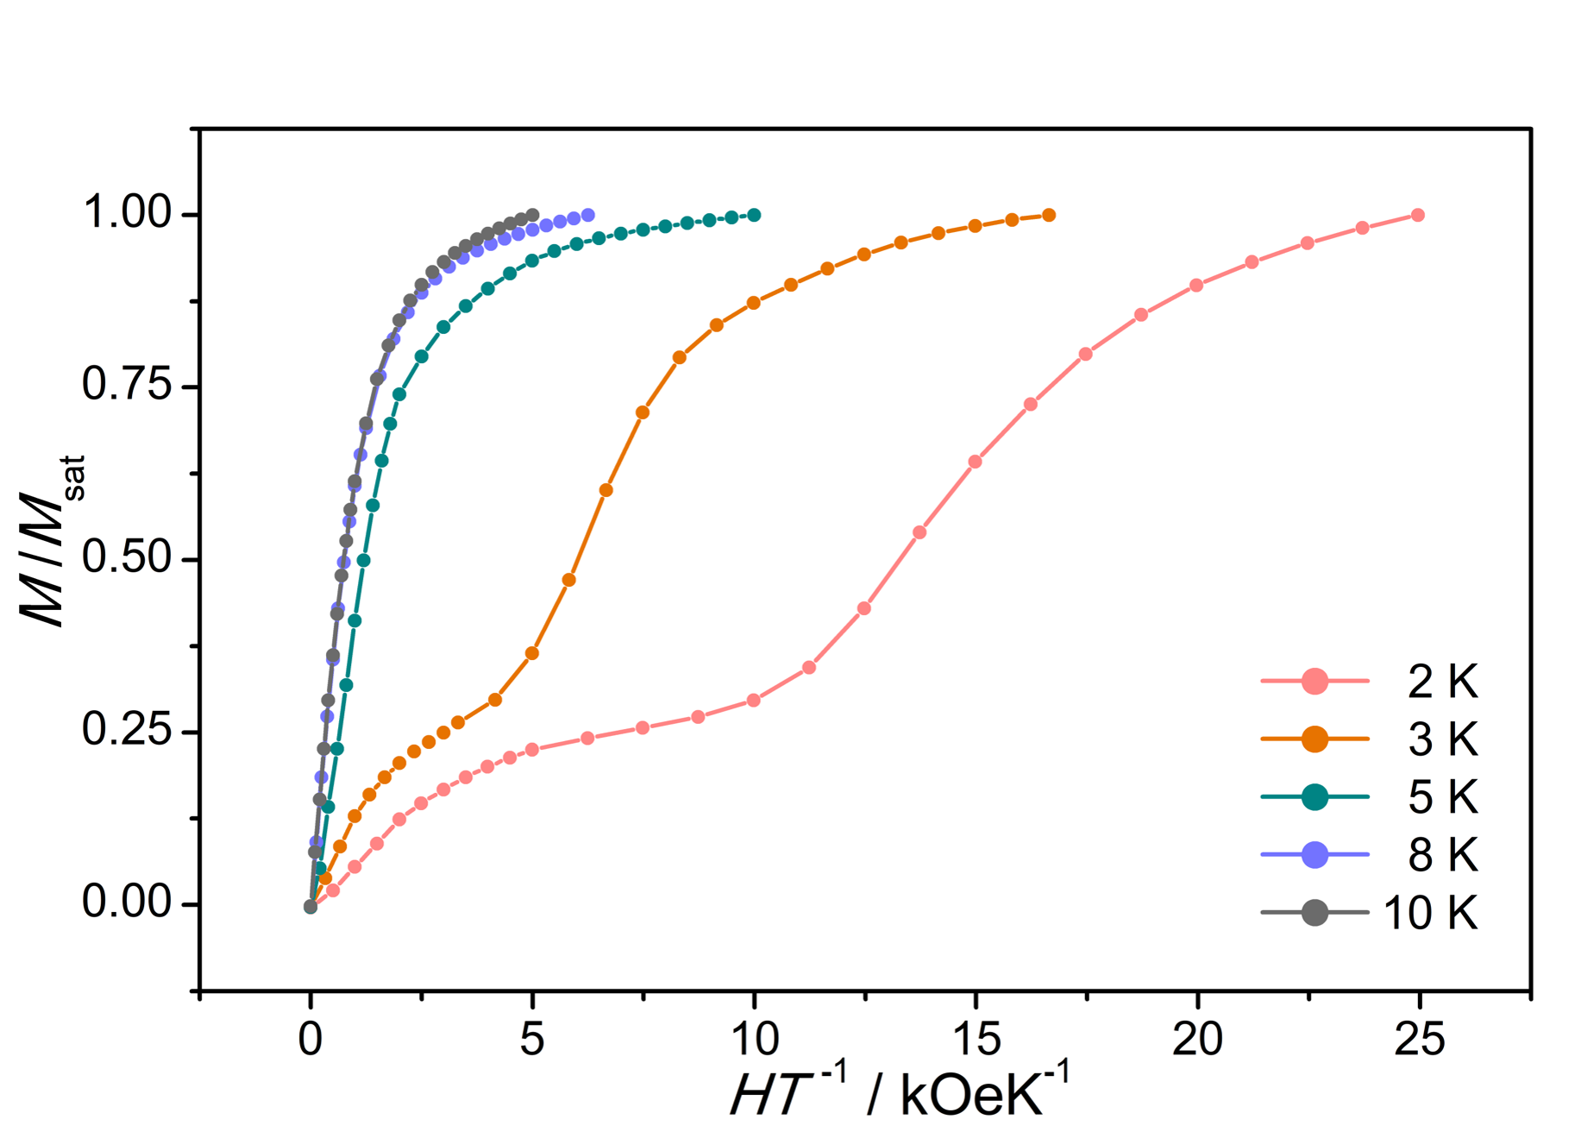

Supplementary Fig. S4. Plots of M vs. HT⁻¹ at the temperatures of 2 K, 3 K, 5 K, 8 K and 10 K, respectively.
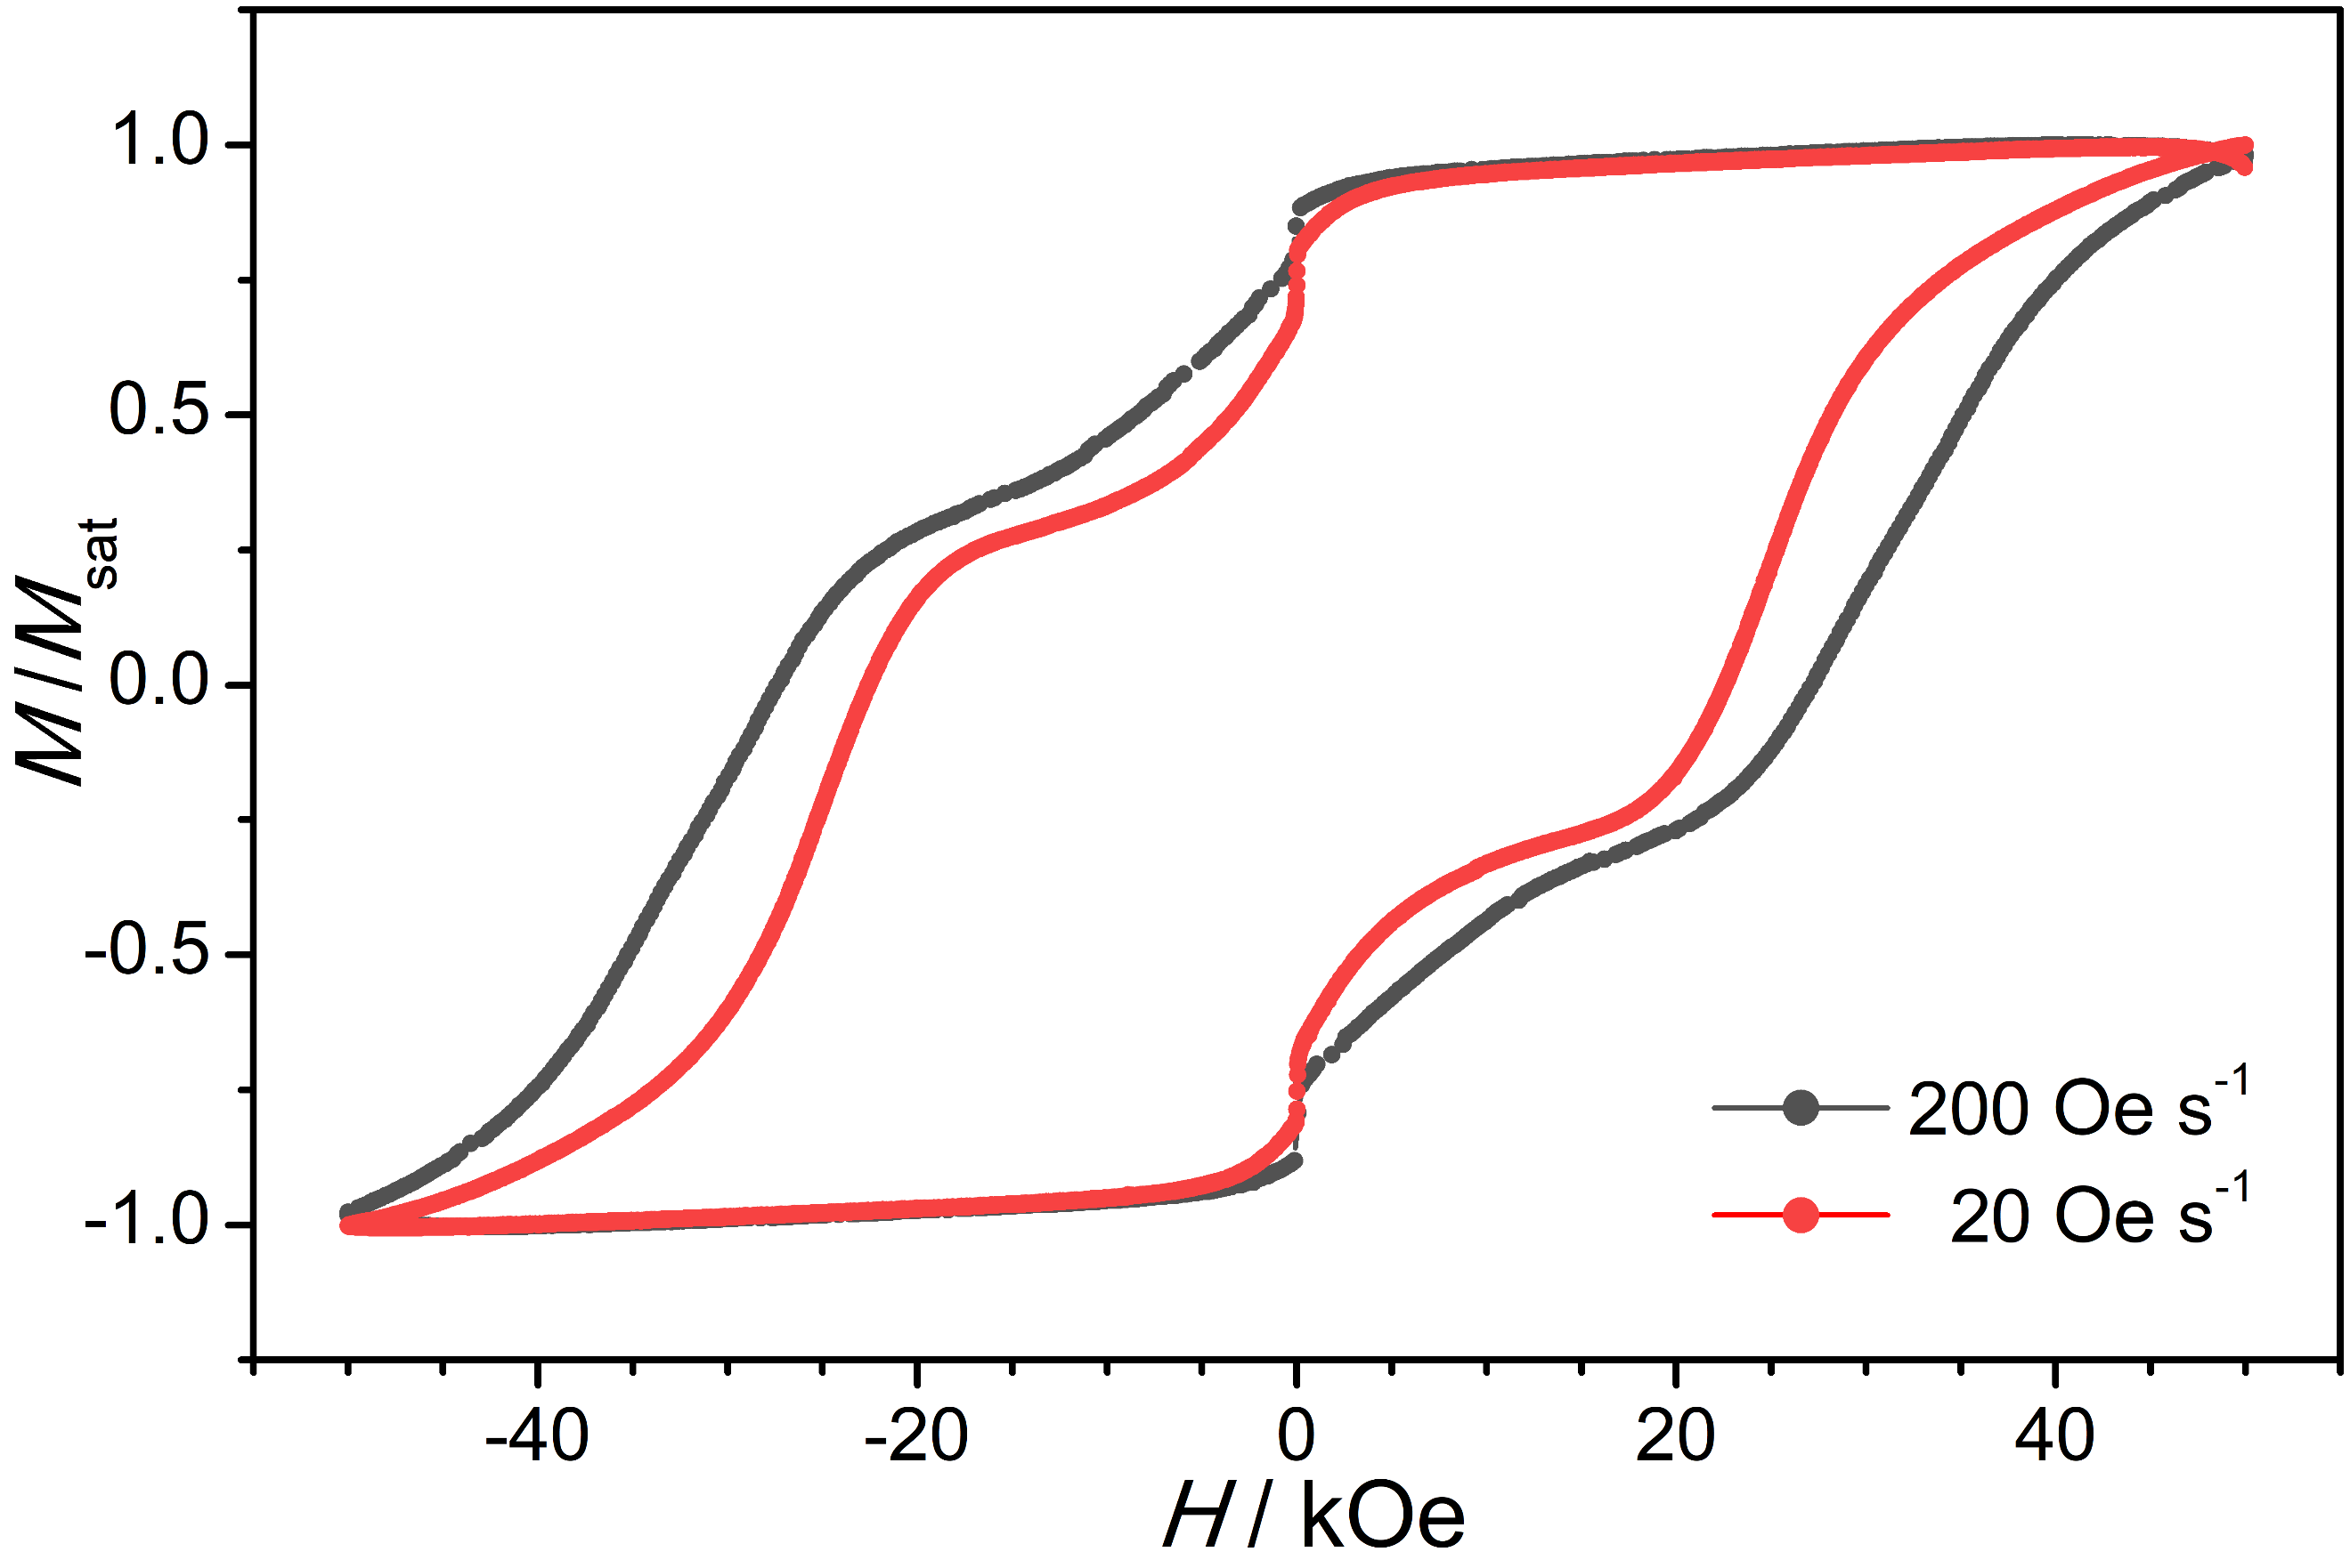
Supplementary Fig. S5. Magnetic hysteresis for Dy₂VN@I_{h}(7)-C₈₀ at 2 K with different field sweep rates.

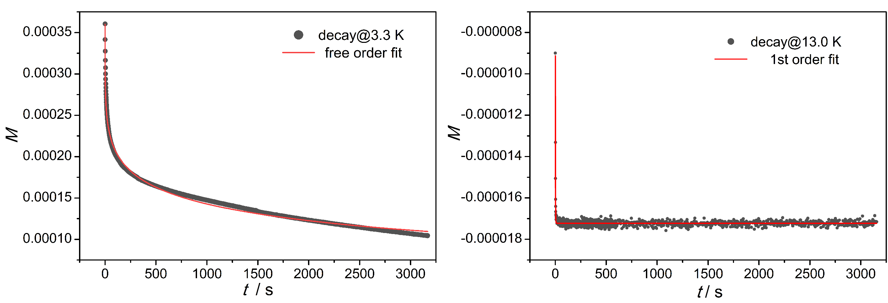
Supplementary Fig. S6. Determination of magnetization relaxation times from the magnetization decay curve at selected temperatures for Dy₂VN@I_{h}(7)-C₈₀.

Supplementary Table S6. The blocking temperatures of different definition (T_{B, ZFCFC} (K), and T_{B, loop} (K)), coercive fields (H_{c} (kOe)) and magnetic interactions (J (cm⁻¹)) for the selected 3d-4f SMMs.
 | T_{B, ZFCFC} / K | T_{B, loop} / K | H_{c} / kOe | J / cm⁻¹ | Ref.
Dy₂V^{III}N | 9.5 (2 kOe,3 K min⁻¹)ª | 12  (200 Oe s⁻¹) | 27.3 (2 K, 200 Oe s⁻¹)  & 22.6 (2 K, 20 Oe s⁻¹) | J_{Dy-V} =53.30  J_{Dy-Dy} = -18.75 | this work
DyCu^{II}₅ | 6.5 (2 kOe,2 K min⁻¹)^{b} | 12  (200 Oe s⁻¹) | butterfly-shaped  (2 K, 200 Oe s⁻¹) | J_{Dy-Cu} =1.5  J_{Cu-Cu} = -108.8 | [S8]
Dy₂Cu^{II}₁₀ | 5.5 (2 kOe,2 K min⁻¹)^{b} | 6  (200 Oe s⁻¹) | 1.37 (2 K, 200 Oe s⁻¹) | J_{Dy-Cu} =5.0 ^{c}  J_{Cu-Cu} = -108.8 ^{c}  J_{Dy-Dy} = 4.4 ^{c} | [S8]
Dy₂Cr^{III}₂ | 3.7  (1 kOe)^{d} | 3.5  (30 Oe s⁻¹) | 28 (1.8 K, 30 Oe s⁻¹) | J_{Dy1-Dy2} =-1.5  J_{Cr1-Cr2} = 0.12  J_{Dy1-Cr1} = -20.3  J_{Dy1-Cr2} = -16.7 | [S9]
Dy₂Fe^{III}₄ | 3  (1 kOe) ^{d} | 4  (200 Oe s⁻¹) | 0.5 <H_{c} < 1  (2 K, 200 Oe s⁻¹) | __ | [S10]
Dy₂Co^{II}₂ | __ | 4  (2350 Oe s⁻¹) | 2.5 <H_{c} < 5  (1.5 K, 2350 Oe s⁻¹) | J_{Dy-Co} =1.6  J_{Co-Co} = 2.0 | [S11]
DyFe^{II}₂ | __ | __ | __ | J_{Dy-Fe1} =0.38  J_{Dy-Fe2} = 0.06  J_{Fe1-Fe2} = 0.09 | [S12]
Dy₂Mn^{II}₂ | __ | __ | __ | J_{Dy-Mn} =4.8  J_{Mn-Mn} = 0.2  J_{Dy-Dy} = 5.5 | [S13]
DyV^{IV}O | __ | __ | __ | J_{Dy-V} = -0.254 | [S14]
Dy₂V^{III}N=Dy₂V^{III}N@C₈₀; DyCu^{II}₅=[DyCu^{II}₅(quinha)₅(sal)₂(py)₅]-(CF₃SO₃)·py·4H₂O;^{S8} Dy₂Cu^{II}₁₀=[Dy₂Cu^{II}₁₀(quinha)₁₀ (sal)₂(OH)(py)₉] (CF₃SO₃)₃·2py·2CH₃OH· 2H₂O; ^{S8} Dy₂Cr^{III}₂=Cr^{III}₂Dy₂(OMe)₂(O₂CPh)₄(mdea)₂(NO₃)₂; ^{S9} Dy₂Fe^{III}₄=[Fe^{III}₄Dy₂(μ₃-OH)₂ (mdea)₆(SCN)₂(NO₃)₂(H₂O)₂]·4H₂O·2MeCN; ^{S10} Dy₂Co^{II}₂=[Co^{II}₂Dy₂(L)₄(NO₃)₂(THF)₂] ·4THF, H₂L=(E)-2-(2-hydroxy-3-methoxybenzylideneamino)phenol; ^{S11} DyFe^{II}₂=[Fe^{II}₂Dy(L)₂(H₂O)]ClO₄·2H₂O, L=v2,2′,2′′-(((nitrilotris(ethane-2,1-diyl))tris(azanediyl))tris(methylene))tris(4-chlorophenol)]; ^{S12} Dy₂Mn^{II}₂=Dy₂Mn^{II}₂(L)₄(NO₃)₂(DMF)₂, H₂L = (E)-2-ethoxy-6-(((2-hydroxyphenyl)imino)methyl)phenol; ^{S13} DyV^{IV}O=Dy(V^{IV}O)L(NO₃)₃(H₂O), H₂L = N, N′-bis(1-hydroxy-2-benzylidene-6-methoxy)-1,7-diamino-4-azaheptane. ^{S14}
- The criterion of diverge temperature defined herein is 1% relative difference between FC and ZFC curves, $\frac{χ_{FC}-χ_{ZFC}}{χ_{ZFC}}>1\%$.
- The criterion of diverge temperature defined herein is 5% relative difference between FC and ZFC curves. If the same criterion is used for Dy₂VN@I_{h}(7)-C₈₀, the T_{B, ZFCFC} will be 9.1 K.
- The J_{Cu-Cu} was obtained from the fitting of [DyCu₅(quinha)₅(sal)₂(py)₅]-(CF₃SO₃)·py·4H₂O, while J_{Dy-Cu} and J_{Dy-Dy} were the effective Ising exchange interaction.
- The temperature sweep rate was not indicated.

Supplementary Table S7. The extracted relaxation times (τ) and parameter b under different temperatures from magnetization decay.
T / K | T⁻¹ / K⁻¹ | τ / s | b
13.0 | 0.07692 | 1.5 | 1.0
11.9 | 0.08403 | 2.6 | 1.0
11.0 | 0.09091 | 4.0 | 1.0
10.0 | 0.10000 | 6.5 | 1.0
9.2 | 0.10870 | 12.1 | 1.0
8.2 | 0.12195 | 27.0 | 1.0
7.2 | 0.13889 | 80.0 | 0.73
6.3 | 0.15873 | 480 | 0.75
5.5 | 0.18182 | 900 | 0.52
3.3 | 0.30303 | 998 | 0.23
2.5 | 0.40000 | 1850 | 0.57

S6. Theoretical Analysis.
Ab initio calculations. Ab initio calculations were performed at the CASSCF/SO-RASSI level of theory with the use of SINGLE_ANISO program^{S15–S17} employing MOLCAS 8.1 program^{S18} for both magnetic centers to obtain the crystal-field/zero-field parameters for Dy(III) and V(III). The calculation models were built on the crystal structure without further optimization. For the calculation of Dy(III), the other Dy(III) was replaced by diamagnetic Lu(III) and V(III) was replaced by diamagnetic Sc(III). The basis sets for all atoms are atomic natural orbitals from the MOLCAS ANO-RCC library^{S19,S20}: ANO-RCC-VTZP for Dy(III)/V(III) ions; VTZ for close N and C; VDZ for distant C and diamagnetic Lu(III)/Sc(III). The calculations employed the second order Douglas-Kroll-Hess Hamiltonian, where scalar relativistic contractions were considered in the basis sets and the spin-orbit couplings were handled in the restricted active space state interaction (RASSI-SO) procedure. We have mixed the maximum number of spin-free states which was possible with our hardware (all from 21 sextets, 128 from 224 quadruplets, 130 from 490 doublets for the Dy(III) fragment). Active electrons in seven active spaces include all f electrons (CAS (9, 7)) of Dy (III) in the CASSCF calculation. For the calculation of V(III), two active electrons in five active spaces (CAS (5,2)) was adopted in the CASSCF calculation. Dynamic correlation energy was also be considered using the CASPT2^{S21} program.
Density functional theory calculations. DFT calculations were performed at the B3LYP, PBE0, TPSSh, and ωB97X-D functionals with the basis function of 6-31G(d) for carbon atom and CEP-4G for metal atoms by using the quantum chemistry package Gaussian 16.^{S22} The natural bond orbital calculations were performed with NBO 3.0 program^{S23} also included in Gaussian 16.
The optimized results in Table S8 indicate the spin-ground state of Dy₂VN@I_{h}(7)-C₈₀ with 2S + 1 = 13. The crystal structure of Dy₂VN@I_{h}(7)-C₈₀ is in line with the optimized one (Fig. S6) at the ωB97X-D/6-31G(d)~CEP-4G, which was considered to further understand the electronic structures. The Mulliken atomic spin population in Table S9 means that there are about 2, 5, and 5 unpaired electrons remain at V, Dy1, and Dy1A atoms, respectively. On the other hand, in comparison of ground-state electronic configuration of Dy (4f¹⁰6s²) and Sc (3d³4s²) atoms, the NPA results indicate the three-electron transfer of each metal atom leading to the formally six-electron transfer from inner cluster to outer fullerene cage, and there are clear back-donation in 3d and 5d for V and Dy atoms, respectively. The formally electronic structure can be characterized as [(Dy³⁺)₂V³⁺N³⁻@I_{h}(7)-C₈₀⁶⁻]. Additionally, the metal-nonmetal interaction in inner cluster show clear covalent characters based on the Wiberg bond order calculations.

Supplementary Table S8. Relative energy (ΔE in kcal·mol⁻¹) of optimized Dy₂VN@I_{h}(7)-C₈₀ with different spin multiplicities (2S + 1) at different density functionals and same basis function 6-31G(d)~CEP-4G where S is the spin angular momentum.
2S + 1 | ΔE/kcal·mol⁻¹ | ΔE/kcal·mol⁻¹ | ΔE/kcal·mol⁻¹ | ΔE/kcal·mol⁻¹
2S + 1 | B3LYP | PBE0 | TPSSh | ωB97X-D
2S + 1 | 6-31G(d)~CEP-4G
1 | 144.5
3 | 80.9
5 | 42.4
7 | 16.7
9 | 0.0 | 1.6 | 0.3 | 3.8
11 | 7.4
13 | 0.4 | 0.0 | 0.0 | 0.0
15 | 15.1
17 | 56.0
19 | 107.6

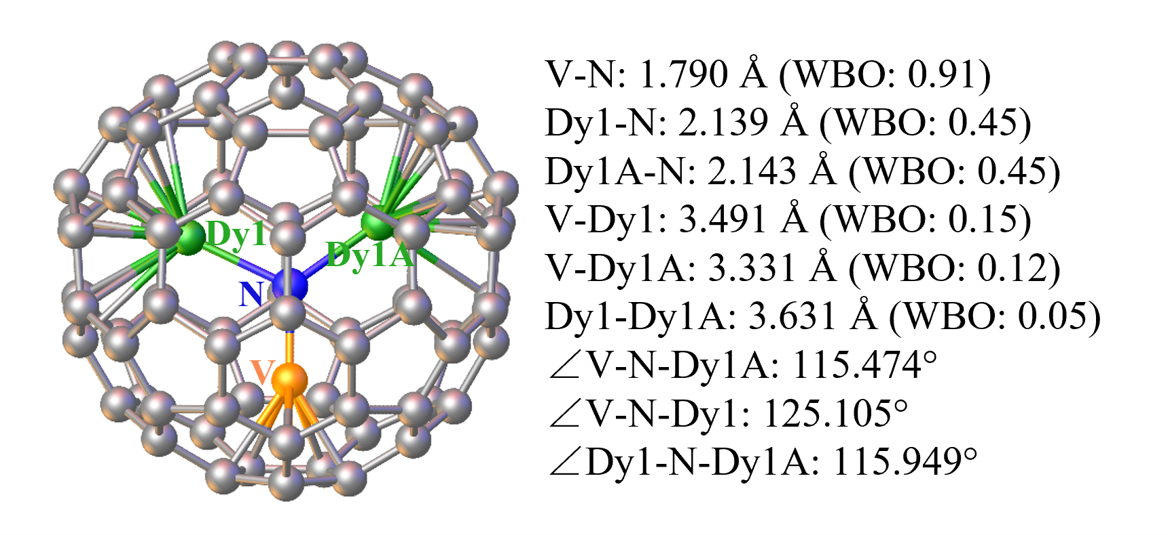
Supplementary Fig. S7. Optimized geometry of Dy₂VN@I_{h}(7)-C₈₀ with 2S + 1 = 13 spin-ground state at the ωB97X-D/6-31G(d)~CEP-4G, where the basis function of 6-31G(d) for carbon atom and CEP-4G for metal atoms, including the bond distance, bond angle, and Wiberg bond order (WBO).

Supplementary Table S9. Mulliken atomic spin population and natural population analysis (NPA) of Dy₂VN in optimized Dy₂VN@I_{h}(7)-C₈₀ with spin-ground state at the ωB97X-D/6-31G(d)~CEP-4G , where the basis function of 6-31G(d) for carbon atom and CEP-4G for metal atoms.
Atoms | Mulliken atomic spin population | NPA
N | -0.12 | 2s^{1.52}2p^{4.72}
V | 2.09 | 3d^{3.57}4s^{0.14}4p^{0.37}4d^{0.20}
Dy1 | 5.09 | 4f^{9.02}5d^{0.94}6s^{0.09}6p^{0.28}
Dy1A | 5.10 | 4f^{9.02}5d^{0.93}6s^{0.09}6p^{0.29}

Magnetic interaction fitting. The magnetic states of this three-center spin system can be described with the total spin Hamiltonian (Eq2) as mentioned in the main text. The calculated crystal field parameters were employed to describe the crystal-field splitting of the single Dy(III) ion. Both the coupling within two Dy centers and the interaction between the Dy center and V center were included into the spin Hamiltonian. The two Dy centers are structurally identical as V–N locates on the crystallographic symmetric plane, thus the interactions between different Dy centers and V center can be considered to be identical.
According to the results from ab initio, the magnetic anisotropy of Dy centers are very close to the Ising limit, while the calculated E/D for V center is 0.31, thus the V center could be treated as isotropic with the average g_{iso} = 1.9. Therefore, the exchange interaction between the magnetic centers was considered within the Lines model using the Hamiltonian (Eq3) in main text, while the dipole−dipole magnetic coupling is treated exactly with the Hamiltonian (Eq. S4) as shown below where $\vec{r}$ is a unit vector and |r| is the distance between the magnetic centers.
$J_{dip}=\frac{μ_{0}μ_{B}^{2}}{{4π|r|}^{3}}∙\left[\overline{g_{1}}∙\overline{g_{2}}-3\left(\overline{g_{1}}∙\vec{r}\right)\left(\vec{r}∙\overline{g_{2}}\right)\right]$ Eq. S4
The fitting was conducted in the POLY_ANISO program^{16,17} and only data above 20 K were considered during the fitting. The best fit gave U_{1, Lines} = 63.4 K and was well consistent with the energy barrier fitted from data of demagnetization (U₁ = 70.7 K).
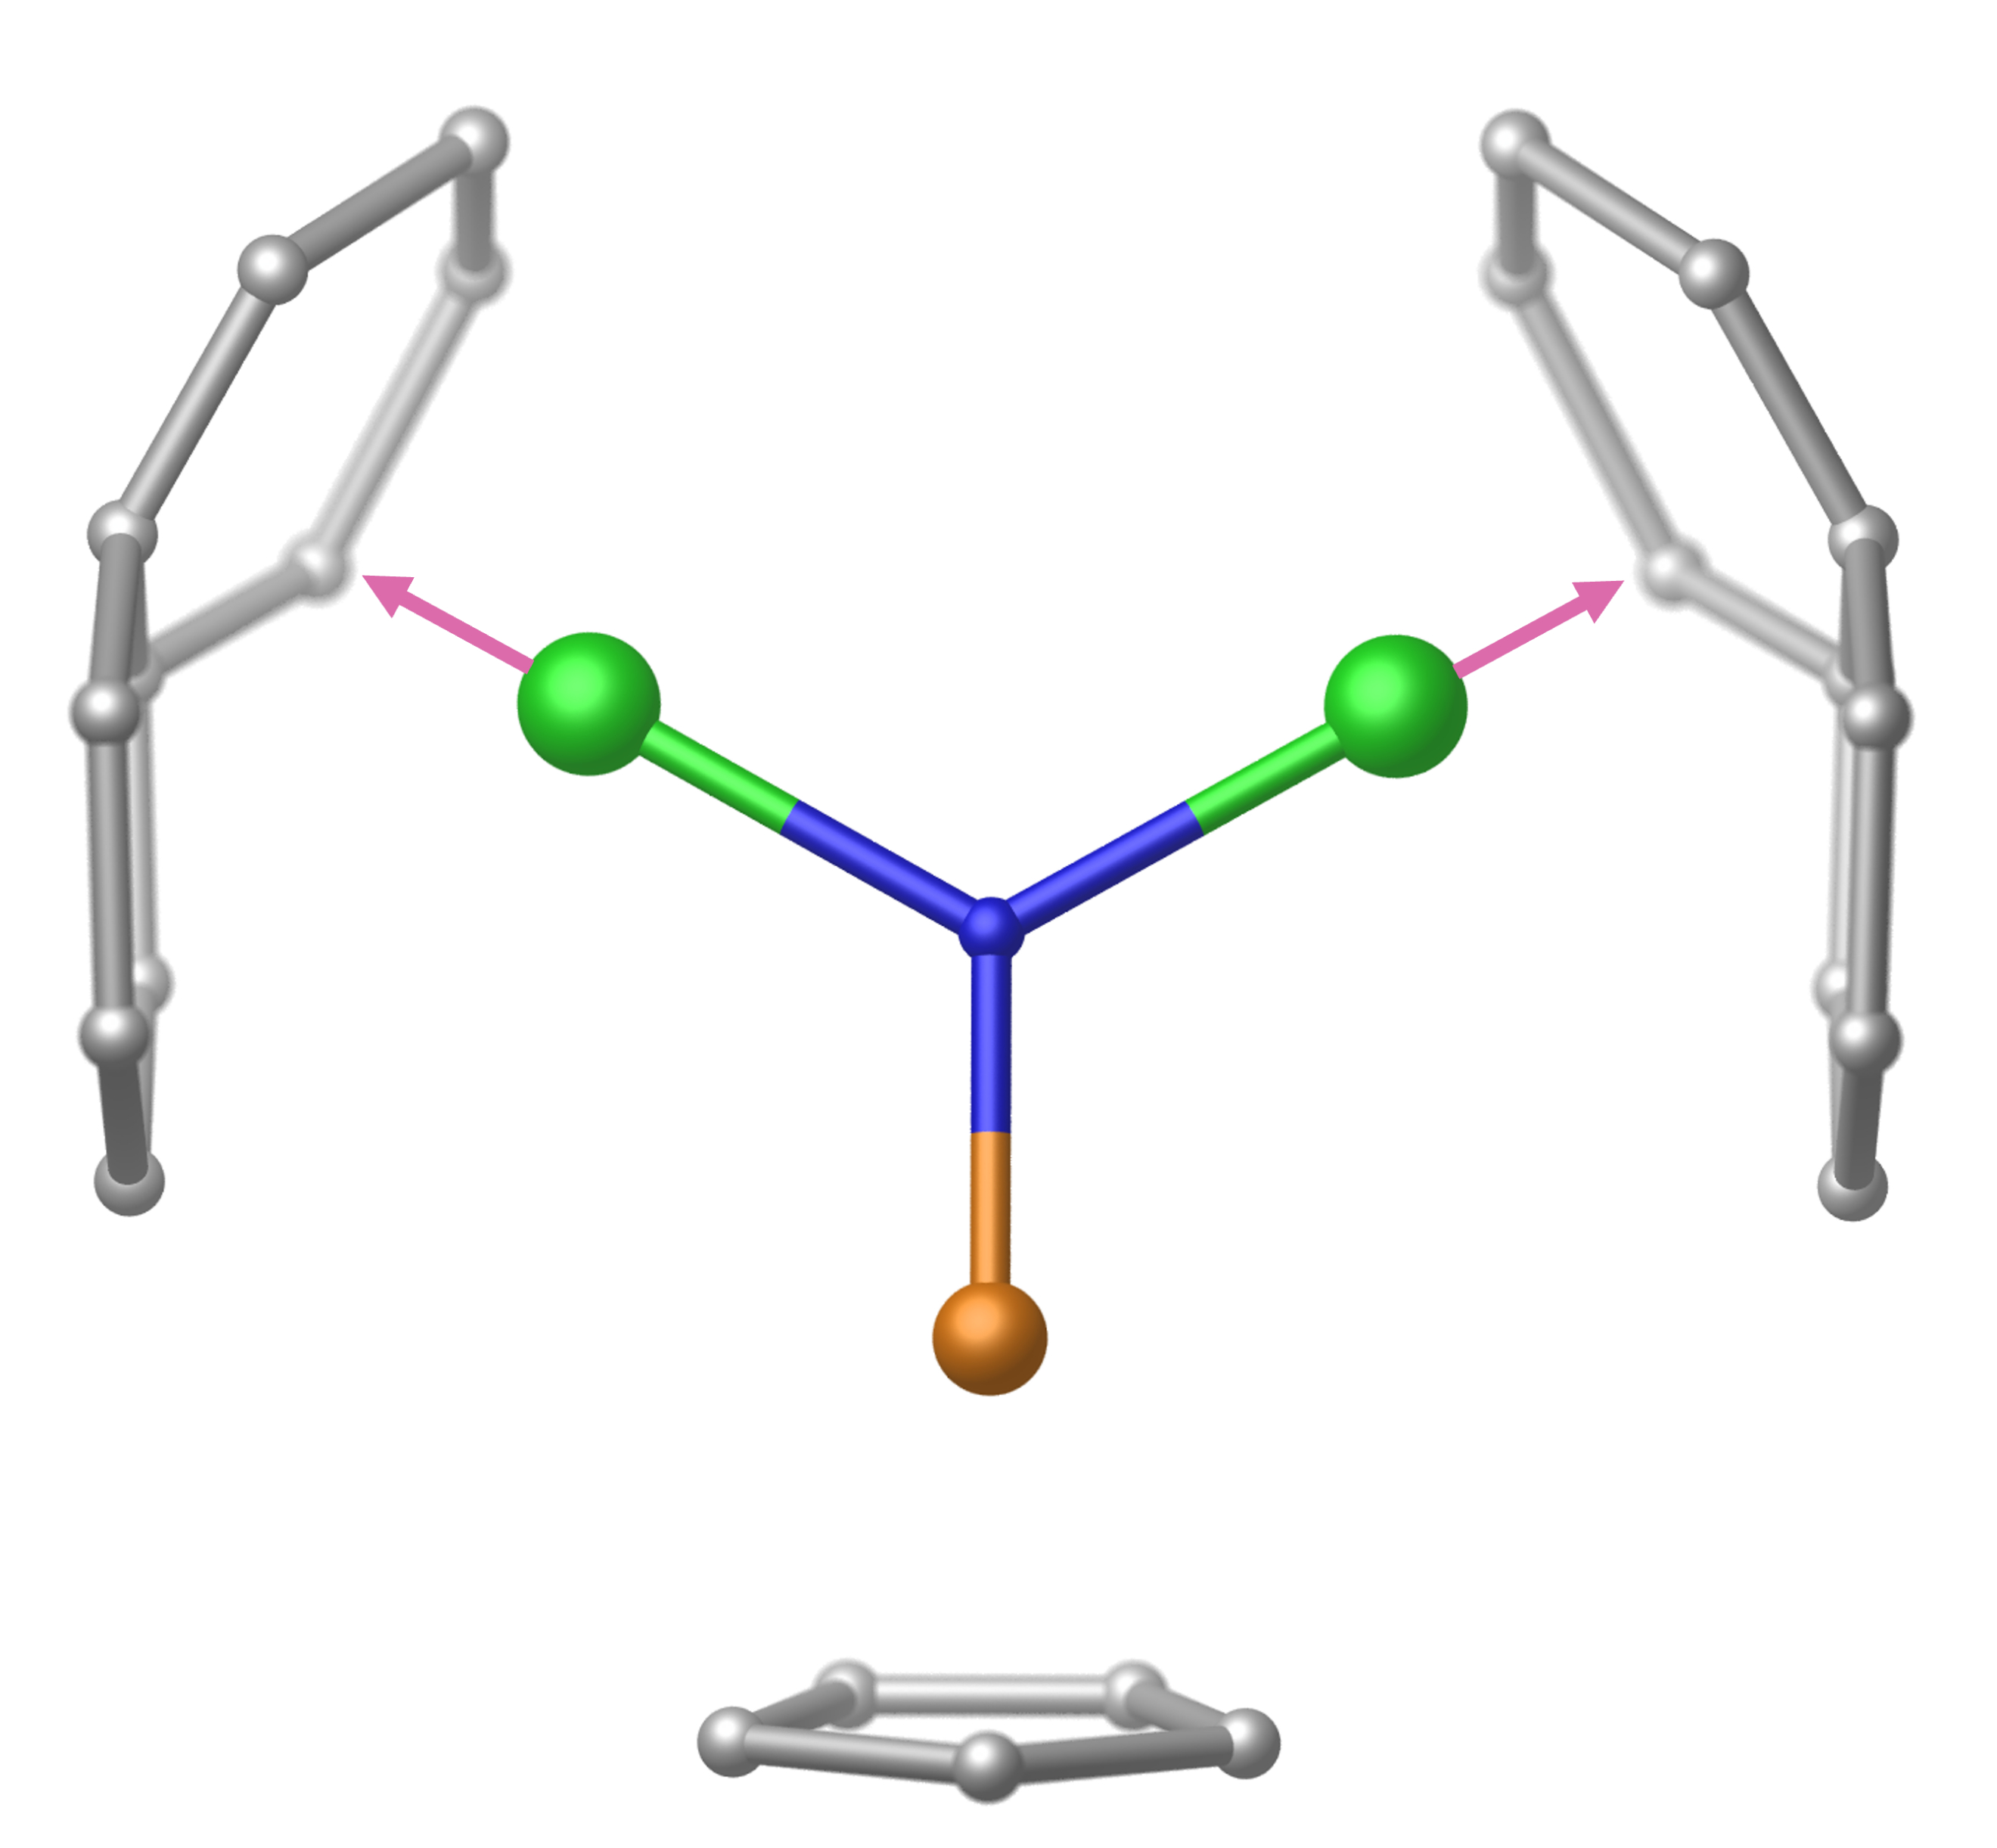
Supplementary Fig. S8 Orientation of easy axis of the ground Kramers doublets on two Dy(III) centers in Dy₂VN@I_{h}(7)-C₈₀. Dy: green; N: blue; V: orange.

Supplementary Table S10. Calculated energy levels and g (g_{x}, g_{y}, g_{z}) tensors of the lowest eight Kramers doublets (KDs) on individual Dy(III), and zero-field splitting parameters D, E and g (g_{x}, g_{y}, g_{z}) tensors of the lowest spin-orbit state on individual V(III) in Dy₂VN@I_{h}(7)-C₈₀.
KDs |  | Dy1 |  |  | Dy1A |  | V1
KDs | E / cm⁻¹ | E / K | g | E / cm⁻¹ | E / K | g | D | E | g
1 | 0.0 | 0.0 | 0.000 0.000 19.852 | 0.0 | 0.0 | 0.000 0.000 19.844 | 1.8093 cm⁻¹ | 0.5593 cm⁻¹ | 1.856  1.908  1.961
2 | 414.1 | 595.5 | 0.004 0.004 17.041 | 414.0 | 595.4 | 0.004 0.004 17.028
3 | 820.6 | 1180.0 | 0.069 0.076 14.261 | 820.5 | 1179.8 | 0.069 0.075 14.247
4 | 1128.3 | 1622.5 | 0.149 0.270 11.471 | 1128.2 | 1622.3 | 0.146 0.267 11.458
5 | 1276.6 | 1835.8 | 0.985 1.849 12.438 | 1276.5 | 1835.6 | 0.980 1.838 12.390
6 | 1345.1 | 1934.2 | 3.452 5.085 10.644 | 1345.0 | 1934.0 | 3.452 5.055 10.584
7 | 1415.8 | 2036.0 | 1.359 2.884 15.008 | 1415.7 | 2035.8 | 1.360 2.871 14.940
8 | 1549.1 | 2227.7 | 0.161 0.441 19.284 | 1549.0 | 2227.5 | 0.161 0.437 19.184

Supplementary Table S11. The obtained energy states based on Lines model and their corresponding g-tensor values.

 | E / cm⁻¹ | E / K | ∆_{t} / cm⁻¹ | g_{x} | g_{y} | g_{z}
1 | 0.0 | 0.0 | 9.1E-10 | 0.000 | 0.000 | 38.23
2 | 15.3 | 22.0 | 2.0E-09 | 0.000 | 0.000 | 23.83
3 | 41.4 | 59.6 | 1.0E-07 | 0.000 | 0.000 | 19.80
4 | 44.1 | 63.4 (U_{Lines}) | 1.1E-07 | 0.000 | 0.000 | 34.35
5 | 67.6 | 97.2 | 2.5E-08 | 0.000 | 0.000 | 15.76
6 | 88.7 | 127.5 | 2.0E-08 | 0.000 | 0.000 | 30.47
7 | 416.3 | 598.6 | 8.6E-10 | 0.000 | 0.000 | 36.09
8 | 418.7 | 602.1 | 2.7E-09 | 0.000 | 0.000 | 36.08

S7. Reference
S1. Yang, S. et al. Mixed metal nitride clusterfullerenes in cage isomers: Lu_{x}Sc_{3-x}N@C₈₀(x=1, 2) as compared with M_{x}Sc_{3-x}N@C₈₀(M =Er, Dy, Gd, Nd). J. Phys. Chem. C 113, 7616–7623 (2009).
S2. Yang, S. & Dunsch, L. A large family of dysprosium-based trimetallic nitride endohedral fullerenes: Dy₃N@C_{2n} (39≤n≤44). J. Phys. Chem. B 109, 12320-12328(2005)
S3. Wei, T. et al. Entrapping a group-VB transition metal, vanadium, within an endohedral metallofullerene: V_{x}Sc_{3−x}N@I_{h}‑C₈₀(x =1,2). J. Am. Chem. Soc. 138, 207–214 (2016).
S4. Wei, T. et al. An expanded family of dysprosium-scandium mixed-metal nitride clusterfullerenes: the role of the lanthanide metal on the carbon cage size distribution. Chem. Eur. J. 21, 5750–5759 (2015).
S5. Wei, T. et al. Blending non-group-3 transition metal and rare-earth metal into a C₈₀ fullerene cage with D_{5h} symmetry. Angew. Chem. Int. Ed. 57, 10273–10277 (2018).
S6. Krylov, D. S. et al. Magnetization relaxation in the single-ion magnet DySc₂N@C₈₀: quantum tunneling, magnetic dilution, and unconventional temperature dependence. Phys. Chem. Chem. Phys. 20, 11656–11672 (2018).
S7. Koponen, I. Random transition rate model of stretched exponential relaxation. J. Non-Cryst. Solids 189, 154–160 (1995).
S8. Wang, J. et al. Opening magnetic hysteresis by axial ferromagnetic coupling: from mono‐decker to double‐decker metallacrown. Angew. Chem. Int. Ed. 60, 5299–5306 (2021).
S9. Langley, S. K. et al. A {Cr^{III}₂Dy^{III}₂} single-molecule magnet: enhancing the blocking temperature through 3d magnetic exchange. Angew. Chem. Int. Ed. 52, 12014–12019 (2013).
S10. Akhtar, M. N. et al. Exploring the role of intramolecular interactions in the suppression of quantum tunneling of the magnetization in a 3d-4f single-molecule magnet. Inorg. Chem. 60, 9302–9308 (2021).
S11. Mondal, K. C. et al. Coexistence of distinct single-ion and exchange-based mechanisms for blocking of magnetization in a Co^{II}₂Dy^{III}₂ single-molecule magnet. Angew. Chem. Int. Ed. 51, 7550–7554 (2012).
S12. Liu, J.-L. et al. A heterometallic Fe^{II}-Dy^{III} single-molecule magnet with a record anisotropy barrier. Angew. Chem. Int. Ed. 53, 12966–12970 (2014).
S13. Li, J. et al. Tuning quantum tunnelling of magnetization through 3d–4f magnetic interactions: an alternative approach for manipulating single-molecule magnetism. Inorg. Chem. Front. 4, 114–122 (2017).
S14. Kotrle, K. et al. 3d–4f magnetic exchange interactions and anisotropy in a series of heterobimetallic vanadium(iv)–lanthanide(iii) Schiff base complexes. Dalton Trans. 50, 13883–13893 (2021).
S15. Chibotaru, L. F. & Ungur, L. Ab initio calculation of anisotropic magnetic properties of complexes. I. Unique definition of pseudospin Hamiltonians and their derivation. J. Chem. Phys. 137, 064112 (2012).
S16. Chibotaru, L. F. et al. Structure, magnetism, and theoretical study of a mixed-valence Co^{II}₃Co^{III}₄ heptanuclear wheel: lack of SMM behavior despite negative magnetic anisotropy. J. Am. Chem. Soc. 130, 12445–12455 (2008).
S17. Chibotaru, L. F., Ungur, L. & Soncini, A. The origin of nonmagnetic Kramers doublets in the ground state of dysprosium triangles: evidence for a toroidal magnetic moment. Angew. Chem. Int. Ed. 47, 4126–4129 (2008).
S18. Aquilante, F. et al. Molcas 8: New capabilities for multiconfigurational quantum chemical calculations across the periodic table. J. Comput. Chem. 37, 506–541 (2016).
S19. Roos, B. O. et al. New relativistic ANO basis sets for actinide atoms. Chem. Phys. Lett. 409, 295–299 (2005).
S20. Roos, B. O. et al. Main group atoms and dimers studied with a new relativistic ANO basis set. J. Phys. Chem. A 108, 2851–2858 (2004).
S21. Finley, J. et al. The multi-state CASPT2 method. Chem. Phys. Lett. 288, 299–306 (1998).
S22. Frisch, M. J. et al. Gaussian, Inc., Wallingford CT, (2016).
S23. Glendening, E.D. et al. Version 3.1, University of Wisconsin, Madison, WI, (1996).

