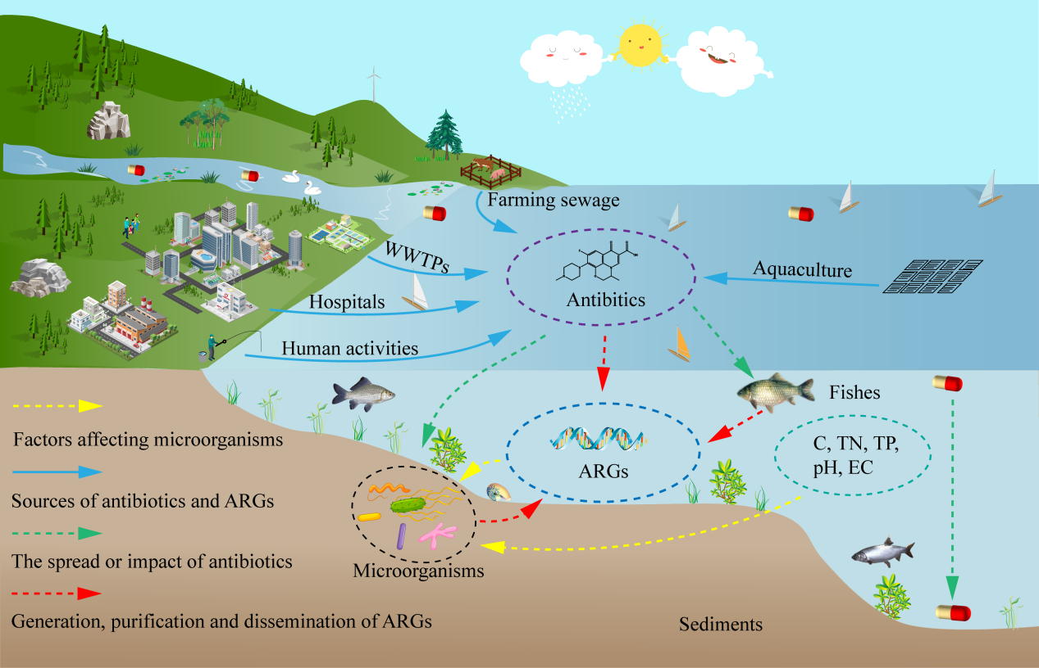

A total of 14 antibiotics were detected in surface water and sediments.
OFX poses a high ecological risk in all points of surface water.
Antibiotics and ARGs were significantly positively correlated in Wanfeng Lake.
Antibiotics and ARGs in sediments were positively correlated with microorganisms.

