Supplementary Information
Amino acids groups and distributions based on Charge, Hydrophobicity, normalized van der Waals volume, polarity, polarizability, secondary structure, and solvent accessibility are presented in Table(S1).
Table S1 Division of amino acids in to three groups based on their physicochemical properties
Property | Class 1 | Class 2 | Class 3
Charge | Neutral | Negatively charged | Positively charged
Residues | A, C, F, G, H, I, L, M, N, P, Q, S,  T, V, W, Y | D, E | K, R
Hydrophobicity | Hydrophobic | Neutral | Polar
Residues | C, F, I, L, M, V, W | A, G, H, P, S, T, Y | D, E, K, N, Q, R
Normalized van der Waals volume | Volume range: 0-2.78 | Volume range: 2.95-4.0 | Volume range: 4.03-8.08
Residues | A, C, D, G, P, S, T | E, I, L, N, Q, V | F, H, K, M, R, W, Y
Polarity | Polarity range: 4.9-6.2 | Polarity range: 8.0-9.2 | Polarity range: 10.4-13.0
Residues | C, F, I, L, M, V, W, Y | A, G, P, S, T | D, E, H, K, N, Q, R
Polarizability | Polarizability range: 0 - .108 | Polarizability range 0.128-0.186 | Polarizability range 0.219-0.409
Residues | A, D, G, S, T | C, E, I, L, N, P, Q, V | F, H, K, M, R, W, Y
Secondary Structure | Coil | Helix | Strand
Residues | D, G, N, P, S | A, E, H, K, L, M, Q, R | C, F, I, T, V, W, Y
Solvent Accessibility | Buried | Intermediate | Exposed
Residues | A, C, F, G, I, L, V, W | H, M, P, S, T, Y | D, E, K, N, R, Q

A list of Global and Peptide descriptors and their definition are summarized in Table(S2).
Table S2. Summary of Global and pepdescriptors
Features Description
Aromaticity | This feature is calculated based on the relative frequency of amino acids with aromatic R groups; Phenylalanine+Tyrosine+Tryptophan [36].
Aliphatic Index | Aliphatic index is based on the correlation between thermal stability and the aliphatic index of a protein. This descriptor is calculated based on the frequency of the alanine, Valine, Leucine and Isoleucine. Aliphatic index = X(Ala)+a X(Val)+b X(Ile)+X(Leu), where X represents the molar percentage of these amino acids, a and b is the side chain volume of the Valine, Leucine and Isoleucine. For Val a = 2.9 and for Leu and Ile b = 3.9 [35].
Boman Index | This index is based on protein-protein interaction. Indeed, high Boman index indicates that the peptide has a high potential for interaction with other proteins [33].
Hydrophobic Ratio | This feature is calculated based on the relative frequency of Ala, Cys, Phe, Ile, Leu, Met, Val [37].
Hydrophobicity | This descriptor is calculated based on Argos [61], Hopp-woods [62], Janin [63], Gravy [64], Kyte-Doolittle [64] and Eisenberg hydrophobicity scale[65].
Instability Index | By studying several stable and unstable proteins, Guruprasad et al. found that some dipeptides in unstable proteins are significantly different from stable proteins. Based on their effects on protein instability, an instability index is assigned for each. Summation of these indexes normalized on the protein sequences and used as a benchmark for a protein or peptide instability [34].
Length | Peptide sequences length
Molecular weight | MW of peptide sequences
Charge | NetCharge, Calculates charge of peptides sequence at pH 7.4, charge_pysc and charge_acid calculates amino acid charge at pH 7 and acidic pH respectively [25].
Charge density | Calculated by dividing charge by molecular weight
Isoelectric point | A pH of a solution that a net charge of a peptide sequence is zero
Bulkiness | This feature is calculated based on amino acid side chain bulkiness [38]
Insertion | E(z) is a residue-based potential for calculating the amino acid side chain insertion propensity into the lipid bilayer [66].
α-helix propensity | This descriptor is obtained based on Levitt amino acid alpha helix propensity. Statistical studies of proteins of the known structure have shown that amino acids have clear conformational preferences for one type of secondary structure [67].
Flexibility | Amino acid side chain flexibility scale [25].
Side chain composition, polarity, molecular volume | Mainly two methods are used to calculate these features: The Grantham method that analyzed amino acid formulation to explain protein evolution[68] and a PCA-derived scale based on amino acid side chain that uses six different probes from GRID program [69].
Isotropic surface area (ISA)  Electronic charge index (ECI) | ISA and ECI are used as descriptor for amino acids side chains. ISA is the molecule’s surface accessible to nonspecific interactions with the solvent; the molecule’s surface involved in specific hydrogen bonding with water is not considered. ECI is a measure of molecular polarity [70].
Polarity | This feature is based on amino acid polarity scale [25].
Refractivity | The refractive index of each amino acid was calculated by McMeekin et al. [71]. For each protein or peptide, their refractivity is estimated based on the refractive index of each amino acid [25].
Selectivity | In modlamp, this feature is calculated based on Juretic et al.’s method [25]. Their study has been done on antimicrobial peptides’ data and assessing their selectivity [72].
Topology | The topological shape and size of the amino acid side chain are calculated based on graph theory and weighted connected graph model of amino acid side chain [73].
Side chain conformation and rotamer | This descriptor is derived from principal component analysis (PCA) applied to MS-WHIM 3D-description matrices. MS-WHIM indexes are a collection of 36 statistical indexes to extract a molecule’s steric and electrostatic 3D properties. Zaliani et al. extended MS-WHIM to natural amino acid’s side-chain conformation and the rotamer library [74]. Modlamp calculates this feature with MSW function [25].
Transmembrane propensity | TM propensity is based on hydrophobicity analysis of transmembrane proteins of known structure [75].
Z-Scale | These features are based on PCA on 26 peptide descriptors, including NMR, TLC, formation heat, absolute electronegativity, etc. Principal properties were calculated and mainly reflected lipophilicity, steric and electrostatic properties [76]. In modlamp, these descriptors are calculated by Z-Scale function [25].
Pharmacophoric features | PepArc is pharmacophoric feature based on hydrophobicity, polarity, positive charge, negative charge and proline [37]. PPCALI is a descriptor obtained by PCA on 143 amino acids physicochemical properties and pepCAT is based on pharmacophoric features of side chains[78].

A list of amino acids based on their side chains’ properties is presented in Table(S3)
Table S3. Amino acids’ R-group properties
Amino acids | Properties
Glycine (Gly, G) | Nonpolar aliphatic R-group
Alanine (Ala, A) | Nonpolar aliphatic R-group
Proline (Pro, P) | Nonpolar aliphatic R-group
Valine (Val, V) | Nonpolar aliphatic R-group
Leucine (Leu, L) | Nonpolar aliphatic R-group
Isoleucine (Ile, I) | Nonpolar aliphatic R-group
Methionine (Met, M) | Nonpolar aliphatic R-group
Lysine (Lys, K) | Positively charged R-group
Arginine (Arg, R) | Positively charged R-group
Histidine (His, H) | Positively charged R-group
Phenylalanine (Phe, F) | Aromatic R-group
Tyrosine (Tyr, Y) | Aromatic R-group
Tryptophan (Trp, W) | Aromatic R-group
Aspartate (Asp, D) | Negatively charged R-group
Glutamate (Glu, E) | Negatively charged R-group
Serine (Ser, S) | Polar, uncharged R-group
Threonine (Thr, T) | Polar, uncharged R-group
Cysteine (Cys, C) | Polar, uncharged R-group
Asparagine (Asn, N) | Polar, uncharged R-group
Glutamine (Gln, Q) | Polar, uncharged R-group
Table S3. Amino acids’ R-group properties

The amino acid composition between hiABFs/ABPs and between hiABFs that act on preformed biofilm and those which prevent biofilm formation are depicted in Fig. S1 and S2, respectively.
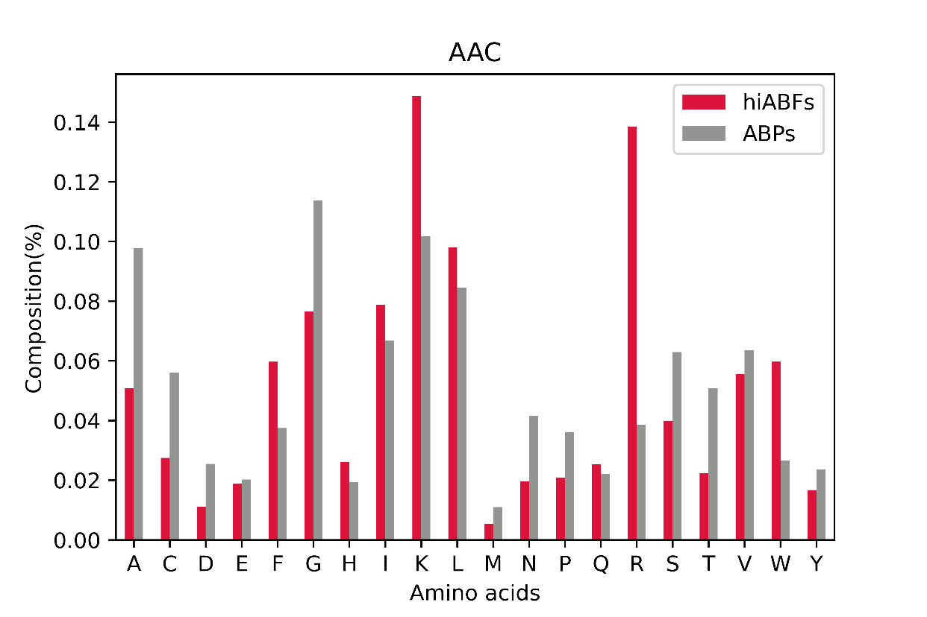
Fig. S1. Comparison between amino acid frequencies between hiABFs and ABPs

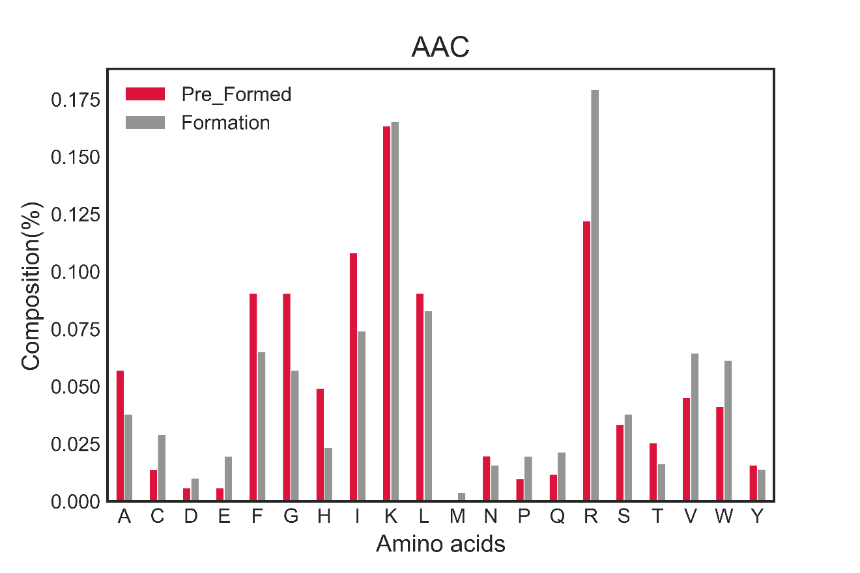
Fig. S2 Comparison between amino acid frequencies between preformed and Formation group.
The hydrophobicity of preformed and formation groups was analyzed, and the comparison result is shown in Fig. S3.

Fig. S3. Comparison hydrophobicity between preformed and Formation groups.
The performance metrics of binary classifiers on train and validation data with ten-fold cross-validation are presented in Table(S4) and Fig. S4.
Table S4. Binary classifiers’ performance metrics, Based on 10-fold cross validation
Classifier | CV (std) | A | P | R | MCC | CK | ROC-AUC score | F1-score
LOGREG | 2.29% | 99% | 99% | 99% | 97.18% | 97.18% | 98.59% | 99%
LOGREG |  | 93% | 93% | 92% | 82.92% | 82.61% | 90.71% | 93%
CART | 5.85% | 92% | 90% | 90% | 84.31% | 83.96% | 92.46% | 90%
CART |  | 83.5% | 83% | 80% | 65.47% | 65.22% | 82.14% | 80%
RF | 2.07% | 99% | 99% | 99% | 98.60% | 98.59% | 99.21% | 99%
RF |  | 94% | 94% | 94% | 87.13% | 87.05% | 93.21% | 93%
GBC | 2.78% | 97% | 97% | 97% | 96.47% | 96.47% | 98.19% | 98%
GBC |  | 85% | 83% | 81% | 69.95% | 69.34% | 83.93% | 82%
ADC | 3.10% | 97% | 96% | 96% | 95.92% | 95.92% | 96.9% | 96%
ADC |  | 91% | 92% | 91% | 80.23% | 80.35% | 91.43% | 92%
LDA | 8.31% | 75% | 70% | 71% | 51.01% | 50.65% | 75.71% | 74%
LDA |  | 75% | 74% | 60% | 48.08% | 46.27% | 72.14% | 70%
QDA | 9.23% | 61% | 60% | 61% | 22.53% | 22.31% | 61.24% | 60%
QDA |  | 55% | 60% | 55% | 4.93% | 4.83% | 52.5% | 50%
NB | 11.93% | 72% | 70% | 75% | 44.60% | 43.64% | 72.40% | 71%
NB | 17.78% | 67% | 62% | 62% | 37.14% | 35.14% | 68.57% | 67%
SVC_lr | 2.29% | 99%* | 98% | 98% | 97.18% | 97.18% | 98.59% | 98%
SVC_lr |  | 93% | 93% | 93% | 82.86% | 82.86% | 91.43% | 93%
SVC_rbf | 3.18% | 98%* | 99% | 98% | 96.48% | 96.48% | 98.28% | 98%
SVC_rbf |  | 93% | 94% | 95% | 88.79% | 88.10% | 93.21% | 92%
SVC_poly | 2.29% | 99%* | 99% | 99% | 97.18% | 97.18% | 98.59% | 99%
SVC_poly |  | 92% | 92% | 94% | 87.79% | 87.60% | 92.21% | 92%
SVC_sig | 3.17% | 97% | 97% | 97% | 95.77% | 97.88% | 97.88% | 96%
SVC_sig |  | 85% | 82% | 82% | 70.66% | 68.89% | 83.21% | 80%
KNN | 5.37% | 90% | 90% | 90% | 83.05% | 82.98% | 91.27% | 91%
KNN |  | 91% | 90% | 90% | 83.67% | 82.35% | 90% | 91%

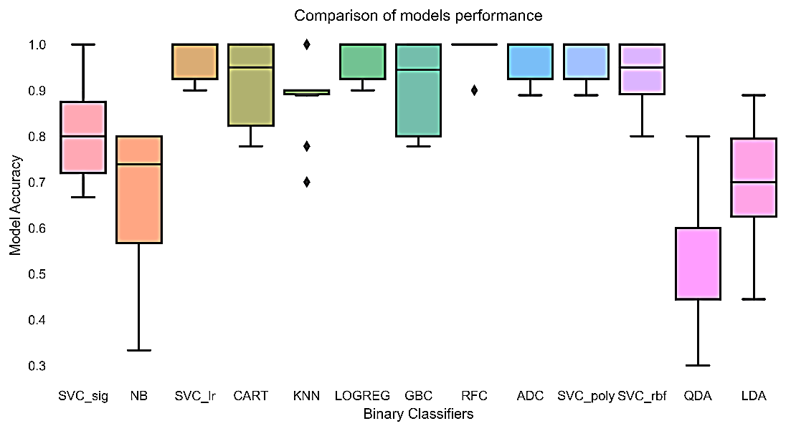
Fig. S4 Comparison of classifiers based on Accuracy

