Appendix B
The control of the power in order to mimic the exact power requirement curve against time given in Fig. 7 above is performed using Pulse Width Modulation (PWM) driving a step-down Buck converter (chopper) MOSFET transistor. The curve above is stored in the memory of the microcontroller responsible for the PWM in the form of an array of 128 elements (from 0 to 127). In this case, the curve is subdivided into 128 points corresponding to the time and the corresponding ordinate values are stored in the 128 elements of the array. The time interval between each two consecutive samples is 11 minutes and 15 seconds. This array is presented in Table B; the values stored in memory (third column of the array) will constitute the reference signal for the PWM operation.
Table B
Sampled data array of the required power
Time of day (HH:MM:SS) | Memory Address/Sample Number | PWM Reference
00:00:00 | 0 | 53
00:11:15 | 1 | 53
00:22:30 | 2 | 53
00:33:45 | 3 | 53
… | … | …
12:00:00 | 63 | 0
12:11:15 | 64 | 0
… | … | …
23:37:30 | 126 | 53
23:48:45 | 127 | 53
The pulse width will increase in order to accommodate for the large value of required power (53 W/m²) and it will decrease to zero at noon in order to generate zero output pulse and consequently zero output power. The operation of the PWM controller is depicted in Fig.B1. The microcontroller system employed (An Arduino Mega) is shown in Fig. B2. It is equipped with a Real-Time-Clock (RTC) connected as a shield to the Arduino. The RTC is responsible for generating the time-of-day that will in turn produce the PWM reference signal from the array. The carrier signal of the PWM is assumed to be a saw tooth signal. It is compared to the reference signal generated from the above array. The comparison of the carrier signal (saw tooth) and the modulating signal (reference) yields a binary (High/Low) decision, which is used after proper electronic buffering and isolation to drive the PWM MOSFET transistor responsible for the Buck converter operation. The PWM implemented in this case is performed as a software program inside the microcontroller. This part is denoted by the dotted of Fig. B2.
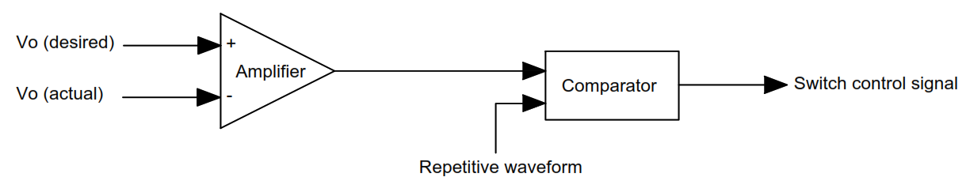

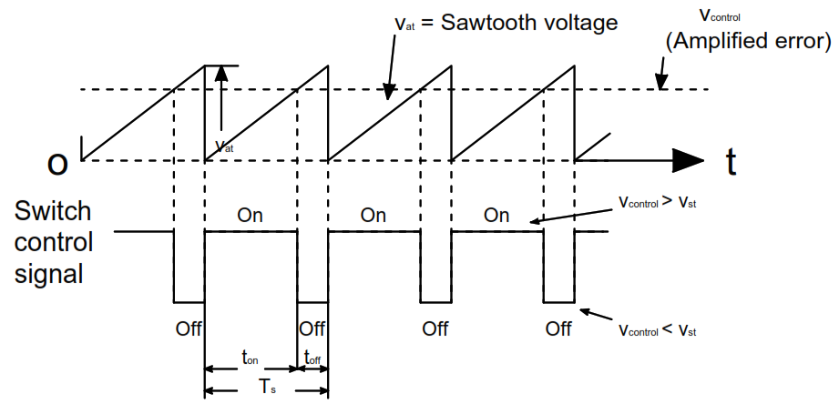
Fig.B1 PWM block diagram and comparator signals
RTC
Reference Array
MOSFET
+
Driver
+12V
Heating Resistor
0V
Time-of-Day
PWM Reference
Saw Tooth Carrier
Comparator
Software inside Arduino Microcontroller
PWM
Fig. B2 Microcontroller system block diagram
The DC chopper power circuit of the MOSFET (including the MOSFET, driver circuit and heating resistor) is shown in Fig. B3, where the MOSFET is represented by a switch CH. The freewheeling diode (FD) is used in order to remove the effect of any stray and/or wiring inductances, which would damage the switching circuit. The heating element is represented here by a resistance (R). The output voltage and currents are pulse width modulated signals. The average of the product of these two signals represents the required power from Fig.7. This power will follow the curve desired according to the time of the day as mandated by the heating requirements of the overall system.
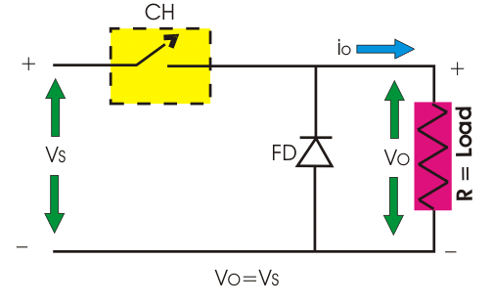
Fig.B3 Power circuit of the MSOFET and heating resistor

