Cuproptosis-Related lncRNAs Signature Predicts Prognosis and Chemotherapeutic Response of Patients with Lung Adenocarcinoma

Yipan Zhu^{1#}, Huiting Deng^{2#}, Xiuyu Wang³, Yi Chen⁴*, Qiangzhe Zhang¹*

¹ State Key Laboratory of Medicinal Chemical Biology and College of Pharmacy, Tianjin Key Laboratory of Molecular Drug Research, Nankai University, Tianjin, 300350, China.
² Tianjin Key Laboratory of Extracorporeal Life Support for Critical Diseases, Institute of Hepatobiliary Disease, Tianjin Third Central Hospital, Nankai University, Tianjin, 300170, China.
³ Department of Neurosurgery, Tianjin First Central Hospital, School of Medicine, Nankai University, Tianjin, 300192, China.
⁴ Shanghai Vocational College of Agriculture and Forestry, Shanghai, 201699, China.

Running title: Cuproptosis-Related lncRNA in LUAD

# Yipan Zhu and Huiting Deng contributed equally to this work
*Correspondence
Qiangzhe Zhang, Email: zhangqiangzhe@nankai.edu.cn or Yi Chen, Email: 297937577@qq.com

Supplementary File
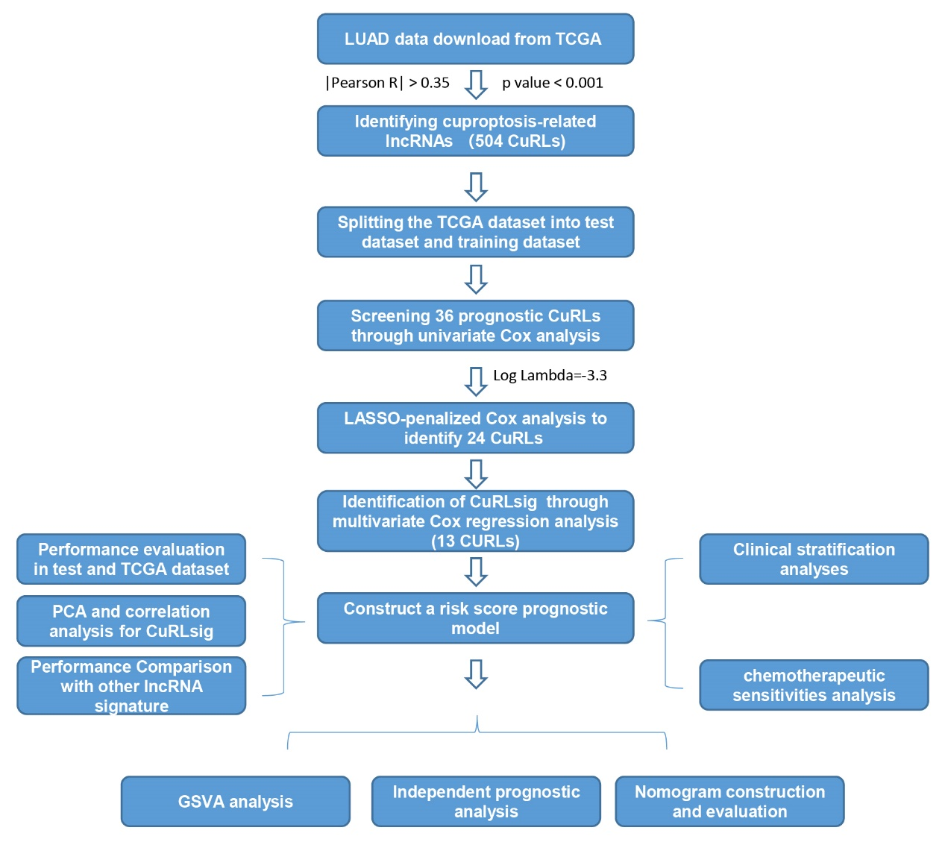
Figure S1. Research roadmap of this study.

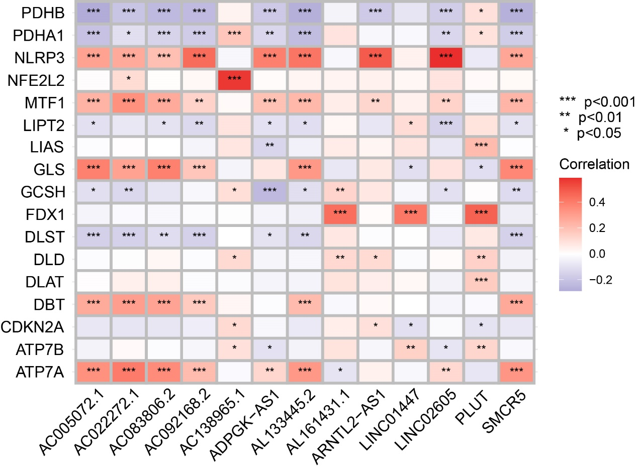
Figure S2. Correlation analysis of CuRGs with CuRLs in LUAD patients.
Heatmap showing the correlation of CuRGs with CuRLs (cor.test, *P < 0.05; **P < 0.01; ***P < 0.001).

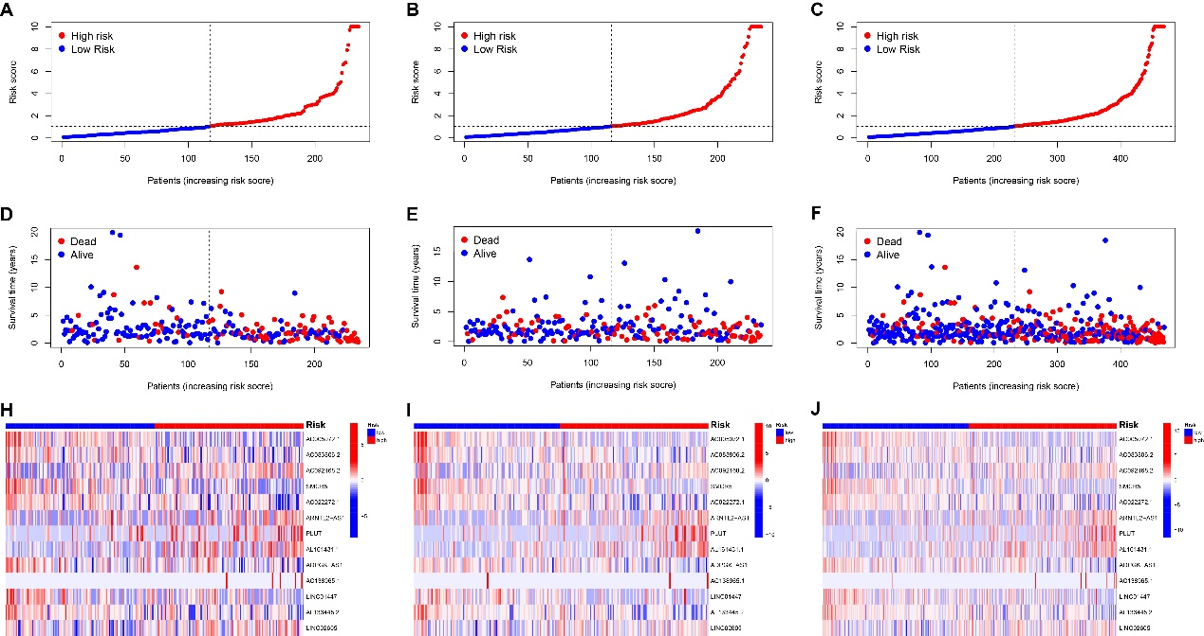
Figure S3. Risk distribution, survival status and expression profile of CuRLsig in training (A, D, H,), testing (B, E, I,) and TCGA (C, F, J) sets.

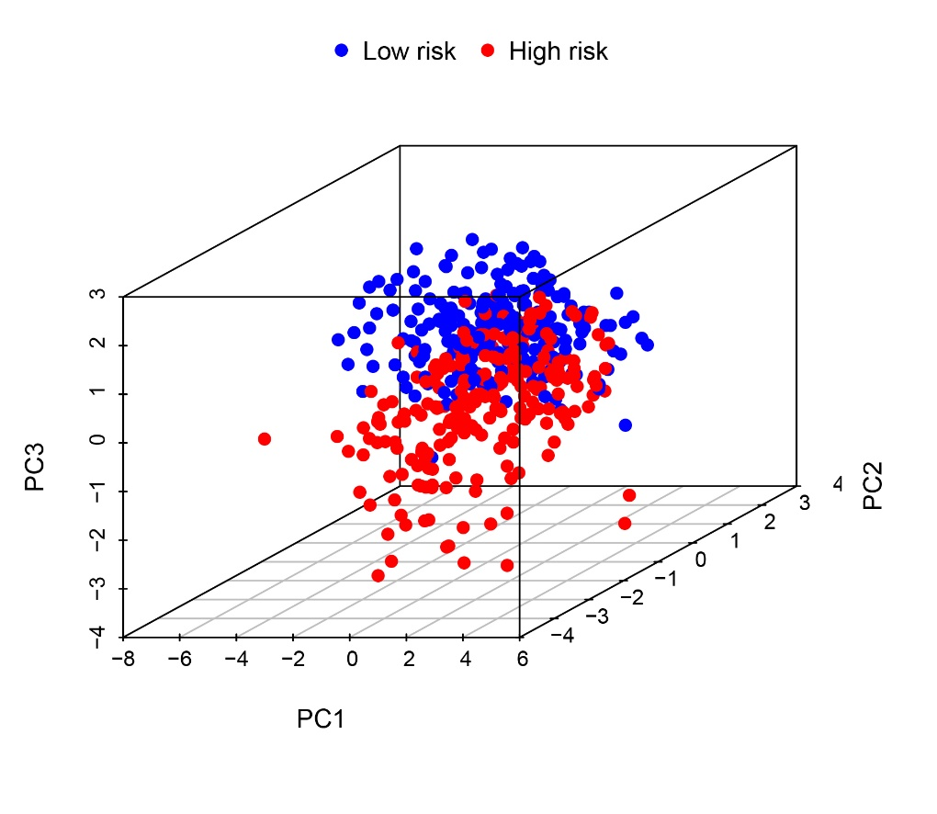
Figure S4. PCA of expression profiles for CuRLsig in high- and low-risk LUAD patients.

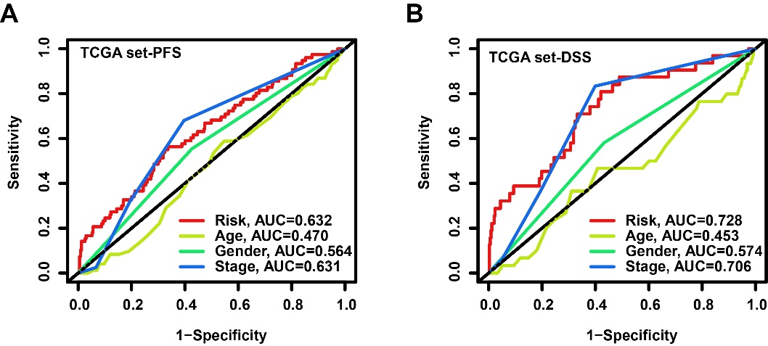
Figure S5. ROC of CuRLsig-derived risk score and clinical variables for PFS (A) and DSS (B) of LUAD patients in TCGA set.

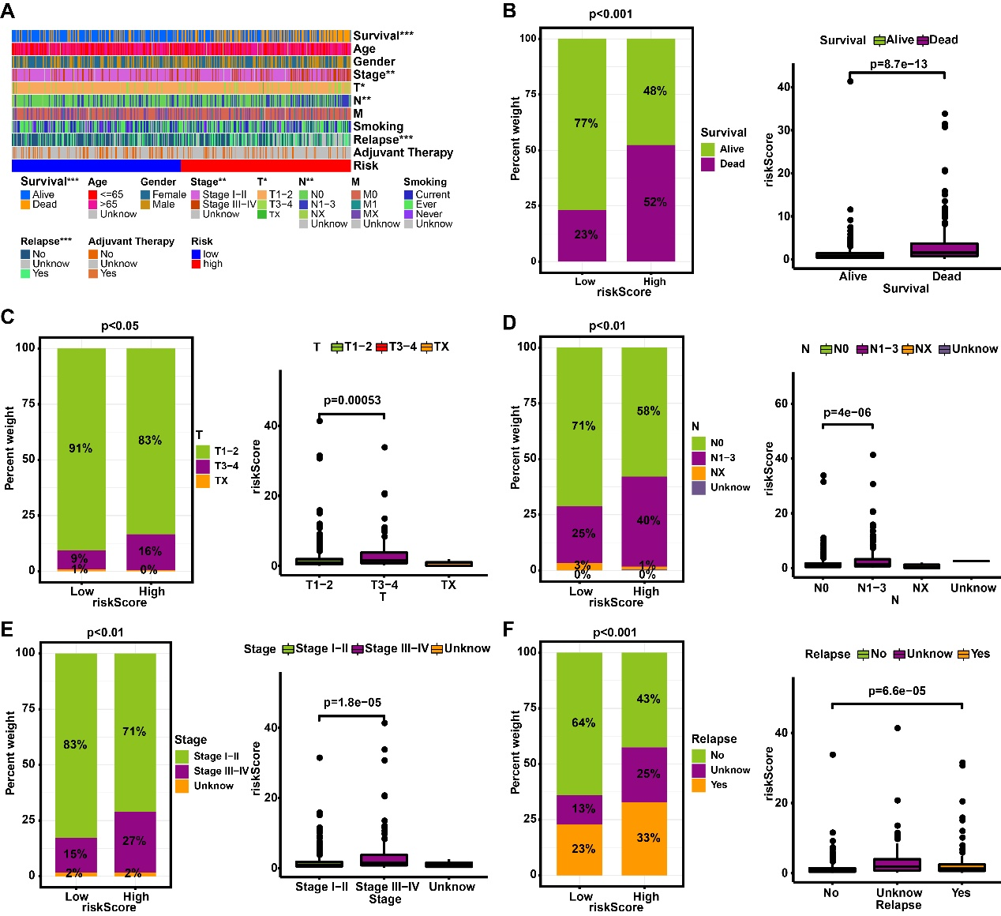
Figure S6. Correlation analyses of CuRLsig-derived risk scores with clinical variables.
(A) Heatmap showing the correlation of prognostic clinical features and CuRLsig-derived risk scores. (B-F) Bar charts (left) and boxplots (right) showing the distribution of survival status (B), T-stage (C), N-stage (D), Stage (E) and relapse (F) in CuRLsig-scored risk groups of LUAD patients.

Table S1
Cuproptosis | lncRNA | cor | pvalue | Regulation
ATP7A | AC104964.3 | 0.385350934 | 4.84E-19 | postive
NFE2L2 | AC120193.1 | 0.401188993 | 1.21E-20 | postive
ATP7A | AC025423.1 | 0.37093282 | 1.17E-17 | postive
NFE2L2 | LINC01258 | 0.689233818 | 2.79E-71 | postive
ATP7A | AC130651.1 | 0.36866981 | 1.90E-17 | postive
NLRP3 | BACH1-IT2 | 0.418648959 | 1.64E-22 | postive
NFE2L2 | AL512363.1 | 0.379279965 | 1.89E-18 | postive
FDX1 | AL512363.1 | 0.433534088 | 3.43E-24 | postive
NLRP3 | AL110115.1 | 0.407072355 | 2.93E-21 | postive
NLRP3 | AC016027.3 | 0.470203334 | 1.05E-28 | postive
ATP7A | SPIN4-AS1 | 0.408066149 | 2.30E-21 | postive
FDX1 | AC110619.1 | 0.35583517 | 2.79E-16 | postive
ATP7A | RAP2C-AS1 | 0.36885142 | 1.83E-17 | postive
NLRP3 | LINC01303 | 0.353519448 | 4.47E-16 | postive
ATP7A | GNG12-AS1 | 0.380923343 | 1.31E-18 | postive
ATP7A | AC012555.2 | 0.353369209 | 4.61E-16 | postive
NFE2L2 | AC005042.1 | 0.574785658 | 4.85E-45 | postive
FDX1 | LINC02570 | 0.476733545 | 1.44E-29 | postive
NFE2L2 | AC097713.1 | 0.764330077 | 2.21E-96 | postive
FDX1 | LINC01300 | 0.446732977 | 9.41E-26 | postive
FDX1 | AC005392.1 | 0.519307061 | 1.14E-35 | postive
ATP7B | LRP4-AS1 | 0.36428152 | 4.83E-17 | postive
NLRP3 | AL359922.2 | 0.381860025 | 1.06E-18 | postive
MTF1 | AL359922.2 | 0.369098179 | 1.74E-17 | postive
GLS | AL359922.2 | 0.424259709 | 3.91E-23 | postive
NLRP3 | PDE4B-AS1 | 0.37012961 | 1.39E-17 | postive
ATP7A | AC074366.1 | 0.370334944 | 1.33E-17 | postive
ATP7A | SHANK2-AS2 | 0.375057913 | 4.79E-18 | postive
NLRP3 | LINC00996 | 0.368701342 | 1.89E-17 | postive
ATP7A | AC007347.1 | 0.4252152 | 3.05E-23 | postive
GLS | AL451047.1 | 0.36708751 | 2.67E-17 | postive
ATP7A | AC092681.2 | 0.379329716 | 1.87E-18 | postive
MTF1 | AC024075.1 | 0.431901963 | 5.29E-24 | postive
MTF1 | AP000766.1 | 0.386767913 | 3.51E-19 | postive
NLRP3 | AL513327.1 | 0.416444657 | 2.87E-22 | postive
MTF1 | AL513327.1 | 0.354231942 | 3.87E-16 | postive
FDX1 | AC092809.3 | 0.822156174 | 3.30E-123 | postive
GLS | AL162394.1 | 0.374026387 | 5.99E-18 | postive
NLRP3 | AC080188.1 | 0.481861435 | 2.94E-30 | postive
GLS | AC005072.1 | 0.389174831 | 2.02E-19 | postive
GLS | BET1-AS1 | 0.381605549 | 1.12E-18 | postive
ATP7A | ZBTB20-AS1 | 0.402782423 | 8.28E-21 | postive
GLS | ZBTB20-AS1 | 0.391350655 | 1.23E-19 | postive
GLS | INO80-AS1 | 0.353286015 | 4.68E-16 | postive
ATP7A | AC022395.1 | 0.362545656 | 6.96E-17 | postive
NLRP3 | AC002306.1 | 0.355182588 | 3.19E-16 | postive
NLRP3 | Z97652.1 | 0.354388199 | 3.74E-16 | postive
NLRP3 | LINC01684 | 0.471723661 | 6.65E-29 | postive
ATP7A | AC036103.1 | 0.388509998 | 2.36E-19 | postive
ATP7A | AC026124.1 | 0.350445996 | 8.30E-16 | postive
ATP7A | CELF2-AS2 | 0.415277801 | 3.85E-22 | postive
ATP7A | LINC01359 | 0.392264559 | 9.92E-20 | postive
GLS | LINC01359 | 0.370369406 | 1.32E-17 | postive
NLRP3 | AC106801.1 | 0.415518625 | 3.62E-22 | postive
ATP7A | PRICKLE2-AS2 | 0.39887634 | 2.10E-20 | postive
ATP7A | MYCBP2-AS1 | 0.406259818 | 3.57E-21 | postive
ATP7A | AC022960.1 | 0.350318311 | 8.52E-16 | postive
NLRP3 | ITPRIP-AS1 | 0.459561858 | 2.45E-27 | postive
NLRP3 | KLF7-IT1 | 0.484523293 | 1.28E-30 | postive
GLS | KLF7-IT1 | 0.368352982 | 2.04E-17 | postive
NLRP3 | AC090559.1 | 0.488746895 | 3.34E-31 | postive
MTF1 | AC073476.3 | 0.373439068 | 6.81E-18 | postive
GLS | AC018442.2 | 0.356922013 | 2.23E-16 | postive
MTF1 | AL513327.2 | 0.355170274 | 3.19E-16 | postive
ATP7A | AC091053.2 | 0.359382416 | 1.34E-16 | postive
NLRP3 | AC026470.2 | 0.527429707 | 6.18E-37 | postive
ATP7A | ANKRD44-IT1 | 0.385938977 | 4.24E-19 | postive
GLS | AL121652.1 | 0.370633759 | 1.25E-17 | postive
FDX1 | CRIM1-DT | 0.617198626 | 1.65E-53 | postive
ATP7A | AC037441.2 | 0.398722525 | 2.18E-20 | postive
FDX1 | AC005532.1 | 0.583013246 | 1.38E-46 | postive
NLRP3 | LINC02863 | 0.380664476 | 1.39E-18 | postive
NLRP3 | AL133330.1 | 0.436341693 | 1.62E-24 | postive
ATP7A | AC083806.2 | 0.35879178 | 1.52E-16 | postive
GLS | AC083806.2 | 0.388999789 | 2.11E-19 | postive
FDX1 | AC010328.1 | 0.559166577 | 3.19E-42 | postive
NFE2L2 | AC019080.3 | 0.627758022 | 8.00E-56 | postive
PDHB | ACVR2B-AS1 | 0.363525713 | 5.67E-17 | postive
ATP7A | AL592430.2 | 0.409630373 | 1.57E-21 | postive
NLRP3 | AC020703.1 | 0.544778339 | 9.35E-40 | postive
NLRP3 | AL109923.1 | 0.397577455 | 2.86E-20 | postive
NLRP3 | SIRPG-AS1 | 0.381478448 | 1.16E-18 | postive
NLRP3 | AC092168.2 | 0.448387044 | 5.93E-26 | postive
NLRP3 | AC011899.2 | 0.358039308 | 1.77E-16 | postive
GLS | SND1-IT1 | 0.362079731 | 7.67E-17 | postive
ATP7A | RBMS3-AS2 | 0.385855017 | 4.32E-19 | postive
LIPT2 | IDH1-AS1 | 0.413141325 | 6.56E-22 | postive
ATP7A | AC087286.4 | 0.383051084 | 8.14E-19 | postive
NLRP3 | AC023825.2 | 0.41025212 | 1.34E-21 | postive
DLAT | AC005562.1 | 0.384129061 | 6.38E-19 | postive
GLS | AL357078.2 | 0.352847461 | 5.12E-16 | postive
ATP7A | AP000941.1 | 0.406621059 | 3.27E-21 | postive
MTF1 | AP000941.1 | 0.392401212 | 9.61E-20 | postive
NLRP3 | AC006033.2 | 0.36640588 | 3.08E-17 | postive
NFE2L2 | AC022916.3 | 0.649709483 | 6.24E-61 | postive
NLRP3 | AC037198.2 | 0.451937502 | 2.18E-26 | postive
NLRP3 | C1orf147 | 0.390288584 | 1.57E-19 | postive
NLRP3 | ATP1B3-AS1 | 0.562569814 | 7.99E-43 | postive
ATP7A | AP005131.1 | 0.375360107 | 4.48E-18 | postive
NLRP3 | AC087286.2 | 0.425045865 | 3.19E-23 | postive
ATP7A | AC087286.2 | 0.397303534 | 3.05E-20 | postive
FDX1 | LINC01895 | 0.355434797 | 3.03E-16 | postive
ATP7A | AC024267.6 | 0.376504081 | 3.49E-18 | postive
GLS | AC008883.2 | 0.433195822 | 3.75E-24 | postive
GLS | AC007906.1 | 0.35095305 | 7.50E-16 | postive
FDX1 | AC018781.1 | 0.654765946 | 3.61E-62 | postive
FDX1 | AL158066.1 | 0.70916171 | 3.72E-77 | postive
NLRP3 | AL157394.1 | 0.357547107 | 1.96E-16 | postive
GLS | AC009229.2 | 0.363145655 | 6.14E-17 | postive
NLRP3 | AL133371.2 | 0.469087551 | 1.47E-28 | postive
NLRP3 | AC090197.1 | 0.423043232 | 5.35E-23 | postive
LIPT2 | RAB30-DT | 0.40444213 | 5.55E-21 | postive
FDX1 | LINC00189 | 0.469210947 | 1.42E-28 | postive
FDX1 | AC091045.2 | 0.390767618 | 1.40E-19 | postive
ATP7A | AC008269.2 | 0.365526556 | 3.72E-17 | postive
DLD | EMSLR | 0.359342951 | 1.36E-16 | postive
NLRP3 | AF131216.1 | 0.362424711 | 7.14E-17 | postive
ATP7A | AF131216.1 | 0.399105073 | 1.99E-20 | postive
GLS | AF131216.1 | 0.356791347 | 2.29E-16 | postive
NLRP3 | AC007780.1 | 0.369241078 | 1.69E-17 | postive
NLRP3 | GK-IT1 | 0.393810652 | 6.93E-20 | postive
DLST | DHRS4-AS1 | 0.366362669 | 3.11E-17 | postive
NLRP3 | AC104564.1 | 0.415000796 | 4.13E-22 | postive
ATP7A | AC104564.1 | 0.358316586 | 1.68E-16 | postive
NLRP3 | AC015878.1 | 0.376347337 | 3.61E-18 | postive
GLS | MAST4-IT1 | 0.444729541 | 1.64E-25 | postive
ATP7A | AC027544.2 | 0.354961061 | 3.33E-16 | postive
GLS | AL354989.1 | 0.378836762 | 2.08E-18 | postive
ATP7A | AC008147.2 | 0.3651917 | 3.99E-17 | postive
DLD | AC099850.4 | 0.419029329 | 1.49E-22 | postive
DLAT | AC099850.4 | 0.39242042 | 9.57E-20 | postive
CDKN2A | DDX11-AS1 | 0.361465146 | 8.72E-17 | postive
FDX1 | AC069029.1 | 0.520807308 | 6.68E-36 | postive
NLRP3 | AC008649.2 | 0.404700774 | 5.21E-21 | postive
NFE2L2 | AC007098.1 | 0.657587343 | 7.19E-63 | postive
ATP7A | TCEAL3-AS1 | 0.432479991 | 4.54E-24 | postive
GLS | TCEAL3-AS1 | 0.358825214 | 1.51E-16 | postive
NLRP3 | AC007529.1 | 0.442728752 | 2.85E-25 | postive
ATP7A | AL162171.2 | 0.373014664 | 7.47E-18 | postive
DLAT | AC005288.1 | 0.366266096 | 3.18E-17 | postive
NLRP3 | AC004672.1 | 0.365916138 | 3.42E-17 | postive
GLS | AC004672.1 | 0.354024571 | 4.03E-16 | postive
NLRP3 | VCAN-AS1 | 0.361565901 | 8.54E-17 | postive
GLS | AC005828.2 | 0.379058436 | 1.98E-18 | postive
GLS | AL391097.1 | 0.359908455 | 1.21E-16 | postive
MTF1 | AC069257.2 | 0.378443625 | 2.27E-18 | postive
NLRP3 | AC016229.1 | 0.413566504 | 5.90E-22 | postive
ATP7A | ENTPD1-AS1 | 0.444445082 | 1.77E-25 | postive
MTF1 | ENTPD1-AS1 | 0.403961085 | 6.23E-21 | postive
DBT | ENTPD1-AS1 | 0.38604141 | 4.14E-19 | postive
ATP7A | AC093535.1 | 0.400313499 | 1.49E-20 | postive
ATP7A | AC023481.1 | 0.381578018 | 1.13E-18 | postive
NLRP3 | AC135166.1 | 0.555876435 | 1.20E-41 | postive
CDKN2A | LINC01305 | 0.411864108 | 9.01E-22 | postive
NFE2L2 | AL359643.2 | 0.700384371 | 1.65E-74 | postive
NLRP3 | AC245884.11 | 0.456487037 | 5.95E-27 | postive
ATP7A | NAV2-AS5 | 0.402323421 | 9.24E-21 | postive
ATP7A | AC010261.2 | 0.47886793 | 7.47E-30 | postive
NFE2L2 | AC009988.1 | 0.412496643 | 7.71E-22 | postive
NLRP3 | AC068025.2 | 0.366974709 | 2.73E-17 | postive
CDKN2A | AC079922.2 | 0.361256908 | 9.11E-17 | postive
NLRP3 | AC020908.3 | 0.383662686 | 7.09E-19 | postive
GLS | AL356311.1 | 0.369018798 | 1.77E-17 | postive
FDX1 | AC090826.1 | 0.670702395 | 3.14E-66 | postive
ATP7A | AC100800.1 | 0.376181998 | 3.74E-18 | postive
GLS | AC100800.1 | 0.362326818 | 7.28E-17 | postive
NFE2L2 | C5orf66-AS1 | 0.506609027 | 9.27E-34 | postive
GLS | WWC3-AS1 | 0.372390006 | 8.55E-18 | postive
ATP7A | AC100774.1 | 0.375972835 | 3.92E-18 | postive
GLS | AC100774.1 | 0.395917254 | 4.23E-20 | postive
CDKN2A | AL449423.1 | 0.453004934 | 1.61E-26 | postive
MTF1 | AL731577.2 | 0.403832792 | 6.43E-21 | postive
NLRP3 | AC002064.3 | 0.452400116 | 1.91E-26 | postive
NLRP3 | AL033543.1 | 0.441412527 | 4.09E-25 | postive
NLRP3 | AL031595.3 | 0.44342876 | 2.35E-25 | postive
LIPT2 | AP002360.2 | 0.389437941 | 1.91E-19 | postive
GLS | LNX1-AS1 | 0.434265037 | 2.82E-24 | postive
GLS | AC022679.2 | 0.408429412 | 2.10E-21 | postive
ATP7A | LINC02024 | 0.355961192 | 2.72E-16 | postive
ATP7A | PSMD6-AS2 | 0.360558079 | 1.05E-16 | postive
ATP7A | AC139792.1 | 0.396713206 | 3.51E-20 | postive
GLS | AC139792.1 | 0.354201558 | 3.89E-16 | postive
ATP7B | HOXB-AS4 | 0.396207948 | 3.95E-20 | postive
GLS | AC087294.1 | 0.395720776 | 4.43E-20 | postive
FDX1 | AC123788.1 | 0.368957869 | 1.79E-17 | postive
ATP7A | TUSC7 | 0.410501562 | 1.26E-21 | postive
NLRP3 | AL355916.2 | 0.450906514 | 2.92E-26 | postive
ATP7A | MAGI1-IT1 | 0.375509218 | 4.34E-18 | postive
GLS | MAGI1-IT1 | 0.400943495 | 1.29E-20 | postive
NLRP3 | AC025280.1 | 0.462952079 | 9.09E-28 | postive
ATP7A | AC007878.1 | 0.398526557 | 2.29E-20 | postive
GLS | AC007878.1 | 0.374227326 | 5.74E-18 | postive
NLRP3 | AC138028.2 | 0.372819205 | 7.79E-18 | postive
NLRP3 | AC004637.1 | 0.363341572 | 5.89E-17 | postive
NFE2L2 | CT69 | 0.368095564 | 2.15E-17 | postive
NLRP3 | AC090673.1 | 0.46355982 | 7.60E-28 | postive
ATP7A | AC025271.2 | 0.363665352 | 5.50E-17 | postive
ATP7A | AC006441.1 | 0.381046752 | 1.27E-18 | postive
MTF1 | AC006441.1 | 0.381493158 | 1.15E-18 | postive
ATP7A | AC087521.2 | 0.394338368 | 6.12E-20 | postive
GLS | AC016866.2 | 0.402382529 | 9.11E-21 | postive
NLRP3 | AL133342.1 | 0.425649908 | 2.73E-23 | postive
NLRP3 | AC005264.1 | 0.513692062 | 8.15E-35 | postive
LIPT2 | AC064807.2 | 0.409549613 | 1.60E-21 | postive
NLRP3 | AL163192.1 | 0.441975226 | 3.50E-25 | postive
ATP7A | AL163192.1 | 0.396859373 | 3.39E-20 | postive
GLS | AC130650.2 | 0.420270348 | 1.09E-22 | postive
LIPT2 | Z99943.1 | 0.403952775 | 6.24E-21 | postive
ATP7A | SHANK2-AS1 | 0.372614017 | 8.15E-18 | postive
GLS | E2F3-IT1 | 0.386722849 | 3.55E-19 | postive
ATP7A | AC007431.1 | 0.361122934 | 9.36E-17 | postive
GLS | AC092828.1 | 0.386627031 | 3.62E-19 | postive
MTF1 | AP001893.1 | 0.375791526 | 4.08E-18 | postive
NLRP3 | MEIS1-AS2 | 0.452722246 | 1.75E-26 | postive
NFE2L2 | AC084211.1 | 0.463888619 | 6.90E-28 | postive
GLS | AC011389.1 | 0.381635666 | 1.12E-18 | postive
NLRP3 | AC138028.1 | 0.404372458 | 5.64E-21 | postive
NLRP3 | LRRC8C-DT | 0.399691087 | 1.73E-20 | postive
NLRP3 | AL731567.1 | 0.360680218 | 1.03E-16 | postive
NLRP3 | AL592301.1 | 0.351298948 | 6.99E-16 | postive
ATP7A | C15orf54 | 0.357945673 | 1.81E-16 | postive
NLRP3 | U73169.1 | 0.476193188 | 1.70E-29 | postive
ATP7A | AC012150.2 | 0.352366904 | 5.64E-16 | postive
GCSH | AC092718.4 | 0.39649038 | 3.70E-20 | postive
ATP7A | LRIG2-DT | 0.359737044 | 1.25E-16 | postive
NLRP3 | AL731563.3 | 0.440789661 | 4.84E-25 | postive
NLRP3 | AC093423.2 | 0.438544223 | 8.92E-25 | postive
MTF1 | AC005726.2 | 0.363640264 | 5.53E-17 | postive
GLS | MIR133A1HG | 0.365597414 | 3.66E-17 | postive
LIPT2 | AC006449.5 | 0.380125642 | 1.56E-18 | postive
FDX1 | AP002478.1 | 0.351030085 | 7.38E-16 | postive
FDX1 | AC026785.3 | 0.435469422 | 2.04E-24 | postive
NLRP3 | DIAPH3-AS2 | 0.418216052 | 1.84E-22 | postive
NLRP3 | GSN-AS1 | 0.475912177 | 1.86E-29 | postive
ATP7A | GSN-AS1 | 0.407542173 | 2.61E-21 | postive
FDX1 | LINC01716 | 0.740292303 | 2.11E-87 | postive
ATP7A | AC108449.2 | 0.371122595 | 1.12E-17 | postive
MTF1 | AC108449.2 | 0.472662366 | 5.00E-29 | postive
DBT | AC108449.2 | 0.369798828 | 1.50E-17 | postive
LIAS | SRP14-AS1 | 0.374851416 | 5.01E-18 | postive
NLRP3 | LINC01093 | 0.410083273 | 1.40E-21 | postive
NLRP3 | AC025822.2 | 0.365332092 | 3.87E-17 | postive
ATP7A | AC092666.1 | 0.368701955 | 1.89E-17 | postive
NLRP3 | MIR3945HG | 0.366867591 | 2.80E-17 | postive
NLRP3 | ZEB2-AS1 | 0.516426597 | 3.14E-35 | postive
NFE2L2 | AL137847.2 | 0.531188322 | 1.56E-37 | postive
FDX1 | LINC01230 | 0.370736446 | 1.22E-17 | postive
NLRP3 | AC018529.2 | 0.454323102 | 1.11E-26 | postive
ATP7A | AC008080.1 | 0.350806318 | 7.72E-16 | postive
GLS | SMCR5 | 0.370209415 | 1.37E-17 | postive
GLS | AC096708.2 | 0.358328122 | 1.67E-16 | postive
NLRP3 | PRICKLE2-AS3 | 0.400374206 | 1.47E-20 | postive
ATP7A | PRICKLE2-AS3 | 0.364038672 | 5.09E-17 | postive
NLRP3 | AL109767.1 | 0.390177012 | 1.61E-19 | postive
GLS | LINC02344 | 0.386467478 | 3.76E-19 | postive
NLRP3 | CD44-AS1 | 0.384713257 | 5.59E-19 | postive
GLS | CD44-AS1 | 0.356609209 | 2.38E-16 | postive
ATP7A | AC022898.1 | 0.399351854 | 1.88E-20 | postive
ATP7A | MTOR-AS1 | 0.360889206 | 9.83E-17 | postive
NLRP3 | AC010609.1 | 0.380856416 | 1.33E-18 | postive
ATP7A | AC012404.2 | 0.412206991 | 8.28E-22 | postive
ATP7A | AC093591.2 | 0.361715581 | 8.28E-17 | postive
GLS | AC093591.2 | 0.358159555 | 1.73E-16 | postive
ATP7A | Z83843.1 | 0.481625553 | 3.17E-30 | postive
GLS | Z83843.1 | 0.359720193 | 1.25E-16 | postive
ATP7B | LINC00567 | 0.3590388 | 1.44E-16 | postive
GLS | AC130371.1 | 0.365773816 | 3.53E-17 | postive
FDX1 | AC092078.1 | 0.399906153 | 1.65E-20 | postive
ATP7A | Z94721.2 | 0.350547059 | 8.13E-16 | postive
MTF1 | Z94721.2 | 0.375910096 | 3.97E-18 | postive
ATP7A | DOCK4-AS1 | 0.383256453 | 7.77E-19 | postive
NLRP3 | AC103876.1 | 0.416892846 | 2.56E-22 | postive
FDX1 | LINC01623 | 0.363203823 | 6.06E-17 | postive
NLRP3 | CLMAT3 | 0.384751731 | 5.54E-19 | postive
LIPT2 | LGALS8-AS1 | 0.350226443 | 8.67E-16 | postive
ATP7A | ZBTB20-AS4 | 0.392947251 | 8.47E-20 | postive
GLS | ZBTB20-AS4 | 0.370450352 | 1.30E-17 | postive
ATP7A | AC022272.1 | 0.404300449 | 5.74E-21 | postive
PDHA1 | AL121832.2 | 0.350850788 | 7.65E-16 | postive
GLS | TGFA-IT1 | 0.369495548 | 1.60E-17 | postive
ATP7A | NCOA7-AS1 | 0.383537773 | 7.29E-19 | postive
NLRP3 | MRTFA-AS1 | 0.376467715 | 3.51E-18 | postive
ATP7A | AC034234.1 | 0.387970682 | 2.67E-19 | postive
NLRP3 | ACAP2-IT1 | 0.366386362 | 3.10E-17 | postive
ATP7A | ACAP2-IT1 | 0.370175383 | 1.38E-17 | postive
MTF1 | ACAP2-IT1 | 0.402364251 | 9.15E-21 | postive
NLRP3 | AC133106.1 | 0.372571308 | 8.22E-18 | postive
ATP7A | LARGE-AS1 | 0.360180907 | 1.14E-16 | postive
ATP7A | AP001825.1 | 0.35934297 | 1.36E-16 | postive
ATP7A | AC008543.5 | 0.353590706 | 4.40E-16 | postive
GLS | AC008543.5 | 0.362025995 | 7.76E-17 | postive
NLRP3 | AC021739.4 | 0.377654286 | 2.71E-18 | postive
ATP7A | AC021739.4 | 0.377258311 | 2.95E-18 | postive
NLRP3 | AC131971.1 | 0.355026278 | 3.29E-16 | postive
GLS | AC131971.1 | 0.35091264 | 7.56E-16 | postive
ATP7A | AF131215.4 | 0.416324384 | 2.96E-22 | postive
ATP7A | AC103853.1 | 0.364061684 | 5.06E-17 | postive
GLS | AC103853.1 | 0.369448012 | 1.61E-17 | postive
NLRP3 | AC018695.2 | 0.444511032 | 1.74E-25 | postive
NLRP3 | ARNTL2-AS1 | 0.49251811 | 9.91E-32 | postive
NLRP3 | LAMA4-AS1 | 0.384356667 | 6.06E-19 | postive
ATP7A | NPTN-IT1 | 0.400670037 | 1.37E-20 | postive
MTF1 | NPTN-IT1 | 0.418769662 | 1.60E-22 | postive
NLRP3 | AL137025.1 | 0.389830363 | 1.74E-19 | postive
NLRP3 | PTPRJ-AS1 | 0.426805604 | 2.02E-23 | postive
NLRP3 | AL355483.2 | 0.441097716 | 4.45E-25 | postive
NLRP3 | AC022001.3 | 0.374053663 | 5.96E-18 | postive
GLS | AC022001.3 | 0.358480318 | 1.62E-16 | postive
ATP7A | PLCE1-AS2 | 0.352389598 | 5.61E-16 | postive
NFE2L2 | CLEC12A-AS1 | 0.499816129 | 9.06E-33 | postive
ATP7A | THOC7-AS1 | 0.361260158 | 9.10E-17 | postive
NFE2L2 | AC004803.1 | 0.592230453 | 2.26E-48 | postive
DLAT | AC108673.3 | -0.360768448 | 1.01E-16 | negative
NLRP3 | CARS1-AS1 | 0.351541281 | 6.66E-16 | postive
GLS | CARS1-AS1 | 0.36386383 | 5.28E-17 | postive
ATP7A | AC018752.1 | 0.44757793 | 7.43E-26 | postive
MTF1 | AC018752.1 | 0.399121156 | 1.99E-20 | postive
DBT | AC018752.1 | 0.371424661 | 1.05E-17 | postive
MTF1 | LINC02035 | 0.351215527 | 7.11E-16 | postive
GLS | AC007001.1 | 0.4103456 | 1.31E-21 | postive
ATP7A | LINC01422 | 0.381864845 | 1.06E-18 | postive
GLS | AC037487.1 | 0.366245641 | 3.19E-17 | postive
NLRP3 | AL031772.1 | 0.390993654 | 1.33E-19 | postive
ATP7A | AL031772.1 | 0.393323874 | 7.76E-20 | postive
NLRP3 | AL451067.1 | 0.422728008 | 5.80E-23 | postive
GLS | LINC02433 | 0.399392096 | 1.86E-20 | postive
ATP7A | MIRLET7A1HG | 0.389154929 | 2.03E-19 | postive
NFE2L2 | AC009123.1 | 0.351294846 | 7.00E-16 | postive
ATP7A | AC011912.1 | 0.351060516 | 7.34E-16 | postive
MTF1 | AC011912.1 | 0.365834539 | 3.48E-17 | postive
ATP7A | AC096741.1 | 0.411916451 | 8.90E-22 | postive
GLS | AC096741.1 | 0.386511117 | 3.72E-19 | postive
FDX1 | LINC01960 | 0.823722822 | 4.56E-124 | postive
NLRP3 | AC011510.1 | 0.411116075 | 1.08E-21 | postive
MTF1 | AL049840.4 | 0.390397395 | 1.53E-19 | postive
NLRP3 | LIMS1-AS1 | 0.541653944 | 3.10E-39 | postive
NFE2L2 | AC010731.2 | 0.360204222 | 1.13E-16 | postive
ATP7A | AC096564.2 | 0.419529869 | 1.32E-22 | postive
NLRP3 | AC079313.1 | 0.619374251 | 5.60E-54 | postive
NLRP3 | AL031005.1 | 0.491701972 | 1.29E-31 | postive
MTF1 | AC004951.1 | 0.366934133 | 2.76E-17 | postive
LIPT2 | TMPO-AS1 | 0.401095973 | 1.24E-20 | postive
ATP7A | MIR29B2CHG | 0.421665023 | 7.63E-23 | postive
FDX1 | LINC02639 | 0.360669465 | 1.03E-16 | postive
NLRP3 | AP001363.1 | 0.353235817 | 4.73E-16 | postive
GLS | AL365356.1 | 0.382373029 | 9.47E-19 | postive
NLRP3 | AC092120.1 | 0.390487088 | 1.50E-19 | postive
NFE2L2 | KCNQ5-AS1 | 0.356930893 | 2.23E-16 | postive
GLS | AC004884.2 | 0.373283718 | 7.04E-18 | postive
NLRP3 | EML4-AS1 | 0.371011429 | 1.15E-17 | postive
GLS | AC008883.1 | 0.429923912 | 8.92E-24 | postive
NLRP3 | WAKMAR2 | 0.517870387 | 1.89E-35 | postive
MTF1 | MCM3AP-AS1 | 0.390102521 | 1.64E-19 | postive
LIPT2 | LINC01816 | 0.418802433 | 1.58E-22 | postive
GLS | AC092535.4 | 0.453443454 | 1.42E-26 | postive
GLS | DPP4-DT | 0.438644377 | 8.68E-25 | postive
NLRP3 | AC145098.1 | 0.37034567 | 1.33E-17 | postive
GLS | AC010082.1 | 0.438885014 | 8.13E-25 | postive
ATP7A | AC007552.2 | 0.364070315 | 5.05E-17 | postive
GLS | AC007552.2 | 0.439994243 | 6.02E-25 | postive
NLRP3 | AC069023.1 | 0.578746771 | 8.85E-46 | postive
CDKN2A | CDKN2A-DT | 0.727732347 | 4.25E-83 | postive
MTF1 | AC005034.6 | 0.352250357 | 5.77E-16 | postive
NLRP3 | CEP250-AS1 | 0.380953743 | 1.30E-18 | postive
ATP7A | PARM1-AS1 | 0.38919633 | 2.01E-19 | postive
GLS | PARM1-AS1 | 0.380036005 | 1.60E-18 | postive
NLRP3 | AC020916.2 | 0.395285812 | 4.91E-20 | postive
ATP7A | CARMN | 0.368319261 | 2.05E-17 | postive
ATP7A | AC006116.6 | 0.365702712 | 3.58E-17 | postive
NFE2L2 | AL365184.2 | 0.451490298 | 2.47E-26 | postive
MTF1 | AC020612.3 | 0.377171544 | 3.01E-18 | postive
DBT | AC020612.3 | 0.358448595 | 1.63E-16 | postive
NLRP3 | HIF1A-AS3 | 0.482128265 | 2.71E-30 | postive
ATP7A | AC010834.3 | 0.369177624 | 1.71E-17 | postive
MTF1 | AC010834.3 | 0.440788867 | 4.84E-25 | postive
DBT | AC010834.3 | 0.39676105 | 3.47E-20 | postive
GLS | ST7-OT4 | 0.384503718 | 5.86E-19 | postive
NLRP3 | AL158832.1 | 0.436255513 | 1.65E-24 | postive
GLS | DIAPH1-AS1 | 0.382099611 | 1.01E-18 | postive
NLRP3 | AC008750.1 | 0.366546505 | 2.99E-17 | postive
ATP7A | STARD13-AS | 0.357697236 | 1.90E-16 | postive
GLS | STARD13-AS | 0.38834302 | 2.45E-19 | postive
GLS | AC025031.4 | 0.359946115 | 1.20E-16 | postive
FDX1 | AC008750.7 | 0.374559701 | 5.34E-18 | postive
ATP7A | AC008507.2 | 0.354525497 | 3.64E-16 | postive
GLS | AC008507.2 | 0.351362844 | 6.91E-16 | postive
GLS | AL360091.3 | 0.36469752 | 4.43E-17 | postive
NLRP3 | AC135782.3 | 0.367690194 | 2.35E-17 | postive
GLS | AC091047.1 | 0.351482916 | 6.74E-16 | postive
GLS | AC244093.5 | 0.355534744 | 2.96E-16 | postive
ATP7A | AC004054.1 | 0.392488661 | 9.42E-20 | postive
NLRP3 | AC100849.1 | 0.411447849 | 9.99E-22 | postive
FDX1 | PLUT | 0.474071041 | 3.26E-29 | postive
GLS | AL513412.1 | 0.36143191 | 8.78E-17 | postive
ATP7A | FTX | 0.50056225 | 7.07E-33 | postive
GLS | FTX | 0.353590632 | 4.40E-16 | postive
MTF1 | AL050343.2 | 0.512002645 | 1.46E-34 | postive
NLRP3 | AC123567.2 | 0.413264449 | 6.37E-22 | postive
NLRP3 | RRN3P2 | 0.41907558 | 1.48E-22 | postive
FDX1 | AL161431.1 | 0.441606807 | 3.87E-25 | postive
NLRP3 | ADPGK-AS1 | 0.391525 | 1.18E-19 | postive
FDX1 | AC020914.1 | 0.483598092 | 1.71E-30 | postive
NLRP3 | AL596247.1 | 0.406789213 | 3.14E-21 | postive
ATP7A | SLIT2-IT1 | 0.352621343 | 5.36E-16 | postive
NLRP3 | AC006059.1 | 0.410243014 | 1.35E-21 | postive
ATP7A | AC006059.1 | 0.382039078 | 1.02E-18 | postive
GLS | AC006059.1 | 0.385798982 | 4.37E-19 | postive
FDX1 | LINC00456 | 0.423698142 | 4.52E-23 | postive
GLS | AC092674.1 | 0.369732857 | 1.52E-17 | postive
NFE2L2 | AC100839.2 | 0.499790838 | 9.13E-33 | postive
ATP7A | AC024267.5 | 0.371032662 | 1.15E-17 | postive
GLS | AC024267.5 | 0.361230631 | 9.16E-17 | postive
GLS | AC010776.1 | 0.414247342 | 4.98E-22 | postive
ATP7A | LINC01878 | 0.373160626 | 7.24E-18 | postive
ATP7A | AC104779.1 | 0.351764359 | 6.37E-16 | postive
ATP7A | AC011379.1 | 0.350159031 | 8.79E-16 | postive
GLS | AC011379.1 | 0.37319541 | 7.18E-18 | postive
FDX1 | AL596223.1 | 0.447458646 | 7.68E-26 | postive
ATP7A | AC009754.1 | 0.371878953 | 9.55E-18 | postive
GLS | AC009754.1 | 0.396283755 | 3.88E-20 | postive
ATP7A | ASTN2-AS1 | 0.355812019 | 2.80E-16 | postive
ATP7A | AC107072.2 | 0.357916874 | 1.82E-16 | postive
GLS | LINC02825 | 0.37467965 | 5.20E-18 | postive
FDX1 | LINC01825 | 0.776481381 | 2.43E-101 | postive
LIPT2 | RAPGEF4-AS1 | 0.411521037 | 9.81E-22 | postive
ATP7A | AL035658.1 | 0.363716626 | 5.44E-17 | postive
FDX1 | AC108112.1 | 0.759174651 | 2.28E-94 | postive
ATP7A | MIR181A1HG | 0.36047565 | 1.07E-16 | postive
GLS | MIR181A1HG | 0.365348371 | 3.86E-17 | postive
GLS | AC244131.2 | 0.360117561 | 1.15E-16 | postive
FDX1 | AC245041.2 | 0.473611828 | 3.75E-29 | postive
GLS | AC012020.1 | 0.461127051 | 1.55E-27 | postive
ATP7A | AC113385.1 | 0.368987024 | 1.78E-17 | postive
GLS | AP003025.1 | 0.442816408 | 2.78E-25 | postive
ATP7A | AC104232.2 | 0.362224323 | 7.44E-17 | postive
GLS | AC016746.1 | 0.358734336 | 1.54E-16 | postive
CDKN2A | MELTF-AS1 | 0.44463325 | 1.68E-25 | postive
GLS | AC007327.2 | 0.399329229 | 1.89E-20 | postive
ATP7A | LINC02250 | 0.372606676 | 8.16E-18 | postive
ATP7A | AC107029.2 | 0.36955358 | 1.58E-17 | postive
GLS | ATP11A-AS1 | 0.464864281 | 5.17E-28 | postive
ATP7A | AC009884.2 | 0.36002186 | 1.18E-16 | postive
ATP7A | AL353804.1 | 0.477395389 | 1.18E-29 | postive
NFE2L2 | AL590226.2 | 0.534986695 | 3.82E-38 | postive
GLS | ASH1L-IT1 | 0.361748266 | 8.22E-17 | postive
NLRP3 | AC092332.1 | 0.358194843 | 1.72E-16 | postive
NLRP3 | AC093799.1 | 0.35168408 | 6.47E-16 | postive
ATP7A | AL136320.1 | 0.398588185 | 2.25E-20 | postive
NLRP3 | AC012613.2 | 0.403881237 | 6.35E-21 | postive
NLRP3 | FAM53B-AS1 | 0.352147159 | 5.90E-16 | postive
ATP7A | FAM53B-AS1 | 0.370011396 | 1.43E-17 | postive
NLRP3 | ADAMTSL4-AS1 | 0.418058819 | 1.91E-22 | postive
NLRP3 | AC107308.1 | 0.414628551 | 4.53E-22 | postive
NLRP3 | LINC01150 | 0.370140334 | 1.39E-17 | postive
NLRP3 | AL357793.2 | 0.35034657 | 8.47E-16 | postive
ATP7A | AC005838.3 | 0.398954515 | 2.07E-20 | postive
MTF1 | AC024075.3 | 0.376944528 | 3.16E-18 | postive
ATP7A | AC022400.2 | 0.390048861 | 1.66E-19 | postive
NLRP3 | MYO3B-AS1 | 0.363411991 | 5.80E-17 | postive
NLRP3 | AC093627.3 | 0.358637458 | 1.57E-16 | postive
NLRP3 | AC007278.2 | 0.541699921 | 3.04E-39 | postive
ATP7A | AC018462.1 | 0.410564844 | 1.24E-21 | postive
GLS | AC018462.1 | 0.37066295 | 1.24E-17 | postive
ATP7A | LINC02514 | 0.375171863 | 4.67E-18 | postive
GLS | LINC02312 | 0.36572313 | 3.57E-17 | postive
NLRP3 | AC025040.1 | 0.370152137 | 1.39E-17 | postive
ATP7A | AC025040.1 | 0.392584021 | 9.21E-20 | postive
NFE2L2 | AC022075.1 | 0.474457965 | 2.90E-29 | postive
FDX1 | LINC00243 | 0.401903087 | 1.02E-20 | postive
NFE2L2 | AC138965.1 | 0.569791364 | 4.01E-44 | postive
NLRP3 | AC111182.1 | 0.46174149 | 1.30E-27 | postive
CDKN2A | AL023803.1 | 0.369456982 | 1.61E-17 | postive
GLS | CLIP1-AS1 | 0.359043003 | 1.44E-16 | postive
NLRP3 | AC092746.1 | 0.544810961 | 9.23E-40 | postive
NLRP3 | AC116903.2 | 0.379012238 | 2.00E-18 | postive
ATP7A | AC116903.2 | 0.395076213 | 5.15E-20 | postive
MTF1 | PABPC4-AS1 | 0.363358614 | 5.87E-17 | postive
GLS | PABPC4-AS1 | 0.350681575 | 7.92E-16 | postive
GLS | AL031770.1 | 0.372611176 | 8.15E-18 | postive
NLRP3 | AC025180.1 | 0.460028873 | 2.14E-27 | postive
GLS | KCNQ5-IT1 | 0.440549119 | 5.17E-25 | postive
NLRP3 | AC016245.1 | 0.351318566 | 6.97E-16 | postive
GLS | NTM-AS1 | 0.383273989 | 7.74E-19 | postive
NFE2L2 | LINC02843 | 0.551515916 | 6.77E-41 | postive
ATP7A | AC004112.1 | 0.386540873 | 3.70E-19 | postive
DBT | AC004112.1 | 0.412218803 | 8.26E-22 | postive
FDX1 | AP005202.1 | 0.755967237 | 3.86E-93 | postive
NFE2L2 | AC007406.5 | 0.425369255 | 2.93E-23 | postive
NLRP3 | LINC02207 | 0.482596565 | 2.34E-30 | postive
NLRP3 | AC015923.1 | 0.359076629 | 1.43E-16 | postive
GLS | AC015923.1 | 0.386467297 | 3.76E-19 | postive
ATP7A | AC022613.3 | 0.406587147 | 3.30E-21 | postive
GLS | AC022613.3 | 0.359705626 | 1.26E-16 | postive
PDHA1 | WWTR1-AS1 | 0.375459343 | 4.38E-18 | postive
ATP7A | ITGB5-AS1 | 0.359385511 | 1.34E-16 | postive
GLS | ITGB5-AS1 | 0.353181565 | 4.78E-16 | postive
NLRP3 | AC080162.1 | 0.37567507 | 4.18E-18 | postive
ATP7A | AC080162.1 | 0.376131442 | 3.78E-18 | postive
ATP7A | LINC00710 | 0.429920028 | 8.93E-24 | postive
NFE2L2 | AC128709.1 | 0.437878763 | 1.07E-24 | postive
GLS | AL356752.1 | 0.357146175 | 2.13E-16 | postive
GLS | AC108159.1 | 0.393830597 | 6.89E-20 | postive
ATP7A | ITFG1-AS1 | 0.356982404 | 2.20E-16 | postive
NLRP3 | AC114752.2 | 0.491582645 | 1.34E-31 | postive
NLRP3 | AL161725.1 | 0.513266762 | 9.45E-35 | postive
ATP7A | AL161725.1 | 0.4012413 | 1.20E-20 | postive
MTF1 | AL161725.1 | 0.367303345 | 2.55E-17 | postive
NLRP3 | CFLAR-AS1 | 0.430957459 | 6.79E-24 | postive
ATP7A | CFLAR-AS1 | 0.403140064 | 7.59E-21 | postive
GLS | CFLAR-AS1 | 0.369412377 | 1.62E-17 | postive
GLS | AC099811.4 | 0.364615776 | 4.50E-17 | postive
NLRP3 | AC011825.2 | 0.361397341 | 8.84E-17 | postive
NLRP3 | WWTR1-IT1 | 0.390050994 | 1.66E-19 | postive
DLAT | CCDC84-DT | 0.414286895 | 4.93E-22 | postive
NLRP3 | RUNX2-AS1 | 0.366308358 | 3.15E-17 | postive
GLS | PLCB1-IT1 | 0.404796718 | 5.09E-21 | postive
ATP7A | AL161457.2 | 0.398134374 | 2.51E-20 | postive
NLRP3 | AC015878.2 | 0.393136987 | 8.10E-20 | postive
FDX1 | LINC01387 | 0.421524836 | 7.90E-23 | postive
NFE2L2 | LINC00885 | 0.429350271 | 1.04E-23 | postive
GLS | AC110921.2 | 0.37453111 | 5.37E-18 | postive
NLRP3 | LINC02649 | 0.423967097 | 4.22E-23 | postive
PDHB | LINC02649 | -0.358774481 | 1.52E-16 | negative
NLRP3 | BACH1-AS1 | 0.382228189 | 9.79E-19 | postive
ATP7A | BTBD9-AS1 | 0.355915523 | 2.74E-16 | postive
GLS | BTBD9-AS1 | 0.371284292 | 1.09E-17 | postive
ATP7A | AC234775.3 | 0.531538558 | 1.37E-37 | postive
MTF1 | AC234775.3 | 0.384412209 | 5.99E-19 | postive
NFE2L2 | AC008278.1 | 0.353770483 | 4.25E-16 | postive
GLS | AC007014.1 | 0.351966583 | 6.11E-16 | postive
FDX1 | LINC01447 | 0.412843926 | 7.07E-22 | postive
FDX1 | LINC02518 | 0.583905122 | 9.32E-47 | postive
NFE2L2 | AL158055.1 | 0.379824459 | 1.67E-18 | postive
NLRP3 | HMGA2-AS1 | 0.589163375 | 9.01E-48 | postive
NLRP3 | AC008680.1 | 0.387121504 | 3.24E-19 | postive
FDX1 | AL512347.1 | 0.622114598 | 1.42E-54 | postive
GLS | AC107909.1 | 0.358272806 | 1.69E-16 | postive
GLS | AC073569.3 | 0.377603346 | 2.74E-18 | postive
NLRP3 | AL391832.3 | 0.352331867 | 5.68E-16 | postive
GLS | AC006460.1 | 0.362954895 | 6.39E-17 | postive
GLS | TCF4-AS2 | 0.379325152 | 1.87E-18 | postive
ATP7A | AP000915.2 | 0.397033385 | 3.25E-20 | postive
ATP7A | LINC00903 | 0.384232405 | 6.23E-19 | postive
NLRP3 | AL133445.2 | 0.421517252 | 7.92E-23 | postive
ATP7A | AC018926.3 | 0.363408153 | 5.81E-17 | postive
GLS | LINC02516 | 0.368778457 | 1.86E-17 | postive
MTF1 | AL160006.1 | 0.423887562 | 4.31E-23 | postive
ATP7A | AC005070.3 | 0.389072446 | 2.07E-19 | postive
GLS | AC092535.2 | 0.439299927 | 7.27E-25 | postive
NLRP3 | LINC02408 | 0.358977173 | 1.46E-16 | postive
NLRP3 | AL049840.7 | 0.411528971 | 9.80E-22 | postive
ATP7A | AL049840.7 | 0.387575752 | 2.92E-19 | postive
MTF1 | AL049840.7 | 0.359255703 | 1.38E-16 | postive
NLRP3 | AC007728.2 | 0.353613638 | 4.38E-16 | postive
NFE2L2 | AC019080.1 | 0.811123226 | 2.19E-117 | postive
ATP7A | AC092436.3 | 0.406504447 | 3.36E-21 | postive
NLRP3 | AC016405.1 | 0.404484603 | 5.49E-21 | postive
GLS | AC016405.1 | 0.373217279 | 7.15E-18 | postive
ATP7A | AC046158.1 | 0.391305378 | 1.24E-19 | postive
ATP7A | AF131215.2 | 0.408105112 | 2.28E-21 | postive
ATP7A | AC013644.1 | 0.376508413 | 3.48E-18 | postive
NLRP3 | AC109630.1 | 0.374064782 | 5.94E-18 | postive
NLRP3 | CELF2-AS1 | 0.426949603 | 1.95E-23 | postive
ATP7A | CELF2-AS1 | 0.435602698 | 1.97E-24 | postive
NLRP3 | BACH1-IT1 | 0.42701053 | 1.91E-23 | postive
NFE2L2 | AC007996.1 | 0.441900764 | 3.57E-25 | postive
MTF1 | MAPKAPK5-AS1 | -0.383305568 | 7.68E-19 | negative
FDX1 | AC025946.1 | 0.694527664 | 8.55E-73 | postive
NLRP3 | TBL1XR1-AS1 | 0.366087366 | 3.30E-17 | postive
GLS | TBL1XR1-AS1 | 0.353799431 | 4.22E-16 | postive
NFE2L2 | AC068831.7 | 0.538590359 | 9.90E-39 | postive
ATP7A | AC010260.1 | 0.365784302 | 3.52E-17 | postive
MTF1 | AP003486.1 | 0.403259976 | 7.38E-21 | postive
NLRP3 | AC087893.3 | 0.389540839 | 1.86E-19 | postive
ATP7A | AC087893.3 | 0.365025844 | 4.13E-17 | postive
GLS | AC023590.1 | 0.363025289 | 6.29E-17 | postive
ATP7A | AC003681.1 | 0.402410905 | 9.05E-21 | postive
FDX1 | LINC02111 | 0.362620651 | 6.85E-17 | postive
FDX1 | AC114812.2 | 0.42245496 | 6.23E-23 | postive
ATP7A | AC009163.4 | 0.434619821 | 2.57E-24 | postive
NFE2L2 | AC024581.1 | 0.438232635 | 9.71E-25 | postive
NLRP3 | PIK3CD-AS1 | 0.517147977 | 2.44E-35 | postive
NFE2L2 | UNC5B-AS1 | 0.525193053 | 1.39E-36 | postive
NLRP3 | AL355483.1 | 0.441812133 | 3.66E-25 | postive
GLS | AC005540.1 | 0.636634644 | 7.71E-58 | postive
NLRP3 | AL139407.1 | 0.411080978 | 1.09E-21 | postive
ATP7A | AL139407.1 | 0.380852473 | 1.33E-18 | postive
GLS | AL139407.1 | 0.419487829 | 1.33E-22 | postive
NLRP3 | LINC00211 | 0.42848073 | 1.30E-23 | postive
NLRP3 | LINC02605 | 0.586828424 | 2.56E-47 | postive
ATP7A | LINC00901 | 0.353018925 | 4.94E-16 | postive

Table S2
Durg | cor | cor p-value | senstivity p-value
OSU-03012 | -0.38 | < 2.2E-16 | 2.70E-12
Cisplatin | -0.34 | 4.60E-14 | 2.40E-09
Talazoparib | -0.34 | 7.00E-14 | 9.00E-10
Epothilone B | -0.33 | 5.00E-13 | 4.10E-10
GSK-650394 | -0.31 | 3.40E-12 | 8.40E-09
Pyrimethamine | -0.31 | 6.40E-12 | 1.80E-08
rTRAIL | -0.31 | 1.10E-11 | 4.70E-07
BMS-754807 | -0.3 | 3.50E-11 | 1.70E-07
JQ12 | -0.29 | 1.30E-10 | 3.30E-08
RO-3306 | -0.29 | 2.80E-10 | 6.10E-08
Cytarabine | -0.28 | 6.40E-10 | 5.00E-05
Doxorubicin | -0.28 | 1.20E-09 | 3.20E-07
Etoposide | -0.28 | 4.70E-10 | 2.20E-08
NU-7441 | -0.28 | 1.30E-09 | 4.30E-07
Bexarotene | -0.27 | 2.90E-09 | 7.20E-08
5-Fluorouracil | -0.26 | 1.20E-08 | 1.70E-06
CCT018159 | -0.26 | 2.00E-08 | 9.80E-07
PD-0332991 | -0.26 | 5.90E-09 | 7.50E-06
Vinorelbine | -0.26 | 6.70E-09 | 3.70E-07
Embelin | -0.25 | 7.20E-08 | 3.80E-06
GSK1904529A | -0.25 | 3.60E-08 | 3.60E-06
JNK-9L | -0.25 | 4.60E-08 | 2.20E-06
CCT007093 | -0.24 | 8.50E-08 | 1.90E-05
Docetaxel | -0.24 | 9.90E-08 | 2.20E-05
FTI-277 | -0.24 | 1.40E-07 | 6.80E-06
YK 4-279 | -0.24 | 2.10E-07 | 1.40E-06
LFM-A13 | -0.23 | 3.10E-07 | 4.90E-07
PF-562271 | -0.23 | 4.10E-07 | 2.30E-06
XAV939 | -0.23 | 8.70E-07 | 7.70E-05
Methotrexate | -0.23 | 8.30E-07 | 3.20E-05
LAQ824 | -0.22 | 2.20E-06 | 1.00E-04
XMD11-85h | -0.22 | 8.90E-07 | 0.00032
PD-0325901 | -0.22 | 2.40E-06 | 1.50E-05
Vinblastine | -0.22 | 1.10E-06 | 3.50E-05
HG-6-64-1 | -0.21 | 3.80E-06 | 1.60E-06
MLN4924 | -0.21 | 4.10E-06 | 1.10E-05
Mitomycin C | -0.21 | 6.80E-06 | 0.00036
AG-014699 | -0.2 | 1.70E-05 | 8.50E-05
CEP-701 | -0.2 | 1.10E-05 | 3.60E-05
PHA-793887 | -0.2 | 1.60E-05 | 6.30E-05
BI-2536 | -0.19 | 5.20E-05 | 3.50E-05
GDC0449 | -0.19 | 2.20E-05 | 9.40E-04
Gemcitabine | -0.19 | 3.90E-05 | 1.70E-04
GW843682X | -0.19 | 3.20E-05 | 4.70E-05
QS11 | -0.19 | 2.70E-05 | 0.00016
Midostaurin | -0.19 | 5.60E-05 | 6.30E-05
Tivozanib | -0.19 | 3.50E-05 | 6.50E-05
VX-11e | -0.19 | 5.20E-05 | 9.30E-05
Camptothecin | -0.18 | 1.00E-04 | 5.30E-04
CI-1040 | -0.18 | 1.00E-04 | 7.30E-04
Tipifarnib | -0.18 | 6.60E-05 | 9.80E-05
VX-680 | -0.18 | 0.00014 | 5.90E-05
Ispinesib Mesylate | -0.17 | 2.60E-04 | 2.00E-04
Masitinib | -0.17 | 0.00027 | 0.00016
MS-275 | -0.17 | 0.00022 | 0.00097
Obatoclax Mesylate | -0.17 | 0.00016 | 0.00024
Thapsigargin | -0.17 | 0.00023 | 0.00019
A-770041 | -0.16 | 0.00037 | 6.70E-05
BMS-509744 | -0.16 | 4.20E-04 | 3.30E-04
Paclitaxel | -0.16 | 0.00046 | 7.60E-05
YM201636 | 0.22 | 1.20E-06 | 0.00074
Phenformin | 0.24 | 1.40E-07 | 0.00014
TL-2-105 | 0.24 | 1.30E-07 | 0.00055
KIN001-135 | 0.26 | 6.40E-09 | 1.20E-07
Rapamycin | 0.29 | 1.80E-10 | 2.20E-05

