Supplement

List of Investigators
Investigator | Institution | Location
Paul Bradley | Meridian Clinical Research | Savannah, Georgia
Adam Brosz | Meridian Clinical Research | Grand Island, Nebraska
Laurence Chu | Benchmark Research | Austin, Texas
Michael Cotugno | Benchmark Research | Metairie, Louisiana
Frank Eder | Meridian Clinical Research, LLC | Binghamton, New York
David Ensz | Meridian Clinical Research | Sioux City, Iowa
Brandon Essink | Meridian Clinical Research | Omaha, Nebraska
Carlos Fierro | Johnson County Clin-Trials | Lenexa, Kansas
Veronica Fragoso | DM Clinical Research - Texas Center for Drug Development | Houston, Texas
Carl Griffin | Lynn Health Science Institute | Oklahoma City, Oklahoma
Greg Hachigian | Benchmark Research | Sacramento, California
Shishir Khetan | Meridian Clinical Research | Rockville, Maryland
Michael Koren | Jacksonville Center for Clinical Research | Jacksonville, Florida
Vicki Miller | DM Clinical Research | Tomball, Texas
Paul Pickrell | Tekton Research Inc. | Austin, Texas
Rachel Presti | Infectious Disease Clinical Research | Saint Louis, Missouri
Howard Schwartz | Research Centers of America | Hollywood, Florida
William Seger | Benchmark Research | Fort Worth, Texas
Charles Harper. Keith Vrbicky, | Meridian Clinical Research | Norfolk, Nebraska
Larkin Wadsworth | Sundance Clinical Research | Saint Louis, Missouri
Stephen Walsh | Brigham and Women’s Hospital | Boston, Massachusetts
Jordan Whatley | Meridian Clinical Research | Baton Rouge, Louisiana
Barton Williams | Trial Management Associates LLC | Wilmington, North Carolina
Marcus Zervos | Henry Ford Health System | Detroit, Michigan

Supplemental methods

Part G Study Eligibility Criteria
Inclusion Criteria:

Each participant must meet all of the following criteria to be enrolled in this study:
- Male or female, at least 18 years of age at the time of consent (Screening Visit).
- Investigator’s assessment that participant understands and is willing and physically able to comply with protocol-mandated follow-up, including all procedures.
- Participant has provided written informed consent for participation in this study, including all evaluations and procedures as specified in this protocol.
- Female participants of nonchildbearing potential may be enrolled in the study.
Nonchildbearing potential is defined as surgically sterile (history of bilateral tubal ligation, bilateral oophorectomy, hysterectomy) or postmenopausal (defined as amenorrhea for ≥ 12 consecutive months prior to Screening [day 0] without an alternative medical cause). A follicle-stimulating hormone level may be measured at the discretion of the investigator to confirm postmenopausal status.
- Female participants of childbearing potential may be enrolled in the study if the participant fulfills all of the following criteria:
- Has a negative pregnancy test on the day of vaccination (day 1)
- Has practiced adequate contraception or has abstained from all activities that could result in pregnancy for at least 28 days prior to day 1
- Has agreed to continue adequate contraception through 3 months following vaccination.
- Is not currently breastfeeding

(Adequate female contraception is defined as consistent and correct use of a Food and Drug Administration approved contraceptive method in accordance with the product label)
- Participant must have been either previously enrolled in the phase 3 mRNA 1273 COVE trial,^{12,13} must have received 2 doses of mRNA 1273 in that study, with his/her second dose at least 6 months prior to enrollment in this study, and must be currently enrolled and compliant in that study (i.e., has not withdrawn or discontinued early); or participant must have received 2 doses of mRNA-1273 under the EUA with their second dose at least 6 months prior to enrollment in this study; or have received a 2 dose primary series of mRNA-1273 followed by a 50-µg booster dose of mRNA-1273 in the mRNA-1273 COVE trial or under EUA at least 3 months prior to enrollment this study; and able to provide proof of vaccination status at the time of screening (day 1).

Exclusion Criteria:

Participants meeting any of the following criteria at the Screening Visit, unless noted

otherwise, will be excluded from the study:
- Had significant exposure to someone with SARS-CoV-2 infection or coronavirus disease 2019 (COVID-19) in the past 14 days, as defined by the CDC as a close contact of someone who has COVID-19).
- Has known history of SARS-CoV-2 infection within 3 months prior to enrollment.
- Is acutely ill or febrile (temperature ≥38.0°C [100.4°F]) less than 72 hours prior to or at the Screening Visit or day 1. Participants meeting this criterion may be rescheduled and will retain their initially assigned participant number.
- Currently has symptomatic acute or unstable chronic disease requiring medical or surgical care, to include significant change in therapy or hospitalization for worsening disease, at the discretion of the investigator.
- Has a medical, psychiatric, or occupational condition that may pose additional risk as a result of participation, or that could interfere with safety assessments or interpretation of results according to the investigator’s judgment.
- Has a current or previous diagnosis of immunocompromising condition to include human immunodeficiency virus, immune-mediated disease requiring immunosuppressive treatment, or other immunosuppressive condition.
- Has received systemic immunosuppressants or immune-modifying drugs for >14 days in total within 6 months prior to Screening (for corticosteroids ≥10 mg/day of prednisone equivalent) or is anticipating the need for immunosuppressive treatment at any time during participation in the study.
- Has known or suspected allergy or history of anaphylaxis, urticaria, or other significant AR to the vaccine or its excipients.
- Has a documented history of myocarditis or pericarditis within 2 months prior to Screening Visit (day 0).
- Coagulopathy or bleeding disorder considered a contraindication to intramuscular (IM) injection or phlebotomy.
- Has received or plans to receive any licensed vaccine ≤ 28 days prior to the injection (day 1) or a licensed vaccine within 28 days before or after the study injection, with the exception of influenza vaccines, which may be given 14 days before or after receipt of a study vaccine.
- Has received systemic immunoglobulins or blood products within 3 months prior to the Screening Visit (day 0) or plans for receipt during the study.
- Has donated ≥450 mL of blood products within 28 days prior to the Screening Visit or plans to donate blood products during the study.
- Plans to participate in an interventional clinical trial of an investigational vaccine or drug while participating in this study.
- Is an immediate family member or household member of study personnel, study site staff, or Sponsor personnel.
- Is currently experiencing an SAE in COVE trial at the time of screening for this study.

Immunogenicity Objectives and Endpoints
The primary objective on immune response is tested with 0.025 two-sided alpha each initially allocated to day 29 and day 91 respectively. For the primary objective of immune response, an alpha of 0.05 (two-sided) is allocated to the two time points. Days 29 and 91 each have an alpha of 0.025 (two-sided) for hypotheses testing. If all objectives are met at day 29, hypotheses at day 91 is tested at an alpha of 0.05 (two-sided).
There were eight pre-specified immunogenicity objectives in the study (Figure S2) including 4 identical objectives at days 29 and 91:
- the second booster dose of 50-µg mRNA‑1273.214 was non-inferior compared to the second booster dose of 50-µg mRNA‑1273 based on the GMT ratio of mRNA‑1273.214 against the Omicron BA.1 variant compared to mRNA‑1273 against the omicron BA.1 variant at days 29 and 91 with a non-inferiority margin of 1.5
- the second dose of 50-µg mRNA‑1273.214 was non-inferior to the second booster dose of 50-µg mRNA‑1273 against the Omicron BA.1 variant based on the difference in seroresponse rate (SRR) at days 29 and 91 with a non-inferiority margin of 10%
- the second booster dose of 50-µg mRNA‑1273.214 was non-inferior to the second booster dose of 50-µg mRNA‑1273 against the ancestral SARS-CoV-2 (D614G) based on the GMT ratio of mRNA‑1273.214 against the ancestral SARS-CoV-2 (D614G) at days compared to mRNA‑1273 against the ancestral SARS-CoV-2 (D614G) with a non-inferiority margin of 1.5
- the second booster dose of 50-µg mRNA‑1273.214 was superior to the second booster dose of 50-µg mRNA‑1273 against Omicron BA.1 based on the GMT ratio of mRNA‑1273.214 against the Omicron BA.1 variant compared to mRNA‑1273 at days 29 and 91 against the Omicron variant. The fourth objective is only tested if the first 3 non-inferiority hypotheses are demonstrated (Figure S2)
If all primary immunogenicity hypotheses are demonstrated, the key secondary objective, the second booster dose of 50-µg mRNA-1273.214 was non-inferior to the booster dose of 50-µg of mRNA-1273 against ancestral SARS-CoV-2 (D614G) based on the difference in SRR at day 29 with a non-inferiority margin of 10% is tested.

Statistical Analysis of Immunogenicity
In part G of the study, 50-µg mRNA-1273.214 as the second booster dose is compared to 50-µg mRNA-1273 as the second booster dose (active control arm in part F, Cohort 2). For the primary objective on immune response, 8 hypotheses (4 identical hypotheses each at days 29 and 91) are specified to be evaluated at days 29 and 91 (online protocol and SAP and Figure S2). Previously, interim analysis results for the day 29 hypotheses were reported as day 91 data were not available; herein results for hypotheses testing for days and 91 are provided.
Below are the 4 identical hypotheses for days 29 and 91 (additional details in online protocol and SAP).
- 50-µg mRNA-1273.214, as a second booster dose, against the Omicron BA.1 variant is non-inferior to the second booster dose of (50-µg) mRNA-1273 against Omicron BA.1 based on the GMT ratio of mRNA1273.214 compared to mRNA-1273 against Omicron BA.1 at day 29 with a non-inferiority margin of 1.5.
- 50-µg mRNA-1273.214, as a second booster dose, against the Omicron BA.1 variant is non-inferior to the second booster dose of (50-µg) mRNA-1273 against Omicron BA.1 based on the difference in SRR at day 29 with a non-inferiority margin of 10%.
- 50-µg mRNA-1273.214, as a second booster dose, against ancestral SARS-CoV-2 (D614G) is non-inferior to the second booster dose of (50-µg) mRNA-1273 against ancestral SARS-CoV-2 (D614G) based on the GMT ratio of mRNA-1273.214 compared to mRNA-1273 against the ancestral SARS-CoV-2 (D614G) at day 29 with a non-inferiority margin of 1.5.
- 50-µg mRNA-1273.214, as a second booster dose, against the Omicron BA.1 variant is superior to the second booster dose of (50-µg) mRNA-1273 against Omicron BA.1 based on the GMT ratio of mRNA-1273.214 compared to mRNA-1273 against the Omicron BA.1 at day 29.
For the primary immunogenicity objective, an alpha of 0.05 (two-sided) is allocated to the two time points (days 29 and 91). Days 29 and 91 each have an alpha of 0.025 (two-sided) for hypotheses testing. The primary immunogenicity objective is considered met if non-inferiority against Omicron BA.1 based on GMR and SRR difference, and non-inferiority against ancestral SARS-CoV-2 (D614G) based on GMR are demonstrated at days 29 or 91. The non-inferiority margins of 1.5 for GMR and 10% for SRR difference were chosen based on FDA guidelines.^{16,17}
For the key secondary immunogenicity objective, there are 2 hypotheses to be tested (days 29 and 91 will each have an alpha of 0.025 [two-sided] for hypotheses testing):
- 50-µg mRNA-1273.214, as a second booster dose, against ancestral SARS-CoV-2 (D614G) is non-inferior to the booster dose of (50-µg) mRNA-1273 against ancestral SARS-CoV-2 (D614G) based on the difference in SRR at day 29 with a non-inferiority margin of 10%.
- 50-µg mRNA-1273.214, as a second booster dose, against ancestral SARS-CoV2 (D614G) is non-inferior to the booster dose of (50-µg) mRNA1273 against ancestral SARS-CoV-2 (D614G) based on the difference in SRR at day 91 with a non-inferiority margin of 10%.

Sample Size
The planned target enrollments are approximately 375 participants for 50-µg mRNA-1273.214 in part G and for the comparator 50-µg mRNA-1273 in part F (cohort 2). Hypotheses testing is performed at days 29 and 91, alpha of 0.025 (2-sided) will be allocated equally to each one of the two time points. Assuming 20% of participants will be excluded from the Per-protocol Set for Immunogenicity–SARS-CoV-2 negative (PPIS-negative), with approximately 300 participants in 50-µg mRNA-1273.214 and 300 participants in 50-µg mRNA-1273 (part F, Cohort 2, 50-µg mRNA-1273) in the PPIS-negative, there is approximately 71% global power to demonstrate the primary immunogenicity objectives with alpha of 0.025 (2-sided) at each time point. The assumptions are: the true GMR (mRNA-1273.214 second booster vs 50-µg mRNA-1273 second booster) against the Omicron B.A.1 variant is 1.5, the true GMR against ancestral SARS-CoV-2 (D614G) is 1, the standard deviation of the log-transformed titer is 1.5, and the non-inferiority margin for GMR is 1.5, the true SRR against Omicron BA.1 after mRNA-1273.214 as a second booster dose is 90% (same assumption for both 50-µg mRNA-1273.214 and 50-µg mRNA-1273), and non-inferiority margin for SRR difference is 10%. With approximately 375 participants exposed to 50-µg mRNA-1273.214, there is at least 90% probability in this group to observe 1 participant reporting an AE if the true rate of AEs is 1%.
An analysis of covariance (ANCOVA) model was performed to assess the difference in antibody responses between mRNA-1273.214 and mRNA-1273 booster doses, with antibody titers post-booster as a dependent variable, and a group variable (mRNA-1273.214 and mRNA-1273) as the fixed effect, adjusting for age groups (<65, ≥65 years) and pre-booster antibody titers. The GMTs (95% CI) estimated by the geometric least square mean (GLSM) from the model for each group and the GMR (mRNA-1273.214 compared with mRNA-1273) estimated by the ratio of GLSM from the model (97.5% CIs) are provided. The 97.5% CI for GMR was used to assess the between group difference in antibody responses.
Seroresponse is defined as ≥4 × LLOQ for those with a pre-dose 1 of a primary series baseline < LLOQ; ≥ 4-foldrise for those with pre-dose 1 of primary series baseline ≥ LLOQ. For participants without pre-dose 1 antibody titer information, seroresponse is defined as ≥4X LLOQ for those with negative SARS-CoV-2 status at pre-dose 1 of the primary series, and antibody titers are imputed as <LLOQ at pre-dose 1 of primary series. For participants who are without SARS-CoV-2 status information at pre-dose 1 of primary series, their pre-booster SARS-CoV-2 status is used to impute their SARS-CoV-2 status at their pre-dose 1 of primary series.
The SRR of each arm against ancestral SARS-CoV-2 (D614G) and variants, defined as the percentage of participants achieving SRR against ancestral SARS-CoV-2 (D614G) and variants respectively, are provided for each arm with the 95% CI calculated using the Clopper Pearson method. The differences of SRR between mRNA-1273.214 and mRNA-1273 are calculated with 97.5% CI based on stratified Miettinen-Nurminen method adjusting for age groups.
An analysis of the primary immunogenicity endpoints was also performed in the PPIS (participants with and without evidence of prior SARS-CoV-2 infection pre-booster), using an ANCOVA model, with antibody titers at day 29 post-booster as the dependent variable and the vaccine group variable as the fixed effect, adjusting for age groups (<65, ≥65 years), pre-booster SARS-CoV-2 infection status, and pre-booster titers. The SRR difference between the mRNA-1273.214 and mRNA-1273 groups was calculated with 97.5% CI based on the stratified Miettinen-Nurminen method adjusted for the pre-booster SARS-CoV-2 infection status and age group. A pre-planned subgroup analysis of participants with prior evidence of SARS-CoV-2-infection pre-booster was performed using an ANCOVA model to assess neutralizing antibody differences between the mRNA-1273.214 and mRNA-1273 groups based on GMRs with 95% CIs. Lastly, a sensitivity analysis was performed excluding the participants with evidence of SARS-CoV-2-infection after the booster dose.
Observed binding antibody GMTs and 95% CIs against variants are provided. Binding antibody level differences between the mRNA-1273.214 and mRNA-1273 groups based on GMRs with 95% CIs were assessed using an ANCOVA model, adjusting for age group and pre-booster titers.

Immunogenicity Assays
SARS-CoV-2 Spike-Pseudotyped Virus Neutralization Assay
SARS-CoV-2 neutralizing antibodies (nAb) in samples were assessed using the validated SARS-CoV-2 Spike (S)-Pseudotyped Virus Neutralization Assay (PsVNA) in 293/ACE2 cells.¹⁸ The PsVNA quantifies nAb using lentivirus particles that express ancestral SARS-CoV-2 Wuhan-Hu-1 full-length spike proteins with the following amino acid substitutions (prototype [D614G]; Omicron [B.1.1.529; BA.1] with the following amino acid changes in the spike protein [A67V, ∆H69-V70, T95I, G142D, ∆143-145, ∆211/L212II, ins214EPE, G339D, S371L, S373P, S375F, K417N, N440K, G446S, S477N, T478K, E484A, Q493R, G496S, Q498R, N501Y, Y505H, T547K, D614G, H655Y, N679K, P681H, N764K, D796Y, N856K, Q954H, N969K, and L981F]; beta (B.1.351 [501Y-V2] L18F, D80A, D215G, Δ242-244, R246I, K417N, E484K, N501Y, D614G, and A701V); and delta ([B.1.617.2; AY.3] T19R, G142D, Δ156-157, R158G, L452R, T478K, D614G, P681R, D950N)]) on their surface, and contain a firefly luciferase reporter gene for quantitative measurements of infection in transduced 293T cells expressing high levels of ACE2 (293T/ACE2 cells) by relative luminescence units (RLU). Serial dilution of antibodies was used to produce a dose-response curve. Neutralization was measured as the serum dilution at which RLU was reduced by 50% (ID50) relative to mean RLU in virus control wells (cells + virus but no sample) after subtraction of mean RLU in cell control wells (cells only). Positive controls were included on each assay plate in order to follow stability over time.

SARS-CoV-2 Meso Scale Discovery (MSD) assay
The validated Meso Scale Discovery (MSD, Rockville, MD) assay (SARSCOV2S2P [VAC123]; https://www.mesoscale.com/products/v-plex-sars-cov-2-panel-24-igg-kit-k15575u/) uses an indirect, quantitative, electrochemiluminescence method to detect SARS-CoV-2 binding IgG antibodies that bind to the SARS-CoV-2 full-length spike protein (Wuhan-Hu-1 ancestral SARS-CoV-2; alpha [B.1.1.7] with the following amino acid changes in the spike protein [ΔH69-V70, ΔY144, N501Y, A570D, D614G, P681H, T761I, S982A, and D1118H]; gamma [P.1] with the following amino acid changes in the spike protein [L18F, T20N, P26S, D138Y, R190S, K417T, E484K, N501Y, D614G, H655Y, T1027I, and V1176F]); delta [B.1.617.2; AY.4; Alt Seq 2] with the following amino acid changes in the spike protein [T19R, T95I, G142D, Δ156/157, R158G, L452R, T478K, D614G, P681R, and D950N]); Omicron [B.1.1.529; BA.1] with the following amino acid changes in the spike protein [A67V, ∆H69-V70, T95I, G142D, ∆143-145, ∆211/L212I, ins214EPE, G339D, S371L, S373P, S375F, K417N, N440K, G446S, S477N, T478K, E484A, Q493R, G496S, Q498R, N501Y, Y505H, T547K, D614G, H655Y, N679K, P681H, N764K, D796Y, N856K, Q954H, N969K, and L981F]) in human serum. The assay was performed by PPD, (Thermo Fisher Scientific Vaccines Laboratory Services, Richmond, Virginia). The assay is based on MSD technology which employs capture molecule MULTI-SPOT® microtiter plates fitted with a series of electrodes.

Incidence of SARS-CoV-2 Infection and COVID-19
Vaccine effectiveness was not formally assessed in this trial, but COVID-19 and SARS-CoV-2 infection were actively surveilled through weekly contact and blood draws. An exploratory objective of the study is to assess symptomatic and asymptomatic SARS-CoV-2 infection. SARS-CoV-2 infection is a combination of symptomatic infection (COVID-19) and asymptomatic SARS-CoV-2 infection for participants with negative SARS-CoV-2 status pre-booster. Symptomatic infection was evaluated using the primary case definition in the COVE study^{12,13} as well as a secondary case definition based on the Centers for Disease Control and Prevention (CDC) criteria.¹⁴ Asymptomatic SARS-CoV-2 infection was defined as a positive reverse-transcriptase polymerase chain reaction (RT-PCR) test or a positive serologic test for anti-nucleocapsid antibody after a negative test at the time of enrollment, in the absence of symptoms.

SARS-CoV-2 infection
SARS-CoV-2 infection is defined in participants with negative SARS-CoV-2 status pre-booster by either bAb levels against SARS-CoV-2 nucleocapsid protein negative (as measured by Roche Elecsys) at day 1 that becomes positive (as measured by Roche Elecsys) starting at day 29 or later, OR a positive RT-PCR counted starting 14 days after the booster dose.
For the analysis, documented infection is counted starting 14 days after the booster dose, which requires a positive serology test result based on bAb specific to SARS-CoV-2 nucleocapsid at day 29 or later, or a positive RT-PCR result starting 14 days after the booster dose. The date of documented infection is the earlier of the date of a positive post-baseline RT-PCR result or of a positive serology test result based on bAb specific to SARS-CoV-2 nucleocapsid. The time to first SARS-CoV-2 infection is calculated as the date of the 1st documented infection minus the date of injection + 1. Cases are counted starting 14 days after the injection (date of documented infection minus date of the injection ≥14). SARS-CoV-2 infection cases are summarized based on tests performed at least 14 days after the booster dose.

Asymptomatic SARS-CoV-2 Infection
Asymptomatic SARS-CoV-2 infection is measured by RT-PCR of nasal swabs and/or serology tests obtained at post-baseline study visits counted starting 14 days after the injection in participants with negative SARS-CoV-2 status pre-booster. Asymptomatic SARS-CoV-2 infection is identified by the absence of symptoms and infections as detected by RT-PCR or serology tests. Specifically, the absence of COVID-19 symptoms AND at least either a positive serology test result based on bAb specific to SARS-CoV-2 nucleocapsid protein at day 29 or later, when blood samples for immunogenicity are collected, or a positive RT-PCR test at scheduled or unscheduled/illness visits. The date of documented asymptomatic infection is the earlier date of positive serology test result based on bAb specific to SARS-CoV-2 nucleocapsid due to infection, or positive RT-PCR, with absence of symptoms. The time to the asymptomatic SARS-CoV-2 infection is calculated as the date of asymptomatic SARS-CoV-2 infection minus the date of injection + 1.

Symptomatic SARS-CoV-2 Infection (COVID-19)
Symptomatic SARS-CoV-2 Infection (COVID-19) is defined as the incidence of the first occurrence of symptomatic SARS-CoV-2 infection measured by RT-PCR of nasal swabs starting 14 days after the booster dose. Surveillance for COVID-19 symptoms is conducted via weekly contact and blood draw, and an illness visit to collect a nasopharyngeal swab was arranged for participants reporting COVID-19 symptoms.
Two definitions of symptomatic SARS-CoV-2 infection (COVID-19) were used. This includes the primary case definition in the COVE trial^{12,13} based on a positive post-baseline RT-PCR result AND at least TWO systemic symptoms (fever [≥ 38ºC/≥ 100.4ºF], chills, muscle and/or body aches [not related to exercise], headache, sore throat, new loss of taste/smell; OR at least ONE of respiratory signs/symptoms [cough, shortness of breath and/or difficulty breathing, OR clinical or radiographical evidence of pneumonia]). The second case definition is based on CDC criteria for symptomatic disease defined as a positive post-baseline RT-PCR test AND at least ONE systemic or respiratory symptoms (fever [≥ 38ºC/≥100.4ºF], chills, cough, shortness of breath and/or difficulty breathing, fatigue, muscle and/or body aches [not related to exercise], headache, new loss of taste/smell, sore throat, congestion, runny nose, nausea, vomiting, or diarrhea).¹⁴
The date of a documented COVID-19 case is the later date of a symptom and the date of positive RT-PCR test, and the two dates should be within 14 days of each other. The time to the first occurrence of COVID-19 is calculated as the date of documented COVID-19 minus the date of injection + 1. Cases are counted starting 14 days after the injection (date of documented COVID-19 minus date of the injection ≥14).

Figure S1. Trial Profile
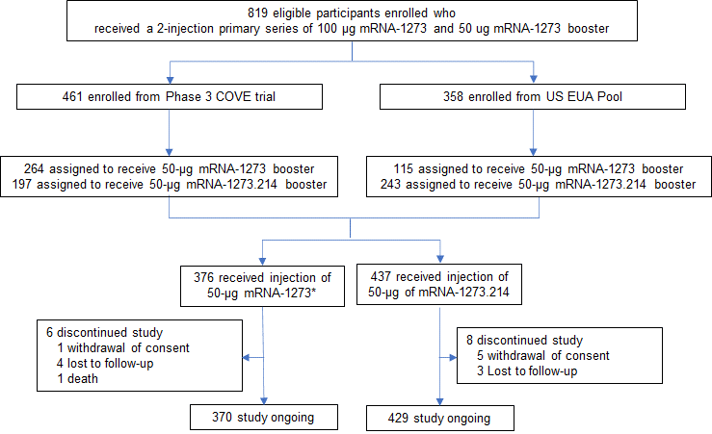

Figure S1. EUA, Emergency Use Authorization; COVE, Coronavirus Efficacy. Eligible participants who received a prior 2-dose primary series of 100-µg mRNA-1273 and a 50-µg mRNA-1273 booster dose either in the COVE trial or under the US EUA were enrolled to receive a second booster dose of 50-µg mRNA-1273 or mRNA-1273.214. *379 participants were enrolled and dosed; two participants had previously received the primary series but not a first booster dose and another participant had a major protocol deviation, and these were excluded from all analysis sets. Data cutoff date is July 6, 2022.

Figure S2. Testing strategy

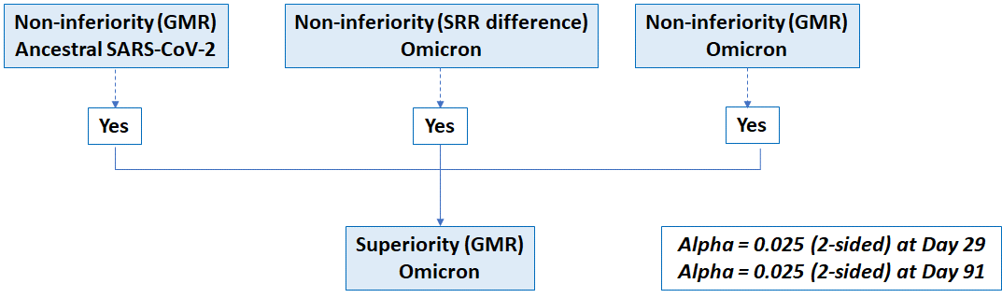
Figure S2. Statistical Hypotheses Testing Strategy. For part G of the study, immunogenicity objectives were tested at days 29 and 91 with the family-wise type I error controlled at 0.05 (2-sided) by equally splitting alpha to the two testing timepoints with alphas of 0.025 (2-sided) at each timepoint. The same testing strategy was applied to days 29 and 91. At days 29 and 91, there were 4 corresponding clinical endpoints for the pre-specified primary objectives: (1) non-inferiority of the antibody response of the second booster dose of 50-µg mRNA‑1273.214 compared with the second booster dose of 50-µg mRNA‑1273 based on the GMR against Omicron BA.1; 2) non-inferiority of the antibody response of the second dose of 50-µg mRNA‑1273.214 compared to the second booster dose of 50-µg mRNA‑1273 against Omicron BA.1 based on the difference in SRR; 3) non-inferiority of the antibody response of the second booster dose of 50-µg mRNA‑1273.214 compared to the second booster dose of 50-µg mRNA‑1273 based on GMR against the ancestral SARS-CoV-2 (D614G) and, 4) superiority of the antibody response of the second booster dose of 50-µg mRNA‑1273.214 compared to the second booster dose of 50-µg mRNA‑1273 based on the GMR against Omicron BA.1 (detailed in Supplementary Statistical Methods). The endpoint testing sequence pre-specified that all 3 endpoints must first be met to test for the fourth endpoint and all tests were based on alpha of 0.025 (2-sided).¹⁵ The immunogenicity endpoints are tested with an alpha of 0.025 (2-sided) for the interim analysis at 28 days (day 29) and 90 days (day 91) after the booster dose. Non-inferiority is considered met when the lower bound of the 97.5% confidence interval (CI) of GMR is ≥0.67 and when SRR difference >-10%. Superiority is considered met when the lower bound of the 97.5% CI of GMR is >1. Superiority of the mRNA-1273.214 antibody response against Omicron BA.1, compared to mRNA-1273, is considered demonstrated if superiority based on GMR is met at day 29. If non-inferiority is demonstrated for both Omicron BA.1 (based on GMR and SRR) and ancestral SARS-CoV-2 (D614G) (based on GMR), the lower bound of 97.5% CI of GMR is compared to 1, and if greater than 1, then superiority against Omicron BA.1 is demonstrated. If all primary and the key secondary objectives were met at day 29, hypotheses at day 91 could be tested at an alpha of 0.05. At day 91, all hypotheses were tested at 0.025 (2-sided) as well as 0.05 level (2-sided), all objectives were met at both alpha level, data presentation only included hypotheses testing at alpha of 0.025 level (2-sided).

Figure S3. Analysis sets in the Trial

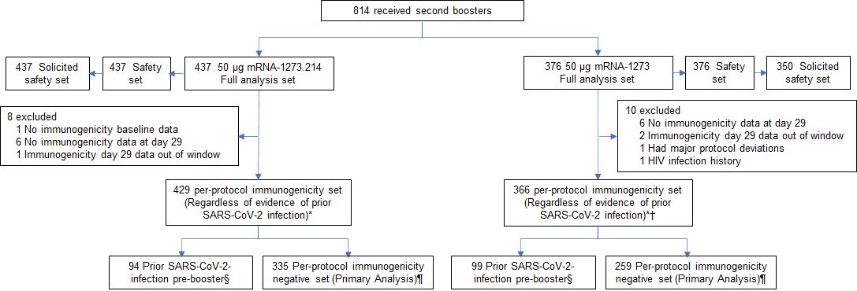

Figure S3. The full analysis set consists of all participants who received study vaccine. The safety set consists of all participants who received study vaccine and was used for all analyses of safety except for solicited adverse reactions which were assessed in the solicited safety set. *The per-protocol set for immunogenicity consists of all participants in the full analysis set who received the planned dose of study vaccination and had antibody data available at pre-booster and day 29 and no major protocol deviations. †8 participants in the mRNA-1273 arm of the per-protocol immunogenicity set had missing pre-booster SARS-CoV-2 information. §Prior SARS-CoV-2-infection based on positive RT-PCR and/or serology test at baseline. ¶The per-protocol immunogenicity negative set (PPSI-negative) consists of participants in the per-protocol set for immunogenicity (PPSI) who have no serologic or virologic evidence of SARS-CoV-2 infection at baseline, i.e., who are SARS-CoV-2-infection negative, based on both negative RT-PCR tests for SARS-CoV-2 and negative SARS-CoV-2-nucleocapsid antibody test, and is the primary analysis set for immunogenicity analysis. A total of 379 participants received a second booster dose of 50-μg mRNA-1273; 2 participants had previously received the primary series but not a first booster dose, and another participant had a major protocol deviation. These three participants were excluded from all analysis sets. A total of 437 participants received a second booster dose of mRNA-1273.214; three participants had discontinued the study prior to dosing and were excluded from all analysis sets. Data cutoff date of July 6, 2022 includes one additional data point at day 29 in mRNA-1273.214 arm and one participant that fell out of per-protocol immunogenicity set mRNA-1273 arm.

Figure S4. Distribution of Neutralizing Antibodies Against Ancestral SARS-CoV-2 (D614G) and Omicron BA.1 by SARS-CoV-2 Status
- SARS-CoV-2 Negative
Omicron BA.1
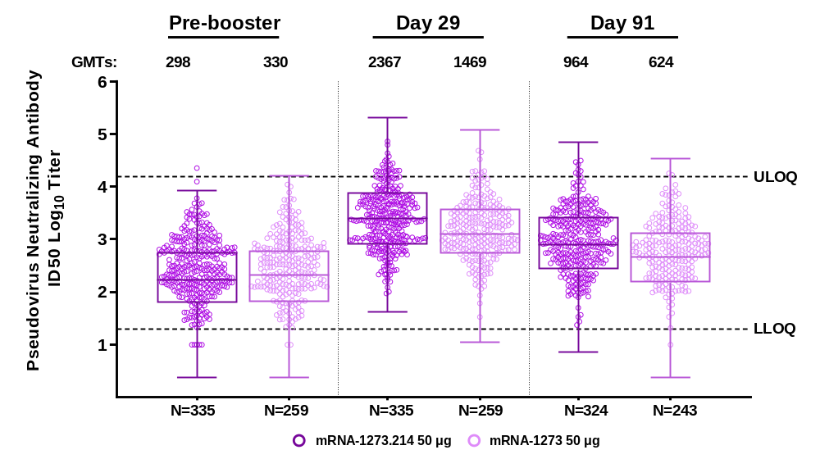
Ancestral SARS-CoV-2 (D614G)
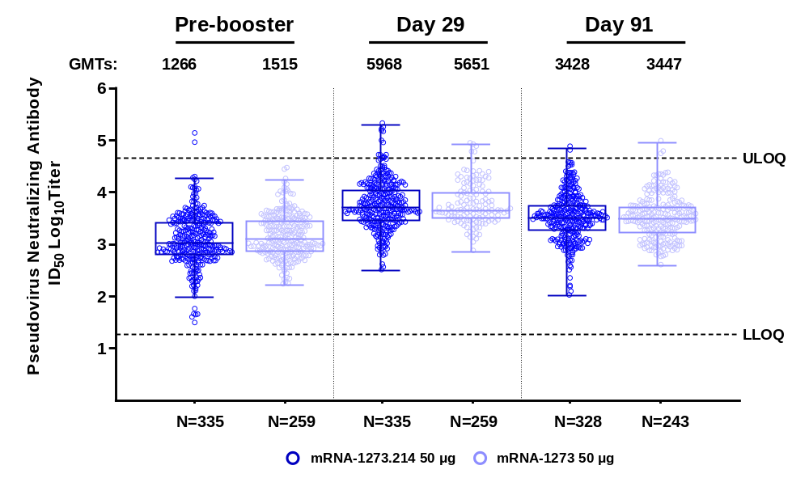
B. SARS-CoV-2 Positive
Omicron BA.1
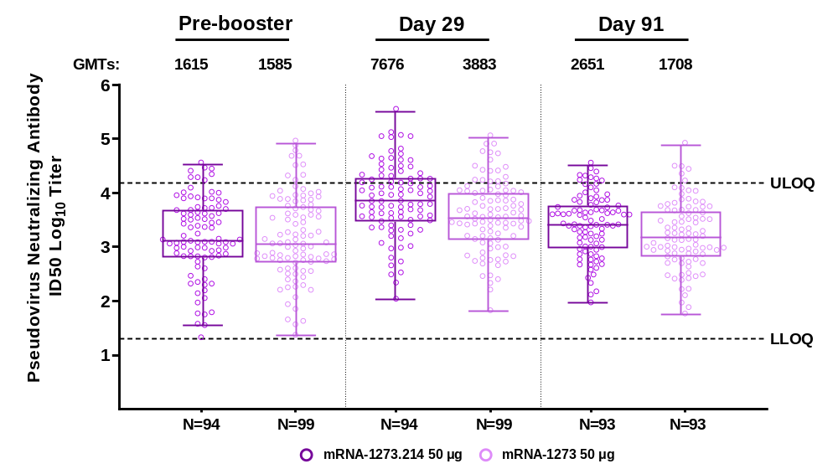
Ancestral SARS-CoV-2 (D614G)
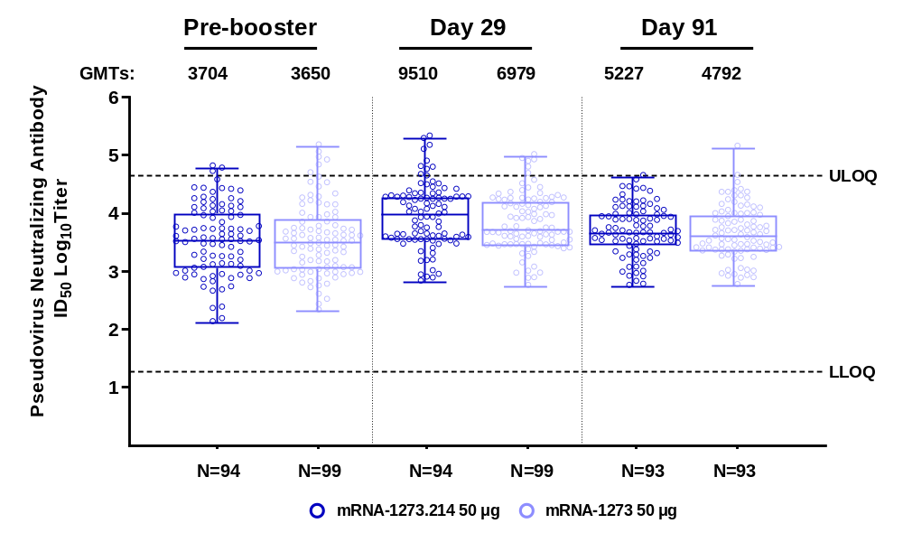

Figure S5. Neutralizing Antibody Response Against Omicron BA.1 after 50-µg of mRNA-1273.214 and mRNA-1273 Administered as Second Boosters in PPIS SARS-CoV-2-negative Participants by Age Groups
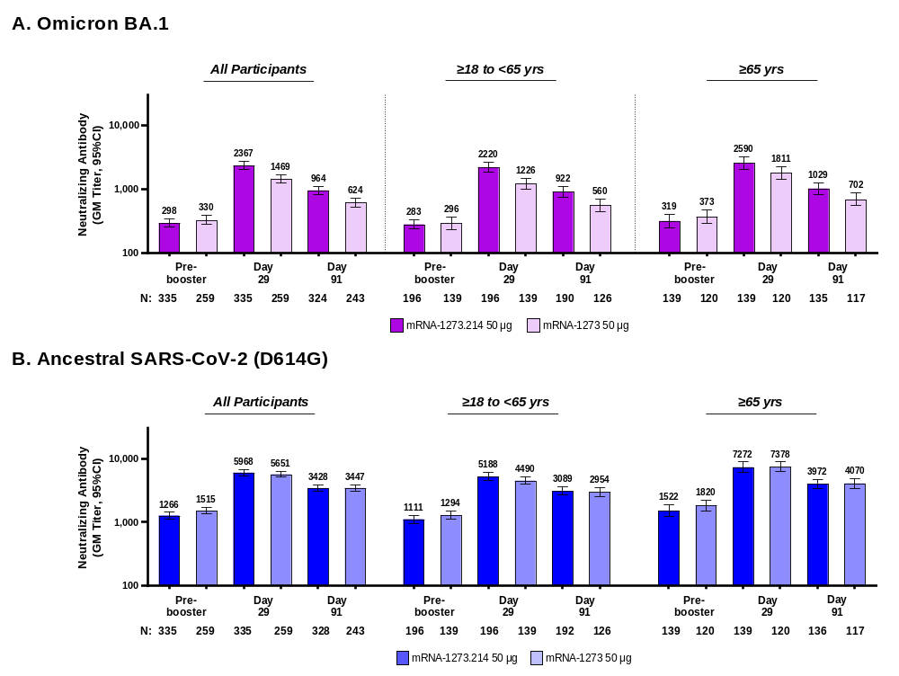

Figure S6. Binding Antibodies Across Variants after 50-µg of mRNA-1273.214 and mRNA-1273 Administered as Second Boosters in Participants with No Prior SARS-CoV-2-Infection
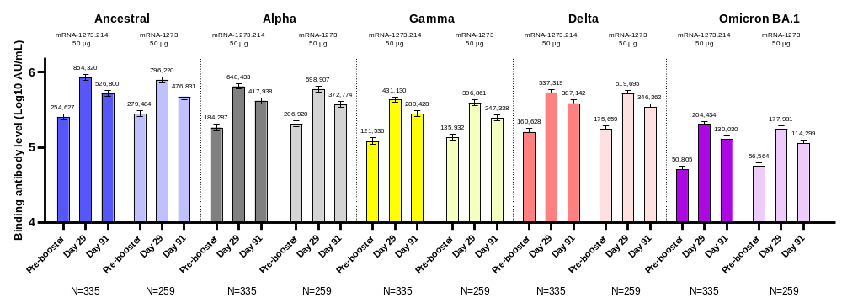

Table S1. Demographics and Study Participant Characteristics, Safety Set
Characteristics n (%)* | mRNA-1273.214  (50 µg)  N=437 | mRNA-1273  (50 µg)  N=376
Age at Screening (yr)
Mean (range) | 57.3 (20-88) | 57.6 (20-96)
Age subgroup
≥18 and <65 years | 263 (60.2) | 226 (60.1)
≥65 years | 174 (39.8) | 150 (39.9)
Gender
Male | 179 (41.0) | 186 (49.5)
Female | 258 (59.0) | 190 (50.5)
Ethnicity
Hispanic or Latino | 46 (10.5) | 37 (9.8)
Not Hispanic or Latino | 390 (89.2) | 340 (90.2)
Not reported or unknown | 1 (0.2) | 0
Race
White | 381 (87.2) | 322 (85.6)
Black or African American | 31 (7.1) | 29 (7.4)
Asian | 14 (3.2) | 16 (4.3)
American Indian or Alaska Native | 0 | 1 (0.3)
Native Hawaiian or Other Pacific Islander | 0 | 1 (0.3)
Multiracial | 7 (1.6) | 2 (0.5)
Other | 3 (0.7) | 2 (0.5)
Not reported or unknown | 1 (0.2) | 4 (1.1)
Time between second injection of mRNA-1273 in the primary series and the first booster dose of mRNA-1273 (days)
n | 437 | 374
Median | 245.0 | 242.0
IQR | 224-275 | 225-260
Time between first booster injection of mRNA-1273 and the second booster (days)
n | 437 | 374
Median | 136.0 | 134.0
IQR | 118-150 | 118-150
Pre-booster RT-PCR SARS-CoV-2
Negative | 434 (99.3) | 366 (97.3)
Positive | 2 (0.5) | 2 (0.5)
Missing | 1 (0.2) | 8 (2.1)
Pre-booster antibody to SARS-CoV-2 nucleocapsid†
Negative | 341 (78.0) | 276 (73.4)
Positive | 95 (21.7) | 100 (26.6)
Missing | 1 (0.2) | 0
Pre-booster SARS-CoV-2 status‡
Negative | 340 (77.8) | 267 (71.0)
Positive | 96 (22.0) | 101 (26.9)
Positive by both RT-PCR and SARS-CoV-2 nucleocapsid† | 1 (0.2) | 1 (0.3)
Positive by RT-PCR only | 1 (0.2) | 1 (0.3)
Positive by SARS-CoV-2 nucleocapsid only† | 94 (21.5) | 99 (26.3)
Missing | 1 (0.2) | 8 (2.1)
IQR=interquartile range; RT-PCR = reverse transcription polymerase chain reaction. *Percentages based on the number of participants in the safety set. †Elecsys assay for binding antibody to SARS-CoV-2 nucleocapsid. ‡Pre-booster SARS-CoV-2 status was positive if there was evidence of prior SARS-CoV-2-infection, defined as positive binding antibody against the SARS-CoV-2 nucleocapsid or positive RT-PCR at day 1; negative SARS-CoV-2 status was defined as negative binding antibody against the SARS-CoV-2 nucleocapsid and a negative RT-PCR at Day 1. Data cutoff date is July 6th, 2022.

Table S2. Solicited Local and Systemic Adverse Reactions Within 7 Days Following Second Booster Injections of mRNA-1273.214 (50 µg) and mRNA-1273 (50 µg), Solicited Safety Set
Adverse Reaction, N (%) | mRNA-1273.214  Second Booster Dose  (50 µg)  N=437 | mRNA-1273  Second Booster Dose  (50 µg)  N=350
Solicited AR, N1 | 437 | 350
Any Solicited AR | 380 (87.0) | 300 (85.7)
Grade 1 | 220 (50.3) | 184 (52.6)
Grade 2 | 125 (28.6) | 88 (25.1)
Grade 3 | 35 (8.0) | 28 (8.0)
Grade 4 | 0 | 0
Any Solicited Local AR, N1 | 437 | 350
Any Solicited Local AR | 347 (79.4) | 278 (79.4)
Grade 1 | 291 (66.6) | 239 (68.3)
Grade 2 | 41 (9.4) | 27 (7.7)
Grade 3 | 15 (3.4) | 12 (3.4)
Local AR, Pain, N1 | 437 | 350
Pain, any | 338 (77.3) | 268 (76.6)
Grade 1 | 303 (69.3) | 240 (68.6)
Grade 2 | 31 (7.1) | 24 (6.9)
Grade 3 | 4 (0.9) | 4 (1.1)
Erythema, N1 | 437 | 350
Erythema, any | 30 (6.9) | 13 (3.7)
Grade 1 | 15 (3.4) | 5 (1.4)
Grade 2 | 6 (1.4) | 6 (1.7)
Grade 3 | 9 (2.1) | 2 (0.6)
Swelling, N1 | 437 | 350
Swelling, any | 30 (6.9) | 22 (6.3)
Grade 1 | 17 (3.9) | 13 (3.7)
Grade 2 | 8 (1.8) | 4 (1.1)
Grade 3 | 5 (1.1) | 5 (1.4)
Axillary Swelling or Tenderness, N1 | 437 | 350
Axillary Swelling or Tenderness, any | 76 (17.4) | 53 (15.1)
Grade 1 | 71 (16.2) | 45 (12.9)
Grade 2 | 4 (0.9) | 4 (1.1)
Grade 3 | 1 (0.2) | 4 (1.1)
Any Systemic AR, N1 | 437 | 350
Any Systemic AR | 307 (70.3) | 231 (66.0)
Grade 1 | 167 (38.2) | 124 (35.4)
Grade 2 | 116 (26.5) | 91 (26.0)
Grade 3 | 24 (5.5) | 16 (4.6)
Fever, N1 | 436 | 350
Fever, any | 17 (3.9) | 11 (3.1)
Grade 1 | 12 (2.8) | 8 (2.3)
Grade 2 | 4 (0.9) | 3 (0.9)
Grade 3 | 1 (0.2) | 0
Headache, N1 | 437 | 349
Headache, any | 192 (43.9) | 143 (41.0)
Grade 1 | 150 (34.3) | 111 (31.8)
Grade 2 | 37 (8.5) | 30 (8.6)
Grade 3 | 5 (1.1) | 2 (0.6)
Fatigue, N1 | 437 | 349
Fatigue, any | 240 (54.9) | 179 (51.3)
Grade 1 | 125 (28.6) | 94 (26.9)
Grade 2 | 100 (22.9) | 74 (21.2)
Grade 3 | 15 (3.4) | 11 (3.2)
Myalgia, N1 | 437 | 349
Myalgia, any | 174 (39.8) | 134 (38.4)
Grade 1 | 102 (23.3) | 68 (19.5)
Grade 2 | 62 (14.2) | 53 (15.2)
Grade 3 | 10 (2.3) | 13 (3.7)
Arthralgia, N1 | 437 | 349
Arthralgia, any | 136 (31.1) | 110 (31.5)
Grade 1 | 93 (21.3) | 69 (19.8)
Grade 2 | 39 (8.9) | 38 (10.9)
Grade 3 | 4 (0.9) | 3 (0.9)
Nausea/vomiting, N1 | 437 | 349
Nausea /vomiting, any | 45 (10.3) | 35 (10.0)
Grade 1 | 39 (8.9) | 27 (7.7)
Grade 2 | 5 (1.1) | 8 (2.3)
Grade 3 | 1 (0.2) | 0
Chills, N1 | 437 | 349
Chills, any | 104 (23.8) | 74 (21.2)
Grade 1 | 65 (14.9) | 46 (13.2)
Grade 2 | 38 (8.7) | 27 (7.7)
Grade 3 | 1 (0.2) | 1 (0.3)
AR=adverse reaction. Any=Grade 1 or higher. N1=Number of exposed participants with any information about the adverse event. Percentages are based on the number of participants who submitted any data for the event.

Table S3. Summary of Unsolicited Adverse Events ≤28 Days Post-booster Dose, Safety Set
n (%) | mRNA-1273.214 50 μg | mRNA-1273 50 μg
n (%) | (N=437) | (N=376)
Unsolicited AEs Regardless of Relationship to Study Vaccination
All | 84 (19.2) | 80 (21.3)
Serious | 2 (0.5) | 1 (0.3)
Fatal | 0 | 0
Medically attended | 51 (11.7) | 57 (15.2)
Leading to discontinuation from study | 0 | 0
Grade 3 or higher | 4 (0.9) | 3 (0.8)
Unsolicited AEs related to study vaccination
All | 21 (4.8) | 21 (5.6)
Serious | 0 | 0
Fatal | 0 | 0
Medically attended | 2 (0.5)* | 2 (0.5)*
Leading to discontinuation from study | 0 | 0
Grade 3 or higher | 1 (0.2) | 2 (0.5)
AE=adverse event. An adverse event was defined as any event not present prior to study vaccination or any event already present that worsened in intensity or frequency after vaccination. Solicited adverse reactions with toxicity Grade=0 that lasted beyond day 7 or started after day 7 are not included in the summary. Percentages are based on the number of participants in the safety set. *Medically attended AEs of fatigue (grade 2) and dermatitis (grade 1) occurred in the mRNA-1273.214 group and of hypertension and urticaria (both grade 1) in the mRNA-1273 groups. Two participants in the mRNA-1273.214 group experienced serious AEs (prostate cancer, traumatic fracture) and one in the mRNA-1273 group (spinal osteoarthritis); none were considered related to study vaccination.

Table S4. Summary of Unsolicited Adverse Events up to Data Cutoff Date Post-booster Dose, Safety Set
n (%) | mRNA-1273.214 50 μg | mRNA-1273 50 μg
n (%) | N=437 | N=376
Unsolicited AEs Regardless of Relationship to Study Vaccination
All | 209 (47.8) | 196 (52.1)
Serious | 8 (1.8) | 10 (2.7)
Fatal | 0 | 1 (0.3)*
Medically attended | 171 (39.1) | 180 (47.9)
Leading to discontinuation from study | 0 | 0
Grade 3 or higher | 8 (1.8) | 9 (2.4)
Unsolicited AEs related to study vaccination
All | 21 (4.8) | 21 (5.6)
Serious | 0 | 0
Fatal | 0 | 0
Medically attended† | 2 (0.5) | 2 (0.5)
Leading to discontinuation from study | 0 | 0
Grade 3 or higher | 1 (0.2) | 2 (0.5)
AE=adverse event. An adverse event was defined as any event not present prior to study vaccination or any event already present that worsened in intensity or frequency after vaccination. Solicited adverse reactions with toxicity Grade=0 that lasted beyond day 7 or started after day 7 are not included in the summary. Percentages are based on the number of participants in the safety set. *One death occurred in the mRNA-1273 group that was considered by the investigator to not be related to study vaccination. The participant was a 73 year-old White female with a medical history of hypocholesterolaemia, hypertension and post-menopausal symptoms who had a fatal hypotension event on study day 64 following a cardiac catheterization procedure which led to sepsis. †Medically attended AEs of fatigue (grade 2) and dermatitis (grade 1) occurred in the mRNA-1273.214 group and of hypertension and urticaria (both grade 1) in the mRNA-1273 groups.

Table S5. Unsolicited Serious Adverse Events Reported Through the Study Cutoff Date
n (%) | mRNA-1273.214 50 ug  (N=437) | mRNA-1273 50 ug  (N=376)
Number of Participants Reporting Serious AEs* | 8 (1.8) | 10 (2.7)
Number of Serious AEs, n | 10 | 10
Infections and infestations | 0 | 1 (0.3)
Pneumonia | 0 | 1 (0.3)
Neoplasms benign, malignant and unspecified  (incl cysts and polyps) | 2 (0.5) | 0
Invasive ductal breast carcinoma | 1 (0.2) | 0
Prostate cancer | 1 (0.2) | 0
Prostate cancer metastatic | 1 (0.2) | 0
Nervous system disorders | 1 (0.2) | 1 (0.3)
Ischaemic cerebral infarction | 1 (0.2) | 0
Syncope | 0 | 1 (0.3)
Cardiac disorders | 1 (0.2) | 1 (0.3)
Coronary artery disease | 1 (0.2) | 0
Atrial fibrillation | 0 | 1 (0.3)
Vascular disorders | 0 | 1 (0.3)
Hypotension† | 0 | 1 (0.3)
Gastrointestinal disorders | 1 (0.2) | 1 (0.3)
Hiatus hernia | 1 (0.2) | 0
Upper gastrointestinal haemorrhage | 1 (0.2) | 0
Diverticulum intestinal haemorrhagic | 0 | 1 (0.3)
Musculoskeletal and connective tissue disorders | 0 | 5 (1.3)
Arthralgia | 0 | 1 (0.3)
Lumbar spinal stenosis | 0 | 1 (0.3)
Rotator cuff syndrome | 0 | 1 (0.3)
Spinal osteoarthritis | 0 | 1 (0.3)
Spinal synovial cyst | 0 | 1 (0.3)
Renal and urinary disorders | 1 (0.2) | 0
Nephrolithiasis | 1 (0.2) | 0
Injury, poisoning and procedural complications | 2 (0.5) | 0
Femur fracture | 1 (0.2) | 0
Traumatic fracture | 1 (0.2) | 0
An adverse event (AE) is defined as any event not present before exposure to study vaccination or any event already present that worsens in intensity or frequency after exposure. Percentages are based on the number of participants in the Safety Set. MedDRA version 23.0. This interim analysis includes immunogenicity data up to the Day 91 visit. AEs occurring up to the data cutoff date for safety and SARS-CoV-2 infection of July 6, 2022 are provided. *None of the reported serious AEs were considered to be related to study vaccination by the investigators. †One death occurred in the mRNA-1273 group that was considered by the investigator to not be related to study vaccination. The participant was a 73 year-old White female with a medical history of hypocholesterolaemia, hypertension and post-menopausal symptoms who had a fatal hypotension event on study day 64 following a cardiac catheterization procedure which led to sepsis.

Table S6. Observed Neutralizing Antibodies Against Ancestral SARS-CoV-2 (D614G) and Omicron BA.1 after 50-µg of mRNA-1273.214 and mRNA-1273 Administered as Second Booster Doses by SARS-CoV-2 Status

 | All participants |  | No prior SARS-CoV-2 infection |  | Prior SARS-CoV-2 infection
 | mRNA-1273.214 | mRNA-1273 | mRNA-1273.214 | mRNA-1273 | mRNA-1273.214 | mRNA-1273
 | 50 µg  Booster Dose | 50 µg  Booster Dose | 50 µg  Booster Dose | 50 µg  Booster Dose | 50 µg  Booster Dose | 50 µg  Booster Dose
Ancestral SARS-CoV-2 (D614G) | N=429 | N=366 | N=335 | N=259 | N=94 | N=98
Pre-booster | 429 | 366 | 335 | 259 | 94 | 99
Observed GMT  (95% CI) | 1601.7 (1419.1, 1807.6) | 1941.0 (1721.5, 2188.4) | 1265.9  (1119.9-1431.0) | 1515.4  (1347.5-1704.2) | 3704.0  (2793.2-4911.7) | 3649.5  (2758.5-4828.2)
Day 29, n | 429 | 366 | 335 | 259 | 94 | 99
Observed GMT  (95% CI) | 6609.5  (5934.5-7361.3) | 6050.2  (5466.3-6696.4) | 5968.1  (5315.4-6700.9) | 5651.4  (5055.7-6317.3) | 9509.7  (7345.9-12310.9) | 6979.3  (5585.6-8720.9)
GMFR  (95% CI) | 4.1 (3.8, 4.4) | 3.1 (2.9, 3.4) | 4.7 (4.4-5.1) | 3.7 (3.4-4.1) | 2.6 (2.2-2.9) | 1.9 (1.6, 2.2)
Day 91, n | 421 | 344 | 328 | 243 | 93 | 93
Observed GMT  (95% CI) | 3763.0  (3405.2-4158.4) | 3801.2  (3423.8-4220.3) | 3428.3  (3062.7-3837.6) | 3447.1  (3054.7-3889.9) | 5226.7  (4256.7-6417.7) | 4792.2  (3866.4-5939.6)
GMFR  (95% CI) | 2.3 (2.2- 2.5) | 2.0 (1.8-2.1) | 2.7 (2.5-2.9) | 2.3 (2.2, 2.5) | 1.4 (1.2-1.6) | 1.3 (1.1-1.5)
Omicron BA.1 | N=428 | N=367- | N=334 | N=260 | N=94 | N=98
Pre-booster | 429 | 366 | 335 | 259 | 94 | 99
Observed GMT  (95% CI) | 431.1  (371.7-499.9) | 509.9  (431.5-602.5) | 297.6 (258.4, 342.8) | 329.5 (280.0, 387.9) | 1614.6  (1149.7-2267.7) | 1585.3  (1110.1-2264.1)
Day 29 | 429 | 366 | 335 | 259 | 94 | 99
Observed GMT  (95% CI) | 3062.7  (2679.2-3501.0) | 1929.8  (1678.0-2219.3) | 2366.6  (2066.2-2710.7) | 1468.7  (1266.2-1703.6) | 7676.2  (5618.2-10488.1) | 3883.3  (2885.0-5227.1)
GMFR  (95% CI) | 7.1 (6.5-7.8) | 3.8 (3.4-4.2) | 8.0 (7.2-8.8) | 4.5 (4.0-5.0) | 4.8 (4.0-5.7) | 2.4 (2.0-3.0)
Day 91 | 417 | 344 | 324 | 243 | 93 | 93
Observed GMT  (95% CI) | 1208.4  (1057.7-1380.5) | 828.4  (716.8-957.5) | 964.4  (834.4-1114.7) | 624.2  (533.1-730.9) | 2651.3  (2028.7-3464.9) | 1708.3  (1271.7-2294.8)
GMFR  (95% CI) | 2.7 (2.5-3.1) | 1.6 (1.4-1.8) | 3.2 (2.8-3.6) | 1.9 (1.7-2.1) | 1.6 (1.3-2.0) | 1.0 (0.8-1.3)
SARS-CoV-2 infection baseline information missing for 9 participants in mRNA-1273 50 µg group. CI=confidence interval; GMFR=geometric mean fold rise (post-baseline/baseline titers); GMT=geometric mean titer; LLOQ=lower limit of quantification; ULOQ=upper limit of quantification. Antibody values assessed by pseudovirus neutralizing antibody assay reported as below the LLOQ (18.5 for ancestral SARS-CoV-2 [D614G] and 19.9 for Omicron BA.1) are replaced by 0.5 × LLOQ. Values greater than ULOQ (45,118 for ancestral SARS-CoV-2 [D614G] and 15,502.7 for Omicron BA.1) are replaced by the ULOQ if actual values are not available. 95% CI is calculated based on the t-distribution of the log-transformed values or the difference in the log-transformed values for GM value and GMFR, respectively, then back transformed to the original scale.

Table S7. Observed Neutralizing Antibodies Against Ancestral SARS-CoV-2 (D614G) and Omicron BA.1 after 50-µg of mRNA-1273.214 and mRNA-1273 Administered as Second Booster Doses by Age Group (PPIS-negative)

 | ≥18-<65 years |  | ≥65 years
 | mRNA-1273.214 | mRNA-1273 | mRNA-1273.214 | mRNA-1273
 | 50 µg  Booster Dose | 50 µg  Booster Dose | 50 µg  Booster Dose | 50 µg  Booster Dose
Ancestral SARS-CoV-2 (D614G) | N=196 | N=139 | N=139 | N=120
Pre-booster | 196 | 139 | 139 | 120
Observed GMT  (95% CI) | 1110.9  (958.8-1287.2) | 1293.9  (1116.2-1500.0) | 1521.9  (1235.4-1874.8) | 1819.7  (1514.1-2186.9)
Day 29, n | 196 | 139 | 139 | 120
Observed GMT  (95% CI) | 5187.7  (4498.0-5983.2) | 4489.5  (3925.7-5134.4) | 7271.9  (6008.7-8800.7) | 7377.9  (6203.2-8775.0)
GMFR (95% CI) | 4.7 (4.2-5.2) | 3.5 (3.1-3.9) | 4.8 (4.2-5.4) | 4.1 (3.6-4.6)
Day 91, n | 192 | 126 | 136 | 117
Observed GMT  (95% CI) | 3088.7  (2655.4-3592.7) | 2954.2  (2519.0-3464.5) | 3972.2  (3358.7-4697.9) | 4070.4  (3397.5-4876.5)
GMFR (95% CI) | 2.8 (2.5-3.1) | 2.4 (2.1-2.6) | 2.6 (2.2-3.0) | 2.3 (2.0-2.6)
Omicron BA.1 | N=196 | N=139 | N=139 | N=120
Pre-booster | 196 | 139 | 139 | 120
Observed GMT  (95% CI) | 283.2  (237.5-337.5) | 295.9  (236.6-370.0) | 319.2  (252.2-404.1) | 373.4  (293.8-474.6)
Day 29 | 196 | 139 | 139 | 120
Observed GMT  (95% CI) | 2219.9  (1867.4-2638.9) | 1225.6  (1007.0-1491.6) | 2590.1  (2079.0-3226.9) | 1811.2  (1450.1-2262.3)
GMFR (95% CI) | 7.8 (6.9-9.0) | 4.1 (3.6-4.8) | 8.1 (6.9-9.5) | 4.9 (4.1-5.8)
Day 91 | 190 | 126 | 134 | 117
Observed GMT  (95% CI) | 921.5  (757.9-1120.3) | 559.7  (446.8-701.1) | 1028.7  (828.3-1277.5) | 702.1  (562.5-876.2)
GMFR (95% CI) | 3.1 (2.7-3.7) | 1.9 (1.6-2.2) | 3.3 (2.7-3.9) | 1.9 (1.6-2.3)
SARS-CoV-2 infection baseline information missing for 9 participants in mRNA-1273 50 µg group. CI=confidence interval; GMFR=geometric mean fold rise (post-baseline/pre-booster baseline titers); GMT=geometric mean titer; LLOQ=lower limit of quantification; ULOQ=upper limit of quantification. Antibody values assessed by pseudovirus neutralizing antibody assay reported as below the LLOQ (18.5 for ancestral SARS-CoV-2 [D614G] and 19.9 for Omicron BA.1) are replaced by 0.5 × LLOQ. Values greater than ULOQ (45,118 for ancestral SARS-CoV-2 [D614G] and 15,502.7 for Omicron BA.1) are replaced by the ULOQ if actual values are not available. 95% CI is calculated based on the t-distribution of the log-transformed values or the difference in the log-transformed values for GM value and GMFR, respectively, then back transformed to the original scale.

Table S8. Binding and Antibody Levels and Analysis of Geometric Mean Ratios Against Ancestral SARS-CoV-2 and Omicron BA.1 after 50-µg of mRNA-1273.214 and mRNA-1273 Administered as Second Booster Doses, PPSI-SARS-CoV-2-Negative

 | Ancestral SARS-CoV-2 (D614G) |  | Omicron BA.1
 | mRNA-1273.214 50 µg  N=335 | mRNA-1273 50 µg  N=259 | mRNA-1273.214 50 µg  N=335 | mRNA-1273 50 µg  N=259
Pre-booster, n† | 335 | 259 | 335 | 259
Observed GM levels§ | 254626.9  (230813.9-280896.8) | 279483.7  (254946.7-306382.2) | 50805.1  (45731.0-56442.1) | 56564.1  (51321.2-62342.6)
Day 29, n† | 334 | 259 | 334 | 259
Observed GM Level (95% CI)§ | 854319.8  (784968.6-929798.2) | 796220.3  (726144.6-873058.6) | 204434.2  (187631.3-222741.9) | 177980.6  (162188.7-195310.2)
GMFR (95% CI)§ | 3.4 (3.2-3.6) | 2.8 (2.7-3.0) | 4.0 (3.8-4.3) | 3.1 (2.9-3.4)
Estimated GM Level (95% CI)¶ | 889290.9  (845307.4-935563.0) | 771456.8  (728507.9-816937.7) | 213308.0  (202362.3-224845.9) | 171934.3  (162004.4-182472.7)
GMR (95% CI)¶ | 1.15 (1.07-1.24) |  | 1.24 (1.15-1.34)
Day 29 SRR, n/N1 %‡ | 333/333, 100 | 257/257, 100 | 333/333, 100 | 257/257, 100
(95% CI) | (98.9-100.0) | (98.6-100.0) | (98.9-100.0) | (98.5-100.0)
Difference (95.0% CI)†† | 0 |  | 0
Day 91, n† | 327 | 244 | 327 | 244
Observed GM Level (95% CI)§ | 526799.7  (479899.4-578283.5) | 476830.7  (433495.6-524497.9) | 130029.9  (117914.2-143390.3) | 114298.7  (103446.1-126289.8)
GMFR (95% CI)§ | 2.1 (1.9-2.2) | 1.7 (1.6-1.8) | 2.5 (2.4-2.7) | 2.0 (1.9-2.1)
Estimated GM Level (95% CI)¶ | 548425.7  (520722.5-577602.7) | 456303.7  (429887.5-484343.1) | 136511.5  (129272.2-144156.2) | 108374.3  (101788.1-115386.6)
GMR (95% CI)¶ | 1.20 (1.11-1.30) |  | 1.26 (1.16-1.37)
Day 91 SRR, n/N1 %‡ | 326/326, 100 | 242/242, 100 | 326/326, 100 | 242/242, 100
(95% CI) | (98.9-100.0) | (98.5-100.0) | (98.9, 100.0) | (98.5-100.0)
Difference (95.0% CI)†† | 0 |  | 0
CI=confidence interval, GM=geometric mean, GMR=geometric mean ratio (mRNA-1273.214 relative to mRNA-1273), LLOQ=lower limit of quantification; Meso Scale Discovery =MSD; ULOQ=upper limit of quantification. Binding antibody values assessed by MSD assay reported as below the LLOQ (69 for ancestral SARS-CoV-2 [D614G] and102 for Omicron BA.1) were replaced by 0.5 × LLOQ. Values greater than ULOQ (14,400,000 for ancestral SARS-CoV-2 [D614G] and 1,180,000 for Omicron BA.1) were replaced by the ULOQ if actual values are not available. Participant immune response data is censored at the last date of study participation (study discontinuation, study completion, or death), non-study COVID-19 vaccination date, or data cutoff/extraction date, whichever is the earliest.
†Number of participants with non-missing data at the timepoint (baseline or post-baseline).
§95% CI based on the t-distribution of log-transformed values or difference in the log-transformed values for GMT value and GMT fold-rise, respectively, then back transformed to the original scale.
¶Log-transformed antibody levels are analyzed using an ANCOVA model with the treatment variable as fixed effect, adjusting for age group (<65, ≥65 years) and pre-booster titers. The resulting LS means, difference of LS means, and 95% CI are back transformed to the original scale for presentation.
‡Seroresponse at a participant level based on pre-injection 1 baseline GM levels is defined as a change from below the LLOQ to equal or above 4 x LLOQ if baseline is below the LLOQ, or at least a 4-fold rise if baseline is equal to or above the LLOQ. For participants without pre-injection 1 antibody titer information who have corresponding day 29 post-boost assessments, seroresponse is defined as ≥4*LLOQ for participants with negative SARS-CoV-2 status at their pre-injection 1 of the primary series, and these participants’ antibody titers are imputed as <LLOQ at their pre-injection 1 of the primary series. For participants without SARS-CoV-2 status information at pre-injection 1 of the primary series, their pre-booster SARS-CoV-2 status is used to impute their SARS-CoV-2 status at their pre-injection 1 of the primary series. Percentages are based on N1. 95% CI is calculated using the Clopper-Pearson method.
††Common risk difference and 95% CI is calculated using the stratified Miettinen-Nurminen method to adjust for age group (<65, ≥65 years). When both groups have response rates equal to 100%, common risk and 95% CI cannot be calculated.

Table S9. Binding and Antibody Levels and Analysis of Geometric Mean Ratios Against Other Variants after 50-µg of mRNA-1273.214 and mRNA-1273 Administered as Second Booster Doses, PPSI-SARS-CoV-2-Negative

 | Alpha |  | Gamma |  | Delta
 | mRNA-1273.214 50 µg  N=335 | mRNA-1273 50 µg  N=259 | mRNA-1273.214 50 µg  N=335 | mRNA-1273 50 µg  N=259 | mRNA-1273.214 50 µg  N=335 | mRNA-127350 µg  N=259
Pre-booster, n† | 335 | 259 | 335 | 259 | 335 | 259
Observed GM levels§ | 184286.7  (166661.7-203775.6) | 206919.5  (188334.0-227339.1) | 121535.9  (110171.0-134073.2) | 135931.8  (123850.4-149191.8) | 160627.8  (145782.9-176984.3) | 175659.4  (159935.1-92929.6)
Day 29, n† | 334 | 259 | 334 | 259 | 334 | 259
Observed GM Level (95% CI)§ | 648433.0  (595629.7-705917.4) | 598907.1  (546449.4-656400.6) | 431130.0  (396018.4-469354.6) | 396861.4  (362419.4-434576.4) | 537318.7  (495865.8-582236.9) | 519695.1  (476509.6-566794.4)
GMFR (95% CI)§ | 3.5 (3.3-3.7) | 2.9 (2.7-3.1) | 3.5 (3.3-3.8) | 2.9 (2.7-3.1) | 3.3 (3.2-3.5) | 3.0 (2.8-3.1)
Estimated GM Level (95% CI)¶ | 678953.7  (646186.7-713382.2) | 575031.5  (543780.8-608078.2) | 451290.8  (428843.6-474912.9) | 381902.9  (360516.9-404557.5) | 557182.3  (531356.4-584263.5) | 504890.9  (478544.5-532687.8)
GMR (95% CI)¶ | 1.18 (1.10-1.27) |  | 1.18 (1.1- 1.28) |  | 1.10 (1.03-1.19)
Day 29 SRR, n/N1 %‡ | 333/333, 100 | 257/257, 100 | 333/333, 100 | 257/257, 100 | 333/333, 100 | 257/257, 100
(95% CI) | (98.9-100.0) | (98.6-100.0) | (98.9-100.0) | (98.6-100.0) | (98.9-100.0) | (98.6-100.0)
Difference (95.0% CI)†† | 0 |  | 0 |  | 0
Day 91, n† | 327 | 244 | 327 | 244 | 327 | 244
Observed GM Level (95% CI)§ | 417937.6  (379856.1-459837.0) | 372773.6  (337917.7-411224.9) | 280427.8  (254763.3-308677.7) | 247338.1  (224898.0-272017.4) | 387142.3  (352518.8-425166.5) | 346362.0  (314867.8-381006.2)
GMFR (95% CI)§ | 2.3 (2.1-2.4) | 1.8 (1.7-1.9) | 2.3 (2.2-2.4) | 1.8 (1.7-1.9) | 2.4 (2.3-2.5) | 1.9 (1.8-2.1)
Estimated GM Level (95% CI)¶ | 438682.9  (416130.1, 462458.0) | 352989.4  (332186.9, 375094.6) | 294306.1  (278624.0-310870.9) | 234125.9  (219827.5- 249354.2) | 401735.1  (381128.2-423456.2) | 332522.6  (312977.9-353287.7)
GMR (95% CI)¶ | 1.24 (1.15-1.35) |  | 1.26 (1.16-1.37) |  | 1.21 (1.12-1.31)
Day 91 SRR, n/N1 %‡ | 326/326, 100 | 242/242, 100 | 326/326, 100 | 242/242, 100 | 326/326, 100 | 242/242, 100
(95% CI) | (98.9-100.0) | (98.5-100.0) | (98.9-100.0) | (98.5-100.0) | (98.9-100.0) | (98.5-100.0)
Difference (95.0% CI)†† | 0 |  | 0 |  | 0
CI=confidence interval, GM=geometric mean, GMR=geometric mean ratio (mRNA-1273.214 relative to mRNA-1273), LLOQ=lower limit of quantification; Meso Scale Discovery =MSD; ULOQ=upper limit of quantification. Binding antibody values assessed by MSD assay reported as below the LLOQ (150 for delta; 143 for gamma; and 52 for alpha) were replaced by 0.5 × LLOQ. Values greater than ULOQ (8,000,000 for delta; 5,800,000 for gamma; and 8,800,000 for alpha) were replaced by the ULOQ if actual values are not available. Participant immune response data is censored at the last date of study participation (study discontinuation, study completion, or death), non-study COVID-19 vaccination date, or data cutoff/extraction date, whichever is the earliest.
†Number of participants with non-missing data at the timepoint (baseline or post-baseline).
§95% CI based on the t-distribution of log-transformed values or difference in the log-transformed values for GMT value and GMT fold-rise, respectively, then back transformed to the original scale.
¶Log-transformed antibody levels are analyzed using an ANCOVA model with the treatment variable as fixed effect, adjusting for age group (<65, ≥65 years) and pre-booster titers. The resulting LS means, difference of LS means, and 95% CI are back transformed to the original scale for presentation.
‡Seroresponse at a participant level based on pre-injection 1 baseline GM levels is defined as a change from below the LLOQ to equal or above 4 x LLOQ if baseline is below the LLOQ, or at least a 4-fold rise if baseline is equal to or above the LLOQ. For participants without pre-Dose 1 antibody titer information who have corresponding Day 29 post-boost assessments, seroresponse is defined as ≥4*LLOQ for participants with negative SARS-CoV-2 status at their pre-dose 1 of primary series, and these participants’ antibody titers are imputed as <LLOQ at pre-dose 1 of primary series. For particpants without SARS-CoV-2 status information at pre-dose 1 of the primary series, their pre-booster SARS-CoV-2 status is used to impute their SARS-CoV-2 status at their pre-dose 1 of primary series. Percentages are based on N1. 95% CI is calculated using the Clopper-Pearson method.
††Common risk difference and 95% CI is calculated using the stratified Miettinen-Nurminen method to adjust for age group (<65, ≥65 years). When both groups have response rate equal to 100%, common risk and 95% CI cannot be calculated.

Table S10. Incidences of SARS-CoV-2-infection and COVID-19 Starting 14 Days After Booster Injection
n (%) | Per-protocol Efficacy Set  No Prior SARS-CoV-2 Infection |  | Full Analysis Set  All Participants
 | mRNA-1273.214  50 µg | mRNA-1273  50 µg | mRNA-1273.214  50 µg | mRNA-1273  50 µg
 | N=339 | N=266 | N=437 | N=376
COVID-19 (COVE definition)*
Cases | 35 (10.3) | 24 (9.0) | 39 (8.9) | 26 (6.9)
COVID-19 (CDC definition)*
Cases | 38 (11.2) | 28 (10.5) | 42 (9.6) | 30 (8.0)
SARS-CoV-2 infection (regardless of symptoms)
Cases | 57 (16.8) | 41 (15.4) | 61 (14.0) | 48 (12.8)
Asymptomatic SARS-CoV-2 infection
Cases | 19 (5.6) | 13 (4.9) | 19 (4.3) | 18 (4.8)
*COVID-19 cases based on 1 symptom per CDC definition; COVID-19 primary case definition based on 2 systemic symptoms or at least one of the respiratory symptoms used in the Coronavirus Efficacy (COVE) trial.^{1,2} The full analysis set consists of all participants who received study vaccine. The per-protocol set for efficacy consists of all participants in the full analysis set (FAS) who are SARS-CoV-2 negative pre-booster and have no major protocol deviations. There was one participant in the mRNA-1273.214 50 µg group and 8 participants in the mRNA-1273 50 µg group with missing pre-booster information in the full analysis set. One participant with missing pre-booster SARS-CoV-2 status had COVID-19 infection (per COVE and CDC definitions). Table includes all events in interim analysis starting 14 days after the booster dose and up to July 6th 2022 data cutoff date. COVID-19, SARS-CoV-2 infection, and asymptomatic SARS-CoV-2 infection are censored at the earlier date of last date of study
participation, non-study COVID-19 vaccination date, or efficacy data cutoff/extraction date.

