Supplemental Materials
This online supplement contains the following information:
- Table S1: An open science disclosure table
- An overview of the Bayesian Causal Forest statistical analysis method.
- Additional background on community policing
- Additional thematic results from qualitative field observations
- A pilot laboratory experiment validating the wrist-worn EDA sensor’s data (Figures S1 and S2)
- Additional results for Experiment 1
- Additional results for Experiments 2-7
- Tables S2 to S14: Descriptive statistics, balance tests, and additional analyses

Table S1. Open Science Disclosure Table for Experiments 1-7.

Study | Registration | Materials | Data | Syntax
1 | tiny.cc/PreRegExp1 | tiny.cc/Exp1-7Mat | tiny.cc/TranspData | tiny.cc/TranspSyntax
2 | tiny.cc/VideoPreReg | tiny.cc/Exp1-7Mat | tiny.cc/TranspData | tiny.cc/TranspSyntax
3 | tiny.cc/PreRegExp3-7 | tiny.cc/Exp1-7Mat | tiny.cc/TranspData | tiny.cc/TranspSyntax
4
5
6
7

Overview of Statistical Approach: Bayesian Causal Forest (BCF) Analysis
All analyses in the main text were conducted with a conservative, Bayesian, machine-learning method called Bayesian Causal Forest (BCF). BCF has been found, in multiple open competitions and simulation studies, to identify average treatment effects (ATEs) with minimal bias, while also detecting true sources of treatment effect heterogeneity, if they are present, while not lending much credence to noise^{1–3}. BCF builds on and has in several cases surpassed the popular Bayesian Additive Regression Trees (BART) approach. Both Bayesian regression tree models and BCF in particular are consistently top performers in empirical evaluations of methods for causal inference^{2–5}.
Here we provide more details about how the BCF model was estimated for the skin conductance response (SCR) outcome, because this is the outcome with the most complex model since it involves repeated measures. A simpler model that excludes the repeated measures and person-level random effect was fit for the person-level outcomes of threat, trust, natural language, and emotions.
In the BCF analysis, the SCR for participant j at 10-second interval $i$ is denoted by $y_{ij}$, and is modeled by
$$\begin{matrix}y_{ij}=α_{j}+β\left(x_{j}, t_{ij}\right)+[τ(t_{ij})⋅z_{ij}]+ϵ_{ij}.\end{matrix}$$
where $x$ is the vector of person-level covariates (police officer ID, age, race/ethnicity, gender, native English speaker status) and $t_{ij}$ is the person-by-time-interval variable. The treatment effect is moderated by time, $t_{ij}$, in that time interacts with the student treatment indicator $z$. We allow for person-level intercept random effects, $α_{j}$. The person-by-time-interval error term is $ϵ_{ij}$ and is assumed to be normally distributed with variance $σ^{2}$.
Here, $β$ is a nonparametric function which allows for nonlinearities and interactions between covariates in affecting the expected outcome. Furthermore, $τ$ is a nonparametric function that allows the treatment effect to vary across time. This model is meant to mimic that of the repeated-measures (i.e. multilevel) linear analysis in terms of the specification of the control and treatment modifier variables, but relax the strict assumption of linearity and additivity between the covariates and the expected value of the outcome.
Using a nonparametric Bayesian approach in this manner has several advantages. First, it allows the data to speak and better inform us about the relationships between the covariates and the outcome. It allows us to uncover (possibly unanticipated) sources of heterogeneity in the treatment effect over time while requiring few prior assumptions. The prior we use results in posterior estimates that are inherently conservative, making it unlikely that we will dramatically over- or under-estimate the effect of the intervention at different time points.
Prior specification
To complete our Bayesian model, we must specify prior distributions for the unknown values in the equation above. These include the nonparametric functions $β(⋅)$ and $τ(⋅)$, the random effect $α_{j}$, and the error variance $σ^{2}$.
The prior for the functions $β(⋅)$ and $τ(⋅)$ is taken from the Bayesian Causal Forests model (BCF; 1). Under this model, both functions have a sum-of-trees representation, as first defined for Bayesian methods⁶. Each tree consists of a set of internal decision nodes which partitions the covariate space, and a set of terminal nodes, or leaves, corresponding to each element of the partition. The prior for each of $β(⋅)$, $φ(.)$ and $τ(⋅)$, is comprised of three parts: the number of trees, two parameters controlling the depth of each tree, and a prior on the leaf parameters. Use of this sum-of-trees term allows for detection of nonlinearity and interactions between covariates.
The key feature of the BCF model is that the prior for $τ(⋅)$, which explains heterogeneity in the intervention effect, is regularized more heavily compared to the control function $β(⋅)$ in order to shrink toward homogeneous effects. The prior for $τ(⋅)$ uses fewer trees, with each tree being regularized to be shallower (that is, contain fewer partitions). Details are on prior specification are given in prior work^{1,6}.
The random effect $α_{j}$ is given a Gaussian prior with the standard deviation having a prior of a half $t$-distribution with 3 degrees of freedom, as recommended^{7,8}. Finally, the error variance is given an inverse chi-squared prior with 3 degrees of freedom and scale parameter informed by the data.
Posterior Inference
After conditioning on observed data, we can update the prior distribution to obtain a posterior distribution. To calculate the posterior distribution for quantities of interest, we implement a Markov chain Monte Carlo (MCMC) sampling scheme. Since the primary component of the model is the sum-of-trees functions $β(⋅)$ and $τ(⋅)$, the MCMC scheme relies on a Bayesian backfitting algorithm ⁶. The rest of the parameters in the model are conditionally conjugate, making their posterior sampling relatively efficient.
The BCF estimate of $τ$ was approximately additive. Therefore, to give an interpretable estimate of this conditional intervention effect, we created an additive summary of the fitted $τ(⋅)$ function using splines, and looked at the partial effect of changing the 10-second time interval. This additive summary captures > 98% of the predictive variance in the posterior of $τ$, so this additive summary is a faithful recapitulation of the fitted CATE function.

Additional Background on Community Policing

Community-oriented policing is a strategy in which police officers prioritize initiating non-enforcement interactions and building cooperative relationships with community members. These interactions happen in a variety of places, including unexpected interactions (e.g., on streets, in businesses, or in public recreation areas) and expected interactions (e.g., community meetings and recreational events). Expected interactions are community- and/or police-organized events that may, for example, involve a panel of police officers asking the community what the problems of in the area are and how the police can mitigate those problems. Or, for example, expected interactions may involve meet-and-greet events where the police and communities offer free resources (e.g., food, drinks) while also providing information to educate others about resources from police or the community. Unexpected interactions that are community-oriented often happen while police are on patrol and observe idle community members in the field. For example, police may initiate conversations with community members in parks by walking up to them and starting a friendly conversation. They may engage in “positive ticketing” with children, where the goal is to reinforce positive behavior (e.g., wearing a helmet while on a bike) with a reward (e.g., free ice cream coupons), hoping to associate positivity with police presence at a young age. Or, police may walk into businesses to check on the well-being of the employees in those businesses, asking if there are any problems that law enforcement can address or having friendly conversation to build a relationship. In our experiments, we focused on the unexpected community-oriented interactions that officers initiate with the public. The percentages of community-oriented interactions in American law enforcement is unclear, and so is the proportion of unexpected to expected officer-initiated, non-enforcement interactions. However, work has suggested that approximately 90 percent of agencies have endorsed community policing as a strategy. The strategic logic of community policing is that gaining trust and perceived legitimacy from community members will increase cooperation. Cooperative community-police teams are expected to facilitate more efficient disclosure of community problems to law enforcement to allow police to serve the public more effectively.

Additional Themes from Qualitative Field Observations
Transparency of intent was a useful tactic for connecting. Officers in the community policing unit had all developed different tactics to connect from their assignments prior to joining the unit. The most concrete form of connection was transparently expressing their intentions. Typically, police prefer to keep information close to the vest and refrain from making themselves more vulnerable. However, we found that they consistently felt comfortable—at a minimum— expressing their intentions clearly to members of the community. There are many reasons these officers could have felt comfortable transparently expressing themselves. For example, these officers were chosen by leadership based on their previous ability to build trusting relationships in their prior units. Additionally, leadership in this unit created a strong culture of openness that comprised biweekly meetings where the officers would share their thoughts and feelings. The leaders of these meetings would often appraise the expressions of their officers, citing examples and concrete tactics they learned. For example, the lieutenant of the community policing unit, a Hispanic male with over 20 years of law enforcement experience, described how he had learned the tactic of being transparent prior to his current role, reflecting on the importance of your “approach” to a member of the community:
“Interesting thing about dealing with Hispanic families and potential gang recruitment. Hispanic families are more protective of males. Females aren’t really ever involved in gang activity anyway, but they are doing most of the actual work. Very protective of sons... So, we approach them and we say, ‘your son is being targeted and we want to keep these things from happening to him, we want to protect him’ rather than saying, ‘your son is part of a gang’ which makes them more defensive.”
The lieutenant understands how his intentions may be misinterpreted, and how he makes sure to communicate his intentions clearly to try to prevent these misinterpretations. Expecting that people may be defensive of their families—due to a belief that police do harm—the lieutenant starts the conversations by explaining his genuine intent and his occupational role as a protector. He speaks about how he wants to “protect” the son who might be recruited by a more harmful organization (i.e., a gang). He minimizes the enforcer role which otherwise could make the mother feel he is going to ruin her son’s life by enforcing the law.
Similarly, on a ride along with this officer and his partner, a female Latina officer, it was clear how effective they were at initiating interactions that could even have resulted in enforcement action (i.e., issuing citations) that remained conversational and did not escalate. Their use of transparency of their intent is particularly clear in an interaction with two middle-aged Latinx males who were visibly intoxicated and who had open containers in sight:
“Two Latinx males in their 40s-50s are sitting on curb of [street in their area] with open containers clearly in sight. A Latino male and Latina female officer roll down the window, and start by saying “Cuidado!” (Spanish for “be careful!”). They go on to explain to them that they cannot be sitting on the curb like that, and that it is dangerous because cars are always coming and going through this alley, and it is hard to spot them, and they wouldn’t want them getting hit. They also say that they shouldn’t be sitting there with open containers. The two men are both very respectful, and respond, ‘We are getting up and going right now, no worries’ and start to pack up and head out immediately.
As we continue on drive after this interaction, the female officer explains that this is a time that they could have issued citations, and that maybe other officers would have issued citations, but that they like to, at least initially, give people the benefit of the doubt. This strategy, they believe, is more effective, because if they don’t necessarily write out citations from the get-go, and they give people a warning the first time or two, this can be another way to build trust and rapport. They will issue citations if they need to if it is really becoming a persistent issue, but they have found that if they don’t issue citations right away, that typically going forward, when they encounter people like these two men, they will stop their behavior right away without being prompted.”
In sum, their focus is primarily on preventing harm, and they do so by explaining their actions and decisions to the community—engaging in transparency of their intentions. While the two men were technically breaking a law, their approach was to explain why they should move because they are not in a safe location, and issue a verbal warning—rather than write up a ticket on the first offense that they witnessed. By utilizing transparency, they were able to signal to community members that they are trustworthy.
Transparency of intent was not the default approach of all officers. Many officers we observed initiated interactions without making their intentions explicitly clear. For example, two officers in the community policing unit did a drive by of a known problem corner in the area, and initiated an interaction with a group of men they presumed might have been part of drug deals that were known to occur in the area:
“The citizens on this block are at their wits end about the drug sales happening here. (I look at the homes on this block. They are two-story brick homes—slightly bigger than the small bungalows I’ve seen on other streets. But every other one is boarded up with wood planks. Some houses are on lawns that are kept, but they are adjacent to houses that appear abandoned with overgrown weeds.)
We get to the end of the block and there are 4 Black males ages 18-30. We pull over and stop our car. Two men approach our car and the other two hang back all looking at us. The two officers speak from the window. The officer driving asks, ‘Why do you hang out here? Don’t you know that this block is hot?’ The other officer adds, ‘This is a hot spot and you don’t want to be here.’
One of the men has tattoos on his neck and arms says something to the effect of the block being safe now, that the party that shot in the area isn’t here anymore.

The officers say they don’t want to be caught in the wrong place at the wrong time. This man says he’s not worried about it. And so the officers say have a good day.”

Unlike some officers, these officers never made it clear that their intent was simply to check in on these individuals – they began the interaction by peppering the group of young Black men with questions. In response, the men replied defensively and spoke curtly, in abbreviated sentences. The initiation never progressed beyond a few cursory rounds of back and forth. As such, the officers quickly decided to move on.

Similarly, on another ride along, a White female officer initiated an interaction with four Black men in their 20s-30s. While she stated her intent for the interaction to the researcher, she did not state it to the group of men. She explained that she was about to do a business check, but when she saw the group of four men, she decided to change course and speak to these men first. While they were not committing a crime, she wanted to do a “well-being check” and to find out why they were loitering:

“She interacted with everyone all at once from her car. She pulled up by four individuals,
in the parking lot, as if she was about to pull into a space but still perpendicular or angled to the spaces so she could face the men, who were standing outside of the business without any visible bags or belongings.
She starts by asking ‘You guys good? How are you doing?’ without any context or lead-up.
The four individuals start moving away from the business immediately, with only a couple speaking-up. They respond ‘We’re good’ as they move away from her car and towards [the street].
She asks, ‘You guys hear about the shooting?’
They mutter something along the lines of ‘No… shooting…?’ seemingly unsure about what she is referring to.
She continues, saying, ‘Yeah, someone died and another is in critical condition--they opened 15 rounds.’
One of the men, the most talkative out of the bunch with her, says ‘15 rounds?!’ in what seems like disbelief.

She continues, saying ‘Yeah… so be careful.’ They are already on their way about midway through the parking lot by the time she says this.”

Akin to the previous example, while the officer clearly did not intend to enforce the law against these four men, she never stated this clearly and explicitly to the group of men. Throughout the brief interaction, most appeared reserved and unwilling to interact with her, and even the individual who did engage with the officer spoke in short sentences. Mirroring this verbal discomfort, the group also physically moved away from the officer quickly before she could even conclude the interaction.

Pilot Study Validating the ambulatory SCR Second Derivative Metric
To validate the algorithm and scoring method used for the present study’s ambulatory SCR data, we conducted a laboratory experiment using a standardized social stress procedure and gold-standard physiological measures. This was needed because no previous study had validated ambulatory SCR metrics within the biopsychosocial model of challenge and threat.
Participants. Participants were prescreened and excluded for physician-diagnosed hypertension, a cardiac pacemaker, BMI > 30, and medications with cardiac side effects (e.g., 18). A total of 166 students were recruited from a university social science subject pool (120 females, 46 males; 76 White/Caucasian, 12 Black/African-American, 17 Latinx, 65 Asian/Asian-American, 2 Pacific Islander, 4 Mixed Ethnicity, 7 Other; M_{age} = 19.81, SD = 1.16, range = 18–26; 32% reported their mothers did not have a college degree). Due to logistical limitations (i.e. the number of available wearable devices and participant schedules), 100 of these participants were able to wear the ambulatory skin conductance sensors during the pilot experiments, in addition to collecting the gold-standard measures of cardiovascular challenge/threat responses.
Procedure. After intake questions, application of sensors, and acclimation to the lab environment, participants rested for a 5-min baseline cardiovascular and skin conductance recording, which occurred approximately 25-min after arrival at the laboratory. Participants then completed the Trier Social Stress Test (TSST; 26), which is depicted in Figure S1 below. The TSST asks participants to give an impromptu speech about their personal strengths and weaknesses in front of two evaluators (see Fig. S1). Evaluators are presented as members of the research team who are experts in nonverbal communication and will be monitoring and assessing the participant’s speech quality, ability to clearly communicate ideas, and nonverbal signaling. Throughout the speech (and math) epochs of the TSST, evaluators provide negative nonverbal feedback (e.g., furrowing brow, sighing, crossing arms, etc.) and no positive feedback, either nonverbal or verbal⁹. At the conclusion of speeches, and without prior warning, participants are asked to do mental math (counting backwards from 996 in increments of 7) as quickly as possible in front of the same unsupportive evaluators. Incorrect answers were identified, and participants were instructed to begin back at the start. This procedure is widely used to induce the experience of negative, threat type stress responses^{10,11}. After completion of the TSST task, participants rested quietly for a 3-min recovery recording. Prior to leaving the lab all participants were debriefed and comforted.

Figure S1. Procedure for the Trier Social Stress Test (TSST).
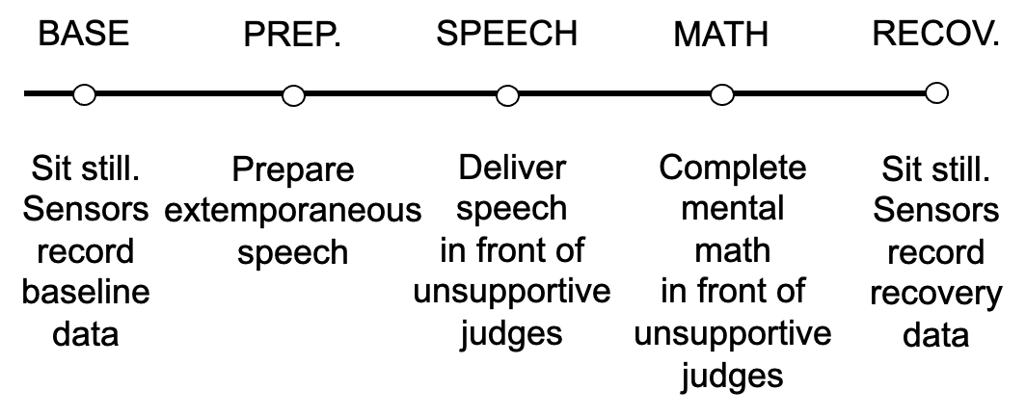
Physiological measures. The following measures were collected during baseline and throughout the TSST: electrocardiography (ECG), impedance cardiography (ICG), and blood pressure (BP), along with skin conductance from an ambulatory (i.e. wrist-worn) sensor. ECG and ICG signals were sampled at 1000 Hz, and integrated with a Biopac MP150 system. ECG sensors were affixed in a Lead II configuration. Biopac NICOO100C cardiac impedance hardware with band sensors (mylar tapes wrapped around participants’ necks and torsos) were used to measure impedance magnitude (Zo) and its derivative (dZ/dt). BP readings were obtained using Colin7000 systems. Cuffs were placed on participants' non-dominant arm to measure pressure from the brachial artery. BP recordings were taken at 2-min intervals during baseline, throughout the stress task, and recovery. BP recordings were initiated from a separate control room. ECG and ICG signals were scored offline by trained personnel. One-minute ensemble averages were analyzed using Mindware software IMPv3.0.21. Stroke volume (SV) was calculated using the Kubicek method ¹⁰. B- and X-points in the dZ/dt wave, as well as Q- and R-points in the ECG wave, were automatically detected using the maximum slope change method. Then, trained coders blind to other variables examined all placements and corrected erroneous placements when necessary.

The key analysis of gold-standard physiological measures sought to categorize individuals into threat vs. challenge groups using two key indices: total peripheral resistance (TPR) and stroke volume (SV). This suite is commonly used to threat- versus challenge-type stress responses (for a review see¹². TPR is the clearest indicator of threat-type responses and was therefore the focal outcome measure in this research; even so, we sought to identify only “true” challenge/threat responses, and so we also attended to SV, a commonly-accepted measure of “challenge” response. TPR assesses vascular resistance, and when threatened, resistance increases from baseline¹². TPR was calculated using the following validated formula: (MAP / CO) ∗ 80¹³. SV is the amount of blood ejected from the heart on each beat (on average per minute). Increases in SV index greater beat-to-beat cardiac efficiency and more blood being pumped through the cardiovascular system, and are often observed in challenge states, as the body spreads more oxygenated blood to the periphery¹⁰. Decreases in SV, on the other hand, are more frequently observed in threat states (even though threat can also elicit little or no change in SV). We computed reactivity scores by subtracting each person’s average levels from the five minutes of the baseline epoch. Thus, all TPR and SV results in the paper account for baseline differences.

Participants were categorized as showing a clear “threat-type” physiological profile when their TPR reactivity and SV reactivity (compared to baseline) were in the highest/lowest quartiles, respectively. They were categorized as showing a clear “challenge-type” physiological profile when their TPR and SV reactivity were in the lowest/highest quartiles, respectively. This “extreme groups” method was used to have very clearly different groups and to avoid ambiguity about the expected SCR values of more mixed challenge/threat profiles. (Note that in the primary study analyses used data from all participants).

SCR values were processed using the same, previously-validated scoring algorithm that was used in the primary police interaction study. The raw data from the devices were read into Python and the same processing scripts were run, which included the same decision rules for implausible biological values, outlying cases, and measurement artifacts, as well as the same function to calculate the second derivative at each moment. Overall, with this data, we could assess what patterns in SCR second derivative should be expected in unambiguous challenge/threat states.

Pilot study results. We found that the TSST validation study (Figure S2A-B) yielded differences in SCR across challenge/threat groups that were highly parallel to the differences across treatment/control groups in the police interaction study (Figure S2C-D). In Figure S2A, we present the minute-by-minute levels of SCR (second derivative) on the y-axis and minutes, across three study epochs, on the x-axis. Among those who were known, through TPR and SV measures, to show a challenge-type responses, we see an initial orienting response—higher SCR—which matches the prediction from BPS models that those with a challenge response should show greater initial SNS reactivity at the onset of a stressor relative to those with more of a threat-type response. In Figure S2B, we plot the “effect” of challenge vs. threat-type responses (i.e. the difference between the two kinds of responses) on SCR levels by minute. Again, we see clear evidence that challenge-type responses are associated with more positive initial SCR responses, and this fades as the interaction proceeds. In Figure S2C-D, we reproduce the results from the main study, and show that the experiment’s results were highly parallel. As a result of this validation study, we have stronger evidence for interpreting higher initial SCR levels (in S2C) as consistent with more positive, challenge-type stress responses, and lower initial SCR levels as a threat-type response.
Figure S2. Validity of SCR second derivative measure with respect to challenge/threat measures (A,B) and comparison to the present police interaction study (C,D). Note: In (A) and (C), lines are the posterior medians; In (B) and (D), the boxes are the IQRs and the lines are the 95% intervals.
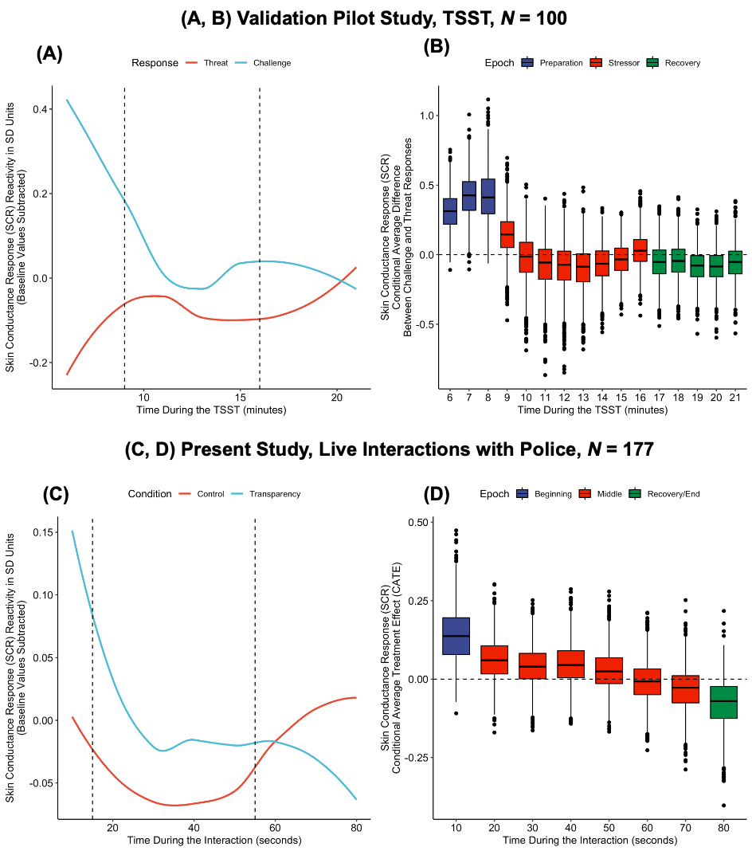
Experiment 1 Additional Results
Primary Outcomes: No moderation by participant demographic characteristics. There was no moderation by participant demographics on our primary outcomes of threat or trust (see Table S5).
Physiological Data: No confounding by condition or participant demographic characteristics. Some participants failed to press the button on the ambulatory device to indicate that the interaction had started. To ensure that there were no systematic differences between participants who did (vs. did not) press the button, we conducted logistic regression analyses. We found no evidence of confounding by condition or participant demographic characteristics (see Table S6).
Three-item version of trust. When including the third item assessing trust (which showed unexpectedly weak correlations with the other two items), we found that civilians in the transparency condition reported directionally more trust (M = 5.59, SD = 1.12) than those in the control condition (M = 5.30, SD = 1.19), p = .053, η² = .016. In effect, there were no treatment effect on the single item that showed very low reliability and appeared to confuse participants, but there was a meaningful effect (reported in the main text) on the two other items combined.

Inspiration. A final exploratory analysis examined the effect of the transparency statement on one of the primary goals of community policing: to inspire citizenry with respectful interactions. We found that just 14% of participants in the control condition reported feeling generally inspired at the end of the conversation with the officer, but this number was twice as high, 28%, in the transparency condition, pr(ATE>0) = .92. Although this finding was from an unplanned analysis, it was consistent with transcripts (such as the one depicted in Fig. 2B in the main text) and suggests a need for future research on the broader trust-building effects of transparent community policing.

Experiment 1 Results without Covariates

Manipulation Check: Perceptions of transparency of intentions. Similar to the results presented in the main text, civilians in the transparency condition perceived that the officer’s intentions were significantly clearer (M = 5.64, SD = 1.21) than those in the control condition (M = 4.40, SD = 1.61, p < .001, η² = .154).

Primary Measure 1: Threat of enforcement. Similar to the results presented in the main text, and in support of Hypothesis 1, civilians in the transparency condition felt significantly less threatened (M = 2.92, SD = 1.45) than those in the control condition (M = 3.40, SD = 1.41, p = .01, η² = .027).
Primary Measure 2: Trust in benevolence. Also similar to the results presented in the main text and in further support of Hypothesis 1, civilians in the transparency condition felt significantly more trust (M = 5.69, SD = 1.14) than those in the control condition (M = 5.31, SD = 1.28, p = .019, η² = .023).

Experiments 3-7 Moderation by Demographics

Primary Outcomes: Moderation by participant demographic characteristic. There was no consistent moderation by participant demographics on threat or trust (see Tables S7-8).

Table S2. Experiment 1: No Baseline Differences Between Conditions.
 | Control |  | Transparency Statement Condition |  | Test Statistic  (t or X²) | p
 | M or % | SD | M or % | SD | Test Statistic  (t or X²) | p
Age | 22.16 | 5.79 | 21.95 | 6.07 | 0.27 | .79
Gender  (1 = Male) | 42% |  | 42% |  | -0.02 | .99
Race  (1 = White) | 35% |  | 32% |  | 0.44 | .66
Native U.S.  (1 = Native) | 78% |  | 82% |  | -0.82 | .41
Education level | 3.66 | 1.32 | 3.47 | 1.32 | 1.11 | .27

Table S3. Experiment 1: No Baseline Demographic Differences by Weekday.
 | Tuesday |  |  | Wednesday |  |  | Thursday |  |  | Friday |  |  | Saturday |  |  | Sunday
 | b | t or Z | p | b | t or Z | p | b | t or Z | p | b | t or Z | p | b | t or Z | p | b | t or Z | p
Age | 0.65 | 0.44 | .66 | 1.81 | 1.29 | .20 | 1.83 | 1.26 | .21 | 2.52 | 1.61 | .11 | 0.16 | 0.09 | .93 | 1.26 | 0.73 | .47
Gender  (1 = Male) | 0.17 | 0.35 | 0.73 | 0.16 | 0.32 | .75 | -0.16 | -0.33 | .75 | 0.17 | 0.32 | .75 | 0.31 | 0.54 | .59 | 0.90 | 1.51 | .13
Race  (1 = White) | -0.54 | -1.01 | .31 | -0.20 | -0.41 | .68 | 0.15 | 0.30 | .77 | 0.30 | 0.57 | .57 | -0.73 | -1.15 | .25 | -0.61 | -0.94 | .35
Native U.S.  (1 = Native) | 0.34 | 0.57 | .57 | -0.05 | -0.09 | .93 | 1.08 | 1.58 | .11 | 0.50 | 0.77 | .44 | 0.08 | 0.12 | .91 | -0.74 | -1.17 | .24
Education level | 0.03 | 0.08 | .94 | 0.64 | 2.07 | .04* | -0.06 | -0.18 | .85 | -0.13 | -0.37 | .71 | -0.04 | -0.11 | .92 | 0.40 | 1.06 | .29

Table S4. Experiment 1 Means, Standard Deviations, and Correlations.
Variable | Mean | S.D. | 1 | 2 | 3 | 4 | 5 | 6 | 7 | 8 | 9 | 10 | 11
1. Condition
(1 = Transparent)
2. Transparency | 4.95 | 1.57 | 0.39***
3. Threat | 3.19 | 1.44 | -0.17* | -0.33***
4. Trust  (3-item) | 5.43 | 1.17 | 0.13⁺ | 0.23*** | -0.54***
5. Trust  (2-item) | 5.47 | 1.23 | 0.15* | 0.23*** | -0.55*** | 0.92***
6. Threat (PANAS) | 0.26 | -- | -0.20** | -0.21*** | 0.36*** | -0.44*** | -0.39***
7. Inspired (PANAS) | 0.20 | -- | 0.16* | 0.24*** | -0.22*** | 0.35*** | 0.34*** | -0.30***
8. Race  (1 = White) | 0.34 | 0.47 | -0.03 | 0.06 | 0.02 | 0.16* | 0.13* | -0.02 | 0.04
9. Gender  (1 = Male) | 0.42 | 0.49 | 0.00 | 0.10 | -0.12⁺ | 0.02 | 0.07 | -0.11⁺ | 0.00 | 0.02
10. Education level | 3.57 | 1.32 | -0.07 | -0.10 | 0.05 | -0.03 | -0.01 | 0.08 | -0.13* | 0.04 | 0.02
11. Age | 22.07 | 5.90 | -0.02 | -0.03 | -0.01 | 0.08 | 0.10 | 0.00 | 0.07 | 0.18* | -0.05 | 0.52***
12. U.S. Native  (1 = Native) | 0.80 | 0.41 | 0.05 | 0.08 | 0.07 | 0.00 | -0.02 | 0.11⁺ | 0.07 | 0.25*** | -0.01 | -0.19*** | -0.02
Note: * p < .05, ** p < .01, *** p < .001.

Table S5. Experiment 1: No Evidence of Moderation of the Transparency Statement Intervention on Threat and Trust by Individual Differences.
 | Threat |  |  | Trust
Moderator tested | b | t | p | b | t | p
Age | -0.02 | -0.62 | .54 | -0.01 | -0.50 | .61
Gender  (1 = Male) | 0.16 | 0.41 | .68 | -0.07 | -0.22 | .82
Race  (1 = White) | -0.46 | -1.17 | .24 | -0.27 | -0.81 | .42
Native U.S.  (1 = Native) | -0.41 | -0.89 | .38 | -0.18 | -0.45 | .65
Education level | -0.24 | -1.69 | .09 | -0.03 | -0.27 | .79
Note: Each row represents the test of a Transparency Statement Intervention × Moderator interaction in a separate regression model that also includes in it the condition variable and the moderator. b=unstandardized regression coefficient. Results from multiple linear regressions models utilizing null hypothesis tests and two-tailed p-values.

Table S6. Experiment 1: No Evidence of Confounding on Ambulatory Device Button Pushing by Condition or Individual Differences.
 | Button Press (1 = pressed)
Moderator tested | b | Z | p
Age | 0.04 | 0.62 | .54
Gender  (1 = Male) | -0.95 | -1.29 | .20
Race  (1 = White) | -0.30 | -0.39 | .69
Native U.S.  (1 = Native) | -0.08 | -0.09 | .93
Education level | 0.15 | 0.28 | .59
Perceived transparency | 0.32 | 1.12 | .26
Threat | 0.01 | 0.04 | .97
Trust | -0.04 | -0.12 | .90
Note: Each row represents the test of a Transparency Statement Intervention × Moderator interaction in a separate regression model that also includes in it the condition variable and the moderator. b=unstandardized regression coefficient. Results from logistic regressions models utilizing null hypothesis tests and two-tailed p-values.

Table S7. Experiment 2: No Evidence of Consistent Moderation of the Transparency Statement Intervention on Outcomes by Demographic Group Membership.

Moderator | Threat | Trust—Integrity | Initiate Rapport with Officer | Initiate Rapport with Another Officer | Return  Rapport Officer
Age | ns | ns | .059+ | ns | ns
Gender  (male=1) | ns | ns | ns | ns | ns
Underrepresented Minority Status  (URM=1) | ns | ns | .02* | ns | ns
Native  (Native=1) | ns | .036* | ns | ns | ns
Education | ns | ns | ns | ns | ns
Income | ns | ns | ns | ns | ns
Economic Conservatism | .002** | ns | .03* | .053+ | ns
Social Conservatism | .018* | ns | .03* | .096+ | ns
Baseline Police Warmth | .054+ | ns | .036* | ns | .087+
Prior Police Contact  (prior contact = 1) | ns | ns | .054+ | .059+ | .022*

Note: + p < .10, * p < .05, ** p < .01.
Table S8. Experiments 3-7: No Evidence of Moderation of the Transparency Statement Intervention on Threat by Individual Differences.
Moderator tested | Experiment 3 |  |  | Experiment 4 |  |  | Experiment 5 |  |  | Experiment 6 |  |  | Experiment 7
Moderator tested | b | t | p | b | t | p | b | t | p | b | t | p | b | t | p
Age | -0.004 | -0.26 | .80 | -0.007 | -1.83 | .07 | 0.006 | 0.36 | .72 | 0.03 | 1.67 | .10 | 0.008 | 0.53 | .60
Gender  1 = Male | 0.33 | 1.08 | .28 | 0.07 | 0.49 | .62 | 0.13 | 0.36 | .72 | -0.61 | -1.59 | .11 | 0.23 | 0.64 | .52
Race  1 =White | -0.76 | -2.11 | .04* | 0.08 | 0.42 | .67 | -0.20 | -0.57 | .57 | -0.50 | -1.14 | .25 | -0.20 | -0.51 | .61
Education level | 0.03 | 0.26 | .80 | 0.008 | 0.12 | .90 | -0.02 | -0.19 | .85 | -- | -- | -- | -- | -- | --
Note: Each row represents the test of a Transparency Statement Condition × Moderator interaction in a separate regression model that also includes in it the condition variable and the moderator. b=unstandardized regression coefficient.

Table S9. Experiment 1 treatment effects for LIWC text analyses.

 | Control |  | Transparency Statement Condition |  | ATE from BCF analysis in SD units
 | M | SD | M | SD | ATE from BCF analysis in SD units
Authentic | 46.26 | 37.34 | 69.44 | 28.71 | .43
Analytic | 17.65 | 23.75 | 15.99 | 15.82 | -.02
Clout | 62.23 | 35.56 | 43.42 | 33.42 | -.39
Tone | 74.72 | 32.21 | 69.28 | 28.72 | -.07
Note: The treatment effect on clout was unexpected. Post-hoc, this effect can be interpreted as a decrease in language meant to signal rank and hierarchy, which would be reasonable for people in the transparency condition if they, in fact, felt less of a need to show dominance and power in the interaction with the officer.

Table S10. Means, Standard Deviations, and Correlations for Experiment 2.
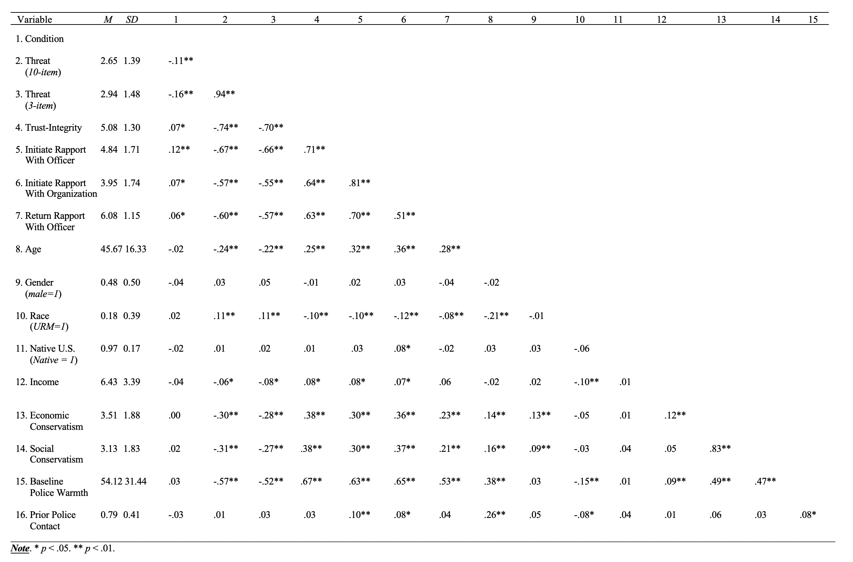
Table S11A-B. Means, Standard Deviations, and Correlations for Experiment 3.
Threat (n = 305)
Variable | Mean | SD | 1 | 2 | 3 | 4 | 5
1. Condition
(1 = Transparent)
2. Threat | 3.92 | 1.39 | -0.25***
3. Race  (1 = White) | 0.72 | -- | -0.04 | -0.09
4. Gender (1 = Male) | 0.47 | -- | -0.01 | 0.08 | -0.10⁺
5. Education level | 5.75 | 1.17 | 0.08 | -0.08 | 0.02 | -0.01
6. Age | 37.00 | 12.28 | 0.07 | 0.00 | 0.17*** | -0.09 | 0.02
Trust (n = 304)
Variable | Mean | SD | 1 | 2 | 3 | 4 | 5
1. Condition
(1 = Transparent)
2. Trust | 4.61 | 0.71 | 0.10⁺
3. Race  (1 = White) | 0.77 | -- | 0.00 | 0.09
4. Gender (1 = Male) | 0.46 | -- | 0.05 | -0.06 | 0.02
5. Education level | 5.68 | 1.14 | -0.05 | -0.03 | 0.04 | 0.08
6. Age | 37.24 | 12.82 | -0.11⁺ | 0.15* | 0.08 | -0.19*** | 0.16***
Note: * p < .05, ** p < .01, *** p < .001.

Table S12. Means, Standard Deviations, and Correlations for Experiment 4.
Variable | Mean | SD | 1 | 2 | 3 | 4 | 5 | 6
1. Condition
(1 = Aggressive Transparency)
2. Condition  (1 = Community Transparency) |  |  | -0.495***
3. Threat | 3.66 | 1.30 | 0.302*** | -0.308***
4. Race  (1 = White) | 0.77 | -- | -0.010 | 0.040 | 0.006
5. Gender (1 = Male) | 0.49 | -- | 0.039 | 0.089 | 0.133** | -0.058
6. Education level | 5.83 | 1.23 | 0.0003 | -0.010 | 0.046 | -0.048 | -0.089
7. Age | 38.52 | 12.54 | -0.037 | 0.063 | 0.001 | -0.069 | 0.027 | 0.059
Note: * p < .05, ** p < .01, *** p < .001.

Table S13. Means, Standard Deviations, and Correlations for Experiment 5.
Variable | Mean | SD | 1 | 2 | 3 | 4 | 5 | 6 | 7
1. Condition
(1 = Ambiguous Positivity)
2. Condition  (1 = Transparency) |  |  | -0.500***
3. Threat | 4.28 | 1.53 | 0.107* | -0.183***
4. Authenticity | 4.11 | 1.59 | -0.116* | 0.144** | -0.797***
5. Race  (1 = White) | 0.49 | -- | 0.006 | 0.026 | -0.086 | 0.068
6. Gender (1 = Male) | 0.50 | -- | 0.016 | -0.041 | 0.034 | -0.002 | 0.049
7. Education level | 4.24 | 1.44 | -0.059 | 0.036 | -0.011 | -0.014 | 0.149** | 0.098*
8. Age | 31.52 | 11.14 | 0.113* | -0.055 | -0.033 | 0.054 | 0.088 | 0.080 | 0.114*
Note: * p < .05, ** p < .01, *** p < .001.

Table S14. Means, Standard Deviations, and Correlations for Experiment 6.
Variable | Mean | SD | 1 | 2 | 3 | 4 | 5 | 6
1. Condition
(1 = Ambiguous Police)
2. Condition  (1 = Transparent Worker) |  |  | -0.340***
3. Condition  (1 = Transparent Police) |  |  | -0.332*** | -0.335***
4. Threat | 3.53 | 1.38 | 0.363*** | -0.194*** | 0.044
5. Race  (1 = White) | 0.76 | -- | -0.101 | 0.010 | 0.030 | -0.107*
6. Gender  (1 = Male) | 0.46 | -- | 0.015 | -0.017 | 0.054 | 0.0485 | -0.088
7. Age | 37.55 | 11.36 | -0.033 | 0.089 | -0.078 | -0.051 | 0.128* | -0.093
Note: * p < .05, ** p < .01, *** p < .001.

Table S15. Means, Standard Deviations, and Correlations for Experiment 7.
Variable | Mean | SD | 1 | 2 | 3 | 4 | 5 | 6
1. Condition
(1 = Ambiguous Police)
2. Condition  (1 = Transparent Ranger) |  |  | -0.33***
3. Condition  (1 = Transparent Police) |  |  | -0.33*** | -0.33***
4. Threat | 3.61 | 1.41 | 0.32*** | -0.18*** | -0.21***
5. Race  (1 = White) | 0.71 | -- | -0.10* | 0.12* | -0.09⁺ | -0.08⁺
6. Gender  (1 = Male) | 0.42 | -- | 0.10* | -0.03 | -0.09⁺ | 0.17*** | 0.00
7. Age | 37.86 | 12.87 | -0.03 | -0.02 | 0.03 | -0.16*** | 0.17*** | -0.14***
Note: * p < .05, ** p < .01, *** p < .001.
References

1. Hahn, P. R., Murray, J. S. & Carvalho, C. M. Bayesian regression tree models for causal inference: Regularization, confounding, and heterogeneous effects (with discussion). Bayesian Anal. 15, 965–1056 (2020).
2. McConnell, K. J. & Lindner, S. Estimating treatment effects with machine learning. Health Serv. Res. 54, 1273–1282 (2019).
3. Wendling, T. et al. Comparing methods for estimation of heterogeneous treatment effects using observational data from health care databases. Stat. Med. 37, 3309–3324 (2018).
4. Dorie, V., Hill, J., Shalit, U., Scott, M. & Cervone, D. Automated versus do-it-yourself methods for causal inference: Lessons learned from a data analysis competition. Stat. Sci. 34, 43–68 (2019).
5. Hahn, P. R., Dorie, V. & Murray, J. S. Atlantic causal inference conference (acic) data analysis challenge 2017. ArXiv Prepr. ArXiv190509515 (2019).
6. Chipman, H. A., George, E. I. & McCulloch, R. E. Bayesian treed models. Mach. Learn. 48, 299–320 (2002).
7. Gelman, A. Prior distributions for variance parameters in hierarchical models (comment on article by Browne and Draper). Bayesian Anal. 1, 515–534 (2006).
8. Gelman, A. You need 16 times the sample size to estimate an interaction than to estimate a main effect « Statistical Modeling, Causal Inference, and Social Science. https://statmodeling.stat.columbia.edu/2018/03/15/need-16-times-sample-size-estimate-interaction-estimate-main-effect/ (2018).
9. Kirschbaum, C., Pirke, K.-M. & Hellhammer, D. H. The ‘Trier Social Stress Test’–a tool for investigating psychobiological stress responses in a laboratory setting. Neuropsychobiology 28, 76–81 (1993).
10. Yeager, D. S., Lee, H. Y. & Jamieson, J. P. How to improve adolescent stress responses: Insights from integrating implicit theories of personality and biopsychosocial models. Psychol. Sci. 27, 1078–1091 (2016).
11. Dickerson, S. S. & Kemeny, M. E. Acute stressors and cortisol responses: a theoretical integration and synthesis of laboratory research. Psychol. Bull. 130, 355 (2004).
12. Blascovich, J. & Mendes, W. B. Social psychophysiology and embodiment. in Handbook of social psychology (ed. Fiske, D. t.) 194–227 (Wiley, 2010).
13. Sherwood, A. et al. Methodological guidelines for impedance cardiography. Psychophysiology 27, 1–23 (1990).

