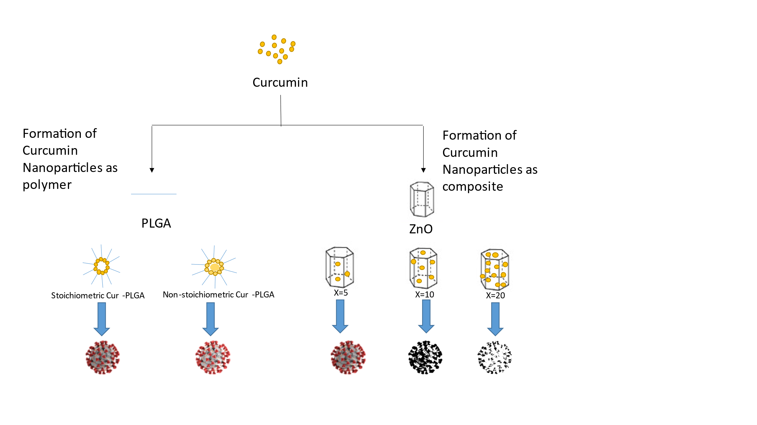
Graphical abstract
X is the percent of curcumin in Cur-ZnO nanocomposite

