The surveillance of patients hospitalised with COVID-19 in Norway: a comparison of two register-based systems
Supplement A

ICD-10 diagnosis codes from the Norwegian patient registry available for this study
Table S1. ICD-10 diagnosis codes from the Norwegian patient registry available to the authors for the comparison of admissions with COVID-19 in NPR and the Norwegian pandemic registry.
Disease group | ICD-10 code | Description
Certain infectious and parasitic diseases | A
Whooping cough | A370 | Whooping cough due to Bordetella pertussis
 | A371 | Whooping cough due to Bordetella parapertussis
 | A378 | Whooping cough due to other Bordetella species
 | A379 | Whooping cough, unspecified species
Certain infectious and parasitic diseases | B
Neoplasms | C
Neoplasms, Diseases of the blood and blood-forming organs and certain disorders involving the immune mechanism | D
Endocrine, nutritional and metabolic diseases | E
Mental, Behavioural and Neurodevelopmental disorders | F
Diseases of the nervous system | G
Diseases of the eye and adnexa, Diseases of the ear and mastoid process | H
Otitis media | H650 | Acute serous otitis media
 | H651 | Other acute nonsuppurative otitis media
 | H659 | Unspecified nonsuppurative otitis media
 | H660 | Acute suppurative otitis media
 | H664 | Suppurative otitis media, unspecified
 | H669 | Otitis media, unspecified
 | H670 | Otitis media in bacterial diseases classified elsewhere
 | H671 | Otitis media in viral diseases classified elsewhere
 | H678 | Otitis media in other diseases classified elsewhere
Diseases of the circulatory system | I
Diseases of the respiratory system | J
Acute upper respiratory infections | J00 | Acute nasopharyngitis [common cold]
 | J010 | Acute maxillary sinusitis
 | J011 | Acute frontal sinusitis
 | J012 | Acute ethmoidal sinusitis
 | J013 | Acute sphenoidal sinusitis
 | J014 | Acute pansinusitis
 | J018 | Other acute sinusitis
 | J019 | Acute sinusitis, unspecified
 | J020 | Streptococcal pharyngitis
 | J028 | Acute pharyngitis due to other specified organisms
 | J029 | Acute pharyngitis, unspecified
 | J030 | Streptococcal tonsillitis
 | J038 | Acute tonsillitis due to other specified organisms
 | J039 | Acute tonsillitis, unspecified
 | J040 | Acute laryngitis
 | J041 | Acute tracheitis
 | J042 | Acute laryngotracheitis
 | J050 | Acute obstructive laryngitis [croup]
 | J051 | Acute epiglottitis
 | J060 | Acute laryngopharyngitis
 | J068 | Other acute upper respiratory infections of multiple sites
 | J069 | Acute upper respiratory infection, unspecified
Influenza | J09 | Influenza due to identified zoonotic or pandemic influenza viruses
 | J100 | Influenza due to identified seasonal influenza virus with pneumonia
 | J101 | Influenza due to identified seasonal influenza virus with other respiratory manifestations
 | J108 | Influenza due to identified seasonal influenza virus with other manifestations
 | J110 | Influenza due to unidentified influenza virus with pneumonia
 | J111 | Influenza due to unidentified influenza virus with other respiratory manifestations
 | J118 | Influenza due to unidentified influenza virus with other manifestations
Pneumonia | J120 | Adenoviral pneumonia
 | J121 | Respiratory syncytial virus pneumonia
 | J122 | Parainfluenza virus pneumonia
 | J123 | Human metapneumovirus pneumonia
 | J128 | Other viral pneumonia
 | J129 | Viral pneumonia, unspecified
 | J13 | Pneumonia due to Streptococcus pneumoniae
 | J14 | Pneumonia due to Hemophilus influenzae
 | J150 | Pneumonia due to Klebsiella pneumoniae
 | J151 | Pneumonia due to Pseudomonas
 | J152 | Pneumonia due to staphylococcus
 | J153 | Pneumonia due to streptococcus, group B
 | J154 | Pneumonia due to other streptococci
 | J155 | Pneumonia due to Escherichia coli
 | J156 | Pneumonia due to other Gram-negative bacteria
 | J157 | Pneumonia due to Mycoplasma pneumoniae
 | J158 | Pneumonia due to other specified bacteria
 | J159 | Unspecified bacterial pneumonia
 | J160 | Chlamydial pneumonia
 | J168 | Pneumonia due to other specified infectious organisms
 | J170 | Pneumonia in bacterial diseases classified elsewhere
 | J171 | Pneumonia in viral diseases classified elsewhere
 | J172 | Pneumonia in fungal diseases
 | J173 | Pneumonia in parasitic diseases
 | J178 | Pneumonia in other diseases classified elsewhere
 | J180 | Bronchopneumonia, unspecified organism
 | J181 | Lobar pneumonia, unspecified organism
 | J182 | Hypostatic pneumonia, unspecified organism
 | J188 | Other pneumonia, unspecified organism
 | J189 | Pneumonia, unspecified organism
Other acute lower respiratory infections | J200 | Acute bronchitis due to Mycoplasma pneumoniae
 | J201 | Acute bronchitis due to Hemophilus influenzae
 | J202 | Acute bronchitis due to streptococcus
 | J203 | Acute bronchitis due to coxsackievirus
 | J204 | Acute bronchitis due to parainfluenza virus
 | J205 | Acute bronchitis due to respiratory syncytial virus
 | J206 | Acute bronchitis due to rhinovirus
 | J207 | Acute bronchitis due to echovirus
 | J208 | Acute bronchitis due to other specified organisms
 | J209 | Acute bronchitis, unspecified
 | J210 | Acute bronchiolitis due to respiratory syncytial virus
 | J211 | Acute bronchiolitis due to human metapneumovirus
 | J218 | Acute bronchiolitis due to other specified organisms
 | J219 | Acute bronchiolitis, unspecified
 | J22 | Unspecified acute lower respiratory infection
 | J80 | Acute respiratory distress syndrome in adults [ARDS]
Diseases of the digestive system | K
Diseases of the skin and subcutaneous tissue | L
Diseases of the musculoskeletal system and connective tissue | M
Diseases of the genitourinary system | N
Pregnancy, childbirth and the puerperium | O
Certain conditions originating in the perinatal period | P
Congenital malformations, deformations and chromosomal abnormalities | Q
Symptoms, signs and abnormal clinical and laboratory findings, not elsewhere classified | R
Injury, poisoning and certain other consequences of external causes | S
Injury, poisoning and certain other consequences of external causes | T
Codes for special purposes | U
COVID-19 | U071 | COVID-19, virus identified
 | U072 | COVID-19, virus not identified
External causes of morbidity | V
External causes of morbidity | W
External causes of morbidity | X
External causes of morbidity | Y
Factors influencing health status and contact with health services | Z

Distribution of ICD-10 diagnosis codes for admissions in NoPaR who were not registered with U07.1 in NPR
For admissions with main cause COVID-19 and other, U07.1 was the most common ICD-10 code registered (11,351/11,771 (96%) and 5,172/6,233 (83%), respectively). The distribution of ICD-10 codes who were not registered with U07.1 in NPR among the 420 admissions with main cause COVID-19, and 1061 with another main cause of admission in NoPaR are presented in figure S1.
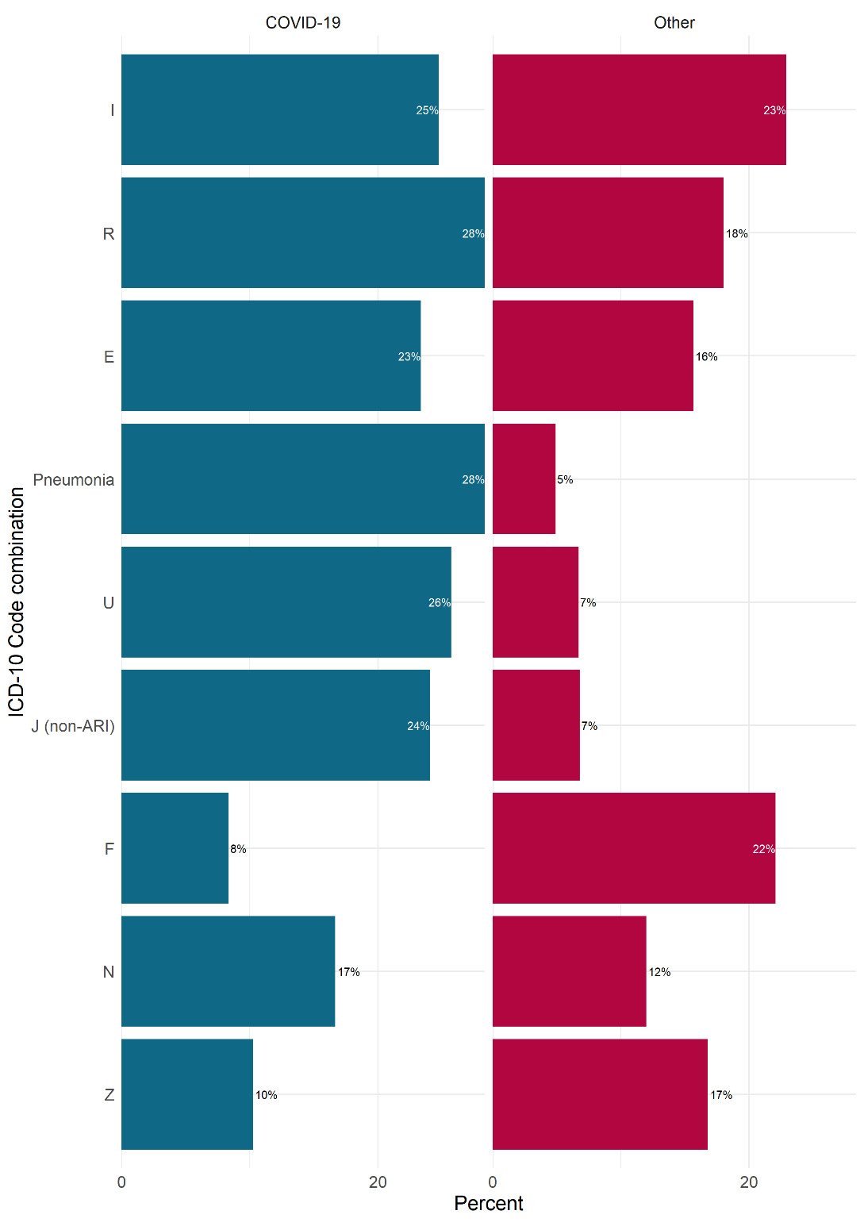
Figure S1. ICD-10 diagnosis codes most often registered in the Norwegian patient registry among admissions registered in the Norwegian pandemic registry by main cause of admission (COVID-19 or other), Norway, excluding patients registered with U07.1, 17 February 2020 – 1 May 2022. Only codes and code combinations with at least 15% of patients for either main cause are presented.
Pneumonia: ICD-10 codes J12-J18, excluding J12.1. J (non-ARI): respiratory diseases other than acute respiratory infections; ICD-10 codes from group J excluding J00-J22 and J80. For descriptions of other codes, see table S1.

ICD-10 diagnosis codes and code combinations by main cause of admission, age group and period
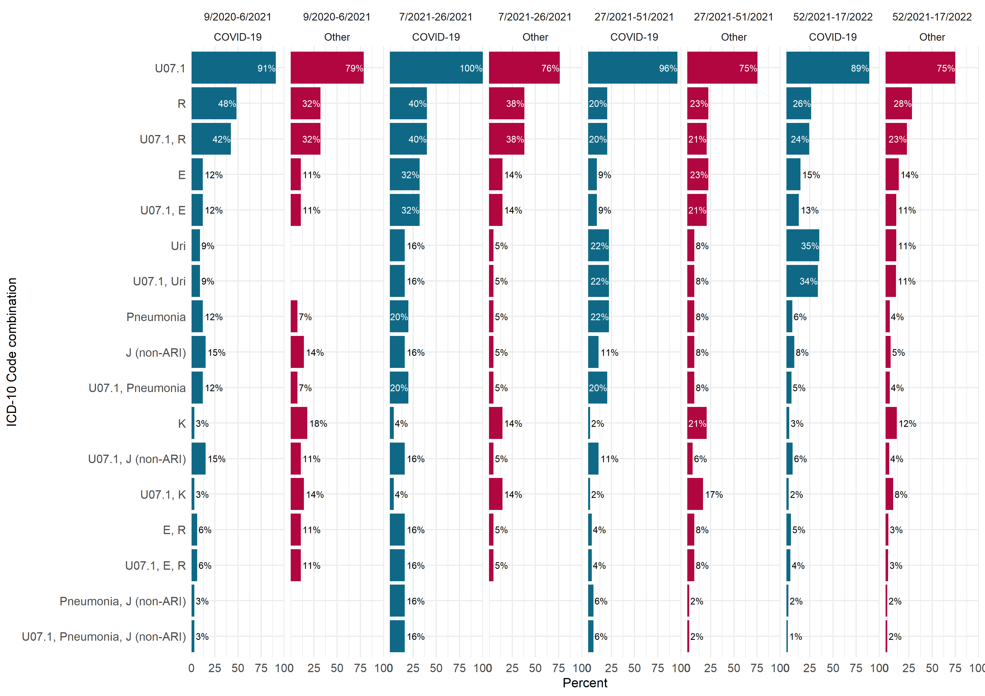
Figure S2. ICD-10 diagnosis codes most often registered in the Norwegian patient registry among admissions registered in the Norwegian pandemic registry, by main cause of admission (COVID-19 or other) and period (week/year), patients aged 0 – 17 years, Norway, 17 February 2020 – 1 May 2022. Only codes and code combinations with at least 15% of patients for either main cause in any period are presented.
Pneumonia: ICD-10 codes J12-J18, excluding J12.1. J (non-ARI): respiratory diseases other than acute respiratory infections; ICD-10 codes from group J excluding J00-J22 and J80. Uri: upper respiratory infections; ICD-10 codes J00-J06. For descriptions of other codes, see table S1.
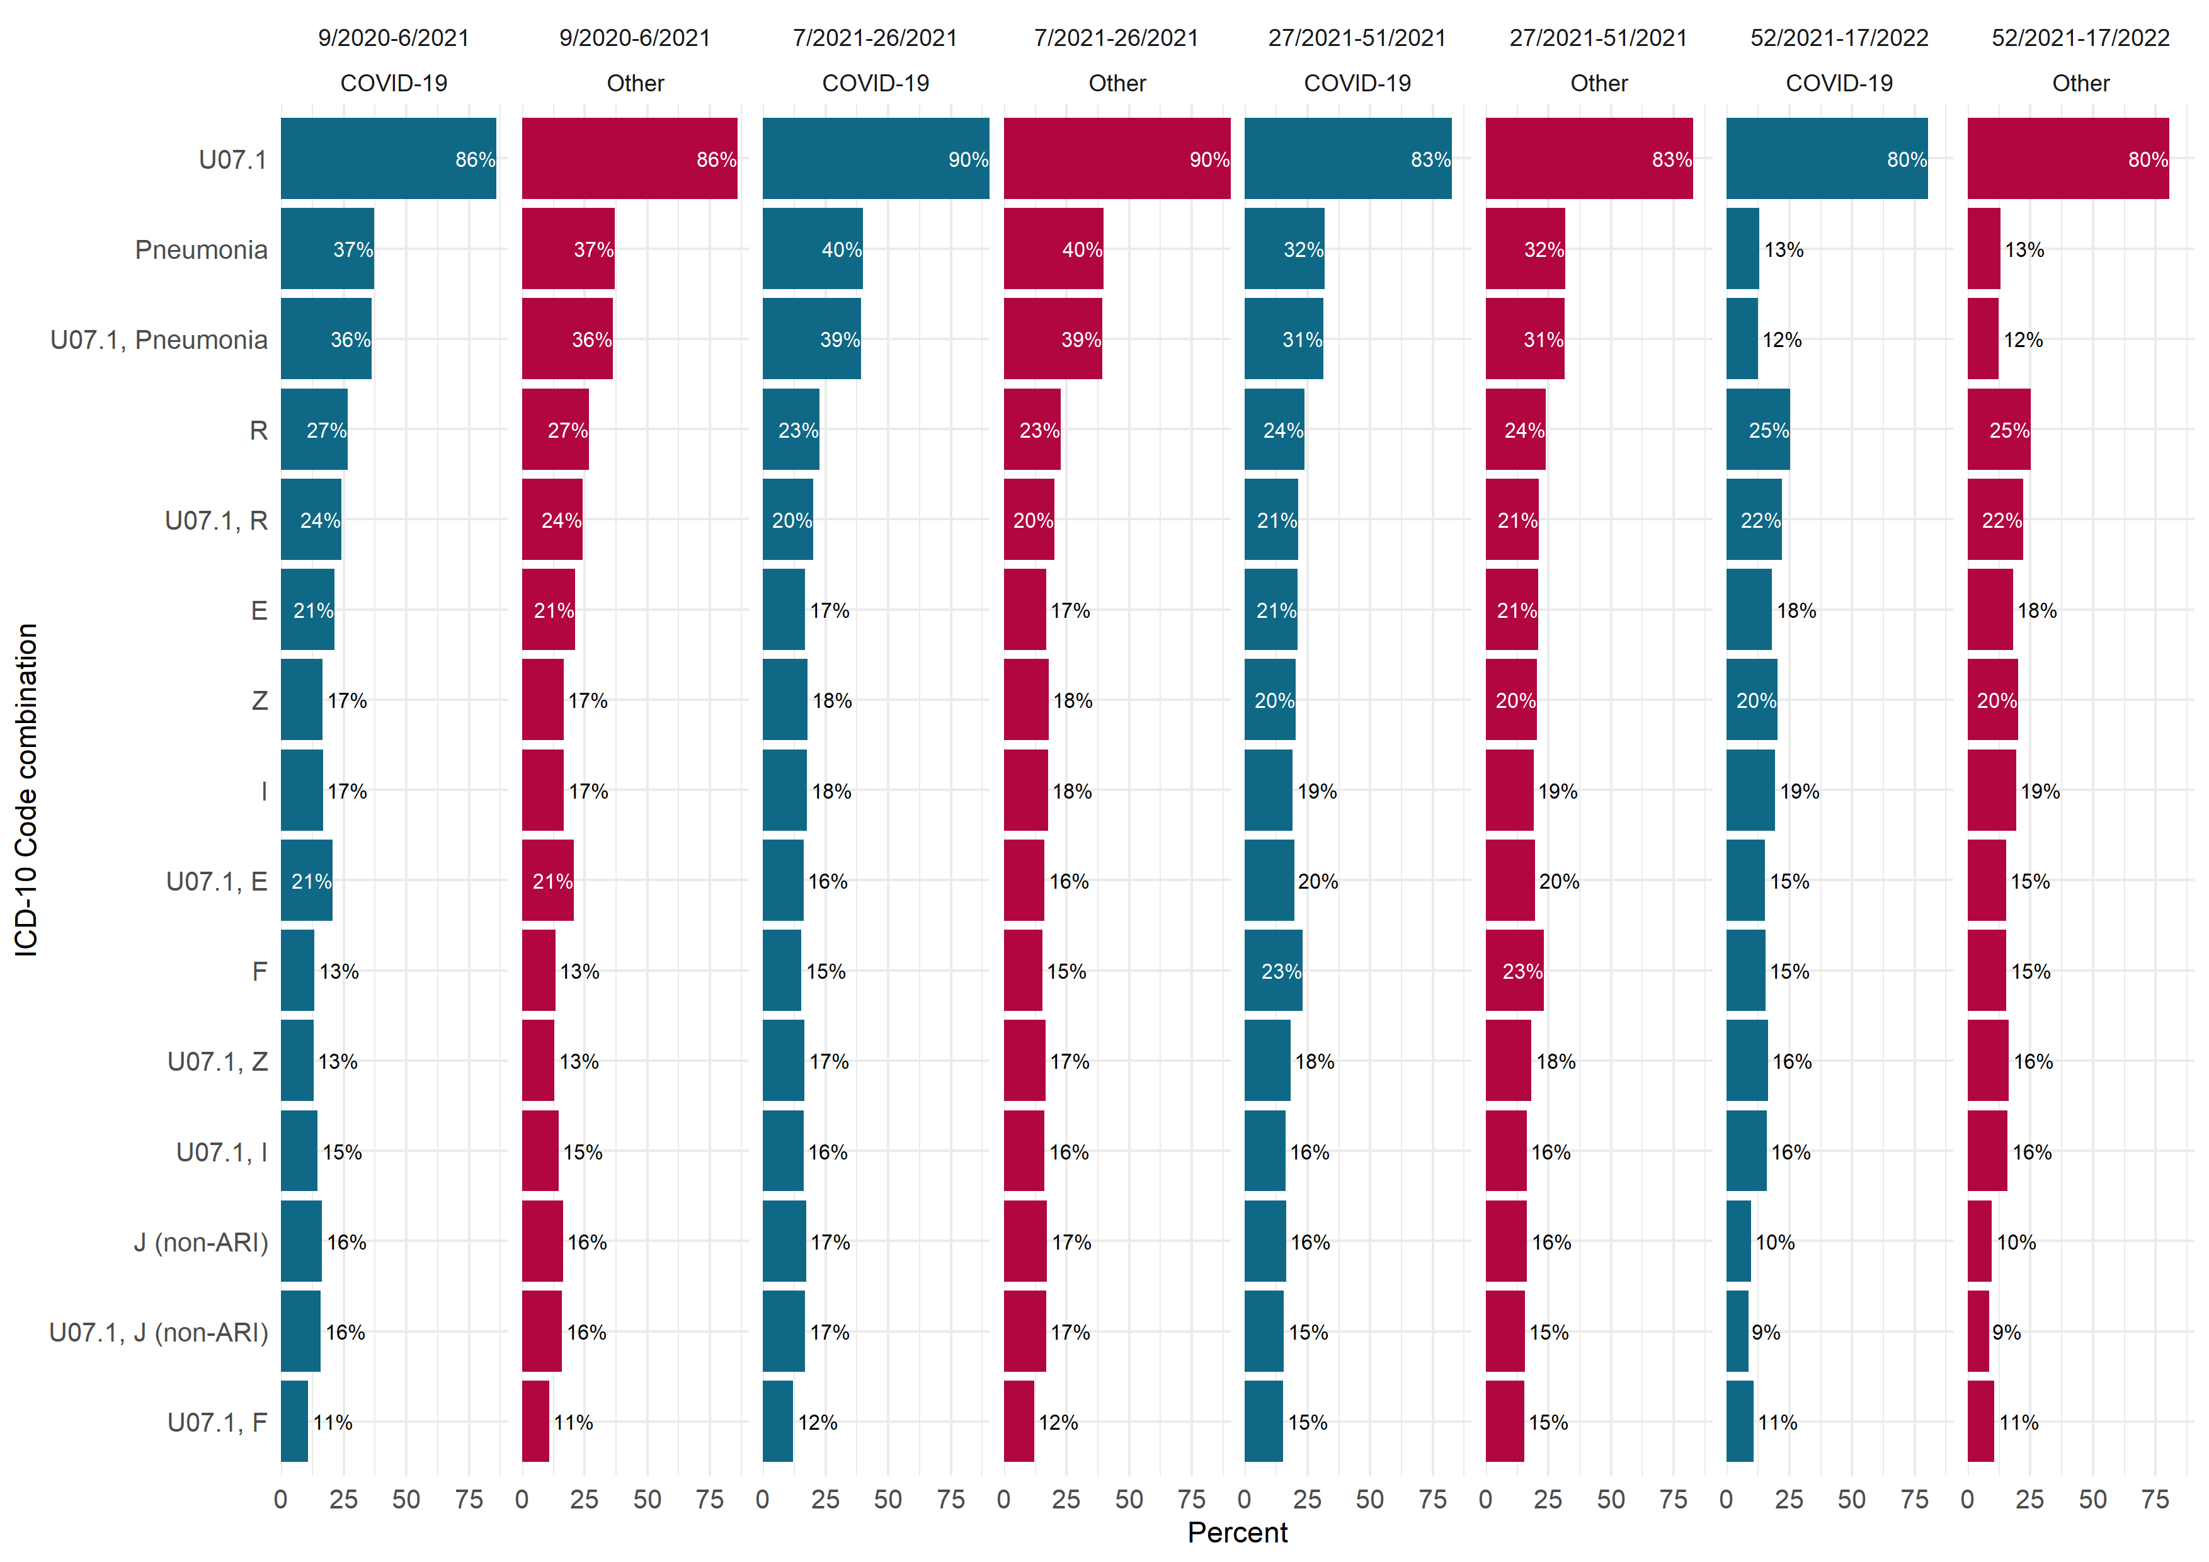
Figure S3. ICD-10 diagnosis codes most often registered in the Norwegian patient registry among admissions registered in the Norwegian pandemic registry, by main cause of admission (COVID-19 or other) and period (week/year), patients aged 18 – 74 years, Norway, 17 February 2020 – 1 May 2022. Only codes and code combinations with at least 15% of patients for either main cause in any period are presented.
Pneumonia: ICD-10 codes J12-J18, excluding J12.1. J (non-ARI): respiratory diseases other than acute respiratory infections; ICD-10 codes from group J excluding J00-J22 and J80. For descriptions of other codes, see table S1.
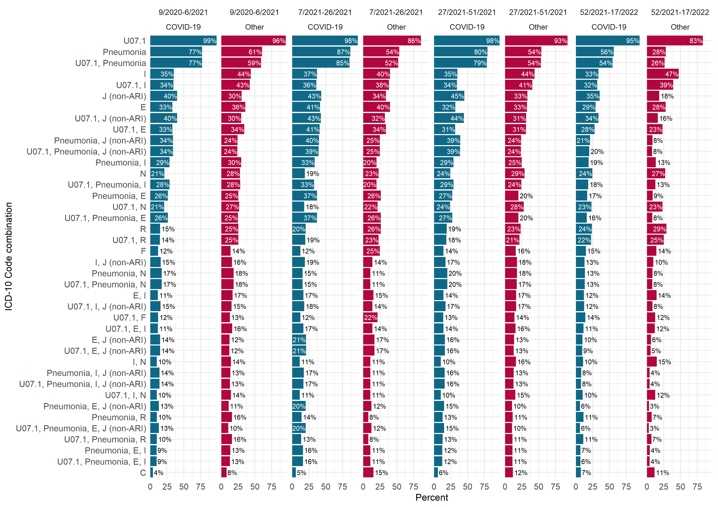
Figure S4. ICD-10 diagnosis codes most often registered in the Norwegian patient registry among admissions registered in the Norwegian pandemic registry, by main cause of admission (COVID-19 or other) and period (week/year), patients aged ≥75 years, Norway, 17 February 2020 – 1 May 2022. Only codes and code combinations with at least 15% of patients for either main cause in any period are presented.
Pneumonia: ICD-10 codes J12-J18, excluding J12.1. J (non-ARI): respiratory diseases other than acute respiratory infections; ICD-10 codes from group J excluding J00-J22 and J80. For descriptions of other codes, see table S1.

