Additional files

S1-The effect of modified composition of inoculation and co-cultivation media on kanamycin resistant calli (%) of various carnation cultivars

S2-The effect of modified composition of inoculation and co-cultivation media on gene transformation rate of various carnation cultivars

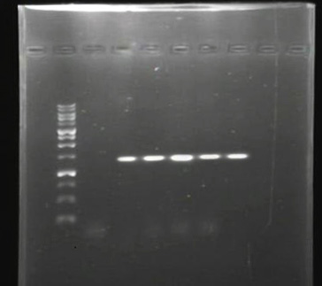

S3- Original gel image of Fig 2: PCR positive shoots recovered from all media

S4-The effect of supplementation of melatonin and LA in inoculation and co-cultivation media on gene transformation rate of various carnation cultivars

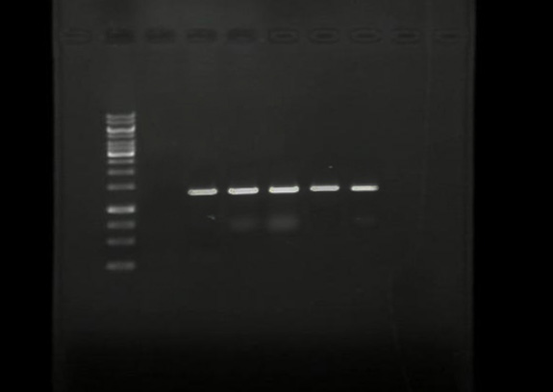

S5: Original gel image of Fig. 5: PCR positive shoots recovered from all media

