Supplementary Materials for

The evolution of Earth’s surficial Mg cycle over the past 2 billion years
Zhiguang Xia^{1,2,8}, Shilei Li^{2,3,8}, Zhongya Hu^{1,4}, Or Bialik⁵, Tianyu Chen^{1,2}, Mebrahtu F. Weldeghebriel⁶, Qishun Fan⁷, Junxuan Fan¹, Xiangdong Wang¹, Shichao An^{1,2}, Feifei Zhang¹, Haoran Xu^{1,2}, Jiayang Chen^{1,2}, Zhihan Ji^{1,2}, Shuzhong Shen¹, Tim K. Lowenstein^{6,*}, Weiqiang Li^{1,2*}
⁸ These authors contributed equally and are co-first authors: Zhiguang Xia, Shilei Li.
* Corresponding authors. Email address: lowenst@binghamton.edu (Tim K. Lowenstein); liweiqiang@nju.edu.cn (W. Li).

This PDF file includes:
Supplementary Text
Figs. S1 to S11
Tables S1 to S4
References

Supplementary Text

Mg isotope evolution in dolomitization fluids
Considering that the dolomitization process preferentially removes ²⁴Mg¹, it may drive the evolution of the δ²⁶Mg value of fluid and precipitated dolomite. Thus, the Mg isotopic composition of the contemporary dolostone profile formed in different sedimentary environments may show significant variation. A carbonate platform formed in the early-middle Cretaceous was chosen to illustrate this issue further.
Three sections from the Albian Levant Platform were selected from the inside out: the MG section in southern Israel², the SU section in central Israel³, and the HF section in northern Israel (Fig. S4). The Albian Levant platform becomes thicker and more extensively dolomitized from south to north. The depositional facies differ between the sites, alternating microbialites, floatstones, and mudstone to grainstone facies (texturally preserved despite dolomitization) in the MG section; laminated fine-grained (mudstone to wackestone, fine-grain textures at times preserved and in other times erased by dolomitization) deposits in the SU section; and exhibiting distal clinoforms capped with submarine channels in the HF section (fully dolomitized with no micro-textured preserved). Detrital beds were present in the MG section, whereas only marly layers were encountered in the SU section, and no indication of detrital material was found in the HF section. The Mg isotope composition of dolostone shows that the δ²⁶Mg values decrease gradually from south to north, and the range of variation was narrowed (Fig. S5). The pattern of Mg isotopes variation from the littoral towards the outer platform of the carbonate platform may indicate the restriction of the interior epi-platform water bodies. Therefore, only the Mg isotope values of the HF profile located in the outer platform may have reached equilibrium with contemporaneous seawater. The dolostone Mg isotope results demonstrate that Mg isotope evolution can occur spanning hundreds of kilometers. Therefore, the lowest δ²⁶Mg values of syn-depositional dolostones are more likely to be in equilibrium with seawater and have the potential to reconstruct the coeval seawater Mg isotope value^{2,3}.

The variability in marine halite δ²⁶Mg values
A series of Late Miocene halite samples from Egypt show a wide range of δ²⁶Mg values, but evidence of Sr isotopes (matching with contemporaneous seawater) excluded the possibility of non-marine contributions. We compared the elemental concentration and isotopic results and found that the δ²⁶Mg values were positively correlated with 1/Mg and 1/K, suggesting that the dissolution of other Mg-K-bearing evaporite minerals affected the measured Mg isotope values (Fig. S6).
To identify the Mg-K-bearing evaporite mineral, we performed detailed SEM-EDS analyses of Egyptian halite. As revealed by SEM observation, the two samples with the lowest Mg isotopes (δ²⁶Mg_{HUR-383}= -1.63‰ and δ²⁶Mg_{HUR-405}= -1.49‰) both contain a small amount of incorporated polyhalite (K₂Ca₂Mg(SO₄)·2H₂O) (Fig. S7). In sample HUR-383, polyhalite occurs in two forms, one as an independent mineral, and the other, associated with anhydrite. In sample HUL-405, polyhalite is characterized by large crystal size, euhedral morphology, and a clear boundary with halite. We also performed SEM observations on samples with higher δ²⁶Mg values (δ²⁶Mg _{HUR-518}= -0.78‰), and no evidence of Mg-bearing minerals in the halite was found.
Therefore, combined with the evidence of elemental concentration and SEM-EDS, we conclude that trace amounts of low-δ²⁶Mg polyhalite are the cause of variability of δ²⁶Mg in the bulk halite samples from Egypt. Furthermore, marine halite with the highest δ²⁶Mg value should thus be used for the reconstruction of seawater Mg isotope composition.

Run the model for the evolution of the Mg cycle for the past 2 Ga
With all the model parameters quantified, we next calculate the evolution of the Mg cycle. The calculation is similar to that described in Methods. For each MC calculation, a random time spot with an age of t is chosen, random values of δ_{carb-in}, f_{carb-in}, δ_{sili-in}, δ_{sw}, Δ_{carb-out}, and Δ_{sil-out} are generated by assuming that they follow normal distributions (Fig. S8 and Fig. S9 a, b and c). We generated a random value for f_{carb-out} following a uniform distribution between 0 and 1 (Fig. S9d). Then the corresponding δ_{sw} value is calculated using equations 3, 4, and 5 (Methods). If the computed δ_{sw} value matches the random value of δ_{sw}, the f_{carb-out} value is taken as a valid solution for the time spot. The MC calculations were repeated until about 25,000,000 solutions were obtained, after we ran the MC calculations 50,000,000,000 times. With these modeling results, we estimate the efficiency of CO₂ consumption of the Mg cycle (Ef_{Mg}), which equals the net carbonate burial efficiency because silicate weathering must provide Mg flux for this fraction of carbonate buried in the ocean and consequently CO₂ is removed from the atmosphere. For example, when Ef_{Mg} equals 1, silicate weathering provides all the Mg for the Mg carbonate burial. When it equals -1, all the Mg deposited as silicates are derived from carbonate weathering. Therefore, Ef_{Mg} is calculated as:
Ef_{Mg}= f_{carb-out}- f_{carb-in} (1)

To compare the state of the Mg cycle at 0 Ga to that at 2 Ga, using the MC approach described above, we produce 1,000,000 solutions for each of the two time points. Both results based on assumptions that f_{carb-in} increased from 0 to 0.42 during the past 3 Ga and that f_{carb-in} follows a uniform distribution between 0 and 1 are generated during the calculation. During the former calculation, for the calculation at 0 Ga and 2 Ga, f_{carb-in} is set as 0.42 ± 0.04 and 0.14 ± 0.04 following equation 7 (Methods), respectively. And δ_{carb-in} is set as 1.8 ± 0.2 ‰ and -0.91 ± 0.2 ‰, respectively, using the calculations of R-weighted average of δ²⁶Mg of the weathered dolostones, as described in Methods. The former results are presented as scatters and the latter ones expressed in graded color contours in Figure 2.

Supplementary discussion of the model
The modeled E_{Mg} decreased from about 0.66 to -0.03 from 2Ga towards the present. We argue that the decline is due to a climate modulation on the Mg cycle, which acts as a negative feedback on the geological carbon cycle. However, there is a possibility that the decline of E_{Mg} is due to our assumption that the fraction of Mg derived from carbonate weathering increased from 2Ga towards the present. Since E_{Mg} is the efficiency of CO₂ removal of the Mg cycle, that is, the CO₂ removal by every mole of Mg that participates in the Mg cycle, with more and more Mg released from carbonate weathering as we assume, even if the rates of silicate weathering, alteration of the oceanic crust, and marine clay formation kept constant, the E_{Mg} would decrease. In this case, the variations in E_{Mg} would have no effect on the carbon cycle.
To quantitively evaluate this possibility, two additional model runs are conducted. The first one is that we run the model by assuming a uniform distribution between 0 and 1 for f_{carb-in} instead of assuming that it increases from 0 to 0.42 from 3 Ga to 0 Ga, with the same assumptions for all the rest model parameters. The modeled E_{Mg} still shows a decreasing trend and decrease from about 0.404 to -0.062 from 2 to 0 Ga (Fig. S10). The magnitude of the decline of 0.47 in E_{Mg} is close to the modeled results (i.e., 0.69), assuming that f_{carb-in} increased with time. Therefore, our model results are not sensitive to the assumption about f_{carb-in}.

Another approach to test this possibility is to keep the rates of silicate weathering, alteration of the oceanic crust, and marine clay formation constant and at the same values at 2Ga, and calculate the evolution of E_{Mg} as f_{carb-in} increases. Since no parameters in our main equations, including equations 3, 4, and 5 (Methods), stand for the rates of these processes, a simplification is used in this calculation. Since the rates of these processes are constant, the ratio of (1- f_{carb-in})/(1- f_{carb-out}) consequently remains unchanged and is set as the value of (1- f_{carb-in})/(1- f_{carb-out}) at 2 Ga. The f_{carb-out} can be estimated from the constant ratio for every time spot. Then E_{Mg} is calculated as the difference between f_{carb-out} and f_{carb-in}, the same as we do in the main model. The model results show that E_{Mg} decreased from 0.66 to 0.45 from 2 to 0 Ga (Fig. S11). In other words, our assumption that f_{carb-in} increased with time drives 31% of the decline of the modeled E_{Mg}, and is not the main reason for the modeled changes in the Mg cycle during 0~2Ga.

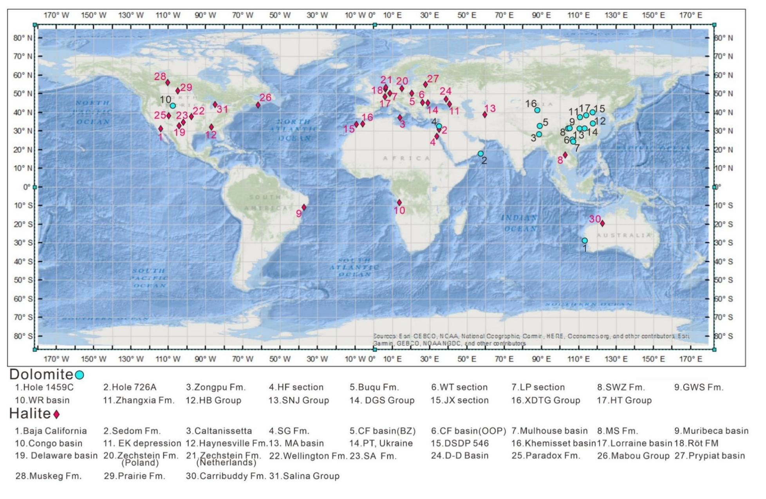
Fig. S1.
Location of marine dolostone and halite samples in this study. The light blue circle represents dolostone, and the red diamond represents halite.

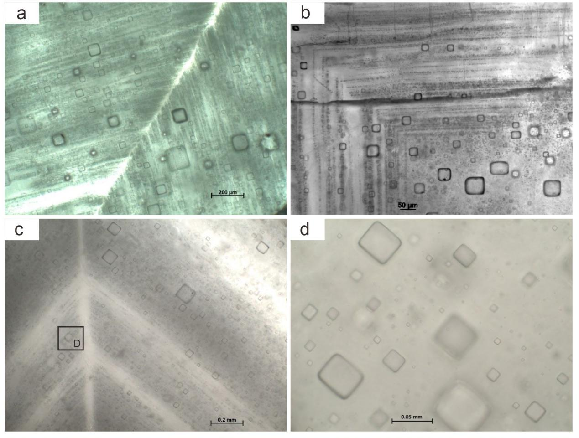

Fig. S2.
Photomicrograph showing a large number of primary fluid inclusions along vertically oriented growth bands of halite crystal from (a) Permian Dnipro-Donets Basin, Ukraine; (b) Cretaceous Maha Sarakham Formation, Laos; and (c) Serravallian-Tortonian Gulf of Suez, Hurghada, Egypt. (d) Close up view of Hurghada halite shows individual fluid inclusions with negative cubic shapes and varying size from 3 to 80 µm.

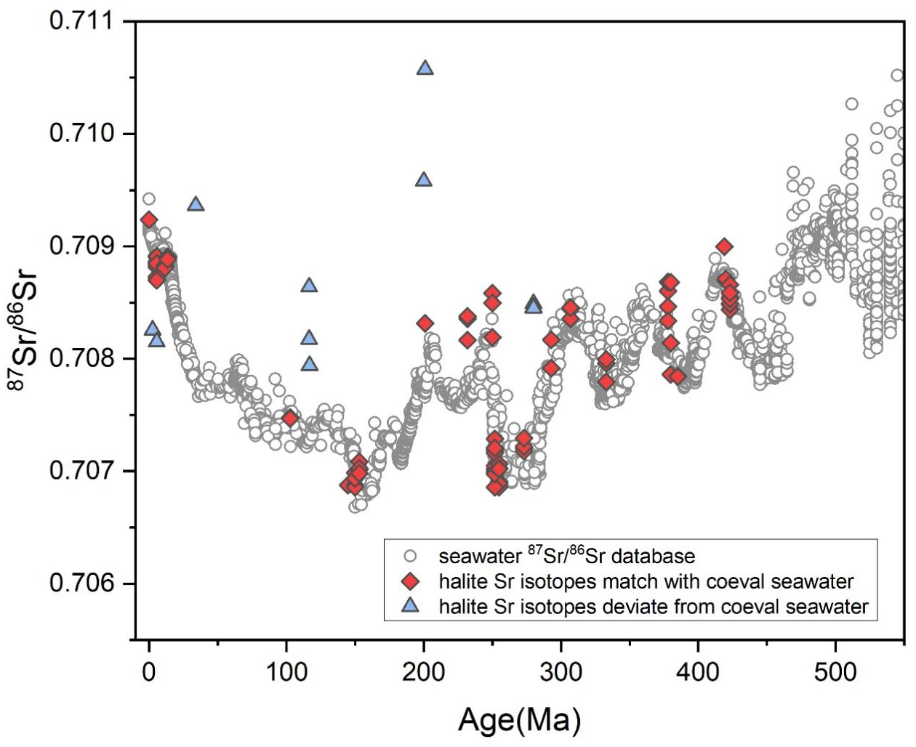
Fig. S3.
Comparison of ⁸⁷Sr/⁸⁶Sr isotopic ratios in halite and Phanerozoic seawater Sr isotope curve ⁴.

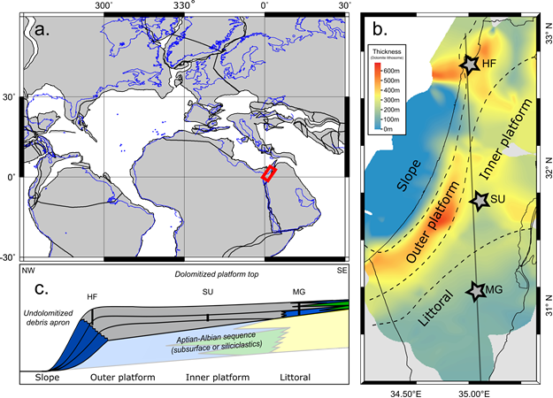
Fig. S4.
Study area and location of the Albian Levant Platform. (a) Paleogeographic reconstruction (http://www.odsn.de/) of the Albian and location of the study area; (b) Isopach map of the Yagur-Havyon Lithosome in Israel overline by paleogeographic domains and locations of the studied section; (c) Schematic cross-section of the Levant Albian Platform illustrating the relevant location and coverage of the studies section.

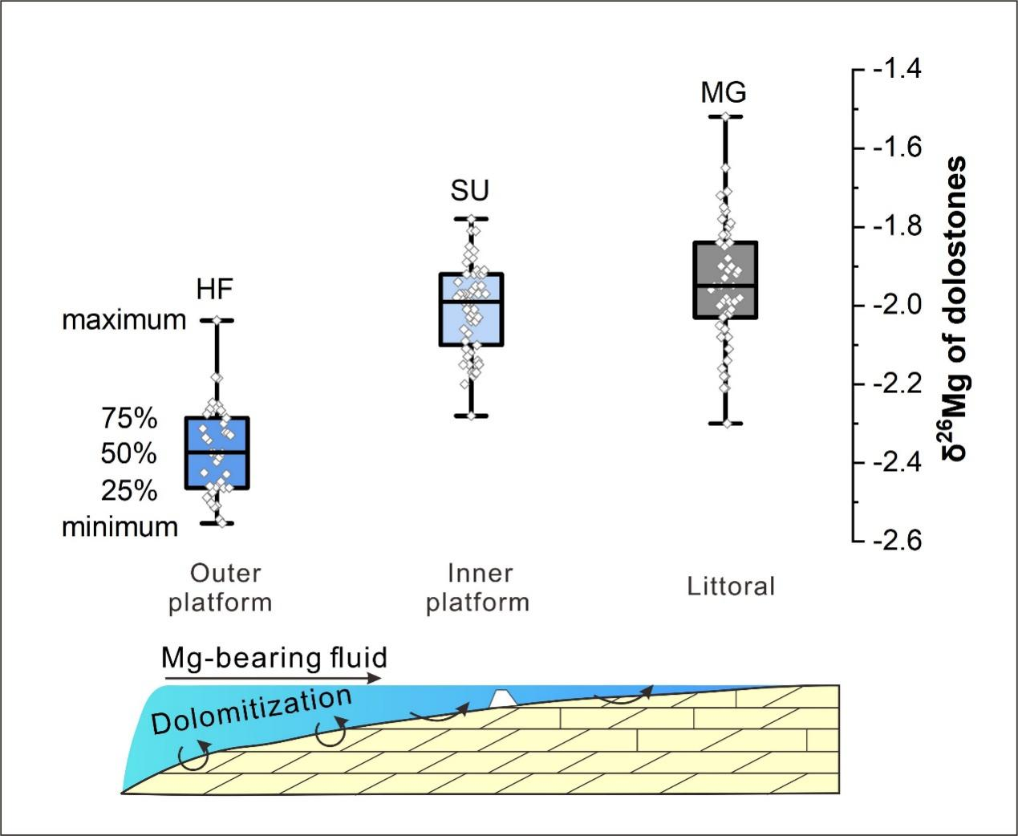
Fig. S5.
Dolostone δ²⁶Mg values shift away from marine values landward.

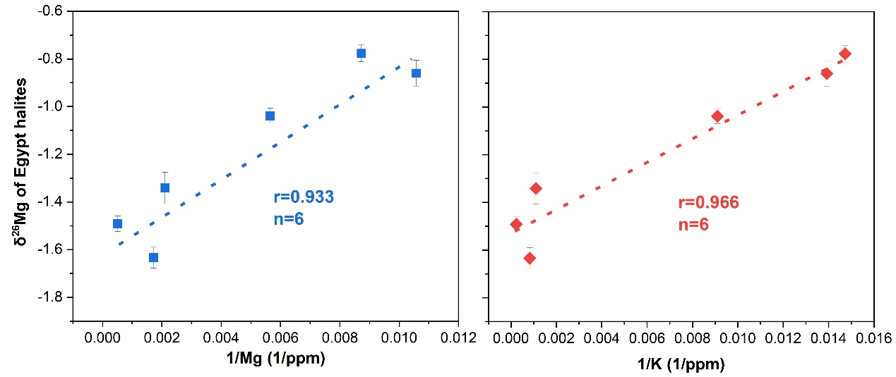
Fig. S6.
The plot of bulk halite δ²⁶Mg values from Egypt with 1/Mg and 1/K.

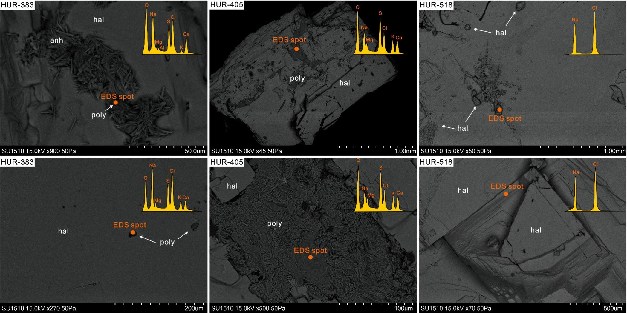
Fig. S7.
The microscopic observation and EDS analysis of the halite sample from Egypt. Abbreviations: anh-anhydrite; poly-polyhalite; hal-halite.

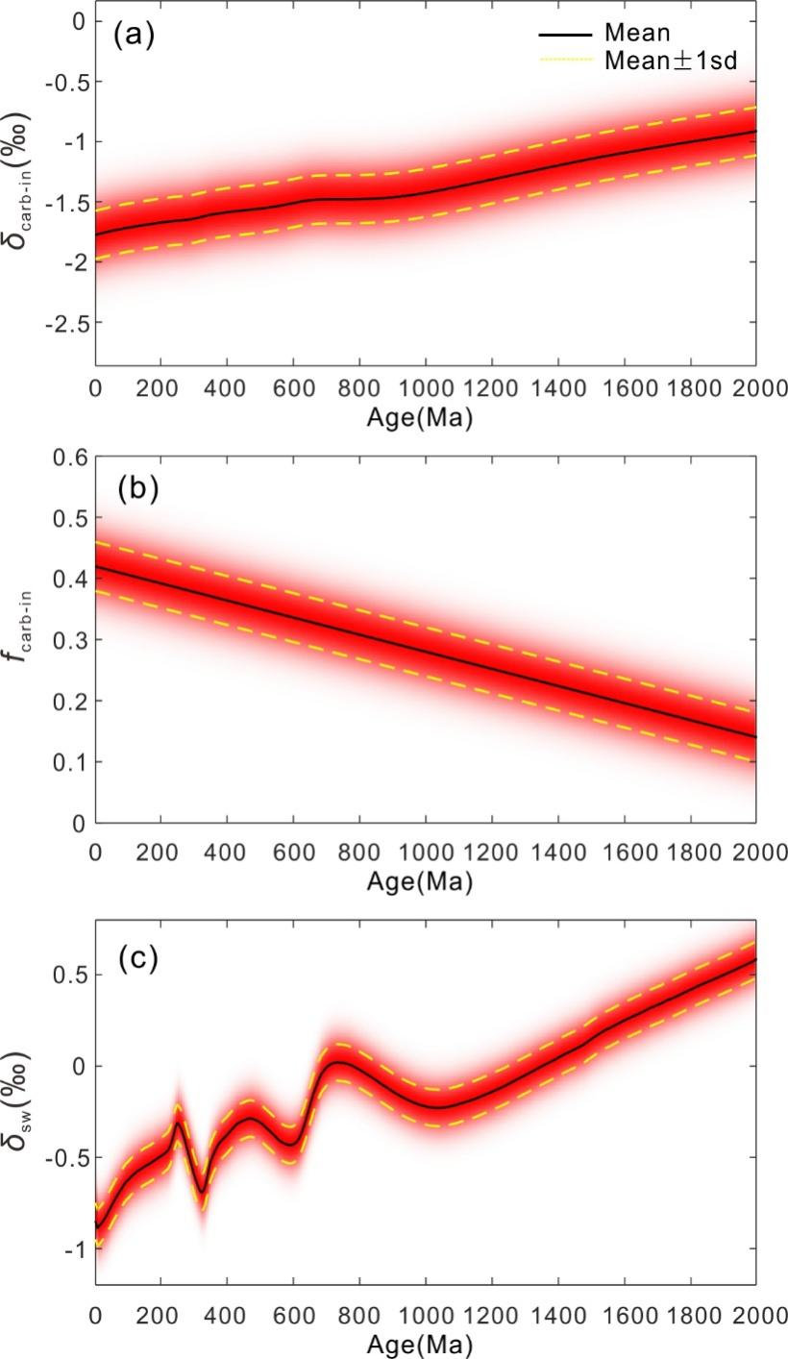
Fig. S8.
The value distribution of δ_{carb-in} (a), f_{carb-in} (b), and δ_{sw} (c). The black lines represent the mean values of the parameters, and the yellow lines stand for the mean ± 1sd values.

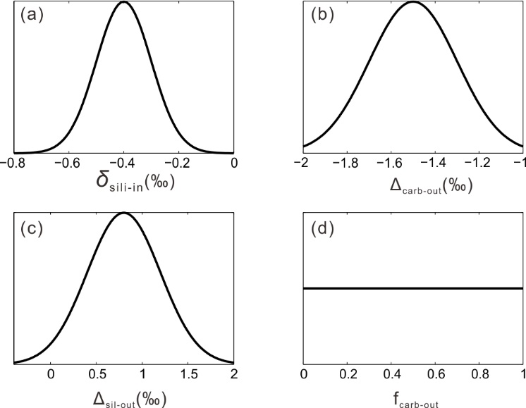
Fig. S9.
The value distribution of some model parameters including δ_{sili-in} (a), Δ_{carb-out} (b), Δ_{sil-out} (c) and f_{carb-out} (d).

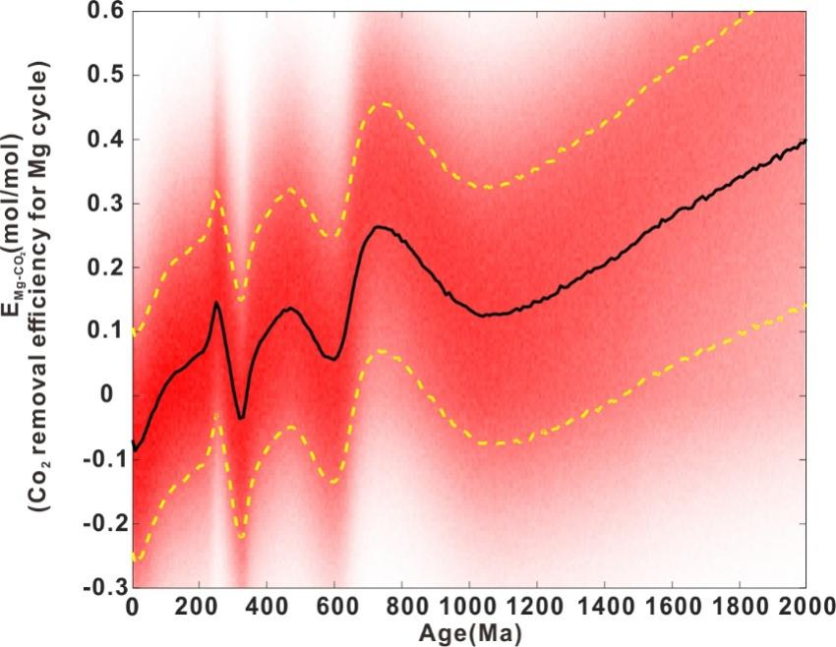
Fig. S10.
The modeled evolution of E_{Mg} without the f_{carb-in} assumption. The black lines represent the mean values of E_{Mg}, and the yellow lines stand for the mean ± 1sd values.

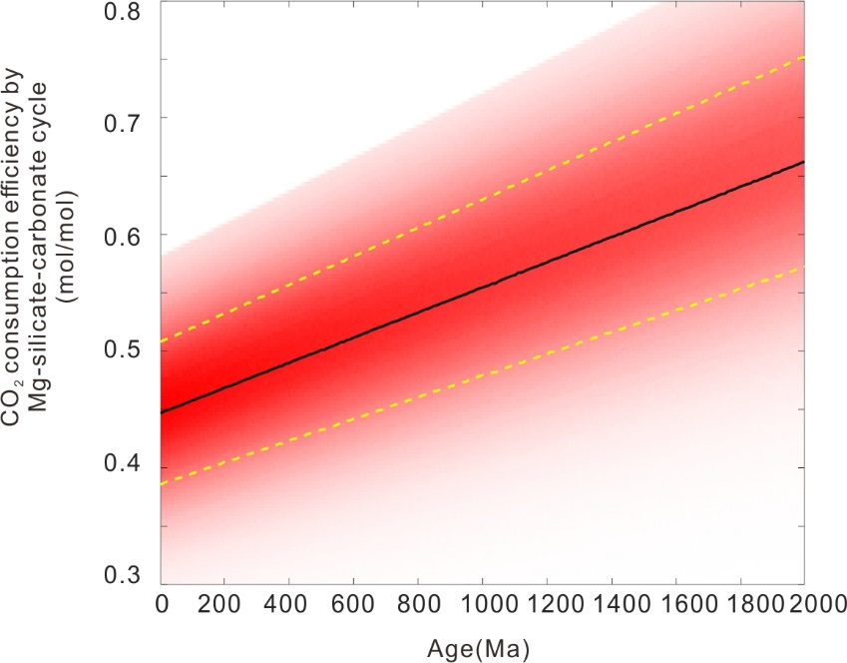
Fig. S11.
The modeled evolution of E_{Mg} by assuming constant rates of silicate weathering, alteration of oceanic crust, and marine clay formation. The black lines represent the mean values of E_{Mg}, and the yellow lines stand for the mean ± 1sd values.

Table S1.
Information on dolostone samples measured in this study.
Sample Information | Stratigraphic Unit | Age (Ma) | Reference (Age)
Hole U1459C, IODP 356 | early middle Eocene to Miocene | 48-5 | ⁵
Hole 726A, ODP 117 | Eocene to Holocene | 56-0 | ⁶
Zongou Formation, Tethyan Himalaya | Paleogene | 62-51 | ⁷
HF section, Albian Levant Platform | Albian, Cretaceous | 113-100 | ^{2,8}
Buqu Formation, Tibet | Middle Jurassic | 168-163 | ^{9,10}
Wangtang section, Guizhou, China | Serpukhovian-Bashkirian, Carboniferous | 330-315 | ¹¹
Langping section, Guangxi, China | Serpukhovian-Bashkirian, Carboniferous | 330-315 | ¹¹
Shawozi Formation, Sichuan, China | late Frasnian to early Farnenian | ～372 | ¹²
Guanwushan Formation, Sichuan, China | Middle Devonian | 387-382 | ¹³
Madison Limestone, Wind River Basin | Early Mississippian, Carboniferous | 358-346 | ^{14,15}
Darby Formation, Wind River Basin, USA | Devonian and earliest Mississippian | ～360 | ¹⁴
Bighorn Formation, Wind River Basin, USA | Late Ordovician | 453-445 | ¹⁶⁻¹⁸
Gallatin Limestone, Wind River Basin, USA | Late Cambrian | 497-485 | ^{8,19}
Zhangxia Formation, Shaanxi, China | early Guzhangian of the Cambrian Series 3 | 504-500 | ²⁰⁻²²
Shijia Formation, Jiangsu, China | Tonian | 950-896 | ^{23,24}
Weiji Formation, Jiangsu, China | Tonian | 1069-896 | ^{24,25}
Jiuidngshan Formation, Jiangsu, China | Tonian | 1069-920 | ^{24,25}
Niyuan Formation, Jiangsu, China | Tonian | 940-1069 | ²⁴⁻²⁷
Shengnongjia group, Hubei, China | Mesoproterozoic | 1400-1100 | ²⁸⁻³⁰
Dagushi group, Hubei, China | Mesoproterozoic | 1400-1100 | ²⁸⁻³⁰
Wumishan Formation, Jixian, China | Mesoproterozoic | ～1487 | ³¹
Gaoyuzhuang Formation, Jixian, China | Mesoproterozoic | ～1577 | ³²⁻³⁴
Tuanshanzi Formation, Jixian, China | Mesoproterozoic | ～1640 | ³⁵⁻³⁷
Xingditage group, Tarim, China | Paleoproterozoic | ～1950 | ^{38,39}
Hutuo group, Shanxi, China | Paleoproterozoic | 2068-1958 | ^{40,41}

Table S2.
Compilation of marine dolostone Mg isotopes in published literature.
Sample Information | Stratigraphic Unit | Age (Ma) | Reference (Mg isotope) data) | Reference (Age)
Modern sabkha Abu Dhabi | Holocene | 0 | ⁴² | ⁴²
Dohat Faishakh Sabkha, Qatar | Holocene | 0 | ⁴³ | ⁴³
Arabian Gulf, Abu Dhabi | Pleistocene | 0.038 | ⁴⁴ | ⁴⁵
Ocean Drilling Program sites (1082, 1012) | late Miocene to the late Pleistocene | 4-1 | ⁴⁶ | ⁴⁶⁻⁴⁸
San Salvador, Bahamas | late Miocene to the Pliocene | 5-2 | ⁴⁹ | ⁵⁰
ODP Site 1196A | Miocene | 23.4-3.2 | ⁵¹ | ⁵²
Clino (Western flank of the Great Bahama Bank) | late Miocene to early Pliocene | 7.2-3.6 | ⁵³ | ⁵⁴
Undo (Western flank of the Great Bahama Bank) | late Miocene to early Pliocene | 7.2-3.6 | ⁵³ | ⁵⁴
Little Bahama Bank (LBB) | middle Miocene to Pliocene | 11.5-2.6 | ⁵³ | ⁵⁵
Xisha Islands | early Miocene to Pliocene | 23-5 | ⁵⁶ | ⁵⁷
ODP Sites 685 and 1230 | late Miocene | 11.6-5.3 | ⁵⁸ | ⁵⁹
Monterey formation, California | Miocene | 19-14 | ⁶⁰ | ⁶¹
Weradim Formation, Soreq | late Cenomanian, Cretaceous | 100-93.5 | ⁶² | ^{8,62}
MG section, Isreal | late Albian, Cretaceous | 105-100 | ² | ²
Shoresh section, IsraelSection | Albian, Cretaceous | 113-100 | ³ | ^{3,8}
Comanche Platform, south Texas, USA | Albian Edwards Group, Cretaceous | 110-105 | ⁶³ | ⁶⁴
Franconian Alp and Swabian Alp, German | Late Jurassic | 163-145 | ⁴⁴ | ^{65,66}
Mizpe Shlagim, Mediterranean basin | Middle Jurassic | 174-163 | ⁶² | ⁶⁷
Hauptdolomit, Austroalpine; Southern Alps, Austria and Italy | Norian, Late Triassic | 227-208 | ⁶⁸ | ^{8,68}
Hydra Island, Greece and Kalkkögel, Innsbruck, Austria | Norian, Late Triassic | 227-208 | ⁴⁴ | ^{8,44}
Western dolomites, Northern Italy | Anisian, Middle Triassic | 247-242 | ⁴⁴ | ^{8,44}
Geshan, Southeast China | Anisian, Middle Triassic | 247-242 | ⁶⁹ | ^{8,69}
GK-1 core, southern Austria | P-T boundary | 254-251 | ⁷⁰ | ^{71,72}
Dajiang and Yanggudong section, South China | P-T boundary | 254-251 | ⁷⁰ | ^{73,74}
Hydra Island, Greece and Kansas, USA | Late Permian | 259-251 | ⁴⁴ | ^{8,44}
New Mexico, USA | Permian | 260-251 | ⁴⁴ | ^{44,75}
Belgium | Middle Mississippian | 346-338 | ⁴⁴ | ^{8,44}
Madison Limestone | Early Mississippian | 358-346 | ⁷⁶ | ^{14,15}
Eifel, Germany | late Givetian, Devonian | 387-382 | ⁴⁴ | ^{8,44}
Winnipegosis Formation, Saskatchewan | Middle Devonian | 393-382 | ⁷⁷ | ^{8,77}
Red River, Saskatchewan | Late Ordovician | 458-443 | ⁷⁷ | ^{8,77}
Majiagou Formation, Beijing | Middle Ordovician | 470-458 | ⁷⁸ | ^{8,78}
George Group, Canada | Early to Middle Ordovician | 485-467 | ⁴² | ^{8,42}
Loushanguan Group in the Upper Yangtze Region | middle to late Cambrian | 509-485 | ⁷⁹ | ^{8,80}
Xuzhuang Fm., North China | middle Cambrian | 509-504 | ⁸¹ | ⁸²
Dengying Fm., Yangtze Platform | Ediacaran | 548-551 | ⁸³ | ^{84,85}
Late-Precambrian and Cambrian dolostones of the Siberian Platform | Ediacaran-Cambrian | 630-530 | ⁸⁶ | ^{8,86}
Member III of the Doushantuo Formation in the Yangtze Gorges area | Ediacaran, Neoproterozoic | 632-551 | ⁸⁷ | ⁸⁴
Shuurgat formations of the Tsagaan-Olom Group | Neoproterozoic | 632-584 | ⁸⁸ | ⁸⁹
Ol Formation of the Tsagaan-Olom Group | Neoproterozoic | 635-632 | ⁸⁸ | ⁸⁹
Mackenzie Mts., Canada | Cryogenian, Neoproterozoic | 635-632 | ⁹⁰ | ⁹¹⁻⁹³
Otavi Group in NW Namibia | Cryogenian, Neoproterozoic | 662-632 | ⁹⁴ | ^{91,92}
Nuccaleena Fm in South Australia; Ol Fm in Mongolia | Cryogenian, Neoproterozoic | ～635 | ⁹⁵ | ^{91,96}
Ongongo and Okaaru, Namibia | Cryogenian, Neoproterozoic | 662-639 | ⁹⁰ | ^{91,92,97}
Thorndike submember, Panamint Range | Cryogenian, Neoproterozoic | 660-640 | ⁹⁸ | ^{98,99}
Taishir Formation of the Tsagaan-Olom Group | Cryogenian, Neoproterozoic | 662-640 | ⁸⁸ | ⁸⁹
Coppercap Formation in northwestern Canada | Tonian, Neoproterozoic | 735-717 | ¹⁰⁰ | ^{97,101,102}
Wumishan Formation in Jixian area, North China | Calymmian, Mesoproterozoic | 1570-1440 | ¹⁰³ | ^{31,104,105}
The lesser Himalaya in central Nepal | Paleoproterozoic | 1896-1780 | ⁶² | ¹⁰⁶
Tulomozero Formation | Paleoproterozoic | ～2100 | ¹⁰⁷ | ¹⁰⁷

Table S3.
Information on marine halite samples in this study.
Sample Information | Stratigraphic Unit | Age (Ma) | Reference (Mg isotope data) | Reference (Age) | Reference (fluid inclusion)
Baja, California | Holocene | 0 | this study | ¹⁰⁸ | ¹⁰⁸
Caltanissetta, Italy | Messinian, late Miocene | 5.6 | this study | ^{109,110} | ¹⁰⁹
South Gharib Formation, Gulf of Suez, Hurghada, Egypt | Serravallian, late Miocene | 11.6 | this study | ¹¹¹ | ¹¹¹
Carpathian Foredeep Basin, BZ-lev-V,Bochnia Mine | Badenian, middle Miocene | 13.5 | this study | ^{112,113} | ¹¹⁴
Carpathian Foredeep Basin, OOP-23, Slanic-Prahova | Badenian, middle Miocene | 13.5 | this study | ^{112,113} | ¹¹⁴
Mulhouse Basin | early Rupelian, Oligocene | 34 | this study | ¹¹¹ | ^{111,115}
Maha Sarakham Formation, Laos, from borehole core L-1 | Albian-Cenomanian, Cretaceous | 103 | this study | ^{8,116} | ¹¹⁶
Muribeca Formation, Sergipe basin, Brazil, borehole core GTP-8 | Aptian, Cretaceous | 117 | this study | ^{8,116} | ¹¹⁶
Loeme Formation, Congo Basin | Aptian, Cretaceous | 117 | this study | ^{8,116} | ¹¹⁶
East-Kuban Depression, Russia, 3669m | Kimmeridgian-Tithonian, Late Jurassic | 145 | this study | ¹¹⁷ | ¹¹⁷
Kimmeridgian, Haynesville Formation, Champion-Klepac #1 core | Kimmeridgian-Tithonian, Late Jurassic | 150 | this study | ^{118,119} | ^{118,119}
Middle Asia Basin, Turkmenistan | Kimmeridgian-Tithonian, Late Jurassic | 150 | this study | ¹²⁰ | This study
Predobrodgea Trough, Ismailski salt deposit, Ukraine, core 1C | Kimmeridgian-Tithonian, Late Jurassic | 153 | this study | ^{117,118,121} | ^{117,118,121}
Khemisset Basin, Gissar Morocco | Late Triassic-Early Jurassic | 200 | this study | ¹²² | ¹¹⁸
Lorraine Basin, France | Olenekian, Triassic | 232 | this study | ^{8,123} | ¹²³
Rustler Formation, Delaware basin, USA | Lopingian, early Permian | 252 | this study | ^{118,124} | ¹¹⁸
Salado Formation, Delaware basin, USA | Lopingian, early Permian | 252 | this study | ^{125,126} | ^{125,126}
Salado Formation, New Mexico (U.S.A.) | Lopingian, early Permian | 252 | this study | ^{125,126} | ^{125,126}
Zachstein, Poland | Lopingian, early Permian | 252 | this study | ^{127,128} | ^{127,128}
Wellington Formation, Kansas Basin-Hutchinson Salt mine, Kansas,USA | Kungurian, middle Permian | 280 | this study | ^{126,129} | ¹²⁵
San Andres Formation, Palo Duro, Texas, USA | Kungurian, middle Permian | 273 | this study | ^{126,129} | ¹²⁶
Nikitovsk Formation, Dnipro-Donets Basin, Ukraine | Asselian, early Permian | 293 | this study | ^{126,130} | ¹³⁰
Paradox Formation, shafer dome, Utah, USA | Desmonian, Pennsylvanian | 307 | this study | ^{131,132} | ¹³¹
Mabou Group, Shubenacadie Basin, Nova Scotia, Canada | Asbian-Pendleian, Mississippian | 333 | this study | ^{131,133} | ¹³¹
Prypiat Basin, Belarus | Frasnian, Late Devonian | 378 | this study | ^{8,134} | ¹³⁴
Frasnian stage, Dnipro-Donefs Basin, Ukraine, 625.5m | Frasnian, Late Devonian | 378 | this study | ^{8,134} | ¹³⁴
Telegraph Member of the Muskeg Formation, Canada | Frasnian-Eifelian | 380 | this study | ^{8,135} | ¹³⁵
Salina Group, Michigan Basin, USA | Frasnian-Eifelian | 420 | this study | ^{136,137} | ¹³⁶
Bruggers 3–7 core (right column), Michigan Basin, USA (Salina Group) | Silurian | 423 | this study | ^{136,137} | ¹³⁶
Sedom Formation, Israel | Plio-Pleistocene | 2.6 | ¹³⁸ | ¹³⁹ | ¹¹⁸
DSDP Site 546, offshore Morocco | Early Jurassic | 200 | ¹³⁸ | ^{140,141} | ¹¹⁸
Keuper Formation, Lorraine Basin,France | Late Triassic | 232 | ¹³⁸ | ¹⁴² | ¹²³
Röt FM Formation, Netherlands | Early-Middle Triassic | 250 | ¹³⁸ | ^{8,143} | ¹⁴³
Salado Formation, New Mexico (U.S.A.) | late Permian | 255 | ¹³⁸ | ^{8,125} | ¹²⁵
Zechstein 2 FM, Netherlands | late Permian | 255 | ¹³⁸ | ^{8,144} | ¹⁴⁴
Prairie Formation, Western Canada | Middle Devonian | 385 | ¹³⁸ | ^{8,145} | ¹⁴⁶
Carribuddy Formation, Western Australia | early Silurian -Late Ordovician | 419 | ¹³⁸ | ^{8,118} | ¹¹⁸

Table S4.
The Mg-Sr isotopic composition of the standards.
Standards | δ²⁶Mg | 2SD | N | Instruments
DSM-3 | -0.01 | 0.10 | 110 | Nu 1700
Cam-1 | -2.62 | 0.09 | 89 | Nu 1700
HPS909104 | -0.72 | 0.11 | 36 | Nu 1700
A-Mg | -3.25 | 0.06 | 107 | Nu 1700
IAPSO seawater | -0.83 | 0.11 | 53 | Nu 1700
DTS-2 | -0.29 | 0.07 | 32 | Nu 1700
DSM-3 | 0.02 | 0.10 | 57 | Neptune
Cam-1 | -2.57 | 0.11 | 69 | Neptune
IAPSO seawater | -0.79 | 0.11 | 34 | Neptune
DTS-2 | -0.25 | 0.10 | 41 | Neptune
Standards | ⁸⁷Sr/⁸⁶Sr | 2SD | N | Instruments
NBS-987 | 0.710228 | 0.000033 | 100 | Triton
AGV-2 | 0.704000 | 0.000102 | 5 | Triton
IAPSO seawater | 0.709157 | 0.000047 | 8 | Triton

Reference:
1 Li, W., Beard, B. L., Li, C., Xu, H. & Johnson, C. M. Experimental calibration of Mg isotope fractionation between dolomite and aqueous solution and its geological implications. Geochimica et Cosmochimica Acta 157, 164-181, (2015).
2 Bialik, O. M. et al. Mg isotope response to dolomitization in hinterland-attached carbonate platforms: Outlook of δ²⁶Mg as a tracer of basin restriction and seawater Mg/Ca ratio. Geochimica et Cosmochimica Acta 235, 189-207, (2018).
3 Li, W. et al. Effects of early diagenesis on Mg isotopes in dolomite: The roles of Mn(IV)-reduction and recrystallization. Geochimica et Cosmochimica Acta 250, 1-17, (2019).
4 Prokoph, A., Shields, G. A. & Veizer, J. Compilation and time-series analysis of a marine carbonate δ18O, δ13C, 87Sr/86Sr and δ34S database through Earth history. Earth-Science Reviews 87, 113-133, (2008).
5 Gallagher, S. International Ocean Discovery Program Expedition 356 Preliminary Report: Indonesian Throughflow: A 5 million year history of the Indonesian Throughflow, Australian monsoon, and subsidence on the northwest shelf of Australia. (2017).
6 Prell, W. L. & Niitsuma, M. Init. Repts., 117: College Station, TX (Ocean Drilling Program). (1989).
7 Li, J., Hu, X., Garzanti, E., An, W. & Wang, J. Paleogene carbonate microfacies and sandstone provenance (Gamba area, South Tibet): Stratigraphic response to initial India–Asia continental collision. Journal of Asian Earth Sciences 104, 39-54, (2015).
8 Cohen, K. M. et al. The ICS International Chronostratigraphic Chart. International Union of Geological Sciences 36, 199-204, (2013).
9 Fang, X. et al. Mesozoic litho- and magneto-stratigraphic evidence from the central Tibetan Plateau for megamonsoon evolution and potential evaporites. Gondwana Research 37, 110-129, (2016).
10 Yin, J., Sun, L., Bai, Z. & Xu, D. New data on the Jurassic ammonites from the Shuanghu and Amdo areas, with comments on the Jurassic strata in north Tibet (in Chinese with English abstract). JOURNALOF STRATIGRAPHY 29, 7-15, (2005).
11 Yao, L. & Aretz, M. Upper Visean (Mississippian) metazoan-microbial reefs from Guangxi, South China: Insights regarding reef recovery after the end-Devonian extinction. Palaeogeography, Palaeoclimatology, Palaeoecology 560, 109994, (2020).
12 Chang, X. et al. Encrustation patterns on brachiopods from the Middle-Upper Devonian and their paleo-environmental implications. Palaeogeography, Palaeoclimatology, Palaeoecology 584, 110703, (2021).
13 Zhang, Y. et al. Genesis and characteristics of the dolomite reservoirs in Middle Devonian Guanwushan Formation, Northwest Sichuan Basin, SW China. Petroleum 6, 138-148, (2020).
14 Keefer, W. R. & Van Lieu, J. A. Paleozoic formations in the Wind River Basin, Wyoming. Report No. 495B, (1966).
15 Smith, L. B., Jr., Eberli, G. P. & Sonnenfeld, M. in Integration of Outcrop and Modern Analogs in Reservoir Modeling (eds G. Michael Grammer, Paul M. “Mitch” Harris, & Gregor P. Eberli) 0 (American Association of Petroleum Geologists, 2004).
16 Amsden, T. W. & Miller, A. K. Ordovician conodonts from the Bighorn Mountains of Wyoming. Journal of Paleontology 16, 301-306, (1942).
17 Stone, G. L. & Furnish, W. M. Bighorn conodonts from Wyoming. Journal of Paleontology 33, 211-228, (1959).
18 Sweet, W. C. in Aspects of the Ordovician System: Palaeontological Contributions from the University of Oslo (ed D. L Bruton) 23-35 (1984).
19 Miller, B. M. Cambrian Stratigraphy of Northwestern Wyoming. The Journal of Geology 44, 113-144, (1936).
20 Chough, S. K. et al. Cambrian stratigraphy of the North China Platform: revisiting principal sections in Shandong Province, China. Geosciences Journal 14, 235-268, (2010).
21 Jeong-Hyun, L., Jusun, W. & Dong-Jin, L. The earliest reef-building anthaspidellid sponge Rankenella zhangxianensis n. sp. from the Zhangxia Formation (Cambrian Series 3), Shandong Province, China. Journal of Paleontology 90, 1-9, (2016).
22 Meng, X., Ge, M. & Tucker, M. E. Sequence Sequence stratigraphy, sea-level changes and depositional systems in the Cambro-Ordovician of the North China carbonate platform. Sedimentary Geology 114, 189-222, (1997).
23 He, T. et al. in Earth System Evolution and Early Life: A Celebration of the Work of Martin Brasier Vol. 448 (eds A. T. Brasier, D. McIlroy, & N. McLoughlin) 0 (Geological Society of London, 2017).
24 Wang, Q., Yang, D. & Xu, W. Neoproterozoic basic magmatism in the southeast margin of North China Craton: Evidence from whole-rock geochemistry, U-Pb and Hf isotopic study of zircons from diabase swarms in the Xuzhou-Huaibei area of China. Science China Earth Sciences 55, 1461-1479, (2012).
25 Yang, D.-B. et al. U–Pb ages and Hf isotope data from detrital zircons in the Neoproterozoic sandstones of northern Jiangsu and southern Liaoning Provinces, China: Implications for the Late Precambrian evolution of the southeastern North China Craton. Precambrian Research 216-219, 162-176, (2012).
26 Gao, L. et al. Reclassification of the Meso- and Neoproterozoic Chronostratigraphy of North China by SHRIMP Zircon Ages. Acta Geologica Sinica - English Edition 83, 1074-1084, (2009).
27 Zhao, H. et al. New geochronologic and paleomagnetic results from early Neoproterozoic mafic sills and late Mesoproterozoic to early Neoproterozoic successions in the eastern North China Craton, and implications for the reconstruction of Rodinia. GSA Bulletin 132, 739-766, (2019).
28 Li, H. et al. Correlation between the Dagushi Group in the Dahongshan area and the Shennongjia Group in the Shennongjia Area on the northern margin of the Yangtze Craton: Constraints from zircon U–Pb ages and Lu-Hf isotopic systematics (in Chinese with English abstract). Earth Science Frontiers 23, 186-201, (2016).
29 Li, H. et al. Zircon and baddeleyite U-Pb geochronology of the Shennongjia Group in the Yangtze Craton and its tectonic significance (in Chinese with English abstract). Acta Petrologica Sinica 19, 673-697, (2013).
30 Liu, H., Xu, D., Wei, Y., Deng, C. & Peng, L. Depositional age of the Dagushi Group in the Dahong Mountain, Hubei Province: Evidence from U-Pb ages of detrital zircons (in Chinese with English abstract). Geological Bulletin of China 36, 715-725, (2017).
31 Li, H. et al. The first precise age constraints on the Jixian system of the Meso-to Neoproterozoic standard section of China: SHRIMP zircon U-Pb dating of bentonites from the Wumishan and Tieling formations in the Jixian section, North China Craton(in Chinese with English abstract). Acta Petrologica Sinica 30, 2999-3012, (2014).
32 Li, H. et al. Zircon U-Pb dating on tuff bed from Gaoyuzhuang formation in Yanqing, Beijing: further constraints on the new subdivision of the Mesoproterozoic stratigraphy in the Northern North China(in Chinese with English abstract). Acta Petrologica Sinica 26, 2131-2140, (2010).
33 Tian, H. et al. SHRIMP U-Pb dating for zircons from the tuff bed of the Mesoproterozoic Gaoyuzhuang Formation in Jixian Section, Tianjin, and its constraints on the Mesoproterozoic bioenvironmental events(in Chinese with English abstract). Geological Survey and Research 43, 153-160, (2020).
34 Tian, H. et al. Zircon LA-MC-ICPMS U-Pb dating of tuff from Mesoproterozoic Gaoyuzhuang formation in Jixian county of North China and its geological significance(in Chinese with English abstract). Acta Geoscientica Sinica 36, 647-658, (2015).
35 Gao, L. et al. SHRIMP Zircon ages: basis for refining the Chronostratigraphic classification of the Meso-and Neoproterozoic strata in North China old land(in Chinese with English abstract). Acta Geoscientica Sinica 29, (2008).
36 Lu, S. & Li, H. A precise U-Pb single zircon age determination of the volcanics of Dahongyu formation, Changcheng system in Jixian(in Chinese with English abstract). Bulletin of the chinese academy of geological sciences 22, 137-146, (1991).
37 Lu, S., Zhao, G., Wang, H. & Hao, G. Precambrian metamorphic basement and sedimentary cover of the North China Craton: A review. Precambrian Research 160, 77-93, (2008).
38 Dong, L., Xu, X. & Zhao, S. Discovery and significance of 1.95 Ga BIF in the Kuluketage Area, Xinjiang (in Chinese with English abstract). Xinjiang Geology 30, 371-376, (2012).
39 Ge, R., Zhu, W., Wu, H., He, J. & Zheng, B. Zircon U–Pb ages and Lu–Hf isotopes of Paleoproterozoic metasedimentary rocks in the Korla Complex, NW China: Implications for metamorphic zircon formation and geological evolution of the Tarim Craton. Precambrian Research 231, 1-18, (2013).
40 Chen, Y., Chen, W., Li, Q., Santosh, M. & Li, J. Discovery of the Huronian Glaciation Event in China: Evidence from glacigenic diamictites in the Hutuo Group in Wutai Shan. Precambrian Research 320, 1-12, (2019).
41 Du, L. et al. The re-examination of the age and stratigraphic subdivision of the Hutuo Group in the Wutai Mountains area, North China Craton: evidences from geology and zircon U-Pb geochronology (in Chinese with English abstract). Acta Petrologica Sinica 27, 1037-1055, (2011).
42 Azmy, K. et al. Magnesium-isotope and REE compositions of Lower Ordovician carbonates from eastern Laurentia: Implications for the origin of dolomites and limestones. Chemical Geology 356, 64-75, (2013).
43 Shalev, N., Bontognali, T. R. R. & Vance, D. Sabkha dolomite as an archive for the magnesium isotope composition of seawater. Geology 49, 253-257, (2020).
44 Geske, A. et al. The magnesium isotope (δ²⁶Mg) signature of dolomites. Geochimica et Cosmochimica Acta 149, (2015).
45 Chafetz, H. S., McIntosh, A. G. & Rush, P. F. Freshwater phreatic diagenesis in the marine realm of Recent Arabian Gulf carbonates. J. Sediment. Res. 58, 433-440, (1988).
46 Higgins, J. A. & Schrag, D. P. Constraining magnesium cycling in marine sediments using magnesium isotopes. Geochimica et Cosmochimica Acta 74, 5039-5053, (2010).
47 Lyle, M., Koizumi, I. & Richter, C. Proc. ODP, Init. Repts., 167: College Station, TX (Ocean Drilling Program). (1997).
48 Wager, G., Berger, W. H. & Richter, C. Proc. ODP, Init. Repts., 175: College Station, TX (Ocean Drilling Program). (1998).
49 Ahm, A.-S. C., Bjerrum, C. J., Blättler, C. L., Swart, P. K. & Higgins, J. A. Quantifying early marine diagenesis in shallow-water carbonate sediments. Geochimica et Cosmochimica Acta 236, 140-159, (2018).
50 Swart, P. K., Ruiz, J. & Holmes, C. W. Use of strontium isotopes to constrain the timing and mode of dolomitization of upper Cenozoic sediments in a core from San Salvador, Bahamas. Geology 15, 262-265, (1987).
51 Fantle, M. S. & Higgins, J. The effects of diagenesis and dolomitization on Ca and Mg isotopes in marine platform carbonates: Implications for the geochemical cycles of Ca and Mg. Geochimica et Cosmochimica Acta 142, 458-481, (2014).
52 Isern, A., Anselmetti, F. S., Blum, P. & Al, E. Proceedings of the Ocean Drilling Program. Initial Reports. (2002).
53 Higgins, J. et al. Mineralogy, early marine diagenesis, and the chemistry of shallow-water carbonate sediments. Geochimica et Cosmochimica Acta 220, 512-534, (2018).
54 Kenter, J. A. M., Ginsburg, R. N. & Troelstra, S. R. in Subsurface Geology of a Prograding Carbonate Platform Margin, Great Bahama Bank: Results of the Bahamas Drilling Project Vol. 70 (ed Robert N. Ginsburg) 0 (SEPM Society for Sedimentary Geology, 2001).
55 Vahrenkamp, V. C., Swart, P. K. & Ruiz, J. Episodic dolomitization of late Cenozoic carbonates in the Bahamas; evidence from strontium isotopes. J. Sediment. Res. 61, 1002-1014, (1991).
56 Hu, Z. et al. The Cenozoic Seawater Conundrum: New constraints from Mg isotopes in island dolostones. Earth and Planetary Science Letters 595, 117755, (2022).
57 Shao, L. et al. Sea-level changes and carbonate platform evolution of the Xisha Islands (South China Sea) since the Early Miocene. Palaeogeography, Palaeoclimatology, Palaeoecology 485, 504-516, (2017).
58 Mavromatis, V., Meister, P. & Oelkers, E. H. Using stable Mg isotopes to distinguish dolomite formation mechanisms: A case study from the Peru Margin. Chemical Geology 385, 84-91, (2014).
59 D'Hondt, S. L., Jørgensen, B. B. & Miller, D. J. Proc. ODP, Init. Repts., 201: College Station, TX (Ocean Drilling Program). (2001).
60 Blättler, C. L., Miller, N. R. & Higgins, J. A. Mg and Ca isotope signatures of authigenic dolomite in siliceous deep-sea sediments. Earth and Planetary Science Letters 419, 32-42, (2015).
61 Lagoe, M. B. Depositional environments in the Monterey Formation, Cuyama Basin, California. GSA Bulletin 96, 1296-1312, (1985).
62 Galy, A., Bar-Matthews, M., Halicz, L. & O’Nions, R. K. Mg isotopic composition of carbonate: insight from speleothem formation. Earth and Planetary Science Letters 201, 105-115, (2002).
63 Hu, Z. et al. Response of Mg isotopes to dolomitization during fluctuations in sea level: Constraints on the hydrological conditions of massive dolomitization systems. Sedimentary Geology 420, 105922, (2021).
64 Scott, R. W. et al. Regional upper Albian–lower Cenomanian sequence boundaries, Texas Comanche shelf: Is timing related to oceanic tectonics? Cretaceous research 98, 335-362, (2019).
65 Koch, R. & Schorr, M. in Reef Diagenesis (eds Johannes H. Schroeder & Bruce H. Purser) 224-244 (Springer Berlin Heidelberg, 1986).
66 Richter, D. K., Gillhaus, A. & Götte, T. Kathodolumineszenzuntersuchungen zur polyphasen Entwicklung des Frankendolomits (Malm, E-Bayern). Terra Nostra 3, 133-134, (2003).
67 John, K. H., Krasheninnikov, V., Francis, H., Chaim, B. & Akiva, F. Geological Framework of the Levant Volume II: The Levantine Basin and Israel (2005).
68 Geske, A. et al. Impact of diagenesis and low grade metamorphosis on isotope (δ²⁶Mg, δ¹³C, δ¹⁸O and ⁸⁷Sr/⁸⁶Sr) and elemental (Ca, Mg, Mn, Fe and Sr) signatures of Triassic sabkha dolomites. Chemical Geology 332-333, 45-64, (2012).
69 Hu, Z. et al. Resetting of Mg isotopes between calcite and dolomite during burial metamorphism: Outlook of Mg isotopes as geothermometer and seawater proxy. Geochimica et Cosmochimica Acta 208, 24-40, (2017).
70 Hu, Z. et al. Mg isotope evidence for restriction events within the Paleotethys ocean around the Permian-Triassic transition. Earth and Planetary Science Letters 556, 116704, (2021).
71 Holser, W. T. et al. A unique geochemical record at the Permian/Triassic boundary. Nature 337, 39-44, (1989).
72 Zhang, F. et al. Two distinct episodes of marine anoxia during the Permian-Triassic crisis evidenced by uranium isotopes in marine dolostones. Geochimica et Cosmochimica Acta 287, 165-179, (2020).
73 Cao, C. Q. et al. Pattern of δ13Ccarb and implications for geological events during the Permian-Triassic transition in South China. Geological Journal 45, 186-194, (2010).
74 Joachimski, M. M. et al. Climate warming in the latest Permian and the Permian–Triassic mass extinction. Geology 40, 195-198, (2012).
75 McArthur, J. M., Howarth, R. J. & Shields, G. A. in The Geologic Time Scale (eds Felix M. Gradstein, James G. Ogg, Mark D. Schmitz, & Gabi M. Ogg) 127-144 (Elsevier, 2012).
76 Jacobson, A. D., Zhang, Z., Lundstrom, C. & Huang, F. Behavior of Mg isotopes during dedolomitization in the Madison Aquifer, South Dakota. Earth and Planetary Science Letters 297, 446-452, (2010).
77 Kimmig, S. R., Nadeau, M. D., Swart, P. K. & Holmden, C. Mg and Sr isotopic evidence for basin wide alteration of early diagenetic dolomite in the Williston Basin by ascending crustal fluids. Geochimica et Cosmochimica Acta 311, 198-225, (2021).
78 Ning, M. et al. Can crystal morphology indicate different generations of dolomites? Evidence from magnesium isotopes. Chemical Geology 516, 1-17, (2019).
79 Ning, M. et al. Towards understanding the origin of massive dolostones. Earth and Planetary Science Letters 545, 116403, (2020).
80 Jiang, W., Hou, M. & Wang, C. Strontium isotopic compositions of Cambrian (Upper Miaolingian–Furongian Series) dolomites from south-eastern Sichuan Basin, China: Significance of sources of dolomitizing fluids and timing of dolomitization. Marine and Petroleum Geology 109, 408-418, (2019).
81 Peng, Y. et al. Constraining dolomitization by Mg isotopes: A case study from partially dolomitized limestones of the middle Cambrian Xuzhuang Formation, North China. Geochemistry, Geophysics, Geosystems 17, 1109-1129, (2016).
82 Xiao, E., Zafar, T., Latif, K., Riaz, M. & Lu, Y. Geochemical and Petrographic Analyses of the Cambrian Oncoids of the North China Platform: Implications for Their Paleogeography and Paleoenvironment. Arabian Journal for Science and Engineering 45, 307-325, (2020).
83 Zhang, P., Huang, K.-J., Luo, M., Cai, Y. & Bao, Z. Constraining the terminal Ediacaran seawater chemistry by Mg isotopes in dolostones from the Yangtze Platform, South China. Precambrian Research 377, 106700, (2022).
84 Condon, D. et al. U-Pb Ages from the Neoproterozoic Doushantuo Formation, China. Science 308, 95-98, (2005).
85 Cui, H. et al. Environmental context for the terminal Ediacaran biomineralization of animals. Geobiology 14, 344-363, (2016).
86 Pokrovsky, B. G., Mavromatis, V. & Pokrovsky, O. S. Co-variation of Mg and C isotopes in late Precambrian carbonates of the Siberian Platform: A new tool for tracing the change in weathering regime? Chemical Geology 290, 67-74, (2011).
87 Li, F.-B. et al. Constraining ribbon rock dolomitization by Mg isotopes: Implications for the ‘dolomite problem’. Chemical Geology 445, 208-220, (2016).
88 Bold, U. et al. Effect of dolomitization on isotopic records from Neoproterozoic carbonates in southwestern Mongolia. Precambrian Research 350, 105902, (2020).
89 Bold, U. et al. Neoproterozoic stratigraphy of the Zavkhan terrane of Mongolia: The backbone for Cryogenian and early Ediacaran chemostratigraphic records. American Journal of Science 316, 1, (2016).
90 Ahm, A.-S. C. et al. The Ca and Mg isotope record of the Cryogenian Trezona carbon isotope excursion. Earth and Planetary Science Letters 568, 117002, (2021).
91 Hoffmann, K. H., Condon, D. J., Bowring, S. A. & Crowley, J. L. U-Pb zircon date from the Neoproterozoic Ghaub Formation, Namibia: Constraints on Marinoan glaciation. Geology 32, 817-820, (2004).
92 Prave, A. R., Condon, D. J., Hoffmann, K. H., Tapster, S. & Fallick, A. E. Duration and nature of the end-Cryogenian (Marinoan) glaciation. Geology 44, 631-634, (2016).
93 Rooney, A. D., Strauss, J. V., Brandon, A. D. & Macdonald, F. A. A Cryogenian chronology: Two long-lasting synchronous Neoproterozoic glaciations. Geology 43, 459-462, (2015).
94 Kasemann, S. A. et al. Continental weathering following a Cryogenian glaciation: Evidence from calcium and magnesium isotopes. Earth and Planetary Science Letters 396, 66-77, (2014).
95 Liu, C., Wang, Z., Raub, T. D., Macdonald, F. A. & Evans, D. A. D. Neoproterozoic cap-dolostone deposition in stratified glacial meltwater plume. Earth and Planetary Science Letters 404, 22-32, (2014).
96 Rose, C. V. & Maloof, A. C. Testing models for post-glacial ‘cap dolostone’ deposition: Nuccaleena Formation, South Australia. Earth and Planetary Science Letters 296, 165-180, (2010).
97 Rooney, A. D. et al. Re-Os geochronology and coupled Os-Sr isotope constraints on the Sturtian snowball Earth. Proceedings of the National Academy of Sciences 111, 51-56, (2014).
98 Nelson, L. L., Ahm, A.-S. C., Macdonald, F. A., Higgins, J. A. & Smith, E. F. Fingerprinting local controls on the Neoproterozoic carbon cycle with the isotopic record of Cryogenian carbonates in the Panamint Range, California. Earth and Planetary Science Letters 566, 116956, (2021).
99 Nelson, L. L. et al. Geochronological constraints on Neoproterozoic rifting and onset of the Marinoan glaciation from the Kingston Peak Formation in Death Valley, California (USA). Geology 48, 1083-1087, (2020).
100 Crockford, P. W. et al. Reconstructing Neoproterozoic seawater chemistry from early diagenetic dolomite. Geology 49, 442-446, (2020).
101 Macdonald Francis, A. et al. Calibrating the Cryogenian. Science 327, 1241-1243, (2010).
102 MacLennan, S. et al. The arc of the Snowball: U-Pb dates constrain the Islay anomaly and the initiation of the Sturtian glaciation. Geology 46, 539-542, (2018).
103 Huang, K.-J. et al. Magnesium isotopic compositions of the Mesoproterozoic dolostones: Implications for Mg isotopic systematics of marine carbonates. Geochimica et Cosmochimica Acta 164, 333-351, (2015).
104 Guo, W. et al. Zircon U-Pb dating and Hf isotopes of K-bentonites from the Tieling formation in a new exposure of the Jixian Section, Tianjin, North China Craton(in Chinese with English abstract). Acta Petrologica Sinica 35, 2433-2454, (2019).
105 Su, W. et al. SHRIMP U-Pb dating for a K-bentonite bed in the Tieling Formation, North China. Chinese Science Bulletin 55, 3312-3323, (2010).
106 Burgy, K. Constraints on the depositional ages of Lesser Himalayan rocks in Central Nepal and their structural implications Master of Science thesis, The University of Maryland, (2009).
107 Kump, L. R. et al. in Reading the Archive of Earth’s Oxygenation: Volume 3: Global Events and the Fennoscandian Arctic Russia - Drilling Early Earth Project (eds Victor A. Melezhik et al.) 1457-1514 (Springer Berlin Heidelberg, 2013).
108 Timofeeff, M. N. et al. Evaluating seawater chemistry from fluid inclusions in halite: Examples from modern marine and nonmarine environments. Geochimica et Cosmochimica Acta 65, 2293-2300, (2001).
109 Garcia-Veigas, J. et al. The Messinian salt of the Mediterranean; geochemical study of the salt from the central Sicily Basin and comparison with the Lorca Basin, Spain. Bulletin de la Société Géologique de France 166, 699-710, (1995).
110 Lugli, S., Schreiber, B. C. & Triberti, B. Giant polygons in the Realmonte Mine (Agrigento, Sicily); evidence for the desiccation of a Messinian halite basin. J. Sediment. Res. 69, 764-771, (1999).
111 Brennan, S. T., Lowenstein, T. K. & Cendon, D. I. The major-ion composition of Cenozoic seawater: The past 36 million years from fluid inclusions in marine halite. American Journal of Science 313, 713-775, (2013).
112 Cendón, D. I., Peryt, T. M., Ayora, C., Pueyo, J. J. & Taberner, C. The importance of recycling processes in the Middle Miocene Badenian evaporite basin (Carpathian foredeep): palaeoenvironmental implications. Palaeogeography, Palaeoclimatology, Palaeoecology 212, 141-158, (2004).
113 Peryt, T. M. The beginning, development and termination of the Middle Miocene Badenian salinity crisis in Central Paratethys. Sedimentary Geology 188-189, 379-396, (2006).
114 Galamay, A. R., Bukowski, K. & Czapowski, G. Chemical composition of brine inclusions in halite fromclayey salt (zuber) facies from the Upper Tertiary (Miocene) evaporite basin (Poland). Journal of Geochemical Exploration 78-79, 509-511, (2003).
115 Lowenstein, T. K. & Spencer, R. J. Syndepositional origin of potash evaporites; petrographic and fluid inclusion evidence. American Journal of Science 290, 1, (1990).
116 Timofeeff, M. N., Lowenstein, T. K., da Silva, M. A. M. & Harris, N. B. Secular variation in the major-ion chemistry of seawater: Evidence from fluid inclusions in Cretaceous halites. Geochimica et Cosmochimica Acta 70, 1977-1994, (2006).
117 Khmelevska, O., Kovalevych, V. & Peryt, T. M. Changes of seawater composition in the Triassic–Jurassic time as recorded by fluid inclusions in halite. Journal of Geochemical Exploration 69-70, 83-86, (2000).
118 Horita, J., Zimmermann, H. & Holland, H. D. Chemical evolution of seawater during the Phanerozoic: Implications from the record of marine evaporites. Geochimica et Cosmochimica Acta 66, 3733-3756, (2002).
119 Land, L. S., Eustice, R. A., Mack, L. E. & Horita, J. Reactivity of evaporites during burial: An example from the Jurassic of Alabama. Geochimica et Cosmochimica Acta 59, 3765-3778, (1995).
120 Sedletsky, V. I. Lithologo-facial peculiarities and the conditions of potash bearing of the Mesozoic deposits of south of Middle Asia (in Russian). Sostojanie I zadachi sovetskoj lithologii, 49-57, (1970).
121 Khmelevska, E. V. Upper Jurassic evaporites of the southwestern slope of East European Platform. Slovak Geol. Mag 3, 213-216, (1997).
122 Clement, G. & Holser, W. T. Geochemistry of Moroccan evaporites in the setting of the North Atlantic Rift. Journal of African Earth Sciences (and the Middle East) 7, 375-383, (1988).
123 Fanlo, I. & Ayora, C. The evolution of the Lorraine evaporite basin: implications for the chemical and isotope composition of the Triassic ocean. Chemical Geology 146, 135-154, (1998).
124 Lowenstein, T. K. Origin of depositional cycles in a Permian "saline giant": The Salado (McNutt zone) evaporites of New Mexico and Texas. GSA Bulletin 100, 592-608, (1988).
125 Horita, J., Friedman, T. J., Lazar, B. & Holland, H. D. The composition of Permian seawater. Geochimica et Cosmochimica Acta 55, 417-432, (1991).
126 Lowenstein, T. K., Timofeeff, M. N., Kovalevych, V. M. & Horita, J. The major-ion composition of Permian seawater. Geochimica et Cosmochimica Acta 69, 1701-1719, (2005).
127 García-Veigas, J., Cendón, D. I., Pueyo, J. J. & Peryt, T. M. Zechstein saline brines in Poland, evidence of overturned anoxic ocean during the Late Permian mass extinction event. Chemical Geology 290, 189-201, (2011).
128 Lowenstein, T. K., Hardie, L. A., Timofeeff, M. N. & Demicco, R. V. Secular variation in seawater chemistry and the origin of calcium chloride. Geology 31, 857-860, (2003).
129 Mazzullo, S. J. in The Permian of Northern Pangea: Volume 2: Sedimentary Basins and Economic Resources (eds Peter A. Scholle, Tadeusz M. Peryt, & Dana S. Ulmer-Scholle) 41-60 (Springer Berlin Heidelberg, 1995).
130 Kovalevych, V. M. et al. Evolution of Permian seawater: Evidence from fluid inclusions in halite. Neues Jahrbuch für Mineralogie - Abhandlungen 178, 27-62, (2002).
131 Holt, N. M., García-Veigas, J., Lowenstein, T. K., Giles, P. S. & Williams-Stroud, S. The major-ion composition of Carboniferous seawater. Geochimica et Cosmochimica Acta 134, 317-334, (2014).
132 Raup, O. B. & Hite, R. J. Lithology of evaporite cycles and cycle boundaries in the upper part of the Paradox Formation of the Hermosa Group of Pennsylvanian age in the Paradox Basin, Utah and Colorado. Report No. 2000B, (1992).
133 Schmitz, M. D. & Davydov, V. I. Quantitative radiometric and biostratigraphic calibration of the Pennsylvanian–Early Permian (Cisuralian) time scale and pan-Euramerican chronostratigraphic correlation. GSA Bulletin 124, 549-577, (2012).
134 Petrychenko, O. & Peryt, T. Geochemical Conditions of Deposition in the Upper Devonian Prypiac' and Dnipro-Donets Evaporite Basins (Belarus and Ukraine). Journal of Geology 112, (2004).
135 Brodylo, L. A. & Spencer, R. J. Depositional environment of the Middle Devonian Telegraph salts, Alberta, Canada. Bulletin of Canadian Petroleum Geology 35 (2), 186-196, (1987).
136 Brennan, S. T. & Lowenstein, T. K. The major-ion composition of Silurian seawater. Geochimica et Cosmochimica Acta 66, 2683-2700, (2002).
137 Van Der Voo, R. Paleozoic paleogeography of North America, Gondwana, and intervening displaced terranes: Comparisons of paleomagnetism with paleoclimatology and biogeographical patterns. GSA Bulletin 100, 311-324, (1988).
138 Xia, Z. et al. Extracting Mg isotope signatures of ancient seawater from marine halite: A reconnaissance. Chemical Geology 552, 119768, (2020).
139 Belmaker, R. et al. 10Be dating of Neogene halite. Geochimica et Cosmochimica Acta 122, 418-429, (2013).
140 Hesselbo, S. P., Ogg, J. G., Ruhl, M., Hinnov, L. A. & Huang, C. J. in Geologic Time Scale 2020 (eds Felix M. Gradstein, James G. Ogg, Mark D. Schmitz, & Gabi M. Ogg) 955-1021 (Elsevier, 2020).
141 Holser, W. T., Saltzman, E. S. & Brookins, D. G. Geochemistry and petrology of evaporites cored from a deep-sea diapir at Site 546 offshore Morocco. Initial Reports of the Deep Sea Drilling Project 79, 509-540, (1984).
142 Georgiev, G. & Tari, G. in Permo-Triassic Salt Provinces of Europe, North Africa and the Atlantic Margins (eds Juan I. Soto, Joan F. Flinch, & Gabor Tari) 483-497 (Elsevier, 2017).
143 Kovalevych, V., Peryt, T. M., Beer, W., Geluk, M. & Hałas, S. Geochemistry of Early Triassic seawater as indicated by study of the Röt halite in the Netherlands, Germany, and Poland. Chemical Geology 182, 549-563, (2002).
144 Biehl, B. C., Reuning, L., Strozyk, F. & Kukla, P. A. Origin and deformation of intra-salt sulphate layers: an example from the Dutch Zechstein (Late Permian). International Journal of Earth Sciences 103, 697-712, (2014).
145 Jin, J. Revised stratigraphy of the Middle Devonian (Givetian) Winnipegosis Carbonate-Prairie Evaporite Transition, Elk Point Group, southern Saskatchewan. Bulletin of Canadian Petroleum Geology - BULL CAN PETROL GEOL 49, 441-457, (2001).
146 Horita, J., Weinberg, A., Das, N. & Holland, H. D. Brine inclusions in halite and the origin of the Middle Devonian Prairie Evaporites of Western Canada. Geochimica et Cosmochimica Acta 66, 956-964, (1996).

