Supplementary Materials for
Lattice Defects Reorganization Induced Simultaneous Increase of Strength and Ductility in a Shock-Loaded Medium-Entropy Alloy
Guibin Shan, Minrong An, Cunxian Wang, Hao Dong, Feng Zhao, Yubin Cong, Kun Jiang, Tian Ye, Jianguo Li, Feng Liu, Tao Suo, Yuzeng Chen

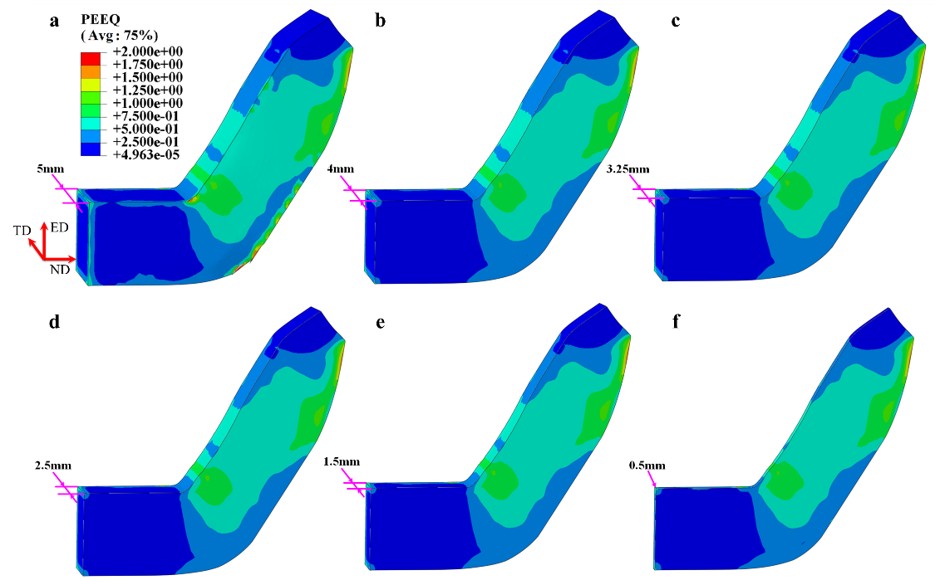
Fig. S1. FEM analysis of homogeneous strain distributions along the TD direction in CrCoNi-based MEA during the D-ECAP process. a, Thickness of 5 mm. b, Thickness of 4 mm. c, Thickness of 3.25 mm. d, Thickness of 2.5 mm. e, Thickness of 1.5 mm. f, Thickness of 0.5 mm. PEEQ: Equivalent plastic strain.

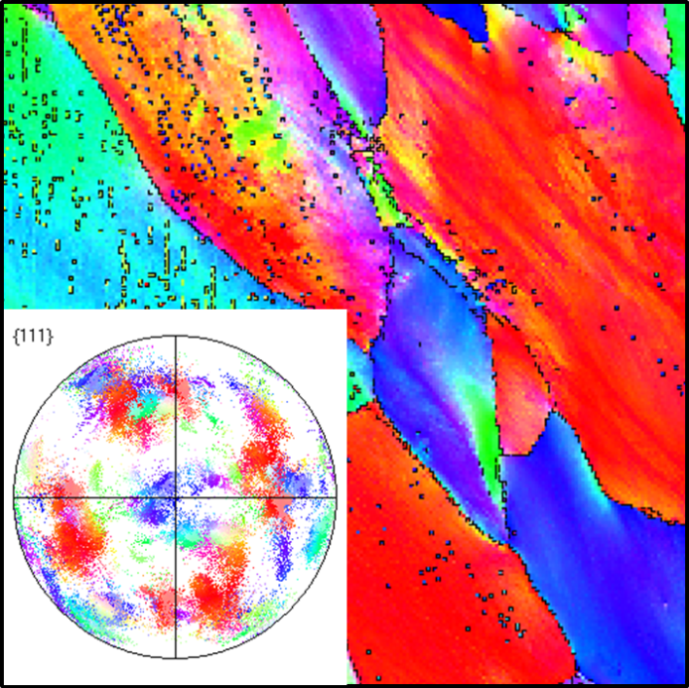
Fig. S2. EBSD mapping showing the microstructure of the CrCoNi-based MEA after ECAP treatment with the pole figures. The dotted lines represent the twins.

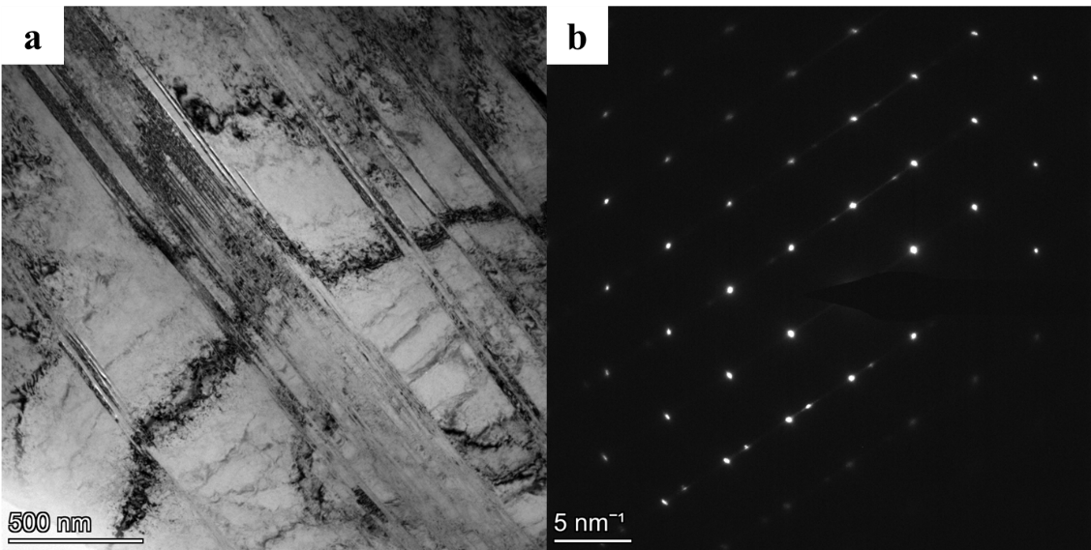
Fig. S3. TEM images of CrCoNi-based MEA subjected to ECAP treatment. a, Bright TEM image of the alloys. b, The corresponding SAED pattern in a.

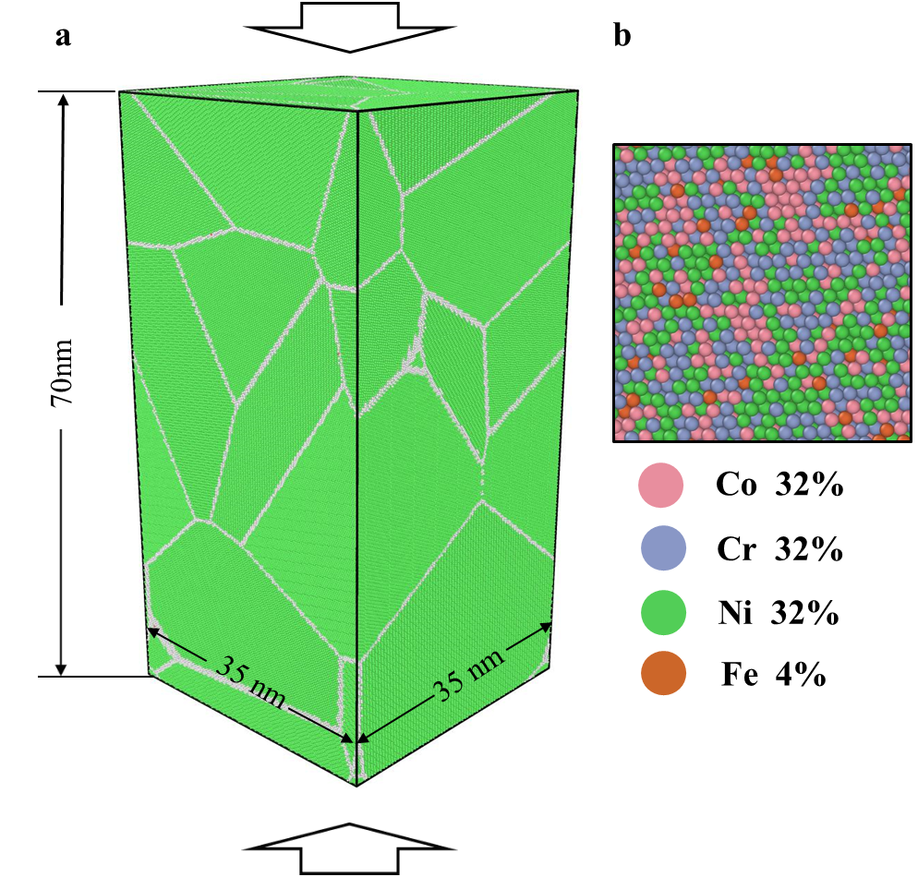
Fig. S4. Setup for MD simulations of CrCoNi-based MEA under D-ECAP process. a, The details of the polycrystalline CrCoNi-based MEA used in the simulations. b, Random distribution of the Co, Fe, Cr, Ni atoms in CrCoNi-based MEA.

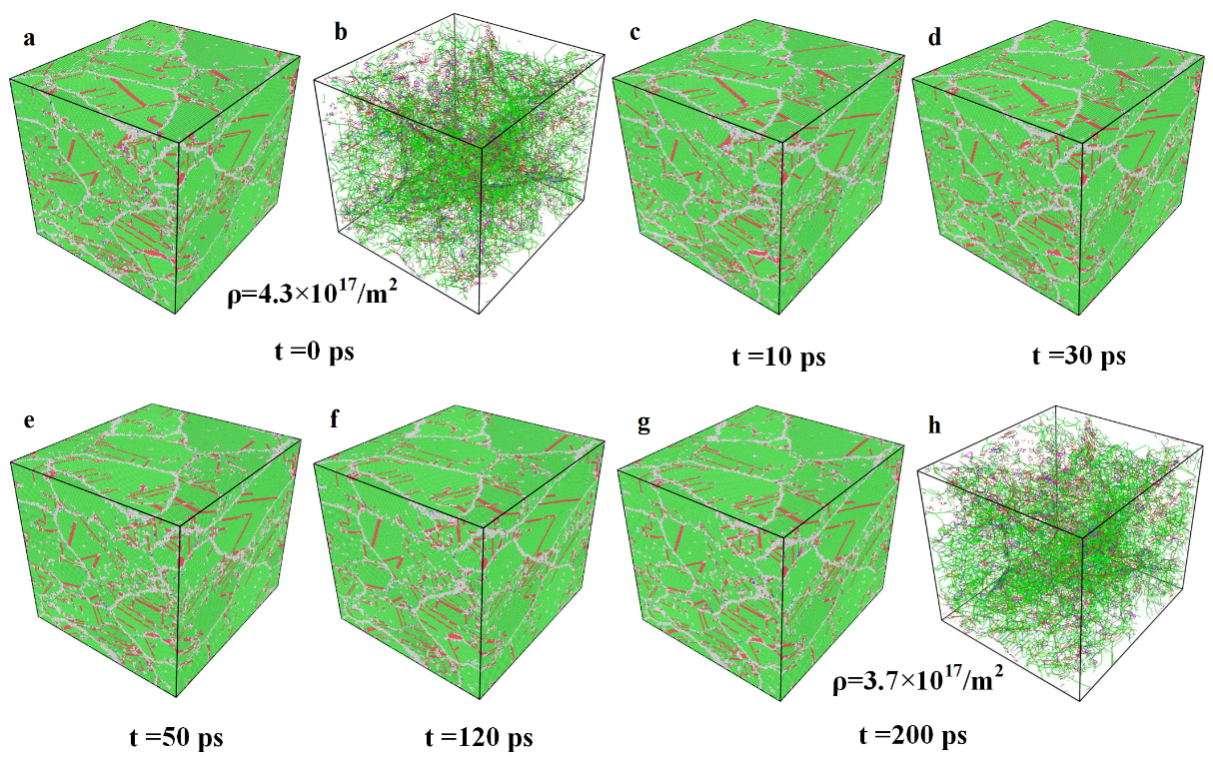
Fig. S5. Snapshots of atomic configuration evolutions for the alloy annealing at different times: a, 0 ps. c, 10 ps. d, 30 ps. e, 50 ps. f, 120 ps. g, 200 ps. b and h represent the results of dislocation density traced using the dislocation extraction algorithm method in OVITO before and after annealing treatment, respectively.

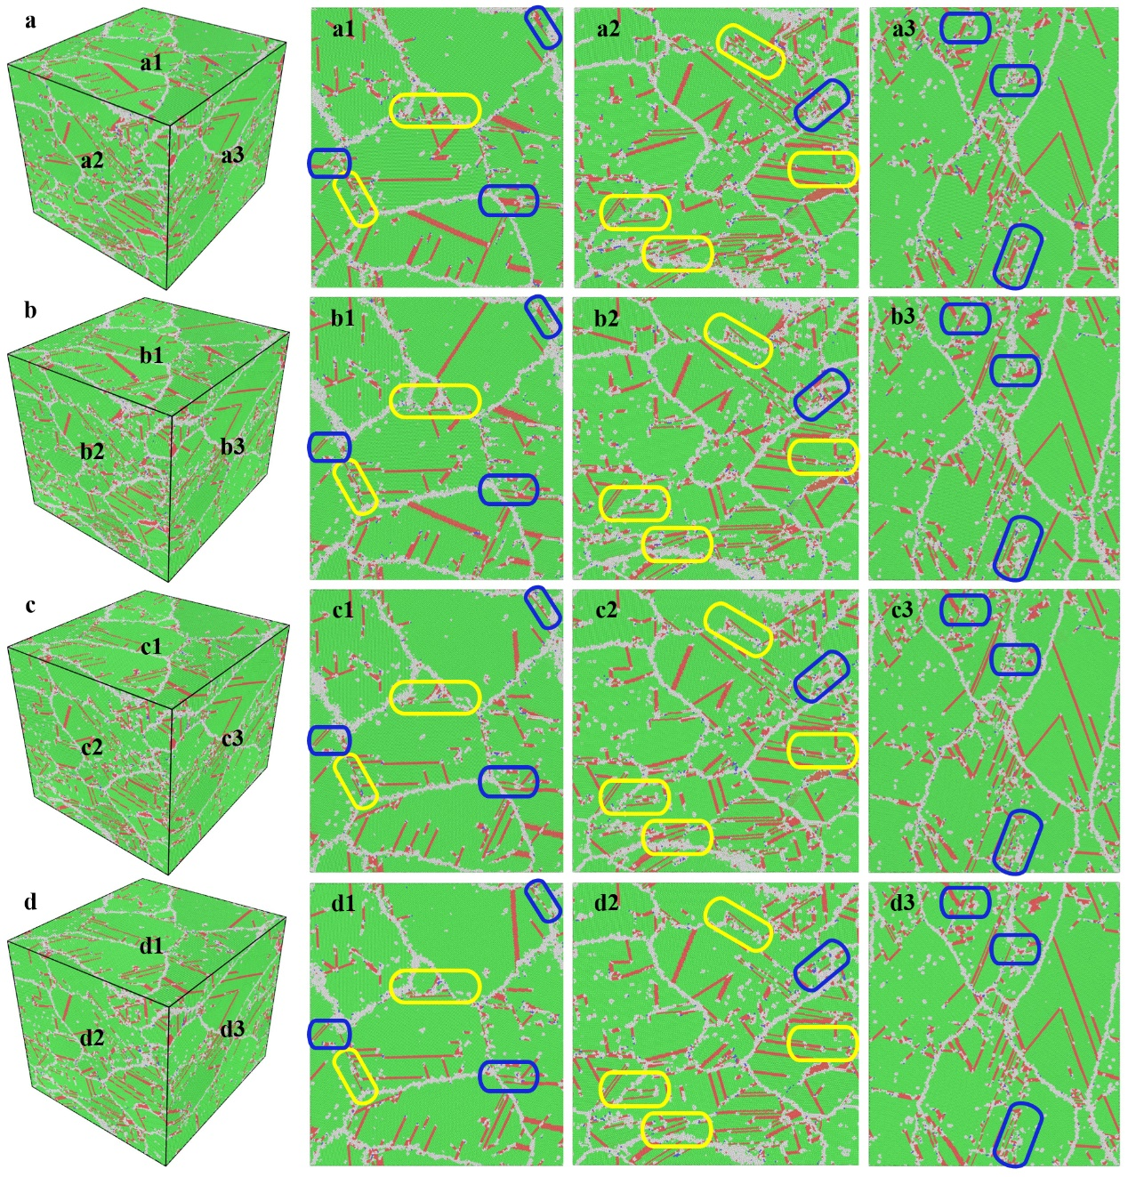
Fig. S6 MD results of the evolution of lattice defects to nanotwins in MEA during the annealing treatment. a-d, Show the three-dimensions atomic configurations of MEA at annealing times of 0 ps, 10 ps, 50 ps and 200 ps, respectively. a1-d1, a2-d2, a3-d3, Show the microstructures evolution of the MEA through different view planes. The disparate ellipses in the pictures indicate the reorganization zones of lattice defects to nanotwins, where two different mechanisms: A, the expansion or growth of initial nanotwins, which is indicated in yellow ellipses; B, the deformation twinning formed by the glide of partial dislocations, which are indicated in blue ellipses.
Fig. S7. Williamson-Hall plots for the synchrotron XRD diffraction patterns of the CrCoNi-based MEA with different states (ECAP, D-ECAP, D-ECAP +Annealing (553 K, 2 h)). The contribution of instrumental broadening to the FWHM was subtracted from every single reflection.

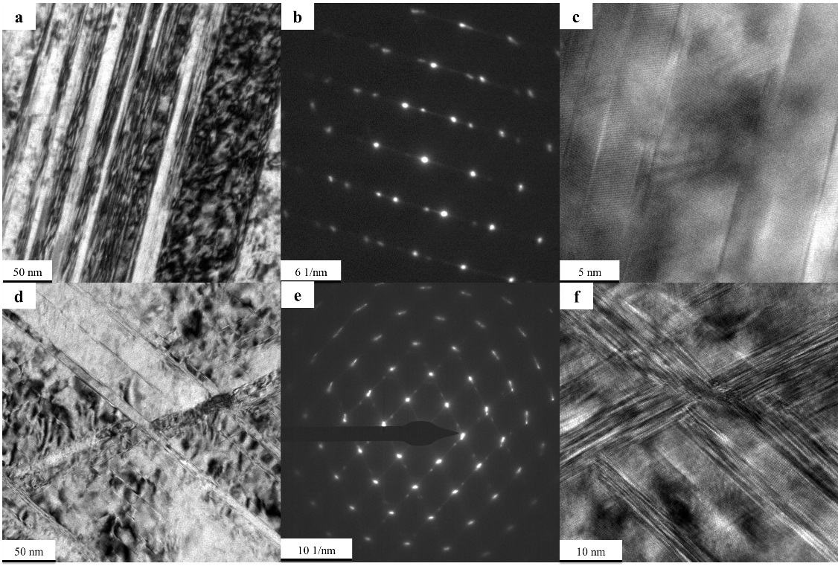
Fig. S8. TEM images of CrCoNi-based MEA specimen after tensile test which are subjected to D-ECAP treatment. a, Bright TEM images of the CrCoNi-based MEA without annealing treatment. b, The corresponding SAED pattern in a. c, A high-resolution TEM image of twins. d, Bright TEM images of the CrCoNi-based MEA with annealing treatment. e, The corresponding SAED pattern in d. f, A high-resolution TEM image of multiple-orientation twins.

Table S1. The list of references in Fig. 2b.
Materials | Change in strength | Change in ductility | Reference
ARB Al | 8.494 | -82.5 | 1
DPD Fe-based superalloy | 9.364 | -15.152 | 2
CR CrMnFeCoNi | 13.043 | -91.036 | 3
ASR+SR Ti | 3.851 | 5.634 | 4
CR Al | 13.824 | -18.644 | 5
ARB Al | 6.921 | -35.169 | 6
Electrodeposited Ni-Fe | 16.32 | -80.603 | 7
ARB Al | 5.963 | -49.125 | 8
ECAP Ti | 5.742 | 0 | 9
Electrodeposited Ni-W | 33.01 | -58.537 | 10
Heavy Drawing Pearlitic wires | 7.059 | 43.75 | 11
CrR Cu-Al-Zn | 6.667 | -42.857 | 12
Electrodeposited Ni-Mo | 18.462 | 0 | 13
CR 316L stainless steel | 22.857 | -39.474 | 14
CR Cu | 2.865 | 23.684 | 15
HPT Ti-Nb | 27.778 | -50 | 16
CR CrCoNi | 17.008 | -82.222 | 17
CR CoCrFeNi | 12.605 | -14.085 | 18
PCE Cu-Al₂O₃ | 7.459 | 28.125 | 19
a. The following acronyms are used: ARB (accumulative roll bonding); DPD (dynamic plastic deformation); ASR (asymmetrical rolling); SR (symmetric rolling); CR (cold rolled); CrR (cryogenic rolled); ECAP (equal channel angular pressing); HPT (high pressure torsion); PCE (powder compact extrusion).
b. These data were obtained from the data presented in the literature.

reference
1. Huang X, Hansen N, Tsuji N. Hardening by annealing and softening by deformation in nanostructured metals. Science 312, 249-251 (2006).
2. Zhang BB, Yan FK, Zhao MJ, Tao NR, Lu K. Combined strengthening from nanotwins and nanoprecipitates in an iron-based superalloy. Acta Mater 151, 310-320 (2018).
3. Gu J, Song M. Annealing-induced abnormal hardening in a cold rolled CrMnFeCoNi high entropy alloy. Scr Mater 162, 345-349 (2019).
4. Li Z, Fu L, Fu B, Shan A. Effects of annealing on microstructure and mechanical properties of nano-grained titanium produced by combination of asymmetric and symmetric rolling. Materials Science and Engineering: A 558, 309-318 (2012).
5. Zeng W, et al. Rapid hardening induced by electric pulse annealing in nanostructured pure aluminum. Scr Mater 66, 147-150 (2012).
6. Kamikawa N, Huang X, Tsuji N, Hansen N. Strengthening mechanisms in nanostructured high-purity aluminium deformed to high strain and annealed. Acta Mater 57, 4198-4208 (2009).
7. Ebrahimi F, Li H. The effect of annealing on deformation and fracture of a nanocrystalline fcc metal. Journal of Materials Science 42, 1444-1454 (2007).
8. Terada D, Houda H, Tsuji N. Effect of strain on “hardening by annealing and softening by deformation” phenomena in ultra-fine grained aluminum. Journal of Materials Science 43, 7331-7337 (2008).
9. Gu Y, et al. Simultaneously improving mechanical properties and corrosion resistance of pure Ti by continuous ECAP plus short-duration annealing. Mater Charact 138, 38-47 (2018).
10. Matsui I, Yamamoto T, Omura N, Takigawa Y. Effect of low-temperature annealing on tensile behavior of electrodeposited bulk nanocrystalline Ni–W alloys. Materials Science and Engineering: A 709, 241-246 (2018).
11. Zhou L, Fang F, Wang L, Chen H, Xie Z, Jiang J. Torsion delamination and recrystallized cementite of heavy drawing pearlitic wires after low temperature annealing. Materials Science and Engineering: A 713, 52-60 (2018).
12. Gong YL, Ren SY, Zeng SD, Zhu XK. Unusual hardening behaviour in heavily cryo-rolled Cu-Al-Zn alloys during annealing treatment. Materials Science and Engineering: A 659, 165-171 (2016).
13. Gubicza J, Pereira PHR, Kapoor G, Huang Y, Vadlamani SS, Langdon TG. Annealing-Induced Hardening in Ultrafine-Grained Ni-Mo Alloys. Adv Eng Mater 20, 1800184 (2018).
14. Zhou Z, Wang S, Li J, Li Y, Wu X, Zhu Y. Hardening after annealing in nanostructured 316L stainless steel. Nano Materials Science 2, 80-82 (2020).
15. Li W, Shen Y, Xie C. Effects of electric pulses on annealing hardening of submicrometre grained copper. Mater Sci Technol 31, 1577-1582 (2015).
16. Völker B, et al. Influence of annealing on microstructure and mechanical properties of ultrafine-grained Ti45Nb. Mater Design 179, 107864 (2019).
17. Sathiyamoorthi P, Asghari-Rad P, Bae JW, Kim HS. Fine tuning of tensile properties in CrCoNi medium entropy alloy through cold rolling and annealing. Intermetallics 113, 106578 (2019).
18. Xiao Q, Wang L, Liang Y-J, Xue Y. Annealing hardening in cryo-rolled high-entropy alloys by belated deformation twinning. Materials Science and Engineering: A 801, 140403 (2021).
19. Li C, et al. Annealing hardening and softening of an ultrafine grained Cu-4.5vol.%Al2O3 nanocomposite. Materials Science and Engineering: A 778, 139126 (2020).

