Supplementary Information:
Enhancing photosynthetic efficiency by assembling metal-organic frameworks on microalgae
Dingyi Li, Hong Dong, Xupeng Cao, Wangyin Wang, Can Li
Corresponding author. Email: canli@dicp.ac.cn; wywang@dicp.ac.cn
Content
Materials and Methods 2
XRD patterns of NH2-MIL-101-Fe 2
Size and zeta potential measurements 2
Measurement of dissolved inorganic carbon 2
Optical/fluorescent microscopy 2
Measurement of ligand, CA inhibitors in medium 3
Measurement of CA activity and the kinetics of CO₂ hydration 3
Supplementary Figures 6
Fig. S1 6
Fig. S2 7
Fig. S3 8
Fig. S4. 9
Fig. S5 10
Fig. S6 11
Fig. S7 12
Fig. S8 13
Fig. S9 14
Fig. S10 15
Fig. S11 16
Fig. S12 17
Table S1 18
Fig. S13 19
Fig. S14 20
Fig. S15 21
Fig. S16 22

Materials and Methods

XRD patterns of NH2-MIL-101-Fe
XRD patterns of NH₂-MIL-101-Fe was plotted by D/MAX 2500/PC X-ray Powder diffractometer (Rigaku, Japan) using Cu Kα radiation (40 kV, 100 mA). Scan range: 0.5° ~ 50°, scan rate: 1°/min.

Size and zeta potential measurements
NH₂-MIL-101-Fe and C. pyrenoidosa were suspended and diluted by water to appropriate concentrations. After pH adjustments (3 ~ 12), their zeta potentials were measured using Zetasizer Nano ZS (Malvern, UK). Their hydration diameters were measured on the same instrument with size mode.

Measurement of dissolved inorganic carbon
The adsorption of dissolved inorganic carbon (DIC) in MOF was determined by a TOC/TN Analyzer (Teledyne Tekmar, US). Phosphoric acid was used to convert bicarbonate/carbonate to CO₂, then release from the solution and be measured with an IR detector. In BG-11 medium, there was negligible organic and inorganic carbon source in fresh BG-11 medium before aeration. Ambient air was bubbled in BG-11 for 30 min, then a series amount of MOF suspensions was dispersed in it. After 30 min adsorption, the supernatants were obtained by centrifugation (12000 rpm, 5 min), then be diluted 5 times for inorganic carbon measurement. A series of sodium bicarbonate solutions were tested in advance and a calibration curve of DIC was mapped.

Optical/fluorescent microscopy
NH₂-MIL-101-Fe, C. pyrenoidosa and C. pyrenoidosa/MOF were centrifugated (4000 rpm, 5 min) and rinsed three times with deionized water. Then, 5 μL suspensions were dropped on a glass slide with a cover slide. The samples were viewed under white illumination light, or green/blue excitation light.

Measurement of ligand, CA inhibitors in medium
The ligand of NH₂-MOF (NH₂-BDC), two kinds of CA inhibitors (AZ and EZ) in medium were analyzed by high performance liquid chromatograph (HPLC) (Agilent 1200, USA) equipped with ultraviolet detector using Unitary C18 column (5 μm, 4.6 ×150 mm) (Agilent Ltd.) at 35 °C. The flow rate of the mobile phase was set as 0.8 mL/min. The injection volume of HPLC was 10 μL. The detection wavelength of UV detector and the mobile phase were listed in Figure S12.

Measurement of CA activity and the kinetics of CO₂ hydration
CA (carbonic anhydrase) activity measurements of the supernatant of microalgal suspension or the MOF suspension were conducted according to Rawat (37). Briefly speaking, 2 ml of the samples (OD₇₅₀ = 2 for microalgal suspensions, contain 20 mM HEPES, pH 8.0) were kept at 4℃. The control group was set as 2 ml 20 mM HEPES buffer (pH 8.0). The reaction:
CO₂ + H₂O → HCO₃－ + H⁺ (Eq. 1)
CA activity is defined as the catalytic activity of the samples on the reaction of Eq. 1. Adding 1 ml of ice-cold CO₂-saturated water to initiate the reaction. Then record the time intervals (T) required for the pH drop from 7.7 to 6.3. To record the kinetics of CO₂ hydration, pH was recorded per 20 s during the process. The CA activity of the test sample was calculated as: CA activity (a. u.) k_{cat.} = T₀/T－1, where T is the time intervals for the test samples, and T₀ is for the control group. The reduction is listed below:
For the initial stage of Eq. 1, its reverse reaction can be neglected, then the forward reaction rate v⁺ should be:
$v^{+}=k^{+}[CO_{2}]$
Where k⁺ is the rate constant of the forward reaction without catalyst. And [CO₂] is the concentration of dissolved CO₂, which can be regarded to be constant at the initial stage of Eq. 1.
Then the produced [H⁺], Δ[H⁺], which can be measured by pH (from 7.7 to 6.3), should be:
$Δ\left[H^{+}\right]= \int_{0}^{t}{v^{+}dt= \int_{0}^{t}{k^{+}[CO_{2}]dt}≈ k^{+}[CO_{2}]t}$
With the existence of CA, the rate constant of the forward reaction should be:
$$k^{'}=k^{+}+k_{cat.}$$
For the same pH change (from 7.7 to 6.3), Δ[H⁺] of the forward reaction w/o CA are equal, then:
$k^{+}\left[CO_{2}\right]T_{0}=(k^{+}+k_{cat.})\left[CO_{2}\right]T$
Then the activity of CA (a. u.) should be: k_{cat.} = T₀/T－1.
For the calculation of the kinetics of CO₂ hydration in different environments. In Eq. 1:
$$-d[{HCO}_{3}^{-}]=kdt$$
$$d[H^{+}]=kdt$$
Where k is the rate constant of CO₂ hydration. Then
$$ln\frac{{[H^{+}]}^{∞}}{{[H^{+}]}^{∞}-[H^{+}]}=kdt$$
Where ${[H^{+}]}^{∞}$ is the maximum proton concentration under experimental conditions, about 10^{-6.2} mol/L in Figure 4d. Then
$$lg{([10}^{-6.2}-{10}^{-pH})=-kt/2.303-6.2$$
Then the rate constant of CO₂ hydration shoule be -2.303 slope, where slope is the slope of the plot of $lg{([10}^{-6.2}-{10}^{-pH})$ versus reaction time t.

Supplementary Figures

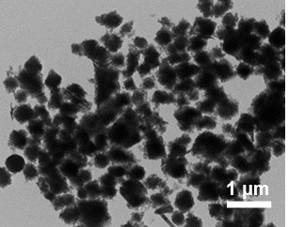
Fig. S1. TEM image of MOF NH₂-MIL-101-Fe.

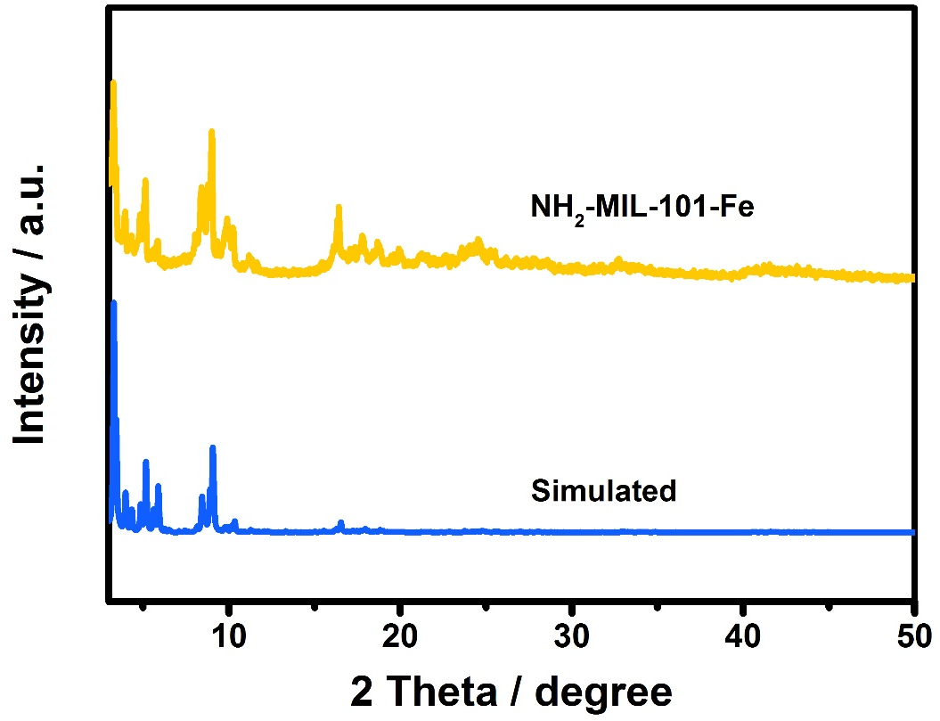
Fig. S2. Experimental and simulated XRD pattern of MOF NH₂-MIL-101-Fe.

Fig. S3. The N₂ ad/desorption isotherms of NH₂-MIL-101-Fe (77 K).

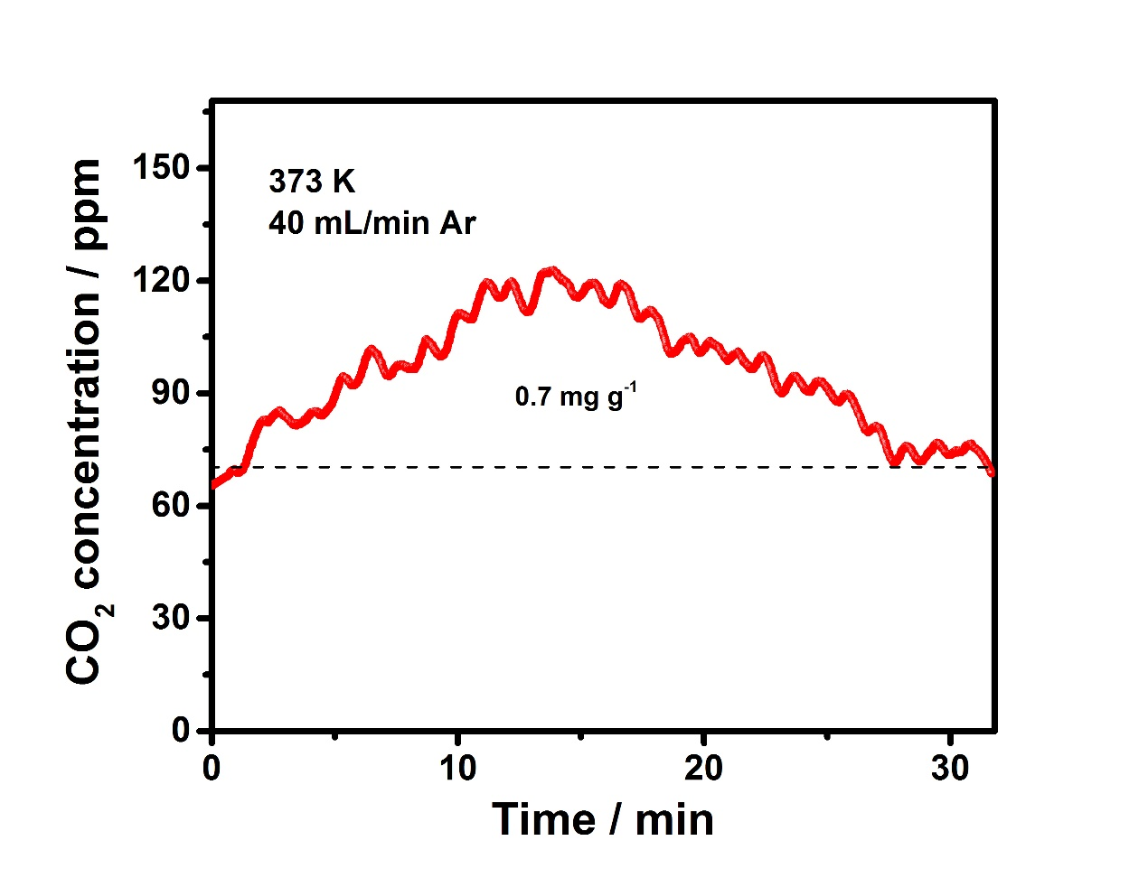
Fig. S4. The CO₂ desorption curve of MOF (373 K), MOF in water adsorbed CO₂ from purged air, the CO₂ uptake amount was determined by thermal desorption.

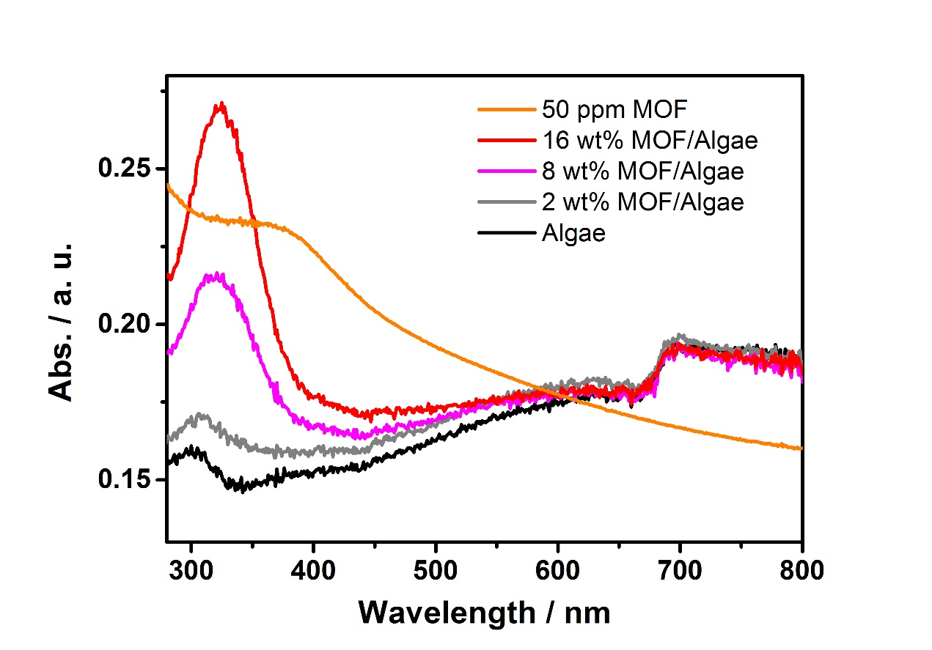
Fig. S5. UV-Vis absorbance spectra of the hybrids of C. pyrenoidosa and different amount of MOF.

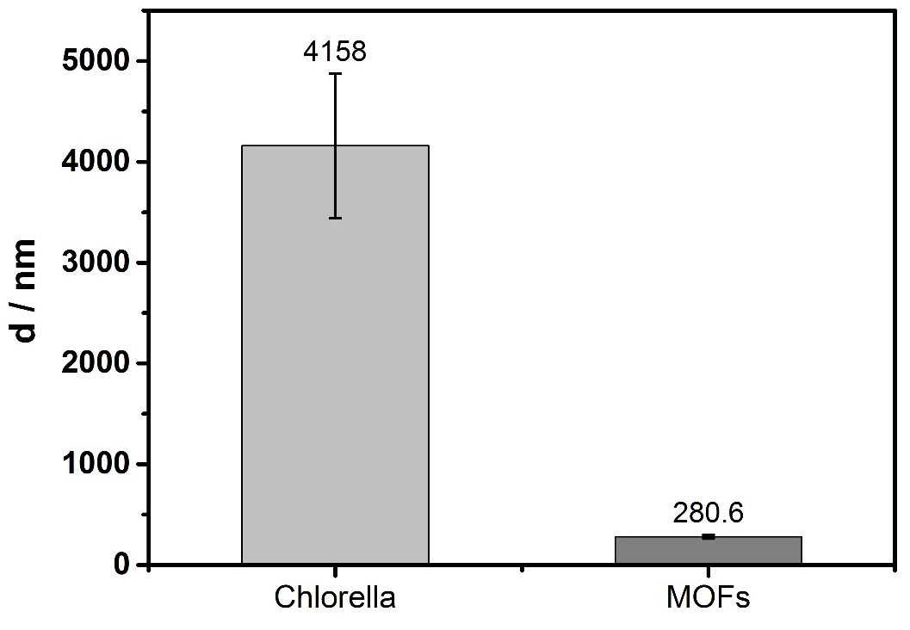
Fig. S6. Size measurements of C. pyrenoidosa and NH₂-MOF using dynamic light scattering method.

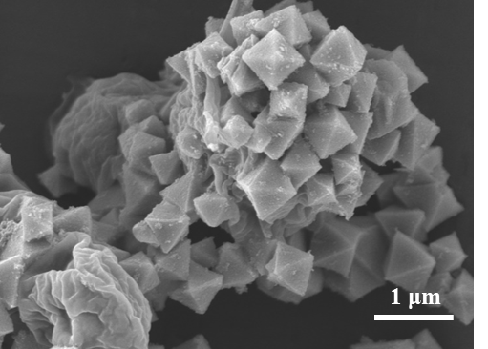
Fig. S7. SEM image of MOF/C. pyrenoidosa after two-day cultivation.

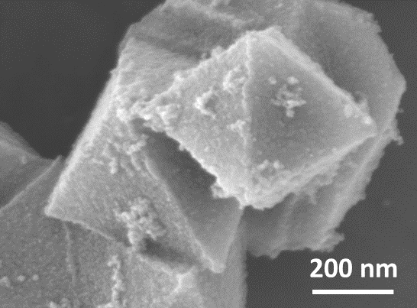
Fig. S8. SEM image of MOF pretreated in the supernatant of C. pyrenoidosa suspension after two-day cultivation.

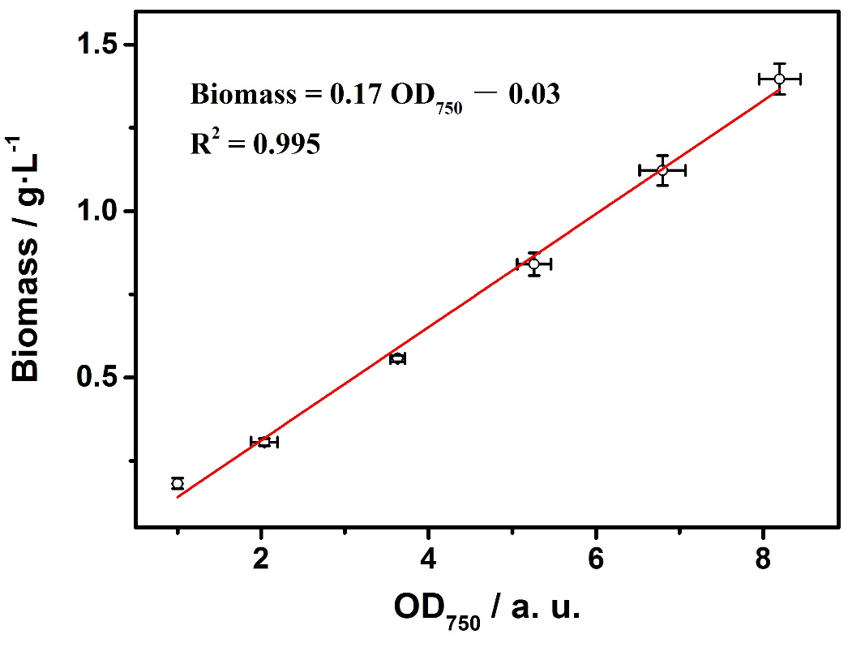
Fig. S9. The calibration curve of the dry cell weight (DCW, net biomass without water) versus the optical density at 750 nm (OD₇₅₀) of C. pyrenoidosa.

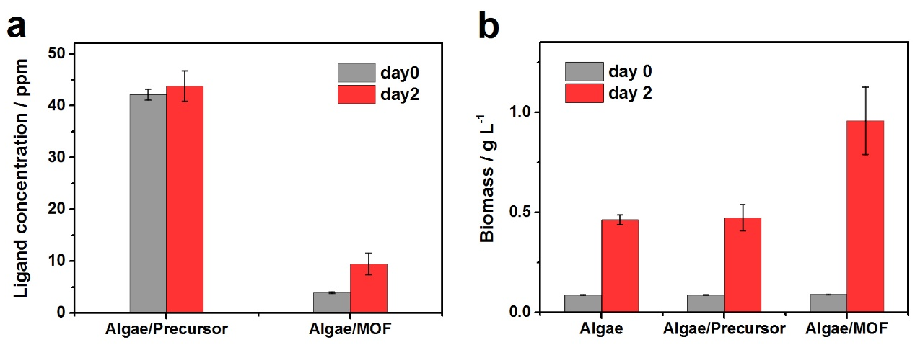
Fig. S10. The growth curves (a) and ligand concentrations in the media (b) of C. pyrenoidosa, C. pyrenoidosa with 50 ppm MOF or the same molar MOF precursors, NH₂-BDC + Fe(III) (the organic ligand of MOF and ferric ammonium citrate, respectively) before and after two-day cultivation.

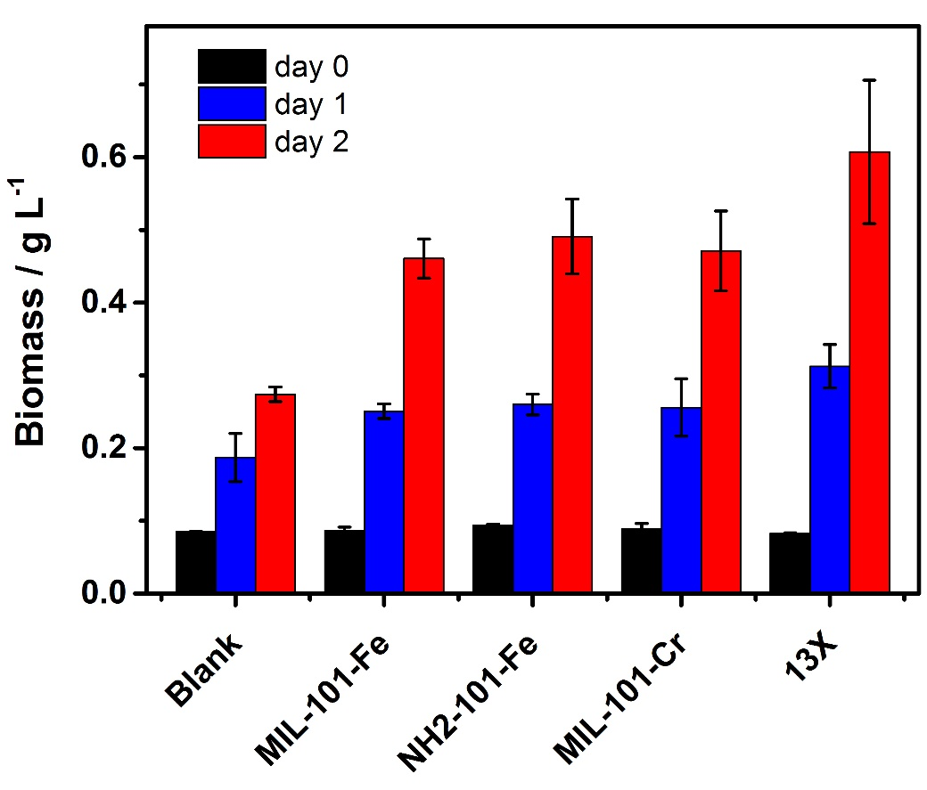
Fig. S11. Biomass growth of bare C. pyrenoidosa and C. pyrenoidosa with three kinds of MOFs, MIL-101-Fe, NH₂-MIL-101-Fe and MIL-101-Cr, and one kind of commercial CO₂-adsorption zeolite 13X.

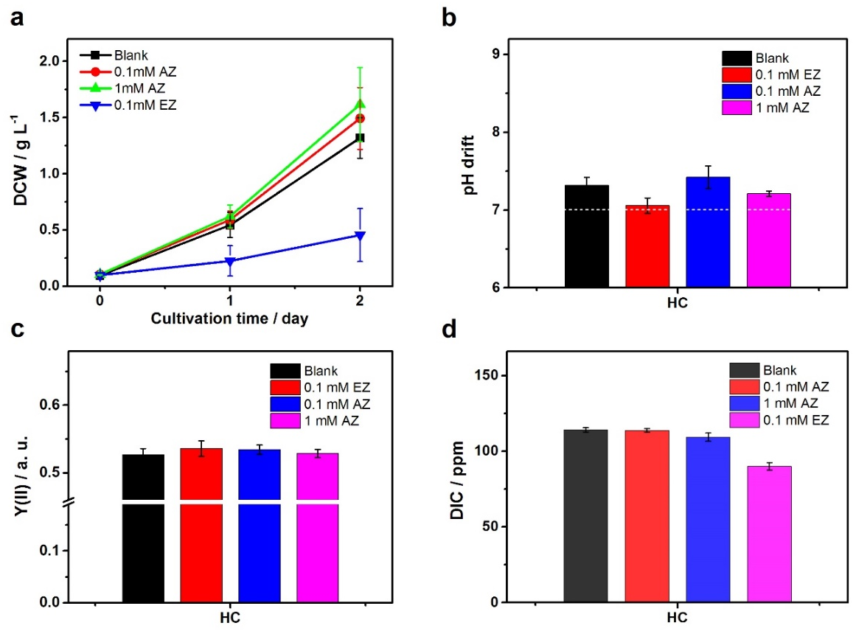
Fig. S12. (a to d) Biomass growth (a) Medium pH (b) Effective quantum yield of PS II (c) DIC in medium (d) of C. pyrenoidosa after two-day cultivation with the addition of 0.1 mM EZ (ethoxazolamide, internal CA), 0.1 mM and 1 mM AZ (acetazolamide, external CA). Cultivation conditions: temperature, 26°C; light intensity, 50 μE m⁻² s⁻¹; 20 mL min^{-P1} 2% CO₂/air flow (HC); 24 hours continuous illumination.

Table S1. The calculated rate constants of CO₂ to HCO₃﹣ in Figure S12
Group | Rate constant k / min⁻¹
pH buffered medium | 0.84
pH buffered medium + MOF | 1.00
pH buffered medium + MOF/CA | 1.49
Supernatant | 2.76
Supernatant + MOF | 2.93

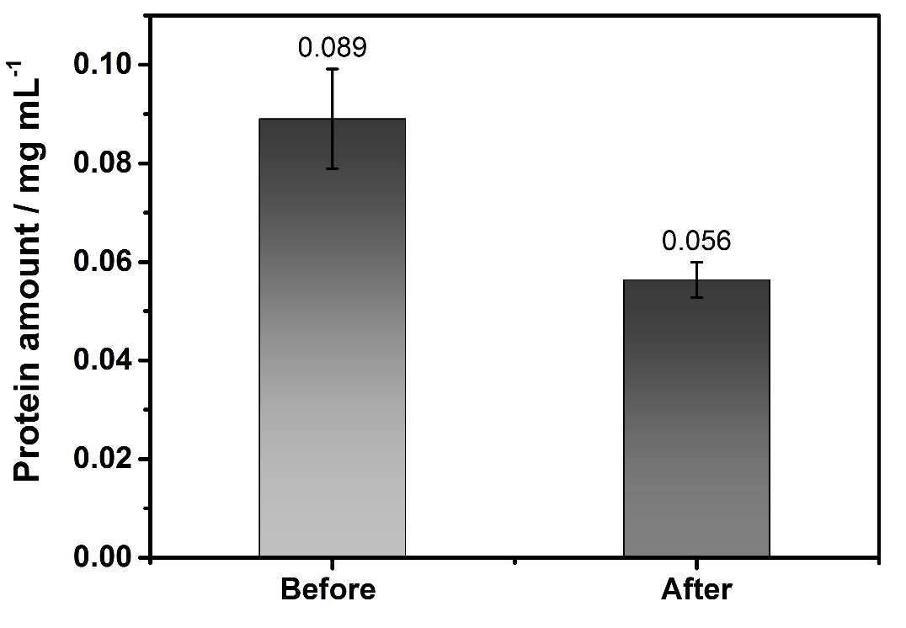
Fig. S13. Protein amount in the supernatant of microalgal suspension before and after the addition of MOF. OD₇₅₀ = 1.5, m(MOF) = 1.5 mg.
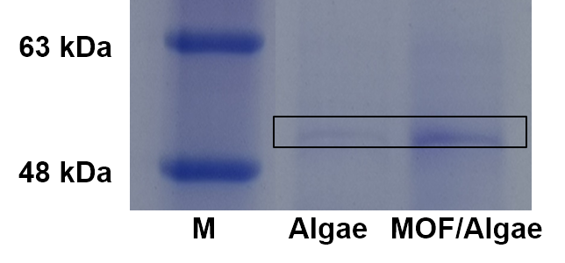
Fig. S14. The Coomassie brilliant blue stained SDS-PAGE analysis of Rubisco in bare C. pyrenoidosa and MOF/ C. pyrenoidosa assembly.

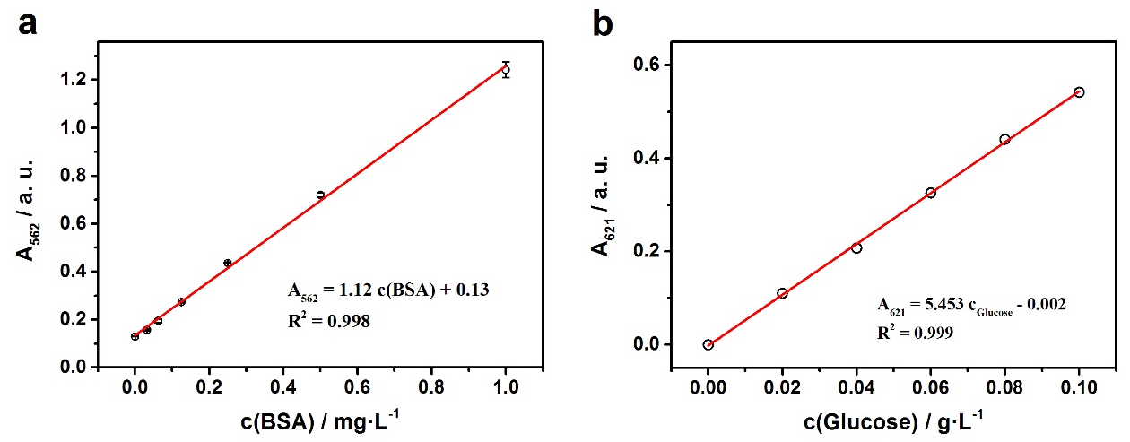
Fig. S15. The calibration curves of protein that A₅₆₂ versus the concentration of BSA standard solutions (a) and carbohydrate that A₆₂₁ versus the concentration of glucose standard solutions (b).

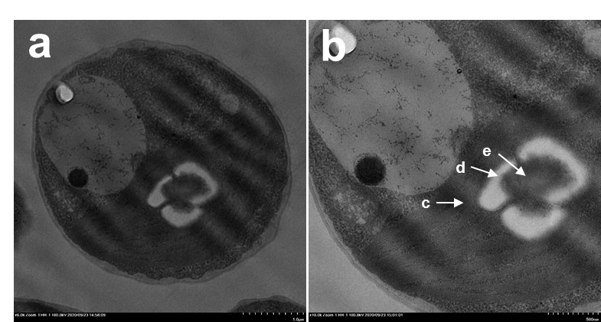
Fig. S16. TEM images of the cross-section of C. pyrenoidosa at low (a) and high (b) magnifications. The arrows marked thylakoid membrane (c), starch sheath (d) and pyrenoid matrix (e) containing dense-packed Rubisco. The scale bars are 1 μm (a) and 500 nm (b), respectively.

