Supplementary Material

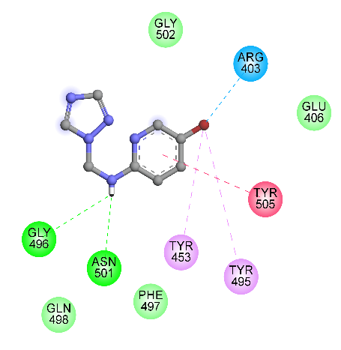
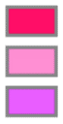

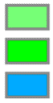
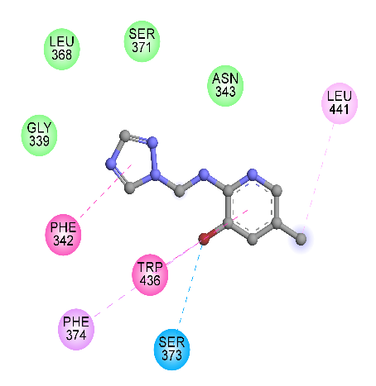
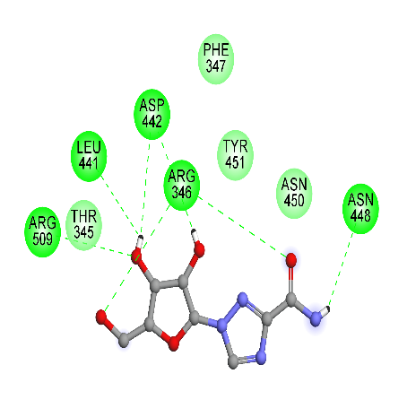
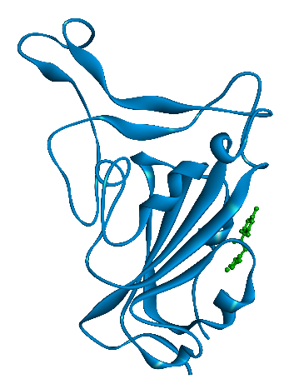
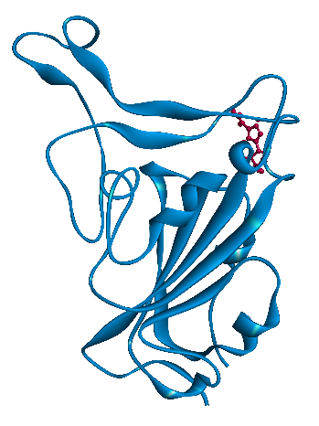
L2
Interactions
Pi-Pi Stacked
Alkyl
Pi-Alkyl
Carbon Hydrogen Bond
Van der Waals
Hydrogen Bond
L1
Ribavirin

Figure S1. Representation of intermolecular interactions of the best docking poses of the L1 and Ribavirin with S-RBD protein.

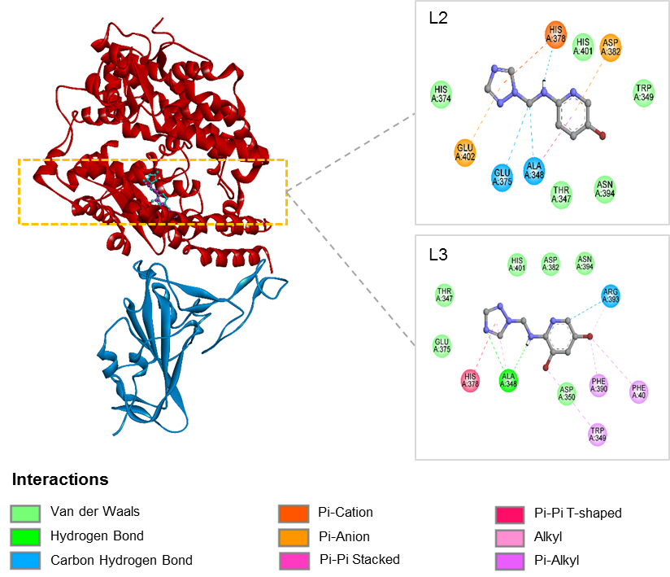

Figure S2. Binding modes of compound L2 and L3 into the interface pocket of SARS-CoV-2-RBD - hACE2 complex

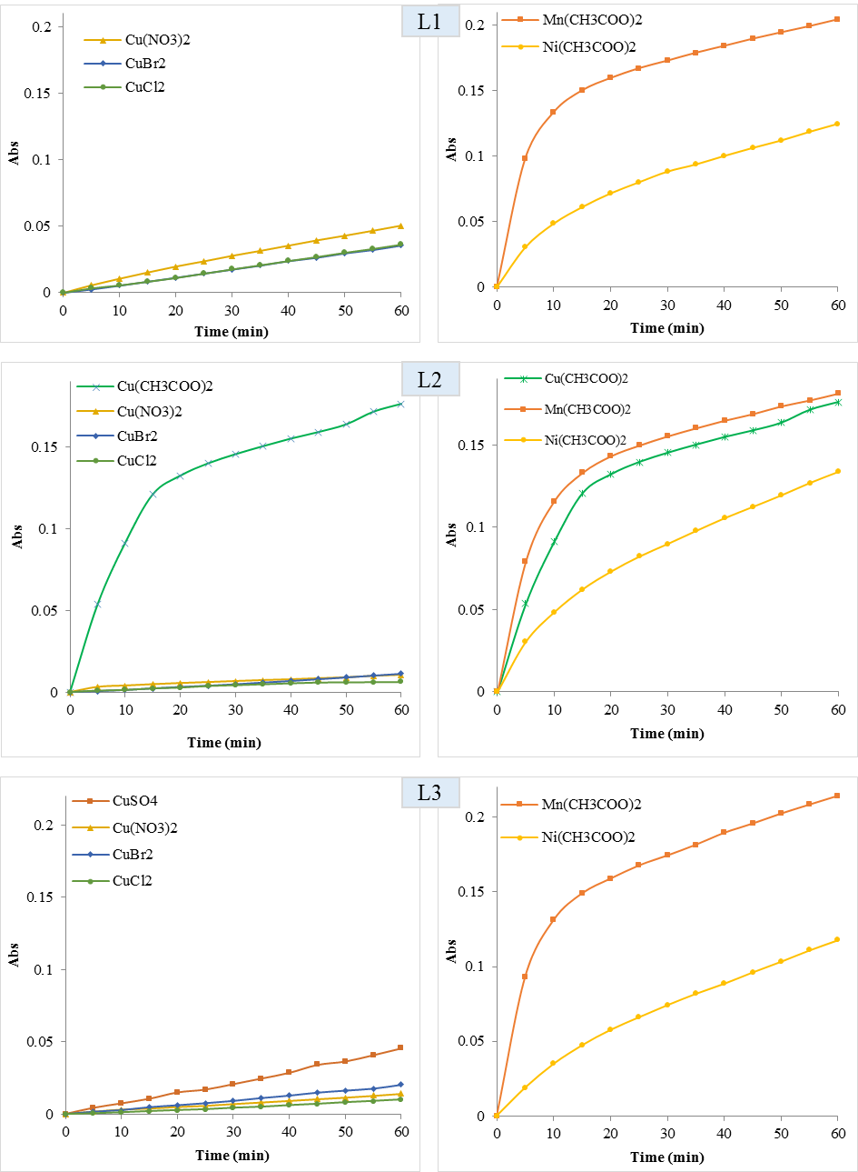
Figure S3. Absorbance plots vs time of catechol oxidation catalyzed by the complexes prepared in situ with L1,L2 and L3, at the molar ration 1:2 (ligand/Metal salt).

