Supplementary information

S1 Emission coverage

Figure S1.1: Anthropogenic non-CO₂ GHG emissions by emission source in 2020 (top) and 2100 (bottom), the share based on total CO₂eq (based on AR4 100-yr Global Warming Potential (GWP). Source: IMAGE SSP2 [2, 35]. No MAC curves have been developed for the light-shaded CH₄ and N₂O sources. Minor sources not shown in the figure: Agricultural Waste Burning (N₂O, CH₄), Biological N-fixation (N₂O), Biomass Burning(N₂O), and Industry (N₂O, CH₄). NCGGs are sorted clockwise from large to small.

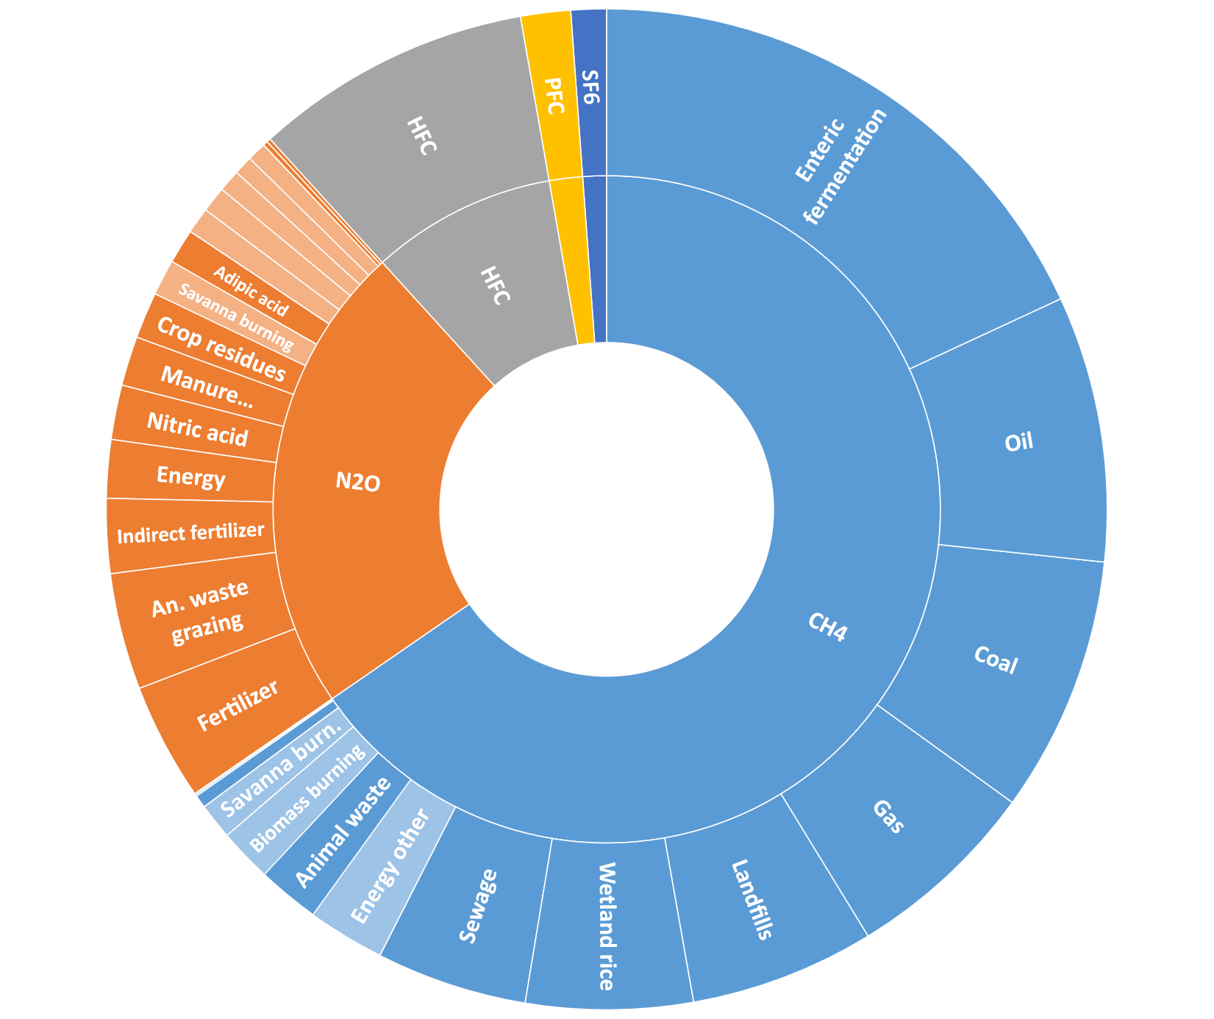

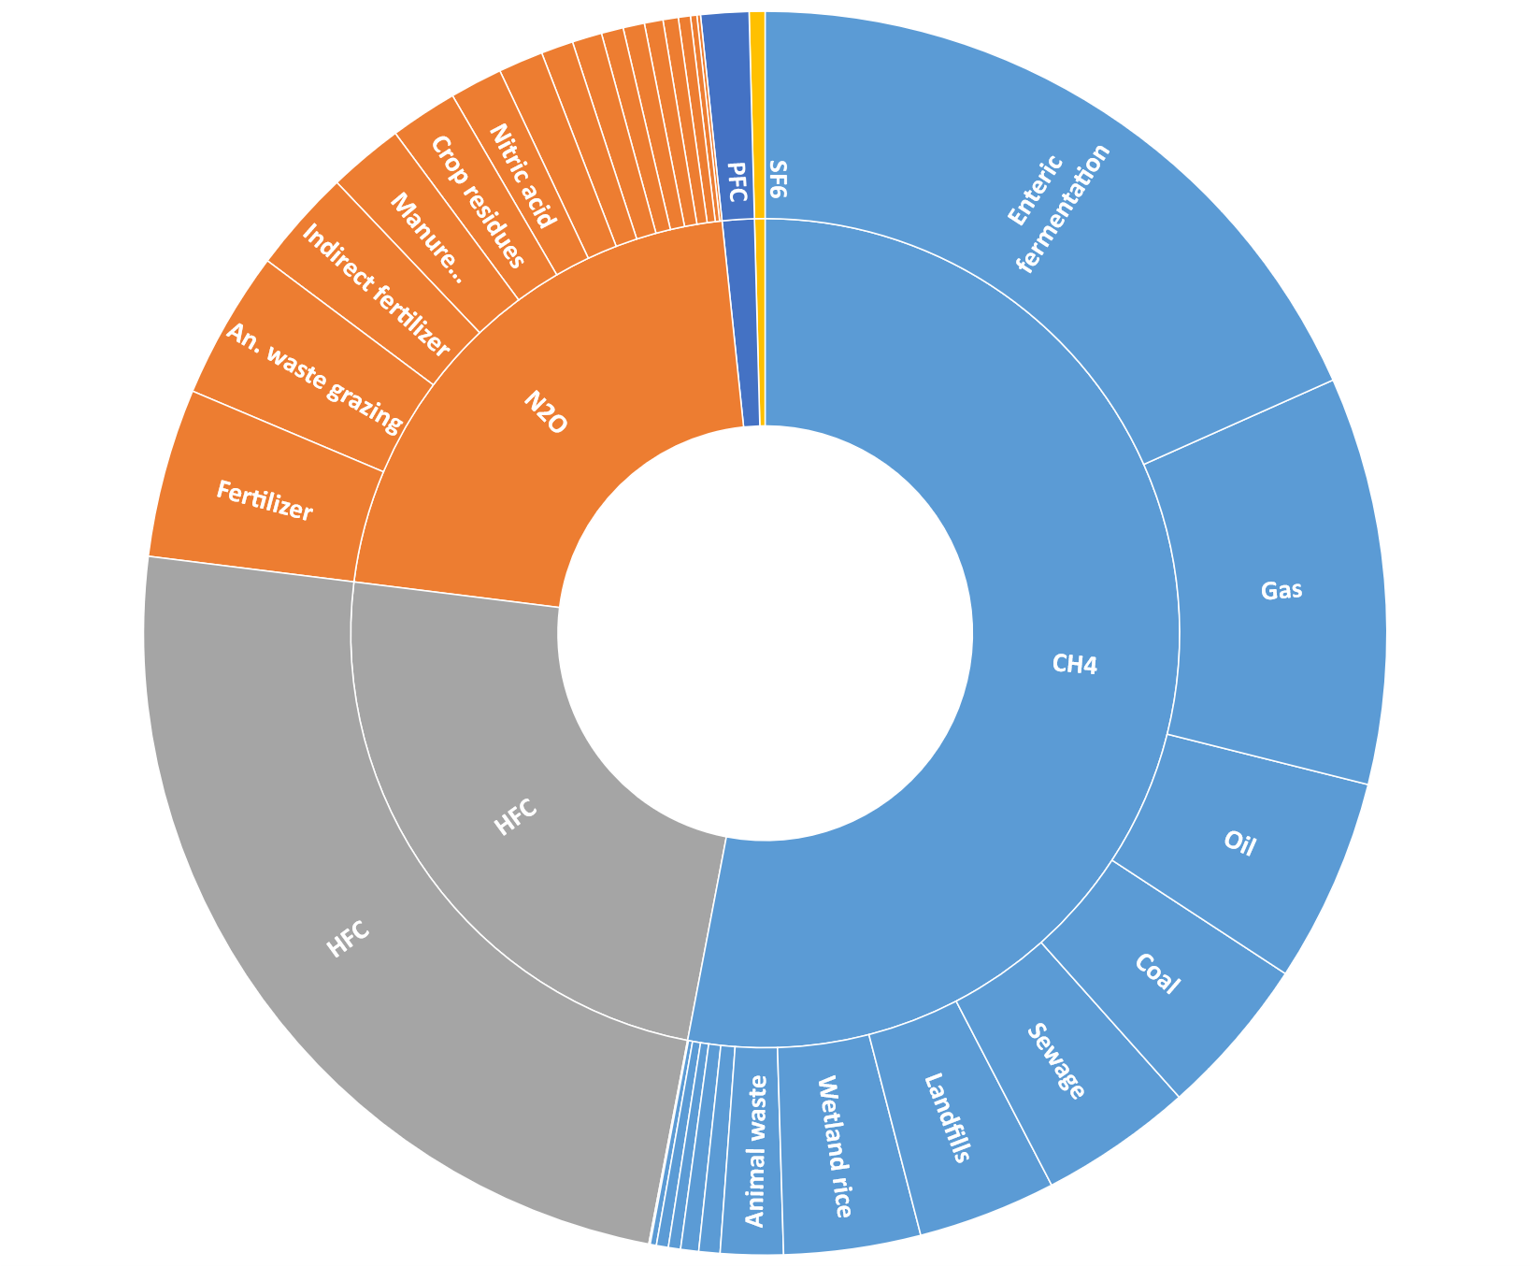
Table S1: Anthropogenic non-CO₂ GHG emissions, share of total CO₂eq in 2020 and 2100 in the IMAGE SSP2 scenario (Stehfest et al., 2014; Van Vuuren et al., 2017) with calibrated CH₄ emissions from fossil energy sources based on GAINS (Höglund-Isaksson, 2017). Data is provided in absolute terms i.e., total CO₂eq (based on AR4 100-yr Global Warming Potential (GWP)) and relative terms, i.e., share of total CO₂eq. Grey-shaded cells indicate sources without a MAC curve.
GHG | Source | 2015 |  | 2100
 |  | Emissions (Mt CO₂eq/yr) | % of total non-CO₂ | Emissions (Mt CO₂eq/yr) | % of total non-CO₂
CH₄ | Enteric fermentation | 2745 | 20% | 3727 | 17%
CH₄ | Oil | 1339 | 10% | 1113 | 5%
CH₄ | Coal | 891 | 7% | 2168 | 10%
CH₄ | Natural gas | 860 | 6% | 1724 | 8%
CH₄ | Landfills | 819 | 6% | 772 | 4%
CH₄ | Rice | 800 | 6% | 876 | 4%
CH₄ | Sewage | 674 | 5% | 843 | 4%
CH₄ | Energy other | 332 | 2% | 142 | 1%
CH₄ | Animal waste | 300 | 2% | 338 | 2%
CH₄ | Biomass burning | 233 | 2% | 54 | 0%
CH₄ | Savannah burning | 158 | 1% | 68 | 0%
CH₄ | Agricultural waste burning | 46 | 0% | 51 | 0%
CH₄ | Industry | 7 | 0% | 22 | 0%
CH₄ Total |  | 9203 | 67% | 11900 | 55%
N₂O | Manure grazing | 591 | 4% | 653 | 3%
N₂O | Fertilizer | 570 | 4% | 883 | 4%
N₂O | Indirect fertilizer | 362 | 3% | 513 | 2%
N₂O | Nitric acid | 277 | 2% | 385 | 2%
N₂O | Energy | 255 | 2% | 422 | 2%
N₂O | Manure application | 250 | 2% | 347 | 2%
N₂O | Crop residues | 184 | 1% | 374 | 2%
N₂O | Adipic acid | 180 | 1% | 178 | 1%
N₂O | Savannah burning | 157 | 1% | 68 | 0%
N₂O | Manure stables | 116 | 1% | 142 | 1%
N₂O | Domestic sewage | 88 | 1% | 103 | 0%
N₂O | Biological N-fixation | 87 | 1% | 135 | 1%
N₂O | Biomass burning | 83 | 1% | 19 | 0%
N₂O | Chemicals | 19 | 0% | 53 | 0%
N₂O | Agricultural waste burning. | 14 | 0% | 15 | 0%
N₂O Total |  | 3234 | 24% | 4291 | 20%
HFC | HFC | 882 | 6% | 5222 | 24%
PFC | PFC | 191 | 1% | 89 | 0%
SF₆ | SF6 | 159 | 1% | 265 | 1%
Total |  | 13670 |  | 21767
Total % covered by MAC curve: |  |  | 92% |  | 96%

S2 Approach for constructing the MAC curves (based on Harmsen et al., 2019)

S2.1 System boundaries

The MAC curves and scenario assessment in this study are based on the emission source categories of the IMAGE 3.2 model [2, 3] as applied in Harmsen et al 2019 [1], representing all anthropogenic non-CO₂ greenhouse gases. See supplement S1 for an overview of these emissions in 2020. The MAC curves provided in this study cover 90% of the present-day non-CO₂ GHG emissions and 95% of the projected emissions in 2100. The missing sources are either small or are indirectly taken into account in the scenarios. Emission sources not covered in the study (light-shaded in S1) are nitrous oxide (N₂O) and methane (CH₄) emissions from: 1) Land clearing for agricultural extension (biomass burning and savannah burning) since this is driven by activities, rather than emission-intensities 2) Combustion (traditional biomass use for heating and cooking and transportation fuels), 3) Agricultural waste burning, and 4) Industry emissions (mainly iron and steel production and the chemical sector). The MAC curves developed in this study represent potential emission reductions under CO₂ equivalent prices up to 4000 $(2010)/tCeq (or 1091 $(2010)/tCO₂eq), the maximum price that is applied in the IMAGE IAM framework. Emissions and emission reductions are calculated for the 26 global IMAGE regions (see supplement S3). Regional differences in present day emission intensities and activities are fully represented in the scenario assessment. Regional emissions in the base year (2015 to 2020, depending on the source) are calibrated with data from several detailed databases covering different emissions sources; CEDS [24], GAINS [23], EDGAR 4.2.3 [25], [26].

S2.2 Construction of the MACs

The construction of the MAC curves is based on the method by ref. [1]. This section therefore also includes literal parts of the methods from that paper. The MACs are built up from individual source-specific measures and assumptions on long-term developments. This fully bottom-up approach has been applied to the agricultural MACs. For the non-agricultural MACs, elements of the bottom-up approach have been applied where possible. Figure S2.1 gives a schematical overview of the approach for one fictional emission source with two reduction measures, A and B. Equations S1 and S2 provide the underlying calculation.

Figure S2.1: General method for construction of the MAC curves[1]. Left graphs: differences between theoretical (A’ and B’) and actual (A and B) reduction potentials and costs, in relation to MAC components (TA: Technical applicability, RE: Reduction efficiency, IP: Implementation potential, OVcorr: Correction for overlap between measures, only influences measure B, RP: Reduction potential). Right graph: MAC curve made up of two measures (TP: Technological progress. Bcorr: Correction for emission reductions in the baseline scenario, MRP: Maximum reduction potential of measures combined). ω represents the cost increase (old minus new) for measure B, due to diminishing returns.

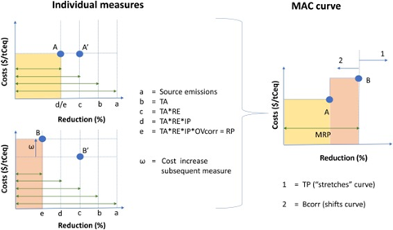

The relative reduction potential (RP) (in %) of each individual mitigation measure in year t and region r is determined by eq. S1. The maximum reduction potential (MRP) (in %) is the maximum relative abatement compared to baseline source emissions when all source-specific measures are implemented (eq. S2).
RP _{(t,r)} = RE * TA_{(r)} * OVcorr _{(t,r)} * IP _{(t)} (S1)
MRP_{(t,r)} = (RP₁ _{(t,r)} + RP₂ _{(t,r)} + RP_{3 (t,r)} … + RPx _{(t,r)}) * TP _{(t)} – Bcorr _{(t,r)} (S2)

With (all in %): TA: Technical applicability, This is the part of the baseline that can technically be covered by the measure. This is often 100%, but can be lower e.g., if only a sub-process is targeted or if regional climatic circumstances are unsuitable. RE: Reduction efficiency, i.e., relative reduction in case a measure can be applied, generally based on multiple case studies. IP: Implementation potential, represents (the lack of) non-technical barriers. This is assumed to increase over time due to increased technology diffusion and policy acceptance. OVcorr: Correction factor for overlap between measures that target the same emissions. It is assumed that the least costly measures are implemented first. If a subsequent measure is applied, it has a diminished benefit due to lower remaining emissions. Note that this correction increases in time (i.e., a lower value for OVcorr) as IP increases (see detailed description below) TP: Technological progress, implemented in time as the increase of the reduction potential in time, as a result of new or improved technologies. This is the only factor that is larger than 100% (see detailed description below) Bcorr: Correction factor for regional emission reductions that already occur in the baseline scenario, e.g., due to zero or negative cost measures, such as the use of fugitive CH₄ emissions as an energy source, or non-climate policy reductions, such as from air quality measures.

Regional differences in mitigation potential are included where these are known. These differences are reflected in the parameters: technical applicability, reduction efficiency, and costs. Partly, these are due to socio-economic circumstances (e.g., different levels of advancements in farming techniques) that can have short-term implications on mitigation potentials. However, in cases of similar biophysical circumstances across regions, we assume convergence in mitigation potentials (i.e., minimum emission intensities) in the long term and at maximum carbon prices. Where differences in mitigation potentials are known to be caused by biophysical regional differences, such as regional temperature, precipitation, geography, etc., this has been taken into account in the form of quantitative constraints on the components underlying the MACs. In this study, we differentiated between regions that have high, medium and low technical applicability for enteric fermentation and CH₄ manure, based on the GAINS model Global CH₄ mitigation potentials for livestock in 2030 and 2050 [22]. Regional differences in reduction efficiency are incorporated in the measure ‘anaerobic digestion’, which has different known impacts in warm and cold environments. Regional differences in costs are incorporated based on region-specific cost assessments.

Correction for overlap

Mitigation measures can “overlap” when they are aimed at reducing the same emissions. This depends on two factors: 1) the share of other source-specific measures already in place and 2) The overlap between targeted emissions by two different measures. Regarding 1: If a subsequent measure is applied next to one or more measures already in place, it can have a diminished benefit since less emissions remain (If measure y is aimed at reducing the same baseline emissions as measure x that is already implemented, the OVcorr_{y} = 1-RP_{x}). Note that this correction increases as implementation increases. Regarding 2: The overlap under 1 is less when measures target (partly) different baseline emissions. Smith, Nayak [27] estimated how much measures differ in terms of targeting source-specific baseline emissions. If this value is “Diff”, then OVcorr_{y} = 1-(RP_{x} * (1-Diff_{x-y})). A value of 100% represents full difference/no overlap, 70%/50%/20% are used for low/medium/high overlap, respectively. The first measure that is implemented has no overlap and therefore, Diff = 100%. For each subsequent measure, the correction for overlap is the product of the overlap values with previously implemented measures.

Technological progress

It can be expected that the future MRP values are higher than the MRP values derived from the MACs (i.e., “MRP_{MAC}” in equations S3 and S4), with all the abatement measures from this assessment fully included, due to new and improved technologies. It can also be expected that this holds more in the far future. The exact effect is highly uncertain, with little to no available literature, so we use a very aggregated (applying TP over the overall MAC, rather than individual sources) and conservative approach (with relatively low values). It is assumed that in 2050 and 2100, after implementing all measures included in the MAC the remaining emissions can be reduced by 10% and 20% more, respectively. So:
MRP₂₀₅₀ = 1 – (1 – MRP_{MAC}) * 90% (S3)
MRP₂₁₀₀ = 1 – (1 – MRP_{MAC}) * 80% (S4)
Between 2050 and 2100, the MRP values are linearly interpolated to determine an MRP for each year. It is conservatively assumed that the additional technology improvements occur at very high GHG prices: linearly increasing between 3000 $/tCeq and 4000 $/tCeq (or 818 $/tCO₂eq and 1090 $/tCO₂eq).

Marginal costs

The combination of measures with the highest estimated maximum reduction potential is used to construct MAC curves. It is assumed that the least costly measures are implemented first. When multiple measures are used, the mitigation cost increases, due to diminishing returns when measures overlap, with for any measure x:
Cost new_{x} = Cost old_{x} * 1/OVcorr_{x} (S4)

Note that ω in Figure S2.1 represents the cost increase (old minus new) for measure B. One consequence of this approach is that the more expensive measures also have a larger cost correction, since these are also the measures that are assumed to be implemented last. Another consequence is that marginal costs tend to be higher later in the century when implementation potentials and thus corrections for overlap are assumed to be higher.

Method by emission category

The MACs for the agricultural emission sources (CH₄ from rice production, CH₄ from enteric fermentation in ruminants, CH₄ and N₂O from manure, N₂O from fertilizer) have been constructed fully bottom-up, using the described methodology, as was also used in Harmsen et al., 2019. Here, we have updated the agricultural MAC curves, by including (mostly) reduction efficiency data from ±120 recent studies. For the Monte Carlo analysis, ranges have been defined for all underlying MAC components (see Supplement S5).
All non-agricultural sources are directly based on [1], with only a few, minor modifications to the default values for the maximum reduction potentials (MRPs). For the development of the pessimistic and optimistic MACs, MRP ranges have been varied, based on literature (see Supplement S6). Waste and industry MACs (CH₄ from landfills/solid waste, CH₄ from sewage and wastewater, N₂O from adipic and nitric acid production, N₂O from transport, N₂O from Domestic sewage), are based on data up to 2030 [28-30], but have added assumptions on the technological progress up to 2100, largely based on current best practices [1]. Fossil energy MACs (CH₄ from coal, oil and gas production) are based on a dataset from the GAINS model [23, 31] with added long-term (MRP) assumptions on included promising technologies that are currently not in use on a large scale. The default F-gas MACs (HFCs, PFCs and SF₆) are directly copied from and described by Harmsen, van Vuuren [1], with recent calibrations by Velders, Fahey [26] and Schwarz, Gschrey [32].

S3 IMAGE 3.2

The IAM used for this study is IMAGE 3.2 [2, 3]. IMAGE 3.2 is suitable for large scale and long-term assessments of interactions between human development and the environment. It integrates a range of sectors, ecosystems and indicators. One of the advantages is that it does not average over larger areas, but it models processes by means of unique grid cells. This differentiates between local conditions.
Model components and structure
The components of IMAGE 3.0 are shown in Figure 1 (note that the structure applies to the last versions; 3.0 and 3.2). Arrows indicate interrelations between subsystems. The framework exists of two main systems, the human system and the earth system. Linkages exist in both directions. Inputs to the model are descriptions of future development of drivers of global environmental change like, among others, population, economic development, lifestyle parameters, technological change, and trade regimes, tariffs and barriers. Since the exact development of these drivers is uncertain, different input values are used to understand the possible impact of the range of future developments. The current situation is used as a starting point and future projections are made until 2050 and 2100.
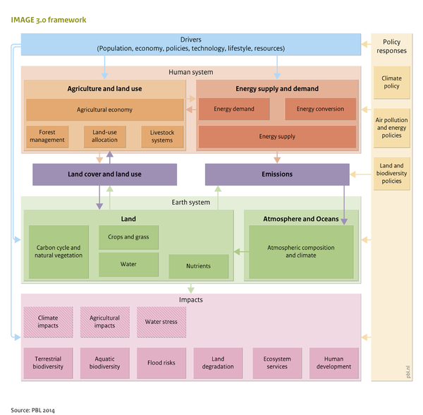
Figure 3: an overview of the IMAGE 3.0, 3.2 framework and its components
Scenarios
IMAGE 3.2 is used to develop and assess future global scenarios. These are, among others, Shared Socio-economic Pathways (SSPs) [3]. There are 5 SSPs, the scenarios SSP1 to SSP5. In this study, the scenarios SSP1, SSP2 and SSP3 will be used. SSP1 includes a world of sustainability-focused growth and equality. SSP2 covers the middle of the road estimates where social, economic and technological trends do not shift markedly from historical patterns. In the SSP3 scenario, a fragmented world of ‘resurgent nationalism’ is assumed. This is a world where concerns about competitiveness, security and regional conflicts push countries to increase their focus on regional problems instead of global problems. These different scenarios can be run for different climate targets [34].

Output
An IMAGE run produces data starting from 1970 to a final ‘base year’ that can be adjusted. The runs from 1971 to 2005 are used to test the model against key historical trends. The model has a long list of outputs, including
- energy use, conversion and supply
- agricultural production, land cover and land-use;
- nutrient cycles in natural and agricultural systems;
- emissions to air and surface water;
- carbon stocks in biomass pools, soils, atmosphere and oceans;
- atmospheric emissions of greenhouse gases and air pollutants;
- concentration of greenhouse gases in the atmosphere and radiative forcing;
- changes in temperature and precipitation; sea-level rise;
- water use for irrigation.

Spatial resolution / Regions
There are 26 regions in IMAGE to capture spatial and multi-scale differences, see Figure 4 and the country distribution here. These regions are different in terms of location-specific biophysical conditions and the level of human development. Besides that, each region has differences in policy interventions, governance structures, cultures, and political factors.
IMAGE provides a relatively high level of detail on land-based processes, also in temporal and spatial resolution. Land use, land cover, and associated biophysical processes (such as water, carbon and nutrient cycles, and derived indicators for biodiversity loss and flood risks) are treated at the grid level to capture local dynamics. The grid size has been reduced to 5 x 5 arcminutes (corresponding to 10 x 10 km at the equator). Operating within global boundaries, the regional approach provides insight to identify where specific problems manifest, where the driving factors are concentrated, and how changes in some regions influence other regions.
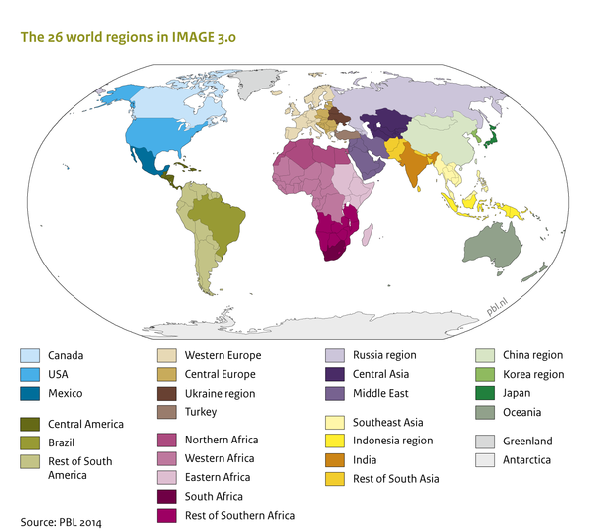

Figure 4: an overview of the 26 regions in IMAGE 3.2.

S4 Emission source-specific measures and assumptions (CH₄ and N₂O)

This supplementary section describes the emission sources, emission-reducing emissions and additional assumptions to construct the MAC curves. Note that large parts of the text are directly copied from [1], as the main structure and assumptions from that study are used here as well. Where relevant, this text is complemented with new insights from this study’s literature assessment. Table S4.1 starts with an overview of the measures and assumptions per emission source, the main references and range in reduction efficiencies in the case of agriculture. The section continues with a description of the source-specific measures and assumptions. This description only includes CH₄ and N₂O sources, since the F-gas MACs are directly based on [1] (who also provide a description of the F-gas assumptions).
Table S4.1: Included measures, assumptions and references by emission source
 | Measures | Long-term assumptions | Range in reduction efficiencies (%) | References reduction efficiencies | References datasets
CH₄
CH₄ – Coal production | Pre-min degasification, Oxidation of ventilation air methane (VAM) | In 2050: Oxidation of lean (up to 0.5%) VAM feasible, abandoned mine CH₄ minimized  In 2100: Post-mining emission reduced by 50% [1] |  |  | GAINS [23, 31]
CH₄ – oil production | Recovery and utilization of vented gas, reducing unintended leakage | In 2100: Small gas-to-liquid plants available for remote oil fields, monitoring of flares [1] |  |  | GAINS [23, 31]
CH₄ – Natural gas production | Reduced leakage rates, installation PE and PVC networks | In 2100: LDAR (infrared cameras) to promptly find and close leakages |  |  | GAINS [23, 31]
CH₄ – landfills/solid waste | Collection and flaring, LFG capture for energy use, Enhanced waste diversion (e.g. recycling, reuse) | 2015-2100: Growth in reduction potential: 2% / 5 years, increased waste diversion and biological treatment [1] |  |  | US-EPA [30]
CH₄ – sewage and wastewater | Anaerobic digestion and CH₄ collection, wastewater treatment plants (wwtp) instead of latrines and disposal | 2015-2100: Growth in reduction potential: 2% / 5 years [1] |  |  | US-EPA [30]
CH₄ enteric fermentation | Addition of nitrate to the feed |  | 21-42 | [36-43] | This study
CH₄ enteric fermentation | Genetic selection and breeding |  | 8-31 | [44-48] | This study
CH₄ enteric fermentation | Adding tannins as a food supplement |  | 10-32 | [49-53] | This study
CH₄ enteric fermentation | Grain processing |  | 10-38 | [51, 54-56] | This study
CH₄ enteric fermentation | Improved health monitoring and illness prevention |  | 4-20 | [47, 57-59] | This study
CH₄ enteric fermentation | Seaweed (Asparagopsis taxiformis) |  | 12-99.5 | [60-65] | This study
CH₄ - rice production | Rice straw mitigation |  | 26.5-61 | [66-71] | This study
CH₄ - rice production | Direct seeding |  | 16.6-47 | [66, 70, 72-74] | This study
CH₄ - rice production | Replacing urea with ammonium sulphate |  | 14.18-42 | [66, 70, 75, 76] | This study
CH₄ - rice production | Addition of phosphogypsum |  | 28-86 | [66, 70, 77-80] | This study
CH₄ - rice production | Alternate flooding and drainage |  | 18.8-79 | [37, 50, 54, 55, 65, 66, 68-80][81-88] | This study
CH₄ manure | Manure acidification |  | 61-98 | [51, 69, 89-93] | This study
CH₄ manure | Anaerobic digestion |  | 25-75 | [66, 94-96] | This study
CH₄ manure | Solid-liquid separation |  | 46-81 | [94, 95] | This study
CH₄ manure | Manure storage: duration |  | 38-76 | [97] | This study
CH₄ manure | Housing systems and beddings |  | 4-96 | [36, 51, 98-102] | This study
CH₄ manure | Manure storage covering |  | 0-90 | [36, 51, 91, 103] | This study
N₂O
N₂O fertilizer | Nitrification inhibitors |  | 17-60 | [30, 36, 104-114] | This study
N₂O fertilizer | Improved land manure application |  | 5-50 | [111, 115-119] | This study
N₂O fertilizer | Irrigation practices |  | 15-67 | [120-123] | This study
N₂O fertilizer | Biochar |  | 14-38 | [124-127] | This study
N₂O fertilizer | Spreader maintenance |  | 22-42 | [15, 66, 128, 129] | This study
N₂O fertilizer | Improved agronomy practices |  | 14-54 | [119, 130-135] | This study
N₂O fertilizer | No tillage |  | 25-48 | [136-140] | This study
N₂O manure | Reduced dietary protein |  | 0-52 | [51, 141-145] | This study
N₂O manure | Decreased manure storage time |  | 35-35 | [51] | This study
N₂O manure | Manure storage covering |  | 30-75 | [36, 51] | This study
N₂O manure | Improved animal housing systems and bedding |  | 9-88 | [36, 98, 100, 101] | This study
N₂O manure | Anaerobic digestion |  | 34-75 | [96, 146, 147] | This study
N₂O manure | Acidification |  | 0-96 | [148-153] | This study
N₂O transport | Low-N₂O catalytic converters for petrol cars | 2015-2100: Growth in reduction potential: 2% / 5 years [1] |  |  | [28, 29]
N₂O – Adipic acid production | Thermal decomposition (potentially combined with catalyst) | 2015-2100: Growth in reduction potential: 2% / 5 years [1] |  |  | US-EPA [30]
N₂O – Nitric acid production | Catalic decomposition, thermal decomposition (potentially including reagent fuel) | 2015-2100: Growth in reduction potential: 2% / 5 years [1] |  |  | US-EPA [30]
N₂O – domestic sewage | N-removal at wastewater treatment plants, N-enriched wastewater as an alternative to fertilizers | 2015-2100: Growth in reduction potential: 2% / 5 years [1] |  |  | [1, 29]
F-gasses
HFCs – refrigeration | Substitution with low-/zero GWP substances, better sealed systems, recovery after use |  |  | [13,16] | [1, 32]
HFCs – foams | Substitution with low-/zero GWP substances |  |  | [13,16] | [1, 32]
HFCs – Production of HCFC-22 (HFC-23 by-product) | Thermal destruction |  |  | [13,16] | [29]
HFCs - other | Substitution with low-/zero GWP substances, better sealed systems, recovery after use |  |  |  | [1, 32]
PFCs – primary Aluminium production | Switch to Point-Feed Prebake technology (PFPB) |  |  | [13,16] | [29]
PFCs – semiconductor manufacturing | Emission capture and (thermal) destruction |  |  | [13,16] | [164]
PFCs – other sources PFCs | Substitution with zero GWP substances |  |  | [13,16] | [164]
SF₆ – production of electrical equipment | Improved recovery and recycling, minimization of leakage (detection and repair), improved handling |  |  | [13,16] | [29]
SF₆ – Use and decommissioning of elec. Eq. | Improved recovery and recycling, minimization of leakage (detection and repair), improved handling |  |  | [13,16] | [29]
SF₆ – Magnesium production | Substitution with zero GWP substances |  |  | [13,16] | [29]
SF₆ – Other sources | Improved recovery and recycling, minimization of leakage (detection and repair), improved handling, substitution with zero GWP substances |  |  | [13,16] | [29]

Agriculture

CH₄ Rice
CH₄ emissions result from the anaerobic breakdown of organic matter in wetland rice paddies in the growing season. The CH₄ transports from the rice paddies into the air by diffusion and through the rice stems. The amount of methane emitted from the rice paddies depends on, among others, rice variety, soil type, climate, period that the paddies are flooded, amount and application of fertilizer, management [165].
The mitigation measures that have been used to construct the MAC curve are: 1) Alternate flooding and drainage / alternate wetting and drying: this measure reduces anaerobic conditions by flooding every time the surface water level naturally declines to 15 cm below the soil surface level [166]. 2) Phosphogypsum: Phosphogypsum is formed as a by-product of the production of fertilizer from phosphate rock. Addition of phosphogypsum to soil releases sulphate, which inhibits methanogenesis (production of methane by bacteria or other living organisms). However, it has a heavy metal content (specially Cd) and radionuclide content, and its use is therefore still limited [167-172]. 3) Direct seeding: DSR (direct seeded rice) refers to the process of growing a rice crop from seeds sown in the field rather than by growing seeds in a nursery and then planting them. This measure includes both wet and dry seeding, these cannot be used simultaneously. In wet seeded rice, the seeds are sown on or into puddled soil [72]. Dry direct seeding has potential to save both water and labor [173]. 4) Replace urea with ammonium sulphate (AS): replaces commonly used urea; sulphate inhibits methanogenesis [66]. 5) Rice straw management. Rice straw is a residual byproduct of rice production at harvest. Current practices in rice production leave a huge amount of wet straw on the field, which cannot be used as feed or for food. Open-field burning of rice straw results in atmospheric pollution and reduced soil quality, therefore, it has a negative impact on the environment. An example of trace gases that are emitted by burning of rice straw are GHGs including CO₂, CH₄, and N₂O, along with other trace gases that contribute to tropospheric ozone and the formation of Atmospheric Brown Cloud (ABC). The formation of ABC is a serious concern for human health [174-179]. Compost production is one way of effectively utilizing rice straw. Composting is a bio-oxidative process and the compost can be used as organic fertilizer [180, 181]. Removing rice straw in flooded rice is considered another mitigation opportunity for CH₄ emissions [182]. Maximum emission reductions and yield (and soil organic carbon (SOC) deposition) may be best achieved by partial straw return/removal in most continuous rice systems [68].

CH₄ manure
Methane is produced from the decomposition of livestock manure under anaerobic conditions [183]. This mostly happens when manure is stored in large piles. The mitigation measures that have been used to construct the MAC curve are: 1) Decreased manure storage time: Reduced storage time through frequent land application to avoid the anaerobic conditions that create CH₄; this can also reduce N₂O emissions depending on application timing. 2) Anaerobic digestion: Application of anaerobic digester for either small-scale farm systems, or centralized plants in intensive agricultural areas. The biogas generated from anaerobic digestion is used to produce heat or both heat and electricity. 3) Storage covering: Covering manure storages with permeable or impermeable covers is an effective mitigation practice. However, with an impermeable cover the CH₄ captured under the cover is burned using a flare system or engine-generator to produce electricity; otherwise, the captured CH₄ would build pressure inside the storage creating an explosion hazard and/or escape through leaks and cover ruptures. 4) Manure acidification: The pH range in manure can impact the growth and activity of different microbial groups. Most methanogens have an optimum pH of around 7 [184-187]. By acidification of the slurry, methanogenic activity may be reduced. 5) Housing systems and beddings: Concrete slatted floors with drainage/flush systems result in fewer CH4 and N2O emissions than solid floors with hay or other bedding. 6) Solid liquid separation: Manure solids can be mechanically separated from manure liquids. The advantages are reduced storage capacity, increased flexibility of manure management and reduced CH₄ emissions [188, 189].

N₂O manure
N₂O is generated during the composting of manure by ammonia (NH₃)-oxidizing bacteria. The mitigation measures that have been used to construct the MAC curve are: 1) Decreased manure storage time: Reduced storage time through frequent land application to avoid the anaerobic conditions that create CH₄; this can also reduce N₂O emissions depending on application timing. 2) Anaerobic digestion: Application of anaerobic digester for either small-scale farm systems, or centralized plants in intensive agricultural areas. The biogas generated from anaerobic digestion is used to produce heat or both heat and electricity. 3) Storage covering: Covering manure storage with permeable or impermeable covers is an effective mitigation practice. However, with an impermeable cover, the CH₄ captured under the cover is burned using a flare system or engine-generator to produce electricity; otherwise, the captured CH₄ would build pressure inside the storage creating an explosion hazard and/or escape through leaks and cover ruptures. 4) Manure acidification: The pH range in manure can impact the growth and activity of different microbial groups. Most methanogens have an optimum pH of around 7 [184-187]. By acidification of the slurry, NH₃-oxidizing activity may be reduced. 5) Housing systems and beddings: Concrete slatted floors with drainage/flush systems result in fewer CH₄ and N₂O emissions than solid floors with hay or other bedding. 6) Reduced dietary protein: this measure aims at reducing animal protein intake beyond what they require. Studies with pigs, poultry, and cattle have shown reduced NH₃ and potentially N₂O emissions from manure.

N₂O fertilizer
Excess application of nitrogen-based fertilizer stimulates microbes in the soil to convert nitrogen (N) to N₂O. Emission reductions can be achieved by minimizing fertilizer overuse and altered microbial conditions. The mitigation measures that have been used to construct the MAC curve are: 1) No tillage: tillage increases greenhouse gas fluxes due to enhanced decomposition of soil organic carbon [190]. 2) Improved land manure: this includes reducing inorganic N application with allowance for manure/residual N, improved timing of slurry and manure application, separating slurry/manure applications from fertilizer applications by several days, applying manure to dry rather than wet areas, applying solid rather than liquid manure / applying liquid and solid manure separately. 3) Improved agronomy: The goal is to increase crop intensity and reduce N₂O emissions by adopting systems less reliant on inputs (nutrients, pesticides), plant varieties with improved N-use efficiency, and use of rotations with legume crops, use of catch or cover crops. Cover crops, for example, have the capacity to scavenge surplus N trough biological nitrogen fixation. As a result, the fertilizer demand is reduced [133]. 4) Spreader maintenance: avoiding over-application and under-application, among others using variable rate technology. 5) Nitrification inhibitors: Nitrification inhibitors such as DCD and Nimin reduces N₂O emission by slowing the conversion of ammonium to nitrate. 6) Biochar: applying biochar to soils may affect conditions that control nitrification and denitrification. This measure is only used in the optimistic MACs because of limited long-term case studies. 7) irrigation practices (drip irrigation): Drip irrigation is a water saving irrigation method. Drip irrigation reduces soil erosion, salinization, and agricultural runoff.

CH₄ Enteric fermentation
The mitigation measures that have been used to construct the MAC curve are the following (taking into account overlap between measures and aiming for the highest MRP): 1) Improved health monitoring and illness prevention: Controlling or eradicating endemic livestock diseases. 2) Addition of nitrate to the feed: The addition of electron receptors such as nitrates (NO₃) may reduce CH₄ emission and increase productivity by acting as an H₂ sink and adding ammonia-based nitrogen to the rumen. (Addition: 17-23 g / kg DM) max 70% TA because the nitrate content in US and EU is already quite high. Adding nitrate is also limited to the time of lactation (about 10 months per year). The technical applicability of adding nitrate is limited to a maximum of 70% because the nitrate content in the food is already quite high in the US and in Europe. 3) Genetic selection and breeding: Selection of low CH₄ generation and higher feed efficiency per unit of milk produced. 4) Adding tannins as a food supplement: Plant extracts such as tannins or saponins are very effective in reducing rumen CH₄ emissions. 5) Grain processing: Improving starch digestibility of grain through mechanical processing such as steam flaking instead of dry rolling may reduce CH₄ emission by 10%. This also improves productivity. 6) Seaweed (Asparagopsis Taxiformis) as a feed additive: This seaweed contains high concentrations of bromoform, a substance that counteracts the formation of methane in the cow's rumen. (Level of inclusion: 0.5%). This measure is only used in the optimistic MACs, since it is questionable if large-scale production of seaweed would be possible and unclear what the long-term effects are in ruminants (in terms of efficacy and health)[65] .

Fossil energy

CH₄ Coal production
Emission reduction measures exist for the underground mining of hard coal, the largest source of CH₄ emissions in coal production. Emissions from surface mining of hard coal and lignite currently cannot be mitigated, but are also much lower per ton of coal (and +/- 15% of total coal CH₄ emissions) owing to the low pressure and coal rank [191]. Ventilation air methane (VAM, with a low concentration of 0.1-0.8% CH4) during underground mining operation constitutes the main emission source (50-60% of total coal CH4 emissions), while the rest of the emissions come from pre-mining activities, post-mining activities and abandoned mines (sources of comparable size) [31, 192]. The mitigation potential for pre-mining degasification is assessed at 90%, which has been seen as possible in the US and as such applied in the GAINS dataset. VAM is seen as difficult and uneconomic to combust and unlike the other sources, it is not a safety risk, so therefore less attractive to mitigate [192]. Since no future technological improvements are assumed in the GAINS dataset, it is assumed that only non-lean VAM (> 0.3% concentration, 66% of all VAM) can be reduced. However, in a recent study, it was found that lower temperature catalytic thermal oxidation of methane led to a 100% removal of VAM CH4, which was maintained for 2 years [192]. Also, other studies describe high reduction efficiencies (90%-100%) in controlled experiments [193-196]. The assumption in this study is therefore that VAM can be fully reduced by 2050. Similarly, CH4 from abandoned mines is assumed to be fully abatable in 2050 in this study. Abandoned underground mines can liberate CH4 at a low, but near-steady rate over an extended period of time. If the mine is flooded, this can be reduced to a few years. In addition, recovery or oxidation of CH4 can in principle also be applied [191]. The GAINS dataset does not include mitigation options for post-mining CH4 emissions (i.e., further processing of coal). Although no known literature exists regarding this source, we assume that in 2100, due to technological advances it is likely that 50% can be reduced by moving some of these activities indoors and applying existing CH₄ removal technologies there.

CH₄ Oil and natural gas production and distribution
CH₄ emissions in the oil and natural gas industry partly originate from unintended leakage from pipelines, wells and facilities, and partly from intended safety induced venting and flaring during maintenance and (oil) drilling. For oil production, emission reduction measures are available that have proven to bring down emissions considerably (leading to a projected 80% in 2050): Recovery and utilization of vented gas and reduction of unintended leakage from wells and temporary storage of captured CH₄ [12, 31, 197]. These measures are often cost-saving or are otherwise relatively economical (0-300 $(2010)/tCeq). In addition to these measures included in the GAINS dataset, it is assumed that in 2100, small gas-to-liquid plants become available for remote oil fields. Such a development would make it economically sound to recover, liquefy and market as much as possible of the associated petroleum gas, instead of flaring and venting the gas [198]. This is estimated to reduce the remaining emissions by half, leading to an MRP of 90% in 2100 [23, 31].
Emission reduction measures for natural gas mainly involve reducing emissions during transmission and distribution and controlling emissions during extraction, in particular from unconventional gas wells. This is realized by: reducing leakage rates to levels currently observed in Western Europe, North America and Japan, and replacing grey cast iron pipes with PE and PVC networks [31]. Based on a case study of Russia, (2010)[199] estimated that up to 60% of distribution emissions can be reduced in 2030. Consistent with this projection, in the GAINS dataset, the overall MRP for natural gas production and distribution is estimated at 62% in 2050. An important limitation for bringing emissions further down is the late identification of leaks. A promising, yet not employed and fully tested technology is optical gas imaging (OGI) in periodic leak detection and repair (LDAR) programs. Here, infrared cameras are used to scan large gas infrastructures for leakages and promptly address the major ones to be cost-effective. The technology can be broadly used and is estimated to help reduce net emissions by 60%-80% [200].

Industry and waste

CH₄ Domestic sewage and wastewater
Wastewater CH₄ emissions, generated by anaerobic bacteria, can be reduced by 1) Anaerobic digestion combined with CH₄ collection 2) Aerobic wastewater treatment 3) Replacing latrines and disposal by wastewater treatment plants (WWTP). For all reduction measures, biological CH₄ removal is commonly applied. In a meta-study, [201] found that aerobic biofilters, which are most commonly used, have the highest reduction efficiencies (REs); in 9 studies, REs of 50% to 100% was found (average = 75.4%). This is in line with [202] who found a reduction potential of 76.5%. The main problem for the removal of wastewater CH₄ is the low implementation potential of WWTPs that can reach maximum reductions. To a limited extent, a CH₄ price can function as a co-beneficial incentive to build WWTP infrastructure, next to health and sanitation. However, [203] found that even without a sewage system, composting toilets and biogas digesters can in principle have reduction efficiencies of up to 100%. The marginal costs of a composting toilet (calculated as the additional cost of a CH₄ mitigation technology beyond the cost of a pit latrine) are estimated at 169-3421 $(2010)/tCeq (large range depending on location). The global MRP in the US-EPA MACs is found to be 36% in 2030. Similar to the assumptions for landfills CH₄, technological progress is simulated by an increase in reduction potential of 2% every 5 years.

N₂O Transport
In transportation, the main N₂O sources are cars with a catalyst converter [204]. In these vehicles, the catalytic converters convert toxic gases and pollutants in exhaust gas such as CO, unburned hydrocarbons, and NO_{x} to less harmful pollutants or more inert gases such as CO₂, H₂O, N₂O, and N₂ through catalytic redox reactions [205, 206]. Apart from a switch in the fuel or propulsion system, the key reduction measure is the implementation of low-N2O catalytic converters [29]. We applied the same assumptions as [29]. Implications of this assumption are expected to be relatively small, as the emission source is small. Short-term costs and reduction potentials are based on [28].

N₂O Nitric acid and Adipic acid
N₂O emissions from industry are mainly generated as a by-product of the production processes of adipic and nitric acid. For both processes, reduction potentials are found to be very high, at very low costs, when applying thermal or catalytic reduction. This study’s MAC curves provide short-term reduction potentials and costs based on [30], which estimated the reduction potentials of adipic and nitric acid at 96% and 95%, respectively. N₂O from adipic acid production is assumed to be fully abatable in 2050 and 2100. While several studies estimate reduction potentials of 98%-99% at costs of 1-11$(2010)/tCeq [15, 29, 207, 208], recent studies also found that emissions can be reduced by 100% [209, 210], at high temperatures (600dC). It is assumed that this can be achieved at 50$(2010)/tCeq. The default MRP of N₂O from adipic acid production is assumed to be 94% in 2050 and 2100 in the middle of the road estimate, based on the best available technology from [15]. This reduction potential is higher than found by [211] (80%) and [212] (80-90%), but deemed likely due to the very low cost of the technology (2$(2010)/tCeq). It is assumed that the MRP (including full technology implementation) can be achieved at 50$(2010)/tCeq.

CH₄ Landfills
Anaerobic bacteria generate CH₄ while degrading organic wastes deposited in landfills. Reduction options include 1) CH₄ collection and flaring 2) CH₄ capture for energy use 3) Biological processing 4) Waste diversion through recycling or incineration of organic waste (US-EPA, 2013). The global MRP of all landfill measures combined in the US-EPA (2019) dataset is found to be 51% in 2050, which excludes technological progress beyond the current state and full implementation of measures in all regions. Furthermore, the role of waste diversion and the banning of landfill of untreated organic waste is gaining in importance, in particular in the EU where it is currently in use in several EU countries and about to be introduced in others (EC, 2015), with the potential to almost fully reduce CH₄ emissions. In addition, biological processing has seen several developments that could potentially increase future reductions. Methanotrophic bacteria placed in layers can in ideal conditions (e.g. low CH4 concentrations) remove generated CH₄ by 95%-100% by using methane as carbon and energy sources [213-215]. Covering low CH4 producing landfills with vegetated soils has led to similar reductions at very low costs (29 to 58 $(2010)/tCeq) [216]. Covering low CH₄ with compost has led to similar reductions as well because it enables the optimization of oxidizing methane into carbon dioxide [217]. After 2050, complementary to the US-EPA MACs, we assume a default increase in reduction potential of 2% per 5 years to simulate the effect of additional waste diversion and biological treatment, which we adopted in this study. Although such options might not be suitable for all landfill conditions, it is considered likely that at medium high costs, emission reductions converge to the maximum in all regions. The global MRP of 2050 obtained from GAINS data is 51%.

S5 Input parameters Monte Carlo analysis

Table S5.1: Main input values for the Monte Carlo analysis
Emission source | Reduction measure |  | Technical Applicability (mean) * | Reduction efficiency (mean) ** | Correction for overlap  *** | Costs (2020$  /tCO₂eq) **** | Implementation potential (2050) | Implementation potential (2100) | Technological progress (2050) | Technological progress (2100)
Rice CH₄ | Direct seeding |  | 75% | 20% | 100% | 0 | 70% | 100% | 90% | 80%
Rice CH₄ | Replace urea with ammonium sulphate |  | 75% | 24% | 97% | 20 | 70% | 100% | 90% | 80%
Rice CH₄ | Straw compost |  | 50% | 48% | 94% | 188 | 70% | 100% | 90% | 80%
Rice CH₄ | Alternate flooding / drainage |  | 40% | 57% | 89% | 196 | 70% | 100% | 90% | 80%
Rice CH₄ | Addition of phospogypsum |  | 75% | 39% | 85% | 510 | 70% | 100% | 90% | 80%
Enteric Fermentation CH₄ | Addition of nitrate to the feed |  | 60% | 23% | 20% | 142 | 90% | 100% | 90% | 100%
Enteric Fermentation CH₄ | Genetic selection and breeding |  | 75% | 19% | 20% | 0 | 90% | 100% | 90% | 100%
Enteric Fermentation CH₄ | Adding tannins as a food supplement |  | 75% | 20% | 50% | 20 | 90% | 100% | 90% | 100%
Enteric Fermentation CH₄ | Grain processing |  | 75% | 23% | 20% | 66 | 90% | 100% | 90% | 100%
Enteric Fermentation CH₄ | Improved health monitoring and illness prevention |  | 75% | 11% | 100% | 0 | 90% | 100% | 90% | 100%
Enteric Fermentation CH₄ | Seaweed |  | 75% | 62% | 50% | 284 | 90% | 100% | 90% | 100%
Fertilizer N₂O | Nitrification inhibitors |  | 100% | 40% | 50% | 42 | 70% | 100% | 90% | 100%
Fertilizer N₂O | Improved land manure application |  | 45% | 19% | 70% | 0 | 70% | 100% | 90% | 100%
Fertilizer N₂O | Irrigation practices |  | 63% | 44% | 30% | 530 | 70% | 100% | 90% | 100%
Fertilizer N₂O | Biochar |  | 80% | 29% | 40% | 292 | 70% | 100% | 90% | 100%
Fertilizer N₂O | Spreader maintenance |  | 100% | 28% | 70% | 65 | 70% | 100% | 90% | 100%
Fertilizer N₂O | Improved agronomy practices |  | 45% | 25% | 50% | 6 | 70% | 100% | 90% | 100%
Fertilizer N₂O | No tillage |  | 63% | 35% | 100% | 0 | 70% | 100% | 90% | 100%
Manure CH₄ | Storage duration |  | 90% | 57% | 100% | 40 | 50% | 100% | 90% | 100%
Manure CH₄ | Anaerobic digestion - warm |  | 90% | 63% | 20% | 23 | 50% | 100% | 90% | 100%
Manure CH₄ | Anaerobic digestion - cold |  | 90% | 45% | 20% | 23 | 50% | 100% | 90% | 100%
Manure CH₄ | Reduced dietary protein |  | 50% | 40% | 20% | 93 | 50% | 100% | 90% | 100%
Manure CH₄ | Storage covering |  | 50% | 82% | 20% | 110 | 50% | 100% | 90% | 100%
Manure CH₄ | Manure acidification |  | 50% | 43% | 30% | 197 | 50% | 100% | 90% | 100%
Manure CH₄ | Housing systems and beddings |  | 50% | 65% | 20% | 201 | 50% | 100% | 90% | 100%
Manure CH₄ | Maximum reduction potential |  |  |  |  | 0
Manure N₂O | Reduced dietary protein |  | 100% | 35% | 20% | 40 | 50% | 70% | 90% | 100%
Manure N₂O | Decreased manure storage time |  | 90% | 52% | 100% | 34 | 50% | 70% | 90% | 100%
Manure N₂O | Manure storage covering |  | 50% | 26% | 30% | 114 | 50% | 70% | 90% | 100%
Manure N₂O | Improved animal housing systems and bedding |  | 100% | 53% | 20% | 93 | 50% | 70% | 90% | 100%
Manure N₂O | Anaerobic digestion |  | 50% | 45% | 20% | 110 | 50% | 70% | 90% | 100%
Manure N₂O | Acidification |  | 100% | 44% | 20% | 197 | 50% | 70% | 90% | 100%
Delta values |  |  | ±30%  points | min-max | ±30%  points | ±80% | ±30 %points | ±30 %points | 10%  points | 10%  points
* These are the highest TA values, regional values may be lower. TA values for CH₄ manure anaerobic digester (90%) applies to the TA of the combination of the two types (warm, cold, which are mutually exclusive). Regional differences in TA are assumed for Enteric Fermentation and CH₄ manure, based on the GAINS model global CH₄ mitigation potentials for livestock in 2030 and 2050 [22]. Note, that this comparison is only indicative, since the GAINS model provides short-term technical reduction estimates and excludes more speculative factors related to future technological change and removal of barriers). We differentiated regions based on regional maximum feasible reductions under equal reduction efficiency assumptions across regions (hence, differences in reductions largely indicate differences in technical applicability). We assume default TA values for regions with relative reductions of >20%, a 30%point reduction in TA for relative reductions between 5% and 20% and a 50%point reduction for relative reductions under 5%. Regions that were assigned a low TA value for CH₄ enteric fermentation are: North Africa, East Africa, South Africa, Turkey, the Middle East, India, Korea, South East Asia, Indonesia, the rest of south Asia, rest of south Africa. Regions that got medium TA values for CH₄ enteric fermentation are: Russia and China. Regions that were assigned the default TA values for CH₄ enteric fermentation are: Canada, USA, Mexico, Central America, Brazil, rest of South America, West Europe, Central Europe, Japan and Oceania. Regions that got low TA values for CH₄ manure are: North Africa, West Africa, East Africa, South Africa, Turkey, Ukraine, Kazakhstan, Middle East, India, Korea, South East Asia, Indonesia, rest of South Asia, rest of south Africa. Regions that got medium values for CH₄ manure are: Mexico, Central America, Brazil, rest of south America, Russia. The TA value for N₂O fertilizer No tillage is based on [154] (worldwide adoption). Irrigation practices is estimated based on an OECD study into water use and irrigation in agriculture [155]. Since irrigation was already integrated in several countries, the technical applicability was estimated at 63%. N₂O manure anaerobic digestion and acidification are assumed to have the same TA values as CH₄ manure.
** Regional differences in RE are implemented in the anaerobic digester for CH₄ manure. Regional differences in reduction efficiency are due to the different impact of anaerobic digester on CH₄ emissions for warm and cold regions. Regions that are assumed cold are: Canada, USA, West Europe, Central Europe, Turkey, Ukraine, Russia. Regions that are assumed warm: Mexico, Central America, Brazil, Rest of South-America, North Africa, West Africa, East Africa, South Africa, Kazachstan, Middle East, India, Korea, China, South East Asia, Indonesia, Japan, Oceania, Rest of South Asia, Rest of South Africa.
*** Correction for overlap. For the measures N₂O anaerobic digestion and N₂O manure acidification the values were obtained from the study of Aberdeen [27] (see also [1] for a quantitative description). Regarding the newly added measures in this study: For biochar no overlap was assumed with irrigation practices, improved agronomy, spreader maintenance and with no tillage. Low overlap was assumed with improved land manure and medium overlap with nitrification inhibitors. For no tillage, no overlap was assumed with nitrification inhibitors, spreader maintenance, and biochar. Low overlap was assumed with improved land manure. Medium overlap was assumed with irrigation practices and improved agronomy. For irrigation practices, it was assumed that no overlap occurs with nitrification inhibitors, spreader maintenance and biochar. Low overlap was assumed with improved land manure application and medium overlap was assumed with no tillage. For seaweed, no overlap was assumed with grain processing, genetic selection and improved health monitoring. Low overlap was assumed with adding nitrate and adding tannins because these are both also feed supplements. For solid-liquid separation, low overlap was assumed with manure storage duration, housing systems and beddings, manure storage covering, manure acidification and reduced dietary protein. High overlap was assumed with anaerobic digestion.
**** Costs: only “Rest of world” values shown. See below for a regional specifications, underlying assumptions and references.

Table S5.2: Measure-specific cost estimates, assumptions and references. Unless otherwise specified, costs are given for the “rest of world” (ROW) regions and in 2020$/tCO₂ eq. See below for regional specification. Costs are implemented in the model on a 2005$ basis (assumed 2005-2020 conversion: 1.325)
Emission source | Costs | Reference | Assumptions / comments
CH₄ enteric fermentation
Nitrate | 142 | [57, 156]
Tannins | 20 | [157]
Grain processing | 66 |  | Estimate (roughly mean of supplements)
Genetic selection | 0 | [66] | Now zero costs, since it is currently aimed at profit maximization through increased production
Improved health monitoring | 0 | [57, 157]
Seaweed (Asparagopsis taxiformis) | 284 |  | No information is available. Assumed twice as expensive as adding nitrate.
CH₄ rice
Alternate flooding and drainage | 196 | [71, 158]
Direct seeding | 83 | [66] | Cost estimate for Asian regions (0 in ROW)
Addition of phosphogypsum | 81 | [66] | Cost estimate for Asian regions (510 in ROW)
Replace urea with ammonium sulphate | 2 | [66] | Cost estimate for Asian regions (19 in ROW)
Straw mitigation | 37 | [66, 67]
CH₄ manure
Manure acidification | 110 | [57]
Anaerobic digestion (cool) | 0 | [66]
Anaerobic digestion (hot) | 45 | [66]
Solid-liquid separation | 201 | [160, 161]
Manure storage: duration | 40 |  | Estimate
Housing and bedding | 791 | [159] | This is for Germany. Also, in [30, 111, 218], some additional mitigation is assumed above 100$/tCO₂.
Manure storage covering | 186 | [159] | Average lowest cost straw covering Dairy/pigs
N₂O fertilizer
Sub-optimal fertilizer applications | 182 | [66] | OECD estimate.
Nitrification inhibitors | 235 | [57, 119, 162] | OECD estimate. [57] show the UK MAC curve update from [119]
Improved land manure application | 0 | [119]
Irrigation practices | 530 | [163, 219, 220] | The carbon footprint of rice is approximately 2504 kg CO₂ eq/ha [220]. Drip irrigation costs approximately $5000 / ha / 5 yrs [219]. This gives a value for the costs of 400 $ / t CO2 eq. This is equal to the value found in [163].
Biochar | 292 |  | The costs of biochar were, very roughly, estimated at 220 $ / tCO₂ eq.
Spreader maintenance | 0 | [66] | OECD estimate.
Improved agronomy practices | 5 | [57, 119, 218] | OECD estimate. [57] show the UK MAC curve update from [119]
No tillage | 0 | [163]
N₂O manure
Reduced dietary protein | 114 | [157] | Supplements high
Decrease manure storage time | 40 |  | Estimated at 30$/tCO₂ eq.
Manure storage covering | 186 | [159] | Average lowest cost straw covering Dairy/pigs
Housing and bedding | 197 | [159] | This is for Germany. Also, in ref. [30, 111, 218], some additional mitigation is assumed above 100$/tCO₂.
Manure acidification | 110 | [57] | UK case study (CH₄ manure focused)
Anaerobic digestion | 34 | [66] | Eastern Europe case study (CH₄ manure focused)

Table S5.3: Regional, measure-specific cost estimates. Unless otherwise specified, Costs in 2020$/tCO₂ eq. Costs are implemented in the model on a 2005$ basis (assumed 2005-2020 conversion: 1.325)
Emission source | Mitigation option | Canada | USA | Mexico | Central America | Brazil | Rest of South-America | North Africa | West Africa | East Africa
CH₄ Rice | Direct seeding | 0 | 0 | 0 | 0 | 0 | 0 | 0 | 0 | 0
CH₄ Rice | Replace urea with ammonium sulphate | 20 | 20 | 20 | 20 | 20 | 20 | 20 | 20 | 20
CH₄ Rice | Straw compost | 188 | 188 | 188 | 188 | 188 | 188 | 188 | 188 | 188
CH₄ Rice | Alternate flooding / drainage | 196 | 196 | 196 | 196 | 196 | 196 | 196 | 196 | 196
CH₄ Rice | Addition of phospogypsum | 510 | 510 | 510 | 510 | 510 | 510 | 510 | 510 | 510
CH₄ Enteric Fermentation | Addition of nitrate to the feed | 142 | 142 | 142 | 142 | 142 | 142 | 142 | 142 | 142
CH₄ Enteric Fermentation | Genetic selection and breeding | 0 | 0 | 0 | 0 | 0 | 0 | 0 | 0 | 0
CH₄ Enteric Fermentation | Adding tannins as a food supplement | 20 | 20 | 20 | 20 | 20 | 20 | 20 | 20 | 20
CH₄ Enteric Fermentation | Grain processing | 66 | 66 | 66 | 66 | 66 | 66 | 66 | 66 | 66
CH₄ Enteric Fermentation | Improved health monitoring and illness prevention | 0 | 0 | 0 | 0 | 0 | 0 | 0 | 0 | 0
CH₄ Enteric Fermentation | Seaweed | 284 | 284 | 284 | 284 | 284 | 284 | 284 | 284 | 284
N₂O Fertilizer | Nitrification inhibitors | 235 | 235 | 42 | 42 | 42 | 42 | 42 | 42 | 42
N₂O Fertilizer | Improved land manure application | 0 | 0 | 0 | 0 | 0 | 0 | 0 | 0 | 0
N₂O Fertilizer | Irrigation practices | 530 | 530 | 530 | 530 | 530 | 530 | 530 | 530 | 530
N₂O Fertilizer | Biochar | 292 | 292 | 292 | 292 | 292 | 292 | 292 | 292 | 292
N₂O Fertilizer | Spreader maintenance | 65 | 65 | 65 | 65 | 65 | 65 | 65 | 65 | 65
N₂O Fertilizer | Improved agronomy practices | 6 | 6 | 6 | 6 | 6 | 6 | 6 | 6 | 6
N₂O Fertilizer | No tillage | 0 | 0 | 0 | 0 | 0 | 0 | 0 | 0 | 0
CH₄ Manure | Storage duration | 40 | 40 | 40 | 40 | 40 | 40 | 40 | 40 | 40
CH₄ Manure | Anaerobic digestion - warm | 69 | 52 | 23 | 23 | 23 | 23 | 23 | 23 | 23
CH₄ Manure | Anaerobic digestion - cold | 69 | 52 | 23 | 23 | 23 | 23 | 23 | 23 | 23
CH₄ Manure | Reduced dietary protein | 93 | 93 | 93 | 93 | 93 | 93 | 93 | 93 | 93
CH₄ Manure | Storage covering | 110 | 110 | 110 | 110 | 110 | 110 | 110 | 110 | 110
CH₄ Manure | Manure acidification | 197 | 197 | 197 | 197 | 197 | 197 | 197 | 197 | 197
CH₄ Manure | Housing systems and beddings | 201 | 201 | 201 | 201 | 201 | 201 | 201 | 201 | 201
N₂O Manure | Reduced dietary protein | 40 | 40 | 40 | 40 | 40 | 40 | 40 | 40 | 40
N₂O Manure | Decreased manure storage time | 34 | 34 | 34 | 34 | 34 | 34 | 34 | 34 | 34
N₂O Manure | Manure storage covering | 114 | 114 | 114 | 114 | 114 | 114 | 114 | 114 | 114
N₂O Manure | Improved animal housing systems and bedding | 93 | 93 | 93 | 93 | 93 | 93 | 93 | 93 | 93
N₂O Manure | Anaerobic digestion | 110 | 110 | 110 | 110 | 110 | 110 | 110 | 110 | 110
N₂O Manure | Acidification | 197 | 197 | 197 | 197 | 197 | 197 | 197 | 197 | 197
Emission source | Mitigation option | South Africa | West Europe | Central Europe | Turkey | Ukraine | Kazachstan | Russia | Middle East | India
CH₄ Rice | Direct seeding | 0 | 0 | 0 | 0 | 0 | 0 | 0 | 0 | 0
CH₄ Rice | Replace urea with ammonium sulphate | 20 | 20 | 20 | 20 | 20 | 20 | 20 | 20 | 20
CH₄ Rice | Straw compost | 188 | 188 | 188 | 188 | 188 | 188 | 188 | 188 | 188
CH₄ Rice | Alternate flooding / drainage | 196 | 196 | 196 | 196 | 196 | 196 | 196 | 196 | 196
CH₄ Rice | Addition of phospogypsum | 510 | 510 | 510 | 510 | 510 | 510 | 510 | 510 | 510
CH₄ Enteric Fermentation | Addition of nitrate to the feed | 142 | 142 | 142 | 142 | 142 | 142 | 142 | 142 | 142
CH₄ Enteric Fermentation | Genetic selection and breeding | 0 | 0 | 0 | 0 | 0 | 0 | 0 | 0 | 0
CH₄ Enteric Fermentation | Adding tannins as a food supplement | 20 | 20 | 20 | 20 | 20 | 20 | 20 | 20 | 20
CH₄ Enteric Fermentation | Grain processing | 66 | 66 | 66 | 66 | 66 | 66 | 66 | 66 | 66
CH₄ Enteric Fermentation | Improved health monitoring and illness prevention | 0 | 0 | 0 | 0 | 0 | 0 | 0 | 0 | 0
CH₄ Enteric Fermentation | Seaweed | 284 | 284 | 284 | 284 | 284 | 284 | 284 | 284 | 284
N₂O Fertilizer | Nitrification inhibitors | 42 | 235 | 235 | 235 | 235 | 235 | 235 | 235 | 42
N₂O Fertilizer | Improved land manure application | 0 | 0 | 0 | 0 | 0 | 0 | 0 | 0 | 0
N₂O Fertilizer | Irrigation practices | 530 | 530 | 530 | 530 | 530 | 530 | 530 | 530 | 530
N₂O Fertilizer | Biochar | 292 | 292 | 292 | 292 | 292 | 292 | 292 | 292 | 292
N₂O Fertilizer | Spreader maintenance | 65 | 65 | 65 | 65 | 65 | 65 | 65 | 65 | 65
N₂O Fertilizer | Improved agronomy practices | 6 | 6 | 6 | 6 | 6 | 6 | 6 | 6 | 6
N₂O Fertilizer | No tillage | 0 | 0 | 0 | 0 | 0 | 0 | 0 | 0 | 0
CH₄ Manure | Storage duration | 40 | 40 | 40 | 40 | 40 | 40 | 40 | 40 | 40
CH₄ Manure | Anaerobic digestion - warm | 23 | 23 | 23 | 34 | 60 | 60 | 60 | 23 | 34
CH₄ Manure | Anaerobic digestion - cold | 23 | 23 | 23 | 34 | 60 | 60 | 60 | 23 | 34
CH₄ Manure | Reduced dietary protein | 93 | 93 | 93 | 93 | 93 | 93 | 93 | 93 | 93
CH₄ Manure | Storage covering | 110 | 110 | 110 | 110 | 110 | 110 | 110 | 110 | 110
CH₄ Manure | Manure acidification | 197 | 197 | 197 | 197 | 197 | 197 | 197 | 197 | 197
CH₄ Manure | Housing systems and beddings | 201 | 201 | 201 | 201 | 201 | 201 | 201 | 201 | 201
N₂O Manure | Reduced dietary protein | 40 | 40 | 40 | 40 | 40 | 40 | 40 | 40 | 40
N₂O Manure | Decreased manure storage time | 34 | 34 | 34 | 34 | 34 | 34 | 34 | 34 | 34
N₂O Manure | Manure storage covering | 114 | 114 | 114 | 114 | 114 | 114 | 114 | 114 | 114
N₂O Manure | Improved animal housing systems and bedding | 93 | 93 | 93 | 93 | 93 | 93 | 93 | 93 | 93
N₂O Manure | Anaerobic digestion | 110 | 110 | 110 | 110 | 110 | 110 | 110 | 110 | 110
N₂O Manure | Acidification | 197 | 197 | 197 | 197 | 197 | 197 | 197 | 197 | 197
Emission source | Mitigation option | Korea | China | South East Asia | Indonesia | Japan | Oceania | Rest of South Asia | Rest of South Africa | Rest of the world
CH₄ Rice | Direct seeding | 84 | 84 | 84 | 84 | 0 | 0 | 0 | 0 | 0
CH₄ Rice | Replace urea with ammonium sulphate | 1 | 1 | 1 | 1 | 20 | 20 | 20 | 20 | 20
CH₄ Rice | Straw compost | 37 | 37 | 37 | 37 | 188 | 188 | 188 | 188 | 188
CH₄ Rice | Alternate flooding / drainage | 196 | 196 | 196 | 196 | 196 | 196 | 196 | 196 | 196
CH₄ Rice | Addition of phospogypsum | 81 | 81 | 81 | 81 | 510 | 510 | 510 | 510 | 510
CH₄ Enteric Fermentation | Addition of nitrate to the feed | 142 | 142 | 142 | 142 | 142 | 142 | 142 | 142 | 142
CH₄ Enteric Fermentation | Genetic selection and breeding | 0 | 0 | 0 | 0 | 0 | 0 | 0 | 0 | 0
CH₄ Enteric Fermentation | Adding tannins as a food supplement | 20 | 20 | 20 | 20 | 20 | 20 | 20 | 20 | 20
CH₄ Enteric Fermentation | Grain processing | 66 | 66 | 66 | 66 | 66 | 66 | 66 | 66 | 66
CH₄ Enteric Fermentation | Improved health monitoring and illness prevention | 0 | 0 | 0 | 0 | 0 | 0 | 0 | 0 | 0
CH₄ Enteric Fermentation | Seaweed | 284 | 284 | 284 | 284 | 284 | 284 | 284 | 284 | 284
N₂O Fertilizer | Nitrification inhibitors | 42 | 42 | 42 | 42 | 235 | 235 | 42 | 42 | 235
N₂O Fertilizer | Improved land manure application | 0 | 0 | 0 | 0 | 0 | 0 | 0 | 0 | 0
N₂O Fertilizer | Irrigation practices | 530 | 530 | 530 | 530 | 530 | 530 | 530 | 530 | 530
N₂O Fertilizer | Biochar | 292 | 292 | 292 | 292 | 292 | 292 | 292 | 292 | 292
N₂O Fertilizer | Spreader maintenance | 65 | 65 | 65 | 65 | 65 | 65 | 65 | 65 | 65
N₂O Fertilizer | Improved agronomy practices | 6 | 6 | 6 | 6 | 6 | 6 | 6 | 6 | 6
N₂O Fertilizer | No tillage | 0 | 0 | 0 | 0 | 0 | 0 | 0 | 0 | 0
CH₄ Manure | Storage duration | 40 | 40 | 40 | 40 | 40 | 40 | 40 | 40 | 40
CH₄ Manure | Anaerobic digestion - warm | 23 | 23 | 23 | 34 | 23 | 23 | 23 | 23 | 23
CH₄ Manure | Anaerobic digestion - cold | 23 | 23 | 23 | 34 | 23 | 23 | 23 | 23 | 23
CH₄ Manure | Reduced dietary protein | 93 | 93 | 93 | 93 | 93 | 93 | 93 | 93 | 93
CH₄ Manure | Storage covering | 110 | 110 | 110 | 110 | 110 | 110 | 110 | 110 | 110
CH₄ Manure | Manure acidification | 197 | 197 | 197 | 197 | 197 | 197 | 197 | 197 | 197
CH₄ Manure | Housing systems and beddings | 201 | 201 | 201 | 201 | 201 | 201 | 201 | 201 | 201
N₂O Manure | Reduced dietary protein | 40 | 40 | 40 | 40 | 40 | 40 | 40 | 40 | 40
N₂O Manure | Decreased manure storage time | 34 | 34 | 34 | 34 | 34 | 34 | 34 | 34 | 34
N₂O Manure | Manure storage covering | 114 | 114 | 114 | 114 | 114 | 114 | 114 | 114 | 114
N₂O Manure | Improved animal housing systems and bedding | 93 | 93 | 93 | 93 | 93 | 93 | 93 | 93 | 93
N₂O Manure | Anaerobic digestion | 110 | 110 | 110 | 110 | 110 | 110 | 110 | 110 | 110
N₂O Manure | Acidification | 197 | 197 | 197 | 197 | 197 | 197 | 197 | 197 | 197

S6 Input parameters pessimistic – default – optimistic MACs – non-Agriculture

The optimistic, default and pessimistic MACs for the non-agricultural sources have been developed by varying the maximum reduction potentials (MRPs) in 2050 and 2100 and scaling them in intermediate years. The default MACs are largely equal to those developed by [1], with some small modifications (see Table 6.1 below for the quantitative assumptions by source). Where known, estimates of current technical reduction potentials (based on projections by GAINS and US-EPA [12, 22, 33]) were used as a minimum value for the pessimistic MACs.
Table S6.1: MRP assumptions for the non-agricultural sources. Compared to MRP assumptions in Harmsen et al., (2019)
 | Old MRP 2050 (%) | Old MRP 2100 (%) | New MRP 2050  Low-medium-high (%) | New MRP 2100  Low-medium-high (%) | Comments
CH₄ Coal | - | 79 | - | 54-79-84 | Low: global mean MRP [22], High = default [1] + 5%
CH₄ Oil | - | 80 | - | 54-80-85 | As CH₄ Coal
CH₄ Gas | - | 90 | - | 82-90-95 | As CH₄ Coal
CH₄ landfill | 75 | 90 | 51-61-66 | 69-79-90 | Low: global mean MRP [33], Default = Low + 5%, High [1]
CH₄ wastewater | 62 | 90 | 36-46-66 | 49-59-90 | As CH₄ landfill
N₂O domestic sewage OECD | 50 | 65 | 30-50-67 | 41.1-64.8-84.9 | RE range based on Sun, Guan [221]. TA*IP = default [1] ±5%
N₂O domestic sewage non-OECD | 22.4 | 50.4 | 10.0-22.4-31.7 | 30.1-50.4-67 | RE range based on Sun, Guan [221]. TA*IP = default [1] ±15%
N₂O transport | 85 | 85 | 75-85-90 | 75-85-90 | Low = default [1] – 10%, High = default [1] + 5%
N₂O Aacid | 100 | 100 | 90-100-100 | 90-100-100 | Low = default [1] – 10%
N₂O Nacid | 94 | 94 | 84-94-96 | 84-94-96 | Low = default [1] – 10%, High = default [1] + 2%
HFCs | 96 to 100 | 96 to 100 | Low: 90 | Low: 92 to 95 | Default[1], high[1]  Low = minimum based on [16, 22, 33]
PFCs | 80 | 90 to 95 | Low: 54 to 77 | Low: 75 to 80 | As HFCs
SF6 | 80 to 90 | 90 to 100 | Low: 60 to 70 | Low: 75 to890 | As HFCs

The 2100 MRP for the pessimistic CH₄ fossil fuel MACs represents the global mean MRP in 2050 (as projected by GAINS [23, 31]). The optimistic MRPs are the default MRPs with an added 5%points. Note: MRP values in the GAINS fossil fuel emissions are applied as the default long-term maximum values for regions that stay below this value in the short term. However, if regions can reach short-term reductions higher than the MRP, this is also assumed for the long term. This implies that the net global MRP can be higher than the default MRP, especially at low MRP values. For CH₄ landfills and wastewater, the MRP in 2050 of the pessimistic MAC was assumed to be the global average MRP in 2050 (as projected by the US EPA [33]). The pessimistic MRP in 2100 is based on the 2050 MAC with added assumptions on technological progress (2% increase in reduction potential per 5 years [1]). The optimistic MACs are based on the MACs from Harmsen, van Vuuren [1], since these have been criticized to be overly optimistic. The default MACs are assumed to be 10% higher than the pessimistic MACs and to represent a middle-of-the-road case. For N₂O domestic sewage, the MACs from Harmsen, van Vuuren [1] were built up from the parameters RE, TA and IP. RE values are based on a meta study by Sun, Guan [221]. Here, the pessimistic and optimistic MACs are based on the 95th and 5th percentile from the assessed measures in that study. The product of TA and IP is assumed to vary between ±15% (non-OECD) and ±5% (OECD). For both N₂O transport, N₂O adipic acid and N₂O nitric acid, the pessimistic maximum reduction potentials are assumed to be 10% points lower than Harmsen, van Vuuren [1]. The optimistic MRPs are 5% points and 2% points higher, respectively. Pessimistic F-gases MACs are based on additional GAINS and US-EPA insights on potential constraints on mitigation potentials [16, 22, 33]. The lower values come from imperfect policy enforcement and technical limitations (for example: high uncertainty in the industry, or leakages).

S7 Range in maximum reduction potentials

Table S7.1: Maximum reduction potentials (note, the MRPs for CH₄ coal/oil/gas, can be higher globally, since individual regions in the original dataset [12] can perform better than the set MRP. The MRP values for agricultural sources show the regional range.
Emission source | Default MRP 2050 (%) | MRP in 2050 (this study) (%) |  |  | Default MRP 2100 (%) | MRP in 2100 (this study) (%)
 | Harmsen et al. 2019 | Pessimistic | Default | Optimistic | Harmsen et al. 2019 | Pessimistic | Default | Optimistic
CH₄
Coal | 54 | - | - | - | 79 | 54 | 79 | 84
Oil | 80 | - | - | - | 90 | 82 | 90 | 95
Gas | 62 | - | - | - | 80 | 54 | 80 | 85
Landfills | 75 | 51 | 61 | 66 | 90 | 69 | 79 | 90
Wastewater | 62 | 30 | 50 | 67 | 90 | 49 | 59 | 90
Rice | 61 | 41 | 59 | 78 | 77 | 57-58 | 70-71 | 82-83
Enteric fermentation with seaweed | - | - | - | 41-58 | - | - | - | 47-65
Enteric fermentation without seaweed | 41 | 8-15 | 18-26 | - | 50 | 18-24 | 28-36 | -
manure | 55 | 11-22 | 25-40 | 39-60 | 71 | 23-40 | 38-57 | 54-74
N₂O
Transport | 85 | 75 | 85 | 90 | 85 | 75 | 85 | 90
Aacid | 100 | 90 | 100 | 100 | 100 | 90 | 100 | 100
Nacid | 90 | 84 | 94 | 96 | 90 | 84 | 94 | 96
Fertilizer with biochar | - | - | - | 69-70 | - | - | - | 74-75
Fertilizer without biochar | 47 | 32 | 49 | - | 64 | 48 | 60-61 | -
N2O manure | 47 | 28 | 50 | 71 | 63 | 46 | 65 | 83
Sewage | 50 | 30 | 50 | 57 | 65 | 41 | 65 | 85
F-gases
HFCs - Refrigeration | 96 | 90 | 96 | 96 | 96 | 92 | 96 | 96
HFCs - Foams | 100 | 90 | 100 | 100 | 100 | 95 | 100 | 100
HFCs - Production of HCFC-22 | 90 |  | 90 | 90 | 98 |  | 98 | 98
HFCs - Other | 97 | 90 | 97 | 97 | 97 | 95 | 97 | 97
PFCs - Aluminium production | 80 | 90 | 80 | 80 | 90 | 93 | 90 | 90
PFCs - Semi-conductor production | 80 | 54 | 80 | 80 | 99 | 80 | 99 | 99
PFCs - Other sources PFCs | 80 | 77 | 80 | 80 | 95 | 77 | 95 | 95
SF6 - Production of electrical equipment | 80 | 60 | 80 | 80 | 90 | 75 | 90 | 90
SF6- Use and decommissioning of elec. Eq. | 80 | 65 | 80 | 80 | 90 | 75 | 90 | 90
SF6 - Magnesium production | 90 | 75 | 90 | 90 | 90 | 75 | 90 | 90
SF6 - Other sources | 90 | 70 | 90 | 90 | 100 | 80 | 100 | 100

S8 Marginal Abatement Cost curves, non-agricultural sources

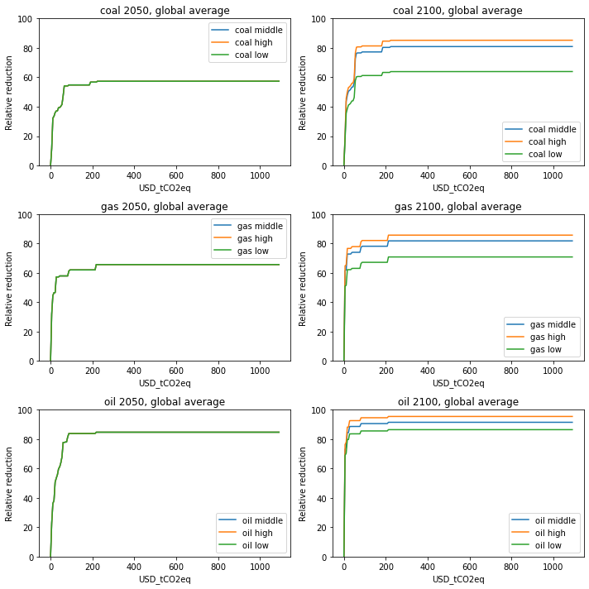
Figure 8.1: Marginal abatement cost curves – Fossil energy sources – 2050 (left) and 2100 (right), global averages.

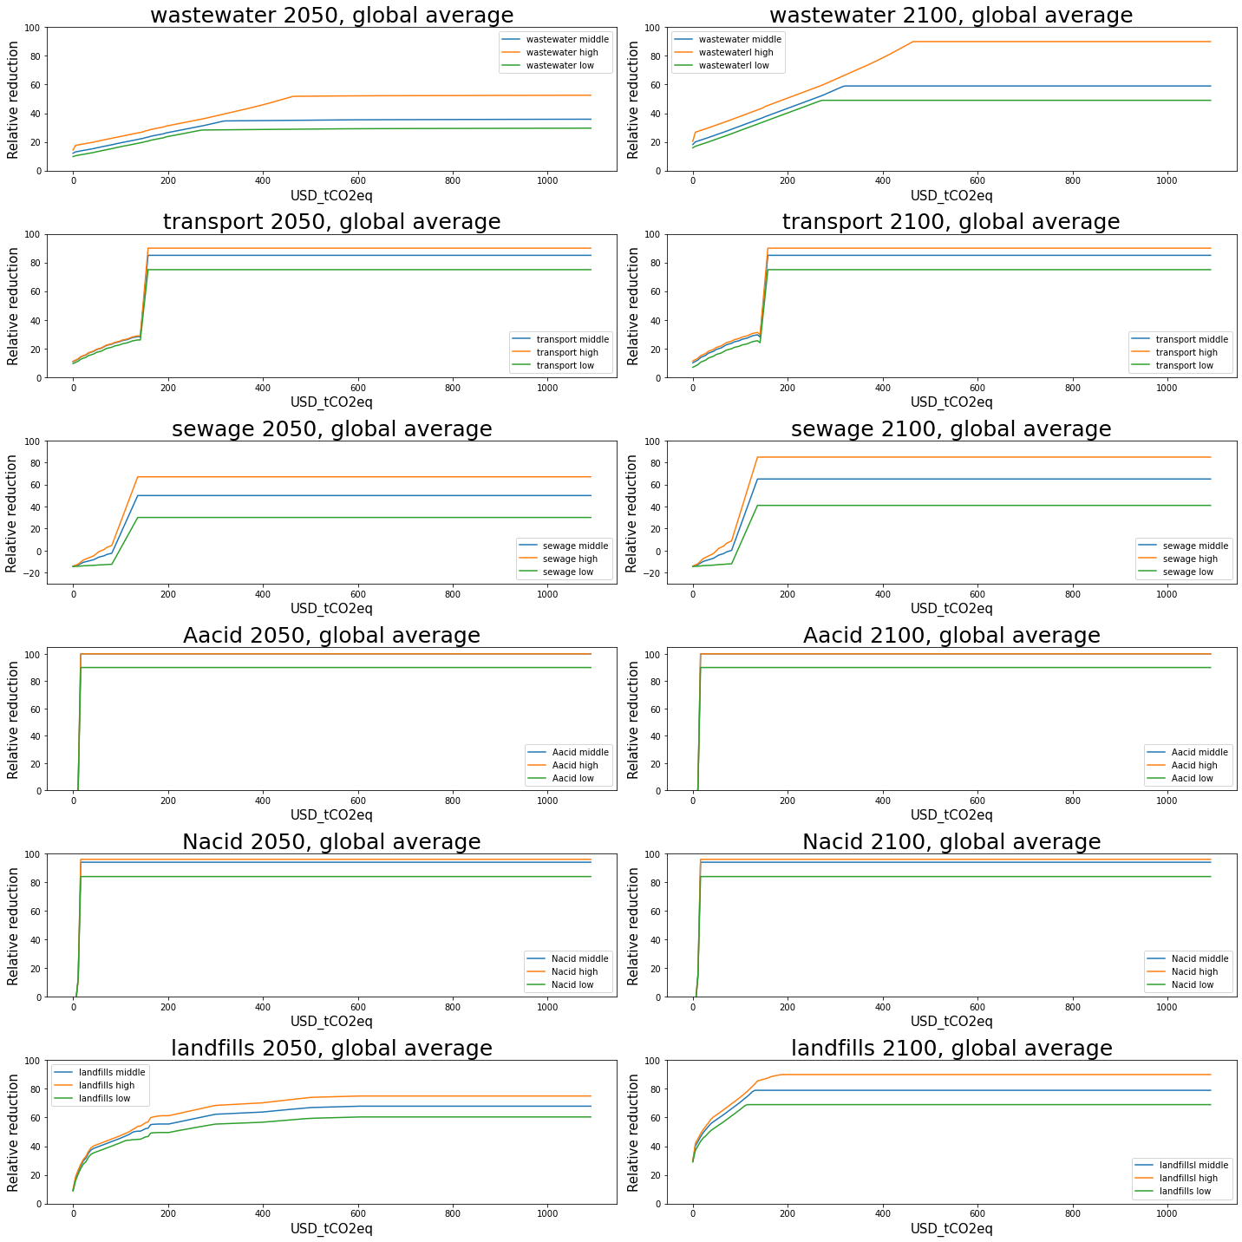
Figure 8.2: Marginal abatement cost curves – Waste and industry sources – 2050 (left) and 2100 (right), global averages.

S9 Emission source-specific NCGG reductions in the scenarios

Table S9.1: Source-specific relative contribution to total NCGG reductions in 2100. Reductions in % reduced CO₂ equivalents based on AR4 GWP₁₀₀.
 | 2H_SSP1 | 2H | 2M | 2L | 1.5H | 1.5M | Average
CH₄ | 50% | 49% | 45% | 46% | 51% | 46% | 48%
N₂O | 17% | 16% | 15% | 13% | 16% | 16% | 16%
HFCs | 31% | 33% | 37% | 38% | 31% | 35% | 34%
PFCs | 0.5% | 0.5% | 0.6% | 0.5% | 0.5% | 0.6% | 0.5%
SF₆ | 1.6% | 1.7% | 1.9% | 1.7% | 1.5% | 1.7% | 1.7%

Table S9.2: Emission source-specific NCGG reductions in 2100. Infeasible scenarios are excluded here (1.5L and 2L_SSP3). Emission reductions in 2H_SSP1 also compared to the SSP2 baseline. F-gas emissions in CO₂ equivalents based on AR4 GWP₁₀₀.
 | Emissions | Reductions
 | Base | 2H_SSP1 | 2H | 2M | 2L | 1.5H | 1.5M
CH₄ AFOLU  (Mt / %) | 212 | 102  (48%) | 77  (36%) | 54  (25%) | 61  (29%) | 116  (55%) | 78  (37%)
CH₄ Energy  (Mt / %) | 179 | 172  (96%) | 162  (91%) | 159  (89%) | 149  (83%) | 162  (90%) | 158  (88%)
CH₄ waste  (Mt / %) | 65 | 47  (72%) | 51  (78%) | 30  (46%) | 21  (32%) | 51  (78%) | 51  (46%)
N₂O AFOLU  (kt / %) | 12614 | 6700  (53%) | 5877  (47%) | 4597  (36%) | 3564  (28%) | 6495  (51%) | 5776  (46%)
N₂O Energy  (kt / %) | 841 | 601  (71%) | 359  (43%) | 352  (42%) | 325  (39%) | 321  (38%) | 295  (46%)
N₂O Waste  (kt / %) | 349 | 305  (87%) | 293  (84%) | 219  (63%) | 130  (37%) | 293  (84%) | 219  (35%)
N₂O Industrial processes  (kt / %) | 1688 | 1595  (94%) | 1515  (90%) | 1513  (90%) | 1451  (37%) | 1546  (92%) | 1569  (93%)
HFCs  (CO₂ eq. / %) | 5157 | 4985  (97%) | 4969  (96%) | 4969  (96%) | 4745  (92%) | 4969  (96%) | 4969  (96%)
PFCs  (CO₂ eq. / %) | 89 | 80  (90%) | 80  (90%) | 80  (90%) | 66  (75%) | 80  (90%) | 80  (90%)
SF₆  (CO₂ eq. / %) | 274 | 253  (92%) | 249  (91%) | 249  (91%) | 207  (76%) | 249  (91%) | 249  (91%)

