Polymeric curcumin nanospheres for lysozyme aggregation inhibition, antibacterial and wound healing applications
Pranita Rananawareª, Samir bauri^{b} Rangappa S. Keriª, Monalisa Mishra^{b}, Varsha P. Brahmkhatriª*
ªNanomaterials for Drug delivery and Therapeutics (NDT-Lab), Centre for Nano and Material Science, Jain University, Jain Global Campus, Bengaluru,562112, Karnataka, India
^{b}Neural Developmental Biology Lab Department of Life Science NIT Rourkela, Rourkela Odisha, India- 769008
*E-mail: b.varsha@jainuniversity.ac.in, brahmkhatri.varsha@gamil.com

1. Synthesis of citrate capped gold nanoparticle (Au nanoparticle)
Citrate capped AuNPs synthesized by J. Turkevich method (Kimling et al. 2006). Chloroauric acid (HAuCl4) is a metallic nanoparticle precursor and tri-sodium citrate used as reducing agent. 100ml of 1mM HAuCl4 was boiled under reflux condenser with continue stirring for 20 min. after boiling 10ml of 38.8mM tri sodium citrate was added dropwise into the boiling solution. Color of the solution has been changed from pale yellow to colorless and finally dark reddish within few minutes.

2. Antimicrobial studies
2.1 Minimum inhibitory concentration (MIC)
MIC was determined by serial dilution technique. The dilution series of C-PVP and C-PVP-Au (250-37 µg/ml) was prepared in a culture bottle containing NB and E.coli bacterial inoculation. A culture bottle contains the different concentrations of C-PVP and C-PVP-Au and E.coli bacterial inoculation with the fresh media and keep positive and negative controls for the reference. The lowest concentrations without apparent growth were taken as concentrations that completely inhibit the growth of microorganisms (MIC) (Azizian-Shermeh et al. 2017).
Antibacterial activity of C-PVP and C-PVP-Au studied at various concentration of C-PVP and C-PVP-Au. Minimum inhibition concentration finds with incubating the bacterial cell with different concentration of C-PVP and C-PVP-Au at 37°c for 24h. Figure S1 mention the inhibitory effect of C-PVP and C-PVP-Au was observed at 250 and 125 µg/ml respectively.
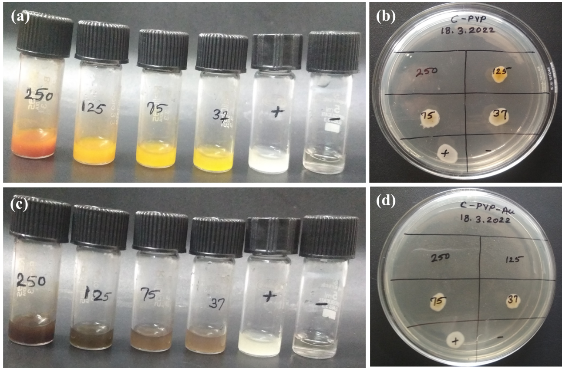
Figure S1: Minimum inhibition concentration (MIC) of C-PVP and C-PVP-Au against E.coli. (a) Serial dilution of C-PVP with E.coli after 24h, (b) Tested the cell viability of serial dilution of C-PVP, (c) serial dilution of C-PVP-Au with E.coli after 24h and (d) Tested the cell viability of serial dilution of C-PVP-Au.

2.2 FE-SEM analysis for determination of cell morphology
E. coli cells were grown overnight in NB at 37 °C. 1% inoculums were taken from the overnight culture and added to 2 mL of NB and adjust the O.D. at 0.3 value. The above mixture was added with C-PVP and C-PVP-Au and incubated at 37 °C for 2 h. The control was maintained without nanoconjugates under the same conditions. The cell pellet was collected at 5000 rpm for 10 min and washed twice with PBS. At room temperature, the pellet was suspended in PBS and fixed in 2% of glutaraldehyde for 30 min. The cell pellet was collected again at 5000 rpm for 10 min and washed with PBS. The fixed cells were again washed with PBS and dehydrated by using 25, 50, 75, 90 and 100% of ethanol, and finally suspended in 200 µl 100% ethanol. 10 µl of suspended E.coli and ethanol solution was poured on a clean and dry silicon wafer and kept at room temperature for overnight drying. The gold sputtering were done after the drying on the surface of E.coli loaded silicon wafer. This deposition process or sputtering is to improve the conductivity of the nonconductive sample surface (Chatterjee et al. 2015).

2.3 Hydrogel membrane (C-PVP@PVA and C-PVP-Au@PVA) patch test
The antibacterial property of membranes, C-PVP@PVA and C-PVP-Au@PVA was identified by modifying the disk diffusion method. This method was adapted from the Clinical and Laboratory Standard Institute (CLSI) protocol (Mukherjee &De 2018, Xue et al. 2015). After incubating overnight at 35±2 °C the OD readings were taken at 600 nm and were equivalent to a 0.6 McFarland standard. Thereafter, by spared plate technique these bacteria were cultured on the NB agar plates. The dried hydrogel membranes of C-PVP@PVA and C-PVP-Au@PVA were sliced into small pieces (1×1 cm). According to the modified disk diffusion method each cut piece was placed on the NB agar plate for 20–30 minutes. Then the plates were incubated at 35±2 °C overnight and the inhibitory effects were observed (Tehrani et al. 2017).
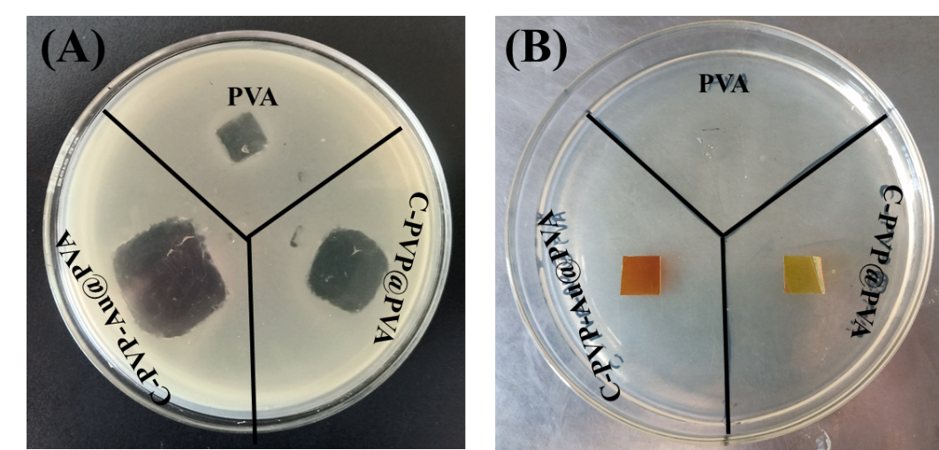
Figure S2: (A) Patch test of C-PVP@PVA and C-PVP-Au@PVA against E.coli and (B) after 24 h patch test of C-PVP@PVA and C-PVP-Au@PVA against E.coli.

Reference
Azizian-Shermeh O, Einali A, Ghasemi A (2017): Rapid biologically one-step synthesis of stable bioactive silver nanoparticles using Osage orange (Maclura pomifera) leaf extract and their antimicrobial activities. Advanced Powder Technology 28, 3164-3171
Chatterjee T, Chatterjee BK, Majumdar D, Chakrabarti P (2015): Antibacterial effect of silver nanoparticles and the modeling of bacterial growth kinetics using a modified Gompertz model. Biochimica et biophysica acta 1850, 299-306
Kimling J, Maier M, Okenve B, Kotaidis V, Ballot H, Plech A (2006): Turkevich method for gold nanoparticle synthesis revisited. The Journal of Physical Chemistry B 110, 15700-15707
Mukherjee M, De S (2018): Antibacterial polymeric membranes: a short review. Environmental Science: Water Research & Technology 4, 1078-1104
Tehrani FA, Modaresifar K, Azizian S, Niknejad H (2017): Induction of antimicrobial peptides secretion by IL-1β enhances human amniotic membrane for regenerative medicine. Scientific reports 7, 17022
Xue J, Niu Y, Gong M, Shi R, Chen D, Zhang L, Lvov Y (2015): Electrospun microfiber membranes embedded with drug-loaded clay nanotubes for sustained antimicrobial protection. ACS Nano 9, 1600-12

