Graphical Abstract
Polymeric curcumin nanospheres for lysozyme aggregation inhibition, antibacterial and wound healing applications
Pranita Rananawareª, Samir bauri^{b} Rangappa S. Keriª, Monalisa Mishra^{b}, Varsha P. Brahmkhatriª*
ªNanomaterials for Drug delivery and Therapeutics (NDT-Lab), Centre for Nano and Material Science, Jain University, Jain Global Campus, Bengaluru,562112, Karnataka, India
^{b}Neural Developmental Biology Lab Department of Life Science NIT Rourkela, Rourkela Odisha, India- 769008
*E-mail: b.varsha@jainuniversity.ac.in, brahmkhatri.varsha@gmail.com

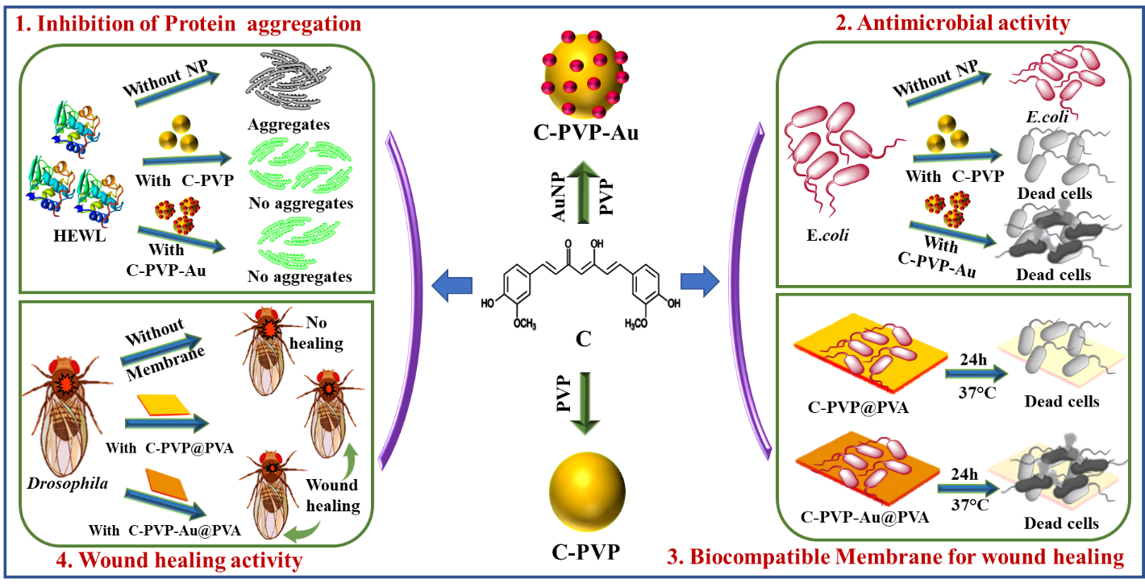
C-PVP, and C-PVP-Au conjugates for inhibition of HEWL aggregation, antibacterial and wound healing activity.

