Table S1. Compositions of working solutions used to construct different substrates.
Samples | Component contents (g) in the exchange solutions of  ddH₂O (200 mL)
Samples | MgCl₂·6H₂O
AT | 0
AT-Mg 1 | 0.008
AT-Mg 2 | 0.080
AT-Mg 3 | 0.800

Table S2 Compositions of modified SBF used to generate CaP coating.
Samples | Component contents (mg) in the mixture solution of ddH₂O (5000 mL)
Samples | NaCl | NaHCO₃ | Na₂SO₄ | Tris | CaCl₂ | MgCl₂·6H₂O | KCl | K₂HPO₄·3H₂O
AT-CaP | 40175 | 1675 | 360 | 30590 | 1752 | 1555 | 1125 | 1386
AT-Mg1-CaP | 40175 | 1675 | 360 | 30590 | 1752 | 1555 | 1125 | 1386
AT-Mg2-CaP | 40175 | 1675 | 360 | 30590 | 1752 | 1555 | 1125 | 1386
AT-Mg3-CaP | 40175 | 1675 | 360 | 30590 | 1752 | 1555 | 1125 | 1386

Table S3 Primer sequences performed for quantitative real-time PCR analysis.
Primer name | Primer sequence (5′to3′)
Runx2(F) | TCCTGTAGATCCGAGCACCA
Runx2 (R) | CTGCTGCTGTTGTTGCTGTT
ALP(F) | CCAGAAAGACACCTTGACTGTGG
ALP(R) | TCTTGTCCGTGTCGCTCACCAT
OPN(F) | GCTTGGCTTATGGACTGAGGTC
OPN(R) | CCTTAGACTCACCGCTCTTCATG
Col1(F) | GCTTGGTCCACTTGCTTGAAGA
Col1(R) | GAGCATTGCCTTTGA TTGCTG
DMP1(F) | AGTGAGGAGGACAGCCTGAA
DMP1(R) | TCCCTGTGGAGTTGCTCTCT
SOST(F) | CCACAGAGGTCATCCCA
SOST(R) | GACACATCTTTGGCGTCATAG
GAPDH(F) | GCACCGTCAAGGCTGAGAAC
GAPDH(R) | TGGTGAAGACGCCAGTGGA

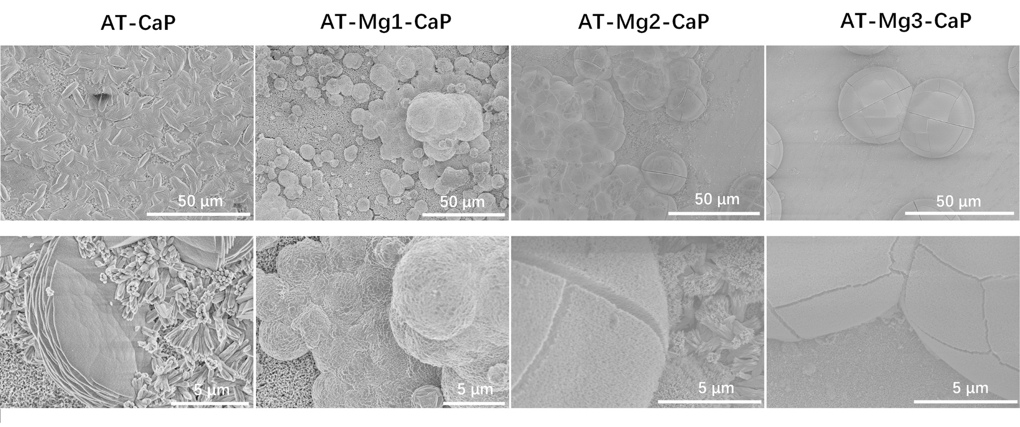
Fig. S1. SEM morphology of the AT-CaP and various AT-Mg(x)-CaP (x=1,2,3) coatings when generated without PAsp

Fig. S2. The EDS spectral line scanning images with Ti, P, and O elements of AT-Mg2-CaP before and after acid elution.

Fig. S3. The EDX mappings (Ti, Mg, Ca, P, O, V, Cl, and Al) images of AT-Mg2-CaP substrates after acid-elution.

Fig. S4. (A) The elemental composition of the AT-Mg2-CaP implant taken from rat femurs by EDS. (B-D) The EDX mappings (Merge, V, and C) images of AT-Mg2-CaP implant taken from rat femurs.

