Anti-leaching Pd catalyst with covalent coordination via p-band engineering for efficient acetylene hydrochlorination
Yuxue Yue^{1,2}, Bolin Wang,³ Saisai Wang¹, Beile Zheng¹, Qi Zhou¹, Kaixuan Zhuge¹, Renqin Chang⁴, Chunxiao Jin², Zhiyan Pan², Haiting Cai,¹ Yihan Zhu^{1,4}, Jia Zhao^{*1}, Xiaonian Li¹
¹ Institute of Industrial Catalysis, Zhejiang University of Technology, Hangzhou, 310014 (China)
² College of Environment, Zhejiang University of Technology, Hangzhou, 310014 (China)
³ School of Chemical Engineering, Northeast Electric Power University, Jilin, 132012 (China)
⁴ Research Center of Analysis Measurement, Zhejiang University of Technology
Hangzhou, 310014 (China)

Figure S1. ¹H NMR spectrum of the pure SIL ligands.

Figure S2. ¹H NMR spectrum of the pure SeIL ligands.

Figure S3. ¹H NMR spectrum of the pure TeIL ligands.

Figure S4. FT-IR spectra of CIL and Pd-CIL complexes. C=X (X stands for S, Se, Te) modes are described as follows: 1780 cm⁻¹ = ν(C–N)+δ(CH); 1230 cm⁻¹ = ν(C–N)+δ(CH)+ν(C=X); 1070 cm⁻¹ =ν(C–N)+ν(C=X); 750 cm⁻¹ =ν_{s}(C=X)+ ν_{as}(C=X); according to Ref. 1-4.

Figure S5. HAADF-STEM images of Pd/AC catalyst.

Figure S6. TG analysis of pure and C₂H₂ treated PdCl₂ samples.

Figure S7. Experimental and fitted EXAFS spectra at the Pd K-edge for Pd-CIL/AC catalysts. (a) k-space, and (b) R-space.

Figure S8. WT analysis of Pd-CIL/AC catalysts with Pd foil, PdCl₂ and PdS as reference.

Figure S9. Total energy of cis- and trans- Pd-CIL structures.

Figure S10. ELF and LOL results of Pd-CIL with Pd-IL and PdS as references.

Figure S11. (a) C 1s and (b) N1s XPS spectrum of Pd-CIL/AC catalysts.

Figure S12. (a) S 2p, (b) Se 3d and (c) Te 3d XPS spectrum of Pd-CIL/AC catalysts.

Figure 13. (a) Arrhenius plot for acetylene hydrochlorination; Reaction rates, r, in acetylene hydrochlorination as a function of the inlet partial pressure of (b) C₂H₂ or (c) HCl. The partial reaction order of both reactants, n, is indicated by the slope of the solid and dashed fitting lines, respectively. Reaction conditions: T_{bed} = 473 K, F_{T} = 20 cm³ min⁻¹, p(C₂H₂, HCl) = 0.1-0.3 bar, W_{cat} = 0.2 g, and P = 1 bar. In order to mitigate the influence of catalyst deactivation, each point was obtained in a single experiment after 15 min tos.

Figure S14. HAADF-STEM images of (a) Hg/AC, (b) Hg-IL/AC and (c) Hg-SIL/AC, the Hg loading were set at 5 wt.%; (d) Experimental and fitted EXAFS spectra at the Hg L3-edge for Hg-SIL/AC catalysts; (e) catalytic performance of Hg-based catalysts at 140 °C, 50 h⁻¹; (f) HAADF-STEM images of used Hg-SIL/AC catalysts; (g) Hg leaching after 12 h reaction over Hg-based catalysts; (h) Y_{VCM} of Hg-SIL/AC before and after Soxhlet extraction, right ordinate axis represents the concentration of Hg in extract solutions (reaction condition: 140 °C, 50 h⁻¹, 2 h).

Figure S15. HAADF-STEM images of (a) Ru/AC, (b) Ru-IL/AC and (c) Ru-SIL/AC, the Ru loading were set at 0.5 wt.%; (d) Experimental and fitted EXAFS spectra at the Ru L3-edge for Ru-SIL/AC catalysts; (e) catalytic performance of Ru-based catalysts at 140 °C, 50 h⁻¹; (f) HAADF-STEM images of used Ru-SIL/AC catalysts; (g) Ru leaching after 12 h reaction over Hg-based catalysts; (h) Y_{VCM} of Ru-SIL/AC before and after Soxhlet extraction, right ordinate axis represents the concentration of Ru in extract solutions (reaction condition: 140 °C, 50 h⁻¹, 2 h).

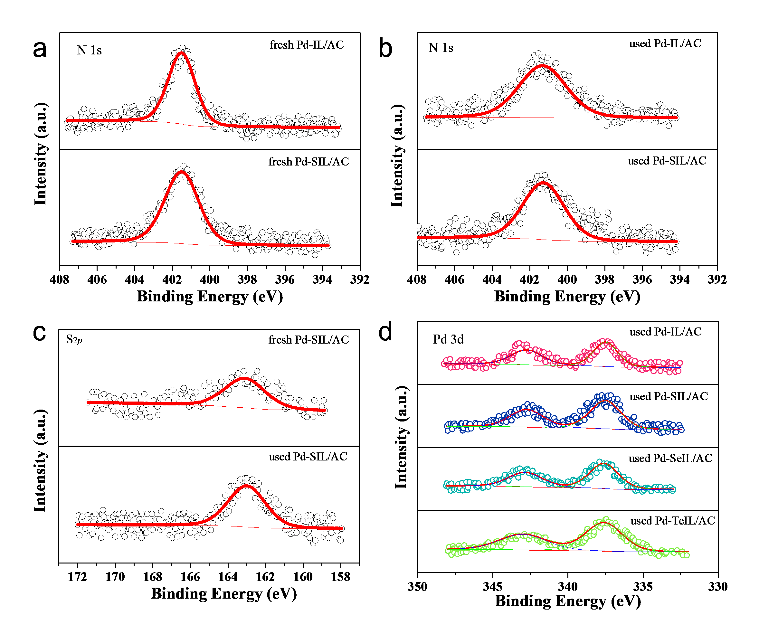
Figure S16. High-resolution XPS spectra of (a) and (b) N 1s, (c) S 2p and (d) Pd 3d for fresh and used Pd-IL/AC and Pd-SIL/AC catalysts.

Figure S17. Nitrogen adsorption–desorption isotherms of fresh and used Pd-IL/AC and Pd-SIL/AC catalysts.

Figure S18. Pores distribution of fresh and used Pd-IL/AC and Pd-SIL/AC catalysts.

Figure S19. Breaking energy of Pd-Cl bond in Pd-IL and Pd-X (X=S,Se,Te) bond in Pd-CIL.

Figure S20. (a) Activation energy of catalysts as a function of the d-center; (b) adsorption energy, differential energy and d-center as functions of the coordination structures.

Figure S21. Scheme of the laboratory set-up used for selective hydrogenation of acetylene.

Table S1. EXAFS fitting parameters at the Pd K-edge for various samples.
Sample | Shell | Nª | R(Å)^{b} | σ²(Å²)^{c} | ΔE₀(eV)^{d} | R factor
Pd foil | Pd-Pd | 12 | 2.74 | 0.0056 | 3.6 | 0.001
PdCl₂ | Pd-Cl | 3.66 | 2.31 | 0.0022 | -0.025 | 0.008
PdS | Pd-S | 2.72 | 2.32 | 0.0052 | -0.060 | 0.019
Pd-SIL/AC | Pd-Cl | 1.97 | 2.32 | 0.0052 | -0.20 | 0.011
Pd-SIL/AC | Pd-S | 1.95 | 2.28 | 0.0024 | -0.09 | 0.011
Pd-SeIL/AC | Pd-Cl | 2.31 | 2.23 | 0.0018 | -0.11 | 0.009
Pd-SeIL/AC | Pd-Se | 2.29 | 2.39 | 0.0024 | -0.11 | 0.009
Pd-TeIL/AC | Pd-Cl | 2.34 | 2.26 | 0.0174 | -0.08 | 0.025
Pd-TeIL/AC | Pd-Te | 2.07 | 2.52 | 0.0028 | -0.30 | 0.025
Hg-SIL/AC | Hg-Cl | 1.29 | 2.50 | 0.0333 | 0.18 | 0.014
Hg-SIL/AC | Hg-S | 0.84 | 2.51 | 0.0061 | -0.10 | 0.014
Ru-SIL/AC | Ru-Cl | 2.46 | 2.23 | 0.0066 | -0.15 | 0.027
Ru-SIL/AC | Ru-S | 2.34 | 2.25 | 0.0343 | -0.12 | 0.027
ªN: coordination numbers; ^{b}R: bond distance; ^{c}σ²: Debye-Waller factors; ^{d} ΔE₀: the inner potential correction. R factor: goodness of fit. Ѕ₀² was set to 0.829, according to the experimental EXAFS fit of Pd foil reference by fixing CN as the known crystallographic value.

Table S2. Pd content in the fresh and used Pd-based catalysts based on the ICP analysis
Catalysts | Nominal Loading (wt.%) | Results of ICP (wt.%) |  | Loss of Pd (%)
Catalysts | Nominal Loading (wt.%) | Fresh | Used | Loss of Pd (%)
Pd/AC | 0.5 | 0.51 | 0.18 | 64.7
Pd-IL/AC | 0.5 | 0.53 | 0.46 | 13.2
Pd-SIL/AC | 0.5 | 0.57 | 0.57 | 0.05

Table S3. BET results of investigated catalysts.
Sample | S_{BET}(m²/g) | V_{tot}(cm³/g) | D(nm)
Pd/AC-fresh | 1099 | 0.599 | 2.78
Pd/AC-used | 1020 | 0.567 | 2.78
Pd-IL/AC-fresh | 791 | 0.437 | 2.78
Pd-IL/AC-used | 587 | 0.327 | 2.81
Pd-SIL/AC-fresh | 887 | 0.488 | 2.83
Pd-SIL/AC-used | 755 | 0.397 | 2.89
AC | 1186 | 0.647 | 2.85

