Title:
A suite of modular, all-synthetic suicide vectors for allelic exchange mutagenesis in multidrug resistant Acinetobacter strains
Alaska Pokhrel¹, Liping Li^{1,2}, Francesca L. Short^{1,3}, Ian T. Paulsen^{1,2}

Supplementary material S1: Step by Step protocol

Step 1: Cloning the mutant allele into an allelic exchange vector (2 days)

  - Design the knockout fragment. The knockout fragment should contain between 600 -1000 bases upstream and downstream flanking the gene of interest.
  - Either have the knockout fragment synthesised or amplify and splice together the upstream and downstream fragments by overlap PCR.
  - Clone the knockout fragment into the desired pALFI vector.
  - Transform the cloning mixture into E. coli Jke201 or another suitable donor strain for biparental mating. The Jke201 donor strain requires DAP supplementation (100 µM).
  - Use colony PCR to screen for correct clones containing the knockout fragment.

Step 2: Conjugation to introduce the knockout vector into the Acinetobacter recipient strain and positive selection (2-3 days)

  - Streak out the donor strain and recipient strain on LB agar + antibiotics/supplements and grow overnight at 37˚C.
  - Resuspend cells from each plate in sterile PBS to an OD_{600nm} of 40 (donor) or 20 (recipient).
  - Spot 25 µl donor, 25 µl recipient and 50 µl combined donor and recipient onto the surface of a very dry LB + DAP (100 µg/ml) plate for the conjugation. Allow patches to dry completely.
  - Incubate plate face up at 37˚C for 2 hours (Time point 1), transfer to room temperature and incubate overnight (Time point 2).
  - At time points 1 and 2, streak out a loopful of cells from the conjugation patch and each control patch onto selective agar plates and incubate overnight at 37˚C.
  - Re-streak 4 putative single-crossover mutants on selective media and grow overnight. Optional: confirm presence of the resistance cassette by PCR, stock single-crossover mutants at -80˚C.

Step 3: Counterselection and mutant screening (4 days)

  - Streak out the single crossovers onto low-salt LB plates supplemented with 5% sucrose. Incubate at room temperature for 2-3 days until you see well defined colonies.
  - Patch colonies from the sucrose plates onto fresh LB + selection and LB + Sucrose plates to confirm loss of the vector. Grow sucrose plates at RT and selection plates at 37˚C.
  - Test clones that grow on sucrose but not selection plates by PCR to confirm loss of the gene of interest.
Supplementary material S2: tetA and tpm gene schematics

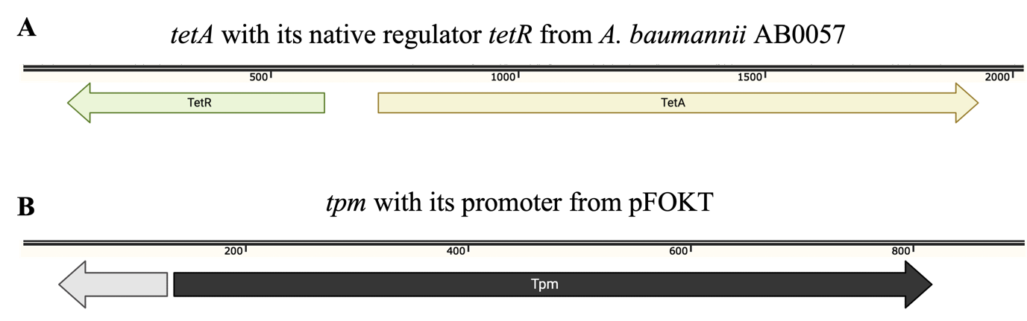

Supplementary material S2: Schematic representation of Tetracycline and Tellurite resistance markers as incorporated in pALFI2 and pALFI3 vectors. A. Tetracycline resistance gene tetA with its native regulator tetR amplified from A. baumannii AB0057, as incorporated in pALFI2. B. Tellurite resistance gene tpm with its promoter amplified from pFOKT plasmid, as incorporated in pALFI3.

Table S1: Primers used in the study.

Primer name | Sequence | Description
aceI_primerA | ACTAGTATAACCGGAATTAAGGCTTCACGT | Forward primer to amplify upstream region of aceI
aceI_primerB | TCTGGGTGCTTATTTACTTGGATAATGTGCATT | Reverse primer to amplify upstream region of aceI
aceI_primerC | GCACATTATCCAAGTAAATAAGCACCCAGATGG | Forward primer to amplify downstream region of aceI
aceI_primerD | ACTAGTACTGCAACAATGACAGCGGGT | Reverse primer to amplify downstream region of aceI
aceIKO_PCRf | AGCAATCGACATACTCACAGCAGA | Forward aceI external primer to screen for knockouts
aceIKO_PCRr | ATTTGCTGCAACTGGTGGTCGTAT | Reverse aceI external primer to screen for knockouts
BAL062_00580_primerA | GAGTGGATCCCTTTGGTTCCGACCCTCGG | Forward primer to amplify upstream region of BAL062_00580 and to screen for knockouts
BAL062_00580__primerB | TAGTAGGAAAAGGGAGCCCGCCTCACAGATTTT | Reverse primer to amplify upstream region of BAL062_00580
BAL062_00580__primerC | ATCTGTGAGGCGGGCTCCCTTTTCCTACTACTACTTGAA | Forward primer to amplify downstream region of BAL062_00580
BAL062_00580__primerD | GAGTGGATCCACCGTTGGTTTCGCCTTGC | Reverse primer to amplify downstream region of BAL062_00580 and to screen for knockouts
pALFI_M13F | GGTTTTCCCAGTCACGAC | Forward M13 primer flanking MCS in pALFI vectors
pALFI_M13R | AGCGGATAACAATTTCACAC | Reverse M13 primer flanking MCS in pALFI vectors
pALFI1_HygR_F | GAAAAAGCCTGAACTCACCGC | Forward primer to amplify hygR resistance gene in pALFI1
pALFI1_HygR_R | CGCTCATTAGGCGGGCTACTA | Reverse primer to amplify hygR resistance gene in pALFI1
TetR_ SwaIF | ATTTAAATTGAGTGGGTTGCGCTCCGG | Forward primer to amplify tetR and tetA regions in A. baumannii AB0057
TetR_ScaIR | AGTACTCCCGCATGGCATAGGCCT | Reverse primer to amplify tetR and tetA regions in A. baumannii AB0057
Tpm_SwaIF | ATTTAAATGCGGGACTCTGGGGTTCGA | Forward primer to amplify tpm with its promoter region in pFOKT
Tpm_ScaIR | AGTACTCCTACCGCGAAAGGTTTTGC | Reverse primer to amplify tpm with its promoter region in pFOKT

