SMALL VOLATILE INHIBITORS TARGETING lncRNA IN RADIORESISTANT NON-SMALL CELL LUNG CANCER
Arnab Mukherjee¹, Mukunthan KS^{1,}*
¹ Department of Biotechnology, Manipal Institute of Technology, Manipal Academy of Higher Education, Manipal, India
*Corresponding author: Associate Professor, Department of Biotechnology, Manipal Institute of Technology, Manipal Academy of Higher Education, Manipal, India. Email: mukunthan.ks@manipal.edu

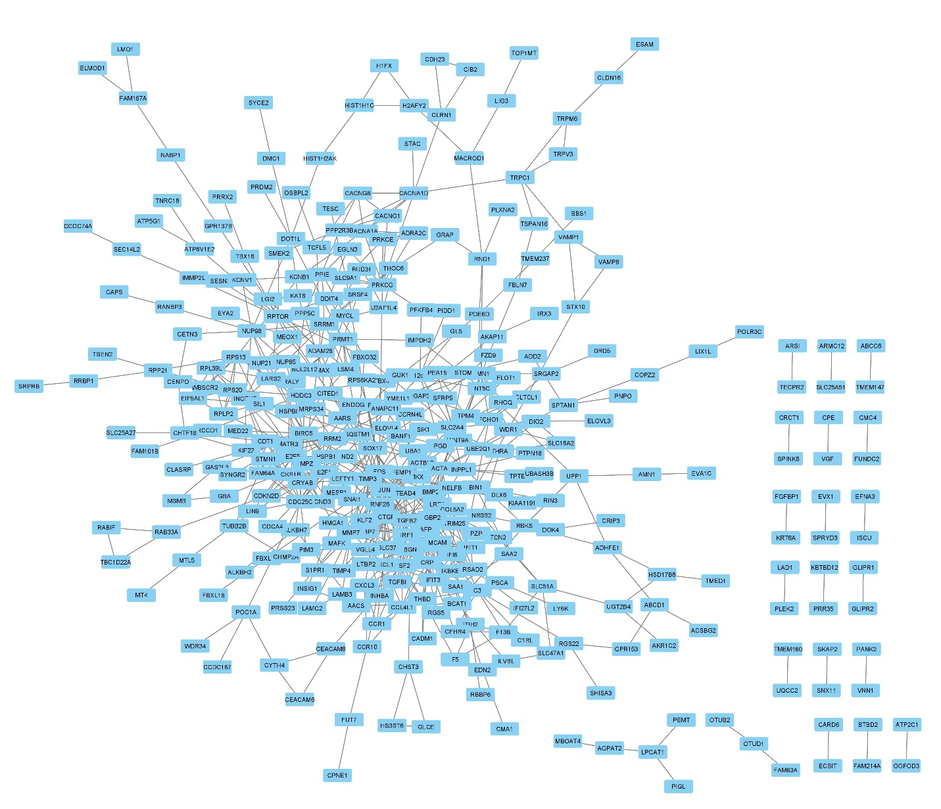
Supp. Fig. 1 The interaction of the DE mRNAs dataset is represented using a PPI network.
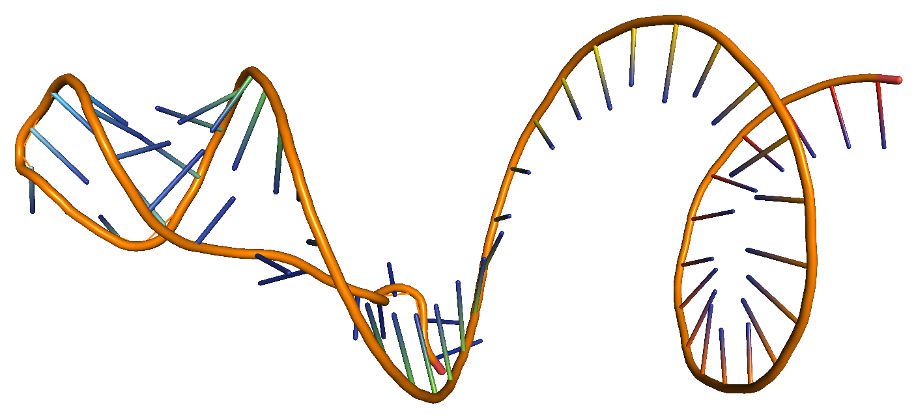
Supp. Table 1 The best clusters obtained from the complexes obtained from the HADDOCK with associated intermolecular interaction energies.
Complexes | Cluster No./size | Z-Score | Van der Waals energy | Electrostatic energy | Desolvation energy | Restraints violation energy
lncRNA-8655 | 1/132 | -1.7 | -18.6 +/- 2.8 | -15.1 +/- 6.9 | 0.5 +/- 0.9 | 0.6 +/- 0.5
lncRNA-62348 | 3/17 | -1.2 | -16.5 +/- 1.8 | -25.3 +/- 15.1 | -1.1 +/- 0.5 | 0.5 +/- 0.6
lncRNA-246929 | 4/9 | -1.2 | -16.8 +/- 1.9 | 0.9 +/- 2.4 | -0.4 +/- 0.6 | 0.0 +/- 0.1

Supp. Fig. 2 The tertiary structure of the ENST00000605056 lncRNA was predicted using RNA COMPOSER.
Supp. Fig. 3 The radar plot represents the predicted pharmacokinetic properties of the selected volatile ligands.
Supp. Table 2 The druglikeness of the selected volatile ligands based on rule of five assessed using SwissADME.
Ligands | Molecular weight | Hydrogen Bond Acceptor | Hydrogen Bond Donor | logP_{O/W}
8655 | 182.17 | 4 | 1 | -0.01
62348 | 154.16 | 3 | 2 | -0.02
246929 | 220.26 | 3 | 0 | 2.52

