Sitagliptin via the activation of AMPK/eNOS signaling improves vascular endothelial function by suppressing Creb5/lncRNA ENSMUST00000213271 axis in obese mice
Yi Zong^{1#}, Xiaorui Wang^{1#}, Yi Zhang^{1,2}, Na Tan¹, Yan Zhang^{1,3}, Li Li^{1,3}, Limei Liu^{1,3*}
¹Department of Physiology and Pathophysiology, School of Basic Medical Sciences, Peking University, Beijing, China; 1911210056@bjmu.edu.cn (Y.Z.); 2011210004@bjmu.edu.cn (X.W.); 2111110083@bjmu.edu.cn (Y.Z.); tanna963@bjmu.edu.cn (N.T.); zhangy18@bjmu.edu.cn (Y.Z.); lilyby@bjmu.edu.cn (L.L.)
²Department of Integration of Chinese and Western Medicine, School of Basic Medical Sciences, Peking University, Beijing, China;
³Key Laboratory of Molecular Cardiovascular Science, Ministry of Education, Beijing, China.

*Correspondence:
Limei Liu, PhD
Department of Physiology and Pathophysiology
Peking University Health Science Center
No. 38 Xue Yuan Road
Beijing, 100191, China
E-mail: liulm@bjmu.edu.cn

#The two authors contributed equally to this work.
Supplemental Materials

1. Additional Methods

1.1. GO and KEGG pathway analyses
Gene ontology (GO) (http://www.geneontology.org) is a comprehensive resource in molecular and cellular biology for cataloguing gene function, which includes cellular components (CC), molecular functions (MF), and biological processes (BP). Kyoto Encyclopedia of Genes and Genomes (KEGG) (http://www.genome.jp/kegg/) analysis is a database resource to interpret the functional meanings to genes and genomes and analyzing the related pathways. Thus, GO enrichment and KEGG pathway analyses were applied to identify the functions of the 12 differentially expressed genes including 7 down-regulated lncRNAs (uc008hps.1, AK020997, ENSMUST00000144860, 126022, 124462, 175709, and 139788) and 5 up-regulated lncRNAs (ENSMUST00000231568, 181467, 148756, 213271, and 150482) in obese mice, which were reversed by sitagliptin.

1.2. Coding-noncoding co-expression analysis
The coding-noncoding gene co-expression network (CNC) was constructed to identify the interactions between differentially expressed lncRNAs and their co-expressed mRNAs. A hybrid hierarchical clustering algorithm was performed to analyze the relationship between the above 12 lncRNAs and related mRNAs and to calculate the Pearson correlation coefficient (PCC) of each pair. The lncRNA-mRNA pairs with a PCC > 0.90, P value ≤ 0.05, and false discovery rate (FDR) ≤ 1 were identified and chosen to construct a network. The network was drawn using Cytoscape software (Version 3.6.0).

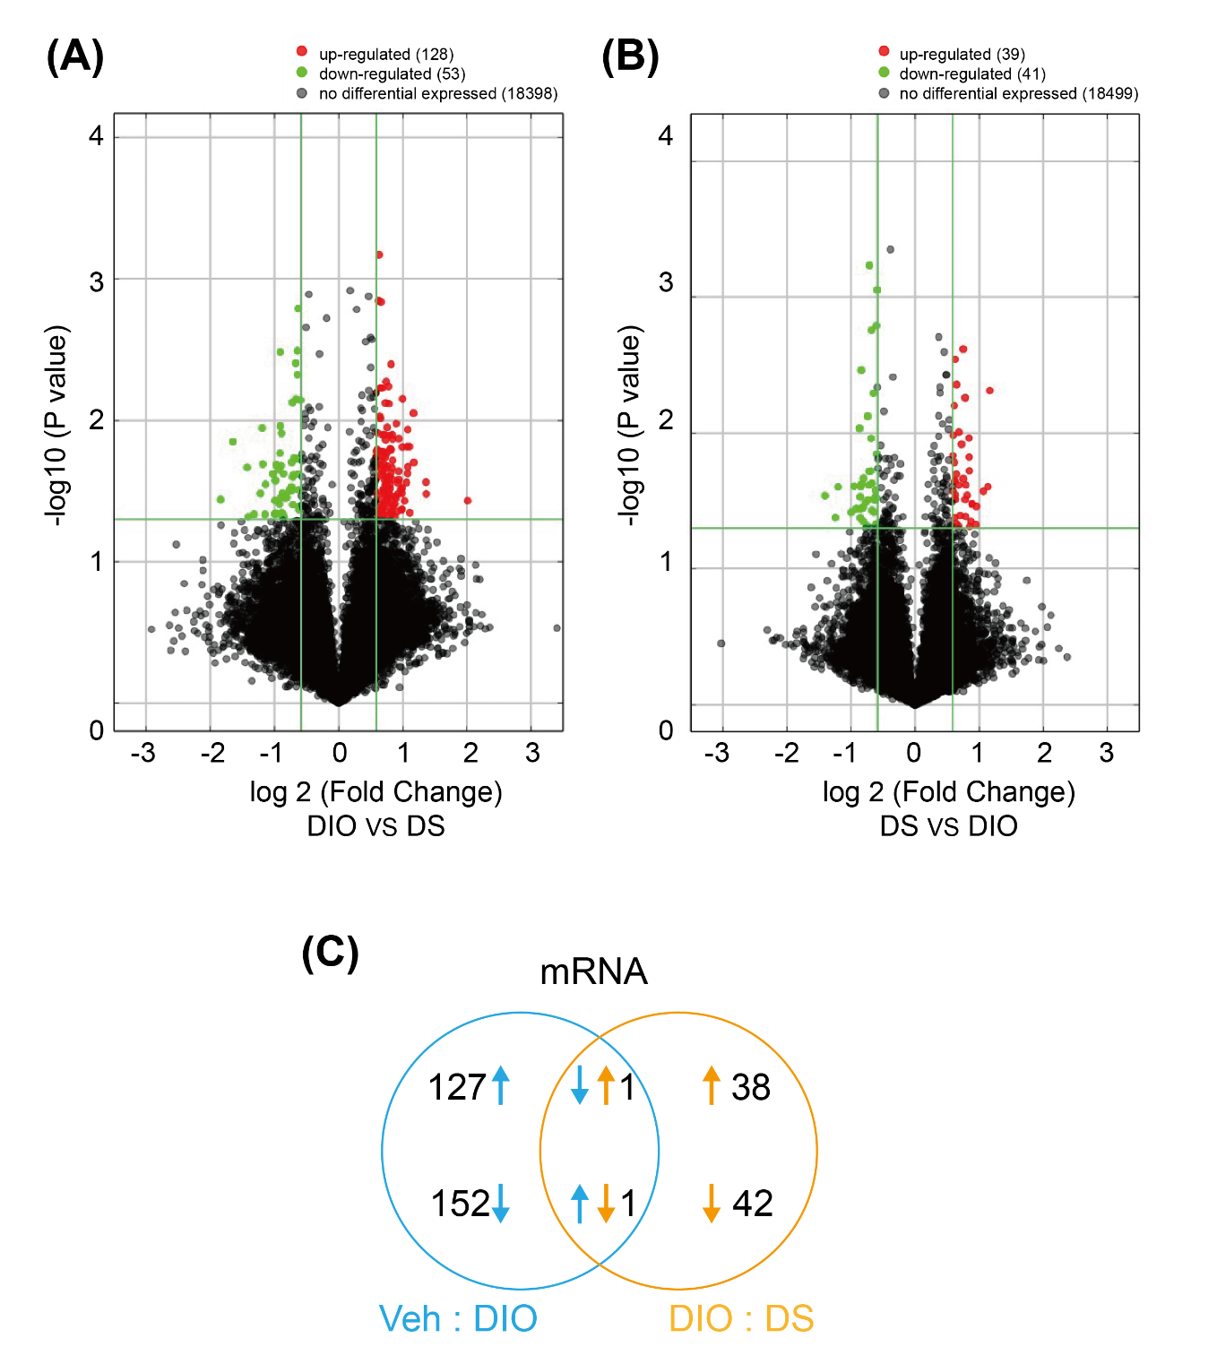
2. Supplemental Figures

Figure S1 Volcano plot for differentially expressed (DE)-mRNAs in DIO group compared with vehicle (A). Volcano plot for DE-mRNAs in obese mice treated with sitagliptin compared with DIO (B). A Venn diagram of DE-mRNAs (C). The comparison of DIO group and Vehicle group (blue); the comparison of DS group and DIO group (orange); the up-regulated genes (upward arrows); the down-regulated genes (downward arrows). Veh: Vehicle; DS: DIO+sitagliptin.

Figure S2 Coding non-coding co-expression (CNC) network analysis of the 12 lncRNAs validated by qPCR.

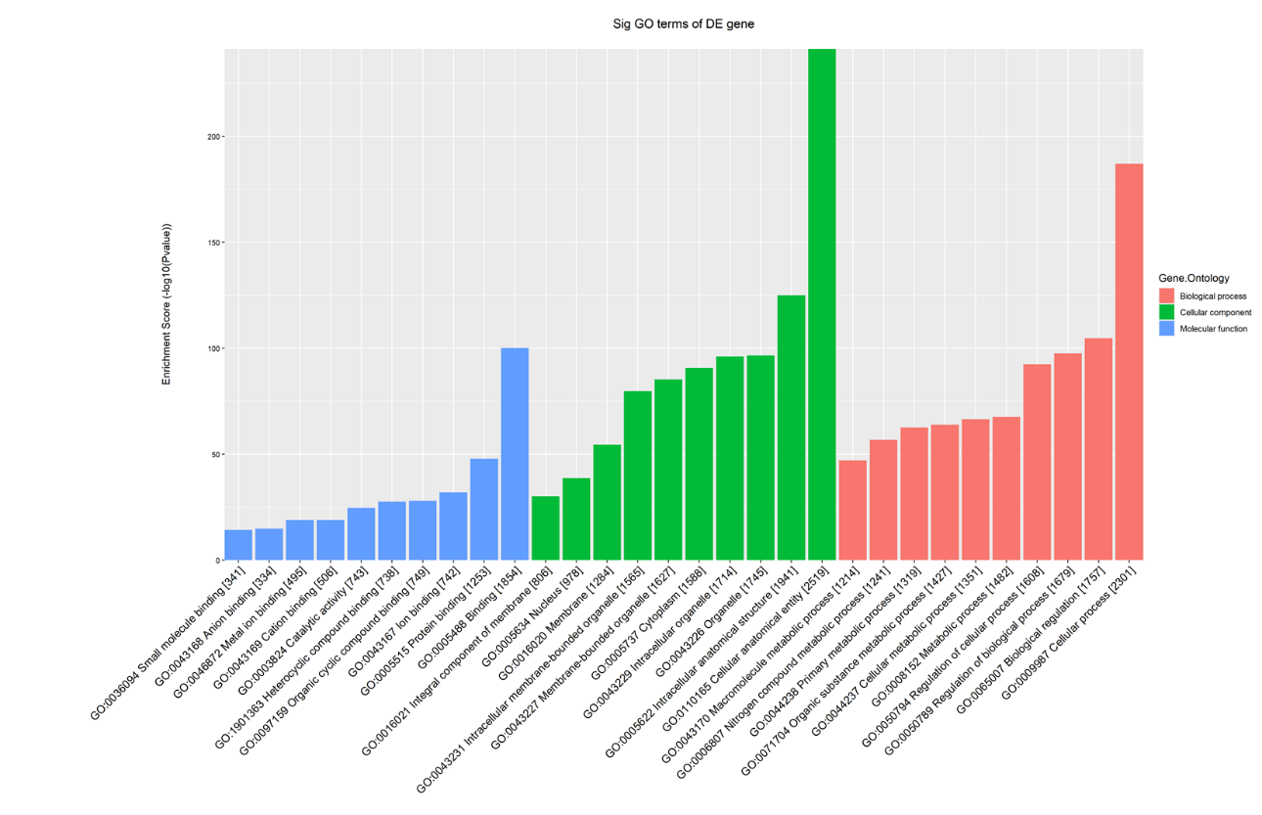

Figure S3 GO analysis of the 12 lncRNAs validated by qPCR. The top 10 GO terms of biological process (red), cellular components (green), and molecular function (blue) were listed.

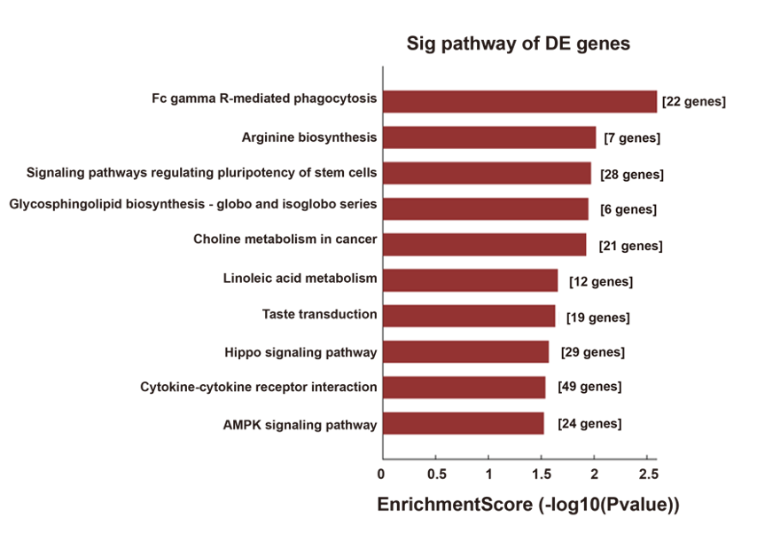
Figure S4 KEGG pathway enrichment analysis of 12 lncRNAs validated by qPCR.
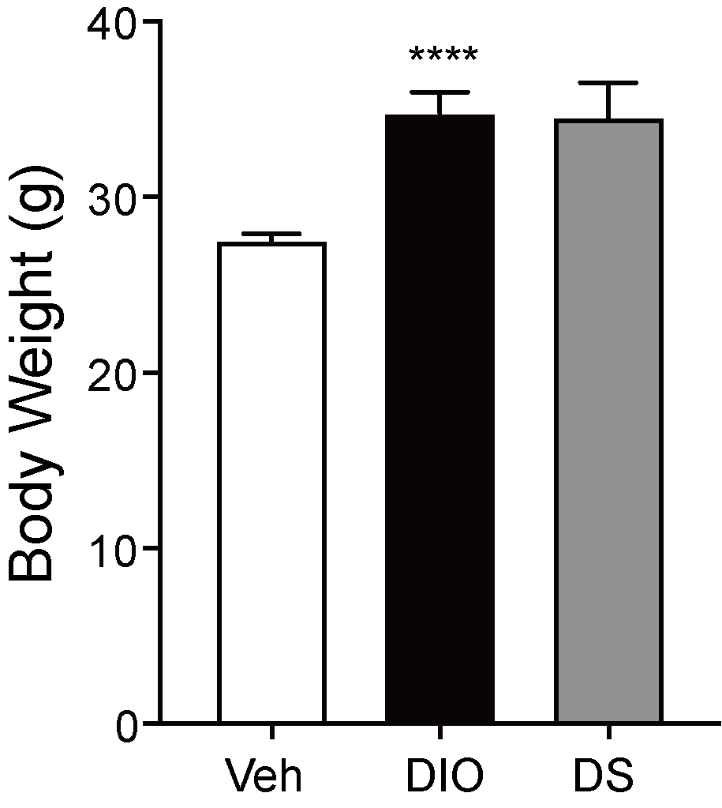

Figure S5 Body weight of Vehicle, DIO, and sitagliptin-treated obese mice. Values are presented as mean ± SEM, ****P < 0.0001 vs. Veh. n=7-13. Veh: Vehicle; DS: DIO+sitagliptin.

Table S1 The primers of the lncRNAs.
Gene name |  | Primer sequence (5’-3’)
ENSMUST00000204479 | Forward | TAGGAGAAGGACAGCCGAGTG
ENSMUST00000204479 | Reverse | AGCGAAGTGGCAGTGAACG
uc.270- | Forward | AGTCATTGTTCACCCTCGGCT
uc.270- | Reverse | GGTTATCAAACGGCGCAGTC
ENSMUST00000231568 | Forward | CGTGGCTGTTGTACGAAGGA
ENSMUST00000231568 | Reverse | GCGCTCAGACCAATGAGGA
ENSMUST00000181052 | Forward | AAATGATCCTGACTGCCGA
ENSMUST00000181052 | Reverse | GGGAAGAGTAAGACATTTGCA
ENSMUST00000129760 | Forward | TAGACACATCAAGGATTGTCTG
ENSMUST00000129760 | Reverse | GAGAATCAGTTCAGGCAAGG
ENSMUST00000181467 | Forward | CCTGGAGAGCAGTAAGAAAAACC
ENSMUST00000181467 | Reverse | TCCCTCCTCGCTTTCCTAATG
ENSMUST00000148756 | Forward | CAGATAGGCAGGCTGAGGGA
ENSMUST00000148756 | Reverse | CGTCGCAATGACACAGCAGTT
ENSMUST00000213271 | Forward | TTGGACTGCTACTAAGGTTGTAAAG
ENSMUST00000213271 | Reverse | CAGAAGTCCCAAGAAGCATAAGA
humanlincRNA2149- | Forward | TCCCTGAGAGCCTGGAAGAAG
humanlincRNA2149- | Reverse | TCTGAAAGACTAATCGCAGAACTG
ENSMUST00000150482 | Forward | TGATTTCAGAGATTCCAGGAGC
ENSMUST00000150482 | Reverse | TGTCATGGAGACGTTAGAATGGT
uc008hps.1 | Forward | TTCCACACCCACGGATACTG
uc008hps.1 | Reverse | CCCACCTGATTTCTTCTGACATT
AK158850 | Forward | TGCTTTACCAACTGAACTACATCC
AK158850 | Reverse | GTTAACACAAAGCCAGGCAGTACA
AK043671 | Forward | GGAGAAGACAGGTGAGCCTAAGT
AK043671 | Reverse | AGAGCACAGCGAGGTGGAAC
AK020997 | Forward | TAGGTTTAGTTCTAGGCGAGGGAT
AK020997 | Reverse | ATGGAGGACCGAGGAGACAGT
ENSMUST00000144860 | Forward | CCTTTGAGGTTTCCTGAGC
ENSMUST00000144860 | Reverse | TATTCTCACTCACCCAGCG
ENSMUST00000126022 | Forward | TAGTGGCTGTAAGTCAGCA
ENSMUST00000126022 | Reverse | CAAAGGATCCTTCAGATCACTC
ENSMUST00000124462 | Forward | AAATCGTTCACGTGTGCAC
ENSMUST00000124462 | Reverse | CTTAGGGTGCCCAATTGGA
ENSMUST00000175709 | Forward | ACTTGACAGCAGATGCGTGATC
ENSMUST00000175709 | Reverse | CCATCTGACTCCATCTCCACATC
ENSMUST00000133355 | Forward | TGAAGGAAGCCAAGCACATC
ENSMUST00000133355 | Reverse | GGCTAGCTGGTGCTCCTCATAT
ENSMUST00000139788 | Forward | CTGTATGTCCTGCCACTCAGCT
ENSMUST00000139788 | Reverse | CTGCCTGTCGCTCCCTGAA
ENSMUST00000173314 | Forward | TACTTCAGACTGTAGAAGGAGC
ENSMUST00000173314 | Reverse | AATTGGGCATAACCTGTTGTC
ENSMUST00000179498 | Forward | AGTAGATCCACTTCCTCCAG
ENSMUST00000179498 | Reverse | TTAGAGGCCGAATGAACTG
ENSMUST00000150542 | Forward | GATTGCCGATCGAGTTCTC
ENSMUST00000150542 | Reverse | TGCATTCACCTGTTCTGTC
ENSMUST00000160061 | Forward | CTGTTACCTTCCTCCAGCA
ENSMUST00000160061 | Reverse | GATGCAGATCAGGACAACAC
ENSMUST00000181286 | Forward | ATCCTGCCAGGAAACAGAG
ENSMUST00000181286 | Reverse | GCTATGTACTCTTTGTTTAGGAGC

Table S2 The primers of the mRNAs.
Gene name |  | Primer sequence (5’-3’)
Creb5 | Forward | AGATGGTCCTCTGTTGGGAA
Creb5 | Reverse | TGGACACGGTTATGAGAATGA
cyp2c29 | Forward | ATCTGGTCGTTCCTAGCG
cyp2c29 | Reverse | AGTAGGCTTTGAGCCCAAATAC
Kcnj3 | Forward | TCAAATCTCGGCAGACACCT
Kcnj3 | Reverse | AACGATGACCCCAAAGCAC
eNOS | Forward | TTCCGGCTGCCACCTGATCCTAA
eNOS | Reverse | AACATATGTCCTTGCTCAAGGCA
AMPKα1 | Forward | CTCAGTTCCTGGAGAAAGATGG
AMPKα1 | Reverse | CTGCCGGTTGAGTATCTTCAC
AMPKα2 | Forward | CATGGCTGAGAAGCAGAAGCAC
AMPKα2 | Reverse | CTTAACTGCCACTTTATGGCCTG
Gapdh | Forward | GTATGACTCCACTCACGGCAAA
Gapdh | Reverse | GGTCTCGCTCCTGGAAGATG

Table S3 The List of siRNA sequence
Name | Sequence (5’-3’)
NC siRNA | ACGUGACACGUUCGGAGAATT
3271 siRNA-1 | AGCAUAAGAGGGUAAGUAGTT
3271 siRNA-2 | AGAAGAAUGUCCUUUUACGTT
3271 siRNA-3 | AAUCACAUACUGACUUAACTT
Creb5 siRNA | GAAAGAATCCCAAGGGTAT
3271: lncRNA ENSMUST00000213271

Table S4 Functional annotation of Creb5
RefseqID | GeneSymbol | Chrom | Regulation | Fold Change  （DIO vs Veh） | P-value  （DIO vs Veh）
NM_001327821 | Creb5 | Chr6 | up | 1.5250576 | 0.012243331
Veh: Vehicle.

