Supporting Information

Synthesis of CaWO4 as a photocatalyst for degradation of methylene blue and carmine under ultraviolet light irradiation

Cunyang Yuan^{1,2}, Fuwei Sun^{1,2}, Haibo Liu^{1,2}, Tianhu Chen^{1,2}, Ziyang Chu^{1,2}, Hanlin Wang^{1,2}, Xuehua Zou^{1,2}, Peixun Zhai^{1,2}, Dong Chen^{1,2∗}

1 Key Laboratory of Nano-Minerals and Pollution Control of Anhui Higher Education Institutes, Hefei University of Technology, Hefei 230009, China
2 Institute of Environmental Minerals and Materials, School of Resources and Environmental Engineering, Hefei University of Technology, Hefei 230009, China

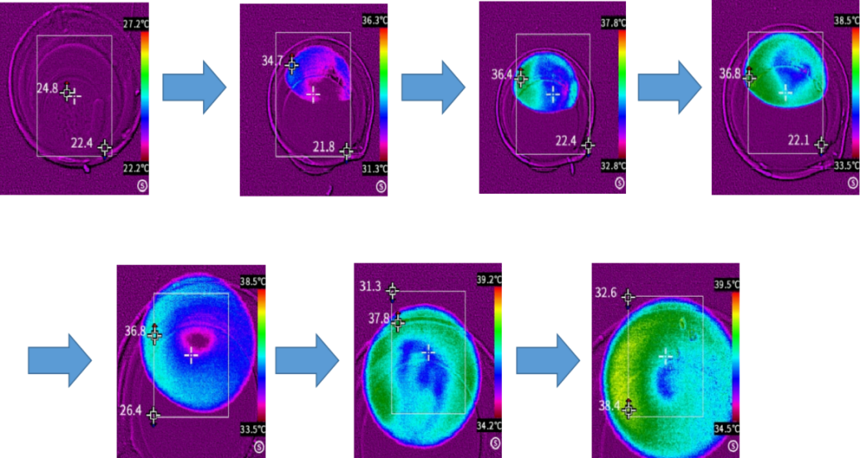

Fig. S1 the temperature of the solution during the reaction process

元素 | 重量百分比 | 原子百分比
O | 21.94 | 65.37
Ca | 15.48 | 18.41
W | 62.58 | 16.22
Fig. S2 calculation of element proportion

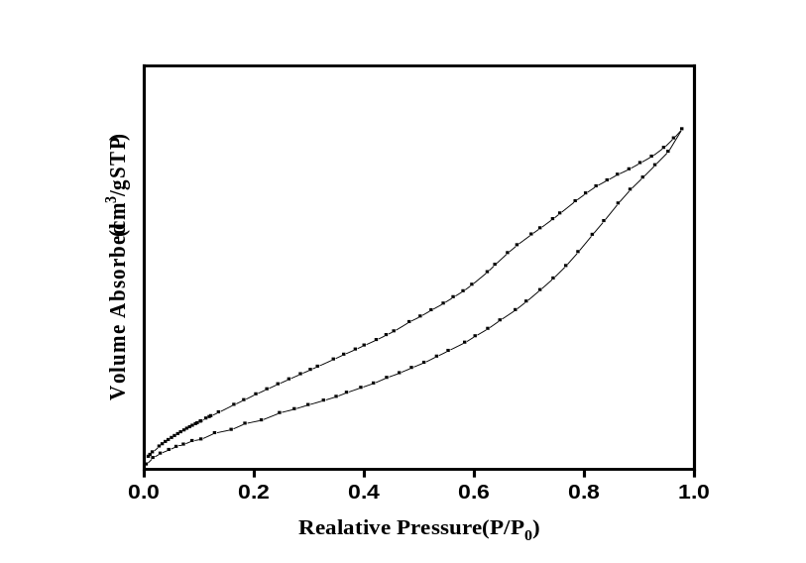
Fig. S3a nitrogen adsorption-desorption isotherms of CaWO₄

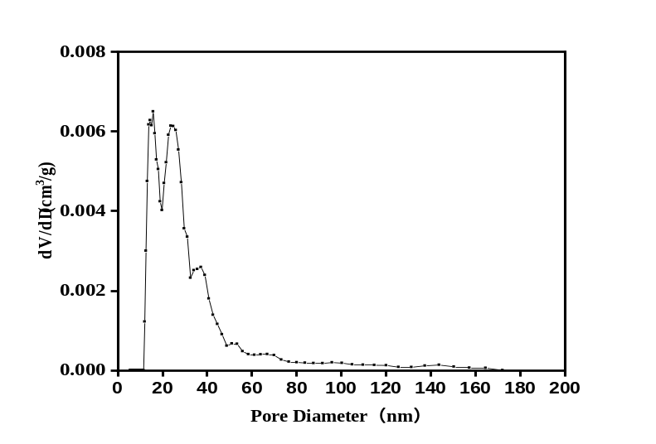
Fig. S3b pore size distribution of CaWO₄

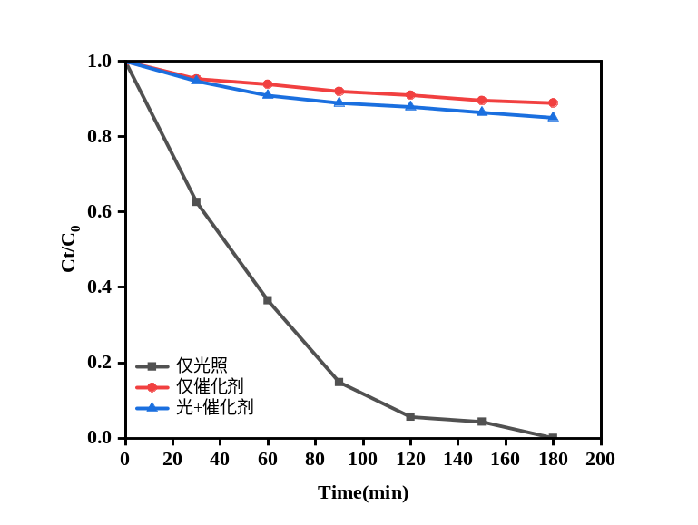
Fig. S4 photocatalytic degradation of MB by comparation experiments.
[CaWO₄]=1.0 g/L; light intensity=80 W; [MB]=100 mg/L; pH=8.2
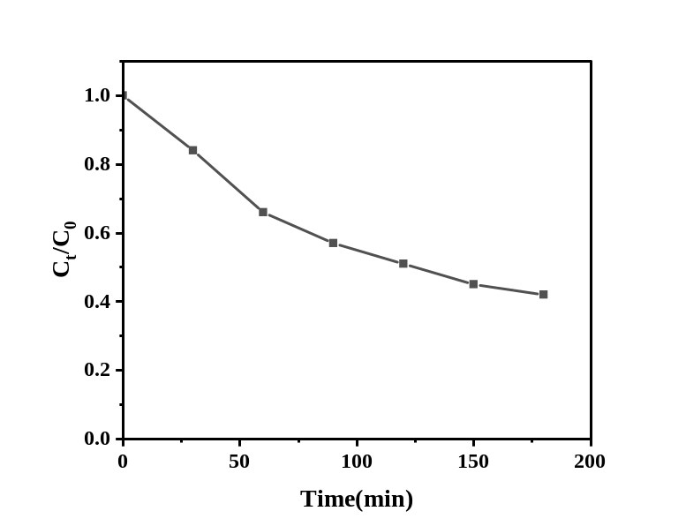
Fig. S5 TOC removal efficiency in photocatalytic degradation of MB
[CaWO₄]=1.0 g/L; light intensity=80 W; [MB]=100 mg/L; pH=8.2

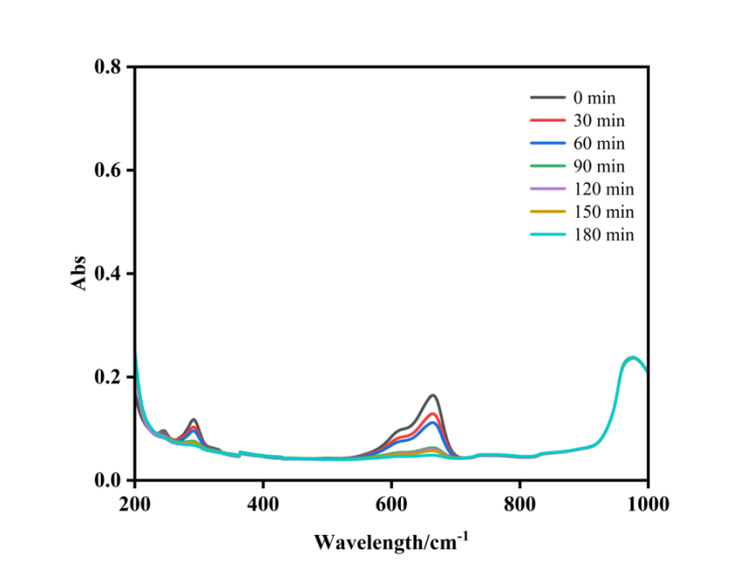
Fig. S6 UV–vis spectra in the course of photocatalytic degradation MB
[CaWO₄]=1.0 g/L; light intensity=80 W; [MB]=100 mg/L; pH=8.2

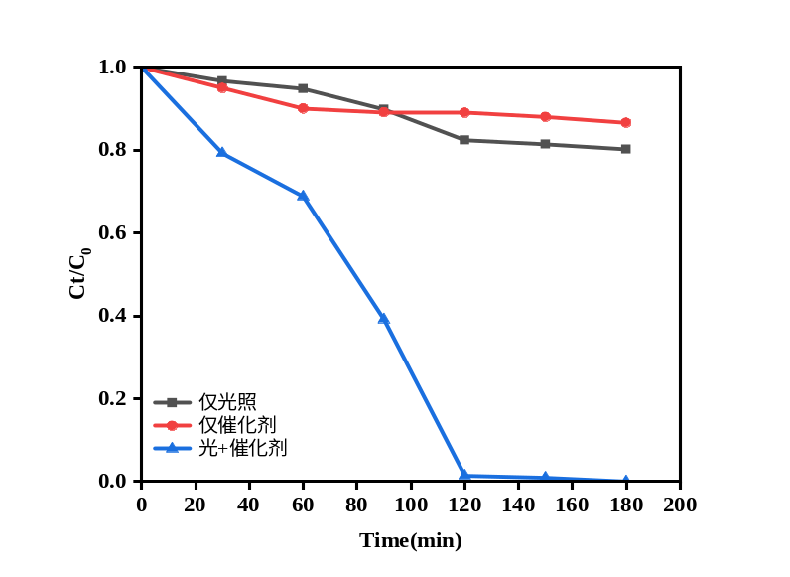
Fig. S7 photocatalytic degradation of CR by comparation experiments.
[CaWO₄]=1.0 g/L; light intensity=80 W; [CR]=100 mg/L; pH=6
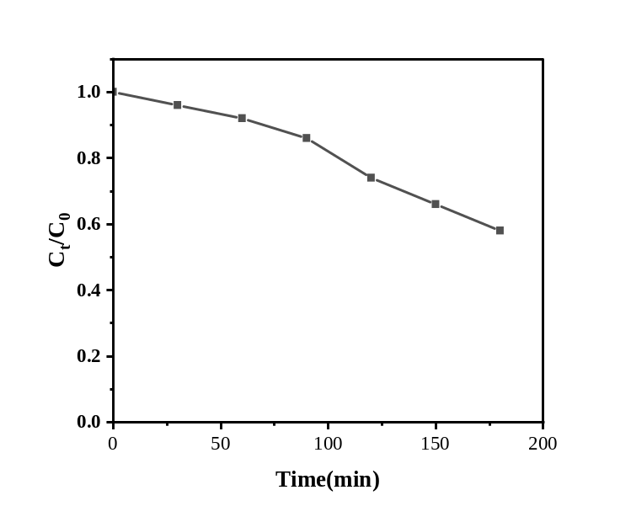
Fig. S8 TOC removal efficiency in photocatalytic degradation of CR
[CaWO₄]=1.0 g/L; light intensity=80 W; [CR]=100 mg/L; pH=6

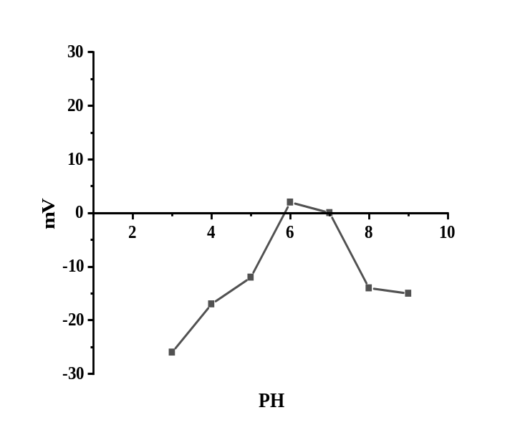
Fig. S9 potential of CaWO4 solution at different pH values

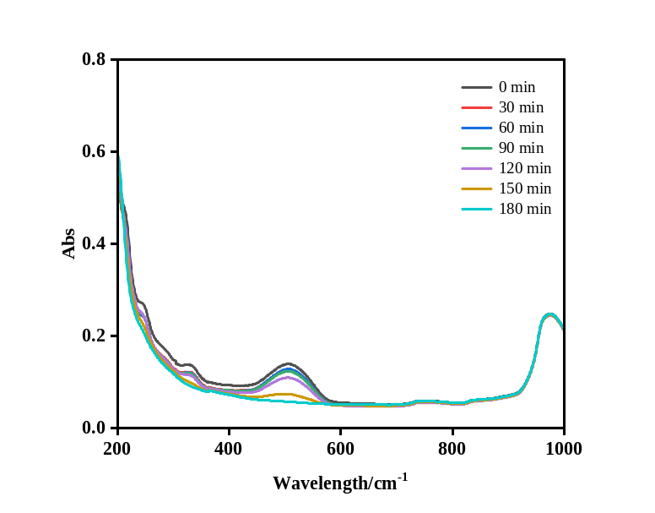

Fig. S10 UV–vis spectra in the course of photocatalytic degradation CR
[CaWO₄]=1.0 g/L; light intensity=80 W; [CR]=100 mg/L; pH=6

∗Corresponding author: Dong Chen, cdxman@hfut.edu.cn

