Supplementary Information
Effect of NaClO and ClO₂ on the bacterial properties in a reclaimed water distribution system: efficiency and mechanisms
Shichao Jiaª, Yimei Tianª, Yarong Songª, Haiya Zhang^{a, b*}, Mengxin Kangª, Hao Guo^{a, c}, Haolin Chenª
ª Environmental Science and Engineering, School of Tianjin University, Tianjin 300072, China
^{b} Institute of Water Ecology and Environment, Chinese Research Academy of Environmental Science, Beijing 100012, China
^{c} The Institute of Seawater Desalination and Multipurpose Utilization, MNR (Tianjin), Tianjin 300192 , China.
*Corresponding Author: Haiya Zhang, flying850612@126.com
11 pages: 1 Tables, 7 Figures

Contents

Supporting Information:
Figure S1 Schematic diagram of the annular reactor operation system. 3
Figure S2 The total sequences and OTUs obtained from the effluents. 4
Figure S3 The abundance-rank curves of all the effluent samples. 5
Figure S4 The structural schematic diagram of ClO₂ and ClO⁻. 6

Supporting Information 1

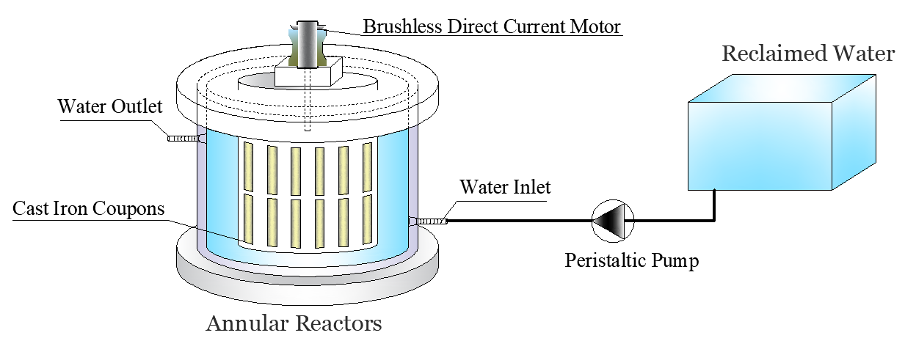

Figure. S1 Schematic diagram of the annular reactor operation system.

Supporting Information 2

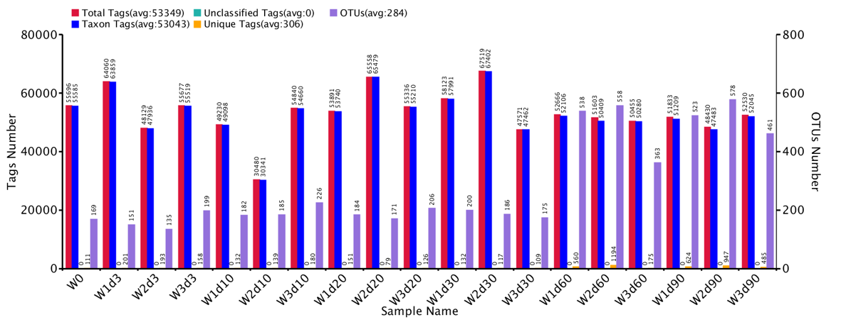
Figure. S2 The total sequences and OTUs obtained from the effluents of ARs

Supporting Information 3
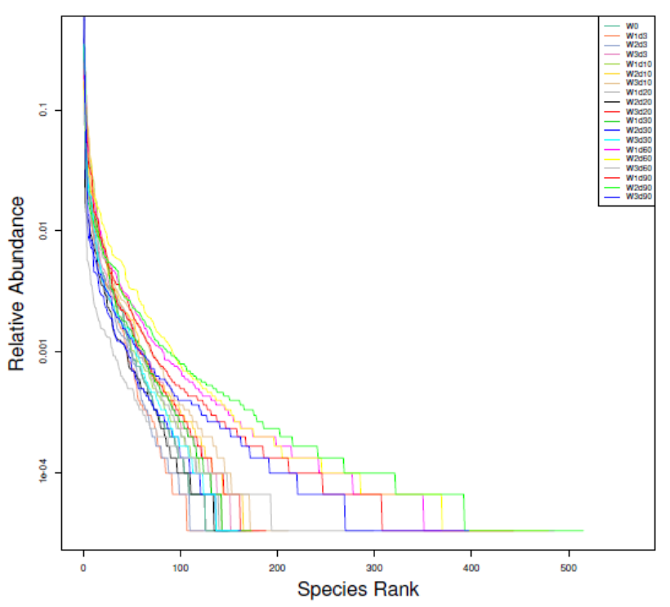

Figure. S3 The abundance-rank curves of all the effluent samples.

Supporting Information 4

Figure. S4 The structural schematic diagram of ClO₂ and ClO⁻.

