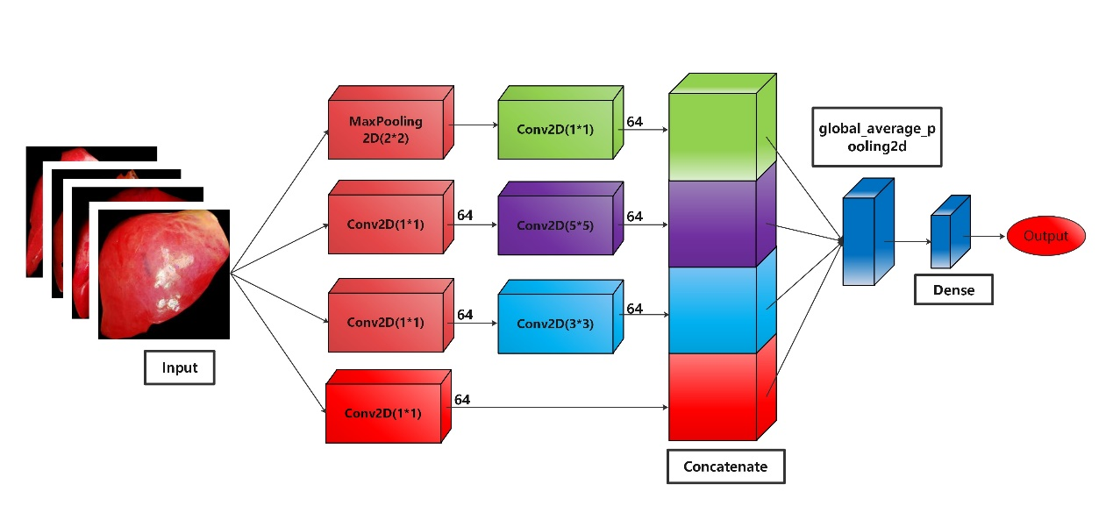
Supplementary Figure 1. Architecture of the proposed convolution neural network (CNN) model, named CNN model 1, for predicting early allograft dysfunction (EAD) based on the donor liver image.

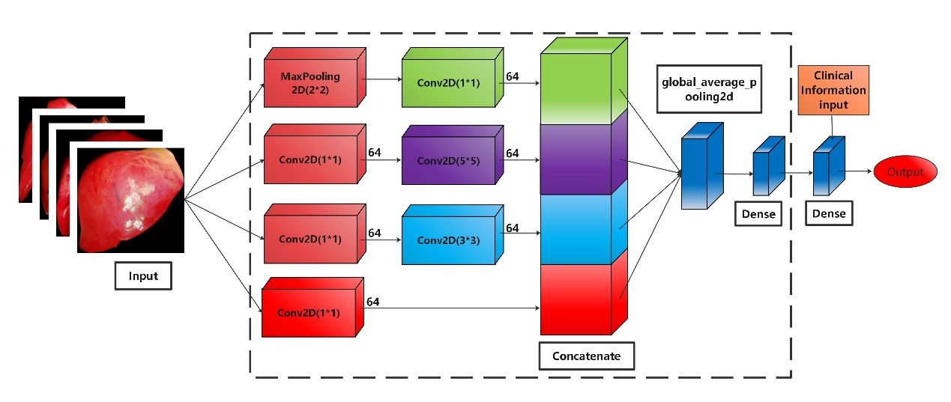
Supplementary Figure 2. Architecture of CNN model 2 for predicting early allograft dysfunction (EAD) based on the donor liver image and clinical information. The part of the model within the dashed box was transferred from CNN model 1, which was untrainable during the new training process.

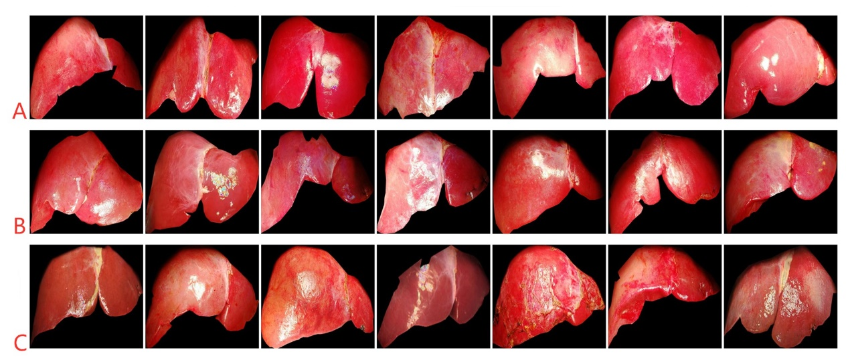
Supplementary Figure 3. Post-reperfusion donor liver images with different image score. (A) Seven instances of donor liver image with the image score as 1; (B) seven instances of donor liver image with the image score as 2, and (C) seven instances of donor liver image with the image score as 3.

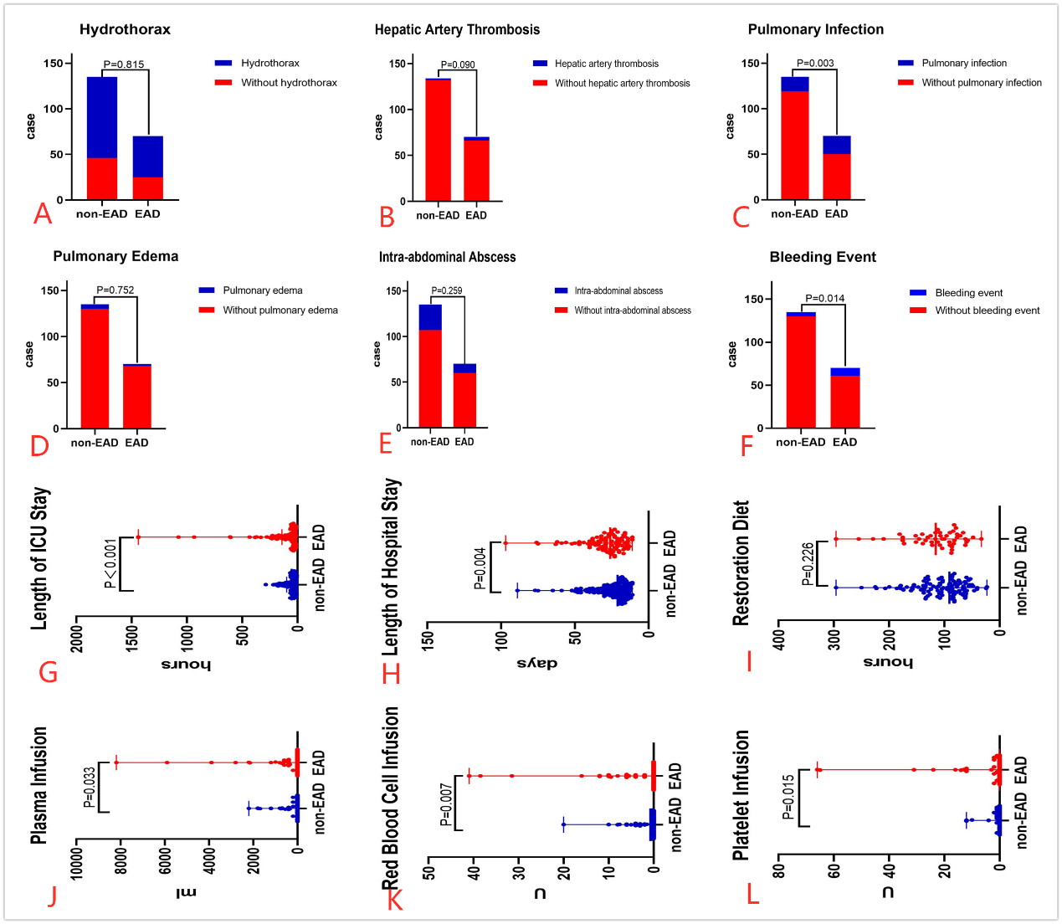
Supplementary Figure 4. Differences in patient outcome between early allograft dysfunction (EAD) and non-EAD patient. The difference on the occurrence of (A) hydrothorax, (B) hepatic artery thrombosis, (C) pulmonary infection, (D) pulmonary edema, (E) intra-abdominal abscess and (F) bleeding event was present at the upper part, while the difference on the length of (G) ICU stay and (H) hospital stay, (I) the time interval from LT surgery to restoration diet, the postoperative infusion volume of (J) plasm, (K) red blood cell and (L) platelet was present at the lower part.

