SUPPORTING INFORMATION

A Novel Natural Scaffold Layer Improving Efficiency, Stability and Reproducibility of Perovskite Solar Cells
Esma Yenel¹*, Mahmut Kus¹*

¹Department of Electricity and Energy, Konya Technical University, Konya, Turkey
²Department of Chemical Engineering, Konya Technical University, Konya, Turkey

*Corresponding authors. Email: esmayenel@gmail.com, mahmutkus1@gmail.com

Experimental section
Glass/FTO was purchased from KINTEC Corp. (with surface resistance 5-7 ohm). Titanium isopropoxide, acetylacetone, lithium bis(trifluoromethanesulfonyl)imide (Li-TFSI), 4-tert-Butylpyridine and solvents were purchased from Merck, phenyl-C61-butyric acid methyl ester (PCBM), Spiro OMETAD were purchased from LUMTEC, perovskite precursors, CH₃NH₃I (MAI), PbI₂, were supplied from TCI, Sepiolite was provided by Sigma-Aldrich and TiO₂ paste was purchased from PVTech (OPV-TiO₂-T).

Device fabrication
Perovskite solar cells (PSCs) were fabricated on FTO coated glass. FTO glass was ultrasonically cleaned with hellmanex, de-ionized water, acetone and isopropyl alcohol for 10 min. and dried with nitrogen. Before coating, oxygen plasma treatment was carried out to remove organic impurities and to activate the surface. Compact TiO₂ layer was coated by spray coating technique. TiO₂ solution was prepared by dissolving 3 ml of titanium isopropoxide in absolute ethanol. Another solution with 2 ml of acetylacetone in 6 ml of absolute ethanol was prepared. Acetylacetone solution was added to stirring titanium isopropoxide dropwise. The mixture was kept overnight by stirring at room temperature. Before spray coating stock solution was 1:1 diluted with absolute ethanol. FTO glasses were heated to 450 °C and coated by spray then kept for 3 min at the same temperature and cooled down to room temperature slowly.

Sepiolite layer
Sepiolite solution was prepared by dissolving in deionized water. The concentration of sepiolite was 1 mg/ml. The solution was kept in ultrasonic bath for 15 min at room temperature. Sepiolite layer was also coated onto TiO₂ layer by spray coating at 130 °C. After coating the films were kept at 130 °C for 10 min. Final thickness of sepiolite layer was calculated to be around 300 nm.

Mesoporous TiO₂
Mesoporous TiO₂ layer was prepared by deposition of commercially provided TiO₂ paste on compact TiO₂ layer. TiO₂ paste were statically spin coated at 6000 rpm for 60 s and annealed at 450 °C for 30 min by heating and cooling rate at 5 °C/min. Final thickness of mesoporous TiO₂ layer was calculated to be 300 nm.
Perovskite layer
In this study, 3 different perovskite solutions were used. Well known GBL, ACN and DMF: DMSO solvent systems were used for perovskite solution.
Perovskite in GBL were prepared according to the previously reported procedure by Jeon et al. ¹. PbI₂ and MAI in gamma butyrolactone at a molar ratio of 1.23 M (PbI₂ and methylammonium halide) was dissolved and kept for 2 hours at 80 °C. Then it was kept for 1 night at 60 °C. Perovskite layer was statically spin-coated at 1000 rpm for 10 s and then at 5000rpm 20s. Toluen was used as antisolvent and dropped when the spin rate reached to 5000 rpm. Obtained perovskite films were annealed at 100 °C for 30 min.
Perovskite in ACN solvent was prepared according to previously published procedure by Noel et al. ². The precursor was prepared with the molar ratio of 1MAI: 1.06 PbI₂ in ACN. CAN solution was exposed methylamine vapor by using argon flow that forms methyl amine bubbles in a glass bottle placed in ice bath until the obtaining clear and transparent perovskite solution. The final concentration of perovskite precursor was 0.5 M in acetonitrile. Perovskite layer was dynamically deposited by using ACN solution at 3000 rpm for 40 sec. Finally, the films were dried at 100 °C for 5 min.
Perovskite in DMSO:DMF solvent was prepared according to previously published procedure Zhang et al.(29). The perovskite precursors, consisting of 922 mg PbI2 and 349.8 mg MAI were dissolved in 900 μL DMF and 100 μL DMSO. Then perovskite layer was deposited statically by spin-coating at 6000 rpm for 30 s. 200 μL of sec butyl alcohol as antisolvent was dropped at 7. second during spinning. At he second step, sec-butyl alcohol was added statically on perovskite coated layer and kept for 12 s and spin coated at 6000 rpm 30 s. Final perovskite films were dried at 100 °C for 30 min.

Hole transport layer
Spiro-OMeTAD solution consisting of 65 mg of spiro-OMeTAD, 20 μL of 4-tert-butyl pyridine, 70 μL of Li-TFSI (170mg mL-1 in acetonitrile) and 1mL of chlorobenzene was prepared and spin-coated at 4000 rpm for 30 s onto perovskite layer.
Finally 100 nm of Au was thermally evaporated onto HTM layer by using a shadow mask. Active area of each electrode was calculated to be 0.023 cm².

IV Characterizations
IV characterizations were carried out in nitrogen filled glove box system under AM 1.5 solar simulator by Keithley 2400 power source. Light intensity were measured with a calibrated KIPP&ZONEN pyronometer and calculated to be 80 mW/cm²

Fig. S1. The photo of sepiolite in different solvents (upper), methanol, GBL, Pyridine, DMSO, Acetonitrile and DMF, and in water (lower).

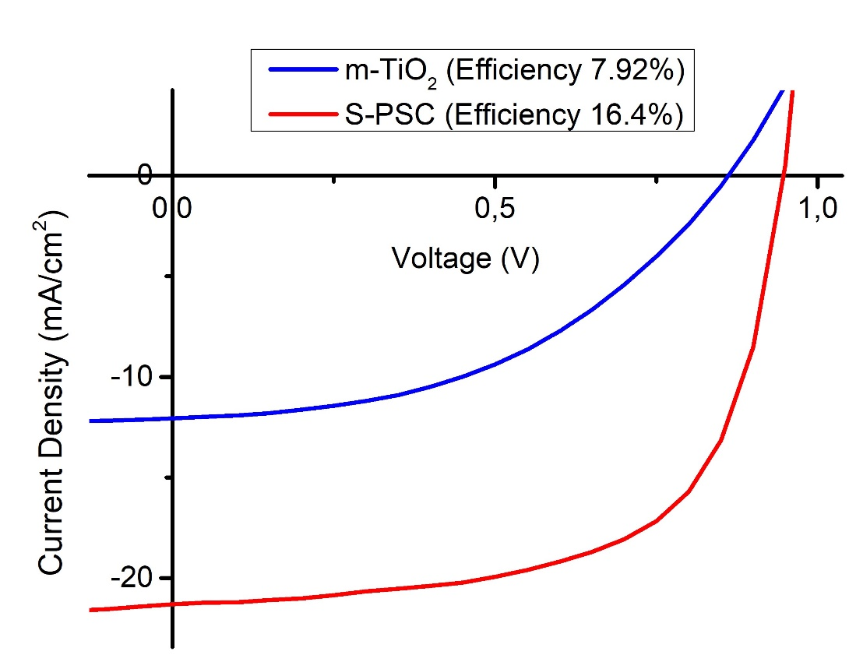
Fig. S2. IV curve of m-TiO₂ and Sepiolite included PSC (S-PSC).
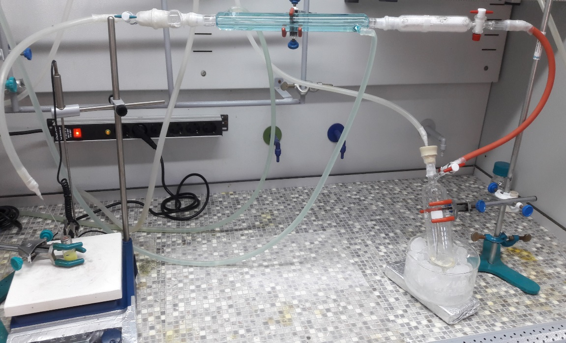
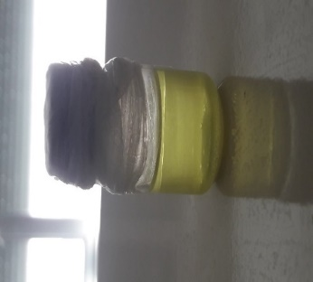
Fig. S3. The photo of preparation of perovskite solution in ACN under methyl amine gas flow (upper) and the photo of final solution (Lower).
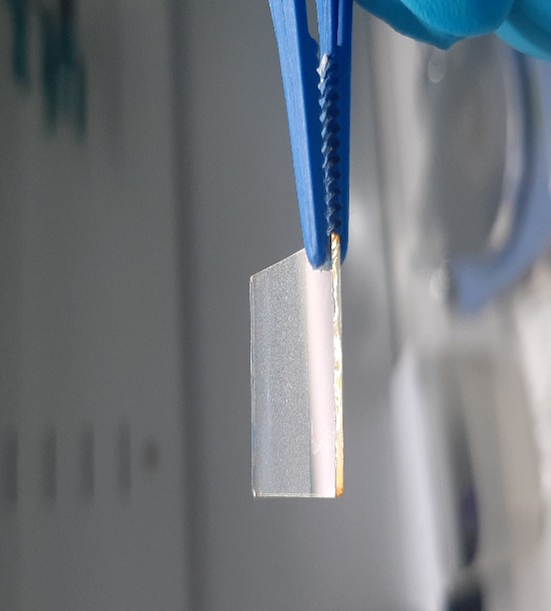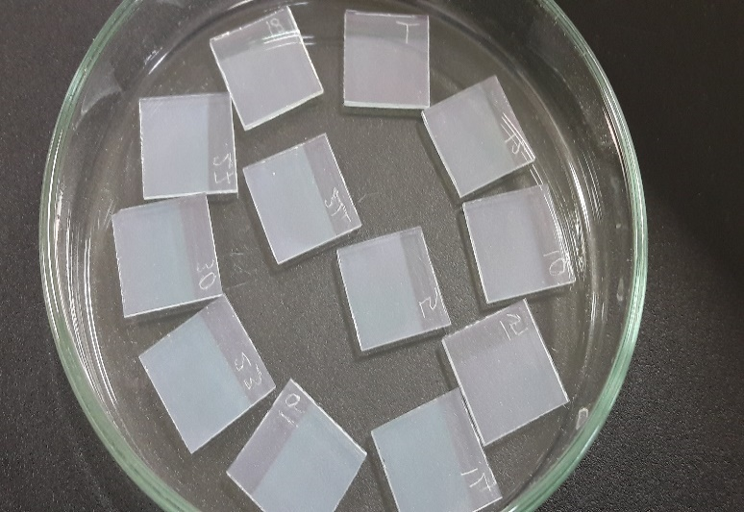
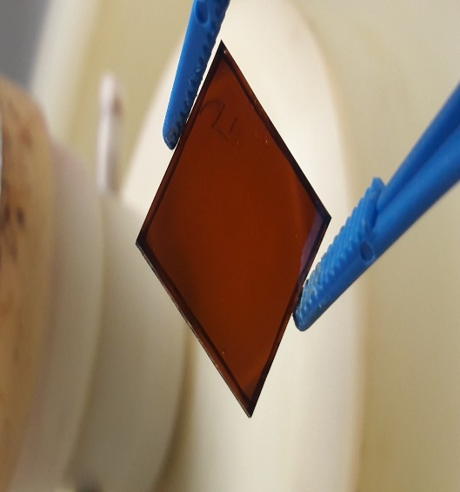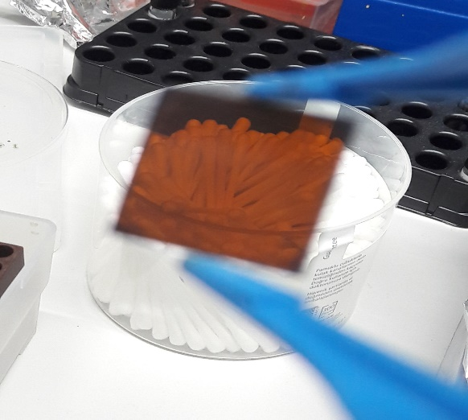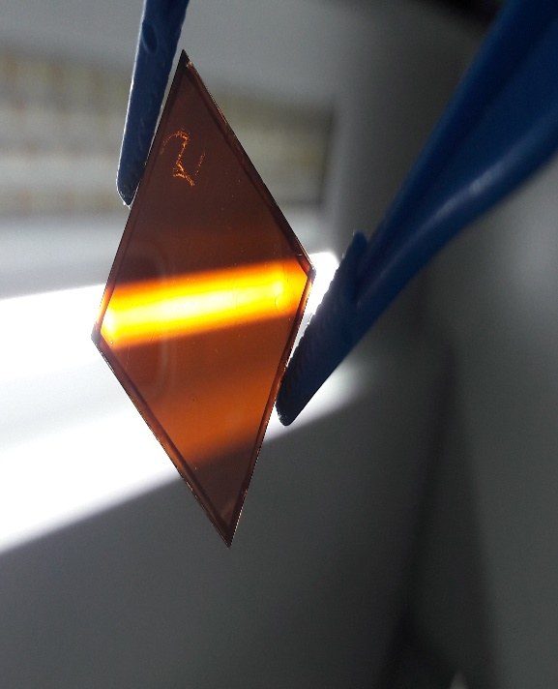
Fig. S4. Photos of sepiolite films and perovskite layers coated onto sepiolite films.

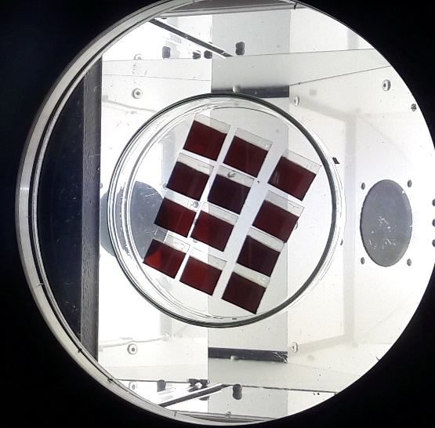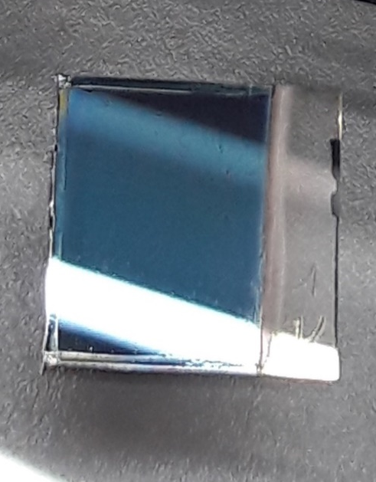
Fig. S5. Photos of HTM coated devices.

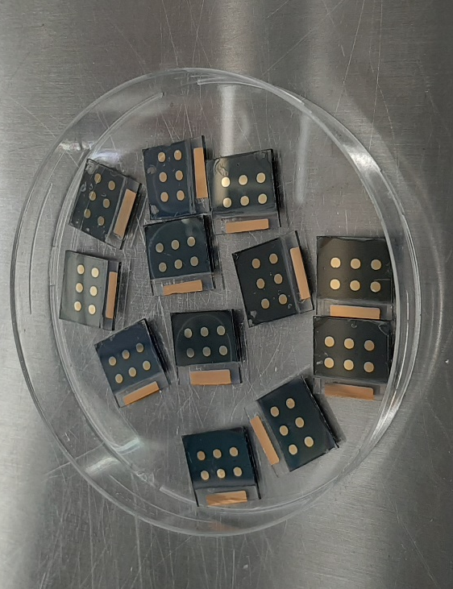
Fig. S6. Photos of final devices

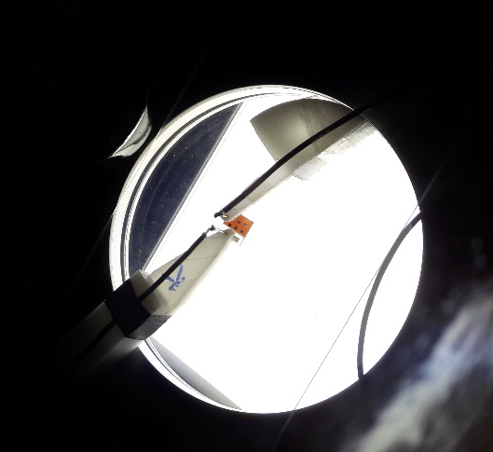
Fig. S7. Photo of measurement of PSCs under AM 1.5 solar simulator

