Supplementary material for: Community ecology and functional potential of bacteria, archaea, eukarya and viruses in Guerrero Negro microbial mat

Authors: P. Maza-Márquez^{1,2}, M.D. Lee^{1,2,3}, B.M. Bebout¹
Affiliations:
¹Exobiology Branch, NASA Ames Research Center, Moffett Field, CA, USA.
² Bay Area Environmental Research Institute, Moffett Field, CA, USA.
³Blue Marble Space Institute of Science, Seattle, WA, USA.
*Corresponding author: Paula Maza Márquez
Paula Maza-Márquez. Exobiology Branch, NASA Ames Research Center, CA, USA
E-mail: paulamazamar@gmail.com

This pdf includes:
Supplementary Figures S1-S13.
Figure S1. Bar plots show the read-based taxonomic classification of bacteria at Phylum, Family and Species in the upper 4 layers examined.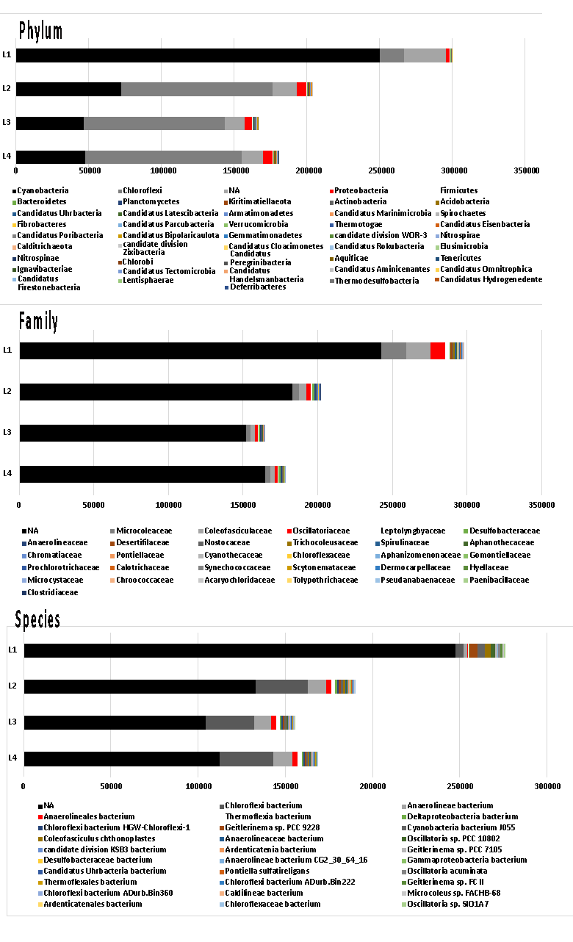
Figure S2. Bar plots show the read-based taxonomic classification of archaea at Phylum, Family and Species in the upper 4 layers examined.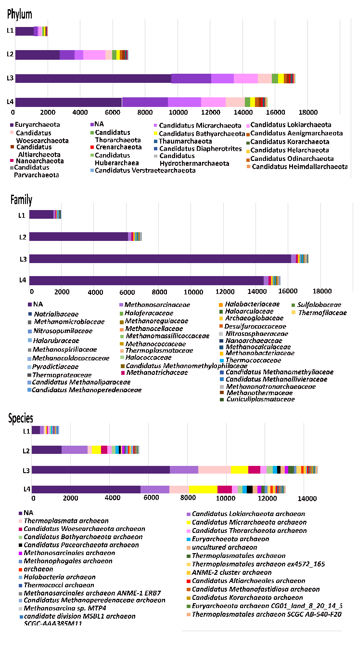
Figure S3. Bar plots show the read-based taxonomic classification of eukarya at Phylum, Family and Species in the uppers 4 layers examined.

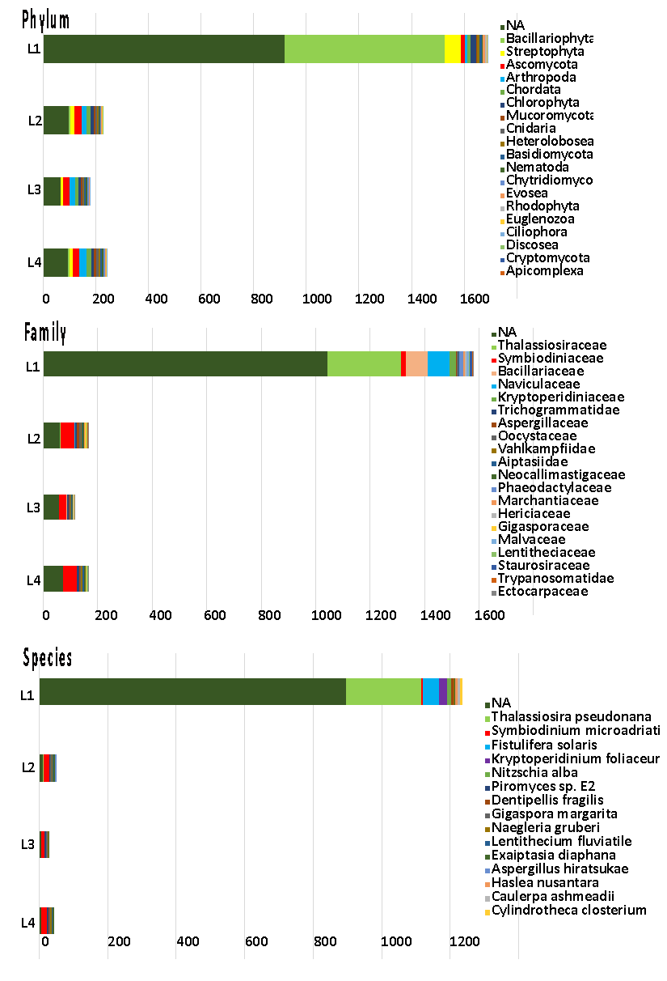

Figure S4. Bar plots show the read-based taxonomic classification of viruses at Phylum, Family and Species in the upper 4 layers examined.
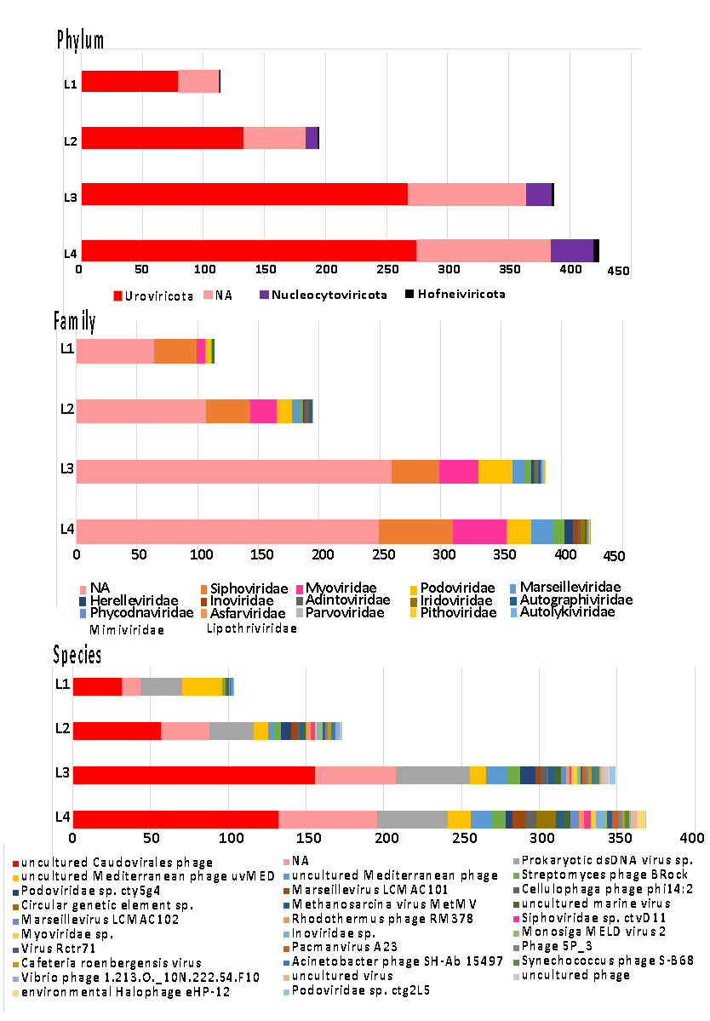

Figure S5. Phylogenetic tree based on amino-acid sequences of superoxide dismutase, Fe-Mn family (SOD2).
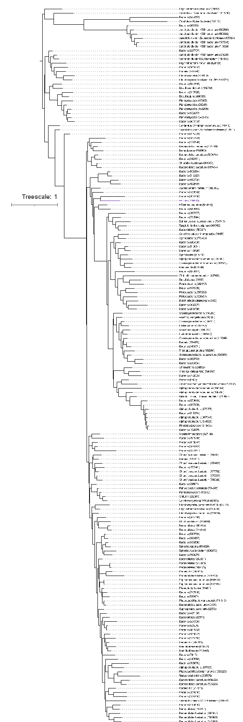
Figure S6. Phylogenetic tree based on amino-acid sequences of superoxide reductase (dfx).
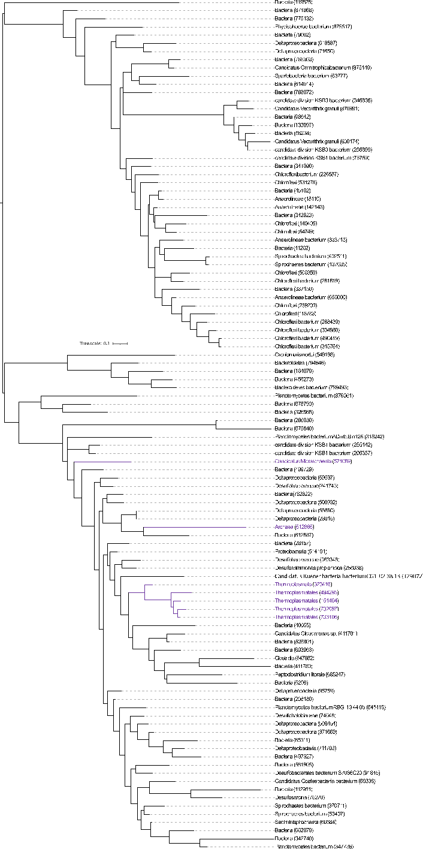
Figure S7. Phylogenetic tree based on amino-acid sequences of heat shock protein HtpX (htpX).
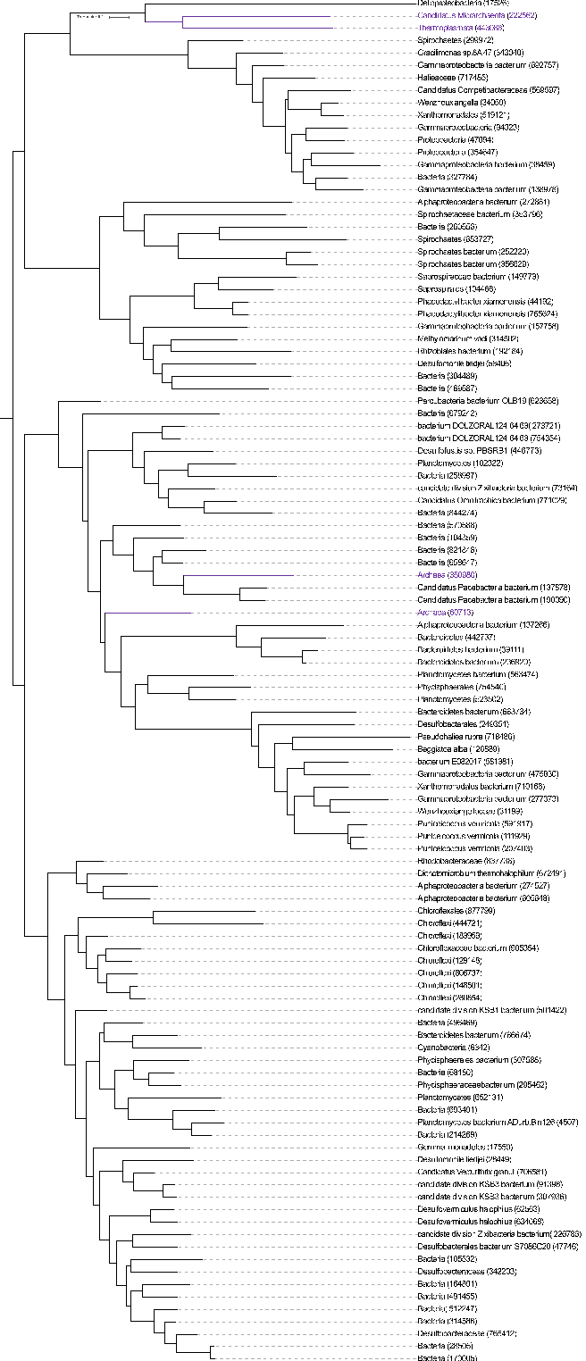
Figure S8. Phylogenetic tree based on amino-acid sequences of cold shock protein (cspA).
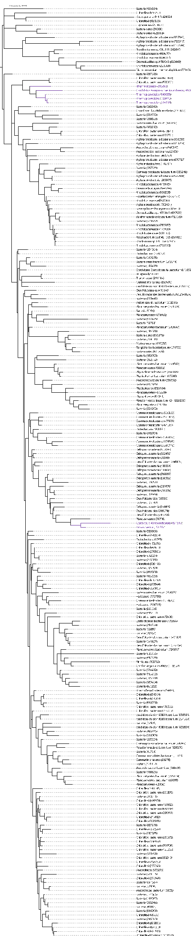
Figure S9. Phylogenetic tree based on amino-acid sequences of phage shock protein C (pspC).
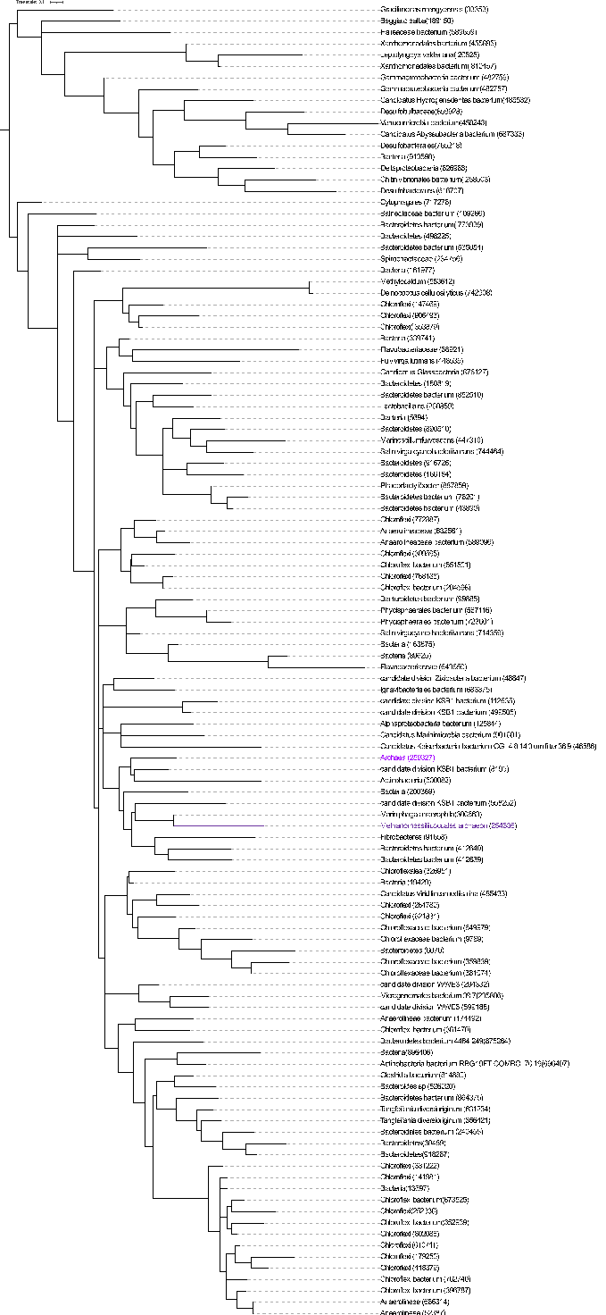
Figure S10. Phylogenetic tree based on amino-acid sequences of excinuclease ABC subunit A (uvrA).
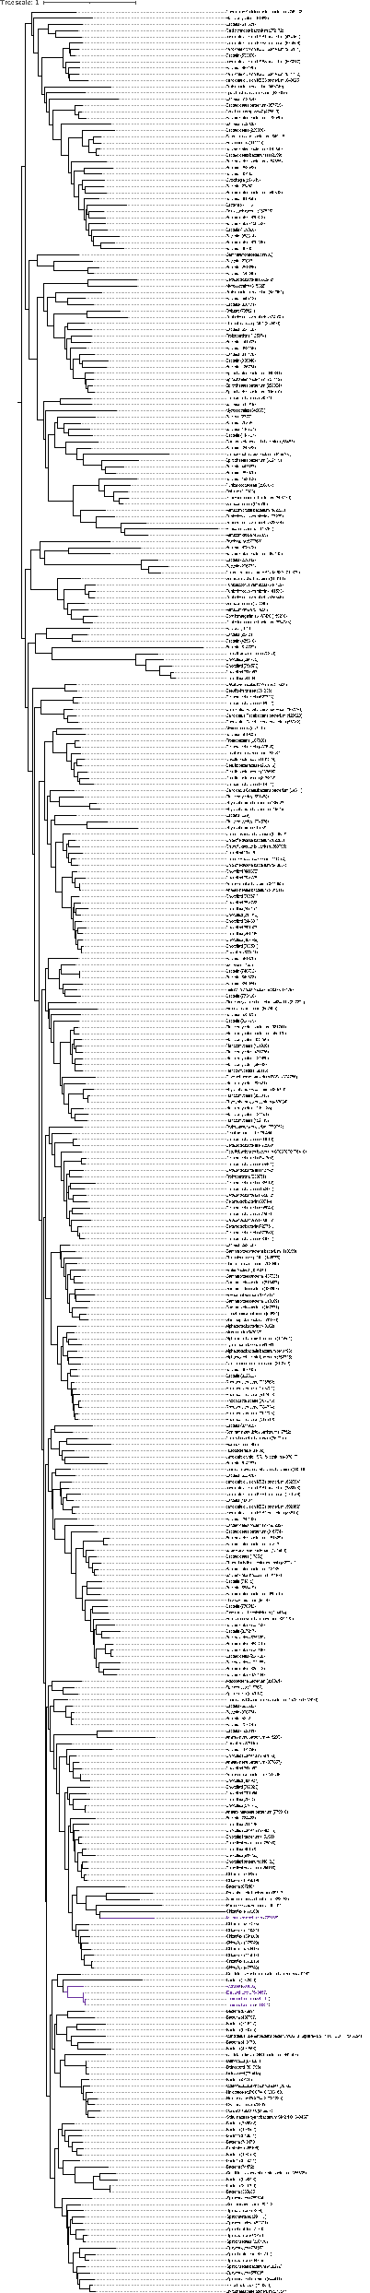
Figure S11. Phylogenetic tree based on amino-acid sequences of excinuclease ABC subunit B (uvrB).

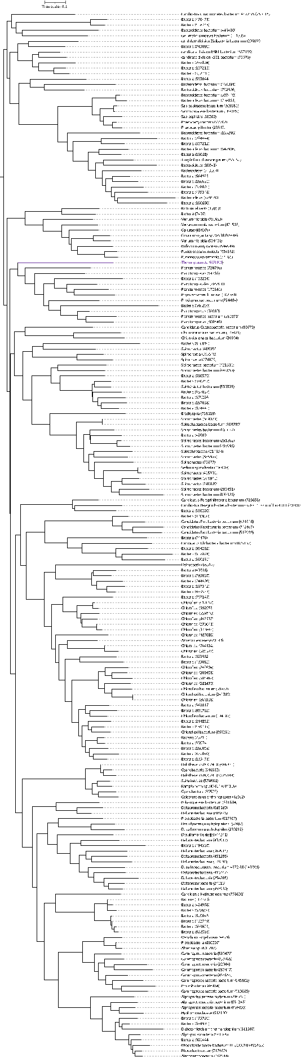
Figure S12. Phylogenetic tree based on amino-acid sequences of excinuclease ABC subunit C (uvrC).
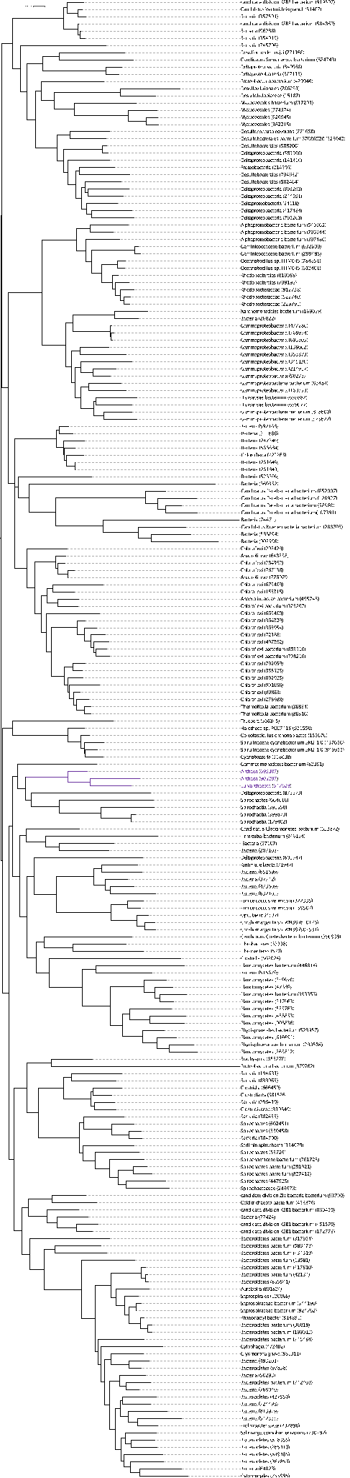
Figure S13. Phylogenetic tree based on amino-acid sequences of DNA helicase II ATP dependent DNA helicase (uvrD, pcrA).
