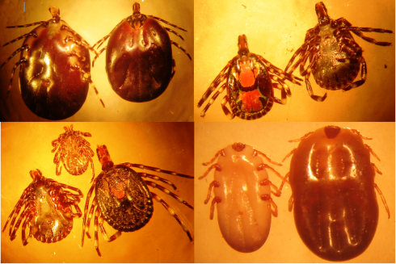
Original photo taken by Achukwi MD:
Different tick species in Wakwa, Ngaoundere
removed from zebu Gudali cattle.

