Single cell RNA sequencing reveals C5aR1 inhibition to selectively target pro-tumorigenic M2 macrophages reversing PARP inhibitor resistance
Xi Li ^{1,2}*, Alfonso Poire ¹, Kang Jin Jeong ¹, Dong Zhang ¹, Tugba Yildiran Ozmen, Gang Chen ², Chaoyang Sun ², Gordon B. Mills ¹
1. Division of Oncological Sciences Knight Cancer Institute, Oregon Health and Science University, Portland, OR 97201, USA.
2. Department of Obstetrics and Gynecology, Tongji Hospital, Tongji Medical College, Huazhong University of Science and Technology, Wuhan 430030, China

* Correspondence: xili@ohsu.edu, xilitongji@gmail.com

Figure S1

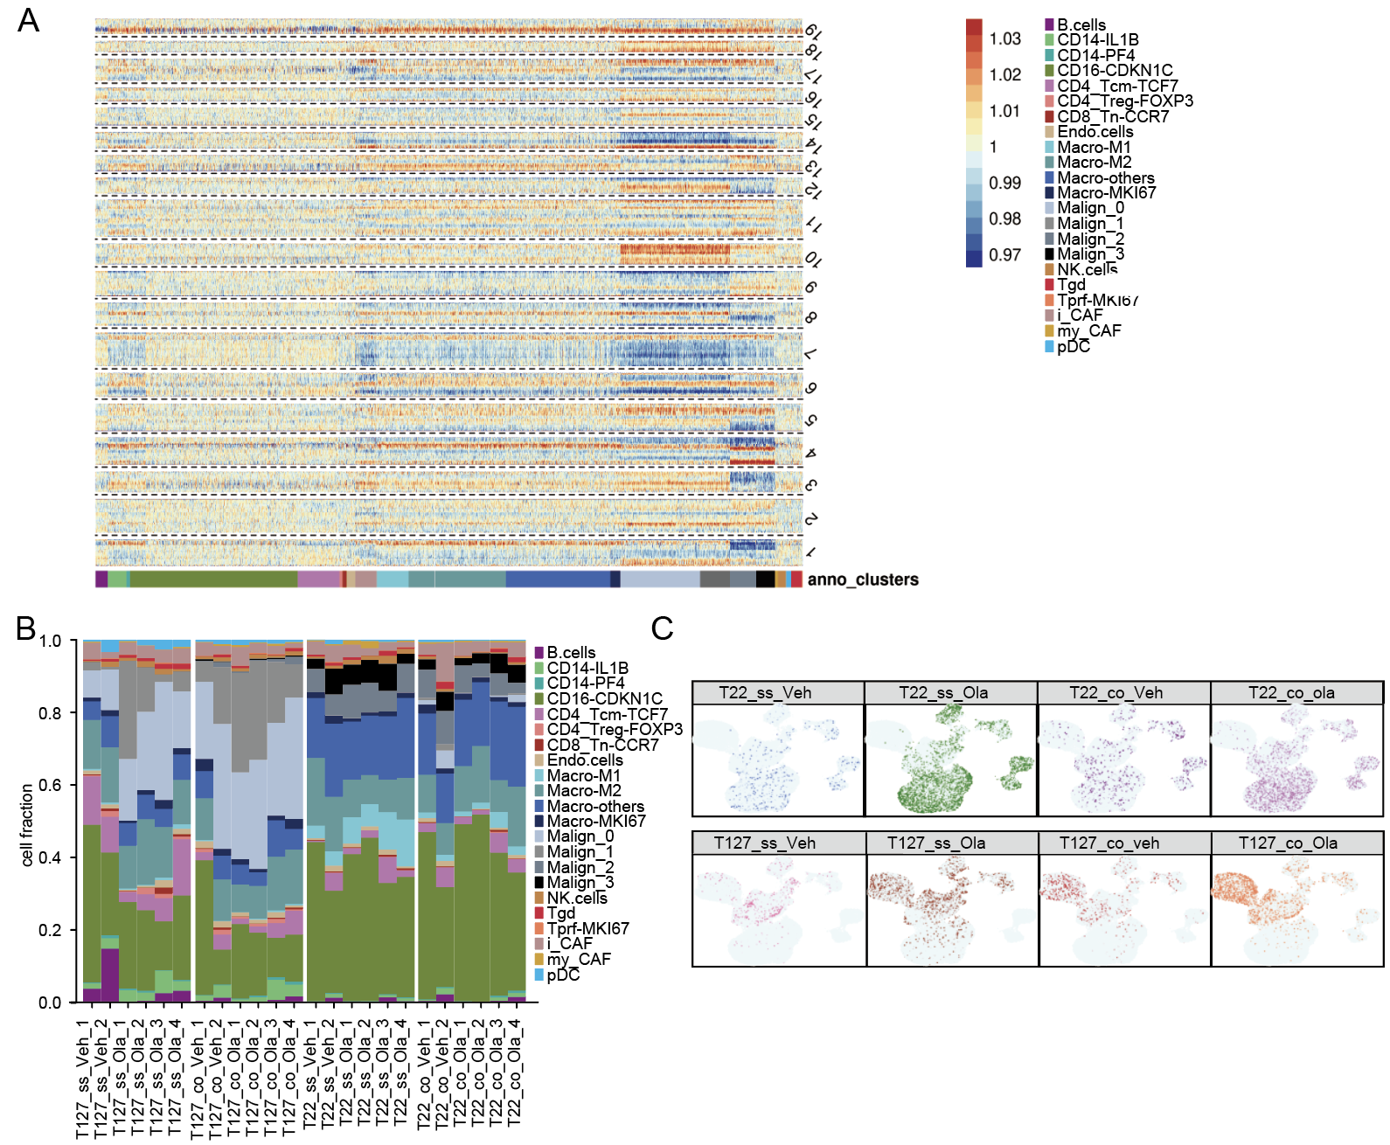
Figure S1: scRNA-seq analysis of T22, T127 and co-transplanted tumors
(A) CNV analysis of T22 and T127 tumors.
(B) Cell fraction of different cell in T22 tumors from indicated treatment.
(C) Distribution of cells in T127 and T22 tumors in the UMAP of Figure 3C. ss: single strain transplantation models. co: co-transplantation models. Veh = vehicle. Ola = olaparib. T127_co_Ola_1: 1159 cells, T127_co_Ola_2: 923 cells, T127_co_Ola_3: 1195 cells, T127_co_Ola_4: 1419 cells, T127_co_Veh_1: 573 cells, T127_co_Veh_2: 821 cells, T127_ss_Ola_1: 1716 cells, T127_ss_Ola_2: 1496 cells, T127_ss_Ola_3: 580 cells, T127_ss_Ola_4: 799 cells, T127_ss_Veh_1: 681 cells, T127_ss_Veh_2: 558 cells, T22_co_Ola_1: 2515 cells, T22_co_Ola_2: 1767 cells, T22_co_Ola_3: 1507 cells, T22_co_Ola_4: 1179 cells, T22_co_Veh_1: 894 cells, T22_co_Veh_2: 929 cells, T22_ss_Ola_1: 2806 cells, T22_ss_Ola_2: 2383 cells, T22_ss_Ola_3: 1943 cells, T22_ss_Ola_4: 1699 cells, T22_ss_Veh_1: 551 cells, T22_ss_Veh_2: 752 cells.

Figure S2

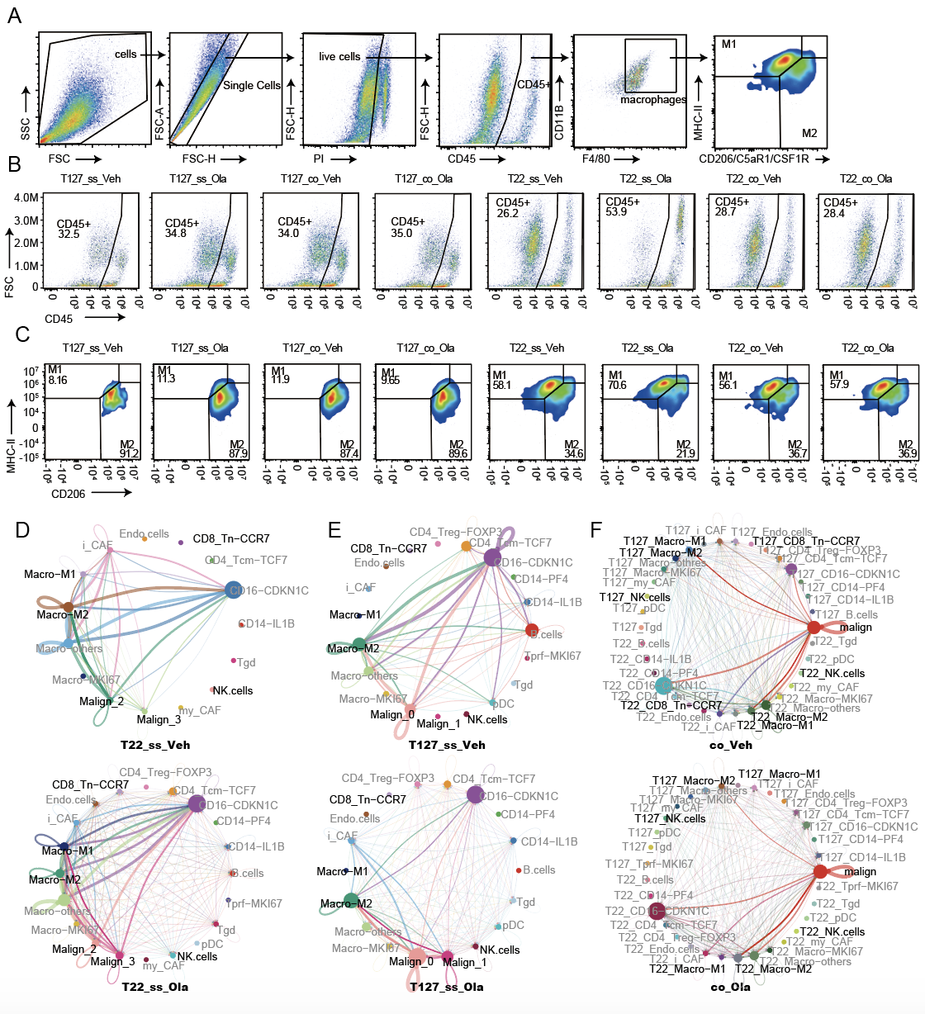
Figure S2. Landscape of tumor microenvironment of T22 and T127 tumors with and without PARPi treatment
(A) Work flow of flow cytometry analysis of lymphocyte panel for Figure 1E, 1I and 1J. After gating cells as macrophages by staining with CD11B and F4/80, for Figure 1E macrophage subtypes were differentiated into M1 and M2 by staining with MHCII and CD206, for Figure 1I macrophage subtypes were differentiated into MHC-II^{hi}C5aR1^{lo} or MHCII^{lo}C5aR1^{hi} by staining with MHCII and C5aR1, for Figure 1J macrophage subtypes were differentiated into MHCII^{hi}CSF1R^{lo} and MHC-II^{lo}CSF1R^{hi} by staining with MHCII and CSF1R.
(B) Number of CD45⁺ cells in each indicated group.
(C) Distribution pattern of M1 and M2 TAMs in each indicated group.
(D-F) Circle plot of cell-cell communication from CellChat among each component in each treatment group. ss: single strain models. ss: single strain transplantation models. co: co-transplantation models. Veh: vehicle. Ola: olaparib.
Figure S3
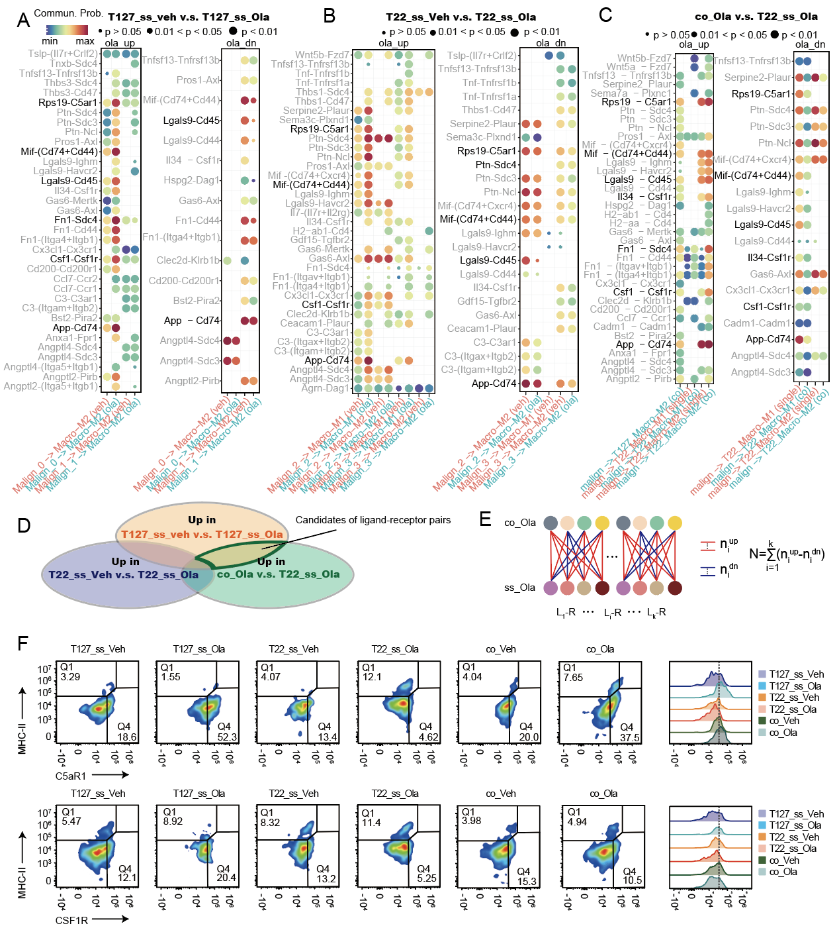
Figure S3. Changes in ligand-receptor pair communication in T22 and T127 models
(A) Ligand-receptor pair changes in single strain transplanted T127 tumors with and without olaparib treatment.
(B) Ligand-receptor pair changes in single strain transplanted T22 tumors with and without olaparib treatment.
(C) Ligand-receptor pair changes in co-transplanted T22 tumors with olaparib treatment compared with single strain transplanted T22 tumors with olaparib treatment. ss: single strain transplantation models. co: co-transplantation models. Veh: vehicle. Ola: olaparib. Interactions of ligand-receptor pairs from Figure 1G are highlighted.
(D) Design of ligand-receptor candidate selection strategy. Candidate ligand-receptor pairs represent those that mediate communication between tumor cells and M2 macrophages in T127 single strain and were upregulated by olaparib in T127 (resistant to olaparib), were not present or weakly present in T22 single strain (sensitive to olaparib) and were up-regulated in T22 in the co-transplantation model treated by olaparib (resistant to olaparib).
(E) Design of interaction count estimation based on CellChat outputs comparing olaparib treated single strain T22 tumors to T22 co-transplanted tumors. Interaction count estimate is the sum of interactions that were increased in each comparison pair using individual tumors and subtracted those that were decreased in each comparison pair (see Methods).
(F) Representative cell distribution pattern of macrophages in blood from T22, T127 and co-transplantation models with and without olaparib treatment.

Figure S4
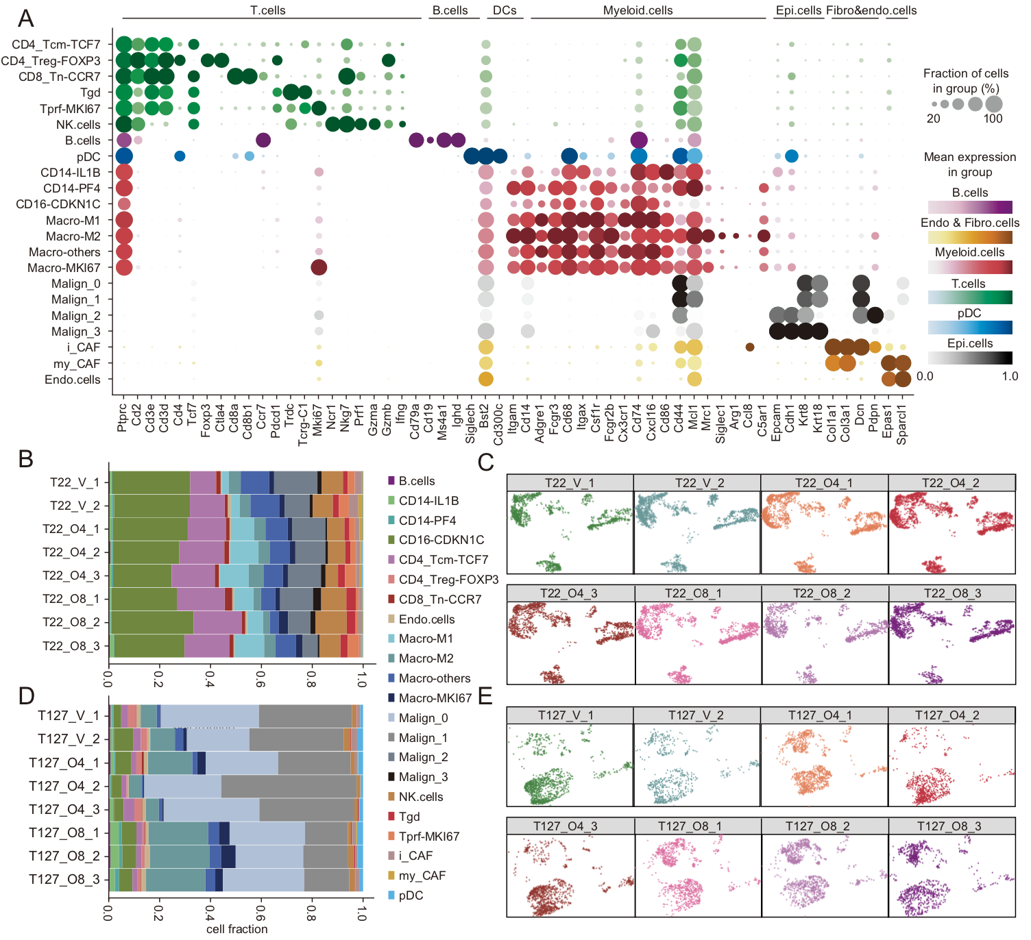
Figure S4. Landscape of tumor microenvironment of T22 and T127 short-term olaparib treated tumors
(A) dot plot of expression of indicated markers in each cell type.
(B) cell fraction of each cell type in T22 tumors V= vehicle, O4= olaparib for 4 days, O8+ olaparib for 8 days.
(C) Distribution of T22 tumor clusters from individual mice in the UMAP Figure 1D. V= vehicle, O4= olaparib for 4 days, O8+ olaparib for 8 days.
(D) cell fraction of each cell type in T127 tumors V= vehicle, O4= olaparib for 4 days, O8+ olaparib for 8 days.
(E) Distribution of T127 tumor clusters from individual mice in the UMAP Figure 1D. V: vehicle, O4: olaparib 4 days, O8: olaparib 8 days. T127_O4_1: 1086 cells, T127_O4_2: 745 cells, T127_O4_3: 1111 cells, T127_O8_1: 1048 cells, T127_O8_2: 1126 cells, T127_O8_3: 1029 cells, T127_V_1: 1182 cells, T127_V_2: 680 cells, T22_O4_1: 2239 cells, T22_O4_2: 2581 cells, T22_O4_3: 1730 cells, T22_O8_1: 1753 cells, T22_O8_2: 1271 cells, T22_O8_3: 1865 cells, T22_V_1: 1485 cells, T22_V_2: 2170 cells.

Figure S5
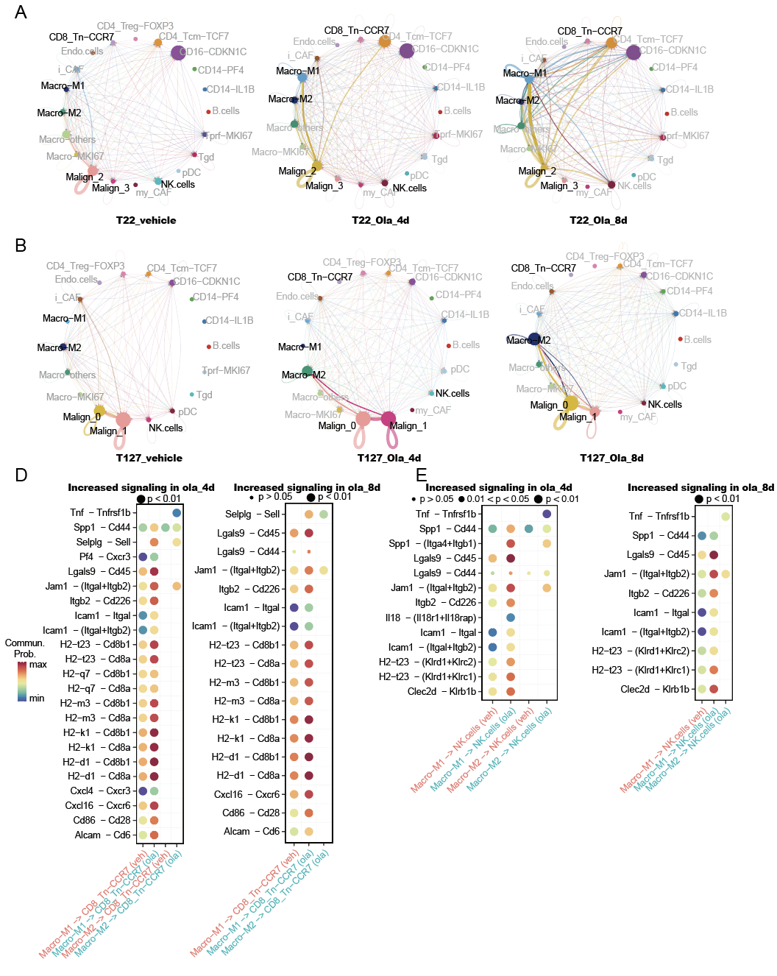
Figure S5. CellChat predicted communication between TAMs and lymphocytes in T22 and T127 tumors
(A) Circle plot of cell-cell communication among each cell type in T22 tumors from each treatment group.
(B) Circle plot of cell-cell communication among each cell type in T127 tumors from each treatment group.
(D) Significant ligand-receptor pairs between macrophages and naïve CD8 T cells in T22.
(E) Significant ligand-receptor pairs between macrophages and NK cell in T22

Figure S6
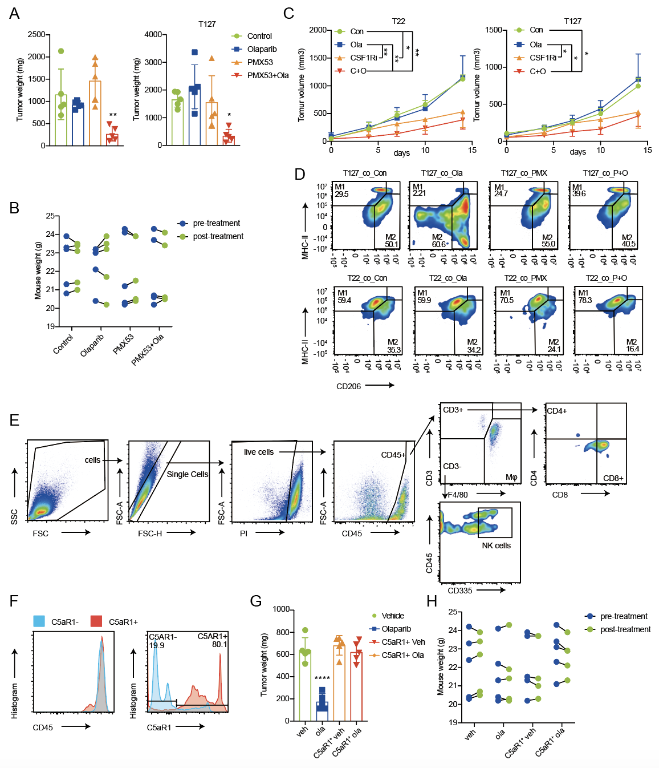
Figure S6. Response and immune characterization of tumors treated with anti-CSF1R or PMX-53 with and without olaparib
(A) Tumor weight of T22 (left) and T127 (right) of co-transplanted T22 and T127 tumor models treated with control (vehicle + PMX-53C), olaparib, PMX-53 or the combination for 14 days.
(B) Mouse weight changes pre- and post- treatment with control, olaparib, PMX-53 or the combination.
(C) Tumor growth curve of T22 (left) and T127 (right) of co-transplanted T22 and T127 treated with control, olaparib, anti-CSF1R or the combination for 14 days. Con = control (vehicle + IgG), Ola = olaparib. C+O = olaparib combined with CSF1R inhibitor.
(D) Representative cell distribution pattern of M1 and M2 TAMs in each treatment for Figure 4E.
(E) Work flow of flow cytometry analysis of lymphocyte panel for Figure 4F. n=5, * p < 0.05, ** P < 0.01, *** p < 0.001, **** p < 0.0001.
(F) Purity of C5aR1⁺ cells after magnetic column selection assessed by flow cytometry.
(G) Tumor weight of T22 of mice receiving C5aR1⁺ positive cells treated with control, olaparib, PMX-53 or the combination for 8 days.
(H) Mouse weight changes pre- and post- treatment of mice receiving C5aR1⁺ positive cells with and without olaparib.
Figure S7
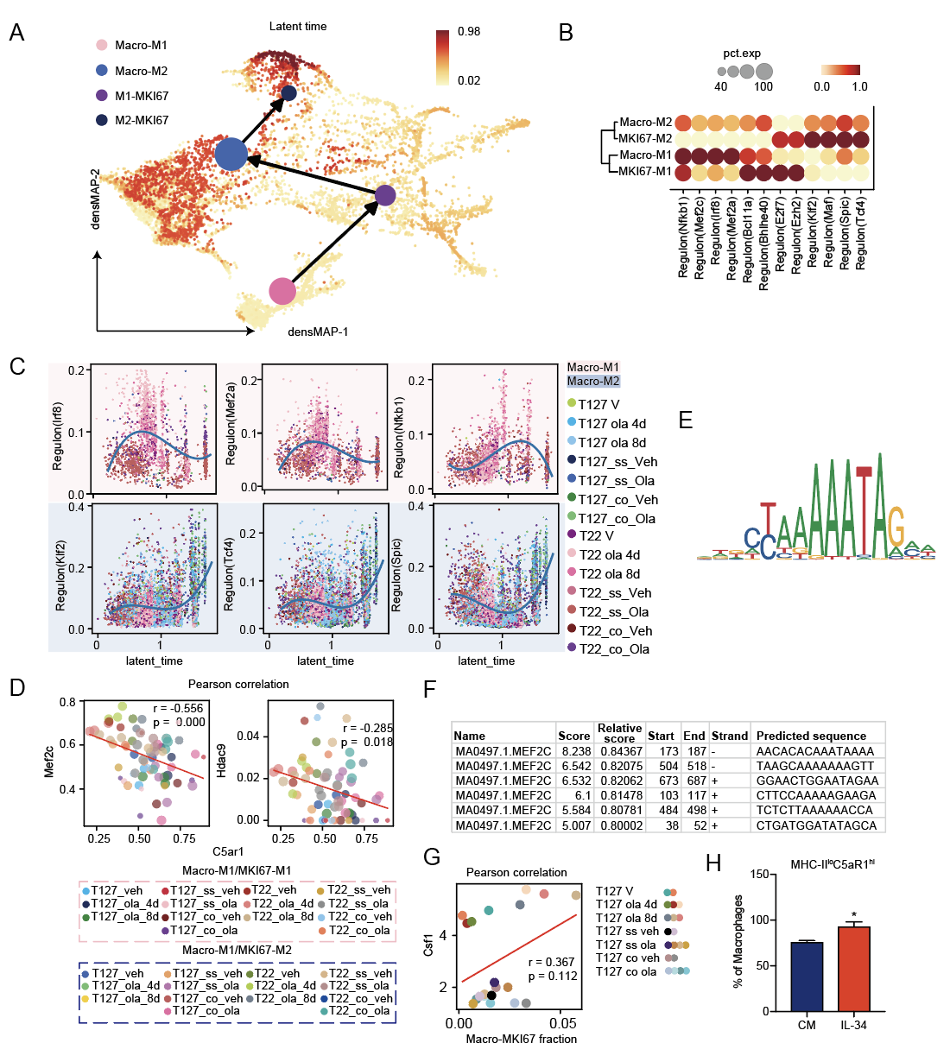
Figure S7. Trajectory analysis of M2 polarization and regulation of C5aR1
(A) Partition-based graph abstraction (PAGA) representation of cell sub-clusters using latent time in scVelo were mapped on a density preserving uniform manifold approximation and projection map (densMAP) colored by latent time score of M1, M2 and MKI67 macrophages from all tumors mentioned in Figure 1 and Figure 2.
(B) Dotplot showing AUC of indicated transcription factors in each macrophage subtype of the pooled macrophages from all the tumors mentioned in Figure 1 and Figure 2.
(C) Scatter plot showing correlation between latent-time and AUC of indicated regulons. Upper pink panel: M1 macrophages from all tumors mentioned in Figure 1 and Figure 2. Lower blue panel: M2 macrophages from all tumors mentioned in Figure 1 and Figure 2.
(D) Correlation between Hdac9 and C5ar1 mRNA expression in pooled macrophages from all tumors from Figure 1 and Figure 2. Dots were colored as sample as indicated in right panel.
(E) Predicted motif of Mef2c binding cite of C5ar1.
(F) Binding potential of Mef2c to C5ar1 transcription regulation region.
(G) Correlation between Csf1 mRNA expressed by malignant cells and the fraction of proliferative M1 macrophages from the same tumor of all tumors mentioned in Figure 1 and Figure 2. V: tumors treated with vehicle for short term. veh: vehicle. ola: olaparib.
(H) Fraction of MHCII^{lo}C5aR1^{hi} macrophages of total macrophages of BMDM cells after treated with complete media with or without IL34.

