Supplementary Information
Undercoordinating OH⁻ network via dispersed electrostatic fields for ultralow overpotential of oxygen evolution in alkaline electrolyte

Contents
1. Supplementary Figures 3
Supplementary Fig. 1 3
Supplementary Fig. 2 3
Supplementary Fig. 3 4
Supplementary Fig. 4 4
Supplementary Fig. 5 5
Supplementary Fig. 6 5
Supplementary Fig. 7 6
Supplementary Fig. 8 6
Supplementary Fig. 9 7
Supplementary Fig. 10 8
Supplementary Fig. 11 9
Supplementary Fig. 12 10
Supplementary Fig. 13 10
Supplementary Fig. 14 11
Supplementary Fig. 15 11
Supplementary Fig. 16 13
2. Supplementary Tables 14
Supplementary table 1 14
Supplementary table 2 15
Supplementary table 3 15
Supplementary table 4 15
Supplementary table 5 16
Supplementary table 6 16
Supplementary table 7 17
Supplementary References 18

- Supplementary Figures

Supplementary Fig. 1 | Scanning electron microscope (SEM) of kaolin NS.

Supplementary Fig. 2 | LSV of ITO/Ni@Ni(OH)₂ electrodes. LSV tested in 1.0 M KOH electrolyte and the borate buffer electrolytes [pH = 9.76 (1.0 M KOH +1.7 M H₃BO₃) and pH = 11.34 (1.0 M KOH +1.7 M H₃BO₃)] with and without 30 mg mL⁻¹ kaolin NS. The scan rate is 50 mV s⁻¹.

Supplementary Fig. 3 | Theoretical structural model. Calculated models for (a) OH⁻/H₂O and (b) OH⁻/H₂O+kaolin.

Supplementary Fig. 4 | SEM of ITO/Ni@Ni(OH)₂ electrodes. (a) The cleaned ITO/Ni@Ni(OH)₂ electrode after aged in 1.0 M KOH electrolyte, and (b) cleaned ITO/Ni@Ni(OH)₂ electrode after aged in 1.0 M KOH electrolyte with kaolin NS. There is no obvious adsorbed kaolin NS on the electrode surface taken out from the clarified electrolyte with kaolin NS according to the scanning electron microscopy photos, which excludes the possibility of residual kaolin NS for keeping OER activation.

Supplementary Fig. 5 | J-t curves tested at 20 ℃ at 2.02 V_{RHE} of ITO/Ni@Ni(OH)₂ electrodes. The kaolin NS (15 mg mL⁻¹) was added to KOH electrolyte at 1000 s during the test.

Supplementary Fig. 6 | Tafel slope of ITO/Ni@Ni(OH)₂ electrodes. The ITO/Ni@Ni(OH)₂ electrode in 1.0 M KOH electrolyte (black) and 1.0 M KOH electrolyte with 30 mg mL⁻¹ kaolin NS (red).

Supplementary Fig. 7 | J-t curves of ITO/Ni@Ni(OH)₂ electrodes. The ITO/Ni@Ni(OH)₂ electrode was tested at 2.52 V_{RHE} in 1.0 M KOH electrolyte (black) and 1.0 M KOH electrolyte with 30 mg mL⁻¹ kaolin NS (red).

Supplementary Fig. 8 | The effect of temperature and solution concentration of electrolyte on the influence law of adding kaolin NS for active electrolyte. a LSV of ITO/Ni@Ni(OH)₂ electrode in 1.0 M KOH electrolyte with and without kaolin NS (30 mg mL⁻¹) in different temperature (10 ℃, 20 ℃, 25 ℃ and 40 ℃). b LSV of ITO/Ni@Ni(OH)₂ electrode in various solution concentration of KOH electrolytes (0.05 M, 0.1 M, 1.0 M, 2.0 M, 3.0 M and 4.0 M) with and without dispersed 30 mg mL⁻¹ kaolin NS.
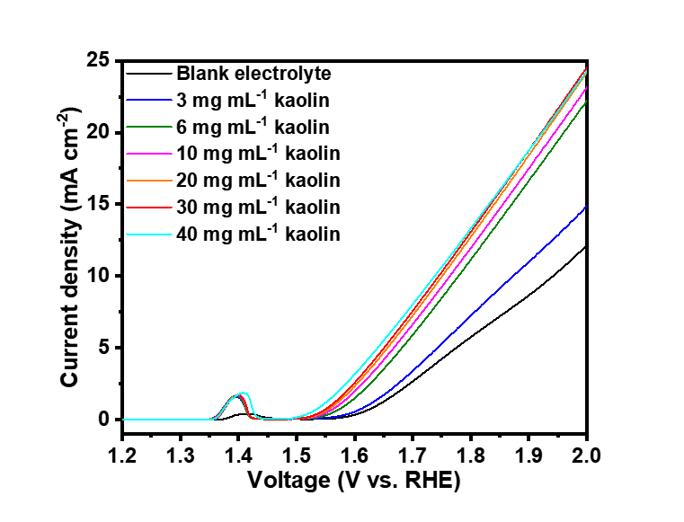

Supplementary Fig. 9 | LSV of ITO/Ni@Ni(OH)₂ electrodes in 1.0 M KOH electrolyte with different kaolin concentration. LSV tested in blank 1 M KOH electrolyte and 1.0 M KOH electrolyte with different kaolin concentration (3 mg mL⁻¹, 6 mg mL⁻¹, 10 mg mL⁻¹, 20 mg mL⁻¹ and 30 mg mL⁻¹). The scan rate is 50 mV s⁻¹.

Supplementary Fig. 10 | The effect of spectator cation types of electrolyte on the influence law of adding kaolin NS for active electrolyte. EIS of ITO/Ni@Ni(OH)₂ electrodes in 1.0 M MOH electrolytes (with M⁺ = Li⁺, Na⁺, K⁺ and Cs⁺) with and without dispersed 30 mg mL⁻¹ kaolin NS and corresponding fitting circuit diagram (inset). A new electrode with Ni@Ni(OH)₂ on ITO was prepared for each different electrolyte to avoid any trace residual of cations on electrodes from the previous experiment.

Supplementary Fig. 11 | SEM of samples. (a), (b) and (c) are SEM images of NF. (d), (e) and (f) are SEM images of NF/Ni(OH)₂. (g), (h) and (i) are SEM images of NF/Ni₃S₂. (j), (k) and (l) are SEM images of NF/NiS_{x}/C₃N₄. (m), (n) and (o) are SEM images of NF/Co₃O₄.
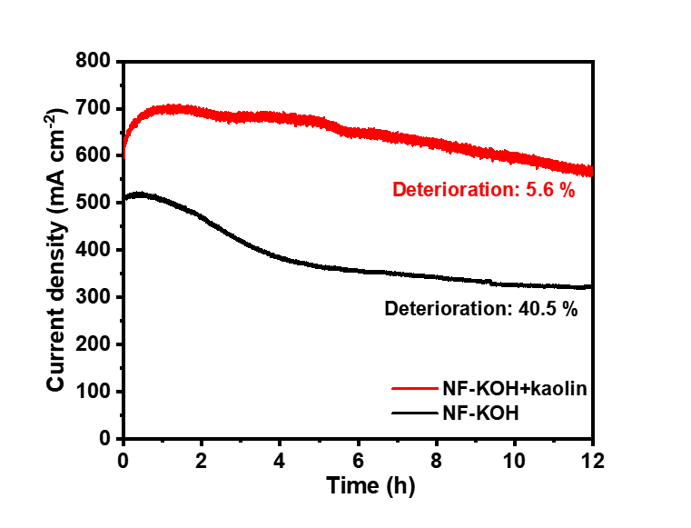

Supplementary Fig. 12 | J-t curves of NF. J-t curves tested at 2.52 V_{RHE} of NF electrodes in blank 1.0 M KOH electrolyte and 1.0 M KOH electrolyte with 30 mg mL⁻¹ kaolin NS.

Supplementary Fig. 13 | Tafel slopes of samples. Tafel slopes of NF, NF/Ni₃S₂, NF/Ni(OH)₂, NF/Co₃O₄ and NF/NiS_{x}/C₃N₄ electrodes in blank 1.0 M KOH electrolyte and 1.0 M KOH electrolyte with kaolin NS.

Supplementary Fig. 14 | Electrochemical test of pure ITO electrodes. (a) LSV and (b) EIS of ITO electrode in 1.0 M KOH electrolyte with and without 30 mg mL⁻¹ kaolin NS and corresponding fitting circuit diagram (inset).

Supplementary Fig. 15 | Optimized surface charge density for enhanced OER activity. a LSV of ITO/Ni@Ni(OH)₂ electrode in blank 1.0 M KOH electrolyte and 1.0 M KOH electrolyte with various particle sizes (1.99 μm, 1.13 μm and 1.04 μm) of kaolin and corresponding zeta potential (inset). b blank 1.0 M KOH electrolyte and 1.0 M KOH electrolyte with kaolin treated by oxygen plasma at different times (1 min, 2 min and 5 min) and corresponding zeta potential (inset). c Particle diameter spectra of kaolin NS with various average feature size (1.99 μm, 1.13 μm and 1.04 μm). d FT-IR spectrum of fresh kaolin NS and kaolin NS treated with oxygen plasma for various time (1.0 min, 3min and 5 min). As the electrostatic field intensity is essential to accelerating OER, to optimize OER activity in this section, we firstly utilized ball-milling method to increase the kaolin edge for increased surface charge density with larger electrostatic field intensity. The zeta potential value changes from -22.3 mV to -36.4 mV after ball-milling for 12 h (insert) with decreased average feature size of kaolin NS from 1.99 μm to 1.04 μm. The OER activity is enhanced with the increased zeta potential value in terms of the decreased 60-mV overpotential at 10 mA cm⁻². On the other hand, the electrostatic field intensity is increased via the oxygen plasma treatment by adding the unsaturated dangling bonds of kaolin NS surface. The Fourier transform infrared (FTIR) spectra shows that the Si-O-Si bonds corresponding to the peak centered at ~1090 cm⁻¹ and Al-O-Si bonds corresponding to the peak centered at ~800 cm⁻¹ becomes broader with longer oxygen plasma treatment time from 0 min to 5 min, indicating the higher disorder degree of interrupted periodic interfacial atom alignment leading to higher charge density in alkaline solution^{1,2}. This is consistent with the negatively increasing Zeta potential from -22.3 mV to -30.6 mV with longer oxygen plasma treatment time from 0 min to 5 min (insert). The LSV curvatures exhibit the enhanced OER activity with decreased overpotential from 530 mV to 500 mV at 10 mA cm⁻² and increased current density from 18.7 mA cm⁻² to 21.8 mA cm⁻² at 1.90 V_{RHE}.

Supplementary Fig. 16 | LSV of NF electrodes. LSV tested in blank KOH electrolyte, KOH electrolyte with kaolin NS and KOH electrolyte with kaolin NS optimized by ball milling and oxygen plasma treatment.

- Supplementary Tables

Supplementary table 1 | Comparisons of OER performance for various non-noble metal based electrocatalysts.
*NF: Ni foam, GCE: glassy carbon electrode, CFP: carbon fiber paper, CF: Cu foam

Supplementary table 2 | ICP of blank KOH electrolyte and KOH electrolyte after removing kaolin NS by centrifugal separation.

Supplementary table 3 | Fitting results obtained from EIS of ITO/Ni@Ni(OH)₂ electrode in 1.0 M KOH electrolyte with and without dispersed 30 mg mL⁻¹ kaolin NS.
There are two parameters of CPE: Y corresponding to its capacitance value without frequency dispersion, and an exponent N ≤ 1. Hence, CPE₁ contains Y₁ and N₁ and CPE_{eff} contains Y_{eff} and N₂. CPE₁ can be calculated according to the Brug equation¹⁶⁻¹⁸:
${CPE}_{1}=(Y_{1}×(\frac{1}{R_{s}}+\frac{1}{R_{1}})^{N_{1}−1})^{\frac{1}{N_{1}}}$ Eq. (3)
The CPE_{eff} can be calculated by the modified Brug equation¹⁹:
${CPE}_{eff}=(Y_{eff}×(\frac{1}{{R_{s}+R}_{1}}+\frac{1}{R_{ct}})^{N_{2}−1})^{\frac{1}{N_{2}}}$ Eq. (4)
All the fitting results are listed above, where R_{ct} is corresponding to the charge transfer resistance and CPE_{eff} is a constant phase element related to the active surface area²⁰.

Supplementary table 4 | Raman peaks of samples. Raman peaks of KOH electrolyte after removing kaolin NS by centrifugal separation after 0 h, 2 h and 12 h, KOH electrolyte with kaolin NS, KOH electrolyte without modification and KOH electrolyte after removing kaolin NS with immediate cooling treatment (20 ℃-5 ℃-20 ℃).

Supplementary table 5 | Ratios of five sub-bands of OH Stretching Raman spectra. Raman spectra of KOH electrolyte after removing kaolin NS by centrifugal separation after 0 h, 2 h and 12 h, KOH electrolyte with kaolin NS, KOH electrolyte without modification and KOH electrolyte after removing kaolin NS by centrifugal separation with immediate cooling treatment (20 ℃-5 ℃-20 ℃).

Supplementary table 6 | Fitting results obtained from EIS of ITO/Ni@Ni(OH)₂ electrode in 1.0 M MOH electrolytes (with M⁺ = Li⁺, Na⁺, K⁺ and Cs⁺) with and without dispersed 30 mg mL⁻¹ kaolin NS.

Supplementary table 7 | Fitting results obtained from EIS of ITO electrode in 1.0 M KOH electrolyte with and without dispersed 30 mg mL⁻¹ kaolin NS.

Supplementary References
1. Teh, E. J., Leong, Y. K., Liu, Y., Fourie, A. B. & Fahey, M. Differences in the rheology and surface chemistry of kaolin clay slurries: The source of the variations. Chem. Eng. Sci. 64, 3817-3825 (2009).
2. Sun, G. W., Zhang, J. J. & Yan, N. Microstructural evolution and characterization of ground granulated blast furnace slag in variant pH. Constr. Build. Mater. 251, 118978 (2020).
3. Esswein, J., McMurdo, M. J., Ross, P. N., Bell, A. T. & Tilley, T. D. Size-dependent activity of Co₃O₄ nanoparticle anodes for alkaline water electrolysis. J. Phys. Chem. C 113, 15068-15072 (2009).
4. Zahran, Z. N. et al. Electrocatalytic water splitting with unprecedentedly low overpotentials by nickel sulfide nanowires stuffed into carbon nitride scabbards. Energy Environ. Sci. 14, 5358-5365 (2021).
5. Wu, Y. et al. Efficient electrocatalysis of overall water splitting by ultrasmall Ni_{x}Co_{3−x}S₄ coupled Ni₃S₂ nanosheet arrays. Nano Energy 35, 161-170 (2017).
6. Yang, H. et al. Preparation of nickel-iron hydroxides by microorganism corrosion for efficient oxygen evolution. Nat. Commun. 11, 5075 (2020).
7. Liu, X. et al. Deep reconstruction of nickel-based precatalysts for water oxidation catalysis. ACS Energy Lett. 4, 2585-2592 (2019).
8. Zhou, W. et al. Ni₃S₂ nanorods/Ni foam composite electrode with low overpotential for electrocatalytic oxygen evolution. Energy Environ. Sci. 6, 2921-2924 (2013).
9. Su, X. et al. Operando spectroscopic identification of active sites in NiFe prussian blue analogues as electrocatalysts: Activation of oxygen atoms for oxygen evolution reaction. J. Am. Chem. Soc. 140, 11286-11292 (2018).
10. Liu, Y. et al. Interface engineering of (Ni,Fe)S₂@MoS₂ heterostructures for synergetic electrochemical water splitting. Appl. Catal. B Environ. 247, 107-114 (2019).
11. Liu, Y. et al. Coupling sub-nanometric copper clusters with quasi-amorphous cobalt sulfide yields efficient and robust electrocatalysts for water splitting reaction. Adv. Mater. 29, 1606200 (2017).
12. Kou, T. Y. et al. Ni foam-supported Fe-doped β-Ni(OH)₂ nanosheets show ultralow overpotential for oxygen evolution reaction. ACS Energy Lett. 4, 622-628 (2019).
13. Liu, X., Meng, J.S., Ni, K., et al. Complete reconstruction of hydrate pre-catalysts for ultrastable water electrolysis in industrial-concentration alkali media. Cell Rep. Phys. Sci. 1, 100241 (2020).
14. Zhao, S. et al. Ultrathin metal-organic framework nanosheets for electrocatalytic oxygen evolution. Nat. Energy 1, 1-10 (2016).
15. Li, F. L., Shao, Q., Huang, X. & Lang, J. P. Nanoscale trimetallic metal-organic frameworks enable efficient oxygen evolution electrocatalysis. Angew. Chem. Int. Ed. 130, 1906-1910 (2018).
16. Li, G., Anderson, L., Chen, Y., Pan, M. & Chuang, P.Y.A. New insights into evaluating catalyst activity and stability for oxygen evolution reactions in alkaline media. Sustain. Energy Fuels 2, 237-251 (2018).
17. Brug, G. J., van den Eeden, A. L. G., Sluyters-Rehbach, M. & Sluyters, J. H. The analysis of electrode impedances complicated by the presence of a constant phase element. J. Electroanal. Chem. Interfacial Electrochem. 176, 275-295 (1984).
18. Hirschorn, B. et al. Determination of effective capacitance and film thickness from constant-phase-element parameters. Electrochim. Acta 55, 6218-6227 (2010).
19. Alobaid, A., Wang, C. & Adomaitis, R. A. Mechanism and kinetics of HER and OER on NiFe LDH films in an alkaline electrolyte. J. Electrochem. Soc. 165, J3395-J3404 (2018).
20. Hao, M. et al. Vertically aligned Ni nanowires as a platform for kinetically limited water-splitting electrocatalysis. J. Phys. Chem. C 123, 1082-1093 (2019).

