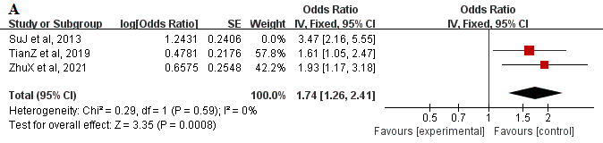
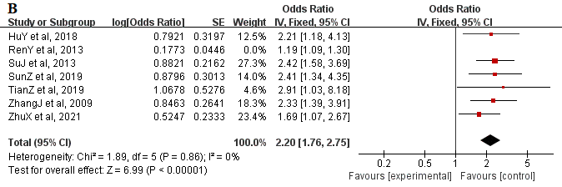
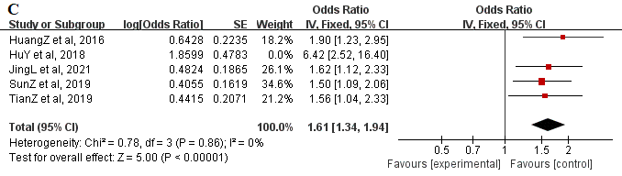
A:Improper use of the pillow,B:Improper sitting posture,C:Staying up late

