Sup files

The natural product erianin induces melanoma apoptosis through

targeting the GSK3α-NF-κB pathway
Sipeng Zuo ^{1,2, #}; Lin Li ^{1,2, #}; Rui Li^{1,2, #}; Fuxiang Ye^{1,2}; Linna Lu^{1,2, *}
¹Department of Ophthalmology, Ninth People’s Hospital, Shanghai Jiao Tong University School of Medicine, Shanghai, People's Republic of China.
²Shanghai Key Laboratory of Orbital Diseases and Ocular Oncology, Shanghai, People's Republic of China.

#These authors contributed equally to this manuscript.
Correspondence: Linna Lu, M.D. & Ph.D., Ninth People’s Hospital, Shanghai JiaoTong University School of Medicine, Shanghai, 200025, P.R. China, E-mail: LULN1084@sh9hospital.org.cn (L.L.).

Supplementary files include 2 figures and 1 Table

Supplementary Figures & Legends

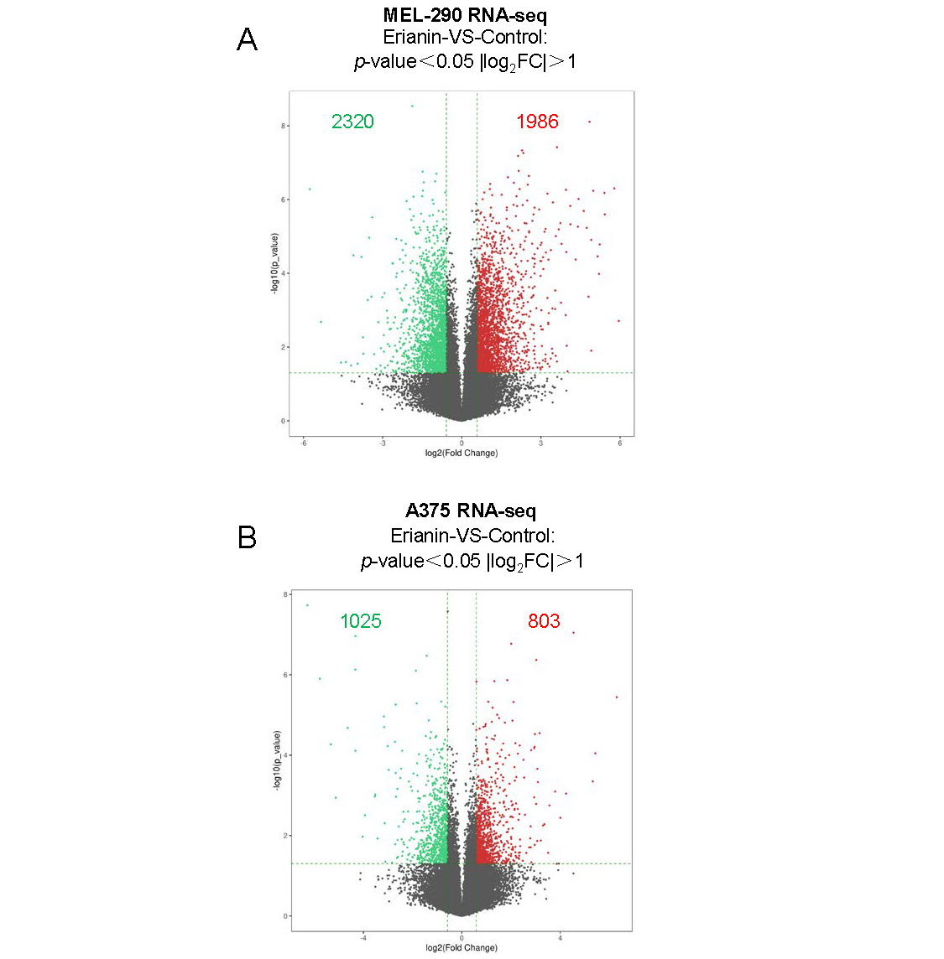
Figure S1: Erianin regulated thousands of genes in melanoma.
Volcano plot showing the transcriptional changes in melanoma after treatment of erianin.

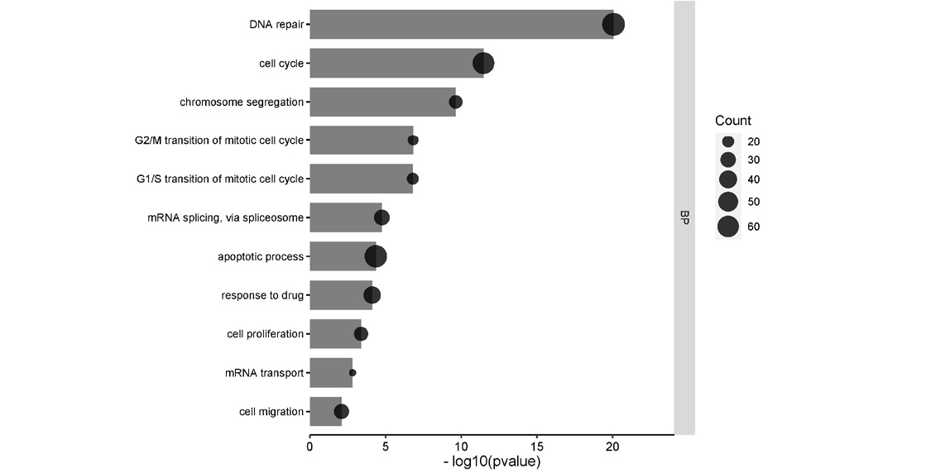
Figure S2: GO analysis of regulated genes in melanoma after treatment of erianin.
GO analysis showing many important cellular processes were affected in melanoma after treatment of erianin, including DNA repair, cell cycle and apoptotic process.

Supplementary Table 1. The clinical characteristics of retinoblastoma patient cohorts
SiRNA | Sequence (5′-3′)
siGSK3α-1  siGSK3α-2 | GCTGGACCACTGCAATATTGT  GGCTTACACGGACATCAAAGT

