Supplemental Figure S1

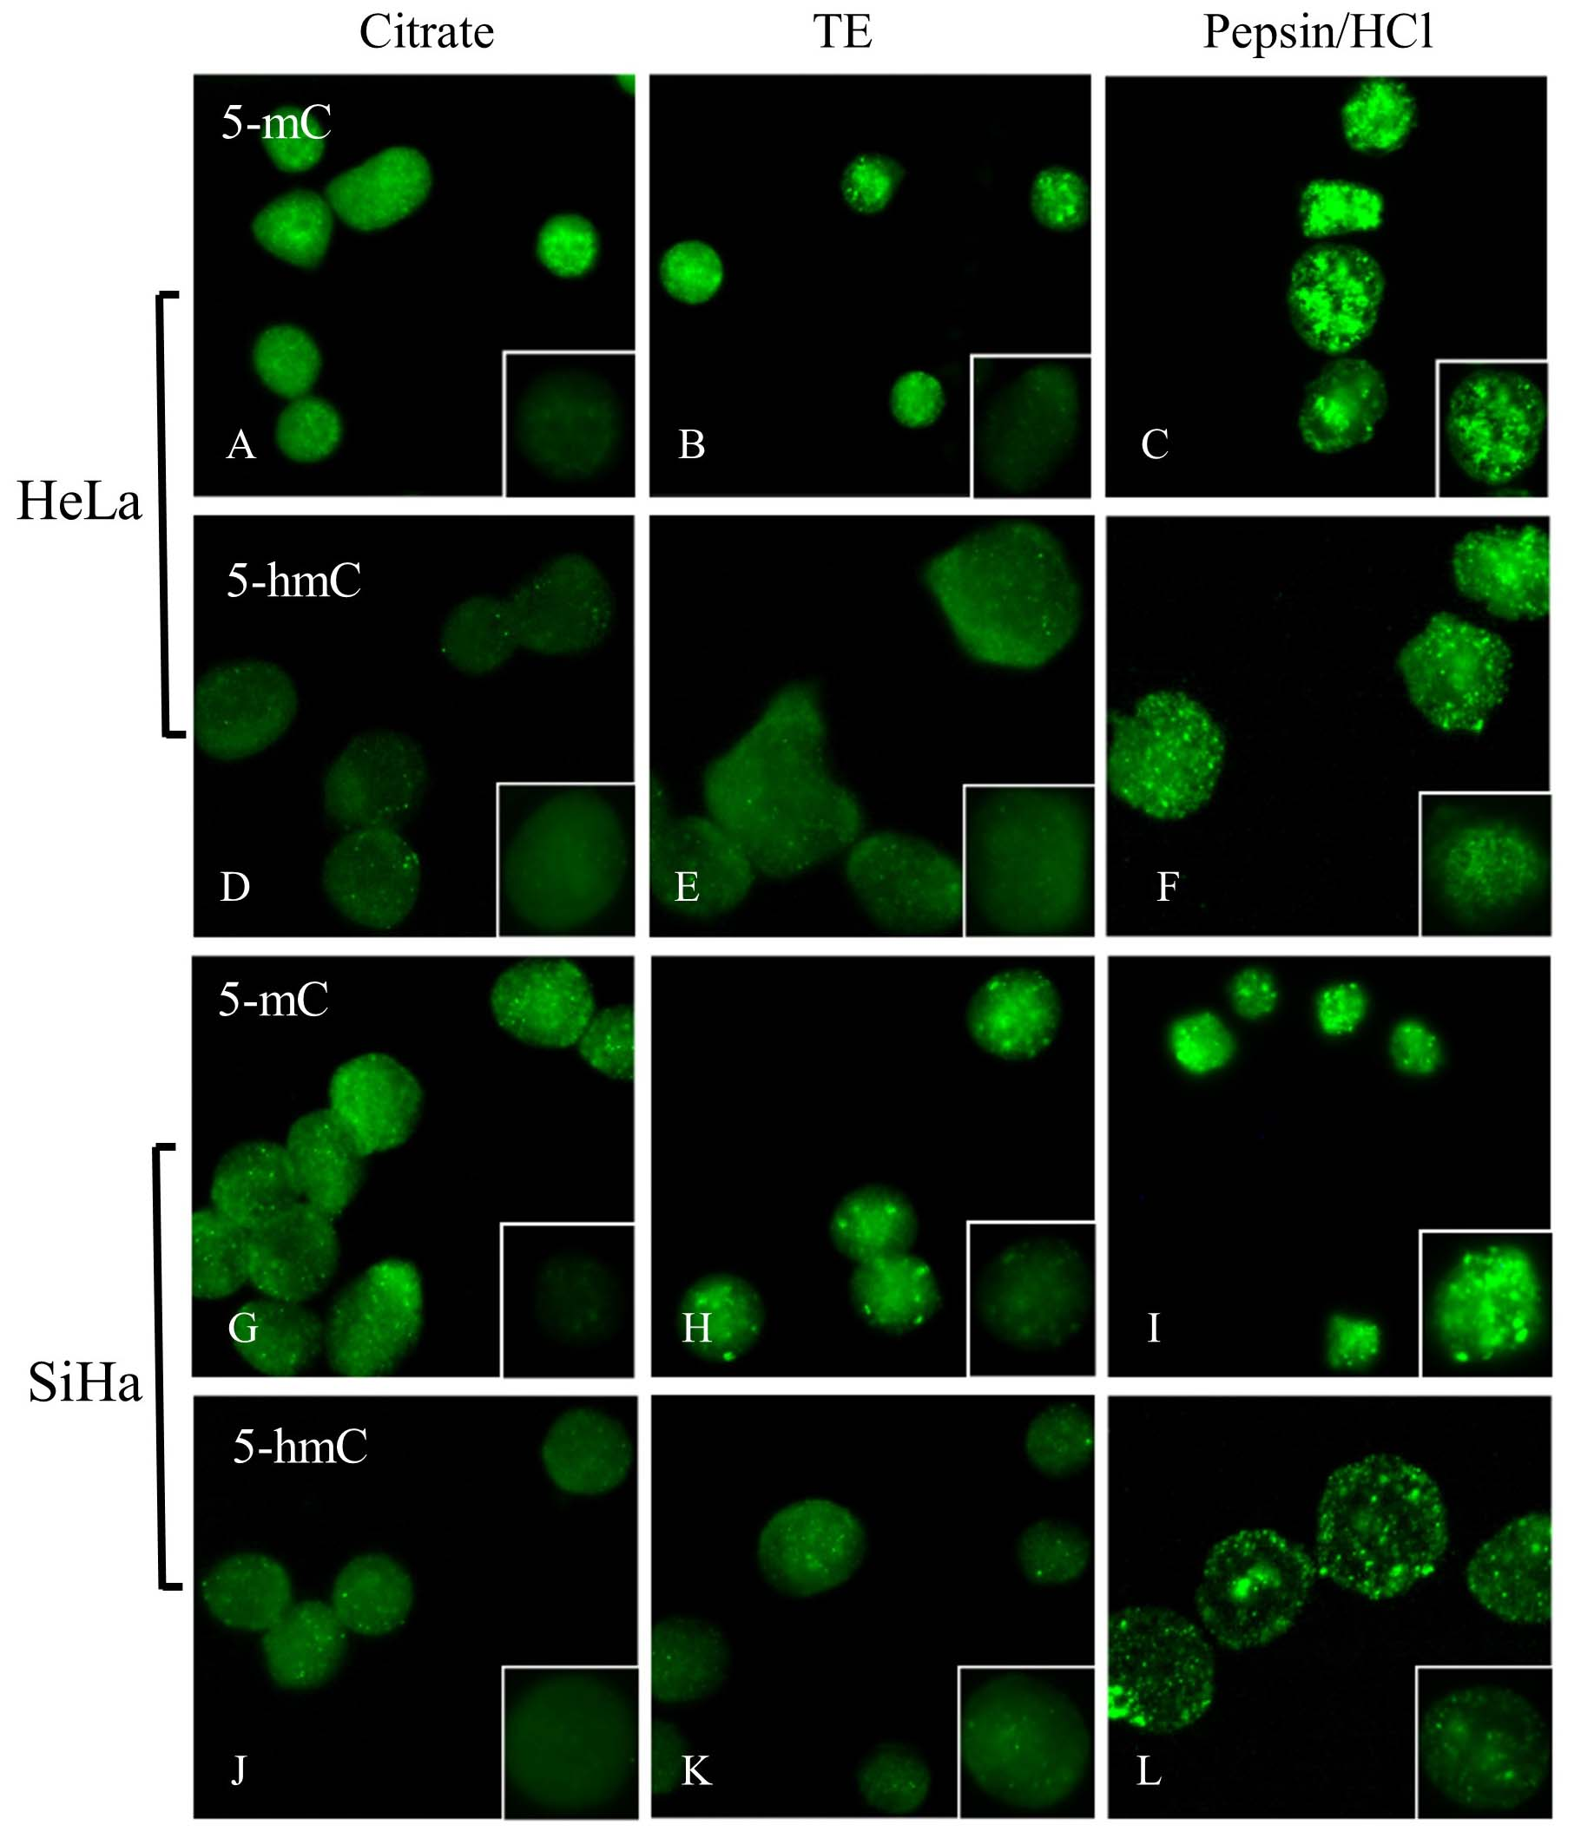

Comparison of immunofluorescent staining of 5-mC and 5-hmC in HeLa and SiHa cells using the Citrate, TE and Pepsin/HCl retrieval methods.
A-L) Detection of 5-mC and 5-hmC after non-confocal imaging and optimization of fluorescence intensity. The fluorescence images were captured using a fixed integration time of 1 sec (inserts) and similar secondary antibody dilutions.

Supplemental Figure S2

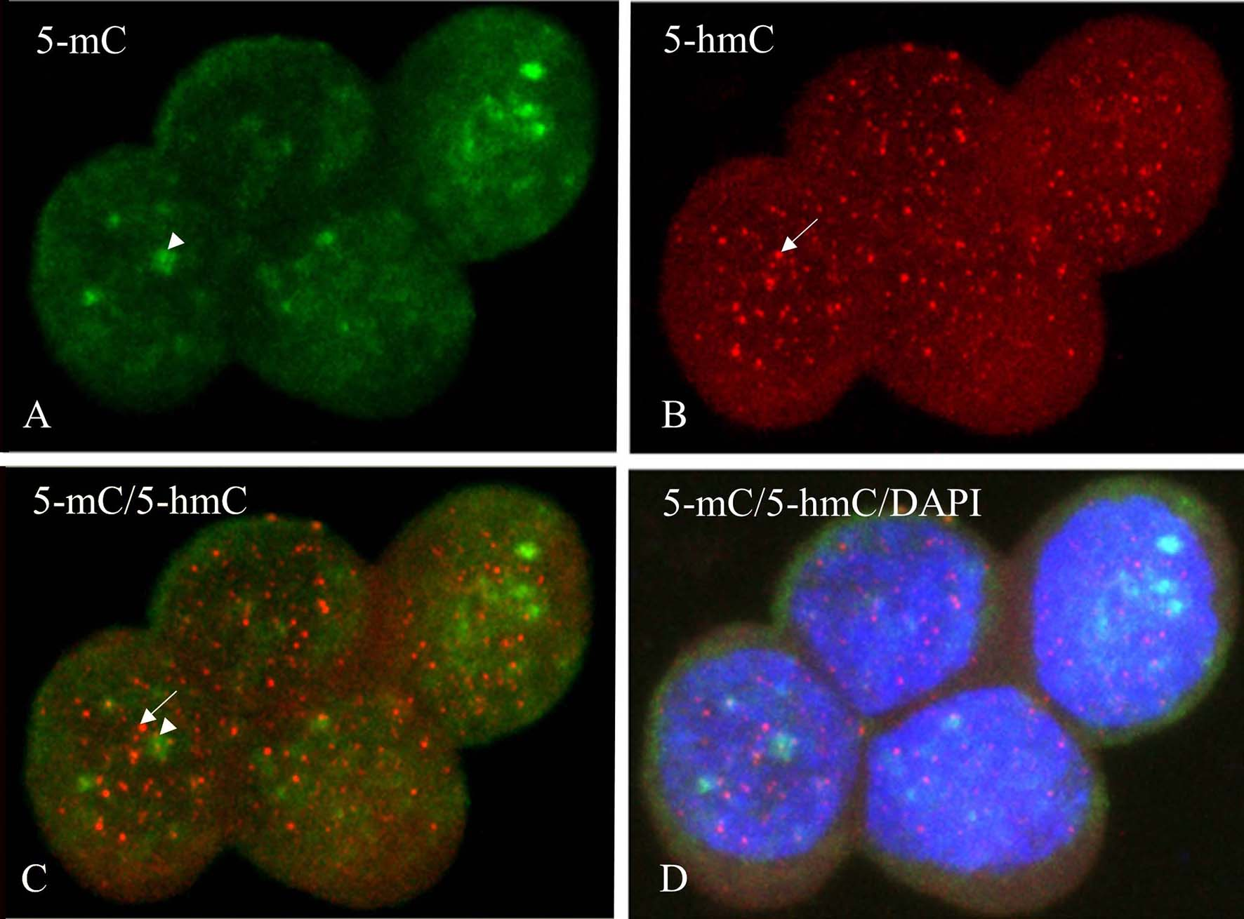

Simultaneous detection of 5-mC and 5-hmC in ethanol fixed normal human lymphocytes using confocal microscopy, pretreated with the Citrate protocol.
A) 5-mC in green (FITC), B) 5-hmC in red (Texas Red), C) merged image of 5-mC and 5-hmC and D) merged image with DAPI included. Note the difference in spot size between 5-mC and 5-hmC and the difference in the frequency of fluorescent spots for both modifications. The arrowhead points to a large fluorescent spot for 5-mC (A) and the arrow to a small spot for 5-hmC (B); the spots are not overlapping but close to each other (C).

Supplemental Figure S3

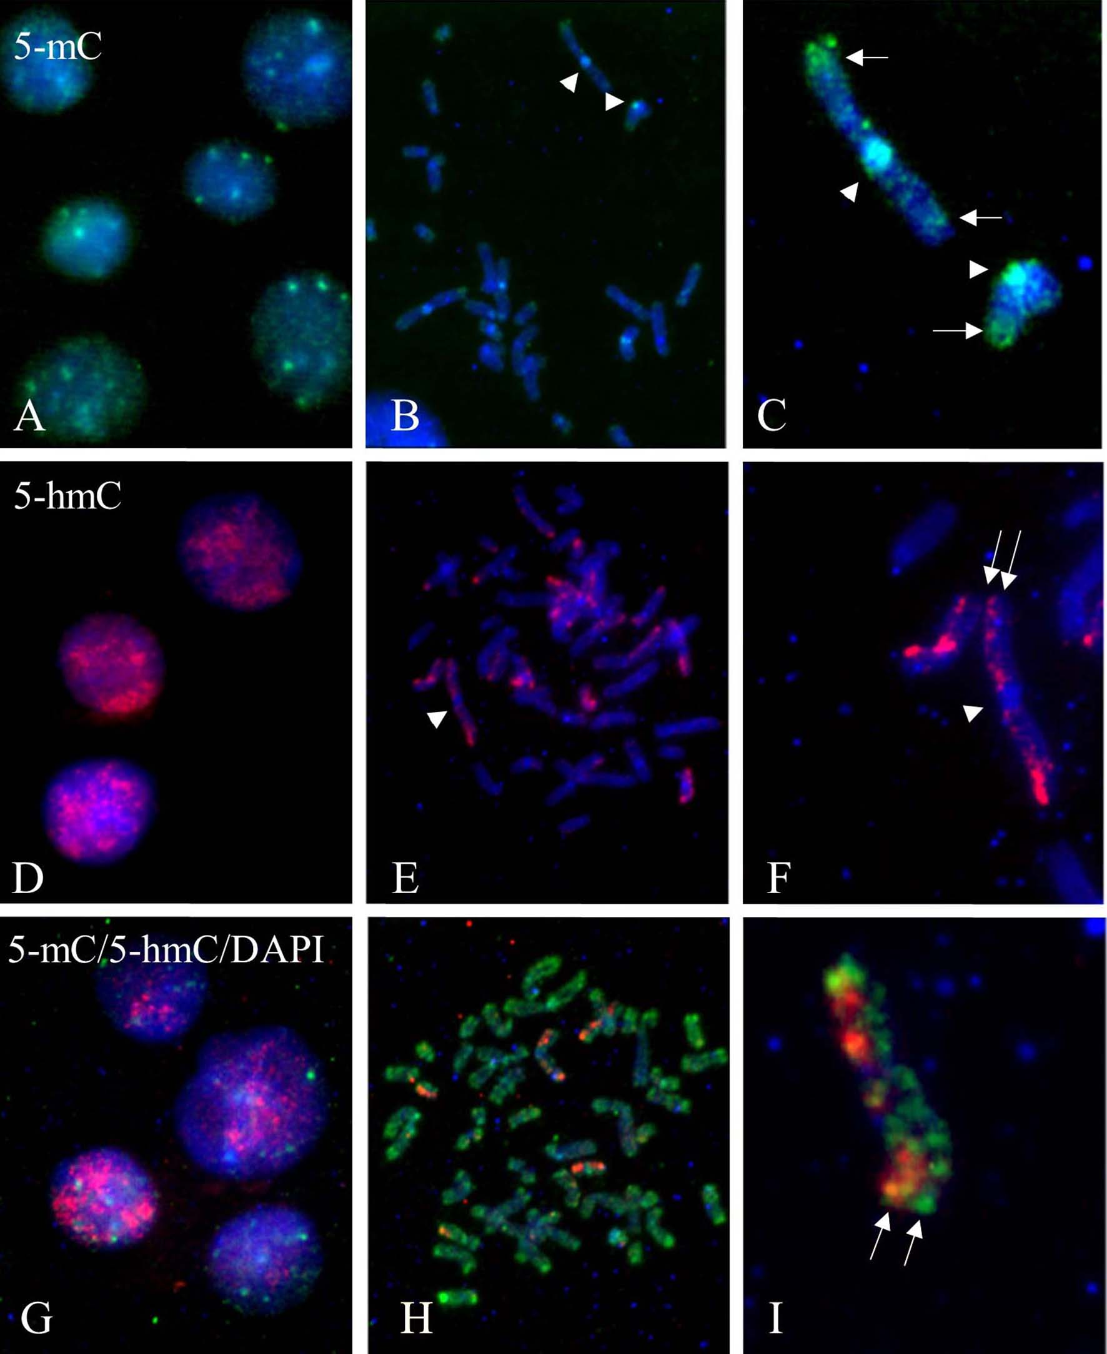
Simultaneous immunofluorescent detection of 5-mC and 5-hmC in TE-treated lymphocyte metaphase preparations.

A, D and E) lymphocyte interphase nuclei and B, E and H metaphase chromosomes showing 5-mC in green (FITC; A-C, G-I), 5-hmC in red (Texas Red, D-I ) and merged images with blue DNA staining using DAPI in all images. In C, F and I selected metaphase chromosomes (see arrowheads in B and E) show the telomere (arrows) and centromere (arrowheads) staining for 5-mC in both chromatids (C). For 5-hmC the positive staining of only one of the chromatids is seen in F and I (see parallel arrows).

