Facile fabrication of a novel self-healing and flame-retardant Hydrogel/MXene coating for wood
Xiaojiong Zhao^{a,b}, Min Tianª, Ruichao Wei^{d,e, *}, Saihua Jiang^{a, b, c, *}
ª Institute of Safety Science and Engineering, School of Mechanical and Automotive Engineering, South China University of Technology, Wushan Road 381, Guangzhou, 510641, P. R. China
^{b} Guangdong Provincial Key Laboratory of Technique and Equipment for Macromolecular Advanced Manufacturing, South China University of Technology, Guangzhou, 510641, P. R. China
^{c} State Key Laboratory of Fire Science, University of Science and Technology of China, Jinzhai Road 96, Hefei, 230026, P. R. China
^{d} Research Institute of New Energy Vehicle Technology, Shenzhen Polytechnic, Shenzhen,
Guangdong 518055, P. R. China
^{e} School of Automobile and Transportation, Shenzhen Polytechnic, Shenzhen, Guangdong
518055, P. R. China

Corresponding author:
*E-mail: meshjiang@scut.edu.cn (S.H. Jiang)
*E-mail: rcwei@mail.ustc.edu.cn

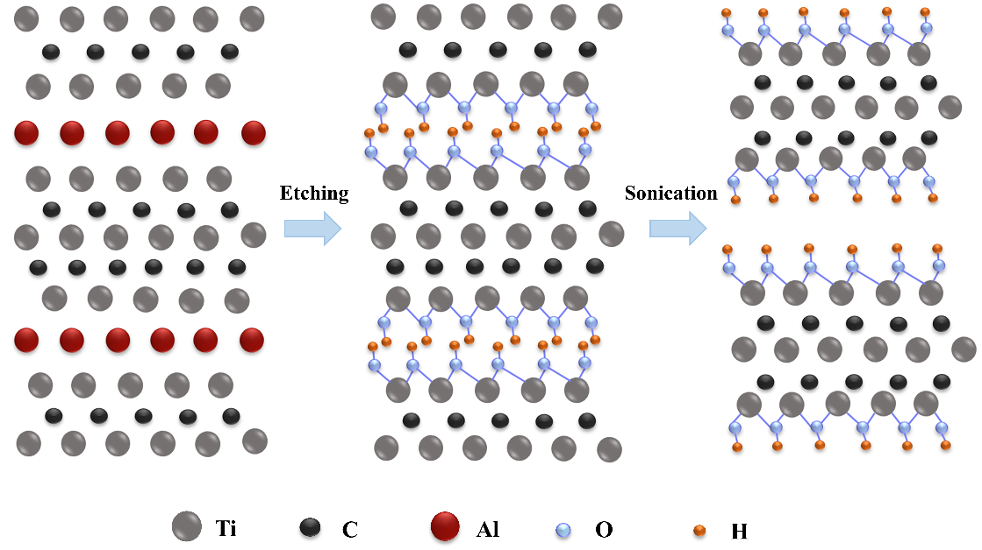
Figure S1. The illustration of the synthetic process of MXene.

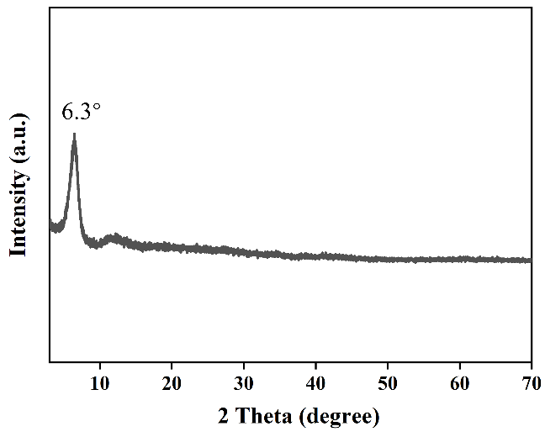
Figure S2. The XRD result of MXene.

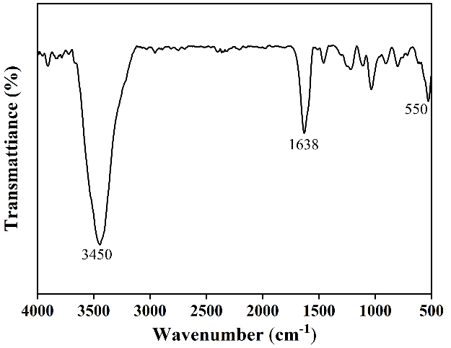
Figure S3. The FTIR result of MXene.

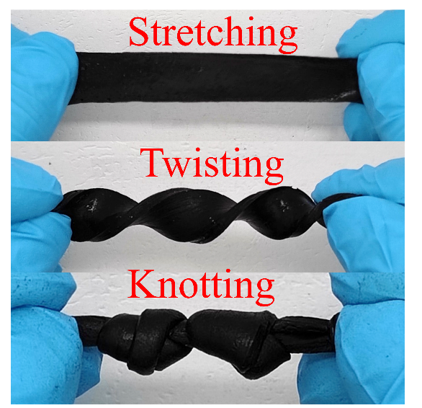
Figure S4. The images of stretching, twisting, knotting of M0.3 hydrogel.

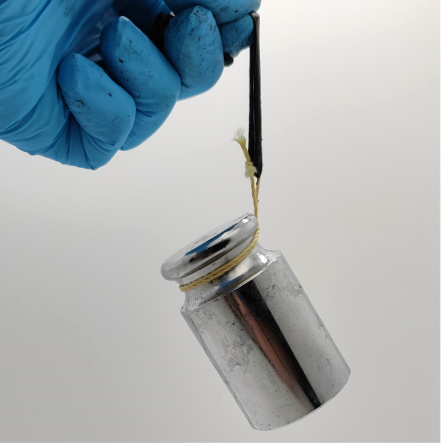
Figure S5. The images of weightlifting of M0.3 hydrogel.

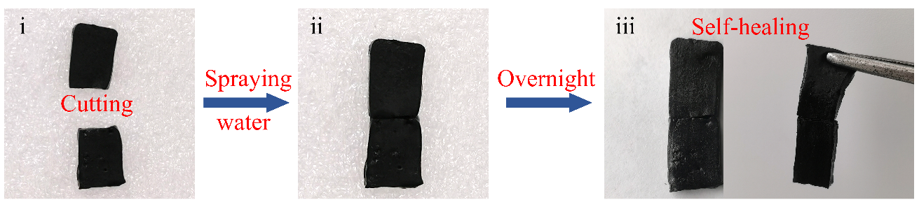
Figure S6. The self-healing process of M0.3 hydrogel.

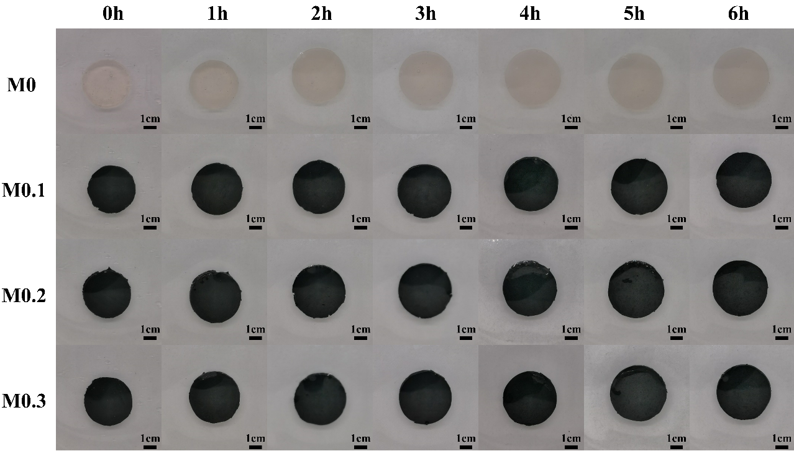
Figure S7. The photographs of M-hydrogels after immersing in water.

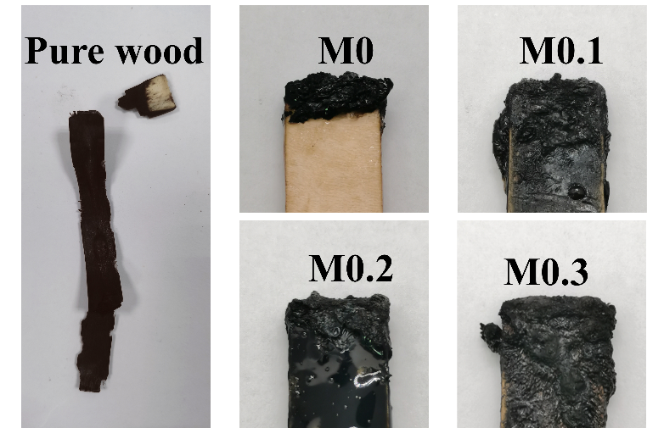
Figure S8. The photographs of M-hydrogels-coated and uncoated wood after UL-94 test.

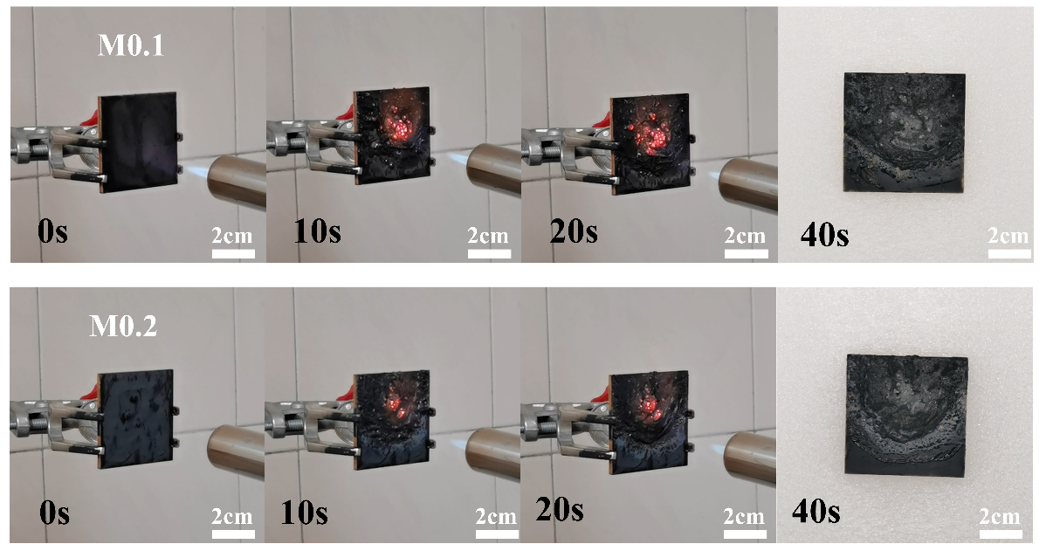
Figure S9. The photos of M0.1, M0.2 hydrogel-coated wood in open fire test.

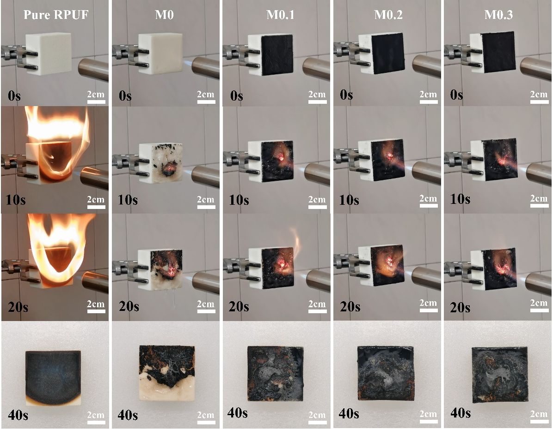
Figure 10. The photos of pure RPUF, M0, M0.1, M0.2 and M0.3 hydrogel-coated RPUF in open fire test.

