Supplementary materials
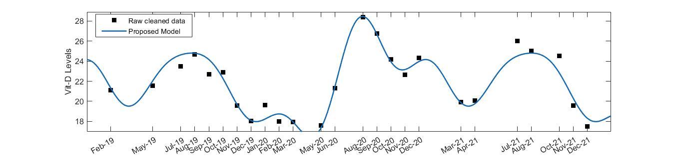
Fig. S1 Comparisons of the estimations of 25(OH)D levels of the proposed model 1 and the real 25(OH)D values

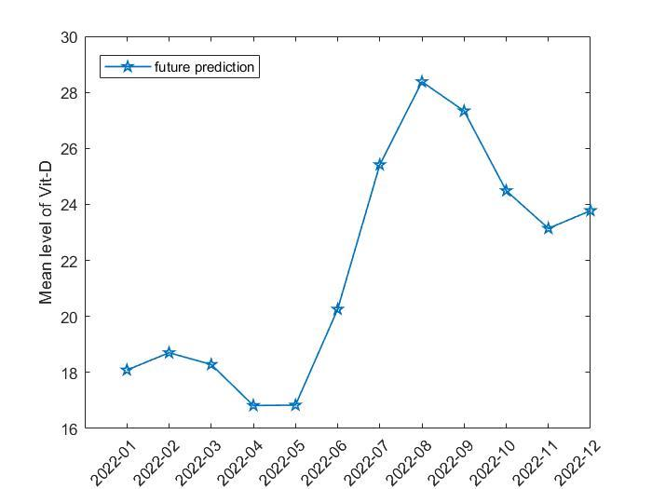

Fig. S2 Future estimation of levels 25(OH)D with the help of the proposed model
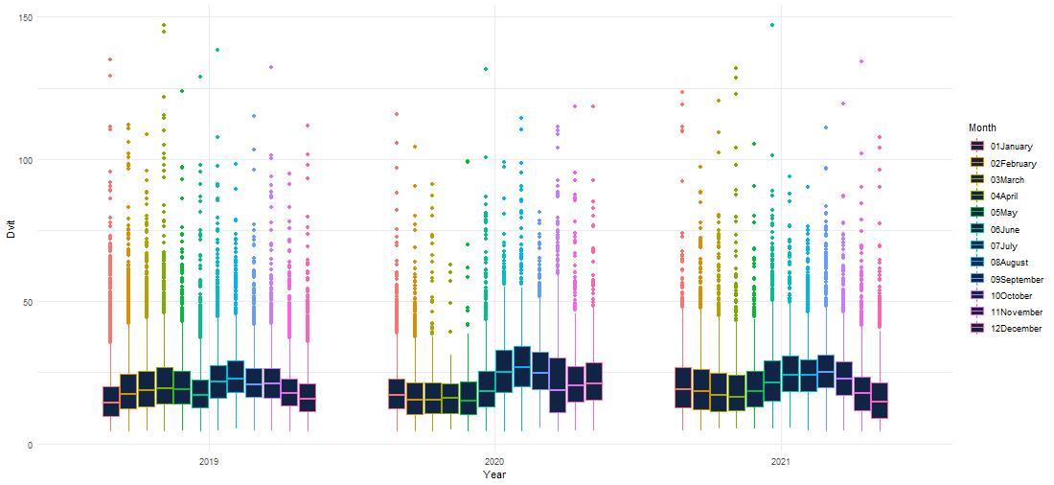
Fig. S3 Distribution of 25(OH)D levels by years and months

