Supplementary Material
Supplementary Figure 1. The appearance of the constant temperature stimulator (A) and the national patent certificate of the constant temperature stimulator (Chinese Patent No. ZL202121087859.2).

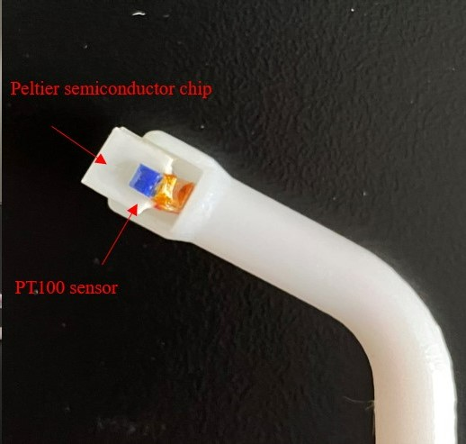
Supplementary Figure 2. The detail of PT100 sensor probe (Heraeus, Germany).

Supplementary Table 1. The characteristics of the subjects.

Subject characteristics
Age | 23 ± 3
Gender (Male/female) | 24/16
Height (m) | 1.71 ± 0.06
Mass (kg) | 58.34 ± 8.27
Mean skin temperature of hand (°C) | 33.09 ± 1.02
Edinburgh Handedness (Left/Right) | 5/35

Supplementary Table 2. The p values of the post-hoc tests for the average power of the six frequency bands under the five conditions: baseline, 45°C, 48°C, 51°C, and 54°C thermal stimuli.

P value |  | Baseline vs. 45°C vs. 48°C vs. 51°C vs. 54°C
 |  | B-45 | B-48 | B-51 | B-54 | 45-48 | 45-51 | 45-54 | 48-51 | 48-54 | 51-54
Delta | Frontal | 1.000 | 1.000 | 1.000 | 1.000 | 1.000 | 1.000 | 0.254 | 0.837 | 1.000 | 1.000
Delta | Central | 1.000 | 1.000 | 0.647 | 1.000 | 1.000 | 1.000 | 0.651 | 0.157 | 0.213 | 1.000
Delta | Occipital | 1.000 | 1.000 | 1.000 | 1.000 | 1.000 | 1.000 | 1.000 | 1.000 | 0.534 | 0.419
Delta | Left | 1.000 | 0.571 | 0.878 | 0.405 | 1.000 | 1.000 | 1.000 | 1.000 | 1.000 | 1.000
Delta | Right | 1.000 | 1.000 | 0.547 | 0.118 | 1.000 | 0.960 | 0.368 | 0.085 | 0.008** | 1.000
Theta | Frontal | 1.000 | 0.022* | 0.040* | 0.003** | 1.000 | 0.339 | 0.069 | 1.000 | 0.588 | 1.000
Theta | Central | 0.023* | 0.001*** | 0.012* | 0.000*** | 1.000 | 1.000 | 0.280 | 1.000 | 1.000 | 0.281
Theta | Occipital | 0.025* | 0.002** | 0.021* | 0.003** | 1.000 | 1.000 | 0.167 | 1.000 | 0.785 | 0.942
Theta | Left | 0.008** | 0.001*** | 0.001*** | 0.002** | 1.000 | 0.940 | 1.000 | 1.000 | 1.000 | 1.000
Theta | Right | 0.068 | 0.008** | 0.034* | 0.000*** | 1.000 | 1.000 | 0.001*** | 1.000 | 0.029* | 0.110
Alpha | Frontal | 1.000 | 0.806 | 1.000 | 0.033* | 1.000 | 1.000 | 0.419 | 1.000 | 0.520 | 0.407
Alpha | Central | 0.005** | 0.025* | 0.066 | 0.004** | 1.000 | 1.000 | 1.000 | 1.000 | 0.855 | 1.000
Alpha | Occipital | 0.672 | 1.000 | 0.004** | 0.308 | 1.000 | 0.513 | 1.000 | 0.821 | 1.000 | 1.000
Alpha | Left | 0.010** | 0.011* | 0.051 | 0.001*** | 1.000 | 1.000 | 0.498 | 1.000 | 0.036* | 0.356
Alpha | Right | 0.002** | 0.001*** | 0.001*** | 0.001*** | 0.852 | 1.000 | 0.393 | 1.000 | 1.000 | 1.000
Low beta | Frontal | 1.000 | 1.000 | 1.000 | 1.000 | 1.000 | 1.000 | 1.000 | 1.000 | 0.256 | 1.000
Low beta | Central | 1.000 | 1.000 | 1.000 | 1.000 | 1.000 | 1.000 | 1.000 | 0.126 | 1.000 | 1.000
Low beta | Occipital | 1.000 | 1.000 | 0.857 | 1.000 | 1.000 | 0.537 | 1.000 | 1.000 | 1.000 | 1.000
Low beta | Left | 1.000 | 1.000 | 0.655 | 1.000 | 1.000 | 1.000 | 0.943 | 0.768 | 0.477 | 1.000
Low beta | Right | 1.000 | 1.000 | 0.260 | 0.965 | 1.000 | 1.000 | 1.000 | 0.746 | 1.000 | 1.000
High beta | Frontal | 0.315 | 0.045* | 1.000 | 0.961 | 1.000 | 1.000 | 1.000 | 0.785 | 0.590 | 1.000
High beta | Central | 1.000 | 0.061 | 1.000 | 1.000 | 1.000 | 1.000 | 1.000 | 0.652 | 1.000 | 1.000
High beta | Occipital | 0.022* | 0.019* | 1.000 | 0.852 | 1.000 | 0.616 | 1.000 | 0.385 | 1.000 | 1.000
High beta | Left | 0.098 | 0.044* | 0.723 | 1.000 | 1.000 | 1.000 | 0.783 | 1.000 | 1.000 | 1.000
High beta | Right | 0.036* | 0.017* | 1.000 | 1.000 | 1.000 | 0.994 | 1.000 | 1.000 | 1.000 | 1.000
Gamma | Frontal | 0.038* | 0.001*** | 0.303 | 0.020* | 1.000 | 1.000 | 1.000 | 1.000 | 1.000 | 1.000
Gamma | Central | 0.045* | 0.005** | 0.301 | 0.033* | 0.450 | 1.000 | 1.000 | 0.902 | 1.000 | 1.000
Gamma | Occipital | 0.001*** | 0.001*** | 0.203 | 0.021* | 1.000 | 0.551 | 1.000 | 0.166 | 1.000 | 1.000
Gamma | Left | 0.005** | 0.001*** | 0.035* | 0.001*** | 1.000 | 1.000 | 1.000 | 1.000 | 1.000 | 1.000
Gamma | Right | 0.001*** | 0.001*** | 0.018* | 0.001*** | 1.000 | 1.000 | 1.000 | 1.000 | 1.000 | 1.000

