Supporting information
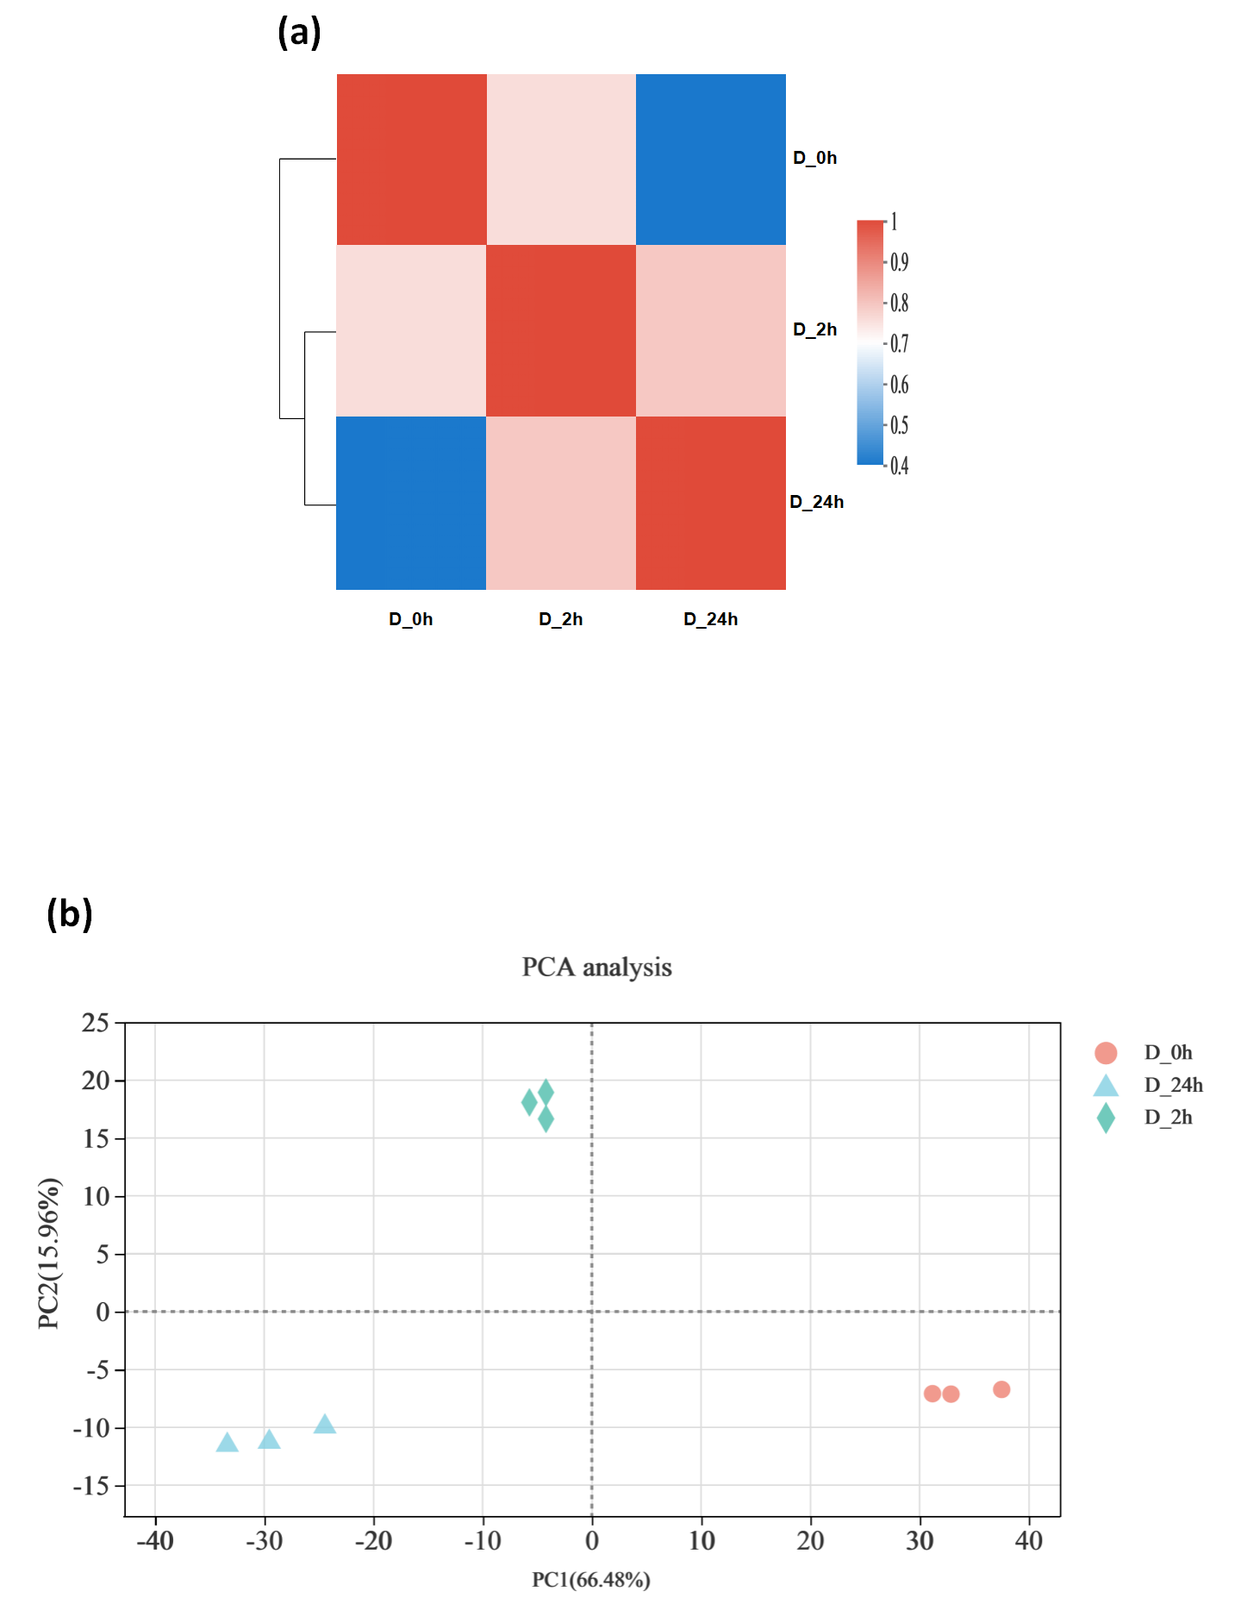 Figure S1. (a) Correlation among the samples. The heat map is based on Pearson correlation coefficient, complete linkage clustering method, and Euclidean distance algorithm. (b) PCA plot of the transcriptome of D_0h, D_2h, and D_24h samples.

Sample | Clean reads | Q30 (%) | GC content (%) | Total mapped reads (Percentage in clean reads) | Multiple mapped reads (Percentage in clean reads) | Uniquely mapped reads (Percentage in clean reads)
D_0h_1 | 42,132,106 | 95.23 | 47.88 | 39,331,362  (93.35%) | 1,918,071  (4.55%) | 37,413,291  (88.8%)
D_0h_2 | 43,776,378 | 95.16 | 47.75 | 40,869,740  (93.36%) | 1,605,138  (3.67%) | 39,264,602  (89.69%)
D_0h_3 | 45,892,522 | 95.41 | 47.74 | 42,767,680  (93.19%) | 1,561,285  (3.4%) | 41,206,395  (89.79%)
D_2h_1 | 45,856,492 | 95.18 | 47.48 | 39,331,362  (93.35%) | 2,859,831  (6.24%) | 39,791,931  (86.77%)
D_2h_2 | 41,804,404 | 95.08 | 47.54 | 40,869,740  (93.36%) | 1,494,862  (3.58%) | 37,575,606  (89.88%)
D_2h_3 | 43,084,806 | 95.04 | 47.64 | 42,767,680  (93.19%) | 1,723,642  (4.0%) | 38,296,666  (88.89%)
D_24h_1 | 47,073,278 | 93.80 | 47.33 | 42,159,359  (89.56%) | 2,654,838  (5.64%) | 39,504,521  (83.92%)
D_24h_2 | 49,195,586 | 93.74 | 47.15 | 44,479,994  (90.41%) | 2,877,047  (5.85%) | 41,602,947  (84.57%)
D_24h_3 | 44,544,988 | 93.39 | 47.61 | 40,930,512  (91.89%) | 4,236,663  (9.51%) | 36,693,849  (82.37%)
Table S1. Summary of de novo transcriptome sequencing data.

Table S2. Top 5 KEGG pathways of DEGs in D_0h vs. D_12h and D_0h vs. D_24h.
 | Number | Pathway id | Description | P-adjust
D_2h vs. D_0h | 75 | map04075 | Plant hormone signal transduction | 0.000
D_2h vs. D_0h | 56 | map04626 | Plant-pathogen interaction | 0.007
D_2h vs. D_0h | 50 | map00500 | Starch and sucrose metabolism | 0.007
D_2h vs. D_0h | 50 | map00940 | Phenylpropanoid biosynthesis | 0.346
D_2h vs. D_0h | 48 | map04016 | MAPK signaling pathway - plant | 0.000
D_24h vs. D_0h | 107 | map04075 | Plant hormone signal transduction | 0.000
D_24h vs. D_0h | 96 | map00940 | Phenylpropanoid biosynthesis | 0.003
D_24h vs. D_0h | 79 | map04626 | Plant-pathogen interaction | 0.042
D_24h vs. D_0h | 70 | map04016 | MAPK signaling pathway - plant | 0.000
D_24h vs. D_0h | 66 | map00500 | Starch and sucrose metabolism | 0.074

Table S3. Top 3 KEGG pathways of cluster_1, cluster_3, and cluster_2.
 | Number | Pathway id | Description | P-adjust
cluster_1 | 29 | map04016 | MAPK signaling pathway - plant | 0.000
cluster_1 | 26 | map04626 | plant-pathogen interaction | 0.037
cluster_1 | 26 | map04075 | plant hormone signal transduction | 0.039
cluster_3 | 21 | map04075 | plant hormone signal transduction | 0.085
cluster_3 | 19 | map00940 | phenylpropanoid biosynthesis | 0.189
cluster_3 | 15 | map00500 | starch and sucrose metabolism | 0.163
cluster_2 | 15 | map04075 | plant hormone signal transduction | 0.017
cluster_2 | 9 | map00941 | flavonoid biosynthesis | 0.017
cluster_2 | 9 | map00940 | phenylpropanoid biosynthesis | 0.637

