Supplementary Figures

Figure S1. Kraken tool analysis parameters.
Figure S2. Observed OTU richness and rarefaction curve of microbial communities associated with cultured and wild A. taxiformis.
Figure S3. Maximum likelihood phylogeny of cox2-cox3 spacer sequences of Asparagopsis taxiformis produced in IQ-TREE 2 (model selected HKY+F+G4, Log-likelihood of the tree: -1521.7327; Minh et al. 2020). Non-parametric bootstrap values >70% (100 replicates) shown on branches. Asparagopsis armata removed for clarity. Lineage 6, GBR strain (Andreakis et al. 2016) indicated. Samples from this study (ASP2018, ASP2019, ASP2021) were identical to sequence KT946701 (Magnetic Island, Queensland, Australia).
Figure S4. Summary of A. taxiformis (L6) gene BLAST match identity.
Figure S5. Number of genes for the top ten most abundant gene ontology terms in cellular component, biological process and molecular function.
Figure S6. Summary of A. taxiformis (L6) gene InterPro annotations.
Figure S7. Principal component scatter plot for RNA-seq of cultured and wild sporophyte.
Figure S8. SWISS-MODEL structure predication for protein encoded by A. taxiformis (L6) gene 3063, using a proximal thread matrix protein (PDB # 4cn9.2.A) as template.

Galaxy Tool ID: | toolshed.g2.bx.psu.edu/repos/devteam/kraken/kraken/1.3.1
Command Line | if [ -d '/mnt/tools-indices/custom-indices/kraken_database/minikraken_20180718/minikraken//Minikraken' ]; then export KRAKEN_DEFAULT_DB='/mnt/tools-indices/custom-indices/kraken_database/minikraken_20180718/minikraken//Minikraken'; else export KRAKEN_DEFAULT_DB='/mnt/tools-indices/custom-indices/kraken_database/minikraken_20180718/minikraken/'; fi && kraken --threads ${GALAXY_SLOTS:-1} --db "$KRAKEN_DEFAULT_DB" --fasta-input '/mnt/user-data-2/005/157/dataset_5157823.dat' --classified-out '/mnt/user-data-2/005/158/dataset_5158825.dat' --unclassified-out '/mnt/user-data-2/005/158/dataset_5158826.dat' > '/mnt/user-data-2/005/158/dataset_5158827.dat'
Tool Standard Output | empty
Tool Standard Error | 38440 sequences (59.44 Mbp) processed in 189.889s (12.1 Kseq/m, 18.78 Mbp/m).  261 sequences classified (0.68%)  38179 sequences unclassified (99.32%)
Tool Exit Code: | 0
Job API ID: | ba487ed5efeafcd9
Tool Outputs |  | Dataset
Convert Kraken |  | 28 Convert Kraken on data 21  View dataEdit attributesDelete
Galaxy Tool ID: |  | toolshed.g2.bx.psu.edu/repos/devteam/kraken2tax/Kraken2Tax/1.2
Command Line |  | awk '{ print $2, $3 }' OFS="\t" "/mnt/user-data-2/005/158/dataset_5158827.dat" | taxonomy-reader "/cvmfs/data.galaxyproject.org/managed/ncbi_taxonomy/ncbi-2015-10-05/names.dmp" "/cvmfs/data.galaxyproject.org/managed/ncbi_taxonomy/ncbi-2015-10-05/nodes.dmp" 1 > "/mnt/user-data-2/005/158/dataset_5158912.dat"
Tool Standard Output |  | empty
Tool Standard Error |  | empty
Tool Exit Code: |  | 0
Job API ID: |  | 845696f3f746b589

Figure S1. Kraken tool analysis parameters.

Figure S2. Observed OTU richness and Rarefaction curve of microbial communities associated with wild and cultured Asparagopsis taxiformis.

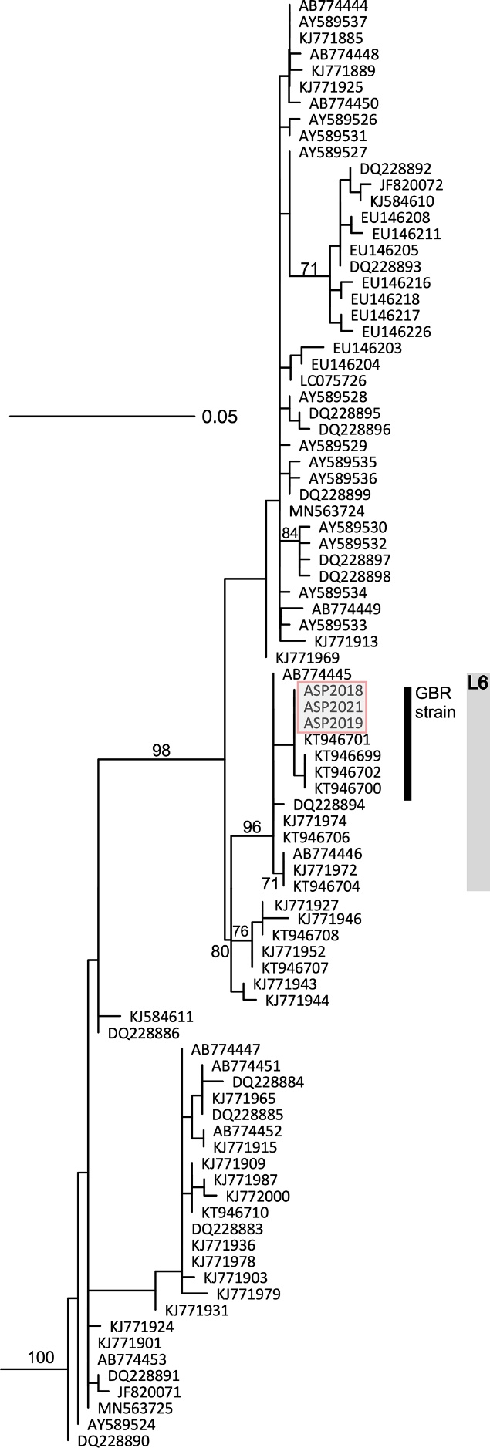
Figure S3. Maximum likelihood phylogeny of cox2-cox3 spacer sequences of Asparagopsis taxiformis produced in IQ-TREE 2 (model selected HKY+F+G4, Log-likelihood of the tree: -1521.7327; Minh et al. 2020). Non-parametric bootstrap values >70% (100 replicates) shown on branches. Asparagopsis armata removed for clarity. Lineage 6, GBR strain (Andreakis et al. 2016) indicated. Samples from this study (ASP2018, ASP2019, ASP2021) were identical to sequence KT946701 (Magnetic Island, Queensland, Australia).

Figure S4. Summary of A. taxiformis (L6) gene BLAST match identity.

Figure S5. Number of genes for the top 10 most abundant gene ontology terms in cellular component, biological process and molecular function.
Figure S6. Summary of A. taxiformis (L6) gene InterPro annotations.

Figure S7. Principal component scatter plot for RNA-seq of culture and wild sporophyte.

Figure S8. SWISS-MODEL structure predication for protein encoded by A. taxiformis (L6) gene 3063, using a proximal thread matrix protein (PDB # 4cn9.2.A) as template.

References
Andreakis, N., Costello, P., Zanolla, M., Saunders, G.W. & Mata, L. 2016. Endemic or introduced? Phylogeography of Asparagopsis (Florideophyceae) in Australia reveals multiple introductions and a new mitochondrial lineage. J Phycol. 52:141–7.
Minh, B.Q., Schmidt, H.A., Chernomor, O., Schrempf, D., Woodhams, M.D., Haeseler, A. von & Lanfear, R. 2020. IQ-TREE 2: New models and efficient methods for phylogenetic inference in the genomic era. Mol Biol Evol. 37:1530–4.

