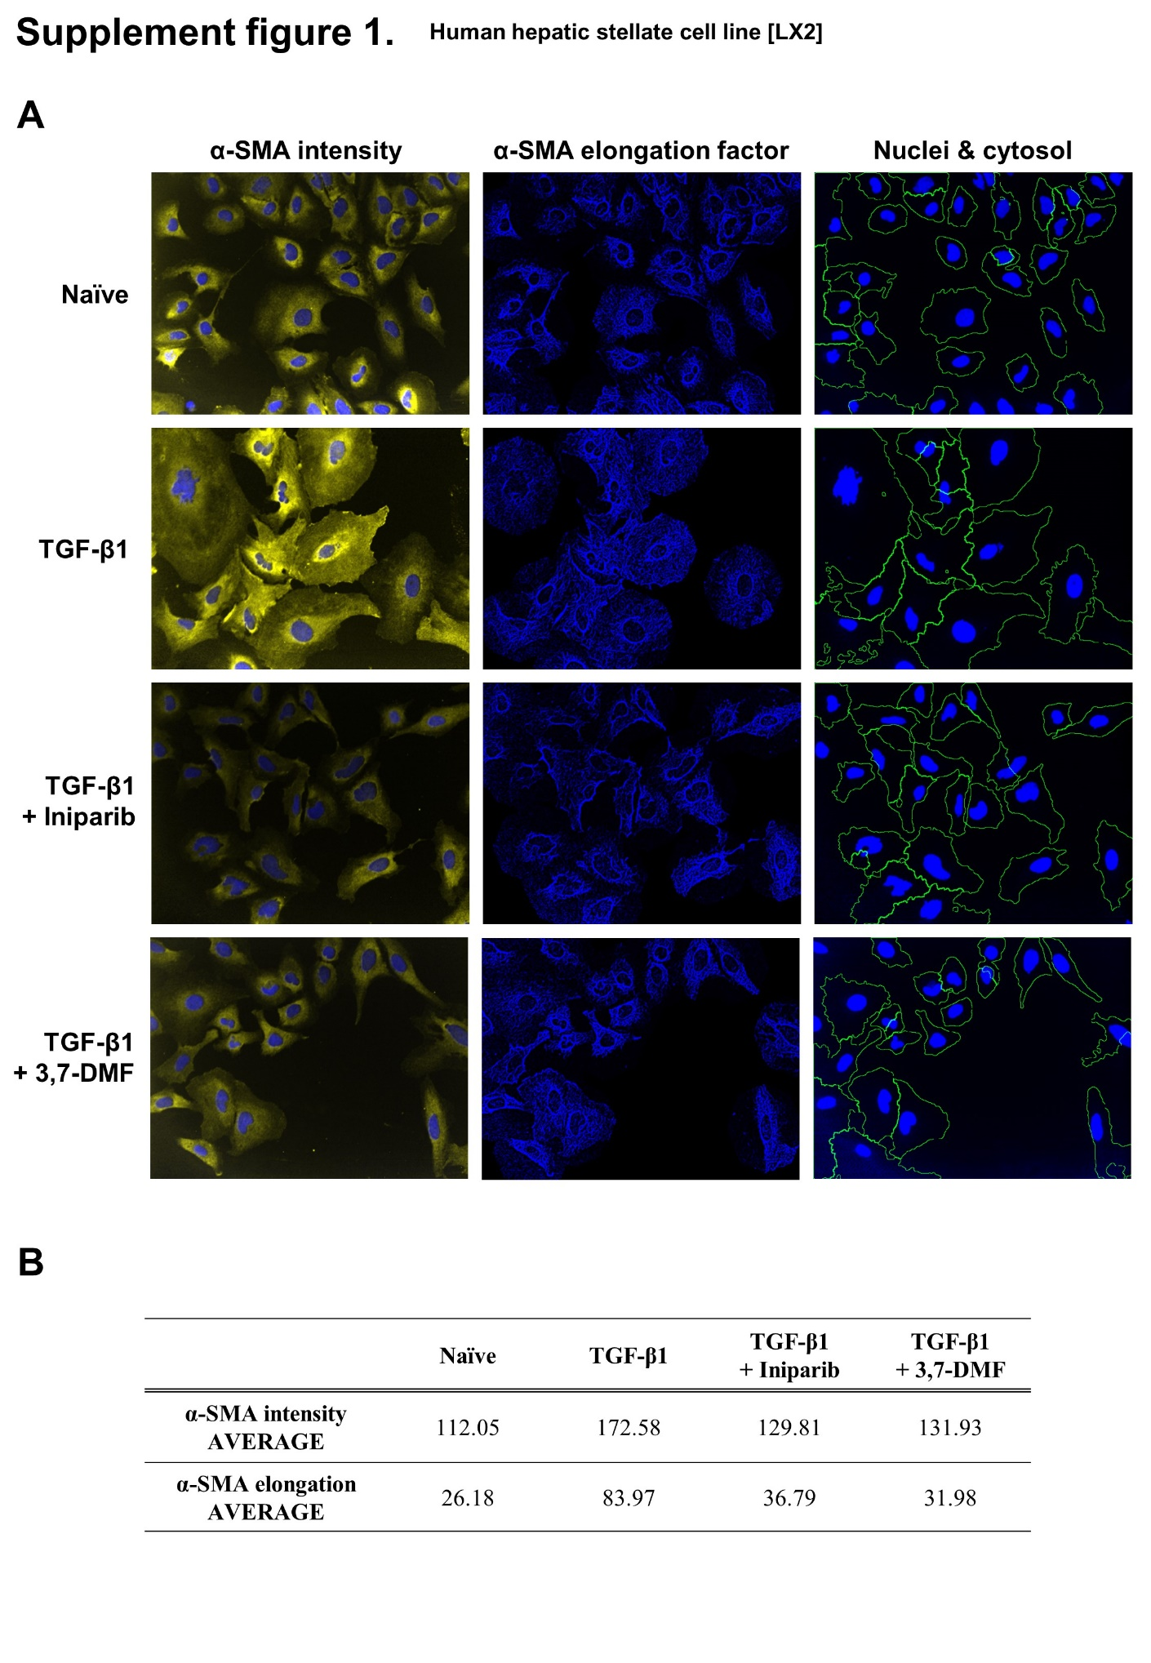

Supplementary Material
Supplemental Figure 1. Two chemicals that inhibit TGF-β1-induced activation of LX2 cells. Representative data for iniparib and 3,7-DMF based on α-SMA intensity and elongated filaments in activated LX2 cells. (A) Immunofluorescence of α-SMA with elongated filaments in LX2 cells. α-SMA intensity (yellow); filaments (blue). (B) α-SMA intensity calculated using the Opera program. The elongated filament factor is calculated using the distribution of the filaments. The average values for the intensity and elongated filament factors for each group are plotted (n = 3/group).

