Supplemental Information for:

Towards universal synthetic heterotrophy using a metabolic coordinator

Sean F. Sullivanª, Anuj Shetty^{b}, Tharun Bharadwaj^{b}, Naveen Krishna^{b}, Vikas D. Trivedi^{a,c}, Venkatesh Endalur Gopinarayanan ª, Daniel Sellers ª, Pravin Kumar R.^{b}, and Nikhil U. Nair ª*
ª Department of Chemical & Biological Engineering, Tufts University, Medford, MA
^{b} Kcat Enzymatic Private Limited, Bengaluru, Karnataka, India 560005
^{c} Current: Department of Structural Biology and Center for Data Driven Discovery, St. Jude Children’s Research Hospital, Memphis, TN

* Corresponding author: nikhil.nair@tufts.edu; @nair_lab

Supplemental Table 1. Aerobic growth rates of previously engineered S. cerevisiae strains on xylose, arabinose, and cellobiose including relevant genotypes.
Substrate | Strain | Relevant Genotype | μ (h⁻¹) | Reference
Xylose | X389 | PiXI, PsXK, HXT7m, PsTAL1, TKL1, RPE1, RKI1 ∆GRE3, ∆ASK10, ∆YPR1 | 0.26 | ¹
Xylose | LI110A | SsXR, SsXDH*, SsXK, SsRPE, SsRKI, SsTKL, SsTAL; Evolved | 0.25 | ²
Xylose | XYL-REG (Syn4.1) | xylA*3, XKS1, TAL1, GAL2^{2.1}, GAL3^{Syn4.1} under GAL promoters, ∆GAL1/3/7/10, ∆GRE3 | 0.24 | ³
Xylose | YRH1114 | PrXK, PrXI, codons optimized for S. cerevisiae; Evolved | 0.23 | ⁴
Xylose | RWB 217 | XYLA, XKS1, TAL1, TKL1, RPE1, RKI1, ΔGRE3; Evolved | 0.22 | ⁵
Xylose | XYL-REG (MC) | xylA*3, XKS1, TAL1, GAL2-2.1, GAL3^{MC} under GAL promoters, ∆GAL1/3/7/10, ∆GRE3 | 0.21 | This Study
Xylose | H131-A3^{SB-1} | XYLA, PsXYL3, PsTAL1, TKL1, RPE1, RKI1; Evolved | 0.197 | ⁶
Xylose | CMB.GS010 | PsXYL1, PsXYL2, PsXYL3; Evolved | 0.18 | ⁷
Xylose | SyBE005 | XYL1, mXYL2, XKS1, RPE1, TAL1, RKI1, TKL1, ∆AUR1; Evolved | 0.165 | ⁸
Xylose | UUU | UbXR1, UbXDH, UbXK | 0.15 | ⁹
Xylose | ATCC-F2 | pgXR, pcXDH, aoXKS; Evolved | 0.15 | ¹⁰
Xylose | ADAP8 | XYLA, XKS, SUT1; Evolved | 0.133 | ¹¹
Xylose | SXA-R2P-E | Ss_xyla*3, XKS1, Ss_tal1, ΔGRE3, ΔPHO13; Evolved | 0.128 | ¹²
Xylose | YSX3-TAL1M | XYL1, XYL2, PsXYL3, psTAL1 | 0.117 | ¹³
Arabinose | ARA-REG (Syn4.1) | Lp_araA, Lp_araB, Lp_araD, TAL1, GAL2-2.1, GAL3^{Syn4.1} under GAL promoters, ∆GAL1/3/7/10, ∆GRE3 | 0.27 | ³
Arabinose | IMX728 | araA, araB, araD, Pc_araT, ∆GLK1, ∆HXK1, ∆HXK2, ∆GAL1, ∆GAL80, ∆GRE3, RPE1, TKL1, TAL1, NQM1, RKI1, TKL2 | 0.26 | ¹⁴
Arabinose | ARA-REG (MC) | Lp_araA, Lp_araB, Lp_araD, TAL1, GAL2-2.1, GAL3^{MC} under GAL promoters, ∆GAL1/3/7/10, ∆GRE3 | 0.22 | This Study
Arabinose | IMS0002 | Piromyces xylA, Lp_araA, Lp_araB, Lp_araD, XKS1, TAL1, TKL1, RPE1, RKI1, ∆GRE3 | 0.15 | ¹⁵
Arabinose | BWY1-SI | araA (codon optimized), araBG361A, araD, GAL2; Evolved | 0.112 | ¹⁶
Arabinose | TMB3664 | XKS1, TAL1, TKL1, RKI1, RPE1, XYL1^{K270R}, XYL2, sLAD1(synthetic), sALX1(synthetic), ΔGRE3 | 0.05 | ¹⁷
Arabinose | TMB3076 | Bs_araA, Ec_araD, Ec_araB, XKS1, TAL1, TKL1, RKI1, RPE1, ΔGRE3 | 0.03 | ¹⁸
Cellobiose | CEL-REG (MC) | Nc_gh1-1, Nc_cdt-1, GAL3^{MC} under GAL promoters, ∆GAL1/3/7/10, ∆GRE3 | 0.25 | This Study
Cellobiose | Y294[SFI] | SfBGL1 (secreted using T. reesei xyn2 signal), ∆FUR1 | 0.23 | ¹⁹
Cellobiose | YE-Aa | AaBGL1 (secreted using T. reesei xyn2 signal) | 0.2005 | ²⁰
Cellobiose | IBP1 | Bs_bglP, SfBGL1 | 0.11 | ²¹
Cellobiose | YPH499 | Nc_gh1-1, Nc_cdt-1 | 0.0341 | ²²

Supplemental Table 2. List of strains used.
Strain | Description
W303-1a | MATa leu2-3,112 trp1-1 can1-100 ura3-1 ade2-1 his3-11,15
VEG16 | W303-1a ΔGAL3; ΔGRE3; ΔGAL1; ΔGAL7; ΔGAL10
VDT13 | VEG16 lys2::GAL3p-GAL3^{Syn4.1}-TEFt/ADH1t-GAL2-2.1-GAL1/10p-TAL1-HXT7t; leu2::GAL1p-GAL3^{Syn4.1}-TEFt
VDT27 | VEG16 lys2::ADH1t-GAL2-2.1-TEF1/TPI1p-TAL1-HXT7t
SFS3 | VEG16 lys2::GAL3p-GAL3^{MC}-TEFt; leu2::GAL1p-GAL3^{MC}-TEFt
SFS6 | VEG16 lys2::GAL3p-GAL3^{MC}-TEF1t; leu2::GAL1p-GAL3^{MC}-TEFt; his3::HXT7t-TAL1-GAL1/10p-GAL2-2.1-ADH1t
SFS11 | VEG16 GAL80∆; lys2::HXT7t-TAL1-GAL1/10p-GAL2-2.1-ADH1t

Supplemental Table 3. List of plasmids used.
Appearance in Manuscript | Plasmid | Description
Expression dynamics - GAL1p | pVEG18-GAL1p | pRS426, 2μ ori, URA3, GAL1p-EGFP-ADH1t
Expression dynamics - GAL7p | pVEG20-GAL7p | pRS426, 2μ ori, URA3, GAL7p-EGFP-ADH1t
Expression dynamics - GAL10p | pVEG21-GAL10p | pRS426, 2μ ori, URA3, GAL10p-EGFP-ADH1t
Expression dynamics – GAL3p | pVEG19-GAL3p | pRS426, 2μ ori, URA3, GAL3p-EGFP-ADH1t
Expression dynamics – GAL80p | pVEG22-GAL80p | pRS426, 2μ ori, URA3, GAL80p-EGFP-ADH1t
Expression dynamics - TEF1p | pVEG24-TEF1p | pRS426, 2μ ori, URA3, TEF1p-EGFP-ADH1t
Expression dynamics - TPI1p | pVEG25-TPI1p | pRS426, 2μ ori, URA3, TPI1p-EGFP-ADH1t
Expression dynamics – TDH3p | pVEG27 | pRS426, 2μ ori, URA3, TDH3p-EGFP-ADH1t
Expression dynamics - GPM1p | pVEG28 | pRS426, 2μ ori, URA3, GPM1p-EGFP-ADH1t
Activation data - ∆GAL3 control | pVEG7 | pRS426, 2μ ori, URA3, ADH1t-EGFP-GAL1p/GAL10p-KANMX-HXT7t
Activation data - Gal3p^{WT} | pVEG8-WT | pVEG7, 2μ ori, URA3,GAL3p-GAL3^{WT}-TEF1t
Activation data - Gal3p^{MC} | pVEG8-MC | pVEG7, 2μ ori, URA3,GAL3p-GAL3^{MC}-TEF1t
Creation of MC integrant strains | pVDT43 | pIS385, URA3, GAL3p-Gal3p-5.1-Teft
Creation of MC integrant strains | pVDT44 | pIS376, URA3, GAL1p-Gal3p-5.1-Teft
Creation of pentose integrant strains | pSFS31 | pIS374, URA3, HXT7t-TAL1-GAL1/10p-GAL2-2.1-ADH1t
pRS426-XYL-REG | pVEG11 | pRS426, 2μ ori, URA3, ADH1t-Piromyces_XYLA*3-GAL1p/GAL10p-XKS1-HXT7t
pRS426-ARA-CONS | pSFS3 | pRS426, 2μ ori, URA3, ADH1t-araB-TPI1/TEF1p-araA-Hxt7t-GPM1p-araD-TEF1t
pRS426-ARA-REG | pVDT23 | pRS426, 2μ ori, URA3, ADH1t-araB-GAL1/GAL10p-araA-HXT7t-GAL7p-araD-TEF1t
pRS426-CEL-CONS | pSFS10 | pRS426, 2μ ori, URA3, ADH1t-gh1-1-TPI1p/TEF1p-cdt-1-HXT7t
pRS426-CEL-REG | pSFS11 | pRS426, 2μ ori, URA3, ADH1t-gh1-1-GAL1p/GAL10p-cdt-1-HXT7t
pRS423-XYL-REG | pSFS24 | pRS423, 2µ ori, HIS3, ADH1t-XKS1-TPI1/TEF1p-XYLA-HXT7t
pRS424-CEL-REG | pSFS22 | pRS424, 2μ ori, TRP1, ADH1t-gh1-1-GAL1/10p-cdt-1-HXT7t
pRS425-ARA-REG | pSFS18 | pRS425, 2μ ori, LEU2, TEF1t-araD-GAL7p-HXT7t-araA-GAL1/GAL10p-araB-ADH1t
BAD | pVDT14 | pRS416, CEN ori, URA3, ADH1t- araB- GAL1p/GAL10p -araA-HXT7t-GAL7p-araD-TEFt
ABD | pVDT38 | pRS416, CEN ori, URA3, ADH1t- araA- GAL1p/GAL10p -araB-HXT7t-GAL7p-araD-TEFt
BDA | pVDT39 | pRS416, CEN ori, URA3, ADH1t- araB- GAL1p/GAL10p -araD-HXT7t-GAL7p-araA-TEFt
DBA | pVDT40 | pRS416, CEN ori, URA3, ADH1t- araD- GAL1p/GAL10p -araB-HXT7t-GAL7p-araA-TEFt
DAB | pVDT41 | pRS416, CEN ori, URA3, ADH1t- araD- GAL1p/GAL10p -araA-HXT7t-GAL7p-araB-TEFt
ADB | pVDT42 | pRS416, CEN ori, URA3, ADH1t- araA- GAL1p/GAL10p -araD-HXT7t-GAL7p-araB-TEFt
ϕ-XK-XI | pVDT57 | pRS423, 2µ ori, HIS3, ADH1t- XKS1- GAL10p/GAL1p -TEF1t -GAL7p- Piromyces_XYLA*3-HXT7t
XK- ϕ-XI | pVDT58 | pRS423, 2µ ori, HIS3, ADH1t- XKS1- GAL1p/GAL10p -TEF1t -GAL7p- Piromyces_XYLA*3-HXT7t
XK-XI-ϕ | pVDT59 | pRS423, 2µ ori, HIS3, ADH1t- XKS1- GAL1p/GAL10p -Piromyces_XYLA*3-HXT7t
XI-XK-ϕ | pVDT60 | pRS423, 2µ ori, HIS3, ADH1t- XKS1- GAL10p/GAL1p -Piromyces_XYLA*3-HXT7t
ϕ-XI-XK | pVDT61 | pRS423, 2µ ori, HIS3, ADH1t- XKS1- GAL7p-TEF1t -GAL1p/GAL10p - Piromyces_XYLA*3-HXT7t
XI-ϕ-XK | pVDT62 | pRS423, 2µ ori, HIS3, ADH1t- XKS1- GAL7p-TEF1t -GAL10p/GAL1p - Piromyces_XYLA*3-HXT7t

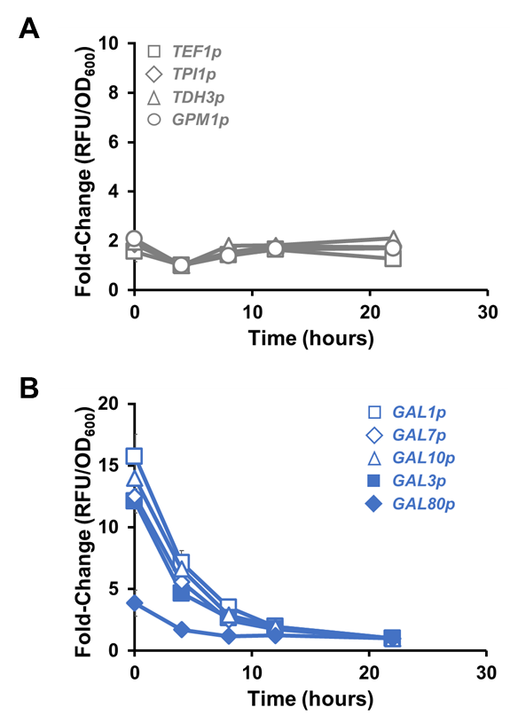
Figure S1: Expression dynamics of constitutive and GAL-inducible promoters during growth on glucose. Expression of EGFP in wild-type strain W303-1a from (A) strong constitutive promoters (TEF1p, TPI1p, TDH3p, GPM1p) and (B) GAL-inducible promoters (GAL1p, GAL7p, GAL10p, GAL3p, GAL80p) at different time points during cultivation on glucose. While expression profile from constitutive promoters is similar to that observed during growth on galactose, GAL-inducible promoters are repressed via carbon catabolite repression. Each data point represents the average of four biological replicates ± sd.

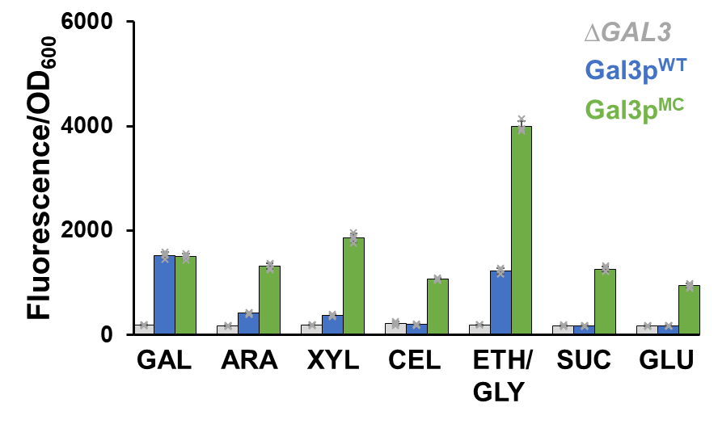
Figure S2: Comparison of fluorescence (normalized for cell density) resulting from interaction between GAL3 variant and carbon source (2% w/v) using sucrose to support growth on substrates (GAL/ARA/XYL/CEL) for which strain VEG16 lacks catabolic genes. Each data point represents the average of four biological replicates ± sd.

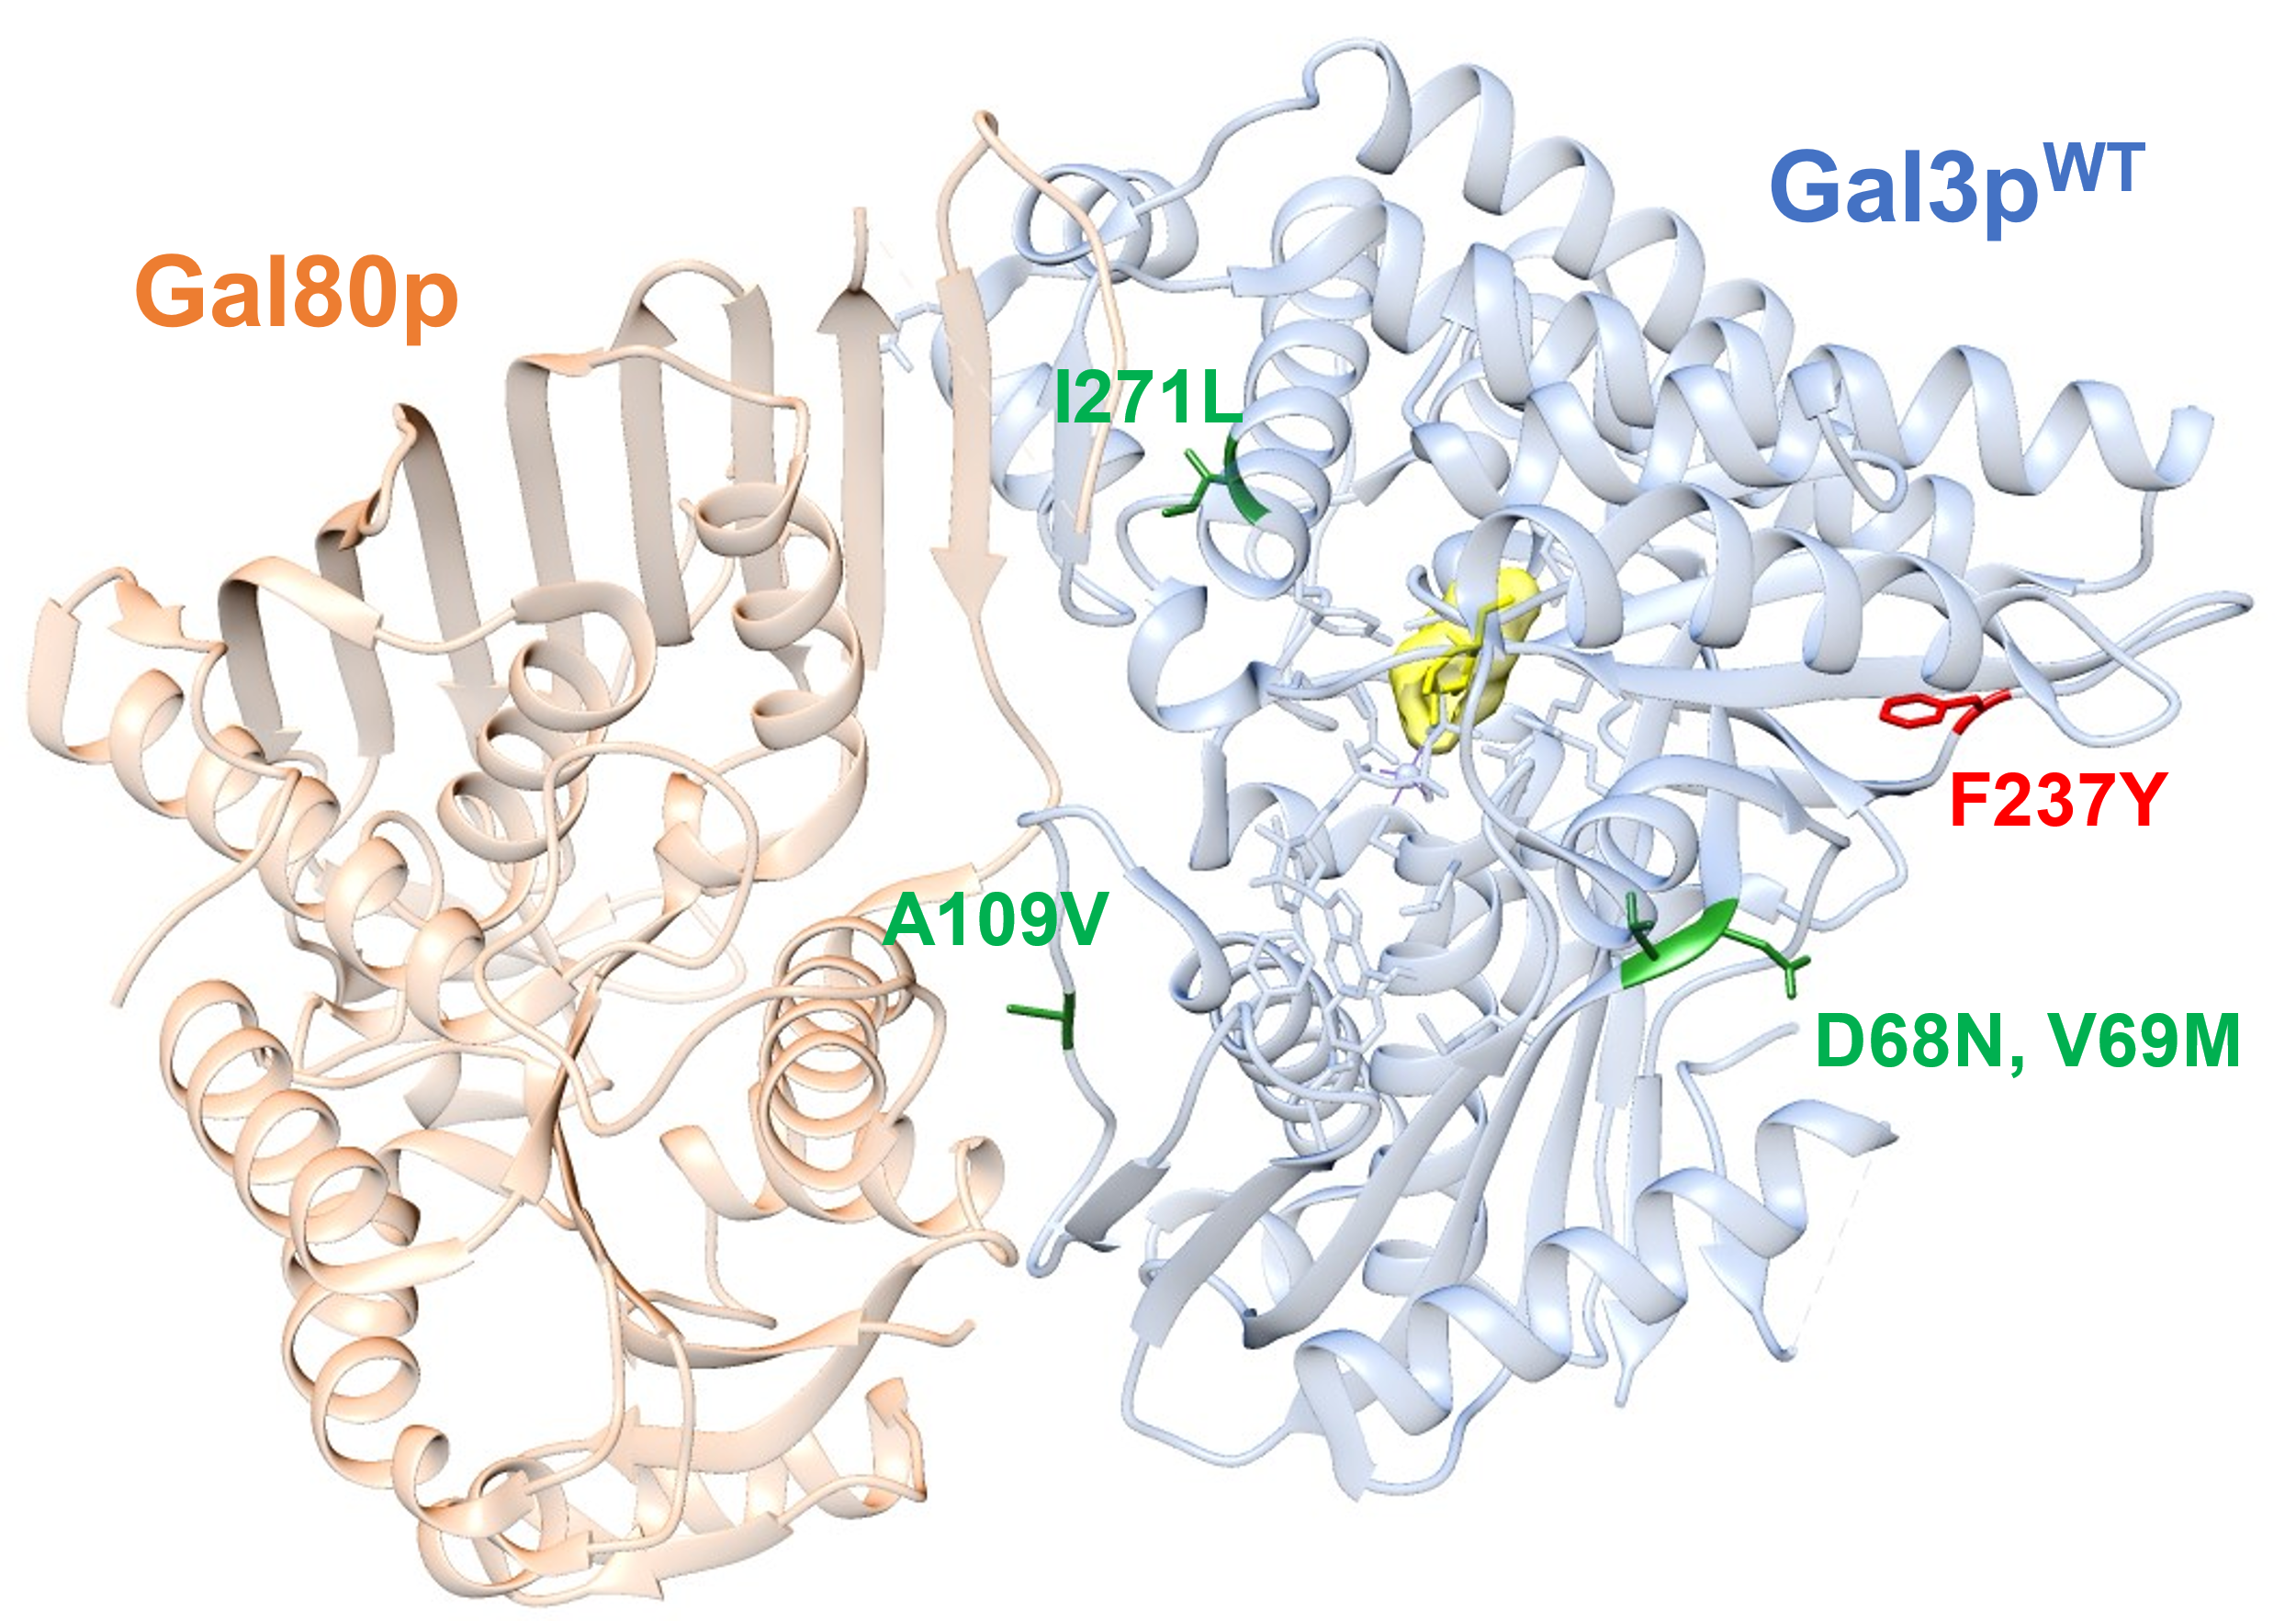
Figure S3: Structure of wild-type Gal3p in complex with Gal80p. Gal3p^{MC} was constructed by combining mutations identified as conferring robust xylose induction (D68N, V69M, A109V, I271L, highlighted in green) ²³ in variant Gal3p^{Syn4.1} with a mutation (F237Y, highlighted in red) as conferring a partial autoactivating phenotype ²⁴. Significantly, no mutations occur near the ligand/inducer (galactose, highlighted in yellow) suggesting GAL regulon activation by Gal3p^{MC} may occur in an inducer-independent manner.

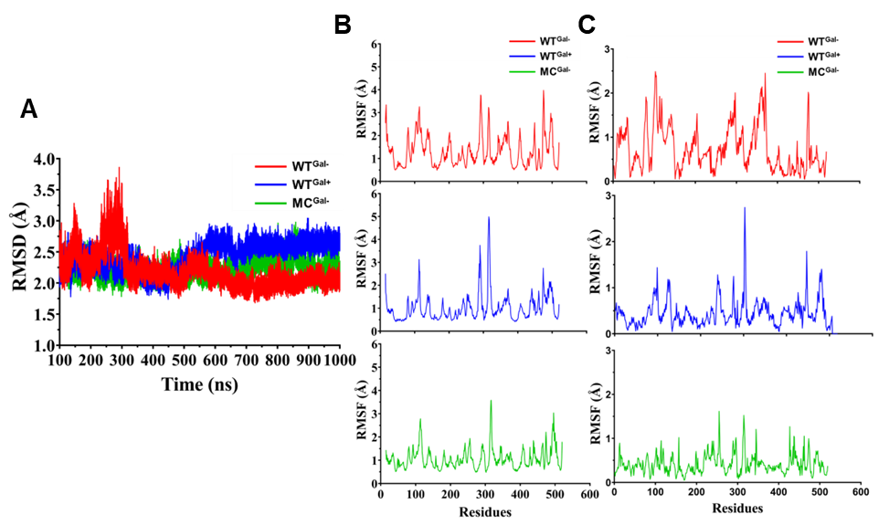
Figure S4: (A) Root mean square deviation (RMSD) across 1000 ns of simulation. WT^{Gal–} was observed to deviate from the starting structure until 300 ns after which it attains a compact, ‘collapsed’ state while WT^{Gal+} and MC^{Gal–} consistently show similar values. Root mean square fluctuations (RMSF) averaged per residue over 1000 ns of simulation plotted for (B) all motion from long-scale molecular dynamics, and (C) principal component analysis (PCA) of the dynamics of each system demonstrate increased movement of WT^{Gal–} across the 1000 ns of simulation relative to the more restrained dynamics of WT^{Gal+} and MC^{Gal–}.

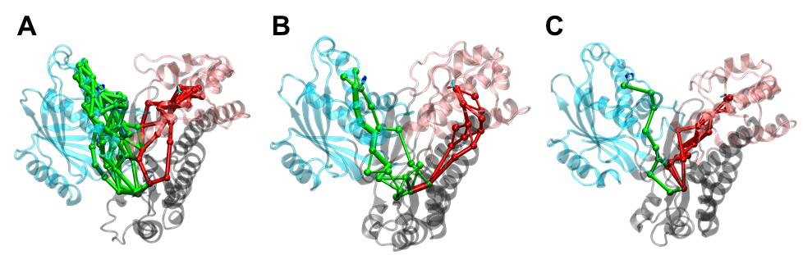
Figure S5: Residue-residue interaction networks were generated for the (A) WT^{Gal–}, (B) WT^{Gal+}, and (C) MC^{Gal–} systems using the NetworkView plugin in Visual Molecular Dynamics. Interaction networks between the static hinge (grey) region and the moving (cyan and pink) regions are visualized using green and red ball-and-stick models, respectively. Spheres represent nodes that are residues while edges represent the interaction between the residues with the thickness of the edge indicating the strength of interaction. The large number of interaction networks seen in WT^{Gal–} likely contributes to the formation the of compact, ‘collapsed’ structure observed during the molecular dynamics simulations. In contrast, the WT^{Gal+} and MC^{Gal–} systems exhibit much sparser interaction networks.

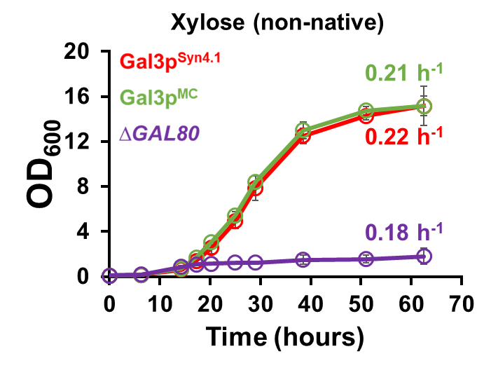
Figure S6: Comparing growth of the three GAL regulon activation systems on the non-native sugar xylose after being sub-cultured from glucose. Gal3p^{Syn4.1} requires induction by xylose, Gal3p^{MC} does not require an inducer but maintains the native regulatory architecture, while ∆GAL80 effects inducer-independent activation by removing native regulatory elements. All data points represent the average of three biological replicates ± sd.

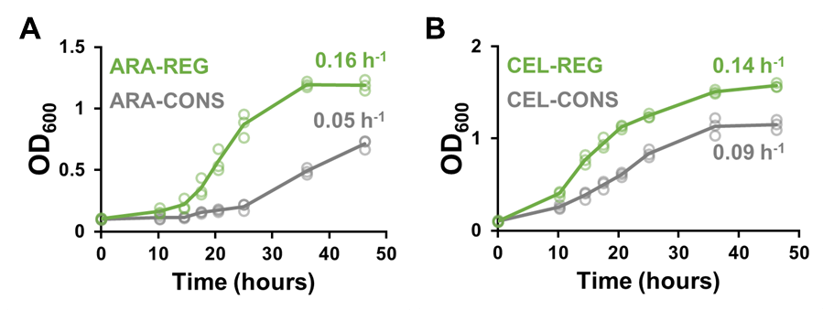
Figure S7: Using Gal3p^{MC} to rapidly apply a regulon approach to growth on the non-native sugars, arabinose and cellobiose. Growth of CONS and REG strains in defined media containing with in (A) 2 % arabinose or (B) 2 % cellobiose as the sole carbon source. All data points represent the average of three biological replicates ± sd.

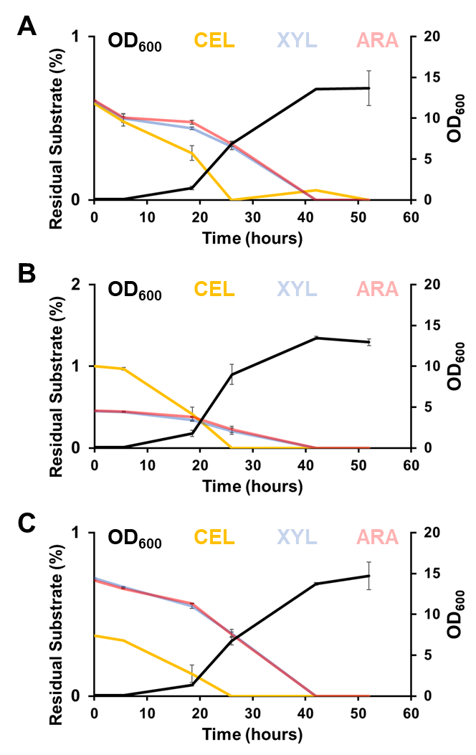
Figure S8: Cell density (black) and percent residual substrate of cellobiose (yellow), xylose (light blue), arabinose (pink), and both pentoses combined (purple) of Consolidated approach to co-utilization in complex media containing (A) 0.7 %-0.7 %-0.7 %, (B) 1 %-0.5 %-0.5 %, or (C) 0.4 %-0.8 %-0.8 % CEL-XYL-ARA (w/v). All data points represent the average of two biological replicates ± sd.

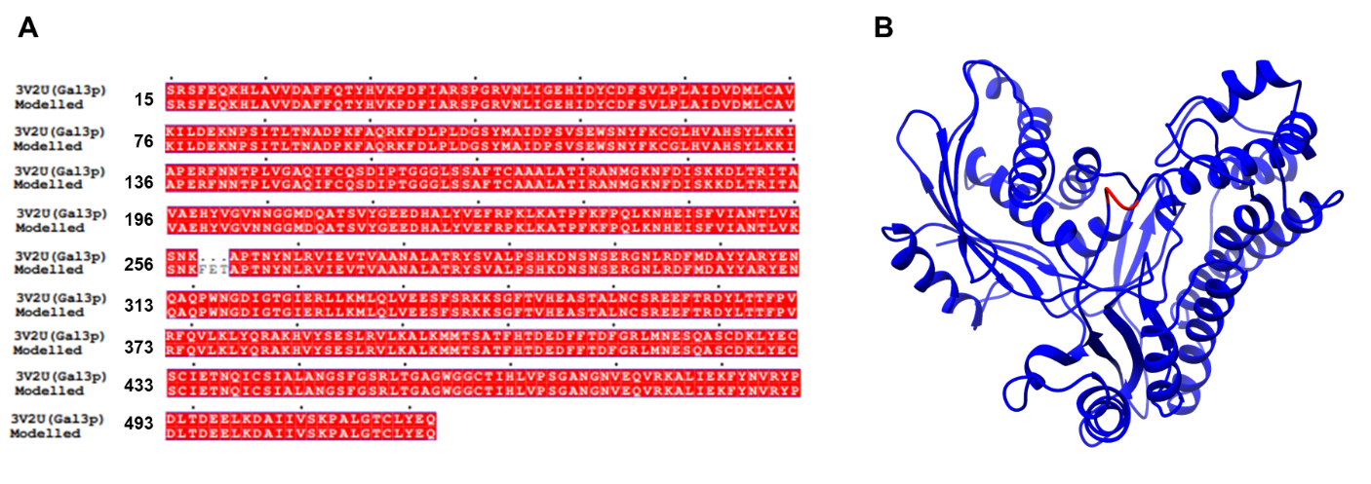
Figure S9: (A) Sequence alignment of the crystal structure and the modelled structure depicting where the location of missing residues 259-261. (B) Modelled structure of Gal3p protein with missing residues 259-261 depicted in red.

REFERENCES
1. Li X, Wang Y, Li G, et al. Metabolic network remodelling enhances yeast’s fitness on xylose using aerobic glycolysis. Nat Catal. 2021;4(September). doi:10.1038/s41929-021-00670-6
2. Latimer LN, Lee ME, Medina-Cleghorn D, Kohnz RA, Nomura DK, Dueber JE. Employing a combinatorial expression approach to characterize xylose utilization in Saccharomyces cerevisiae. Metab Eng. 2014;25:20-29. doi:10.1016/j.ymben.2014.06.002
3. Trivedi VD, Sullivan SF, Choudhury D, Endalur Gopinarayanan V, Nair NU. Integration of metabolism and regulation reveals rapid adaptability to growth on non-native substrates. bioRxiv. Published online 2022. doi:10.1101/2022.05.21.492926
4. Hector RE, Dien BS, Cotta M a, Mertens J a. Growth and fermentation of D-xylose by Saccharomyces cerevisiae expressing a novel D-xylose isomerase originating from the bacterium Prevotella ruminicola TC2-24. Biotechnol Biofuels. 2013;6(1):84. doi:10.1186/1754-6834-6-84
5. Kuyper M, Hartog MMP, Toirkens MJ, et al. Metabolic engineering of a xylose-isomerase-expressing Saccharomyces cerevisiae strain for rapid anaerobic xylose fermentation. FEMS Yeast Res. 2005;5(4-5):399-409. doi:10.1016/j.femsyr.2004.09.010
6. Zhou H, Cheng JS, Wang B, Fink GR, Stephanopoulos G. Xylose isomerase overexpression along with engineering of the pentose phosphate pathway and evolutionary engineering enable rapid xylose utilization and ethanol production by Saccharomyces cerevisiae. Metab Eng. 2012;14(6):611-622. doi:10.1016/j.ymben.2012.07.011
7. Scalcinati G, Otero JM, Van Vleet JRH, Jeffries TW, Olsson L, Nielsen J. Evolutionary engineering of Saccharomyces cerevisiae for efficient aerobic xylose consumption. FEMS Yeast Res. 2012;12(5):582-597. doi:10.1111/j.1567-1364.2012.00808.x
8. Zha J, Shen M, Hu M, Song H, Yuan Y. Enhanced expression of genes involved in initial xylose metabolism and the oxidative pentose phosphate pathway in the improved xylose-utilizing Saccharomyces cerevisiae through evolutionary engineering. J Ind Microbiol Biotechnol. 2014;41(1):27-39. doi:10.1007/s10295-013-1350-y
9. Lee SM, Jellison T, Alper HS. Bioprospecting and evolving alternative xylose and arabinose pathway enzymes for use in Saccharomyces cerevisiae. Appl Microbiol Biotechnol. 2016;100(5):2487-2498. doi:10.1007/s00253-015-7211-z
10. Kim B, Du J, Eriksen DT, Zhao H. Combinatorial design of a highly efficient xylose-utilizing pathway in Saccharomyces cerevisiae for the production of cellulosic biofuels. Appl Environ Microbiol. 2013;79(3):931-941. doi:10.1128/AEM.02736-12
11. Madhavan A, Tamalampudi S, Srivastava A, Fukuda H, Bisaria VS, Kondo A. Alcoholic fermentation of xylose and mixed sugars using recombinant Saccharomyces cerevisiae engineered for xylose utilization. Appl Microbiol Biotechnol. 2009;82(6):1037-1047. doi:10.1007/s00253-008-1818-2
12. Lee SM, Jellison T, Alper HS. Systematic and evolutionary engineering of a xylose isomerase-based pathway in Saccharomyces cerevisiae for efficient conversion yields. Biotechnol Biofuels. 2014;7(1):1-8. doi:10.1186/s13068-014-0122-x
13. Jin YS, Alper H, Yang YT, Stephanopoulos G. Improvement of xylose uptake and ethanol production in recombinant Saccharomyces cerevisiae through an inverse metabolic engineering approach. Appl Environ Microbiol. 2005;71(12):8249-8256. doi:10.1128/AEM.71.12.8249-8256.2005
14. Verhoeven MD, Bracher JM, Nijland JG, et al. Laboratory evolution of a glucose-phosphorylation-deficient, arabinose-fermenting S. cerevisiae strain reveals mutations in GAL2 that enable glucose-insensitive l-arabinose uptake. FEMS Yeast Res. 2018;18(6):1-15. doi:10.1093/femsyr/foy062
15. Wisselink HW, Toirkens MJ, del Rosario Franco Berriel M, et al. Engineering of Saccharomyces cerevisiae for efficient anaerobic alcoholic fermentation of L-arabinose. Appl Environ Microbiol. 2007;73(15):4881-4891. doi:10.1128/AEM.00177-07
16. Wiedemann B, Boles E. Codon-optimized bacterial genes improve L-arabinose fermentation in recombinant Saccharomyces cerevisiae. Appl Environ Microbiol. 2008;74(7):2043-2050. doi:10.1128/AEM.02395-07
17. Bettiga M, Bengtsson O, Hahn-Hägerdal B, Gorwa-Grauslund MF. Arabinose and xylose fermentation by recombinant Saccharomyces cerevisiae expressing a fungal pentose utilization pathway. Microb Cell Fact. 2009;8:40. doi:10.1186/1475-2859-8-40
18. Bettiga M, Hahn-Hägerdal B, Gorwa-Grauslund MF. Comparing the xylose reductase/xylitol dehydrogenase and xylose isomerase pathways in arabinose and xylose fermenting Saccharomyces cerevisiae strains. Biotechnol Biofuels. 2008;1:0-8. doi:10.1186/1754-6834-1-16
19. Van Rooyen R, Hahn-Hägerdal B, La Grange DC, Van Zyl WH. Construction of cellobiose-growing and fermenting Saccharomyces cerevisiae strains. J Biotechnol. 2005;120(3):284-295. doi:10.1016/j.jbiotec.2005.06.013
20. Ding J, Liang G, Zhang K, et al. Extra metabolic burden by displaying over secreting: Growth, fermentation and enzymatic activity in cellobiose of recombinant yeast expressing Β-glucosidase. Bioresour Technol. 2018;254(October 2017):107-114. doi:10.1016/j.biortech.2017.12.030
21. Guo Z peng, Zhang L, Ding Z yang, Gu Z hua, Shi G yang. Development of an industrial ethanol-producing yeast strain for efficient utilization of cellobiose. Enzyme Microb Technol. 2011;49(1):105-112. doi:10.1016/j.enzmictec.2011.02.008
22. Galazka JM, Tian C, Beeson WT, Martinez B, Glass NL, Cate JHD. Cellodextrin Transport in Yeast for Improved Biofuel Production. Science (1979). 2010;330(6000):84-86. doi:10.1126/science.1192838
23. Endalur Gopinarayanan V, Nair NU. A semi-synthetic regulon enables rapid growth of yeast on xylose. Nat Commun. 2018;9(1). doi:10.1038/s41467-018-03645-7
24. Blank TE, Woods MP, Lebo CM, Xin P, Hopper JE. Novel Gal3 proteins showing altered Gal80p binding cause constitutive transcription of Gal4p-activated genes in Saccharomyces cerevisiae. Mol Cell Biol. 1997;17(5):2566-2575. doi:10.1128/mcb.17.5.2566

