Label | Degree | Betweenness | Chemical formula | Structure
Aflatoxin B1 | 12 | 110.76 | C₁₇H₁₂O₆ | 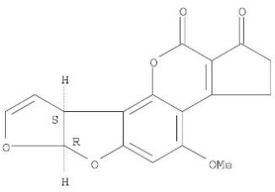
Benzo(a)pyrene | 12 | 108.58 | C₂₀H₁₂ | 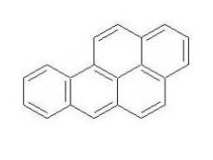
Estradiol | 12 | 102.42 | C₁₈H₂₄O₂ | 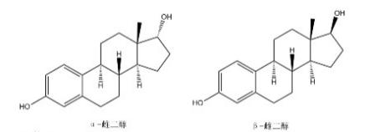
Valproic Acid | 12 | 100.19 | C₅H₁₀O₂ | 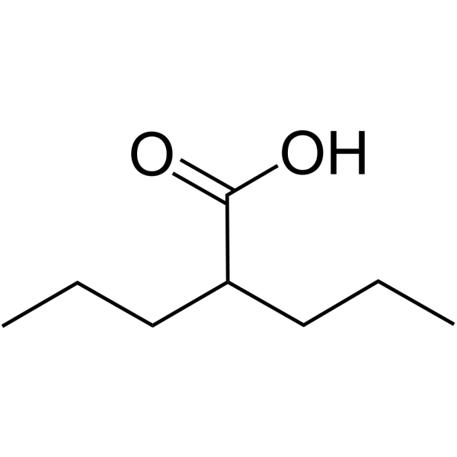
Nickel | 11 | 112.8 | Ni
Tetrachlorodibenzodioxin | 11 | 103.89 | C₁₂H₄Cl₄O₂ | 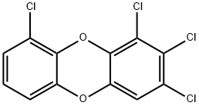
Cyclosporine | 11 | 82.47 | C₆₂H₁₁₁N₁₁O₁₂ | 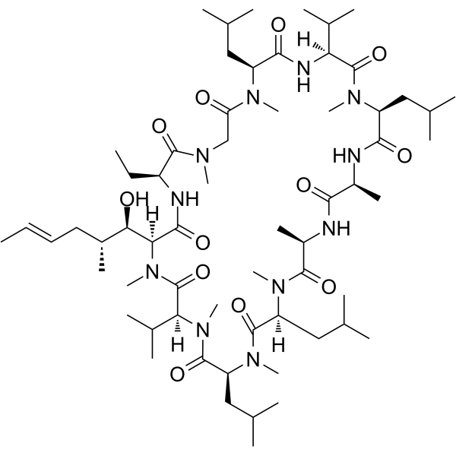
Silicon Dioxide | 10 | 67.27 | SiO₂
Antirheumatic Agents | 10 | 66.06 |  | —
Copper Sulfate | 10 | 65.38 | CuSO₄ | 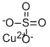
Supplementary table1.Top 10 chemicals that interacted most tightly with common DEGs

