Supplementary table 2. Drugs in the upper 10 based on p-values
Name | P-value | Chemical formula | Structure
aspirin | 0.000001627 | C₉H₈O₄ | 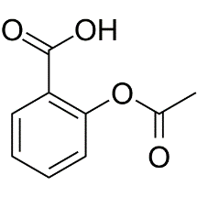
Medroxyprogesterone acetate | 0.00002541 | C₂₂H₃₂O₃ | 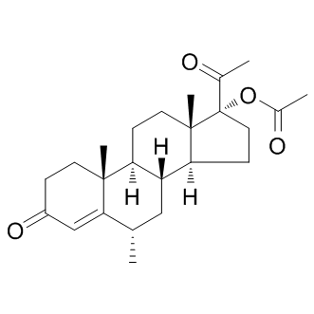
p-Phenylenediamine | 0.00007927 | C₆H₈N₂ | 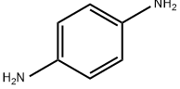
COBALT | 0.0001418 | Co
Sodium dodecyl sulfate | 0.0001870 | C₁₂H₂₅NaO₄S | 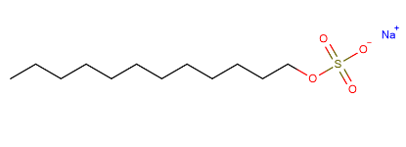
Sodium dichromate | 0.0002869 | Na₂Cr₂O₇ | 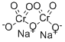
AC1L1WKQ | 0.0003503 | — | —
3,3'-Diindolylmethane | 0.0005523 | C₁₇H₁₄N₂ | 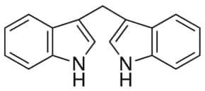
enoxolone | 0.0006282 | C₃₀H₄₆O₄ | 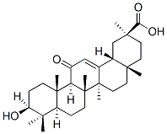
MAGNESIUM | 0.0006822 | Mg

