Supplemental information
A new family of sulfamidophosphonates derivatives: Microwave-accelerated multicomponent synthesis, characterization and X-Ray Crystallographic Study
Racha GHODBANEª, Hacène K’TIR^{a,b}, Sofiane BOUACIDA^{c,d}, Malika IBRAHIM-OUALIe, Zineb AOUFª, Nour-Eddine AOUF*¹
ª Laboratory of Applied Organic Chemistry, Bioorganic Chemistry Group, Chemistry Department, Sciences Faculty, Badji Mokhtar-Annaba University, Box 12, 23000 Annaba.
^{b} Medical Sciences faculty, Badji-Mokhtar-Annaba University, Box 12, Annaba 23000, Algeria.
^{c} Département sciences de la matière, université Oum El Bouaghi, 04000 Oum El-Bouaghi, Algérie.
^{d} Unité de Recherche de Chimie de l’Environnement et Moléculaire Structurale.
Université Constantine 1. Constantine 25000, Algérie.
^{e} Aix Marseille Univ, CNRS, Centrale Marseille, iSm2, F-13397 Marseille, France.
Corresponding author: noureddine.aouf@univ-annaba.dz
1. General information ……………..…………………….……………………...………………….1
2. Spectral Data…………………………………………….………….……………..….…….2
3. Copies of NMR and IR spectra for compounds……………..8

- General information
Melting points (uncorrected) were determined using a Kofler bench and are uncorrected. Infrared spectra (IR) were recorded from KBr disk on a Shimadzu FT-IR-8000 PC spectro meter. The 1H NMR (Proton nuclear magnetic resonance) spectra were obtained with a Brüker 400 MHz in DMSO-d6. Chemical shift (δ)values are given in ppm (parts per million) with TMS as reference (δ0.00). The peak patterns are indicated as follows: singlet (s); doublet (d); triplet (t); quartet (q); multiplet (m); doublet of doublets (dd). All coupling constants (J) are reported in hertz (Hz).
The 13C NMR (Carbon nuclear magnetic resonance) spectra were recorded on a Brücker spectrometer at 100MHz.The progress of the reactions was monitored by thin layer chromatography (TLC) on silica gel Merck 60 F₂₅₄. All reactions were carried out in the microwave Lightwave Oven MJ3281BCS, using 100 W of microwave power at 50 °C. Sonication was performed in a FUNGILAB ultrasonic bath with a frequency of 40 kHz and an output power of 250 W

- Data spectral
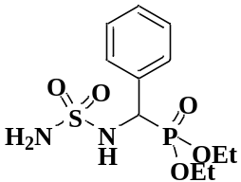
Diethyl (S)-(phenyl(sulfamoylamino)methyl)phosphonate (4a, C₁₁H₁₉N₂O₅PS).
White powder. m.p = 124-126 °C. R_{f} (EtOAc- Petet: 50/50) = 0.13. IR (KBr/cm⁻¹) ν_{max=} 3277.22 and 3218.05(NH₂₎, 3100.68(NH), 1335.62 and 1163.55 (SO₂), 1209.17(P=O), 1050.80 (P-O).³¹P NMR (120 MHz, DMSO d₆) δ=20.82; ¹H NMR (400 MHz, DMSO) δ= 1.07 (t, ³J_{H-H} 6.8 Hz, 3H, H₃C-CH₂-), 1.20 (t, ³J_{H-H} 7.2 Hz, 3H, H₃C-CH₂-) 3.72-3.92 (m, 2H, -H₂C-CH₃), 3.99-4.07 (m, 2H, -H₂C-CH₃) 4.65 (dd, J_{1(H-H)} 9.6, J_{2(Hc-p)} 24 Hz, 1H, *CH), 6.5 (s, 2H, NH₂), 7.24-7.33 (m, 3H, H-Ar), 7.46-7.48 (m, 2H, H-Ar), 7.7 (d, J 12 Hz ,1H, NH). ¹³C NMR (100 MHz, DMSO) δ=16.1(d, ³J_{C-p} 5.4Hz, CH₃), 16.3(d, ³J_{C-p} 5.5 Hz, -CH₃), 53,54-55.09(d, ¹J_{C-P} 155 Hz, *CH), 62.4(d, ²J_{C-p} 6.6 Hz, -CH₂-), 62.86(d, ²J_{C-p} 6.9 Hz, -CH₂-), 127.45 (d, J_{C-p} 3 Hz, CH-Ar), 127.86 (d, J_{C-p} 2 Hz, 2CH-Ar), 128.52 (d, J_{C-p} 5 Hz, CH-Ar), 136.08 (C-Ar) ppm.
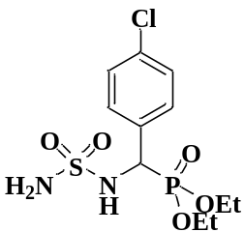
Diethyl ((4-chlorophenyl)(sulfamoylamino)methyl)phosphonate (4b, C₁₁H₁₈ClN₂O₅PS).
White powder. m.p = 153-155 °C. R_{f} (EtOAc- Petet: 50/50) = 0.15. IR (KBr/cm⁻¹) ν_{max=} 3261.24 and 3230.50 (NH₂₎, 3092.25(NH), 1335.16, 1143.55(SO₂), 1235.13(P=O), 1015.71 (P-O). ³¹P NMR (120 MHz, DMSO) δ=20.22; ¹H NMR (400 MHz, DMSOd₆) δ= 1.1 (t, ³J_{H-H} 8 Hz, 3H, H₃C-CH₂-), δ=1.2 (t, ³J_{H-H} 8 Hz, 3H, H₃C-CH₂-) 3.79-3.97 (m, 2H, -H₂C-CH₃), 4.01-4.08 (m, 2H, -H₂C-CH₃) 4.71 (dd, J_{1(H-H)} 12, J_{2(Hc-p)} 24Hz, 1H, *CH), 6.56 (s, 2H, NH₂), 7.38-7.41 (m, 2H, H-Ar), 7.48-7.51 (m, 2H, H-Ar) 7.74 (dd, J 4 Hz ,1H, NH). ¹³C NMR (100 MHz, DMSO) 16.04 (d, ³J_{C-p} 5 Hz, H₃C-CH₂-), 16.21 (d, ³J_{C-p} 6 Hz, H₃C-CH₂-), 52,82-54.37 (d, ¹J_{C-P} 155Hz *CH), 62.37(d, ²J_{C-p} 7Hz, H₃C-CH₂-), 62.88(d, ²J_{C-p} 7Hz, H₃C-CH₂-), 127.74(d, J_{C-p} 2Hz, 2CH-Ar), 130.28(d, J_{C-p} 5 Hz, 2CH-Ar), 132.08(d, J_{C-p} 3 Hz, (Cl-C-Ar), 135.25(C-Ar) ppm.

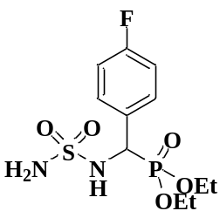
diethyl ((4-fluorophenyl)(sulfamoylamino)methyl)phosphonate (4c, C₁₁H₁₈FN₂O₅PS).
White powder. m.p = 162-164 °C. R_{f} (EtOAc- Petet: 50/50) = 0.19. IR (KBr/cm⁻¹) ν_{max=} 3268.75, 3216.57 (NH₂₎, 3100.00(NH), 1334.19, 1144.86(SO₂), 1233.51(P=O), 1016.09 (P-O). ³¹P NMR (120 MHz, DMSO) δ=22.19; ¹H NMR (400 MHz, DMSO)
δ= 1.08 (t, ³J_{H-H} 4.6 Hz, 3H, H₃C-CH₂-), δ=1.22 (t, ³J_{H-H} 7 Hz, 3H, H₃C-CH₂-), 3.67-3.99(m, 2H, H₃C-CH₂-), 4.01-4.10(m, 2H, -H₂C-CH₃), 4.70 (dd, J_{1(H-H)} 6.6, J_{2(Hc-p)} 16.2 Hz 1H,*CH), 6.58 (s, 2H, NH₂), 7.38-7.39 (d, 2H, J_{(H-H)} 5.6 Hz, H-Ar), 7.48-7.50 (m, 2H, H-Ar), 7.77 (d, J 7.2 Hz, 1H, NH ); ¹³C NMR (100 MHz, DMSO) 16.53 (d, H₃C-CH₂-), 16.75 (d, H₃C-CH₂-), 53,54-54.57 (d, ¹J_{C-P} 103.3Hz *CH), 62.86(d, ²J_{C-p} 4.7Hz, H₃C-CH₂-), 63.38 (d, ²J_{C-p} 4.7Hz, H₃C-CH₂-), 128.25(2CH-Ar), 130.78(d, J_{C-p} 4 Hz, 2CH-Ar), 132.57(d, J_{C-p} 2.5 Hz, C-Ar), 135.75(F-C-Ar) ppm.
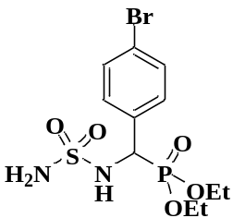
Diethyl ((4-bromophenyl)(sulfamoylamino)methyl)phosphonate (4d, C₁₁H₁₈BrN₂O₅PS).
White powder. m.p = 218-220 °C. R_{f} (EtOAc- Petet: 50/50) = 0.25. IR (KBr/cm⁻¹) ν_{max=} 3275.25 and 3215.12 (NH₂₎, 3096.61(NH), 1335.10 and 1143.94(SO₂), 1236.78(P=O), 1049.55(P-O). ³¹P NMR (120 MHz, DMSO) δ=19.82 (d, J_{P-H} 5.76 Hz, P-CH); ¹H NMR (400 MHz, DMSOd₆) δ= 1.07 (t, ³J_{H-H} 7.2 Hz, 3H, H₃C-CH₂-), δ=1.95 (t, ³J_{H-H} 7.2 Hz, 3H, H₃C-CH₂-) 3.727-3.793 (m, 1H, -H₂C-CH₃), 3.833-3.895 (m, 1H, -H₂C-CH₃) 4.95-4.018 (m, 2H, -H₂C-CH₃), 4.60 (d, J_{(Hc-p)} 24Hz 1H, *CH), 7.16 (d, J 2 Hz, 2H, H-Ar), 7.35 (d, J 8.4 Hz, 2H, H-Ar), 8.11 (sbr, 1H, NH); ¹³C NMR (100 MHz, DMSO) δ=16.04 (d, ³J_{C-p} 5.5 Hz, H₃C-CH₂-), 16.24 (d, ³J_{C-p} 5.4 Hz, H₃C-CH₂-), 53.65 (d, ¹J_{C-P} 154.6Hz *CH), 62.42 (d, ²J_{C-p} 6.9 Hz, H₃C-CH₂-), 62.89 (d, ²J_{C-p} 7Hz, H₃C-CH₂-), 120.89 (d, J_{C-p} 7 Hz, Br-C-Ar), 130.29 (d, J_{C-p} 5 Hz, 2CH-Ar), 130.51 (d, J_{C-p} 5 Hz 2CH-Ar), 134.65 (C-Ar) ppm.

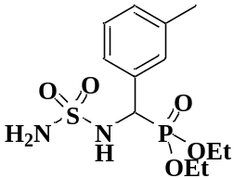
Diethyl ((sulfamoylamino)(m-tolyl)methyl)phosphonate (4e, C₁₂H₂₁N₂O₅PS).
White powder. m.p = 137-139 °C. R_{f} (EtOAc- Petet: 50/50) = 0.17. IR (KBr/cm⁻¹) ν_{max=} 3268.93 and 3251.12 (NH₂), 3102.28(NH), 1334.75 and 1145.00(SO₂), 1233.93(P=O), 1016.67(P-O).¹H NMR (400 MHz, DMSOd₆) δ= 1.08 (t, ³J_{H-H} 7.2 Hz, 3H, H₃C-CH₂-), δ=1.21 (t, ³J_{H-H} 7.2 Hz, 3H, H₃C-CH₂-), 2.29 (S, 3H, -CH₃), 3.70-4.07 (m, 4H, -H₂C-CH₃), 4.64 (dd, J_{1(H-H)} 7, J_{2(Hc-p)} 20.6 Hz 1H,*CH), 6.51 (s, 2H, NH₂), 7.03-7.18 (m, 2H, H-Ar), 7.20-7.28 (m, 2H, H-Ar), 7.60 (dd, J₁ 2.8 Hz , J₂ 10 Hz ,1H, NH). ¹³C NMR (100 MHz, DMSO) 16.03 (d, ³J_{C-p} 5.5 Hz, H₃C-CH₂-), 16.25 (d, ³J_{C-p} 5.4 Hz, H₃C-CH₂-), 21.03(S, CH₃), 54.22 (d, ¹J_{C-P} 154.2Hz *CH), 62.28(d, ²J_{C-p} 13.4Hz, H₃C-CH₂-), 62.78(d, ²J_{C-p} 6.9Hz, H₃C-CH₂-), 125.55 (d, J_{C-p}5.5 Hz, CH-Ar), 127.63 (d, J_{C-p}12.1 Hz, CH-Ar), 128.81 (d, J_{C-p}5.4 Hz, CH-Ar), 129.05(d, J_{C-p}5.8 Hz, CH-Ar), 135.64(d, J_{C-p}54.3 Hz, C-Ar),136.68 (d, J_{C-p}10.6 Hz, CH₃-C-Ar) ppm.
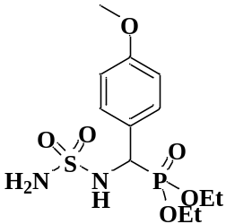

Diethyl ((4-methoxyphenyl)(sulfamoylamino)methyl)phosphonate (4f, C₁₂H₂₁N₂O₆PS).
White powder. m.p = 133-135 °C. R_{f} (EtOAc- Petet: 50/50) = 0.15. IR (KBr/cm⁻¹) ν_{max=} 3342.05 and 3296.17(NH₂₎, 3160.71(NH), 1319.94 and 1149.70 (SO₂), 1227.04(P=O), 1080.56(P-O). ¹H NMR (400 MHz, DMSOd₆) δ= 1.06 (t, ³J_{H-H} 4.6 Hz 3H, H₃C-CH₂-), δ=1.20 (t, ³J_{H-H} 4.8 Hz 3H, H₃C-CH₂-), 3.73 (s, 3H, OCH₃), 3.74-3.88 (m, 1H, -H₂C-CH₃), 3.89-3.91 (m, 1H, -H₂C-CH₃), 4.00-4.06 (m, 2H, -H₂C-CH₃), 4.68 (dd, J_{1(H-H)} 4.8, J_{2(Hc-p)} 16 Hz 1H,*CH), 6.55 (s, 2H, NH₂), 7.31 (t, J_{H-H} 5.4 Hz 2H, H-Ar), 4.46-4.48 (dd, 2H, H-Ar), 6.69 (d, J 6.8 Hz ,1H, NH); ¹³C NMR (100 MHz, DMSO) 16.05 (d, ³J_{C-p} 3.6 Hz, H₃C-CH₂-), 16.27 (d, ³J_{C-p} 3.6 Hz, H₃C-CH₂-), 54.25 (d, ²J_{C-P} 102.9 Hz *CH), 58.49 (OCH₃), 62.29 (H₃C-CH₂-), 62.77 (H₃C-CH₂-), 127.37 (d, J_{C-p} 2.1 Hz, 2C_{ar}) 127.79 (2 C_{ar}) 128.47 (d, J_{C-p} 4 Hz, C_{Ar}), 136.06 (C_{q}-OCH₃) ppm.

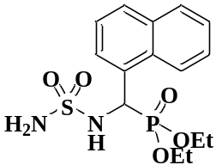

Diethyl (naphthalen-1-yl(sulfamoylamino)methyl)phosphonate(4g, C15H21N2O5PS).
White powder. m.p = 172-174 °C. R_{f} (EtOAc- Petet: 50/50) = 0.25. 3294.12 and 3243.10 (NH₂₎, 3122.34(NH), 1334.76 and 1156.23(SO₂), 1231.37(P=O), 1021.43(P-O). ³¹P NMR (120 MHz, DMSO) δ20.63; ¹H NMR (400 MHz, DMSO) δ= 1.22ppm (t, ³J_{H-H} 7 Hz, 3H, CH₃), δ=1.06 (t, ³J_{H-H} 5.2 Hz, 3H, CH₃), 3.76-3.98 (m, 2H, CH₂), 4.00-4.10 (m, 2H, -H₂C-CH₃), 4.88 (dd, J_{1(H-H)} 8.4, J_{2(Hc-p)}24.2 Hz 1H,*CH),
, 6.55 (s, 2H, NH₂), 7.42-7.90 (m, 7H, H-Ar), 8.00 (s,1H, NH). ¹³C NMR (100 MHz, DMSO) 15.53 (d, ³J_{C-p} 5.5 Hz, H₃C-CH₂-), 16.74 (d, ³J_{C-p} 5.5 Hz, H₃C-CH₂-), 54.98 (d, ²J_{C-P} 154.2Hz *CH), 62.85 (d, ²J_{C-p} 6.9Hz, H₃C-CH₂-), 63.34(d, ²J_{C-p} 6.9Hz, H₃C-CH₂-), 126.35-134.25 (CH-Ar) ppm.
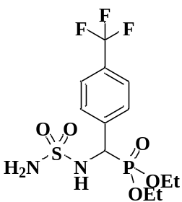
Diethyl((sulfamoylamino)(4(trifluoromethyl)phenyl)methyl)phosphonate (4h, C12H18F3N2O5PS ).
White powder. m.p = 154-156 °C. R_{f} (EtOAc- Petet: 50/50) = 0.26.
IR (KBr/cm⁻¹) ν_{max=} 3288.57(NH₂₎, 3174.66(NH), 1344.13-1152.91(SO₂), 1289.76(P=O), 1152.91(P-O); ¹H NMR (400 MHz, DMSO) δ= 1.09ppm (t, J 4.6 Hz, 3H, CH₃,), δ=1.20ppm (t, J 4.6 Hz, 3H, CH₃,) 3.80-3.94 ppm (m, 2H, CH₂), 4.01-4.06 (m, 2H, CH₂) 4.70 (dd, J 6.6 Hz, 1H, CH,), 6.57ppm (s, 2H, NH₂), 7.38 (d, 2H, H-Ar), 7.48-7.50 (m, 2H, H_{ar}), 7.77ppm (d, J 7.2 Hz ,1H, NH). ¹³C NMR (100 MHz, DMSO) 16.15 (d, ³J_{C-p} 5.5 Hz, H₃C-CH₂-), 16.35 (d, ³J_{C-p} 5.1 Hz, H₃C-CH₂-), 52.87 (d, ²J_{C-P} 151.3Hz *CH), 62.59 (d, ²J_{C-p} 9.6 Hz, H₃C-CH₂-), 62.85(d, ²J_{C-p} 6.9Hz, H₃C-CH₂-), 127.09 (s, C_{ar}), 128.19 (d, J_{C-p} 2.5 Hz, C_{ar})131.80 (s, C_{ar}), 130.14 (d, J_{C-p} 5.5 Hz, C_{ar}), 135.54 (C-Ar) ppm.
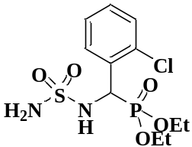
Diethyl ((2-chlorophenyl)(sulfamoylamino)methyl)phosphonate (4i,
C₁₁H₁₈ClN₂O₅PS).
White powder. m.p = 160-162°C. R_{f} (EtOAc- Petet: 50/50) = 0.20. IR (KBr/cm⁻¹) ν_{max=} 3286.65 (NH₂₎, 3194.04(NH), 1304.54 and 1148.98(SO₂), 1282.64(P=O), 1051.56(P-O). ¹H NMR (400 MHz, DMSO) δ= 1.06 (t, ³J_{H-H} 7 Hz, 3H, H₃C-CH₂-), δ=1.17 (t, ³J_{H-H} 7 Hz, 3H, H₃C-CH₂-), 3.72-3.94(m, 2H, H₃C-CH₂-), 4.00-4.09(m, 2H, -H₂C-CH₃), 4.70 (dd, J_{1(H-H)} 6.9, J_{2(Hc-p)} 24.4 Hz 1H,*CH), 6.55 (s, 2H, NH₂), 7.05-7.56 (m, 4H, H-Ar), 7.67 (d, J 2 Hz). ¹³C NMR (100 MHz, DMSO) 16.09 (d, ³J_{C-p} 5.1 Hz, H₃C-CH₂-), 16.31 (d, ³J_{C-p} 4.1 Hz, H₃C-CH₂-), 52.81 (d, ¹J_{C-P} 153.1Hz *CH), 61.17(d, ²J_{C-p} 5.5Hz, H₃C-CH₂-), 62.30(d, ²J_{C-p} 13.4Hz, H₃C-CH₂-), 126.91 (d, 2CH-Ar), 129.42 (d, J_{C-p}5.8Hz, CH-Ar), 132.32 (s, CH-Ar), 150.21(d, J_{C-p}13.5Hz, Cq-Ar), 156.84 (d, J_{C-p}2.6Hz, Cl-C-Ar) ppm.
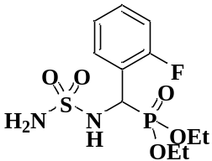

Diethyl ((2-fluorophenyl)(sulfamoylamino)methyl)phosphonate(4j,C₁₁H₁₈FN₂O₅PS).
White powder. m.p = 165-167 °C. R_{f} (EtOAc- Petet: 50/50) = 0.20 IR (KBr/cm⁻¹) ν_{max=} 3336.30 and 3270.40(NH₂₎, 3102.25(NH), 1315.53-1149.46(SO₂), 1208.35(P=O), 1027.13(P-O). ¹H NMR (400 MHz, DMSO) δ= 1.05ppm (t, J 4.6 Hz, 3H, CH₃,), δ=1.22ppm (t, J 4.6 Hz, 3H, CH₃,), 3.77-3.93 (m, 2H, -H₂C-CH₃), 4.04-4.09 (m, 2H, -H₂C-CH₃), 5.01 (dd, J_{1(H-H)} 6.6, J_{2(Hc-p)} 16.2 Hz 1H,*CH), 6.63 (s, 2H, NH₂), 7.13-7.20 (m, 2H, H-Ar), 7.30-7.33 (m, 1H, H-Ar), 7.71 (t, J_{c-p} 5 Hz,1H, H-Ar), 7.80 (d, J_{c-p} 6.4 Hz,1H, NH) . ¹³C NMR (100 MHz, DMSO) 15.99 (d, ³J_{C-p} 3.6 Hz, H₃C-CH₂-), 16.26 (d, ³J_{C-p} 3.6 Hz, H₃C-CH₂-), 46.88 (d, ¹J_{C-P} 5.8Hz *CH), 62.46 (d, ²J_{C-p} 2.5Hz, H₃C-CH₂-), 62.99(d, ²J_{C-p} 4.7Hz, H₃C-CH₂-), 114.72 (d, J_{C-p} 14.8 Hz, CH-Ar), 123.83 (d, J_{C-p} 9.8 Hz, CH-Ar), 129.71(d, J_{C-p}62.8Hz, CH-Ar), 158.58(C-Ar),160.25 (F-C-Ar) ppm.
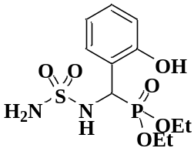
Diethyl ((2-hydroxyphenyl)(sulfamoylamino)methyl)phosphonate (4k,
C₁₁H₁₉N₂O₆PS).
White powder. m.p = 180-182 °C. R_{f} (EtOAc- Petet: 50/50) = 0.17. IR (KBr/cm⁻¹) ν_{max=} 3343.79(NH₂₎, 3097.92(NH), 1323.66-1147.64 (SO₂), 1219.42(P=O), 1016.02(P-O).
¹H NMR (400 MHz, DMSO) δ= 1.08 (t, J 7.2 Hz, 3H, CH₃,), δ=1.17ppm (t, J 7 Hz, 3H, CH₃,) 3.75-3.99 (m, 2H, CH₂), 4.00-4.09 (m, 2H, CH₂) 5.21 (dd, J_{1(H-H)} 9.6, J_{2(Hc-p)} 24.8 Hz 1H,*CH), 6.86 (s, 2H, NH₂), 7.05-7.55 (m, 4H, H-Ar), 6.61 (d, J_{c-p} 1.6 Hz,1H, NH) . ¹³C NMR (100 MHz, DMSO) 16.16 (d, ³J_{C-p} 5.5 Hz, H₃C-CH₂-), 16.37 (d, ³J_{C-p} 5.1 Hz, H₃C-CH₂-), 52.75 (d, ¹J_{C-P} 152 Hz *CH), 62.57 (d, ²J_{C-p} 6.9Hz, H₃C-CH₂-), 62.79(d, ²J_{C-p} 6.6 Hz, H₃C-CH₂-), 115.16 (d, J_{C-p} 2.5 Hz, CH-Ar), 127.10 (CH-Ar), 130.25-130.38(2CH-Ar), 131.74(C-Ar),132.58 (OH-C-Ar) ppm.
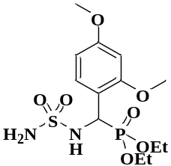
Diethyl ((2,4-dimethoxyphenyl)(sulfamoylamino)methyl)phosphonate (4l, C₁₃H₂₃N₂O₇PS).
White powder. m.p = 150-152 °C. R_{f} (EtOAc- Petet: 50/50) = 0.18 IR (KBr/cm⁻¹) ν_{max=} 3335.00 and 3257.22(NH₂₎, 3167.08(NH), 1343.22-1162.93 (SO₂), 1271.23(P=O), 1037.28(P-O). ¹H NMR (400 MHz, DMSO) δ= 1.08 (t, J 4.8 Hz, 3H, CH₃,), δ=1.13ppm (t, J 4.8 Hz, 3H, CH₃,), 3.74 (s, 2 OCH₃), 3.85-3.98 (m, 2H, CH₂), 4.01-4.06 (m, 2H, CH₂) 4.59 (dd, J_{1(H-H)} 6.6, J_{2(Hc-p)} 15.4 Hz 1H,*CH), 6.56 (s, 2H, NH₂), 6.86-7.03 (m, 3H, H-Ar), 7.61 (d, J_{c-p} 1.6 Hz,1H, NH) . ¹³C NMR (100 MHz, DMSO) 16.28 (d, ³J_{C-p} 3.2 Hz, H₃C-CH₂-), 16.34 (d, ³J_{C-p} 2.1 Hz, H₃C-CH₂-), 55.44 (d, ¹J_{C-P} 2.5 Hz, ²J_{C-P} 4.9 Hz *CH),61.75 (s, 2OCH₃) 62.06 (d, ²J_{C-p} 4.3Hz, H₃C-CH₂-), 62.24 (d, ²J_{C-p} 4.3 Hz, H₃C-CH₂-), 111.22 (d, J_{C-p} 3.6 Hz, CH-Ar), 112.38(d, J_{C-p} 3.2 Hz, CH-Ar), 119.80(d, J_{C-p} 4.3 Hz, CH-Ar), 121.00(d, J_{C-p} 4.7 Hz, C-Ar), 128.17 (MeO-C-Ar), 130.69 (MeO-C-Ar) ppm.

Diethyl (E)-(((N-benzylidenesulfamoyl)amino)(phenyl)methyl)phosphonate (4m, C₁₈H₂₃N₂O₅PS)
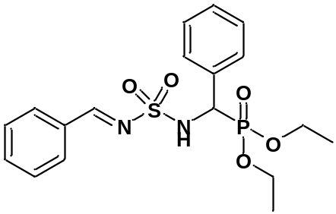

White powder. m.p = 158-160 °C. R_{f} (EtOAc- Petet: 50/50) = 0.26,³¹P NMR (120 MHz, DMSO) δ20.63, ¹H NMR (400 MHz, DMSOd₆) δ= 1.03 (t, ³J_{H-H} 7.2Hz, 3H, H₃C-CH₂-), δ=1.34 (t, ³J_{H-H} 7 Hz, 3H, H₃C-CH₂-), 3.60-3.70 (m, 1H, -H₂C-CH₃), 3.85-3.95 (m, 1H, -H₂C-CH₃), 4.19-4.56 (m, 2H, -H₂C-CH₃), 4.84 (d, J_{(H-H)} 5.6 Hz,1H,*CH), 6.28 (s, 1H, NH), 7.06-7.55 (m, 10H, H-Ar), 8.54 (s, 1H, HC=N), ¹³C NMR (100 MHz, DMSO) 16.18 (d, ³J_{C-p} 5.8 Hz, H₃C-CH₂-), 16.56 (d, ³J_{C-p} 5.8 Hz, H₃C-CH₂-), 55.88 (d, ¹J_{C-P} 154.2Hz *CH), 63.89 (d, ²J_{C-p} 6.9Hz, H₃C-CH₂-), 64.11(d, ²J_{C-p} 7.3Hz, H₃C-CH₂-), 128.31-134.52 (C-Ar), 169.21 (HC=N) ppm.

Diethyl (E)-(((N-benzylidenesulfamoyl)amino)(2,4 dihydroxyphenyl)methyl) phosphonate (4n, C₁₈H₂₃N₂O₇PS)
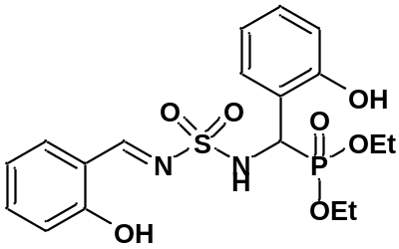
White powder. m.p = 160-162 °C. R_{f} (EtOAc- Petet: 50/50) = 0.24, ¹H NMR (400 MHz, DMSOd₆) δ= 1.01 (t, ³J_{H-H} 4.8Hz, 3H, H₃C-CH₂-), δ=1.23 (t, ³J_{H-H} 4.8 Hz, 3H, H₃C-CH₂-), 3.66-3.70 (m, 1H, -H₂C-CH₃), 3.71-3.87 (m, 1H, -H₂C-CH₃), 4.03-4.08 (m, 2H, -H₂C-CH₃), 5.25 (d, J_{(H-H)} 15.2 Hz,1H,*CH), 6.61 (d, J_{(H-H)} 6.4Hz, 1H, H-Ar), 6.67 (t, J_{(H-H)}4.4Hz 1H, H-Ar), 6.76 (t, J_{(H-H)} 5.2 Hz ,1H, H-Ar), 6.89 (d, J_{(H-H)} 5.2 Hz,1H, H-Ar), 6. 93 (t, J_{(H-H)} 5.2 Hz,1H,H-Ar), 7.20 (dd, J_{(H-H)} 1.2 Hz, J_{(H-p)} 5.2 Hz 1H,H-Ar), 7.40-7.42 (m,1H,H-Ar), 7.45 (d, J_{(H-H)} 3.6 Hz, 1H, H-Ar), 8.59 (s, 1H, NH), 8.91 (s, 1H, HC=N), 9.65 (b, 1H, -OH), 10.59 (b, 1H, -OH); ¹³C NMR (100 MHz, DMSO) 15.96 (d, ³J_{C-p} 5.5 Hz, H₃C-CH₂-), 16.25 (d, ³J_{C-p} 3.6 Hz, H₃C-CH₂-), 55.47 (d, ¹J_{C-P} 102.5Hz *CH), 62.43(d, ²J_{C-p} 4.4Hz, H₃C-CH₂-), 62.62(d, ²J_{C-p} 4.7Hz, H₃C-CH₂-), 114.68 (C-Ar), 165.22 (HC=N) ppm.

- Copies of NMR and IR spectra for compounds
Diethyl (S)-(phenyl(sulfamoylamino)methyl)phosphonate (4a, C₁₁H₁₉N₂O₅PS).
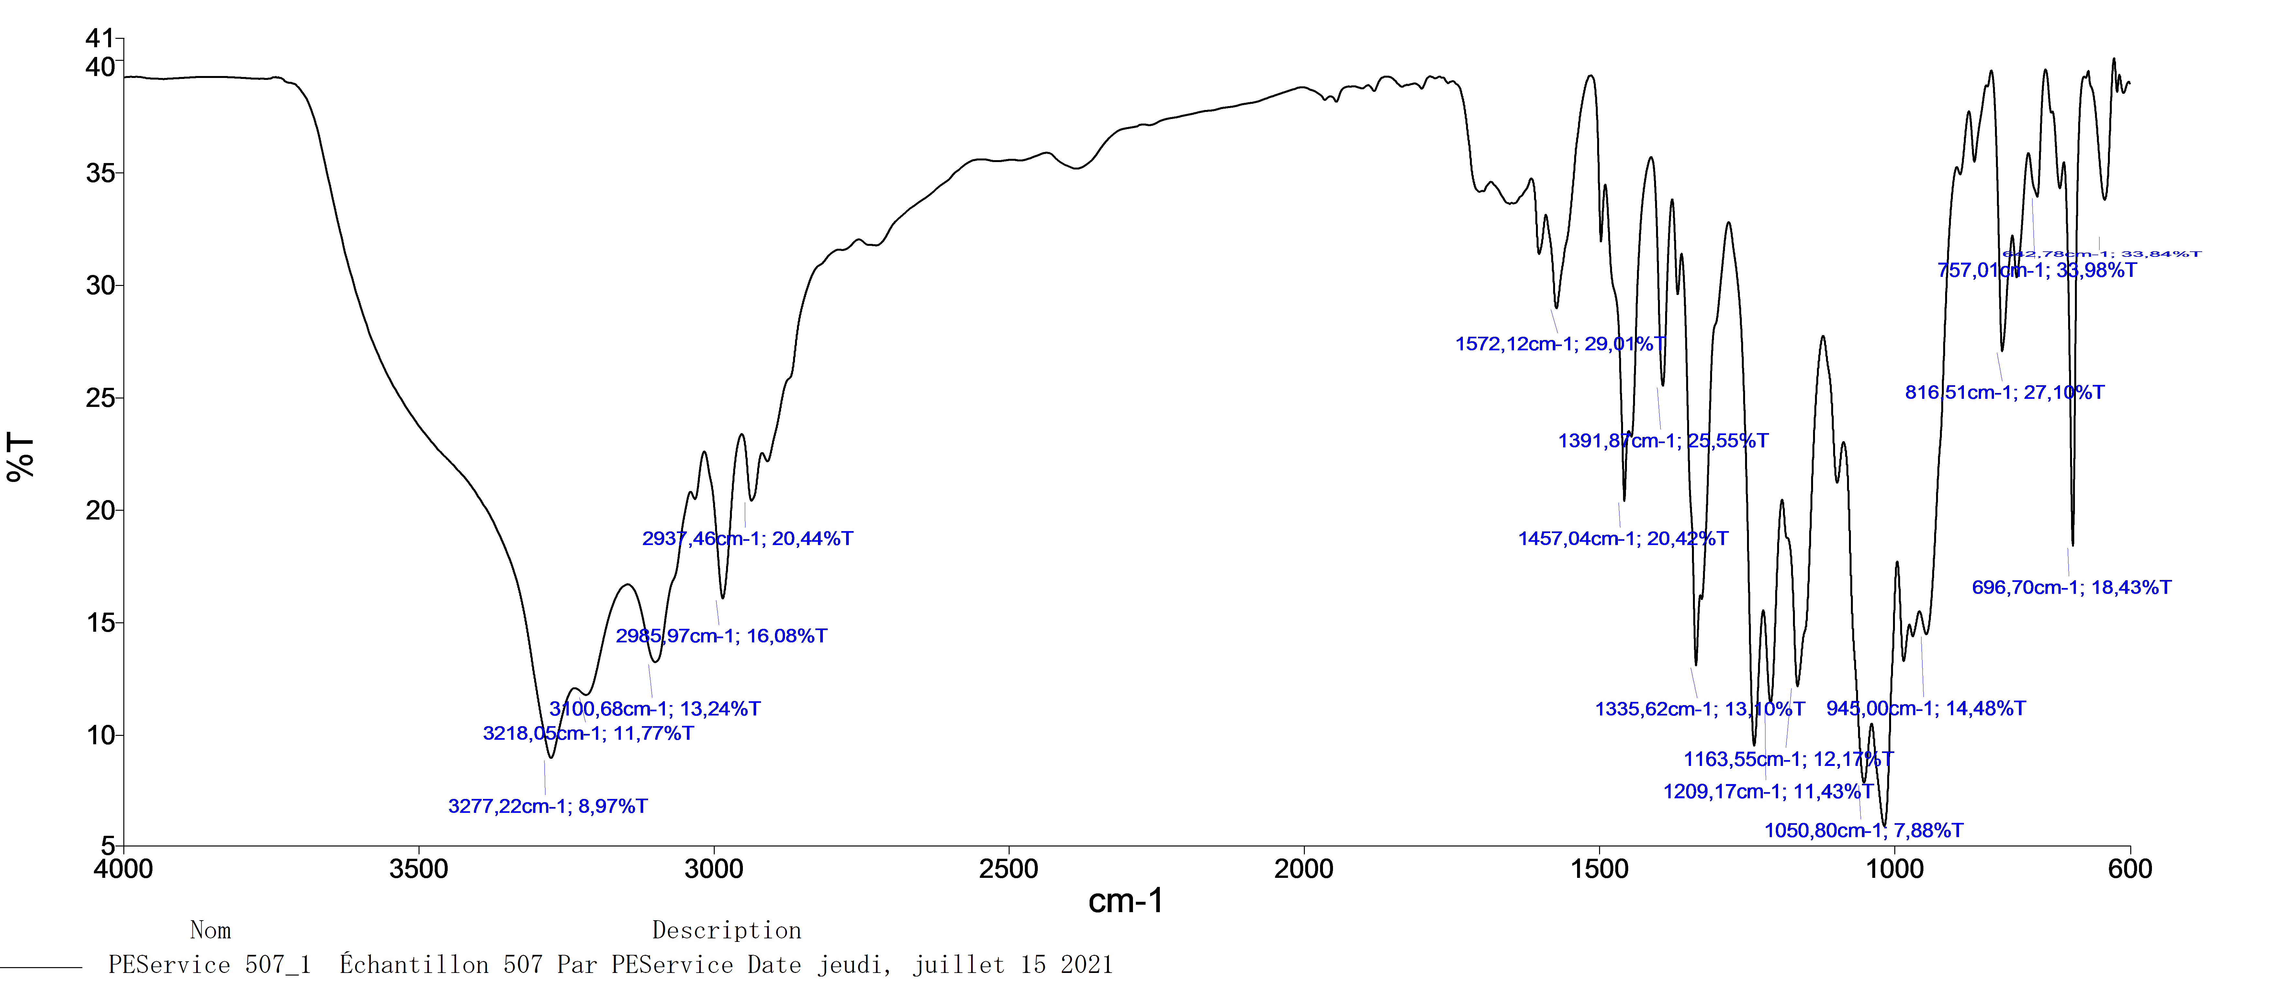
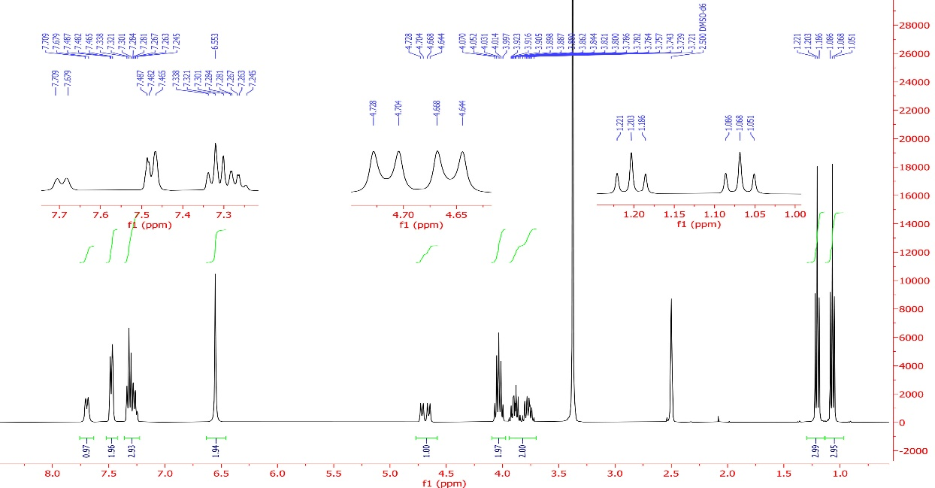

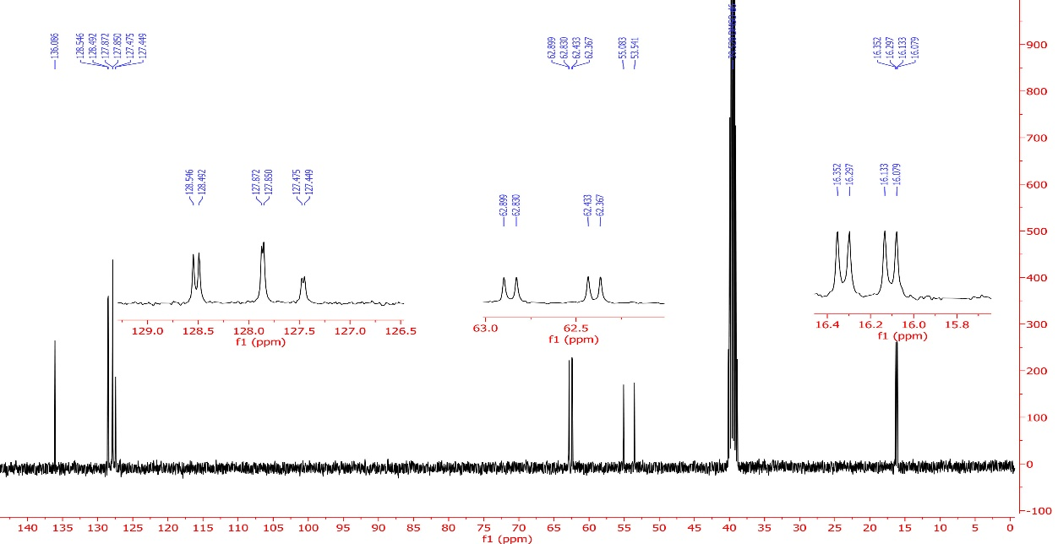
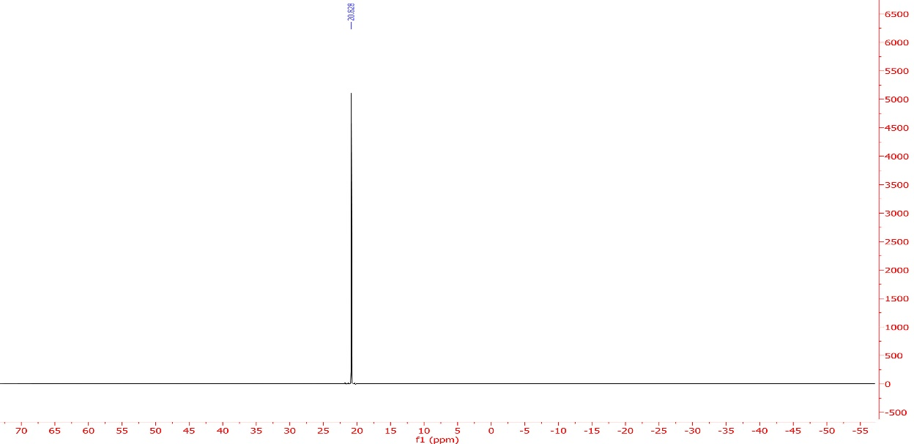
Diethyl ((4-chlorophenyl)(sulfamoylamino)methyl)phosphonate (4b, C₁₁H₁₈ClN₂O₅PS).
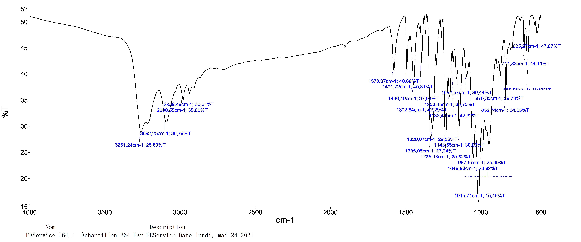
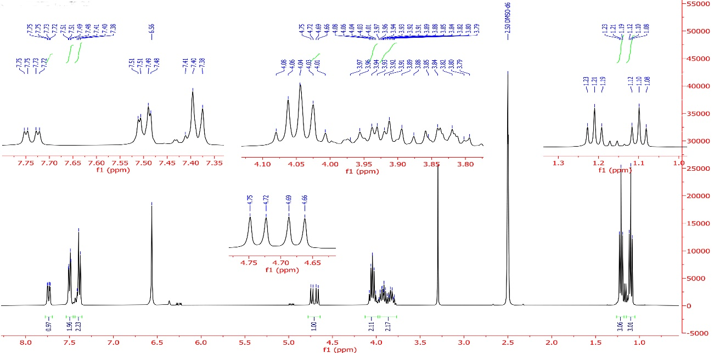
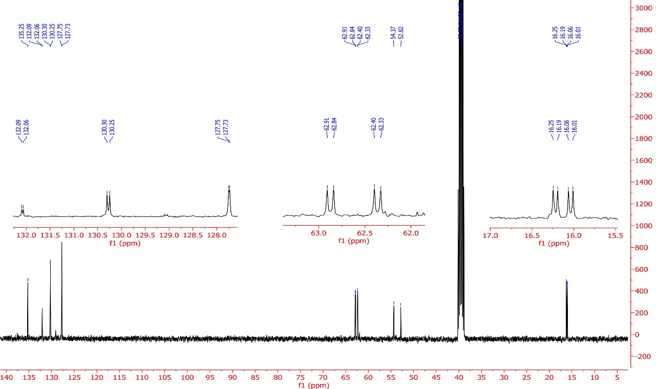
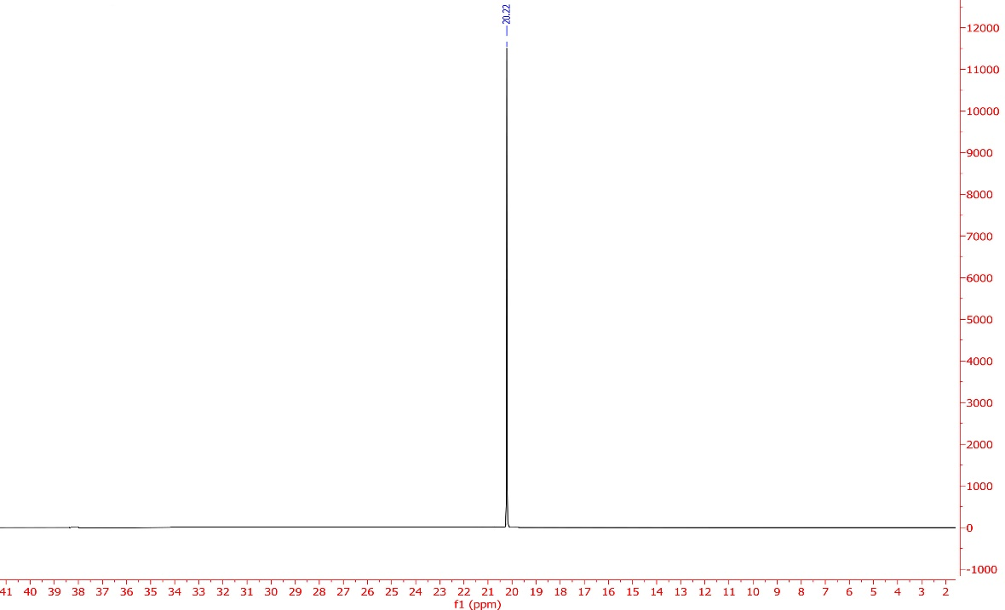
Diethyl ((4-fluorophenyl)(sulfamoylamino)methyl)phosphonate (4c, C₁₁H₁₈FN₂O₅PS).
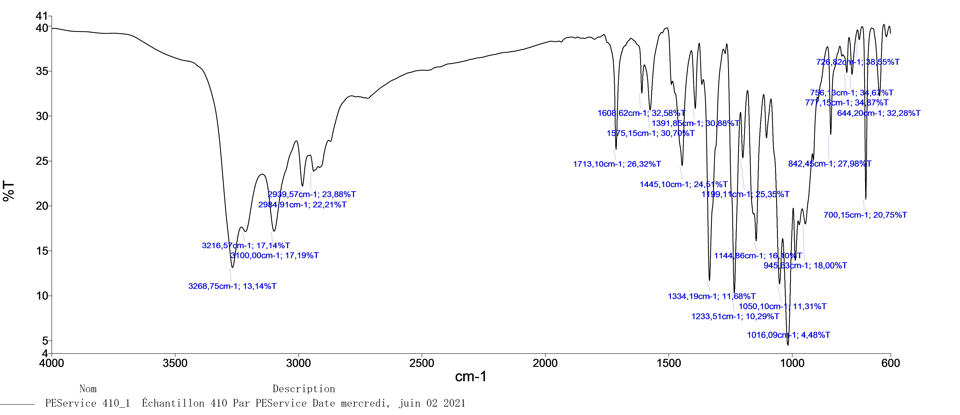
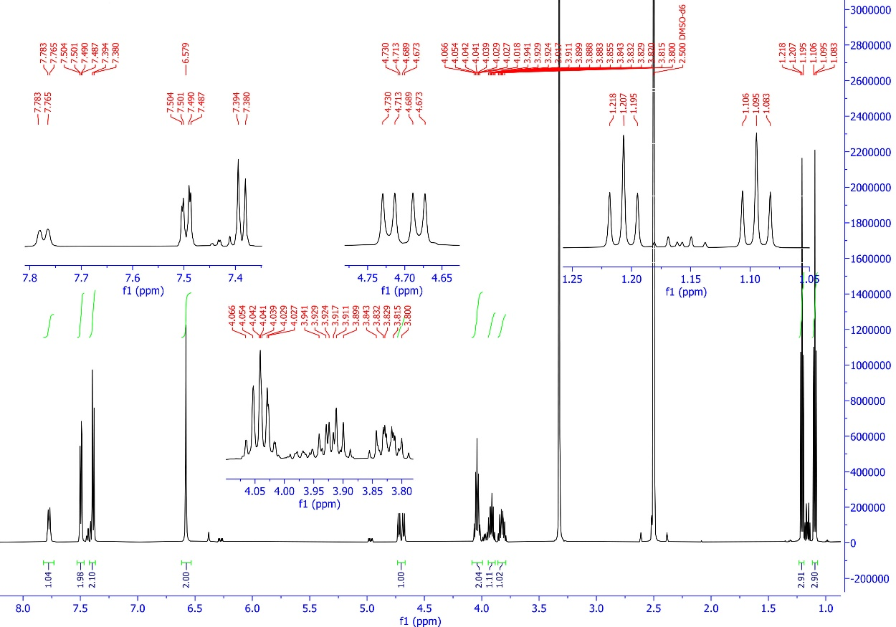
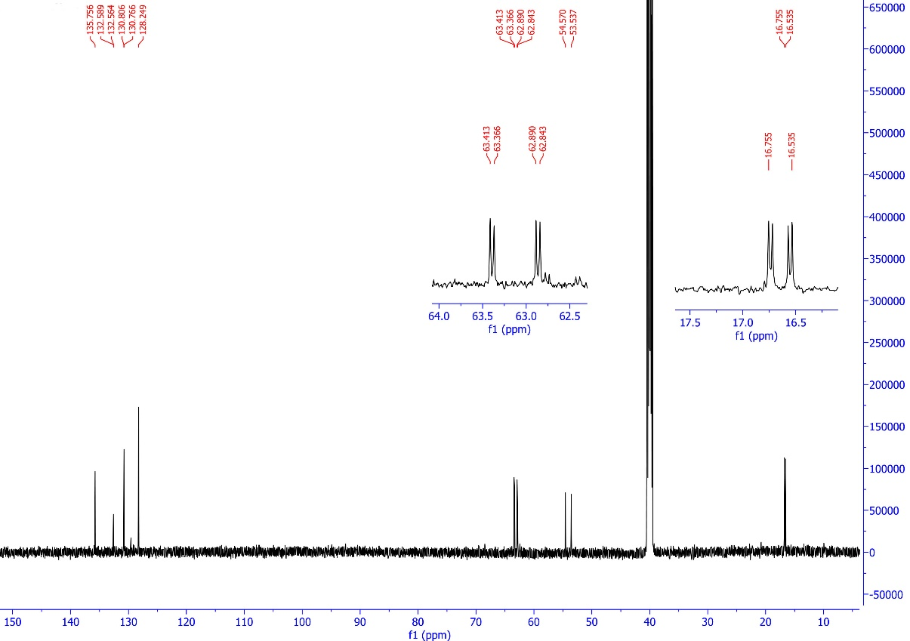
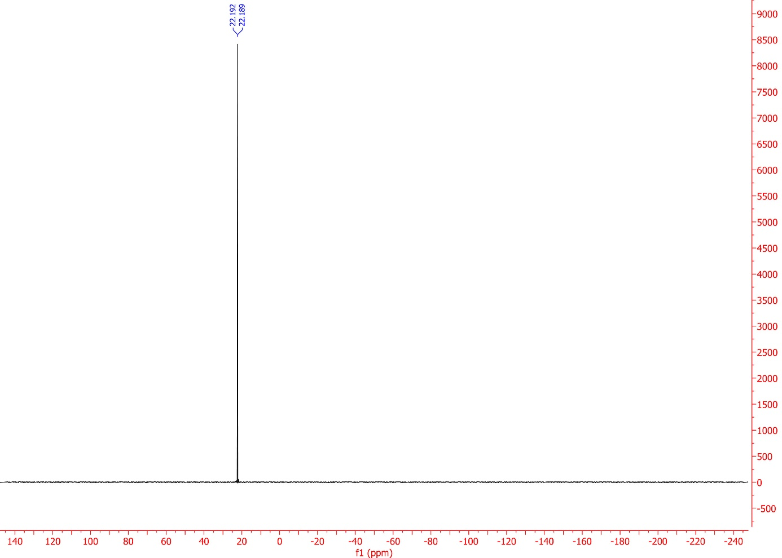
Diethyl ((4-bromophenyl)(sulfamoylamino)methyl)phosphonate (4d, C₁₁H₁₈BrN₂O₅PS).
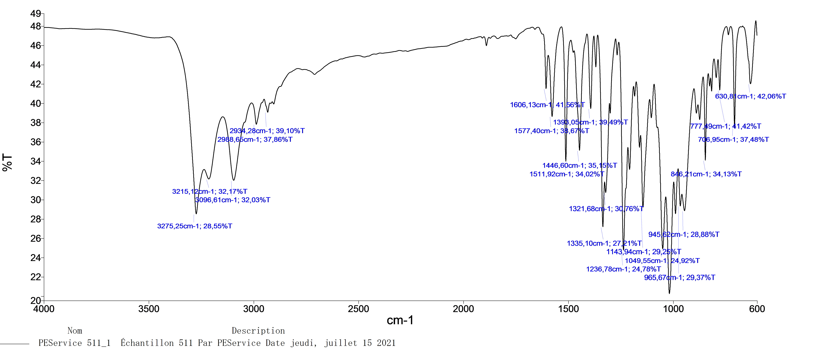
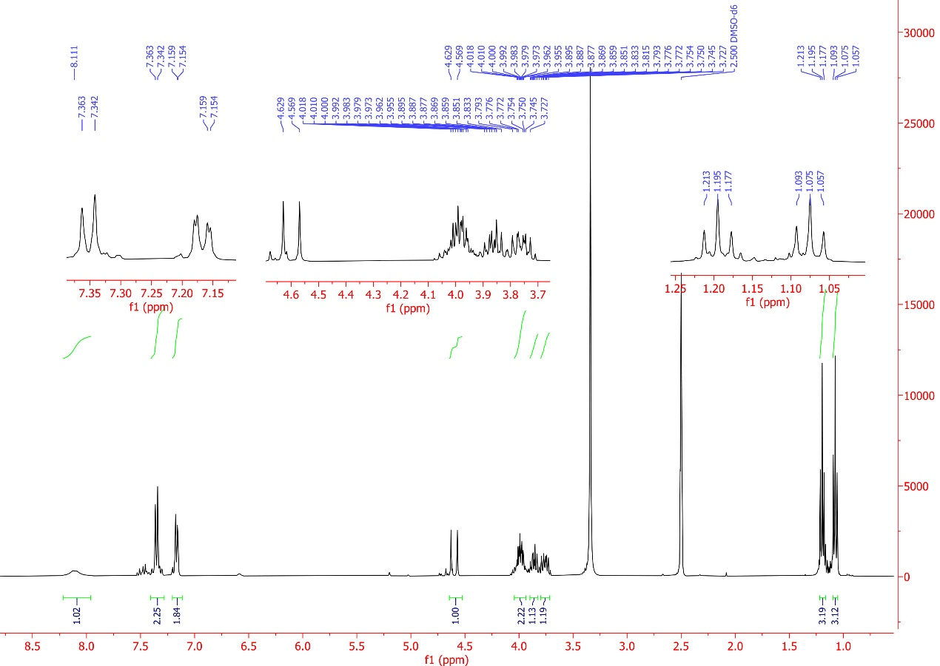
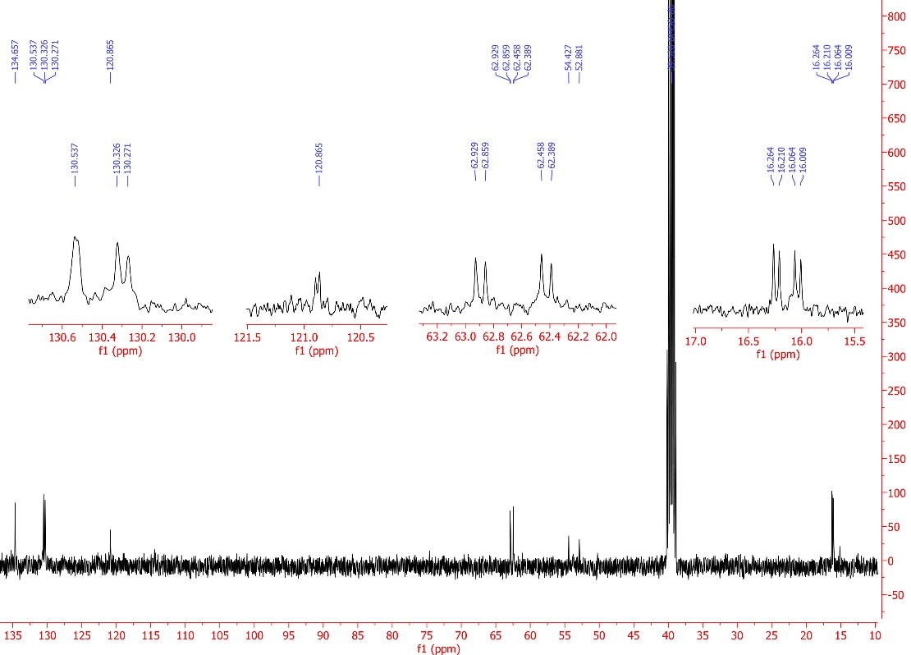
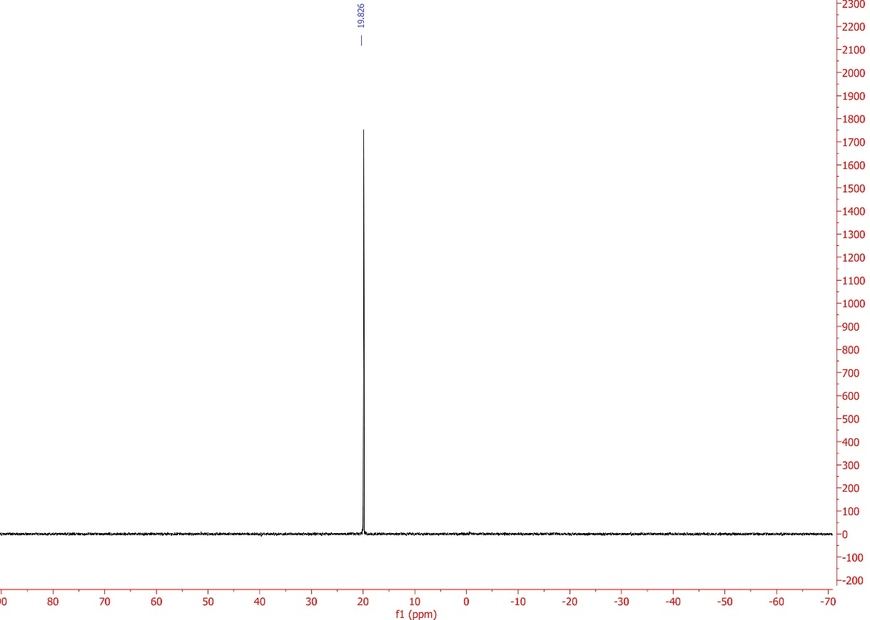
Diethyl ((sulfamoylamino)(m-tolyl)methyl)phosphonate (4e, C₁₂H₂₁N₂O₅PS).
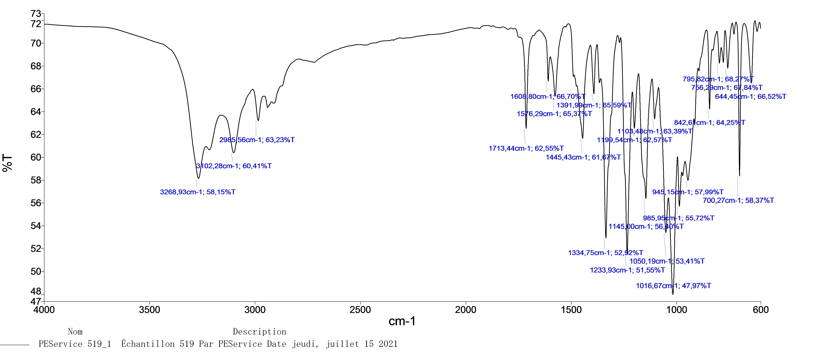
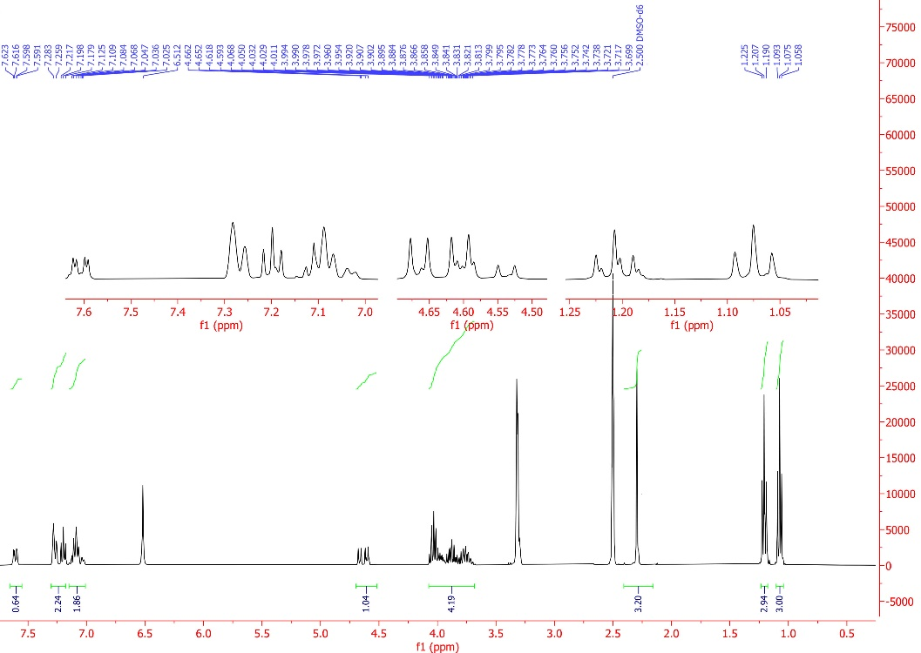
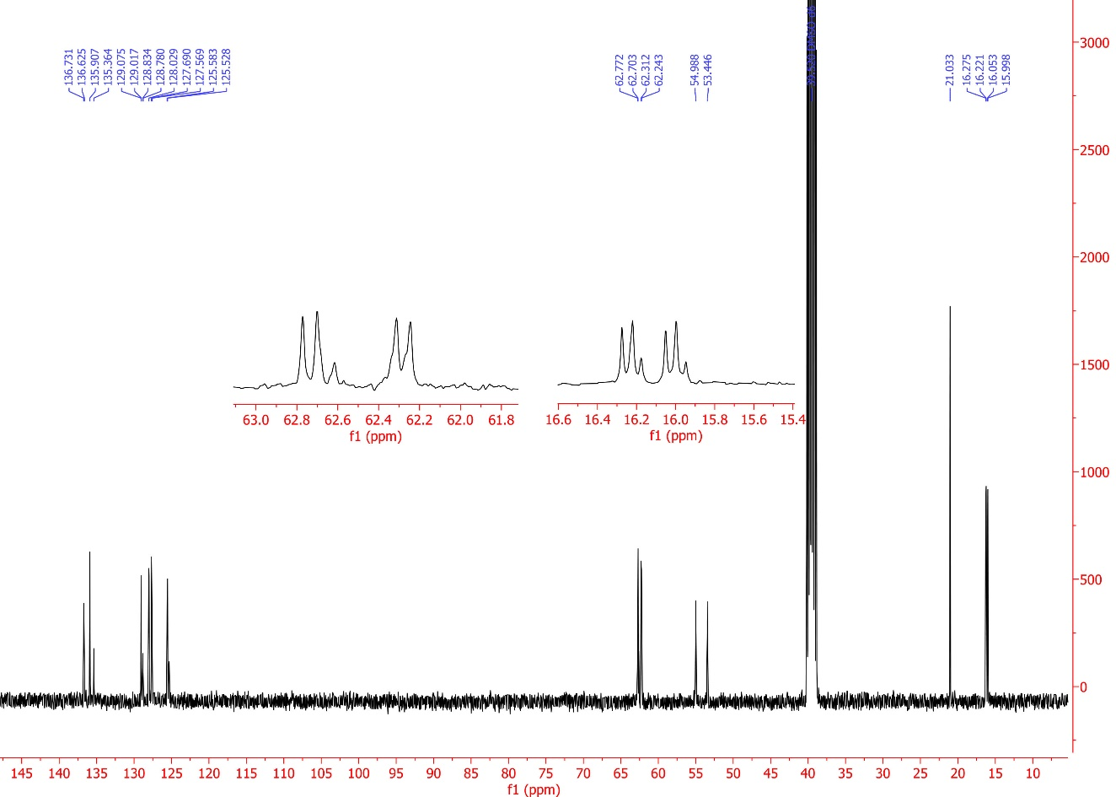
Diethyl ((4-methoxyphenyl)(sulfamoylamino)methyl)phosphonate (4f, C₁₂H₂₁N₂O₆PS).
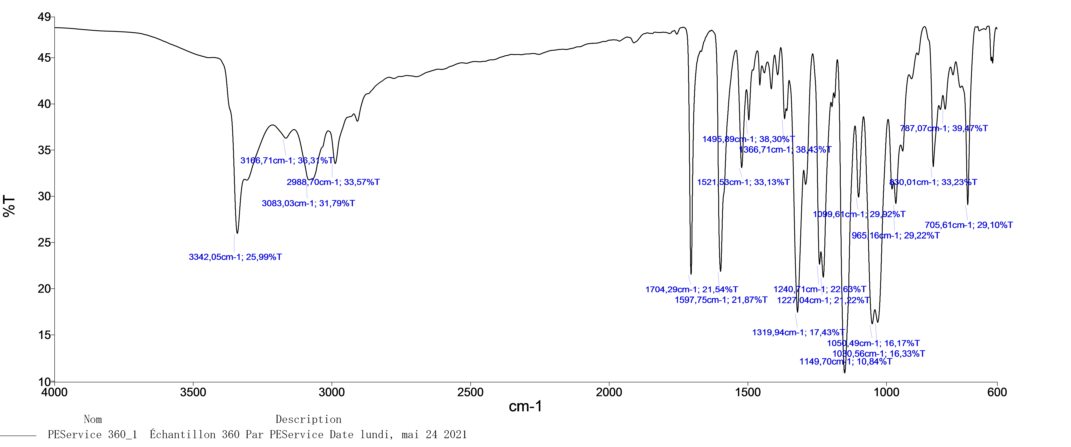

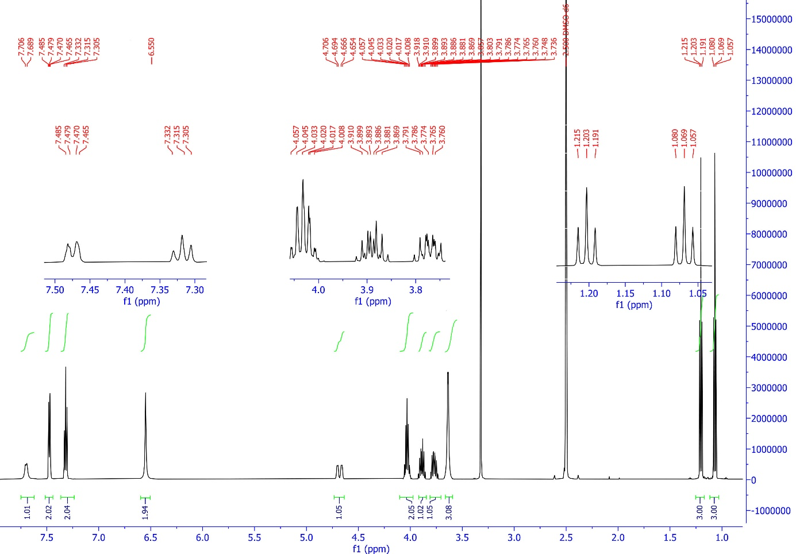
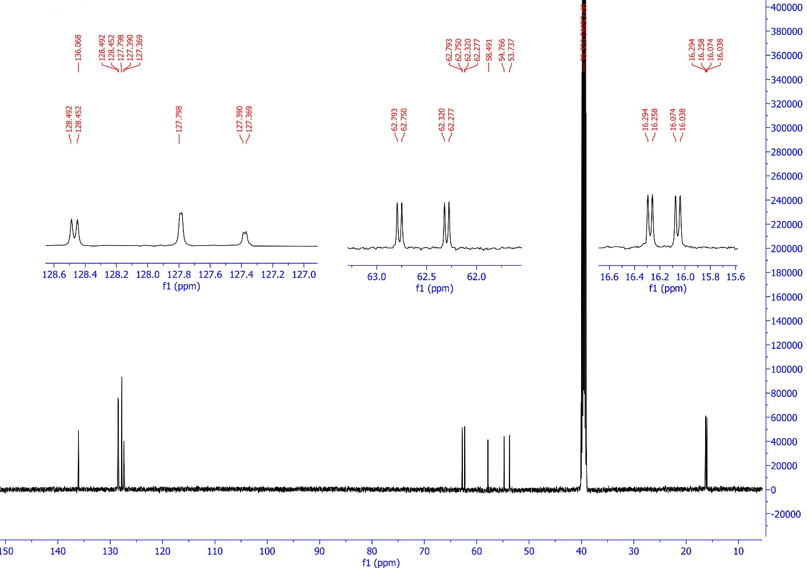
Diethyl (naphthalen-1-yl(sulfamoylamino)methyl)phosphonate(4g, C15H21N2O5PS).
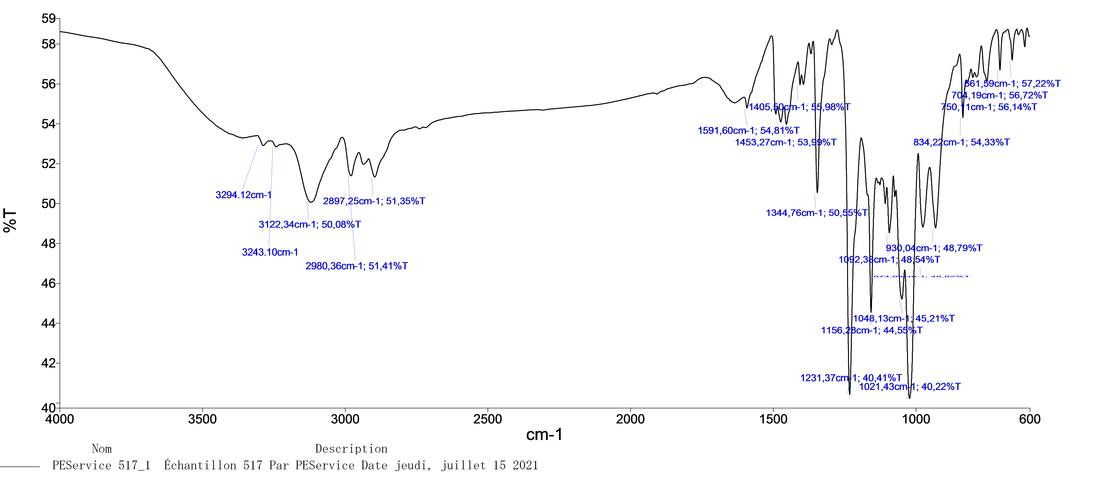
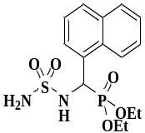
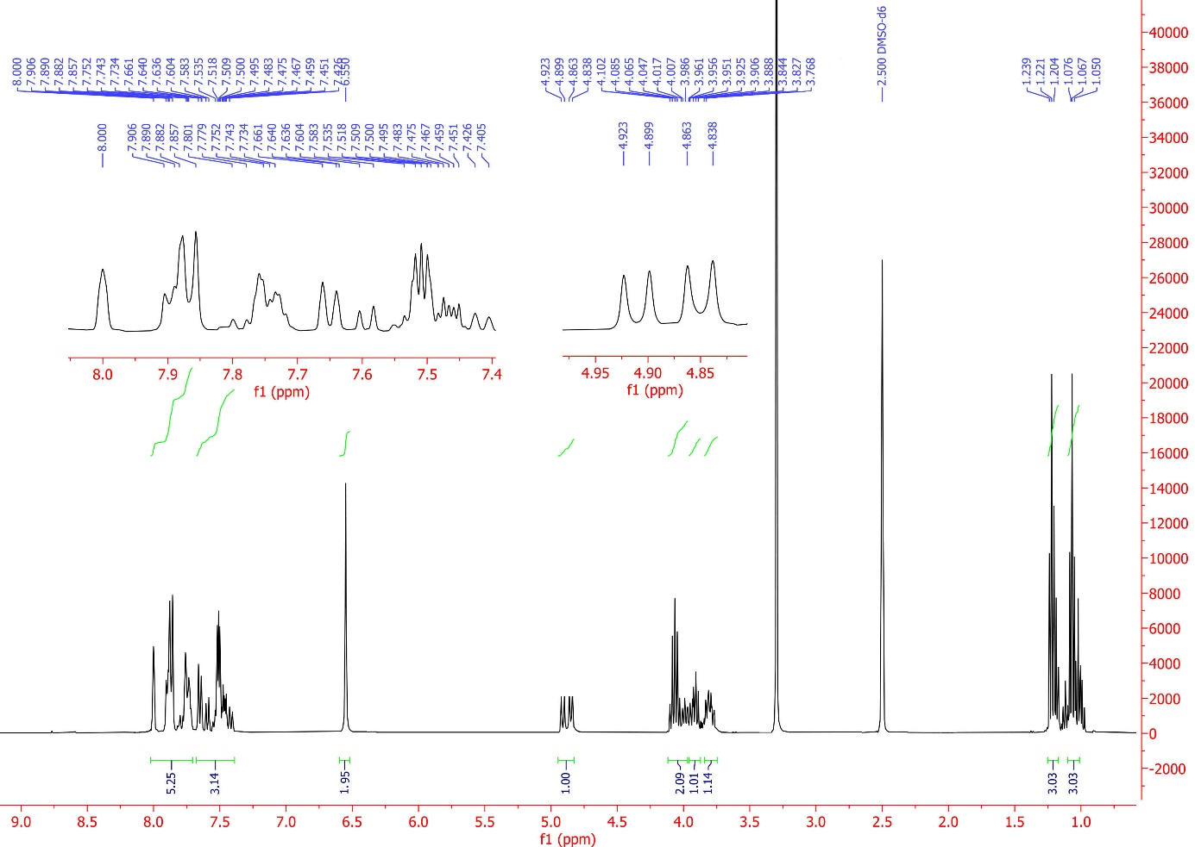
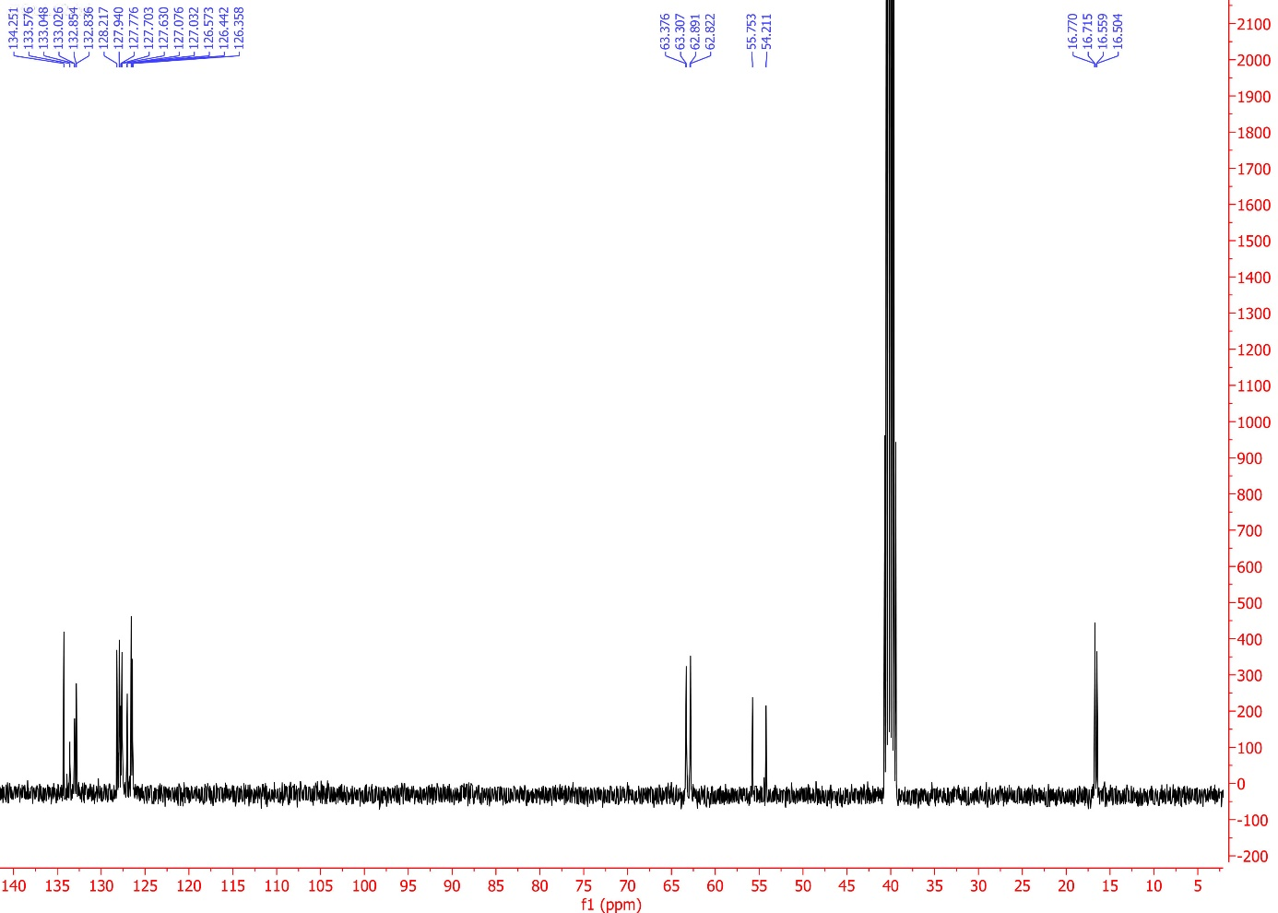
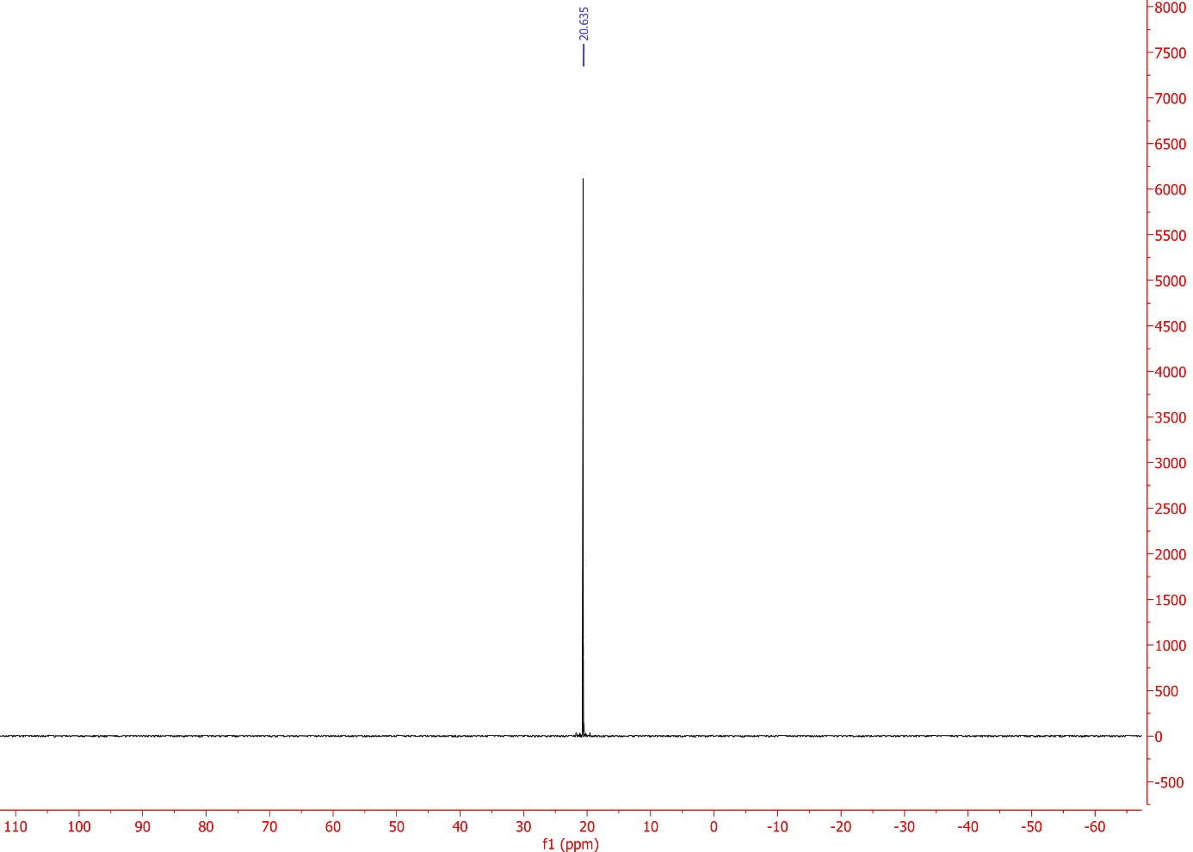
Diethyl((sulfamoylamino)(4(trifluoromethyl)phenyl)methyl)phosphonate (4g, C12H18F3N2O5PS ).
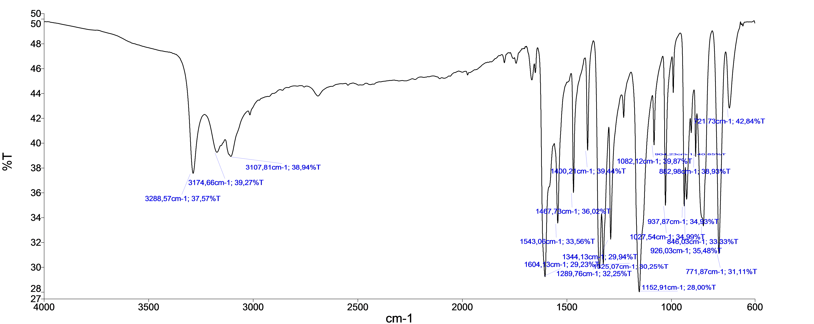
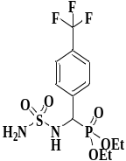

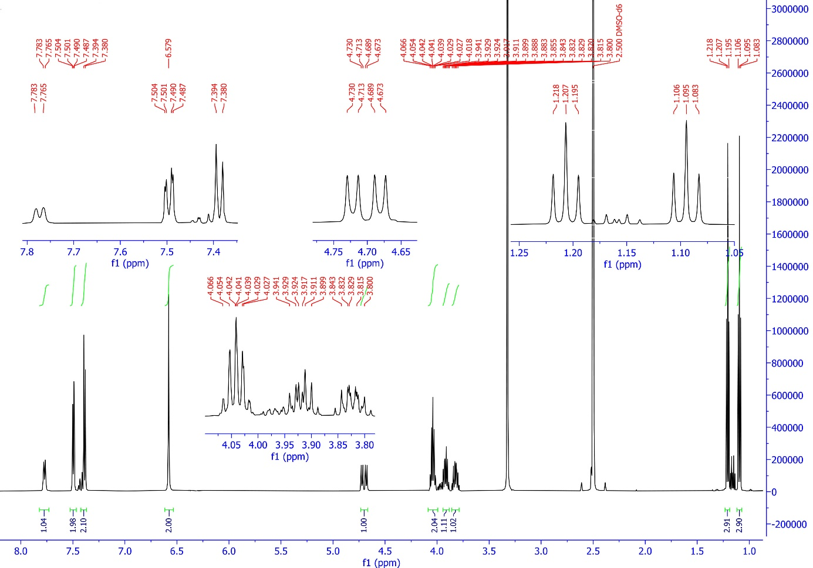
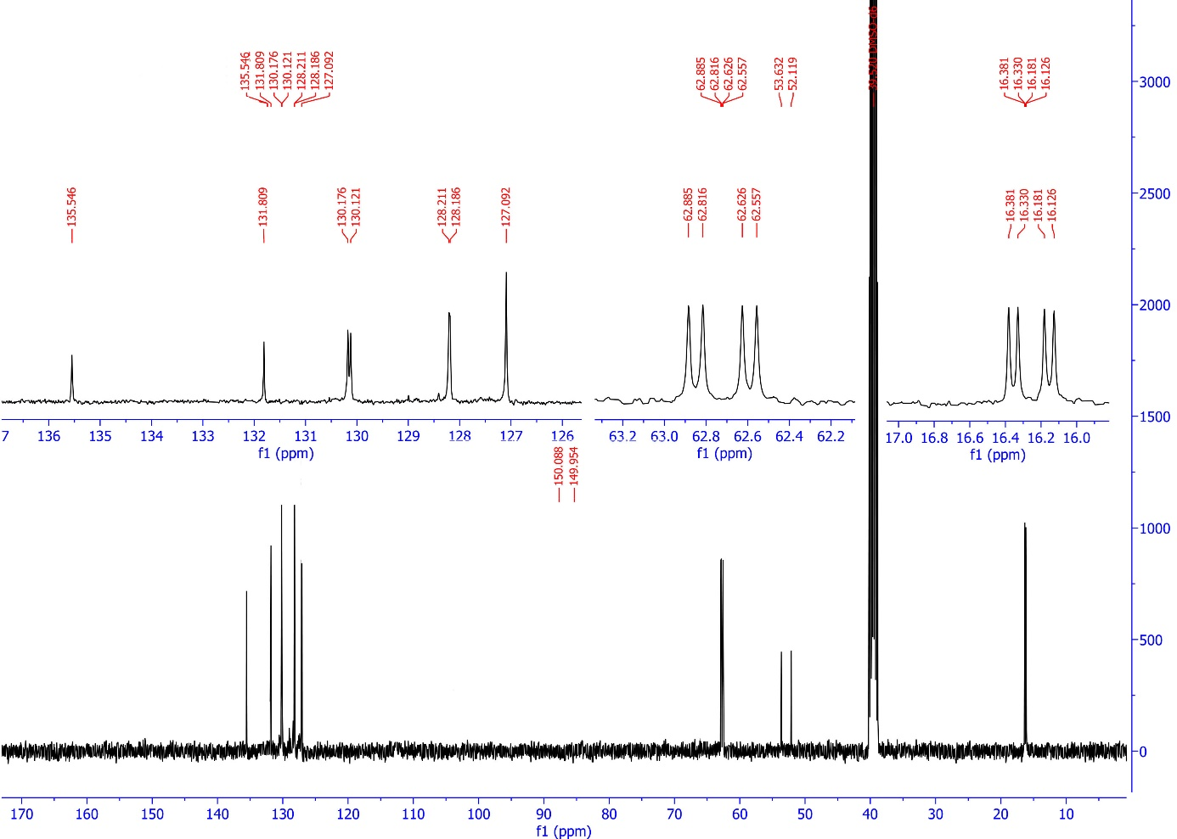
Diethyl ((2-chlorophenyl)(sulfamoylamino)methyl)phosphonate (4h,
C₁₁H₁₈ClN₂O₅PS).
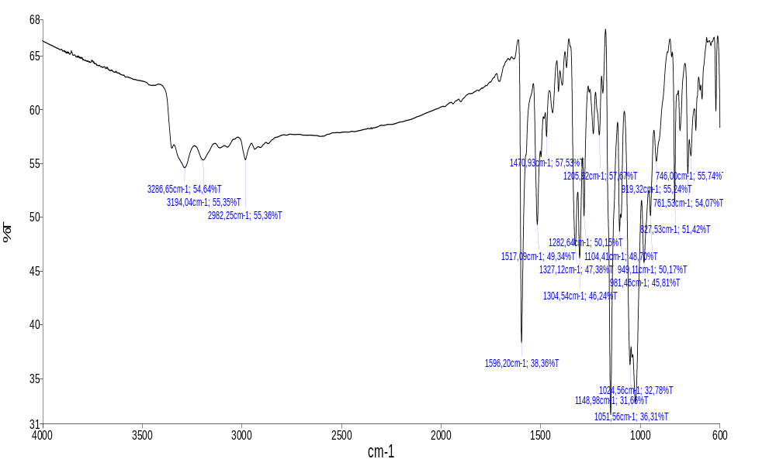
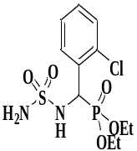
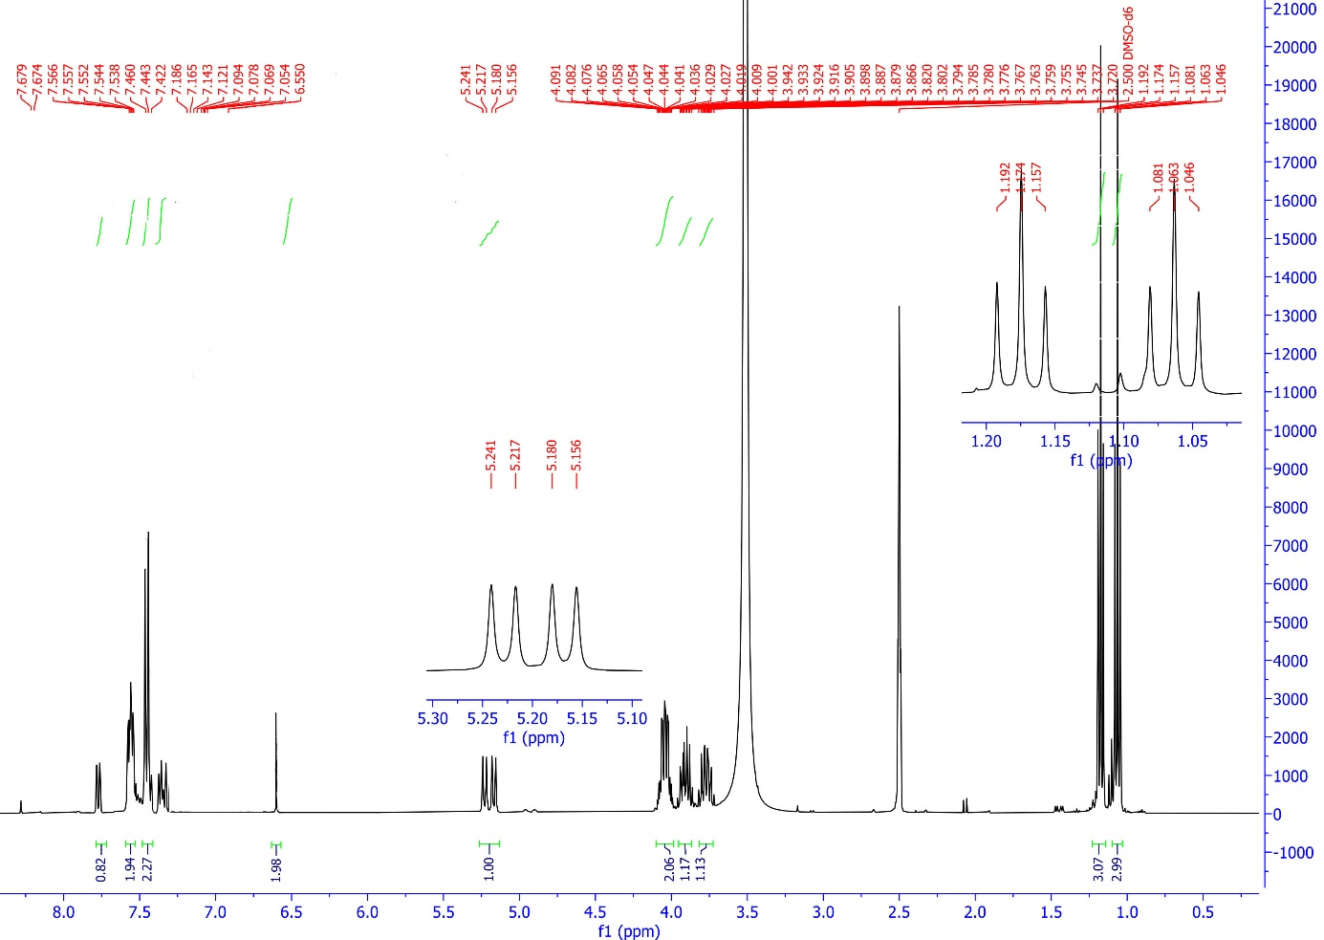

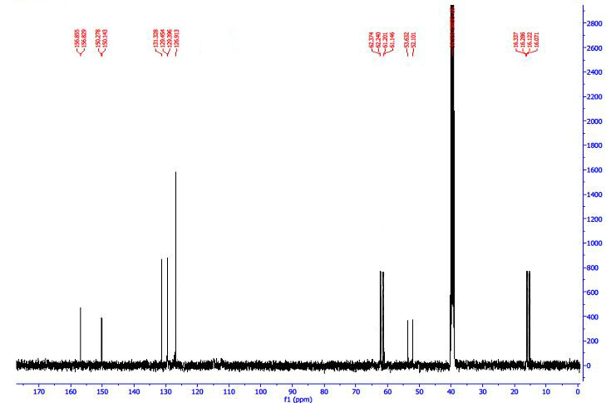
Diethyl ((2-fluorophenyl)(sulfamoylamino)methyl)phosphonate(4i,
C₁₁H₁₈FN₂O₅PS).
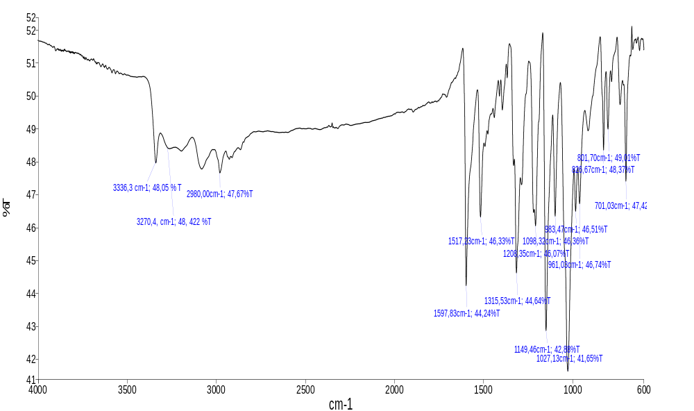
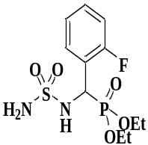
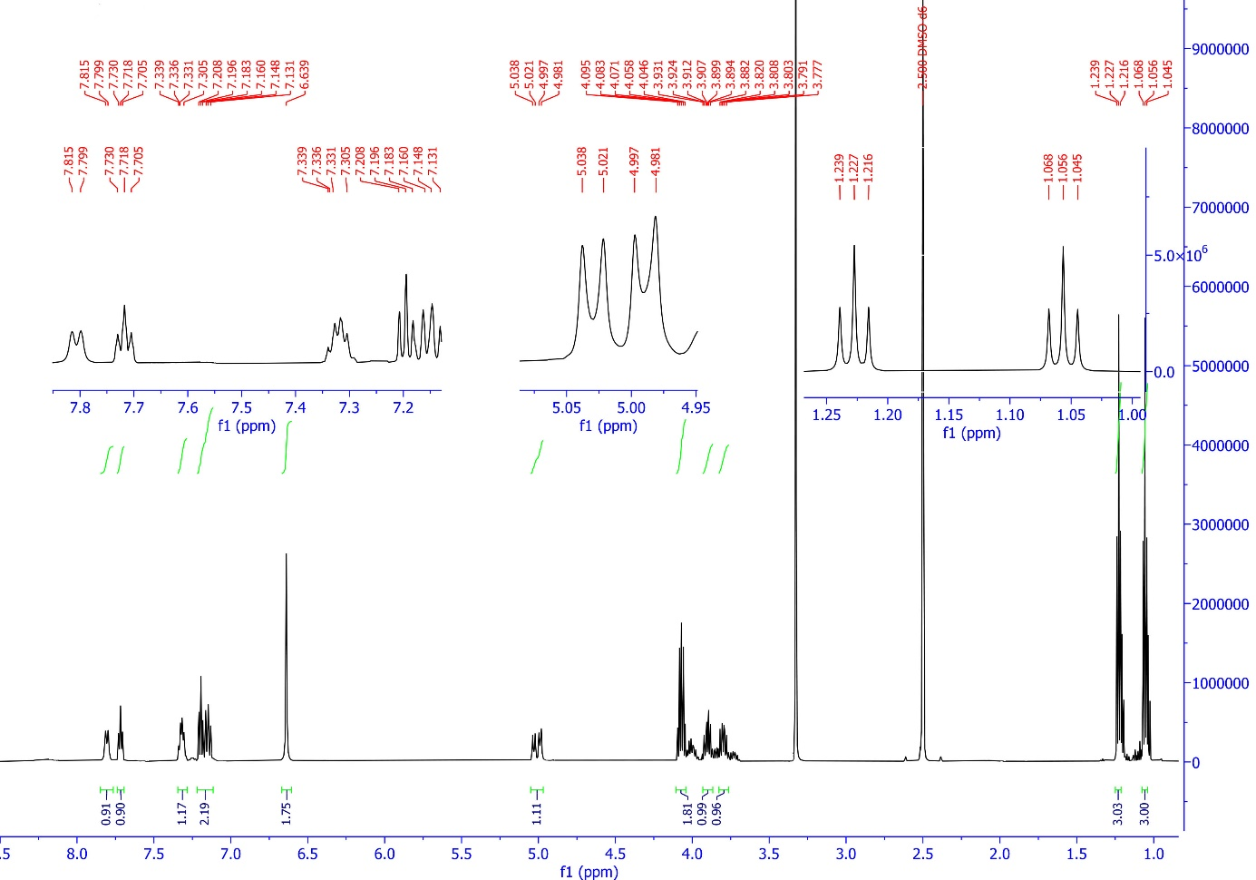
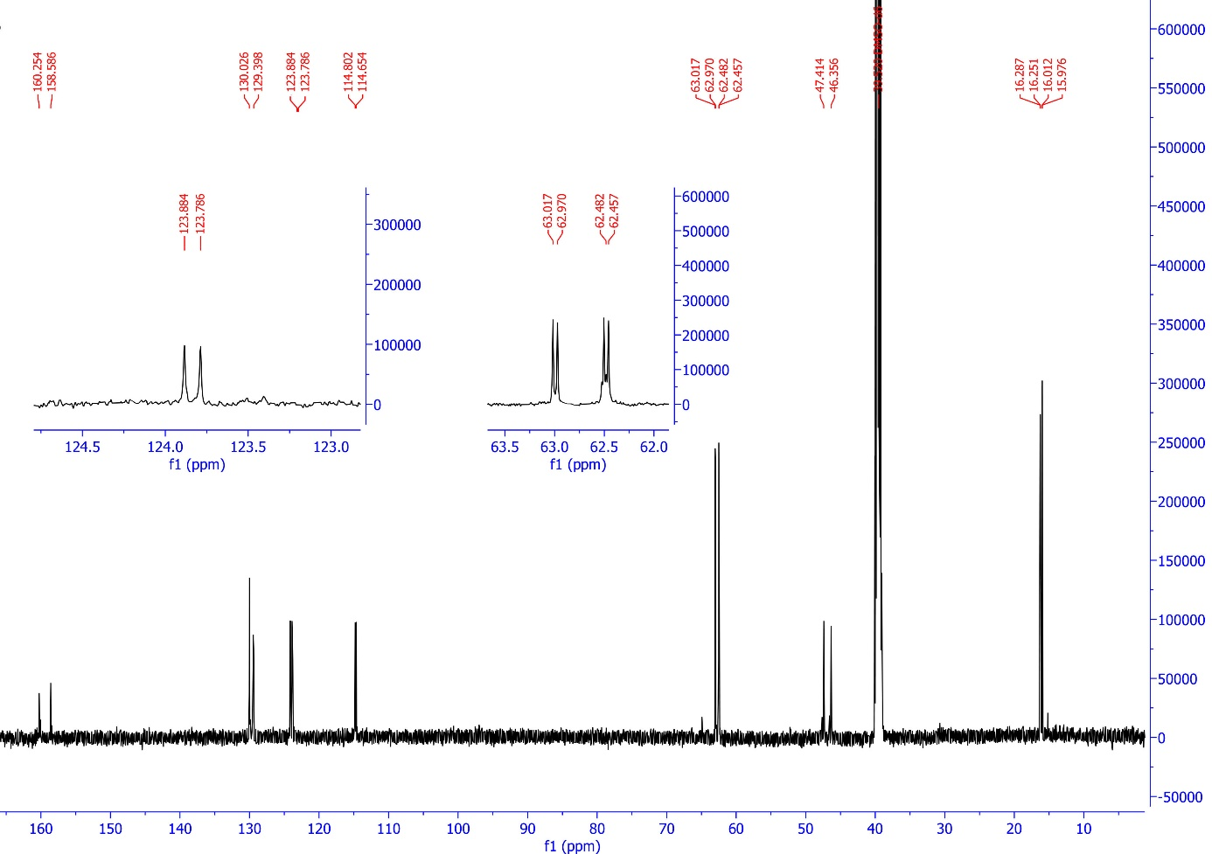

Diethyl ((2-hydroxyphenyl)(sulfamoylamino)methyl)phosphonate (4k,
C₁₁H₁₉N₂O₆PS).
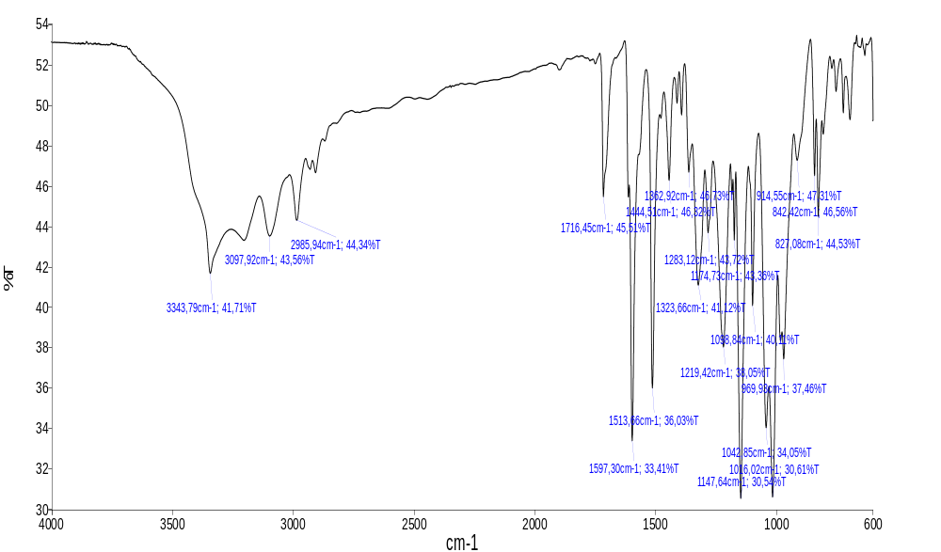
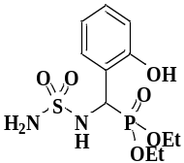
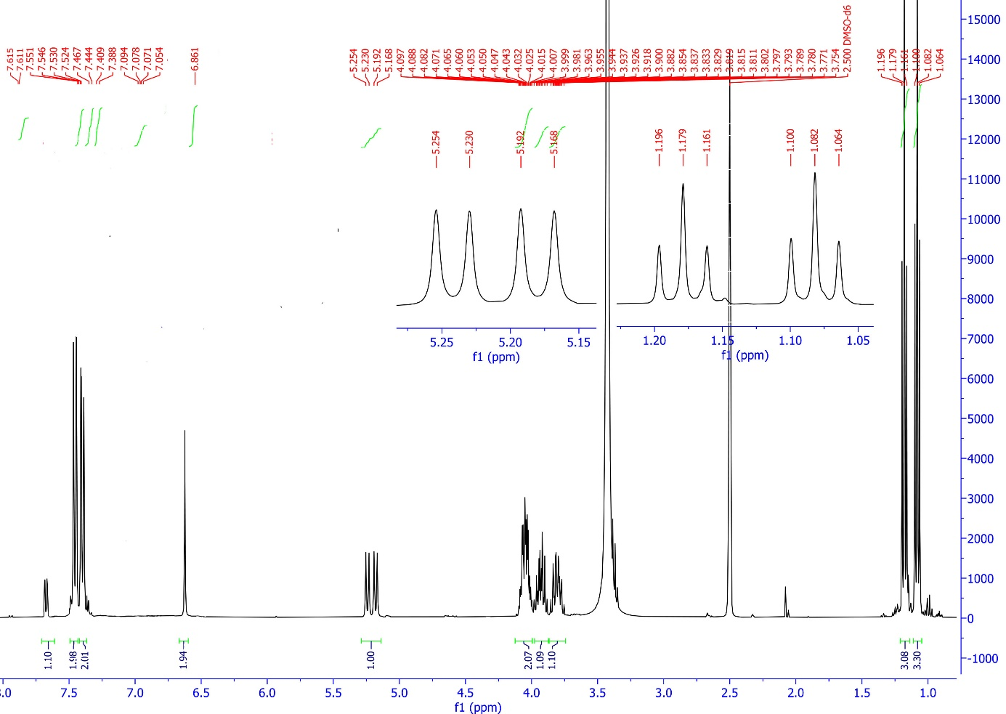
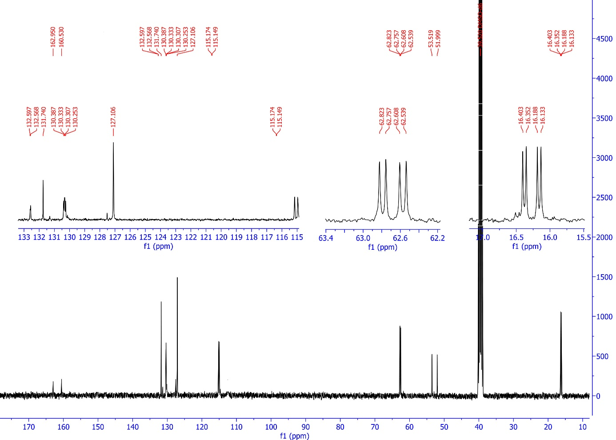
Diethyl ((2,4-dimethoxyphenyl)(sulfamoylamino)methyl)phosphonate (4l, C₁₃H₂₃N₂O₇PS).
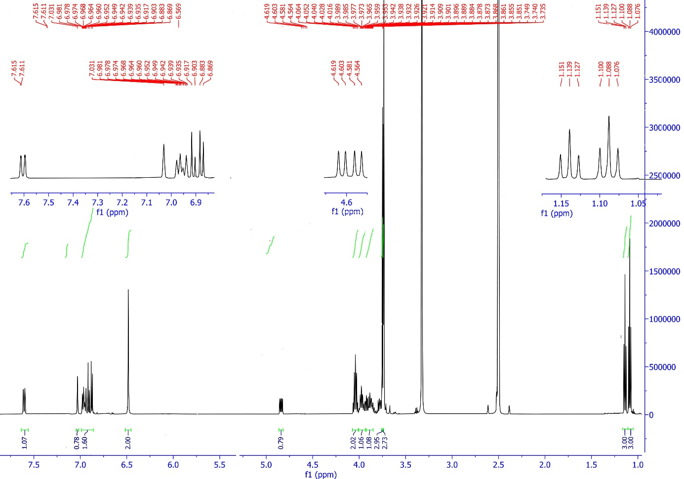
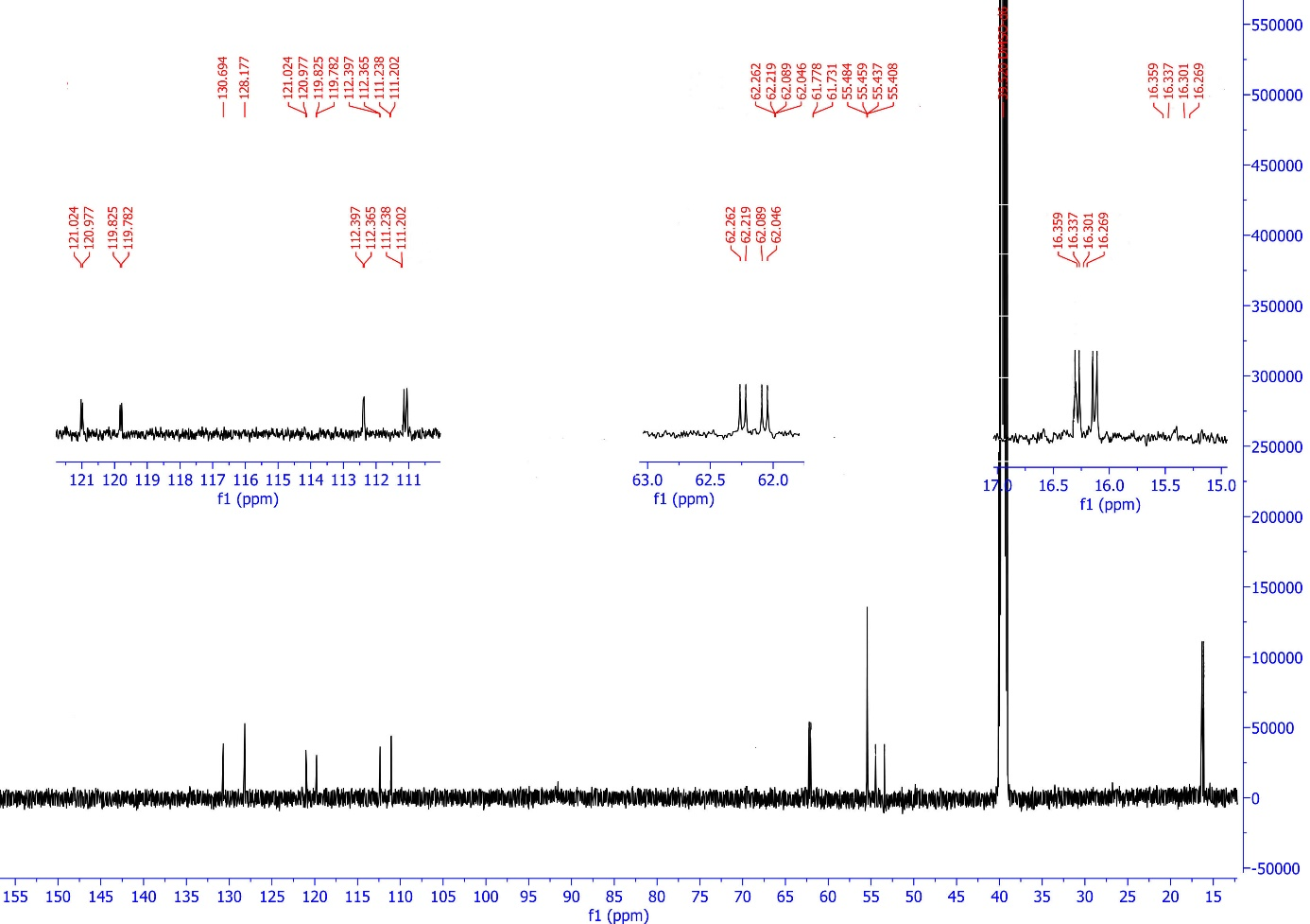
Diethyl (E)-(((N-benzylidenesulfamoyl)amino)(phenyl)methyl)phosphonate (4m, C₁₈H₂₃N₂O₅PS)
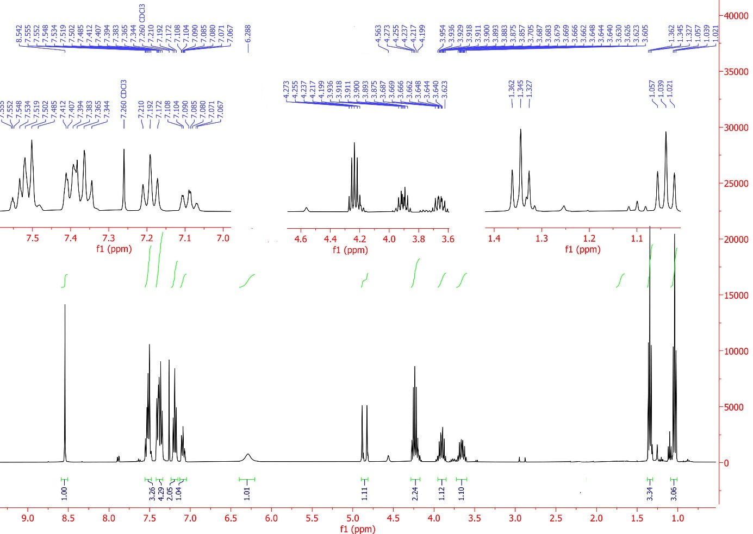
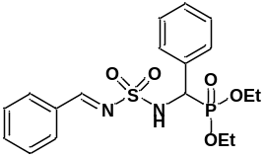
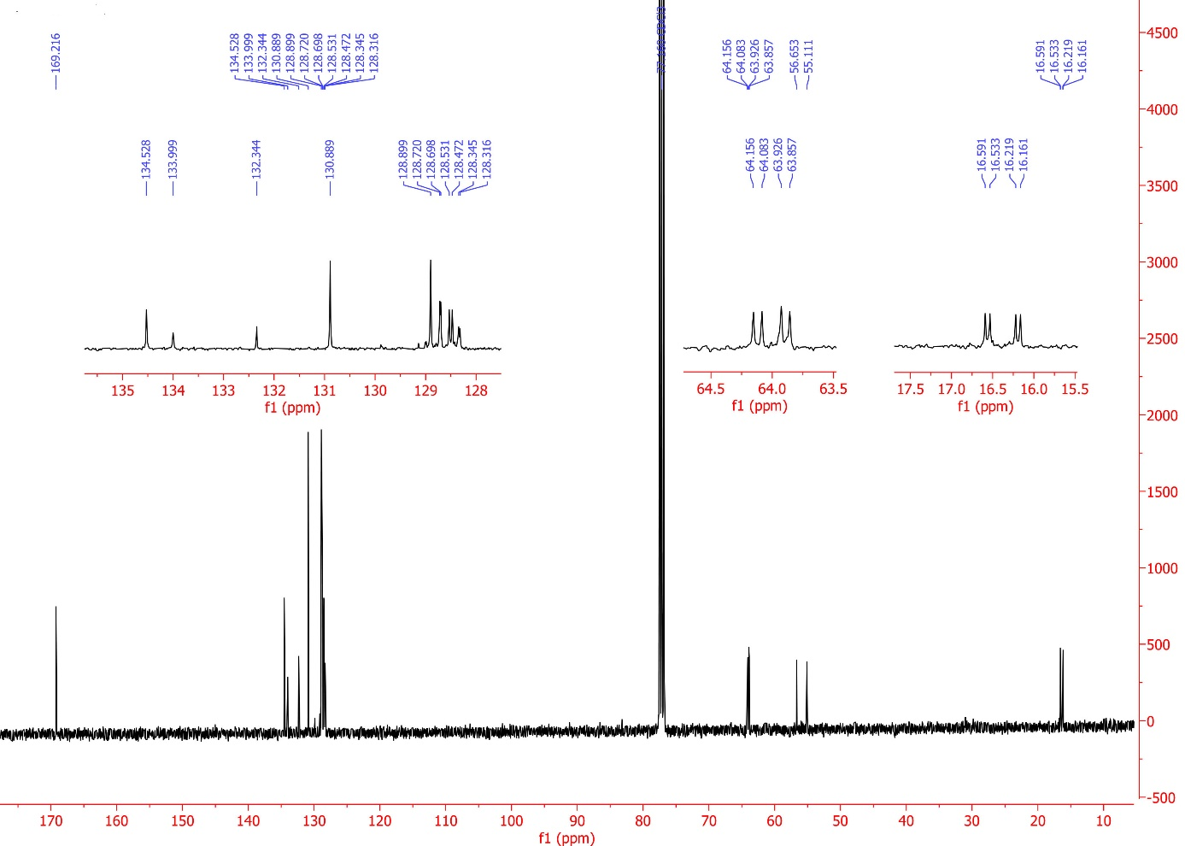
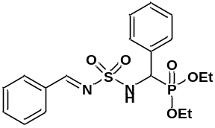

Diethyl (E)-(((N-benzylidenesulfamoyl)amino)(2,4 dihydroxyphenyl)methyl)phosphonate (4m, C₁₈H₂₃N₂O₇PS)
