A.1 Methods
In this section, we describe the methods we use to train CoDoC and choose a final Deferral AI model we use for the results reported in the paper.

We now present results showing how CoDoC generalizes to unseen readers, by training the CoDoC on data that omit opinions from a particular clinician, but evaluating the resulting CoDoC on cases paired with opinions from that clinician. In the datasets we use, not every clinician provides an opinion on every case. Thus, we only include clinicians who rank in the top 10 in terms of number of cases they read.

A.1.1 Training the Deferral AI for CoDoC

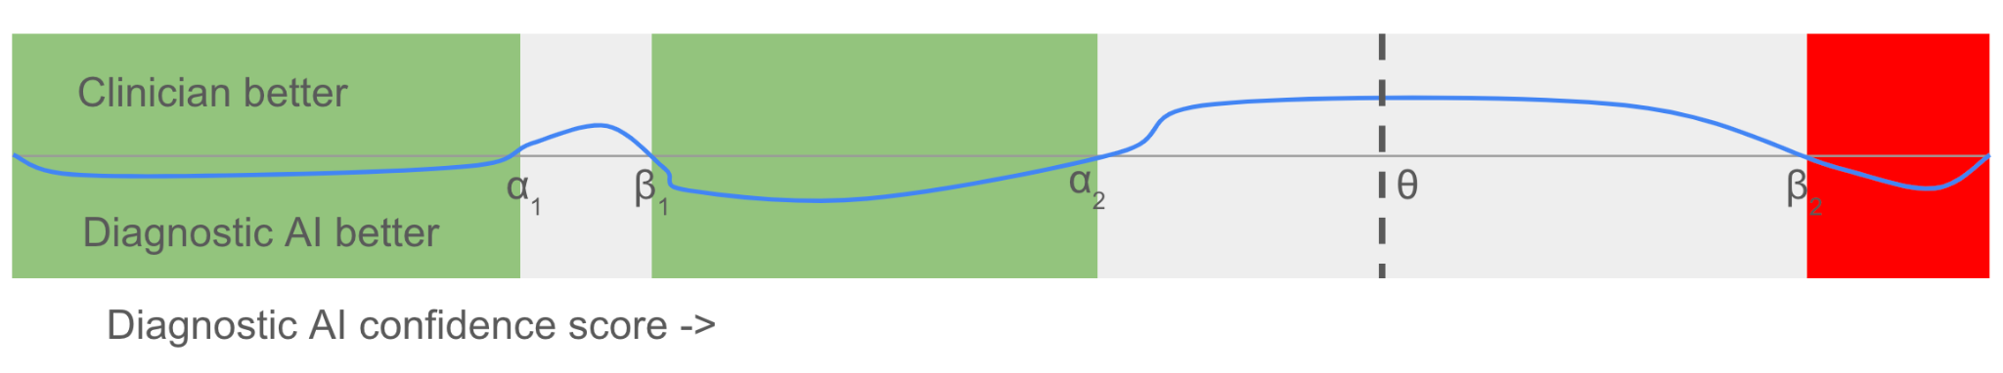
Diagram A0: CoDoC Deferral Model Structure. Given an operating point, CoDoC works by computing an advantage function (shown in blue above). The zero-crossings of the advantage function represent thresholds within which CoDoC prefers to defer to a clinical workflow. $θ$ denotes the operating point above which CoDoC predicts that the disease is present if it does not defer.

The algorithms for learning the parameters of a deferral AI system are trained using a tuning dataset consisting of datapoints
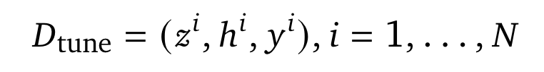
where $h^{i}$ is the clinician opinion on datapoint $i$, $y^{i}$the ground truth label and $z^{i}$ the diagnostic AI confidence score.

CoDoC implements a rule-based deferral mechanism: If the confidence score of the diagnostic AI is within a set of deferral regions, CoDoC decides to defer and when the confidence score is outside this set, CoDoC predicts that the disease is present or absent depending on whether the score is above a threshold. Concretely, the parameters of CoDoC are
- Deferral regions: ${{0<=α}_{1}<β_{1}<α_{2}<β_{2} ... < α_{k }< β_{k} <= 1}_{}$. These numbers parameterize intervals such that when the weighted model score is within one of these intervals, the deferral AI decides to defer to a clinical expert.
- Operating point: ${0 < θ < 1}_{}$

CoDoC then implements the following decision rule (as depicted in Diagram A0):

$α_{j}≤z≤β_{j}$ for some $j∈\left\{1, 2, ..., k\right\}$ | Defer to clinical workflow
${z not in [α}_{j}, β_{j}]$ for any $j∈\left\{1, 2, ..., k\right\}$, $z^{}≥θ$ | Predict disease present
${z not in [α}_{j}, β_{j}]$ for any $j∈\left\{1, 2, ..., k\right\}$, $z^{}< θ$ | Predict disease absent

We denote $CoDoCDecision(z)$ the final predictive decision (disease present / absent) form CoDoC when the diagnostic AI score is $z$, which is a result of either applying a threshold to the model prediction or deferring and using the prediction from a clinical workflow, and by $Defer(z)$ the decision to defer or not.

In the remaining subsections, we: a) Derive the mathematically optimal deferral strategy assuming access to certain probability distributions relevant to the deferral task b) Derive a practical algorithm from the mathematical strategy by using practical density estimation algorithms to estimate the probability distributions of interest.

A.1.1.1 Derivation of Mathematically Optimal Deferral Strategy

We proceed via a mathematical argument sketched in Section 2.1 of the main paper. In particular, we assume that we can estimate the following conditional probability distributions:
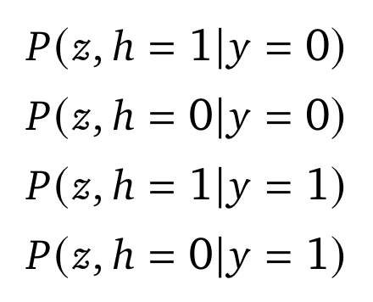
Here $z$ denotes the model output $z∈[0, 1]$, $h$ is the reader/workflow opinion and $y$ is the ground truth label. We provide details on how these are estimated in the next subsection. However, given access to these distributions, there is a mathematically principled way to determine the deferral strategy.

Let $CoDoC$ denote the binary random variable indicating the final decision arrived at by CoDoC for a particular case, and $y$ denote the ground truth label for the same case.

We denote by
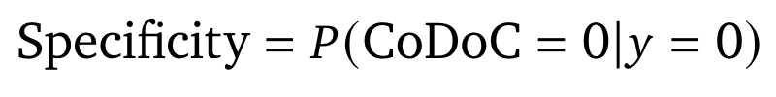
the probability that CoDoC predicts disease is absent given that the disease is indeed absent and
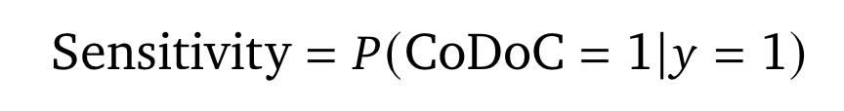
the probability that CoDoC predicts disease is present given that the disease is present.

Lemma 1:
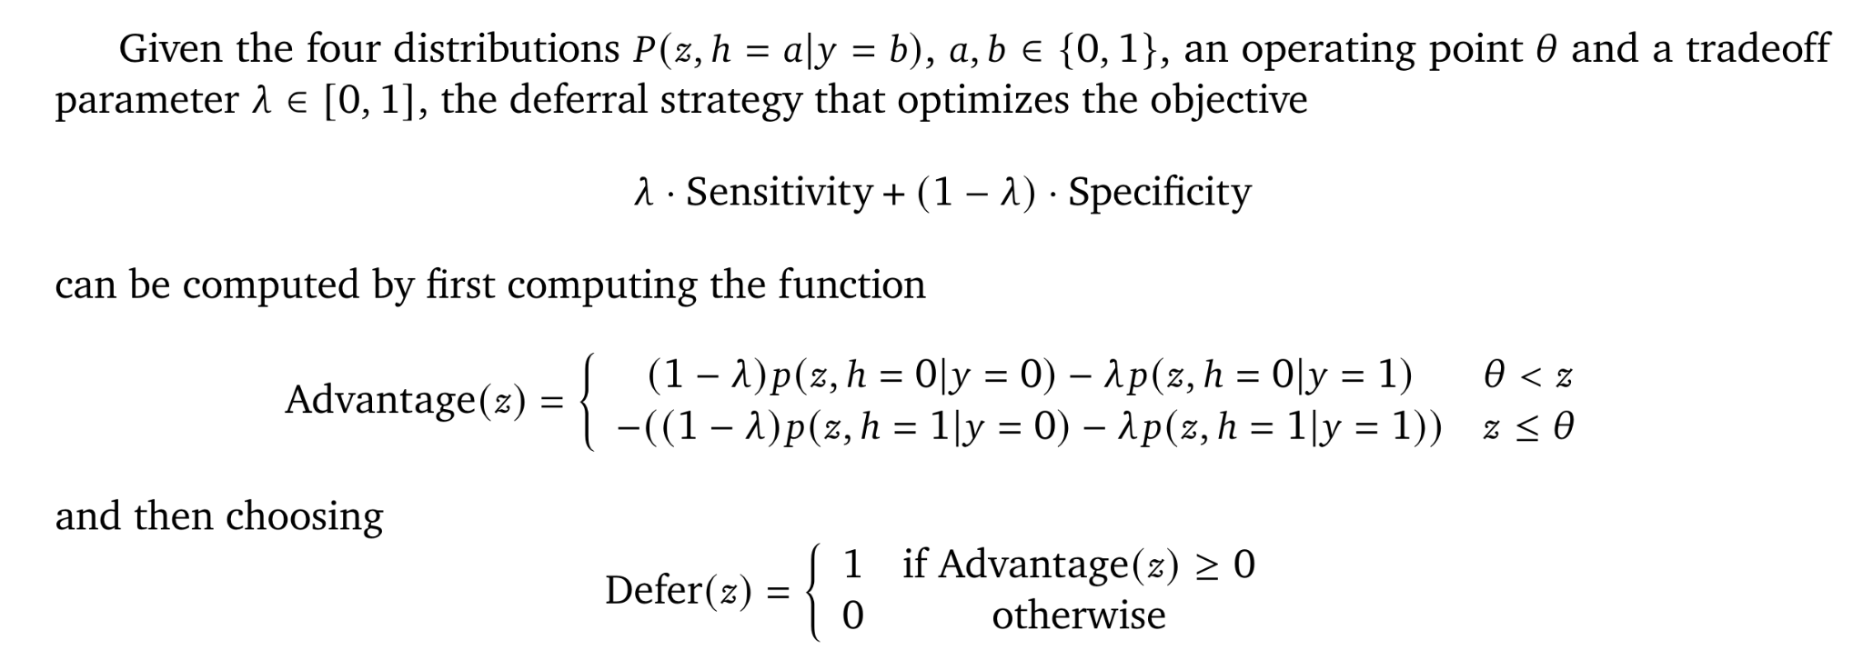
Proof:

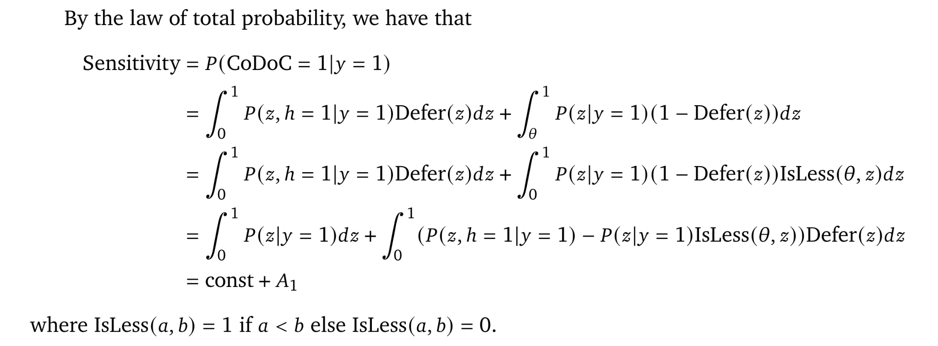
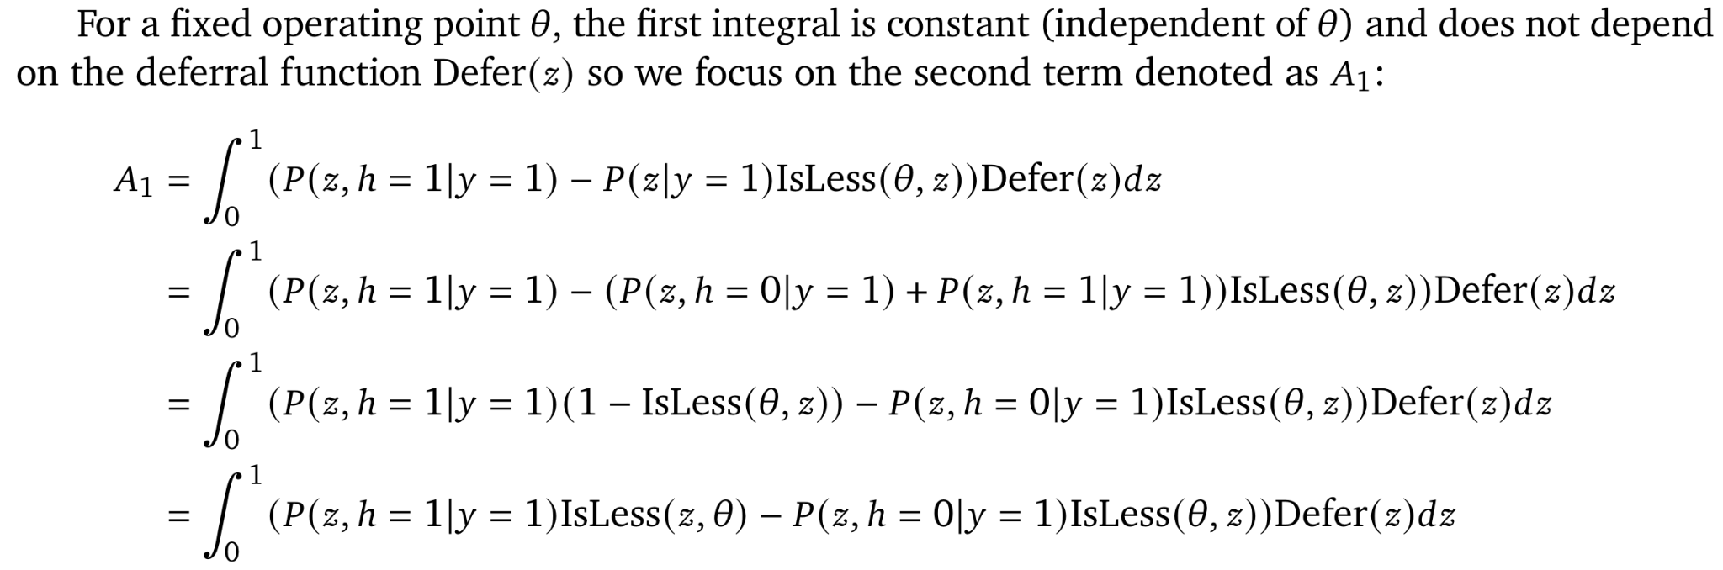
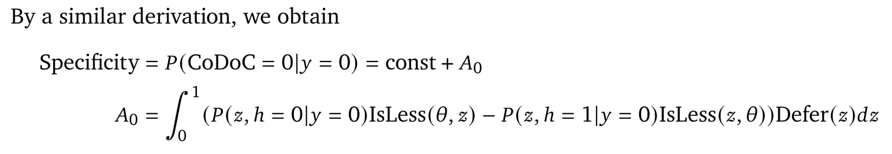

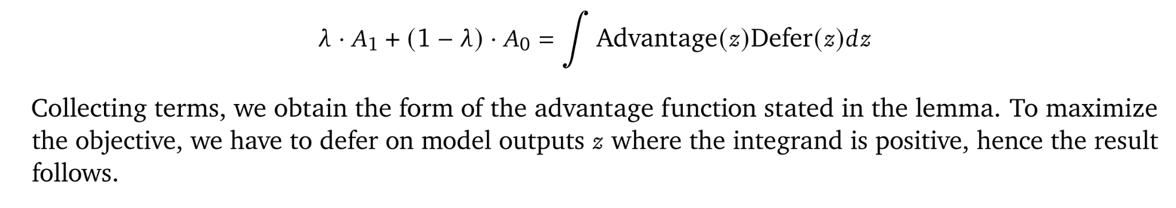

A.1.1.2 Density Estimation
We now consider the problem of estimating the four densities $P(z, h=a|y=b)$ where $a, b ∈ \{0, 1\}$. The method is independent of the specific values $a, b$ take, so we will describe things abstractly. Since $z$ is one dimensional, there are a variety of standard approaches for density estimation, for example, kernel density estimation ¹. We use a technique based on smoothing histogram based estimates of the density. Concretely, we divide the interval $[0, 1]$ into $N_{b}$ bins of equal width $I_{t}=[(t-{1)/N_{b},}_{}t{/N_{b}]}_{}$ with $t=1, ..., N_{b}$. We then count the number of datapoints in $D_{tune}$ such that
$y=b, h=a, z ∈ I_{t}$
and denote the count as
$c_{y, h,t}$. We additional add a smoothing parameter ${κ > 0}_{}$ to the counts (so as to avoid assigning 0 counts to certain bins even when data is highly sparse). We define an $M$-component Gaussian RBF kernel with center parameter $ξ_{j}=(j-1/2)/M)_{}$and spread $σ$ as
$R_{j}(x)=\frac{exp(-(x-ξ_{j})^{2}/2σ^{2})}{\sum_{k}{}exp(-(x-ξ_{k})^{2}/2σ^{2})}$

Let $μ_{t}$ be the midpoint of $I_{t}$. Then, the kernels evaluate at $μ_{t}$ evaluate to
$B_{t,j}=R_{j}(μ_{t})$

We model the smoothed counts as
$c_{y,h,t^{}}+ κ ≈ {c_{y,h,t}^{est}}_{}(w)=\sum_{j=1}^{M}{}B_{t,j}w_{j,y,h}$
where we optimize $w$ by solving
${minimize}_{}\sum_{y, h, t}{}KL(c_{y,h,t^{}}+κ|| {c_{y,h,t}^{est}}_{}(w))$
where
$KL(u||v) = vlog(u/v)-u+v$
denotes the Kullback-Leibler divergence between un-normalized distributions represented by arbitrary positive real numbers $u,v$. Solving for $w$ essentially can be done using an iterative minimization procedure using multiplicative updates similar to non-negative matrix factorization ², where only $w_{j,y,h}$ are updated by keeping $B_{t,j}$ fixed.

A.1.1.3 Overall Algorithm
For a given choice of operating point of the diagnostic model $θ ∈[0, 1]$ and trade-off parameter $λ$, the overall algorithm for computing deferral regions can be stated as follows:
- Compute the density estimates for $P(z, h=a|y=b)$ (for $a, b ∈ \{0, 1\}$) using the procedure from Section A.1.1.2
- Compute the advantage function $Advantage(z)$as defined in Lemma 1.
- Find all $s$ such that $Advantage(z)=0$. Let the set of solutions be ${0 ≤p}_{1} <p_{2} < .. p_{k} ≤ 1$.
- Compute deferral thresholds as follows:
  - If $Advantage(0) ≥ 0$ and $k$ is even set $α_{0}=0, { β}_{0}= p_{1}, { α}_{1}=p_{2}, ⋯, { α}_{k/2}=p_{k},{ β}_{k/2} =1$.
  - If $Advantage(0) ≥ 0$ and $k$ is odd set $α_{0}=0, { β}_{0}= p_{1}, { α}_{1}=p_{2}, ⋯, α_{(k-1)/2}=p_{k-1}, { β}_{(k-1)/2} =p_{k}$.
  - If $Advantage(0) < 0$ and $k$ is odd set $α_{0}=p_{1}, { β}_{0}= p_{2}, { α}_{1}=p_{3}, ⋯, { α}_{(k-1)/2}=p_{k},{ β}_{(k-1)/2} =1$.
  - If $Advantage(0) < 0$ and $k$ is even set $α_{0}=p_{1}, { β}_{0}= p_{2}, { α}_{1}=p_{3}, ⋯, α_{k/2-1}=p_{k-1},{ β}_{k/2-1} =p_{k}.$

A.1.1.4 Hyperparameter optimization and model selection
In the above section, we described how the deferral model is trained for a given objective function tradeoff parameter $λ$ and for a fixed operating point $θ$ and algorithmic hyperparameters: pseudocounts $κ$, number of bins $N_{b}$ and $M={|D}_{tune}|$. We view $θ,λ, κ, N_{b,} M$ as hyperparameters of the deferral AI and perform a sweep over these. Let the collection of deferral AI models obtained as be denoted as $DeferralModels.$

Model selection is conducted on $D_{val}$ according to the final criterion of interest. In particular, we consider:
- Obtaining sens superiority and spec non-inferiority over the baselines (AI-only and human-only)
- Obtaining spec superiority and sens non-inferiority over the baselines (AI-only and human-only)

The algorithm for model selection for either of these objectives conform to the following procedure for choosing a CoDoC model that is superior on sensitivity and non-inferior on specificity to the diagnostic AI and clinical workflow:
- Filter out models from among $DeferralModels$ that are inferior on specificity (by a margin of 1% or more) to either the diagnostic AI or clinical workflow according to $D_{tune}$ or $D_{val}$ to find a set of viable models.
- Set $k>=2$ to the smallest value such that the set of viable models has at least one model with at most $k$ zero-crossings in the advantage function $Advantage(z)$. Note that $k=2$ corresponds to a model with a single deferral region, so we prefer the simplest (in terms of number of deferral regions) viable model.
- Select the model that performs the best according to sensitivity on $D_{val}$.
A similar approach (interchanging sensitivity and specificity above) is used to choose a model that is superior on sensitivity and non-inferior on specificity.

The margin of 1% is chosen as a conservative value since we ultimately test for non-inferiority with a margin of 5%, following prior work (see Section A.1.3).

At the end of this procedure, we obtain a single CoDoC model (along with its operating point and deferral regions) that is chosen to be evaluated on the test set, as outlined in Section A.1.3.

A.1.2 Computing theoretical limits of confidence based deferral via Dynamic Programming
To compute the theoretical limits of confidence based deferral, we optimize the deferral strategy directly on the test set $D_{test}$ and report the best possible performance achievable by any confidence based deferral strategy of the form outlined in Section A.1.1.1. Even though this might seem like a simple problem, the complexity of a naive approach search in a brute force manner over possible choices of the deferral thresholds grows exponentially in the number of deferral regions and becomes intractable when the number of regions is large. Hence, we develop an efficient dynamic programming algorithm, that runs in complexity $O(k^{2}N )$ where $k$ is the number of deferral regions and $N$ is the number of datapoints in $D_{test}.$

We describe the dynamic programming algorithm for computing the deferral regions and operating point. The algorithm works on the sorted vector of scores and computes an independent predict/defer decision for each datapoint.

Without loss of generality, assume that we reorder the dataset so that
$z^{1}≤ z^{2}≤ z^{3}≤ ... ≤ z^{N}$.
Let $d^{i}∈\left\{0, 1\right\}$ denote the deferral decision at datapoint $i$ and $p^{i}∈\left\{0, 1\right\}$denote the prediction (AIOpinion) at datapoint $i$. We let $Sens(p, d)$ denote the sensitivity of the deferral system with predictions $p$ and deferrals $d$ and $Spec(p, d)$ the specificity of the same deferral system.

Objective function:
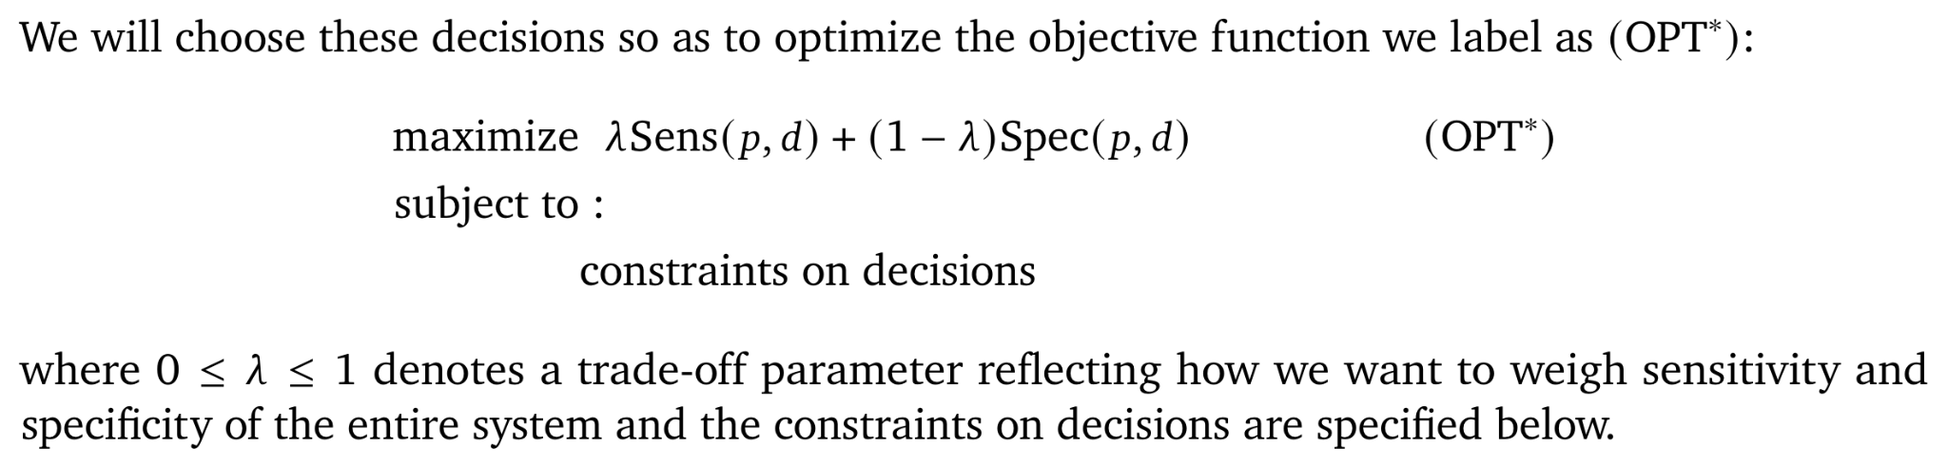
Constraints on decisions:
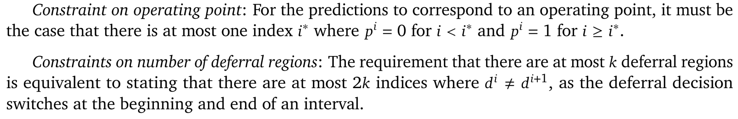
Formulation:
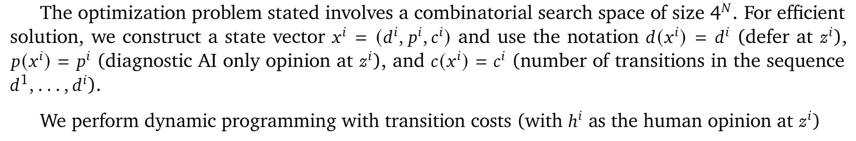

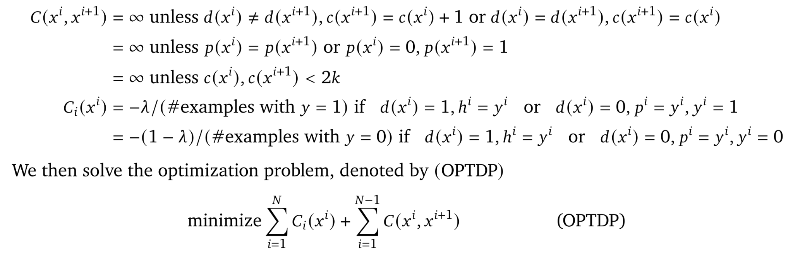
Lemma 2:

Proof:
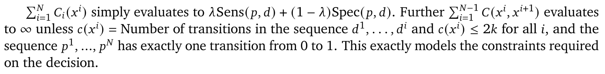
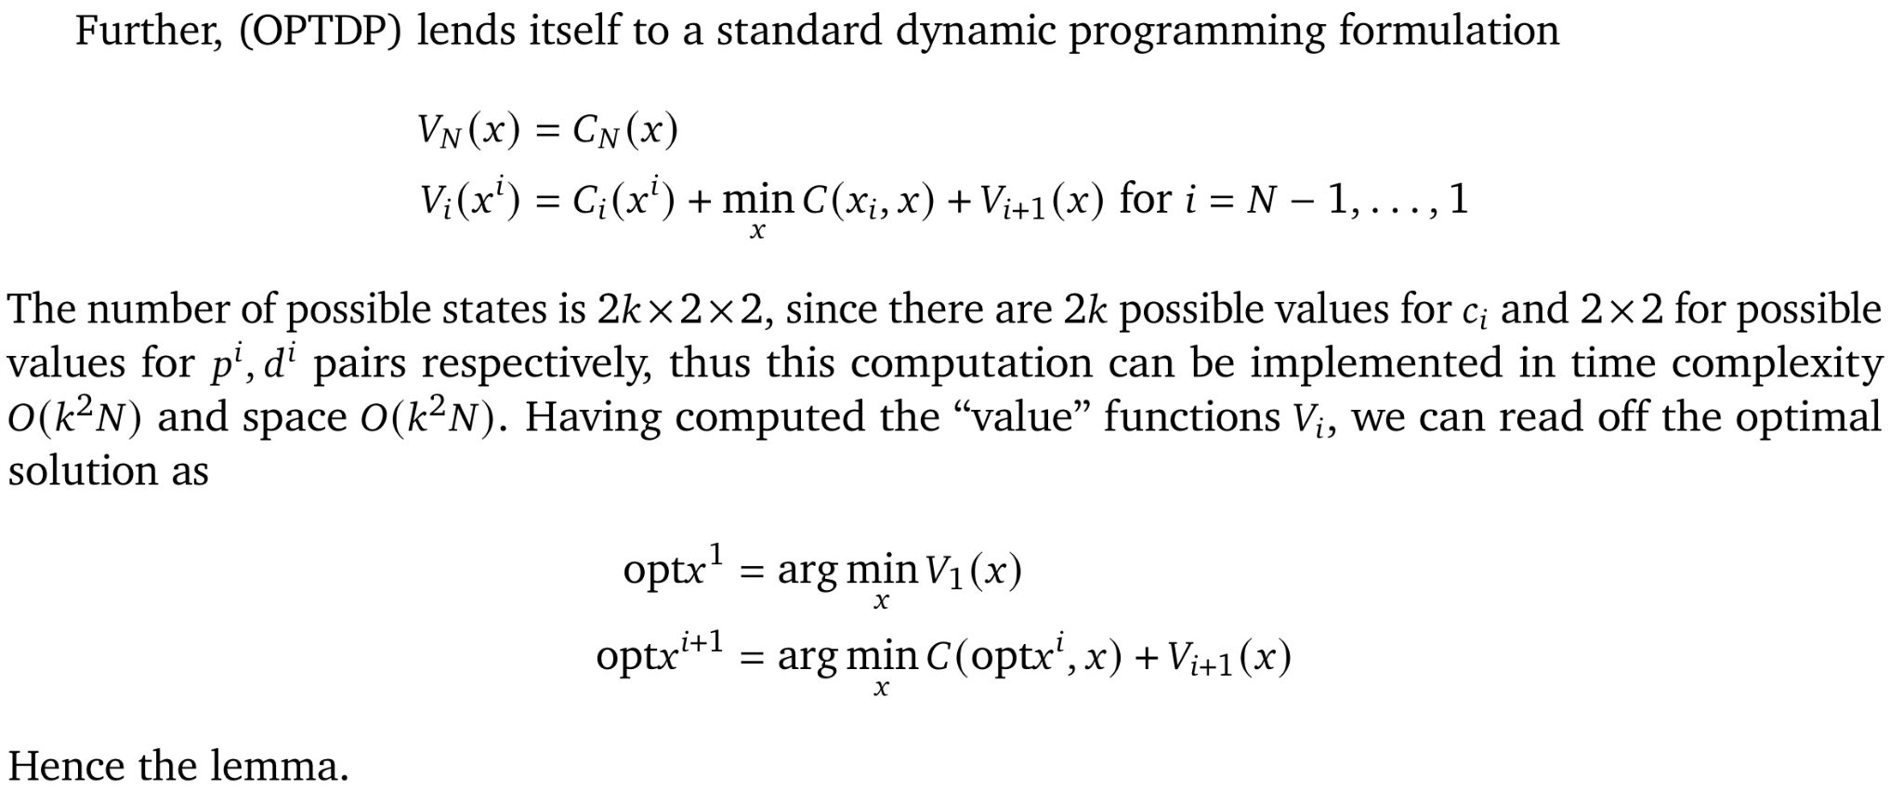

A.1.3 Details of the hypothesis tests

The performance of CoDoC was compared to that of a standalone diagnostic AI system and clinical readers. We used the Wald test⁴ to establish non-inferiority and the McNemar test⁵ to establish superiority. We used a statistical significance threshold of 0.05. For non-inferiority comparisons, a 5% absolute margin was pre-specified before the test set was inspected. Confidence intervals on the differences are Wald intervals⁶.

Our primary comparisons numbered 28 in total: 4 per setting in Table 1. For each setting, sensitivity and specificity of CoDoC is compared to both the sensitivities and specificities of the standalone diagnostic AI system and the clinical readers. All P values survived correction for multiple comparisons within a setting using the Holm–Bonferroni method⁷.

A.2 Additional experimental results
We now present additional experimental results that provide further insights into the results presented in sections 3, 4, 5 of the main paper.

A.2.1 Reader and Site Generalization
This section expands on the results presented in Section 4 of the main paper. We begin by plotting the the results outlined in Section 4.2 of the main paper:

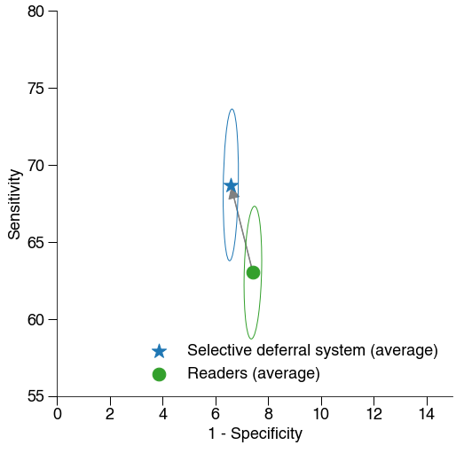
Figure A0: Generalization of CoDoC to previously-unseen readers. The circular dot represents the mean standalone performance of a reader (clinician) and the corresponding star shows mean performance under CoDoC working with the reader (connected to the circle by an arrow). The ellipses indicate the 95% confidence intervals of the mean. The results show that performance improves (the star is above and to the left of the circle) with little variation between readers. The bold circle star represents the average change in performance across all leave-one-out reader generalization experiments.

We now present results showing how CoDoC generalizes to unseen readers, by training the CoDoC on data that omit opinions from a particular clinician, but evaluating the resulting CoDoC on cases paired with opinions from that clinician. In the datasets we use, not every clinician provides an opinion on every case. Thus, we only include clinicians who rank in the top 10 in terms of number of cases they read.

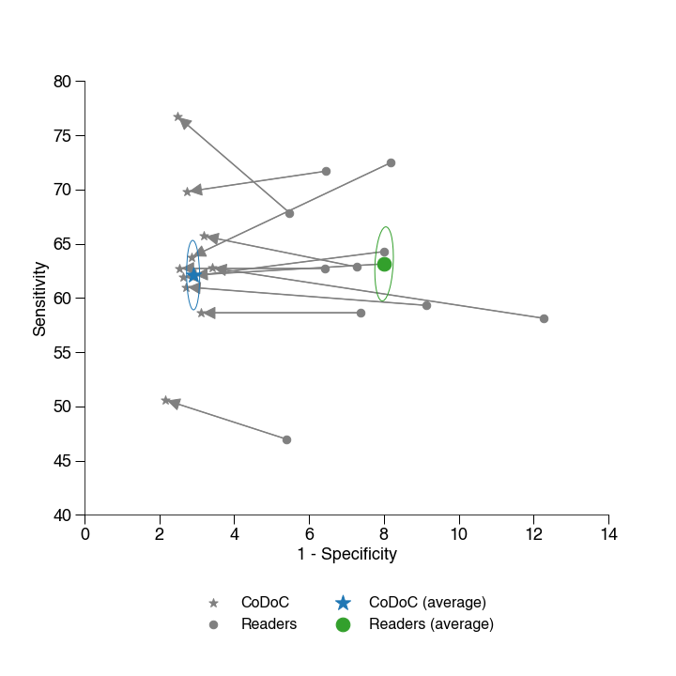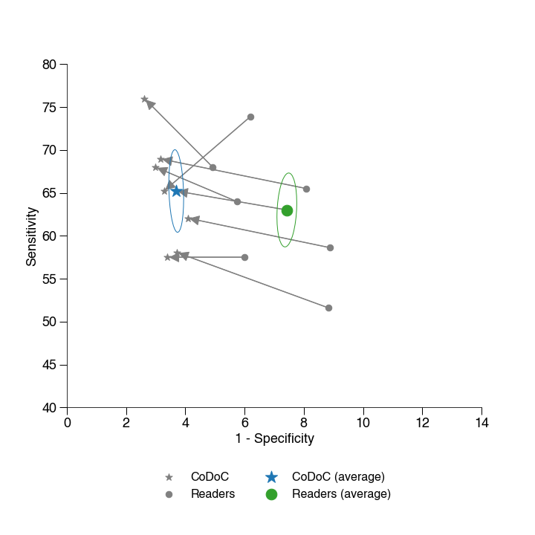
Figure A1.1. Breast Cancer Detection (UK Dataset 1), Defer to R1, Spec Superior CoDoC on the validation set (Left) and on the test set (Right).

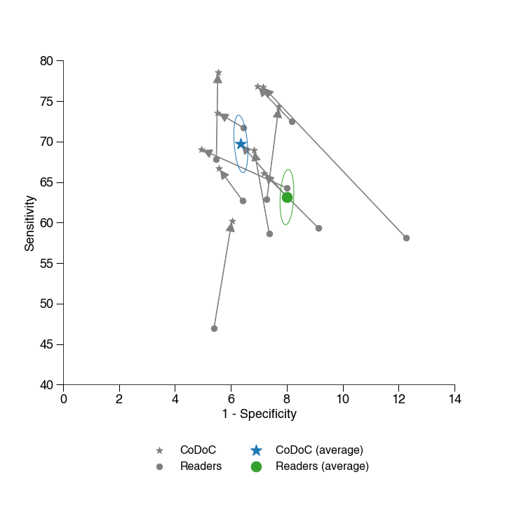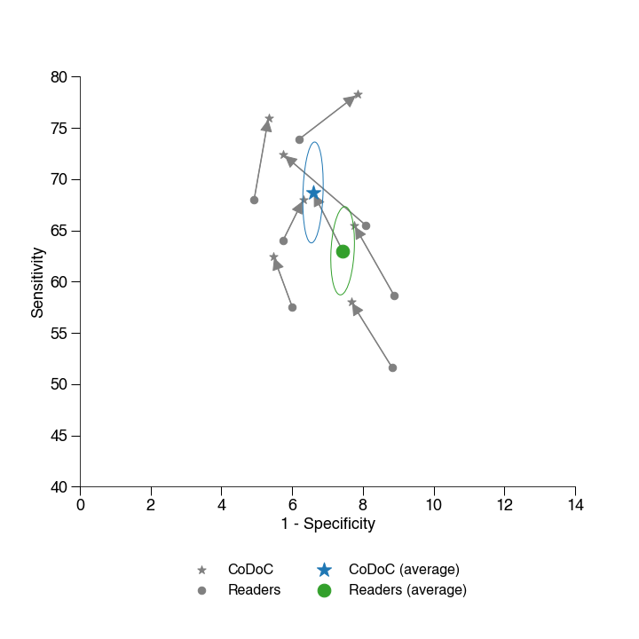
Figure A1.2. Breast Cancer Detection (UK Dataset 1), Defer to R1, Sens Superior CoDoC on the validation set (Left) and on the test set (Right).

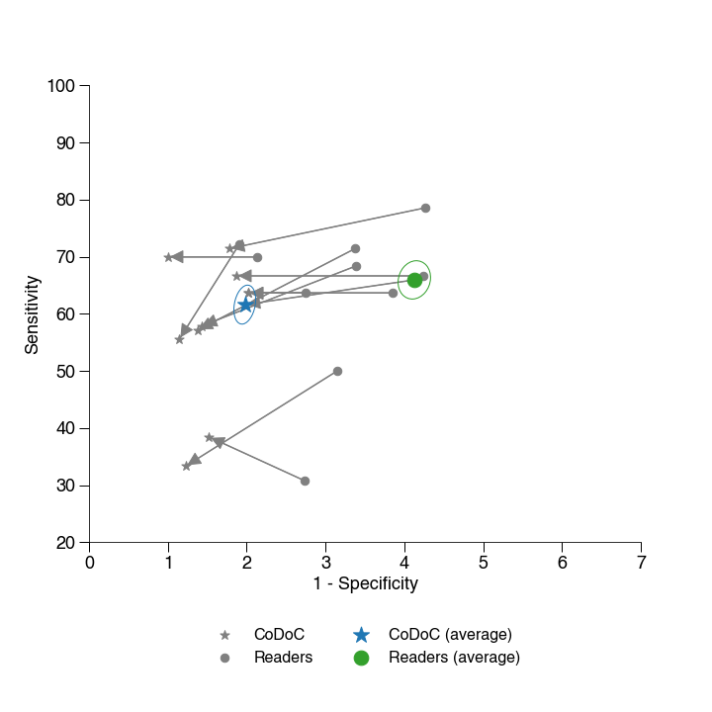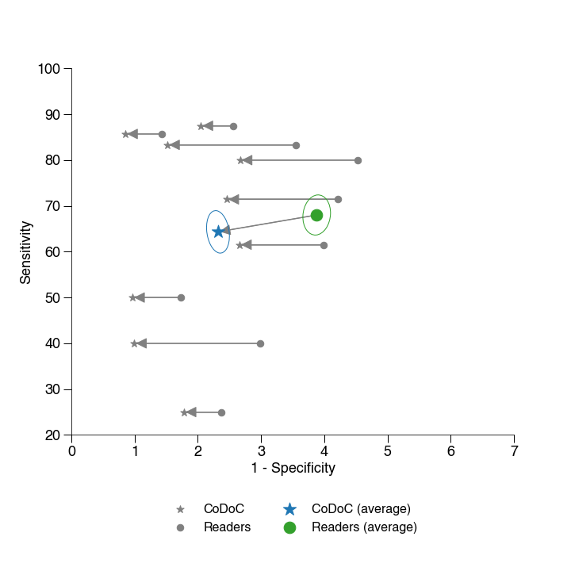
Figure A1.3. Breast Cancer Detection (UK Dataset 1), Defer to Routine, Spec Superior CoDoC on the validation set (Left) and on the test set (Right).

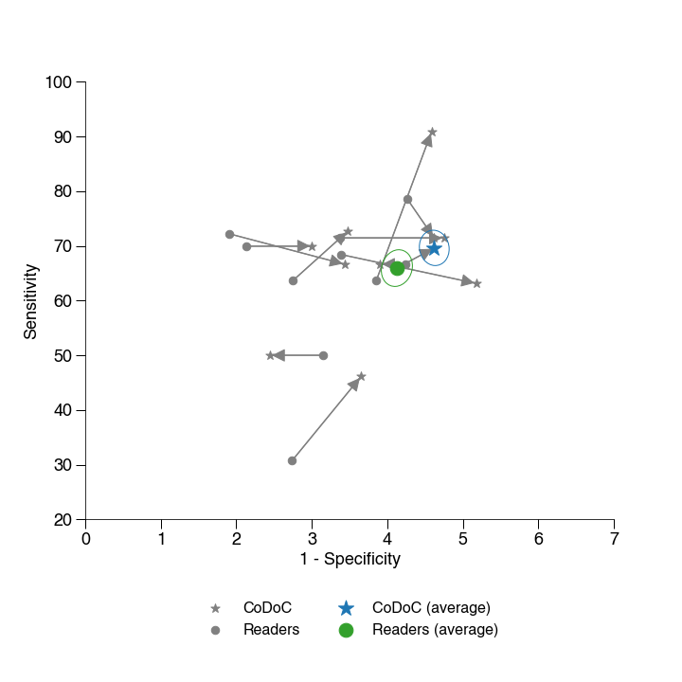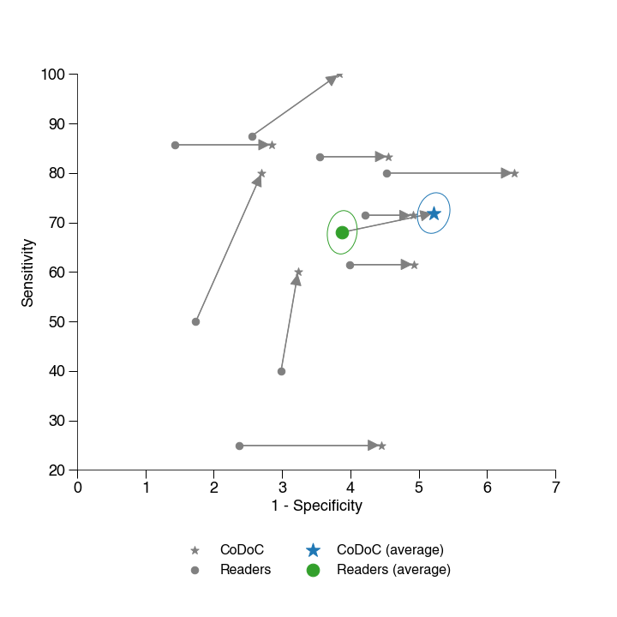
Figure A1.4. Breast Cancer Detection (UK Dataset 1), Defer to Routine, Sens Superior CoDoC on the validation set (Left) and on the test set (Right).

Figure A1: Reader generalization experiments. Each figure displays the generalization of the model for each of the top ten clinicians (by number of cases read). The gray circle represents the performance of the clinician (reader) operating in isolation, and the gray star represents the performance of CoDoC trained without data from that clinician, but evaluated on cases read by that clinician (hence, this represents a generalization to a novel previously unseen clinician). Ideally, we would want the star to be above and to the left of the circle (showing that CoDoC improves on the clinician in terms of both sens and spec), but in practice, due to the nature of the objective optimized by CoDoC, there is an improvement only in one or the other. The larger, colored points display the average of the gray, showing, on average, how the CoDoC improves upon the performance of a previously unseen clinician. These consistently demonstrate that the CoDoC improves upon the previously unseen clinician in terms of diagnostic accuracy either on sensitivity or specificity (with a mild drop in the other), and sometimes improves on both sensitivity and specificity (in particular, for the Defer to R1 workflow for UK Dataset 1 for Breast Cancer Screening).

A.2.2 Details on dataset sizes
We present the numbers of cases in the tuning set used for training the deferral AI in Table A1 and the corresponding sizes are further summarized in Diagram A1. The tuning set is broken into two parts, the tune subset (used to optimize parameters of the deferral AI) and the validation subset (used to select hyperparameters of the deferral AI). The 2nd/3rd columns contain the number of cases in the original tuning set, for each of the datasets considered in the paper. The 4th/5th columns contain the number of cases in the reduced tuning set, which is chosen to be the minimum number of cases such that CoDoC improves on the performance of both the diagnostic AI and the clinician uniformly over the range of interest in sensitivity/specificity - note that this is estimated purely graphically. We do not consider the statistical significance tests described in Section A.1.3 for this analysis since the variance in the results can be large due to the stochastic nature of subsampling used to produce the reduced tuning set. We represent that the numbers presented here are indicative rather than statistically rigorous estimates.

Dataset | Number of cases (+ve cases in parentheses) in tune-train | Number of cases (+ve cases in parentheses) in tune-val | Number of cases (+ve cases in parentheses) in test
UK Mammo Dataset 1 | 12169 (243) | 48586 (955) | 25856 (268)
US Mammo Dataset 1 | 4392 (69) | 4391 (70) | 9052 (176)
US Mammo Dataset 2 | 3537 (16) | 3537 (15) | 7074 (30)
TB Dataset | 5988 (918) | 5989 (919) | 11977 (1838)

Table A1. The table above gives details of the number of cases in the tuning set used to train and validate the deferral AI.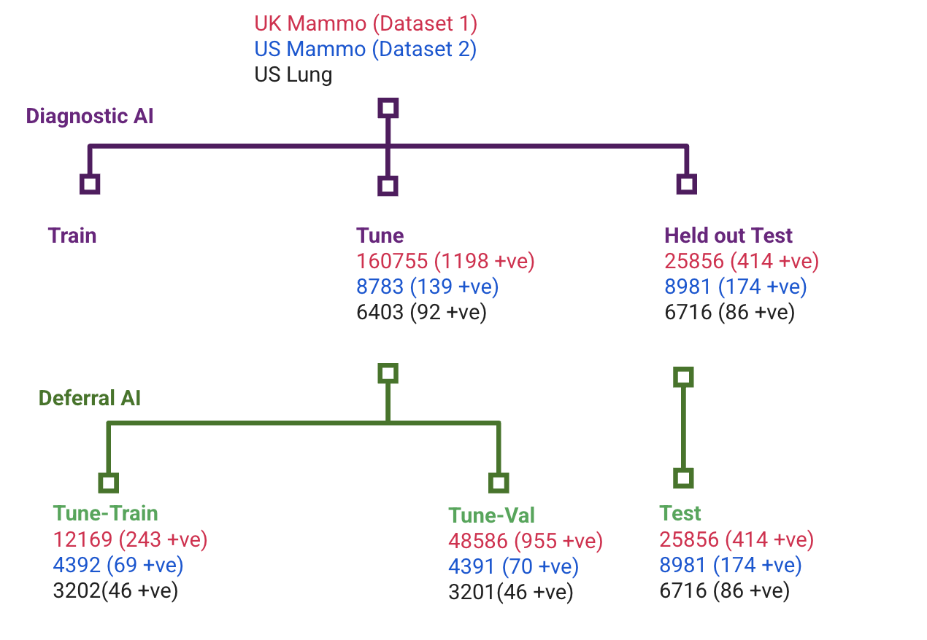
Diagram A1. Data splits and sizes for training and evaluation of the deferral model.

A.2.3 Comparison to weighted combination of diagnostic AI and clinical workflow
We also compare CoDoC to a simple baseline that takes a weighted combination of the confidence score from the diagnostic AI and the prediction from the clinical workflow and applies a threshold to the weighted score to compute the final prediction (disease present/absent). We set the weights and the thresholds on the tuning dataset to optimize a given weighted combination of sensitivity and specificity with a trade-off parameter $λ$ as in section A.1. We sweep over over the weights, thresholds and $λ$ and perform model selection as described in section A.1.4 on the validation set.

We implemented and compared this baseline against CoDoC on (US Mammography Dataset 2).
 | Sensitivity | Specificity | # Clinician reads per case
Weighted Combination | .87 | .96 | 1
CoDoC | .9 | .96 | .47
Clinical workflow | .84 | .96 | 1
Diagnostic AI | .87 | .7 | 0

Thus, with less than half the number of clinician reads per case, CoDoC is able to achieve a better performance than the weighted combination approach and the clinical workflow.

A.3 Analysis and Interpretability
The above section focused on results that provide insights into the quantitative behavior of CoDoC under generalization stress tests and data constraints. In this section, we focus on qualitative analysis and interpretability of CoDoC. The first subsection looks at visualization of the deferral strategy learned by the Deferral AI, the second subsection discusses the behavior of CoDoC on various subpopulations of interest and the final subsection presents qualitative impressions of an expert clinician (radiologist specialized in Breast Cancer Screening) on the cases that CoDoC chooses to defer on for the breast cancer detection task.

A.3.1 Analysis of deferral model

The deferral AI model learns deferral regions in the combined model score $s$. This provides a convenient way to visualize what the deferral AI model learns, and why it does so. In particular, since the deferral AI model is trained to maximize a certain combination of the sensitivity and specificity, we simply partition the test data by consider all examples where the model score was in a small interval (say [.1, .15]) and compute the contribution of those examples to the weighted combination of sensitivity and specificity being optimized. We then compute the difference between the performance of the diagnostic AI and the clinician (as measured by the weighted combination of sens and spec), and plot this as a function of the model score.

By overlaying these plots on top of the deferral regions computed by the deferral AI system, one can interpret why the deferral AI system decides to defer in certain regions of the model score. In the remainder of this section (in Figures A4.1-A4.7), we provide these plots for each of the evaluation setups considered in the main paper.

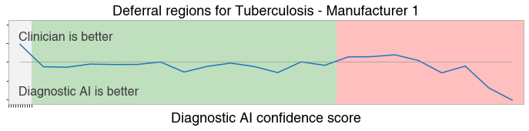
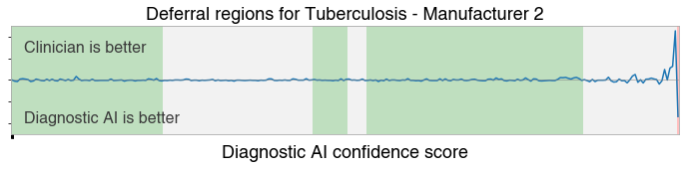
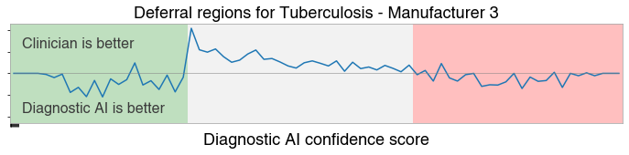
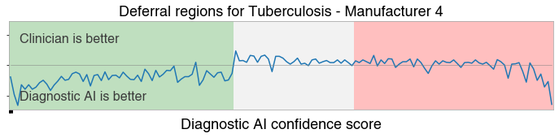
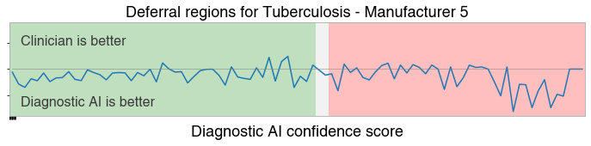
Figure A4.1. Tuberculosis models

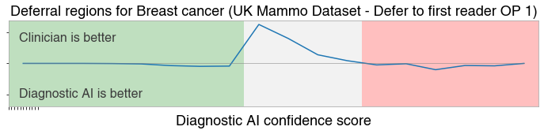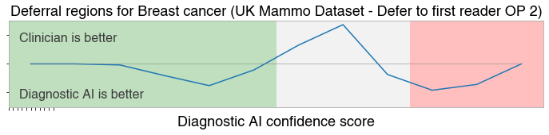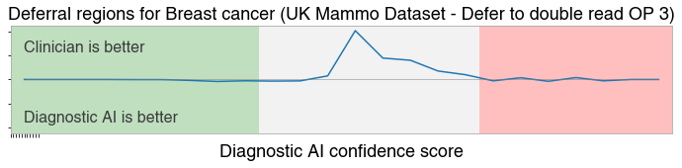
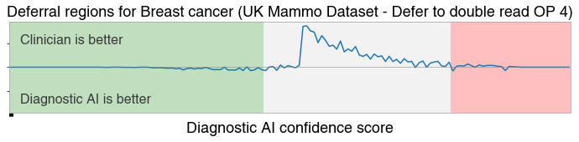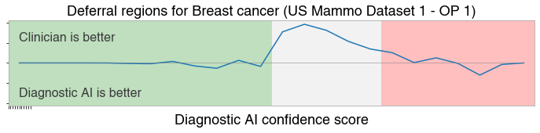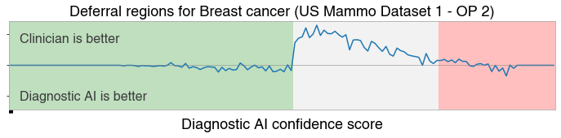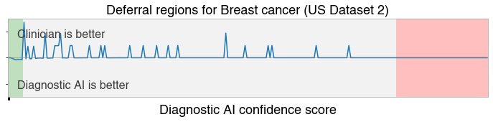
Figure A4.2. Breast cancer detection models
Figure A4: Deferral regions vs AI-Human performance gain. The x-axis denotes the confidence score predicted by the diagnostic AI model. The red curve in the top panel shows a smoothed estimate of the difference between the performance of the diagnostic AI model and the clinician (measured as a weighted arithmetic mean of sens and spec). The bottom panel shows where the SD system predicts cancer (in red), no cancer (in green) and decides to defer (in gray). The gray regions coincide well with the region where the clinician outperforms the diagnostic AI model (i.e. the red curve is below 0).

A.3.2 Subpopulation analysis
In this section, we present further results showing how the performance of CoDoC varies on subpopulations grouped by ethnicity and by manufacturer of the imaging device used to capture the Mammogram on UK Mammography Dataset 1. We see that for both groupings, CoDoC improves upon the standalone diagnostic AI and clinician performance, in most cases on both sensitivity and specificity, and in other cases on at least one of them. Note that there are error bars around these point estimates

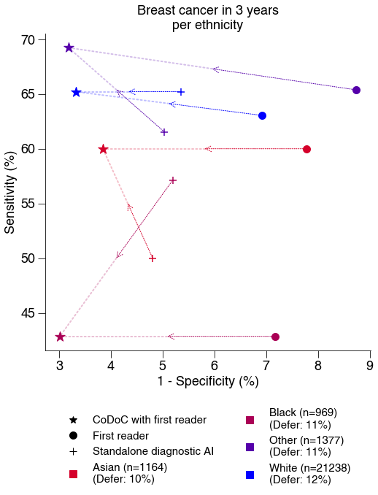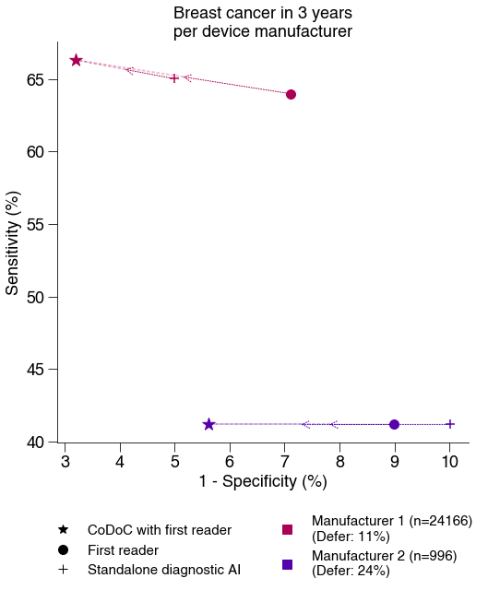

Figure A5: Subgroup breakdown across age groups (top left), breast density grades (top right), ethnicity groups (bottom left) and device manufacturers (bottom right) on the UK dataset. Across subgroups, CoDoC (★) combines performance from both the human reader (●) and standalone diagnostic AI system (+). CoDoC shown is “Defer to First reader OP 1” from Table 1 in the main paper.

A.3.3 Qualitative case analysis
We present qualitative results and notes of an expert radiologist examining a selection of cases from amongst those that CoDoC decides to defer on, for the test set from UK Mammography Dataset 1. We include one example each of cases where the biopsy proven ground truth was Cancer/NoCancer and the final diagnosis from the double read with arbitration clinical workflow arrived and the same/opposite conclusion, giving a total of 4 cases.

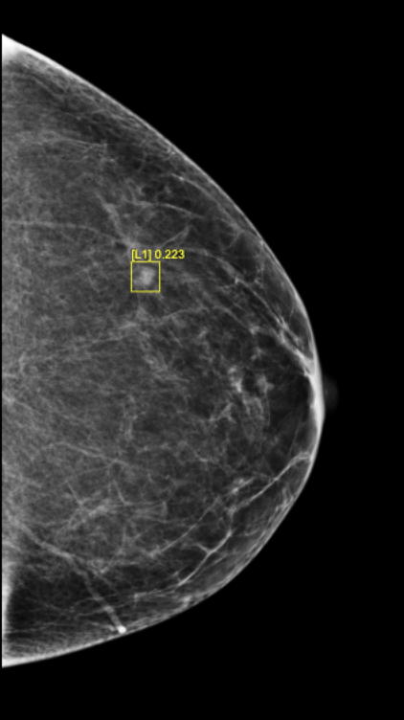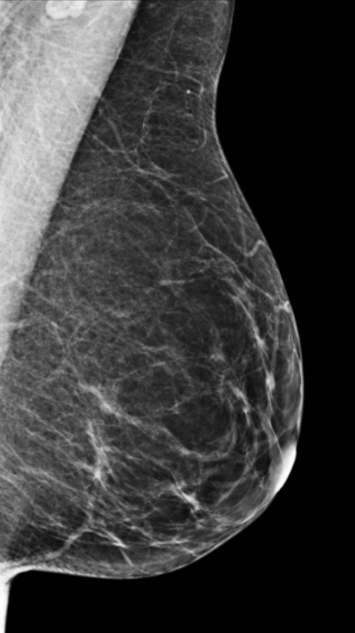
Figure A6.1: CoDoC decision - defer to clinical workflow (do not use diagnostic AI)
- Ground Truth: Cancer Negative
- Double-reading with arbitration: Routine recall (no cancer)
- Diagnostic AI system: Recall for assessment (cancer)
- Descriptive notes from review by board-certified radiologist: “There is a small isolated density which appears probably benign but some readers might recommend a recall for assessment.”

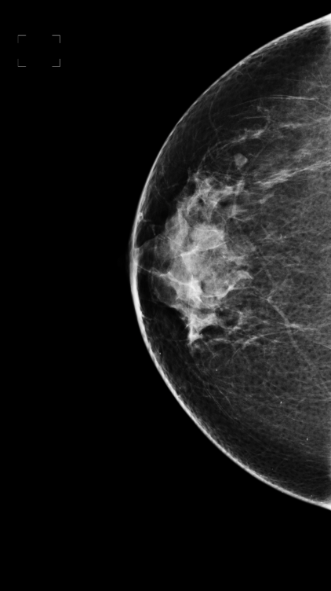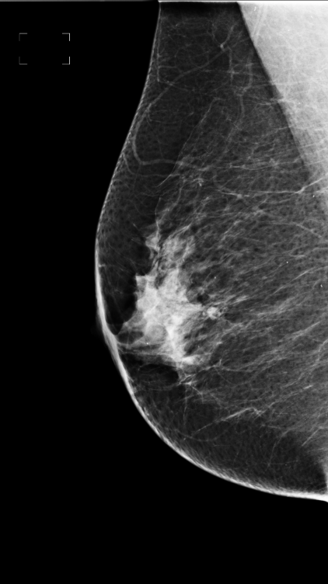
Figure A6.2: CoDoC decision - do not defer to clinical workflow (use diagnostic AI)
- Ground Truth: Cancer Negative
- Double-reading with arbitration: Recall for assessment (cancer)
- Diagnostic AI system: Routine recall (no cancer)
- Descriptive notes from review by board-certified radiologist: “There is a small mass (possible lymph node) in the lateral breast seen on both the MLO and CC view. This was recalled and assessed with ultrasound, which determined the mass to be benign”.

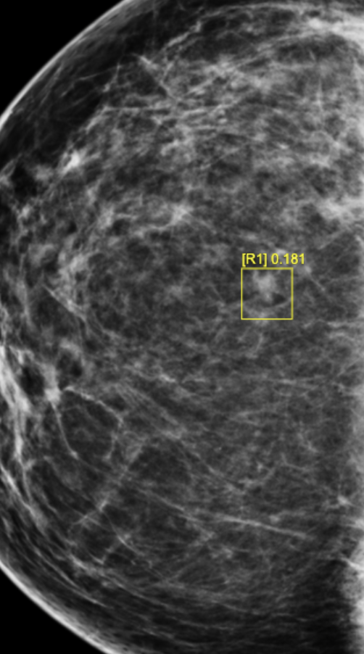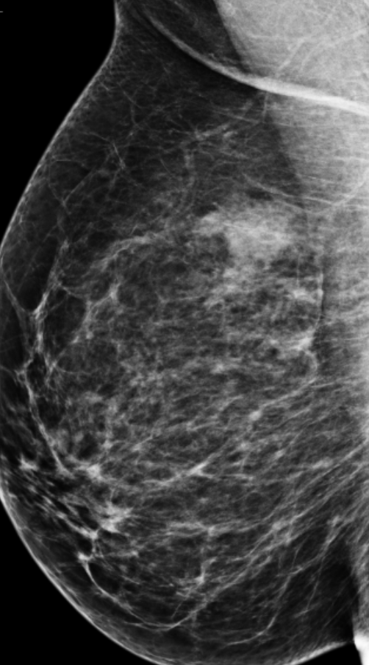

Figure A6.3: CoDoC decision - do not defer to clinical workflow (use diagnostic AI)
- Ground Truth: Cancer Positive
- Double-reading with arbitration: Routine recall (no cancer)
- Diagnostic AI system: Recall for assessment (cancer)
- Descriptive notes from review by board-certified radiologist: “The original screening images show a subtle lesion in the central breast on the CC view. The lesion is not obviously distinct from background parenchyma and I would not have recalled for assessment. However, subsequent images show a convincing malignant lesion in the same location”

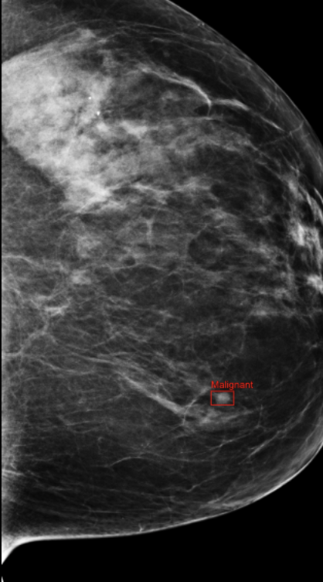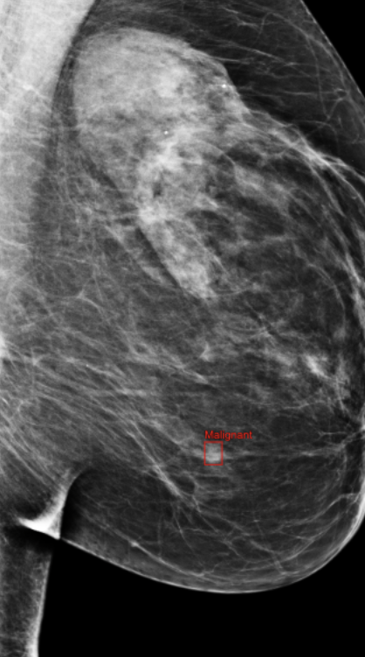
Figure A6.4: CoDoC decision - defer to clinical workflow (do not use diagnostic AI)
- Ground Truth: Cancer Positive
- Double-reading with arbitration: Recall for assessment (cancer)
- Diagnostic AI system: Routine recall (no cancer)
- Descriptive notes from review by board-certified radiologist: “There is a small mass in the left breast CC view, highlighted by a bounding box. The lesion is less conspicuous on the MLO view.”

A.4 Details of clinical implications calculations

In this section, we provide the descriptions of the expected clinical improvements claimed in sections 3.1.2 and 3.2.3.

Breast Cancer detection:
In a breast cancer screening programme, we consider two alternative strategies to implement the deferral mechanism into a screening workflow.
1) The double-reader system is replaced by CoDoC deferring to a single reader alone (Defer to single-reader workflow).
2) The double-reader system is not replaced but improved by CoDoC (Defer to double-reader workflow).

To compute the figures for the two-human-readers-only baseline workflow, we assume that a consensus panel will need to make two additional reads (avg_reads_by_panel = 2), when presented with a case due to disagreement of both readers.

We observe, as shown in Figure 2, that CoDoC attained superior diagnostic accuracy to the historic double-reader system. On the test set, CoDoC defers only 12 percent of the cases to the human reader. As the average number of reads per case is 2.1 in the double read workflow, when this is replaced by a single reader, deferred to only 12% of times, we expect the clinical workload to reduce to about 0.12 per case, that leads to an 16-fold reduction from 2.1 to 0.12 reads per case. While retaining the same cancer detection rate as a double-reader system, this also reduced the "recall to assessment rate" by 10 per cent (from 48 to 43 per 1000 cases), when compared to the double reader system.

In this deployment scenario the desired outcome is to achieve the highest diagnostic performance, and CoDoC defers to the standard double-reader workflow.
This would deliver a valuable 19% reduction in recall-to-assessment (from 48 to 39 per 1000 cases) while matching the cancer detection rate of double-reading, alongside a three-fold reduction in clinician workload (from 2.1 to 0.7 reads per case).

A.5 Details of demographics
We used UK Mammography Dataset 1 and US Mammography Datasets 1/2 to study the robustness of CoDoC against population shift. In this section, we provide details on how these datasets differ in terms of population, both by the ethnicity of patients in the dataset and by the breast density of patients in the dataset.

Table A2. The table below gives details of the population drift between the three datasets we use for Breast cancer detection, in terms of the subpopulation breakdowns by ethnicity and breast density. Note that we did not have access to breast density information for US Mammography Dataset 1.

Ethnicity | UK Mammography Dataset 1 | US Mammography Dataset 2 | US Mammography Dataset 1
Asian | 4.8% | 0.8% | 4.7%
Black | 3.2% | 1.2% | 12.3%
Mixed | 1.0% | 0.0% | 0.0%
Other | 5.5% | 0.0% | 0.0%
White | 82.5% | 96.3% | 47.5%
Unknown | 2.9% | 1.8% | 35.5%

Breast Density | UK Mammography Dataset 1 | US Mammography Dataset 2
1.0 | 4.9% | 3.2%
2.0 | 31.5% | 18.6%
3.0 | 19.5% | 24.3%
4.0 | 8.0% | 6.6%
Unknown | 36.1% | 47.4%

Table A3. Characteristics of a) the UK Mammography Dataset test set and b) the Tuberculosis Dataset
a
 |  | UK test set | CI at 95% | NHS BSP
 | Years | 2012 to 2015 | - | 2011 to 2016
 | Sources | 2 sites in the UK | - | All UK screening sites
 | No. women | 25,856 | - | 10,257,551
 | No. normals | 25,588 (99.0%) | (98.8, 99.1) | 10,171,074 (99.1%)
 | No. cancers | 268 (1.0%) | (0.9, 1.2) | 86,477 (0.8%)
 | Recall rate | 1,235 (4.8%) | (4.5, 5.1) | 427,457 (4.2%)
Age | 45 – 49 | 1,707 (6.6%) | (6.2, 7.1) | 832,883 (8.1%)
Age | 50 – 52 | 4,399 (17.1%) | (16.4, 17.7) | 1,487,366 (14.5%)
Age | 53 – 54 | 2,742 (10.6%) | (10.1, 11.1) | 944,823 (9.2%)
Age | 55 – 59 | 6,034 (23.3%) | (22.6, 24.0) | 2,139,701 (20.9%)
Age | 60 – 64 | 5,457 (21.1%) | (20.4, 21.8) | 2,044,746 (19.9%)
Age | 65 – 70 | 4,575 (17.7%) | (17.0, 18.3) | 2,217,947 (21.6%)
Age | >= 70 | 942 (3.6%) | (3.3, 4.0) | 590,085 (5.8%)
Cancer type | Invasive | 204 (76.1%) | (69.5, 81.8) | 68,006 (78.6%)
Cancer type | Non-invasive | 58 (21.6%) | (16.2, 28.1) | 17,733 (20.5%)
Cancer type | Micro-invasive | - | - | 654 (0.8%)
Cancer type | Unknown | 6 (2.2%) | (0.9, 5.6) | 84 (0.1%)
Cancer size  (Invasive only) | < 10mm | 41 (20.1%) | (13.7, 28.3) | 17,242 (25.4%)
Cancer size  (Invasive only) | 10 – 15mm | 44 (21.6%) | (15.3, 30.4) | 17,745 (26.1%)
Cancer size  (Invasive only) | 15 – 20mm | 39 (19.1%) | (12.9, 27.2) | 12,864 (18.9%)
Cancer size  (Invasive only) | 20 – 50mm | 61 (29.9%) | (22.1, 38.7) | 16,316 (24.0%)
Cancer size  (Invasive only) | >= 50mm | 13 (6.4%) | (3.1, 12.4) | 1,527 (2.3%)
Cancer size  (Invasive only) | Unknown | 6 (2.9%) | (1.0, 7.9) | 2,312 (3.4%)
For each feature, we constructed a joint 95% confidence interval on the proportions in each category. The UK test set was drawn from two sites in the UK over a four-year period. For reference, we present the corresponding statistics from the broader UK NHSBSP. For comparison with national numbers, only cancers that were detected by screening are reported here.
b
 |  | Overall (n=23954) | Xpert results |  |  | Tuberculosis history
 |  |  | Positive (n=3675) | Negative (n=20 279) | p value | Previously treated (n=3586) | New case (n=20 341) | p value
Age, years |  | 42·0 (30·0–57·0) | 37·0 (27·0–53·0) | 43·0 (31·0–58·0) | <0·0001 | 44·0 (31·0–58·0) | 42·0 (30·0–57·0) | <0·0001
Age group |  |  |  |  | <0·0001 |  |  | <0·0001
 | Young (15 to <25 years) | 2666 (11·1%) | 664 (18·1%) | 2002 (9·9%) | .. | 309 (8·6%) | 2355 (11·6%) | ..
 | Middle aged (25 to <60 years) | 16 056 (67·0%) | 2378 (64·7%) | 13 678 (67·4%) | .. | 2437 (68·0%) | 13 606 (66·9%) | ..
 | Older (≥60 years) | 5232 (21·8%) | 633 (17·2%) | 4599 (22·7%) | .. | 840 (23·4%) | 4380 (21·5%) | ..
Sex |  |  |  |  | <0·0001 |  |  | 0·541
 | Female | 7876 (32·9%) | 1061 (28·9%) | 6815 (33·6%) | .. | 1163 (32·4%) | 6706 (33·0%) | ..
 | Male | 16 078 (67·1%) | 2614 (71·1%) | 13 464 (66·4%) | .. | 2423 (67·6%) | 13 635 (67·0%) | ..
Previous tuberculosis medication |  | 3586 (15·0%) | 608 (16·5%) | 2978 (14·7%) | 0·0041 | 3586 (100·0%) | 0 | ..
Symptoms
 | Cough | 21 494 (89·7%) | 3416 (93·0%) | 18 078 (89·1%) | <0·0001 | 3176 (88·6%) | 18 318 (90·1%) | 0·0090
 | Fever | 19 041 (79·5%) | 3200 (87·1%) | 15 841 (78·1%) | <0·0001 | 2931 (81·7%) | 16 110 (79·2%) | 0·0006
 | Shortness of breath | 13 011 (54·3%) | 2062 (56·1%) | 10 949 (54·0%) | 0·022 | 1888 (52·6%) | 11 123 (54·7%) | 0·024
 | Weight loss | 15 035 (62·8%) | 2774 (75·5%) | 12 261 (60·5%) | <0·0001 | 2475 (69·0%) | 12 560 (61·7%) | <0·0001
 | Haemoptysis | 3103 (13·0%) | 471 (12·8%) | 2632 (13·0%) | 0·807 | 511 (14·2%) | 2592 (12·7%) | 0·014
 | Any symptoms | 23 582 (98·4%) | 3644 (99·2%) | 19 938 (98·3%) | 0·0002 | 3499 (97·6%) | 20 056 (98·6%) | <0·0001
Patient source |  |  |  |  | <0·0001 |  |  | <0·0001
 | Community screening | 170 (0·7%) | 16 (0·4%) | 154 (0·8%) | .. | 20 (0·6%) | 150 (0·7%) | ..
 | Contact screening | 172 (0·7%) | 9 (0·3%) | 163 (0·8%) | .. | 11 (0·3%) | 161 (0·8%) | ..
 | Private referral | 17 056 (71·2%) | 2822 (78·7%) | 14 234 (70·2%) | .. | 2515 (70·1%) | 14 521 (71·4%) | ..
 | Public DOTS retesting | 2496 (10·7%) | 436 (12·2%) | 2060 (10·2%) | .. | 597 (16·6%) | 1897 (9·3%) | ..
 | Public referral | 485 (2·1%) | 100 (2·8%) | 385 (1·9%) | .. | 47 (1·3%) | 438 (2·2%) | ..
 | Walk-in | 2992 (12·8%) | 204 (5·7%) | 2788 (13·7%) | .. | 294 (8·2%) | 2694 (13·2%) | ..
Bacteriologically positive (Xpert) |  | 3675 (15·3%) | 3675 (100·0%) | 0 | .. | 608 (17·0%) | 3063 (15·1%) | ..
Mycobacterium tuberculosis burden |  |  |  |  | .. |  |  | 0·0004
 | Very low | 634/3675 (17·3%) | 634 (17·3%) | .. | .. | 127/608 (20·9%) | 507/3063 (16·6%) | ..
 | Low | 1093/3675 (29·7%) | 1093 (29·7%) | .. | .. | 192/608 (31·6%) | 903/3063 (29·5%) | ..
 | Medium | 1299/3675 (35·3%) | 1299 (35·3%) | .. | .. | 187/608 (30·8%) | 1111/3063 (36·3%) | ..
 | High | 648/3675 (17·6%) | 648 (17·6%) | .. | .. | 103/608 (16·9%) | 546/3063 (17·8%) | ..
Rifampicin resistance |  |  |  |  | .. |  |  | <0·0001
 | Detected | 181/3675 (4·9%) | 181 (4·9%) | .. | .. | 87/608 (14·3%) | 94/3063 (3·1%)
 | Not detected | 3475/3675 (94·6%) | 3475 (94·7%) | .. | .. | 520/608 (85·5%) | 2951/3063 (96·3%)
 | Indeterminate | 14/3675 (0·4%) | 14 (0·4%) | .. | .. | 1/608 (0·2%) | 13/3063 (0·4%)
Radiologist grading |  |  |  |  | <0·0001 |  |  | <0·0001
 | Abnormal: highly suggestive | 3683 (15·4%) | 1441 (39·2%) | 2242 (11·1%) | .. | 969 (27·0%) | 2712 (13·3%) | ..
 | Abnormal: possibly tuberculosis | 7154 (29·9%) | 1813 (49·3%) | 5341 (26·3%) | .. | 1467 (40·9%) | 5679 (27·9%) | ..
 | Abnormal: not tuberculosis | 3625 (15·1%) | 240 (6·5%) | 3385 (16·7%) | .. | 396 (11·0%) | 3224 (15·8%) | ..
 | Normal | 9492 (39·6%) | 181 (4·9%) | 9311 (45·9%) | .. | 754 (21·0%) | 8726 (42·9%) | ..
Data are n (%), n/N (%), or median (IQR), unless specified otherwise. Breakdown by radiologist grading is given in table 2. AI=artificial intelligence. DOTS=directly observed treatment short course. Xpert=Xpert MTB/RIF.

References
1. Devroye, L. & Lugosi, G. Combinatorial Methods in Density Estimation. (Springer New York).
2. Lee, D. & Seung, H. S. Algorithms for Non-negative Matrix Factorization. Adv. Neural Inf. Process. Syst. 13, (2000).
3. Leibig, C. et al. Combining the strengths of radiologists and AI for breast cancer screening: a retrospective analysis. Lancet Digit Health 4, e507–e519 (2022).
4. Liu, J.-P., Hsueh, H.-M., Hsieh, E. & Chen, J. J. Tests for equivalence or non-inferiority for paired binary data. Statistics in Medicine vol. 21 231–245 Preprint at https://doi.org/10.1002/sim.1012 (2002).
5. McNEMAR, Q. Note on the sampling error of the difference between correlated proportions or percentages. Psychometrika 12, 153–157 (1947).
6. Fagerland, M. W., Lydersen, S. & Laake, P. Recommended tests and confidence intervals for paired binomial proportions. Stat. Med. 33, 2850–2875 (2014).
7. Aickin, M. & Gensler, H. Adjusting for multiple testing when reporting research results: the Bonferroni vs Holm methods. Am. J. Public Health 86, 726–728 (1996).

