Supplementary Material

Competition for water and rapid exclusion of an island endemic by a pantropical species in a tropical climate.

Anabele S. Gomes¹, Ragan M. Callaway², Bruno S. Rabelo¹, Graziela L. Petry ¹, Eduardo M. Barbosa¹ and Fabian Borghetti^{1*}

¹Departamento de Botânica, Universidade de Brasília, 70910-970, Brasília - DF
²Division of Biological Sciences and the Institute on Ecosystems, University of Montana, Missoula, MT 59812
*Corresponding author: Fabian Borghetti, +55 61 999963377, borghetti.fabian@gmail.com

Fig. S1 Mean monthly precipitation and temperature on Trindade Island from 1962 to 2010 provided by the National Oceanographic Data Bank of the Brazilian Navy. Bars represent precipitation and the line represents the temperature.

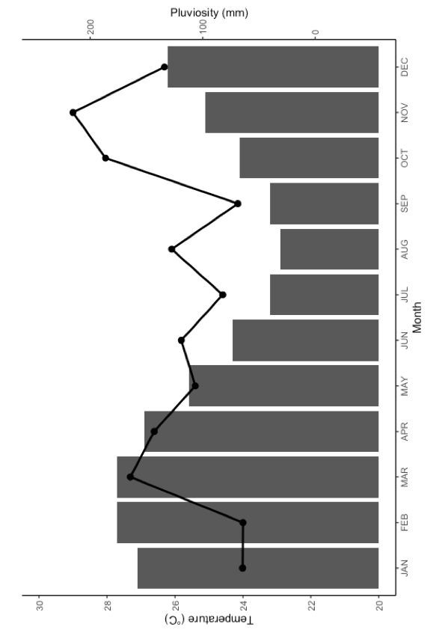

Fig. S2 Lateral roots of Guilandina bonduc (~ 14m long) extending far from the mother plant and into Cyperus atlanticus meadows at Site 2, Trindade Island, Brazil.

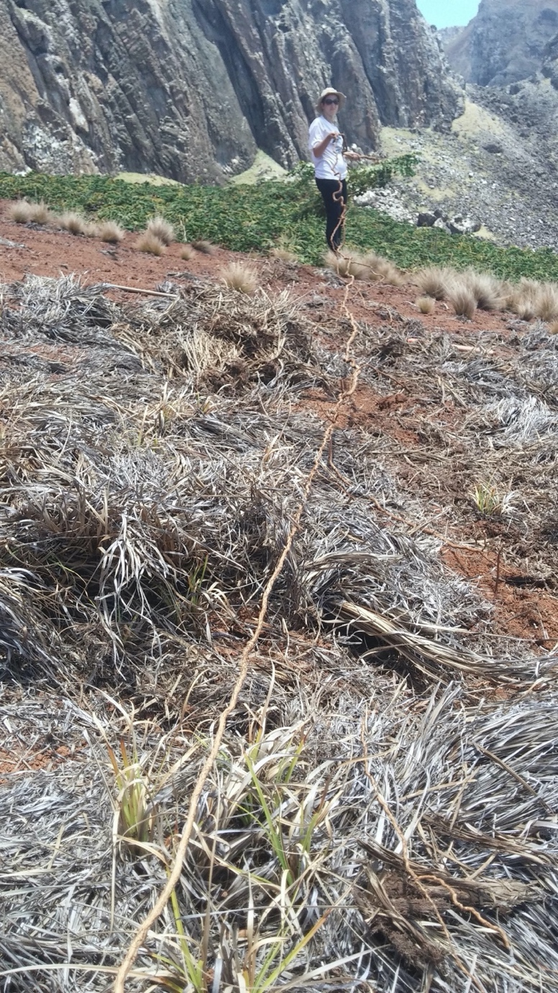
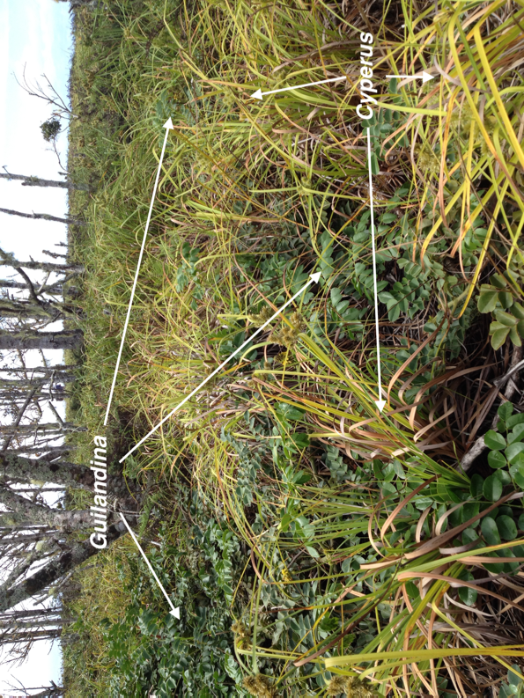
Fig. S3 Populations of Guilandina bonduc and Cyperus Atlantics growing side by side at the high elevation (Site 1) on Trindade Island, Brazil.

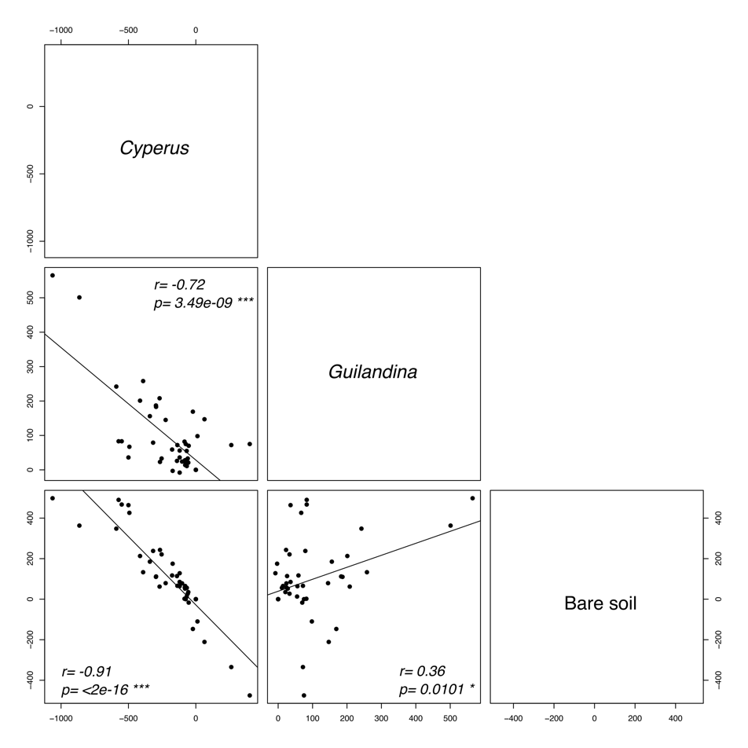
Fig. S4 Pearson`s Correlations between the accumulated temporal variation in the areas covered by populations of Guilandina bonduc and Cyperus atlanticus, and by bare soil, on Trindade Island, Brazil.
Fig. S5 Biomass of shoots and roots of Cyperus atlanticus seedlings grown for 45 days in soil collected in Guilandina bonduc, Cyperus atlanticus and bare soil zones on the Trindade Island, Brazil. Error bars represent 1 SE.

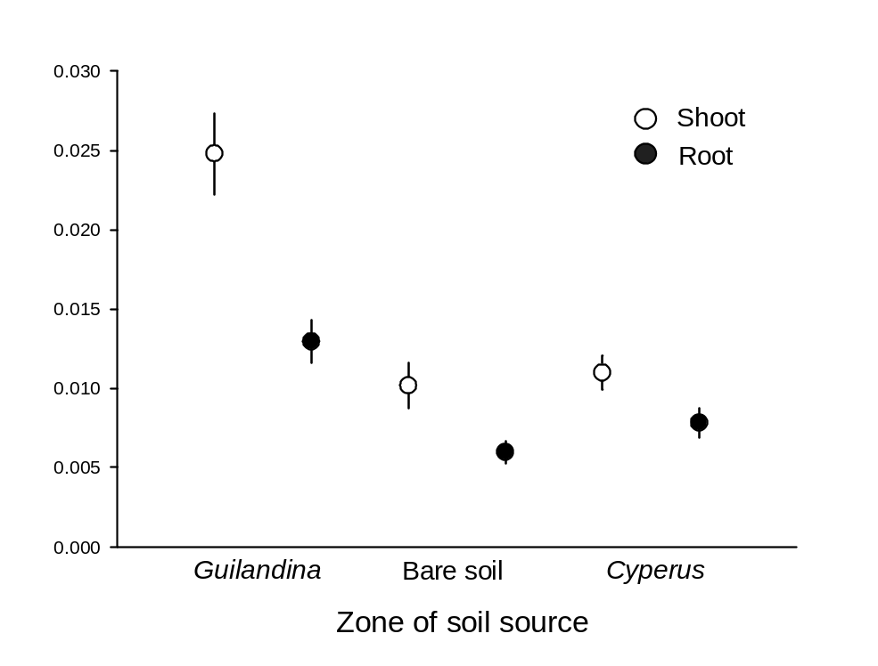
Fig. S6 Principal Component Analysis (PCA) showing substantial overlap among all three zones based on soil nutrients, pH, organic matter and cation-exchange capacity.

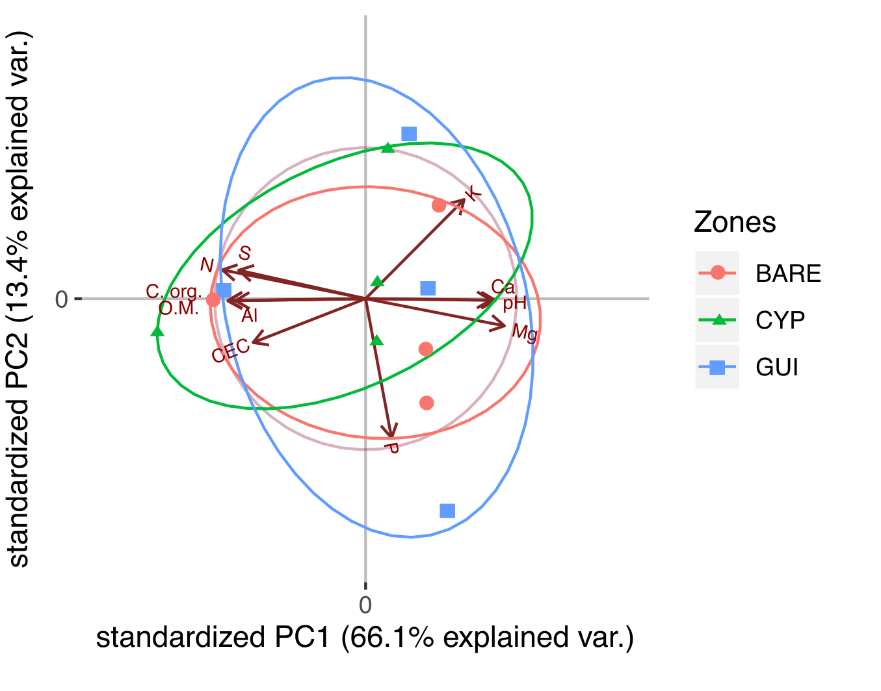

Fig. S7 Probability of soil being water-saturated by zone and soil depth. Higher values represent higher probabilities of water saturation. Mean across all four sites and 1 SE are presented.

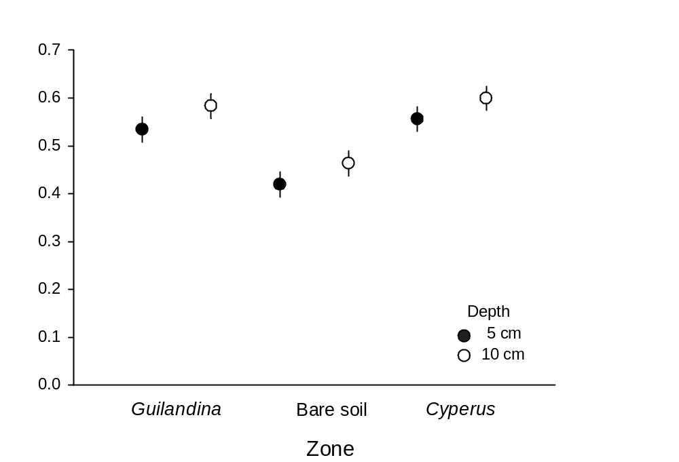

Table S1 Type III Analysis of Variance summary table comparing variation in the area (m²) occupied by bare soil zones, by Guilandina bonduc zones and by Cyperus atlanticus zones six and 12 months after the removal of shoot parts of Guilandina. Table is with Satterthwaite's method, model (formula: var_area~ zone*time_cut+(1 | area)). ¹ degrees of freedom of the model ² degrees of freedom of the error.

 | Sum Sq | Mean Sq | NumDF¹ | DenDF² | F value | Pr(>F)
zone | 541058 | 270529 | 2 | 30 | 29.93 | 7.133e-08 ***
zone*time_cut | 112802 | 56401 | 2 | 30 | 6.24 | 0.005421 **

Table S2 Permutational multivariate analysis of variance comparing fine roots of Guilandina bonduc and Cyperus atlanticus under Cyperus, Guilandina and bare soil zones, model (formula = weight ~ zone * sp_root, method = "Euclidian”). Number of permutations: 999.

 | Df | Sum Sq | Mean Sq | F model | R² | Pr(>F)
zone | 2 | 0.4631 | 0.23153 | 18.3265 | 0.13590 | 0.001 ***
sp_root | 2 | 0.0790 | 0.07902 | 6.2546 | 0.02319 | 0.020 *
Zone:sp_root | 2 | 0.6545 | 0.32723 | 25.9017 | 0.19207 | 0.001 ***
residuals | 175 | 2.2109 | 0.01263 |  | 0.64884

Table S3 Type III Analysis of Variance comparing shoot dry mass of Cyperus atlanticus seedlings grown in soil from under Guilandina, Cyperus and bare soil zones. Table shown with Satterthwaite's method, model (formula: log_shootpart ~ soil + (1 | halo)). ¹ degrees of freedom of the model ² degrees of freedom of the error.

Sum Sq | Mean Sq | NumDf¹ | DenDf² | F value | Pr(>F)
21.704 | 10.853 | 2 | 100.11 | 24.072 | 2.912e-09 ***

Table S4 Type III Analysis of Variance comparing root dry mass of Cyperus atlanticus seedlings grown in soil from under Guilandina, Cyperus and bare soil zones. Table shown with Satterthwaite's method, model (formula: log_rootpart ~ soil + (1 | halo)). ¹ degrees of freedom of the model ² degrees of freedom of the error.

Sum Sq | Mean Sq | NumDF¹ | DenDF² | F value | Pr(>F)
13.575 | 6.7876 | 2 | 100.27 | 13.569 | 6.094e-06 ***

Table S5 Chemical and physical characteristics of soil samples collected at each of the four sites on Trindade Island, Brazil. In each site, soil samples were collected at three zones: Cyperus atlanticus stands, Guilandina bonduc stands and bare soil zones.
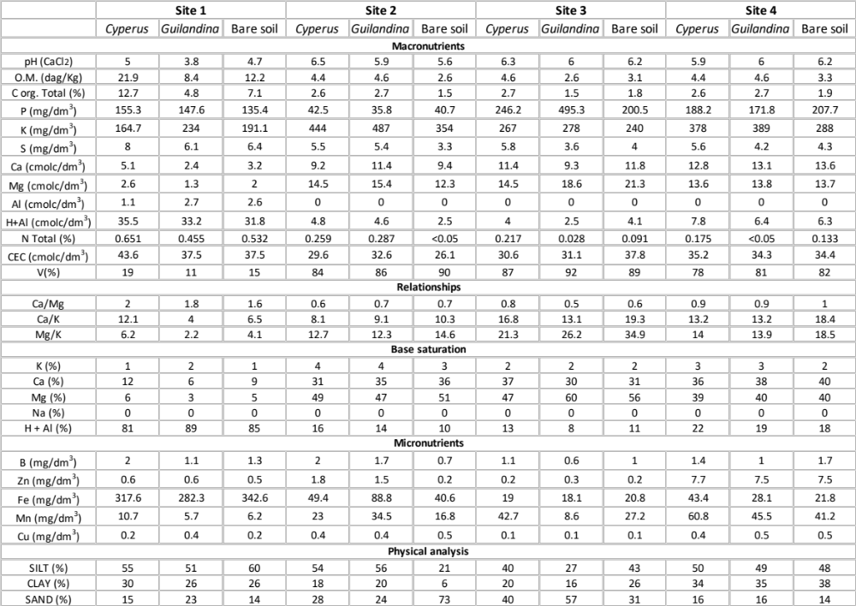

Table S6 Type III Analysis of Variance comparing soil water potential under Guilandina bonduc, Cyperus atlanticus and bare soil zones, at 5 cm and 10 cm depth. Table shown with Satterthwaite's method, model (formula: log_wpsoil~ depth + zone + depth * zone + (1 | area/day/period)). ¹ degrees of freedom of the model ² degrees of freedom of the error.

 | Sum Sq | Mean Sq | NumDF¹ | DenDF² | F value | Pr(>F)
depth | 22.864 | 22.864 | 1 | 610.83 | 23.6060 | 1.504e-06 ***
zone | 159.741 | 79.871 | 2 | 625.53 | 82.4616 | < 2.2e-16 ***
deep*zone | 12.283 | 6.142 | 2 | 611.12 | 6.3409 | 0.001881 **

Table S7 Analysis of Variance comparing the probability of the soil being water-saturated under Guilandina bonduc, Cyperus atlanticus and bare soil zones, at 5 cm and 10 cm depth. Model formula: wp~depth * zone + (1 | area/day/period), family=binomial.

 | DF | Sum Sq | Mean Sq | F value | P
depth | 1 | 9.338 | 9.3383 | 9.3383 | 0.002*
zone | 2 | 51.884 | 25.9422 | 25.9422 | 8.538947e-12 ***
depth*zone | 2 | 1.056 | 0.5280 | 0.5280 | 0.5898

Table S8 Type III Analysis of Variance comparing soil water potential at 5 cm and 10 cm depth at the four sites delimited for this study. Table shown with Satterthwaite's method, model (formula: log_wpsoil~depth + site + (1 | zone/day/period)). ¹ degrees of freedom of the model ² degrees of freedom of the error.

 | Sum Sq | Mean Sq | NumDF¹ | DenDF² | F value | Pr(>F)
depth | 26.37 | 26.370 | 1 | 620.53 | 21.742 | 3.822e-06 ***
site | 240.48 | 80.161 | 3 | 661.12 | 66.092 | <2.2e-16 ***

Table S9 Analysis of Variance comparing leaf water potential of Cyperus plants growing with Guilandina and growing in pure stands, at midday and midnight. Table shown with Satterthwaite's method, model (formula: log_wpleaf~ zone*period+(1 | area)). ¹ degrees of freedom of the model ² degrees of freedom of the error.

 | Sum Sq | Mean Sq | NumDF¹ | DenDF² | F value | Pr(>F)
zone | 2.76451 | 2.76451 | 1 | 224 | 28.1331 | 2.714e-07 ***
period | 2.05549 | 2.05549 | 1 | 224 | 20.9178 | 7.934e-06 ***
zone*period | 0.29514 | 0.2951 | 1 | 224 | 3.0035 | 0.08446

